Supplementary Information for
Controllable Experimental Technique and Efficient Electromagnetic Modeling Method of Femtosecond Electron Emission from Nano Emitters

Zheyu Luo^{2,3†}, Zheyu Song^{1†}, Yan Shen^{1†}, Yumao Wu^{2,3,4*},
Ningsheng Xu^{1,3,5*}, Shaozhi Deng^{1*}
¹State Key Laboratory of Optoelectronic Materials and Technologies, Guangdong Provincial Key Laboratory of Display Materials and
Technologies, School of Electronics and Information Technology, Sun Yat-sen University, Guangzhou, China.
²Key Laboratory for Information Sciences of Electromagnetic Waves
(MoE), College of Future Information Technology, Fudan University, Shanghai, China.
³The Nano Institute, Fudan University, Shanghai, China.
⁴The State Key Laboratory of Integrated Chips and Systems, Fudan University, Shanghai, China.
⁵The Frontier Institute of Chip and System, Fudan University, Shanghai, China.
*Corresponding author(s). E-mail(s): yumaowu@fudan.edu.cn; xns@fudan.edu.cn; stsdsz@mail.sysu.edu.cn;
†These authors contributed equally to this work.
Keywords: Ultrafast and ultrashort electron field emission, Electron autocorrelation method, Electromagnetic modeling, Method of moments, Drude-Lorentz model, Augmented electric-field integral equation, Terahertz radiation

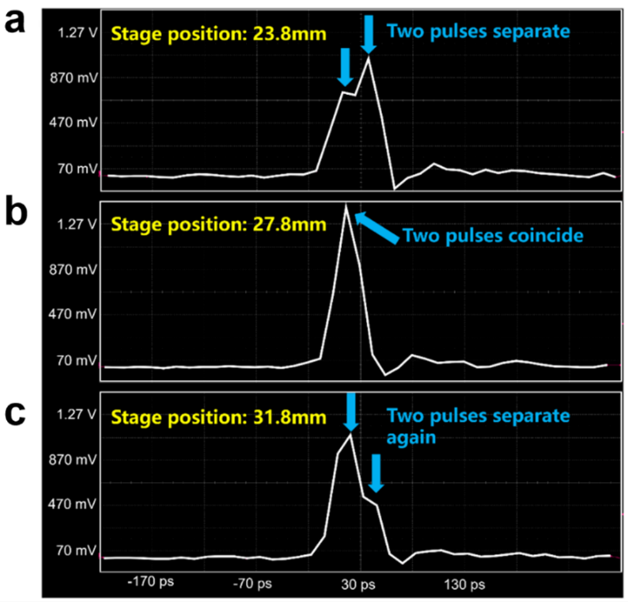
Supplementary Fig. 1. Initial calibration of the “zero-point" position for the two femtosecond laser pulses: Oscilloscope displays the characteristic waveforms of the two laser pulses transitioning from (a) separation to (b) coincidence, and then to (c) separation.

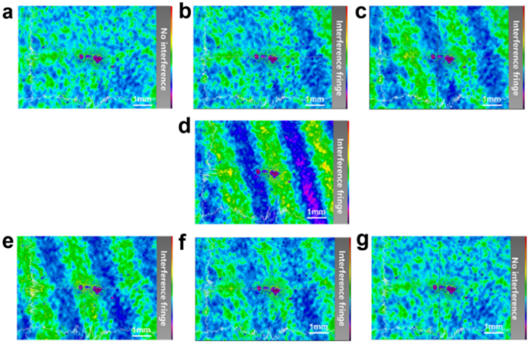
Supplementary Fig. 2. Precise calibration of the “zero-point" position for two femtosecond laser pulses: The beam analyzer displays (a) the absence of interference when the two laser pulses are separated, (b, c) the gradual emergence of interference fringes as the two laser pulses progressively overlap, (d) the most intense interference fringe pattern at the “zero-point" position, (e, f) the gradual weakening of interference fringes as the two laser pulses begin to separate, and (g) the complete disappearance of interference when the two laser pulses become fully separated again.

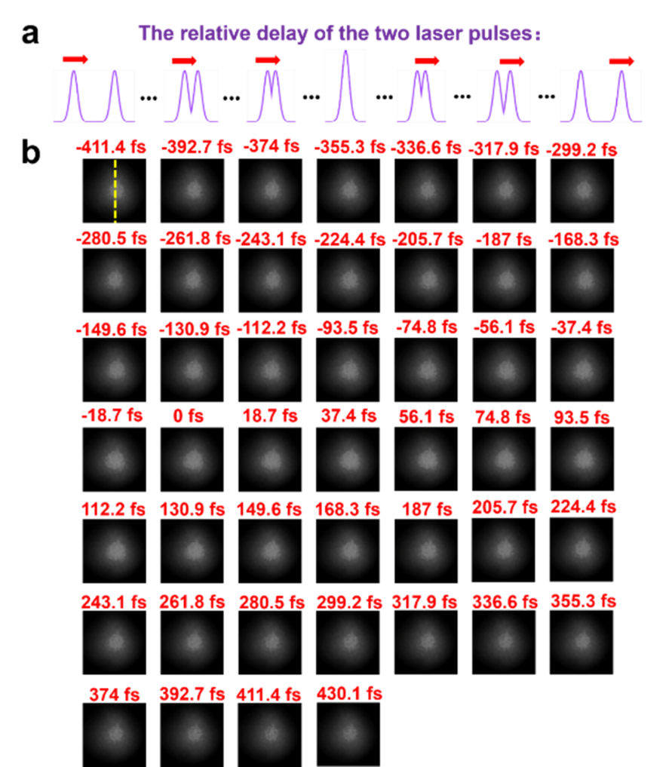
Supplementary Fig. 3. Variation in size of electron emission fluorescence patterns recorded by a high-speed sCMOS camera: (a) schematic diagram illustrating the relative delay between the two excitation laser pulses, (b) the corresponding electron emission fluorescence patterns showing variations during the process where the two electron pulses transition from separation to coincidence and then back to separation.

The Experimental Method
According to the principle of this electron autocorrelation method, the key to enabling interaction between two ultrafast and ultrashort electron pulses lies in first determining the delay stage position corresponding to temporal overlap of the excitation laser pulses-termed the “zero-point" position-before scanning around this point for data acquisition. Experimentally, the “zero-point" was determined using a combination of an ultrafast photodetector, high-bandwidth oscilloscope, and beam analyzer. Laser pulses were initially directed onto an ultrafast photodetector (ET-3600, EOT, USA) with 16 ps rise/fall times, coupled to a 36 GHz high-bandwidth oscilloscope (LabMaster 10-36Zi-A, Teledyne LeCroy, USA) to preliminarily identify the approximate zero-point range. During this process, Fig. 1 displays the complete transition of two laser pulse waveforms from separation to coincidence, then to separation as the delay stage was adjusted. This confined the zero-point to the 23.8-31.8 mm range (centered near 27.8 mm). Due to response limitations of the photodetector and oscilloscope bandwidth, the measured laser pulse duration broadened to 10 ps. Thus, femtosecond-scale zero-point calibration only provided an approximate range, narrowing the search window for refinement. Finer determination of the zero-point position was achieved using a beam analyzer (BM-USB-SP907-OSI, Spiricon, USA). As shown in Fig. 2, two collimated but unfocused laser beams (after beam expansion) were directed onto the beam analyzer. Scanning the delay stage near 27.8 mm clearly revealed: no interference when pulses separated (Fig. 2a), emerging interference fringes during approach (Fig. 2b, c), maximum fringe contrast at zero-point (27.58 mm, confirming complete temporal overlap, see Fig. 2d), fading fringes during separation (Fig. 2e, f), and no interference when fully separated again (Fig. 2g).
Following precise zero-point determination at 27.58 mm, Fig. 3 documents the electron pulse measurements. Electron emission fluorescence images for pulse width analysis were recorded using a high-speed sCMOS camera (Flash 4.0 V3, Hamamatsu, Japan). Specifically, the delay stage scanned from 27.52 to 27.65 mm in 2.8 μm steps (equivalent to 18.7 fs per step). As schematized in Fig. 3a, 46 electron emission images were equally spaced and extracted (Fig. 3b) during the entire transition of electron pulses from separation to coincidence and back. Analysis of these emission images revealed distinct fluorescence pattern size variations: Minimal at separation, progressive expansion during convergence, maximum diameter at full overlap, followed by contraction during separation. Size measurements extracted from sCMOS- captured fluorescence images (500 ms exposure per frame) ultimately generated the electron autocorrelation curve for cold-cathode emission. Spot sizes were quantified via the camera’s “Line Profile" function, performing dynamic high-precision intensity analysis along the yellow dashed trajectory in Fig. 3b. Another method for quantifying the spot size is to calculate the cross-sectional area of the emitted spot’s 3D distribution map at a defined grayscale value (for representative case, see below).

Detailed EM Modelling Methods
To establish the proposed modeling method, we begin with the EFIE. Using the RWG basis functions $Λ_{n}(r)$ to expand the surface current density $J(r)$, the matrix elements in the discretized EFIE system are given by
$$\left(ikη_{0}\overline{V}+\frac{η_{0}}{ik}\overline{S}\right)⋅J=b$$
with
[V]mn&=μrSm​Λm(r)Sn​g(r,r')Λn(r')dr'dr
[S]mn&=εr−1Sm​∇⋅Λm(r)Sn​g(r,r')∇'⋅Λn(r')dr'dr
[b]m&=Sm​Λm(r)⋅E(r)incdr
Here, $Λ$ represents the normalized RWG basis
$$\begin{matrix}Λ_{i}(r)=\left\{\begin{matrix}\frac{r−r_{i}^{+}}{2S_{i}^{+}}, & r∈T_{i}^{+}, \\ \frac{r_{i}^{−}−r}{2S_{i}^{−}}, & r∈T_{i}^{−}, \\ 0, & \text{elsewhere}.\end{matrix}\right.\end{matrix}$$
To build the A-EFIE system, the charge density is introduced as an additional unknown. The pulse basis function $h_{j}(r)$ is defined as
$$h_{j}(r)=\left\{\begin{matrix}\frac{1}{S_{j}}, & r∈T_{j} \\ 0, & \text{elsewhere}\end{matrix}\right.$$
The current continuity condition is given as follows
$$\overline{D}⋅J=ik_{0}c_{0}ρ$$
with
$$[\overline{D}]_{mn}=\left\{\begin{matrix}0, & \text{Patch }m∉\text{RWG }n \\ 1, & \text{Patch }m∈\text{RWG }n^{+} \\ −1, & \text{Patch }m∈\text{RWG }n^{−}\end{matrix}\right.$$
We define a patch-to-patch scalar potential matrix as
[P]mn=εr−1Tm​hm(r)Tn​G(r,r')⋅hn(r')dr'dr
By combining EFIE system with the continuity condition, we can get the A-EFIE formulation
$$\left[\begin{matrix}\overline{V} & {\overline{D}}^{T}⋅\overline{P} \\ \overline{D} & k_{0}^{2}\overline{I}\end{matrix}\right]\left[\begin{matrix}ik_{0}J \\ c_{0}ρ\end{matrix}\right]=\left[\begin{matrix}η_{0}^{−1}b \\ 0\end{matrix}\right]$$
To further improve the convergence, a preconditioner is applied to the A-EFIE to improve the convergence of the iterative matrix solution.
$$\overset{‾}{M}=\left[\begin{matrix}\text{diag}(\overline{V}) & (\overline{F}⋅\overline{D})^{T}⋅\left(\overline{F}⋅\text{diag}(\overline{P})⋅{\overline{F}}^{T}\right) \\ \overline{F}⋅\overline{D} & k_{0}^{2}{\overset{‾}{I}}_{r}\end{matrix}\right]$$
Based on the A-EFIE for the perfect electric conductor (PEC), we now extend its application to realistic nano emitters. In practice, such emitters exhibit finite conductivity and must be modeled as dielectric objects with complex permittivity material, derived here from the Drude-Lorentz model. By incorporating equivalent magnetic current, the electric field integral equations for the interior and exterior regions of the emitter can be written as
$$\begin{aligned}ℒ_{\text{ext}}(r,r^{'})⋅J(r^{'})+K_{\text{ext}}(r,r^{'})⋅M(r^{'})−\frac{1}{2}\hat{n}×M(r)&=−E_{\text{inc}}(r) \\ ℒ_{\text{int}}(r,r^{'})⋅J(r^{'})+K_{\text{int}}(r,r^{'})⋅M(r^{'})+\frac{1}{2}\hat{n}×M(r)&=0\end{aligned}$$
The A-EFIE formulation for the dielectric material is given by
$$\left[\begin{matrix}{\overline{V}}_{ext} & −\frac{1}{2}\hat{n}×\overline{I}+K_{ext} & {\overline{D}}^{T}⋅{\overline{P}}_{ext}⋅\overline{B} \\ {\overline{V}}_{int} & \frac{1}{2}\hat{n}×\overline{I}+K_{int} & {\overline{D}}^{T}⋅{\overline{P}}_{int}⋅\overline{B} \\ \overline{F}⋅\overline{D} & 0 & k_{0}^{2}{\overline{F}}_{r}\end{matrix}\right]⋅\left[\begin{matrix}ik_{0}J \\ η_{0}^{−1}M \\ c_{0}ρ_{r}\end{matrix}\right]=\left[\begin{matrix}−η_{0}^{−1}b \\ 0 \\ 0\end{matrix}\right]$$
The corresponding elements of the impedance matrix in the formulation are defined as
[K]mn=S​Tm(r)⋅P.V.S'​∇'g(r,r')×Λn(r')dr'dr
[n×I]mn=S​Tm(r)⋅(n(r)×Λn(r))dr
Specifically, for the interior problem, the wavenumber $k$ is derived from the emitter’s complex permittivity given as follows
$$k=ω\sqrt{εμ}=k_{0}\sqrt{ε_{r}^{'}+i\frac{σ}{ωε_{0}}}=k^{'}+ik^{″}$$
Using this system of equations, the surface electric and magnetic current distributions induced by the laser excitation at the intrinsic frequency can be solved. Subsequently, the electric field distribution on the emitter surface or within the surrounding free space can be computed by
$$E=−ℒ(J)+K(M)$$
where
ℒ(X)=jk0S​X(r')g0(r,r')+1k02∇'⋅X(r')∇g0(r,r')dr'K(X)=P.V.S​X(r')×∇g0(r,r')dr'
Here, P.V. denotes the Cauchy principal value of the integral.

