Support Information
Dynamic Light Regulation of Surface CO Coverage Enables Efficient Low-Temperature RWGS on Electron-Rich Pt
Qingzheng Guo,+ ^{[a]} Haopeng Ge,+ ^{[a]} Guangyao Zhai, ^{[c]} Zeyan Wang, ^{[a]} Yuanyuan Liu, ^{[a]} Peng Wang, ^{[a]} Hefeng Cheng, ^{[a]} Ying Dai, ^{[b]} Baibiao Huang, ^{[a]} Zhaoke Zheng*^{[a]}
[a] Q. Guo, H. Ge, Prof. Z. Wang, Prof. Y. Liu, Prof. P. Wang, Prof. H. Cheng, Prof. B. Huang, Prof. Z. Zheng.
State Key Laboratory of Crystal Materials
Shandong University
Jinan, Shandong, 250100 (China)
*Corresponding author’s email address: zkzheng@sdu.edu.cn
[b] Prof. Y. Dai,
School of Physics
Shandong University
Jinan, Shandong, 250100 (China)
[c] Dr. G. Zhai,
College of Chemistry, Chemical Engineering and Materials Science, Shandong key laboratory of
next-generation high-performance OLED display material
Shandong Normal University
Jinan, Shandong, 250014 (China)

+These authors contributed equally to this work
*Corresponding author’s email address: zkzheng@sdu.edu.cn

Experimental Section

Catalyst preparation

Preparation of Al₂O₃: Al₂O₃ support was synthesized via a hydrothermal method. Al(NO₃)₃·9H₂O solution (25 mL, 0.9 M) and CO(NH₂)₂ solution (7.5 mL, 0.7 M) were mixed and stirred at room temperature for 15 min. The mixture was transferred to a 50 mL Teflon-lined autoclave and heated at 200℃ for 24 h. After natural cooling, the precipitate was filtered, washed with deionized water, dried at 60℃ for 24 h, and finally calcined at 500℃ for 5 h with a heating rate of 3℃/min.

Preparation of Pt-Al₂O₃: Pt-Al₂O₃ catalyst was prepared by an ice-templating method. Chloroplatinic acid solution was dissolved in 50 mL deionized water, followed by addition of Al₂O₃ powder. The suspension was sonicated for 30 min and stirred for 4 h. The mixture was frozen at -5℃ overnight and then freeze-dried to remove ice crystals, yielding a gray powder precursor. The precursor was placed in a tube furnace and calcined at 400℃ for 2 h (heating rate 5℃/min) under Ar/H₂ flow (10% H₂) to obtain Pt-Al₂O₃. Catalysts with different Pt loadings were prepared by adjusting the amount of chloroplatinic acid.

Preparation of Pd-Al₂O₃: The preparation procedure was similar to that of Pt-Al₂O₃, except that the calcination temperature was 350℃ and the duration was 1 h to avoid Pd particle agglomeration.

Preparation of MoO_{3-x}: MoO_{3-x} with abundant oxygen vacancies was synthesized via a solvothermal method. 2 mmol Mo powder was added to 24 mL anhydrous ethanol, followed by slow addition of 1.6 mL H₂O₂ solution (30 wt%). The mixture was stirred at room temperature for 30 min until a yellow transparent solution formed. The solution was transferred to a Teflon-lined autoclave and heated at 160℃ for 12 h. After natural cooling, the product was centrifuged, washed with anhydrous ethanol and deionized water, and vacuum-dried at room temperature to obtain MoO_{3-x} powder.

Preparation of MoO₃: MoO₃ nanosheets were obtained by annealing the as-prepared MoO_{3−x} nanosheets at 400 ℃ for 1 hour in air, with a ramping rate of 5 ℃ min⁻¹.

Preparation of Pt-MoO_{3-x}: Pt was loaded on MoO_{3-x} surface by the ice-templating method. Chloroplatinic acid solution was dissolved in 50 mL deionized water, followed by addition of MoO_{3-x} powder. The suspension was sonicated for 30 min and stirred for 4 h. The subsequent freeze-drying and calcination steps were identical to those for Pt-Al₂O₃ preparation.

Catalyst characterization

X-ray diffraction (XRD) patterns were recorded on a Bruker AXS D8 diffractometer using Cu Kα radiation (λ = 0.154056 nm). Field-emission scanning electron microscopy (SEM, Hitachi S-4800) equipped with energy-dispersive spectroscopy (EDS) was employed to observe morphology and elemental distribution. Transmission electron microscopy (TEM, JEOL JEM-2100) was used to analyze microstructure and Pt nanoparticle dispersion. X-ray photoelectron spectra (XPS) were obtained on a Thermo ESCALAB 250Xi spectrometer (Al Kα) with C 1s peak (284.8 eV) as reference. UV-vis diffuse reflectance spectra (DRS) were recorded on a Shimadzu UV-2550 spectrophotometer using BaSO₄ as reference. Electron paramagnetic resonance (EPR) spectra were measured on a Bruker EMXplus spectrometer. H₂ temperature-programmed reduction (H₂-TPR) and H₂ temperature-programmed desorption (H₂-TPD) were performed on a Micromeritics AutoChem II 2920 apparatus. Photoluminescence (PL) spectra and time-resolved fluorescence spectra were recorded on Horiba Fluorolog-3 and Edinburgh Instruments FLS1000 spectrometers, respectively.

Photothermal catalytic performance test

Photothermal catalytic RWGS reaction was conducted in a homemade fixed-bed reactor. 5 mg catalyst was dispersed in ethanol/water (1:1) mixed solution and dropped onto a glass fiber sheet (diameter 2.5 cm). The catalyst was evenly loaded after baking with a xenon lamp. The catalyst-loaded glass fiber sheet was placed in the center of a quartz reaction tube. A xenon lamp (Perfect Light PLS-SME300E H1, simulating solar light) was used as the light source. CO₂ and H₂ flow rates and ratios were controlled by mass flow controllers. Reaction products were quantitatively analyzed by online gas chromatography (GC-2014, Shimadzu, TCD and FID detectors). The catalyst bed temperature was monitored in real time by an embedded thermocouple, and the surface temperature was measured by an infrared thermometer. In addition, the internal thermocouple was positioned to maximize contact with the catalyst bed, ensuring reliable monitoring of the actual catalyst temperature.

In situ characterization

Continuous-flow CO-DRIFTS: Continuous-flow CO-DRIFTS experiments were performed on a Thermo Scientific iS50 FT-IR spectrometer equipped with a Harrick Praying Mantis diffuse reflectance accessory and a temperature-controlled reaction chamber. Prior to each measurement, the catalyst sample was loaded into the reaction cell and pretreated under Ar flow (50 mL min⁻¹) at 200 °C for 2 h to remove surface contaminants. After cooling to the desired temperature, a background spectrum was collected under flowing Ar. Subsequently, a 10 vol% CO/Ar gas mixture was continuously introduced into the reaction chamber at a total flow rate of 30 mL min⁻¹. After the CO adsorption signal reached a steady state, spectra were continuously recorded under either dark conditions or full-spectrum illumination. For illumination experiments, light from a 300 W Xe lamp (200–1100 nm) was delivered to the reaction chamber through an optical fiber and introduced into the cell via a quartz window, thereby illuminating the catalyst bed directly. Spectra were collected at regular time intervals with a resolution of 4 cm⁻¹ and averaged over 64 scans. The continuous-flow configuration was designed to mimic the continuously replenished CO environment generated during the RWGS reaction.

Adsorption–purge DRIFTS: Adsorption–purge DRIFTS experiments were conducted using the same spectroscopic setup. Before each measurement, the catalyst was pretreated under flowing Ar (50 mL min⁻¹) at 200 °C for 2 h and then cooled to the desired temperature. A background spectrum was collected under Ar flow. The catalyst was subsequently exposed to a 10 vol% CO/Ar gas stream at a flow rate of 30 mL min⁻¹ until saturation adsorption was achieved. Afterward, the CO feed was switched to pure Ar while maintaining the same total flow rate. The first spectrum recorded immediately after CO removal was defined as the initial adsorbed CO state (A₀). The evolution of surface adsorbed CO species was then monitored under either dark conditions or full-spectrum illumination. For illuminated measurements, light from a 300 W Xe lamp (200–1100 nm) was delivered through an optical fiber and introduced into the reaction chamber via a quartz window simultaneously with the initiation of the Ar purge. Spectra were collected continuously at predetermined time intervals with a resolution of 4 cm⁻¹ using 64 scans per spectrum. The adsorption–purge protocol minimizes interference from gas-phase CO and enables direct evaluation of the stability and desorption behavior of chemisorbed CO species on the catalyst surface.

While the continuous-flow experiment simulates the CO-rich reaction environment encountered during RWGS catalysis, the adsorption–purge experiment serves as a complementary approach to distinguish the behavior of chemisorbed CO species from contributions of gas-phase CO.

In situ XPS measurements: Catalyst was pressed into a pellet and placed on the XPS sample stage connected to a gas control system. XPS measurements were performed under dark and light irradiation (xenon lamp, 2.8 W/cm²) conditions, respectively, after stabilization in reaction atmosphere. Electronic structure changes before and after light irradiation were compared and analyzed.

Theoretical calculations

Density functional theory (DFT) calculations were performed using the Vienna Ab initio Simulation Package (VASP). The generalized gradient approximation (GGA) with PBE functional was employed to describe exchange-correlation effects. The projector augmented wave (PAW) method was used to treat ion-electron interactions with a plane wave cutoff energy of 400 eV. DFT+U correction (Ueff = 4.4 eV) was applied for Mo atoms. After optimizing the lattice parameters of orthorhombic MoO₃, a p(3×3) MoO₃(010) surface supercell model was constructed with 15 Å vacuum layer in the Z direction, and a Pt₁₀ cluster was loaded on the surface. Structural optimization employed a 2×2×1 k-point mesh with energy convergence criterion of 10⁻⁵ eV and force convergence criterion of 0.02 eV/Å. Transition states were searched using the climbing image nudged elastic band (NEB) method with 5 intermediate images along the reaction pathway^{[17-24]}.
To deeply investigate the localized interfacial electronic structures and the orbital-level origins of photo-induced CO desorption, a sub-nanometer Pt₄ cluster model supported on both pristine MoO₃ and oxygen-deficient MoO_{3-x} surfaces was additionally constructed. The Projected Density of States (PDOS) was extracted to analyze the orbital hybridization between Pt active sites and the adsorbed CO molecules. Furthermore, to quantitatively evaluate the covalent bond strength and explicitly visualize the occupancy of anti-bonding orbitals, Crystal Orbital Hamilton Population (COHP) and integrated COHP (ICOHP) analyses were conducted using the LOBSTER (Local Orbital Basis Suite Towards Electronic-Structure Reconstruction) code.

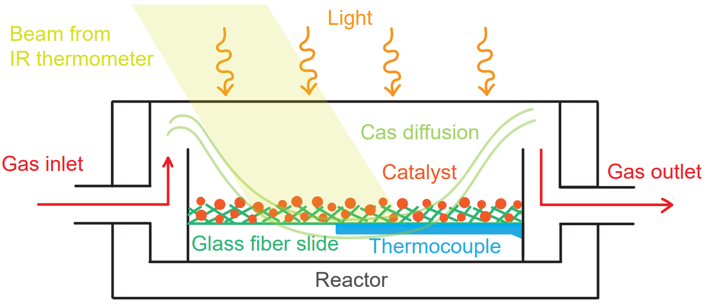
Supplementary Figure 1. Schematic illustration of the photothermal reactor.

Supplementary Figure 2. Infrared thermal imaging under a light intensity of 2.8 W/cm².

Supplementary Figure 3. (a) Photographs of the catalyst during reaction in a flow reactor. (b,c) Reactor photographs before (b) and after (c) catalyst loading.
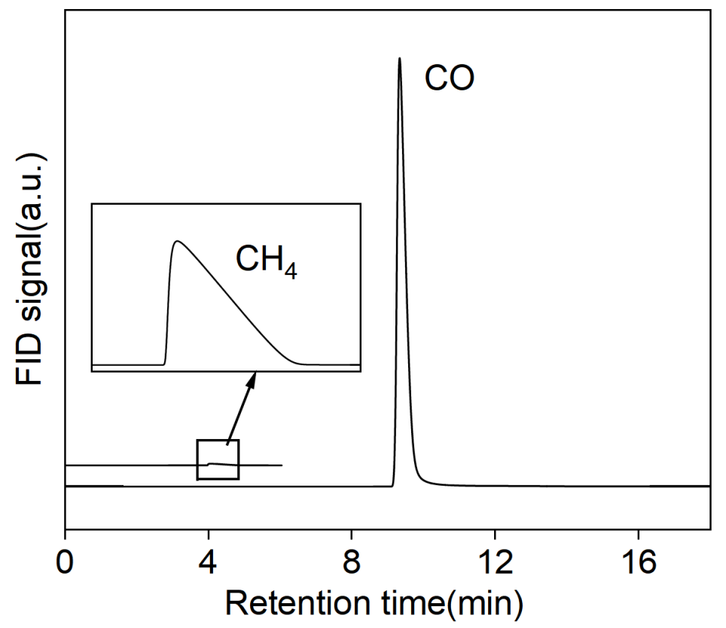
Supplementary Figure 4. FID signals of CO and CH₄ detected by GC during the actual reaction process.

Supplementary Figure 5. CO production rate of Pt-MoO_{3-x} as a function of temperature changes induced solely by an external heat source under identical conditions (2.8W/cm², CO₂:H₂=1:1, 360 L g_{cat}⁻¹ h⁻¹).

Supplementary Figure 6. CO production rate of Pt-MoO_{3-x} as a function of temperature under thermal catalytic (dark) conditions (CO₂:H₂=1:1, 360 L g_{cat}⁻¹ h⁻¹).

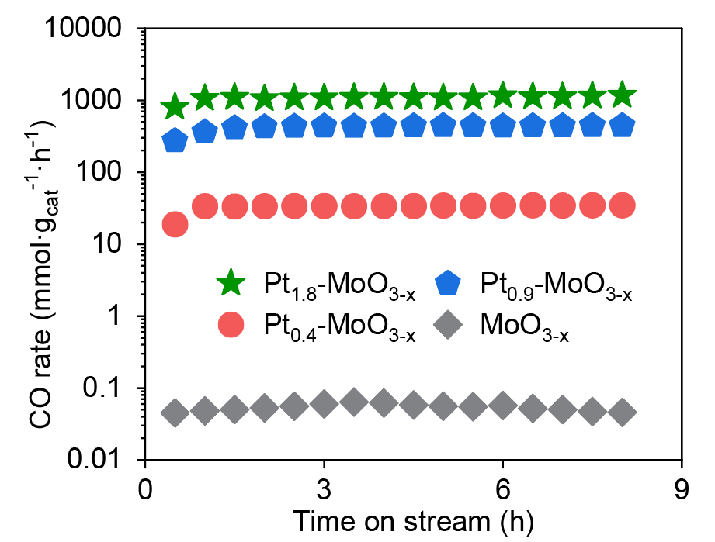
Supplementary Figure 7 CO production rate of catalysts with varying Pt loadings.

Supplementary Figure 8. (a) Raman spectra of MoO₃ and MoO_{3-x}. (b) Raman spectra of Pt-MoO_{3-x} catalyst before and after the reaction.

Supplementary Figure 9. XRD patterns of the Pt-MoO_{3-x} catalyst before and after reaction.

Supplementary Figure 10. (a, b) STEM images of Pt-MoO_{3-x} catalyst before and after reaction, and (c, d) corresponding Pt particle size distributions.

Supplementary Figure 11. XPS spectra of (a) Pt 4f, (b) Mo3d, and (c) O 1s for the Pt-MoO_{3-x} catalyst before and after reaction.

Supplementary Figure 12. STEM image of Pt-MoO_{3-x} after an 8-hour reaction at 700 ℃.

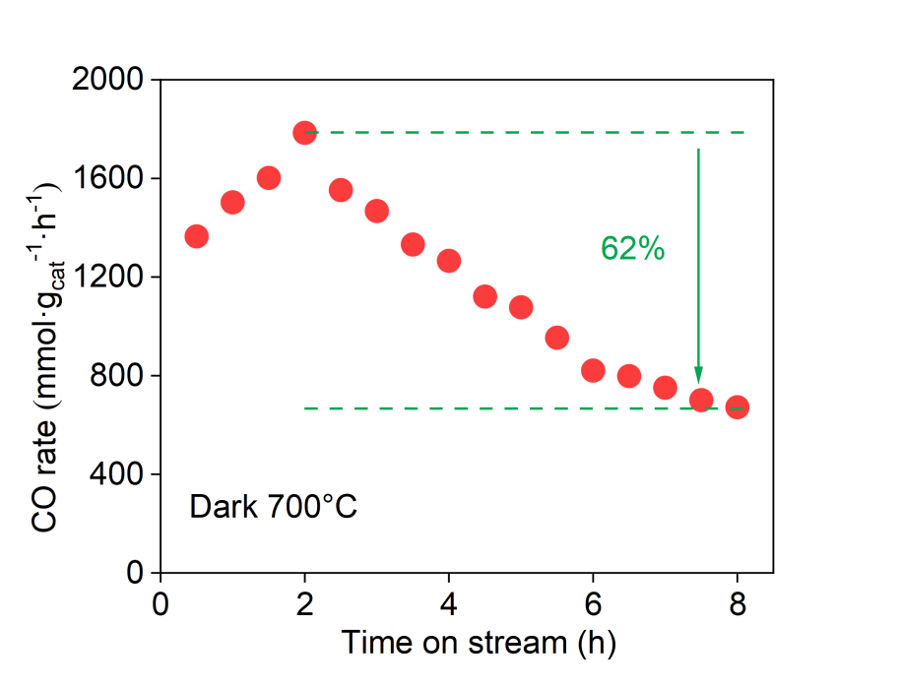
Supplementary Figure 13. CO production rate of Pt-MoO_{3-x} under thermal catalytic conditions at 700 °C.
Supplementary Figure 14. CO production rate of Pt-MoO_{3-x} as a function of light intensity under otherwise identical reaction conditions (constant temperature = 350 ℃, CO₂:H₂=1:1, 360 L g_{cat}⁻¹ h⁻¹).

Supplementary Figure 15. CO production rate of Pt-MoO_{3-x} as a function of light intensity under otherwise identical reaction conditions (CO₂:H₂=1:1, 360 L g_{cat}⁻¹ h⁻¹).

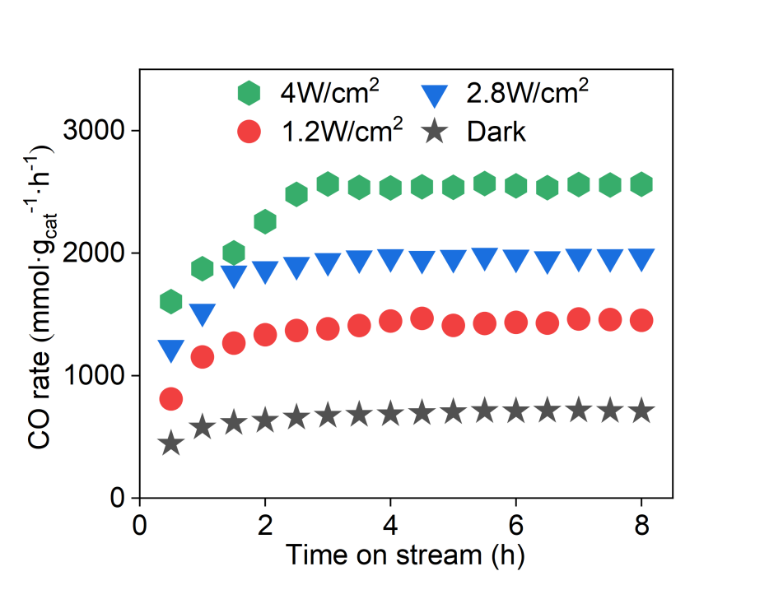
Supplementary Figure 16. CO production rate of Pt-MoO_{3-x} under different light intensities (CO₂:H₂=1:1, 360 L g_{cat}⁻¹ h⁻¹).

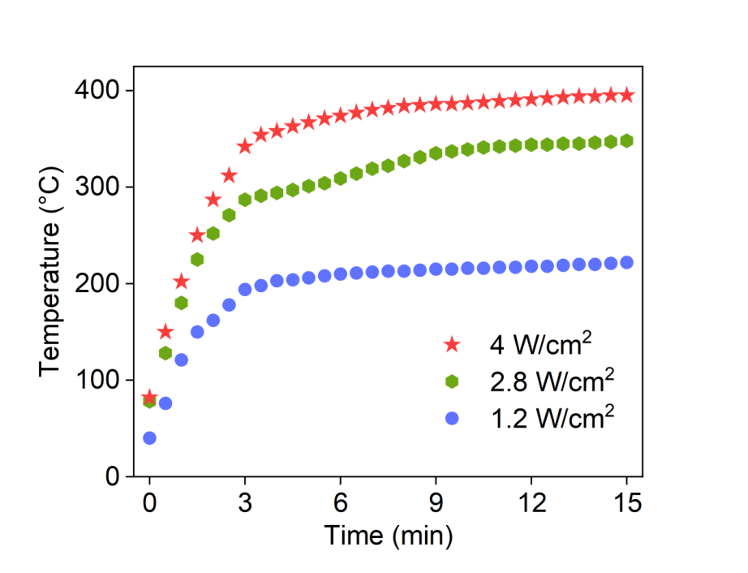
Supplementary Figure 17. Time-dependent surface temperature profiles of Pt-MoO_{3-x} under different light intensities.

Supplementary Figure 18. CO production rate of Pt-MoO_{3-x} at various GHSV values from 120 to 360 L g_{cat}⁻¹ h⁻¹.

Supplementary Figure 19. CO production rate of Pt-MoO_{3-x} at various ratios of CO₂ to H₂ from 1:1 to 1:4.

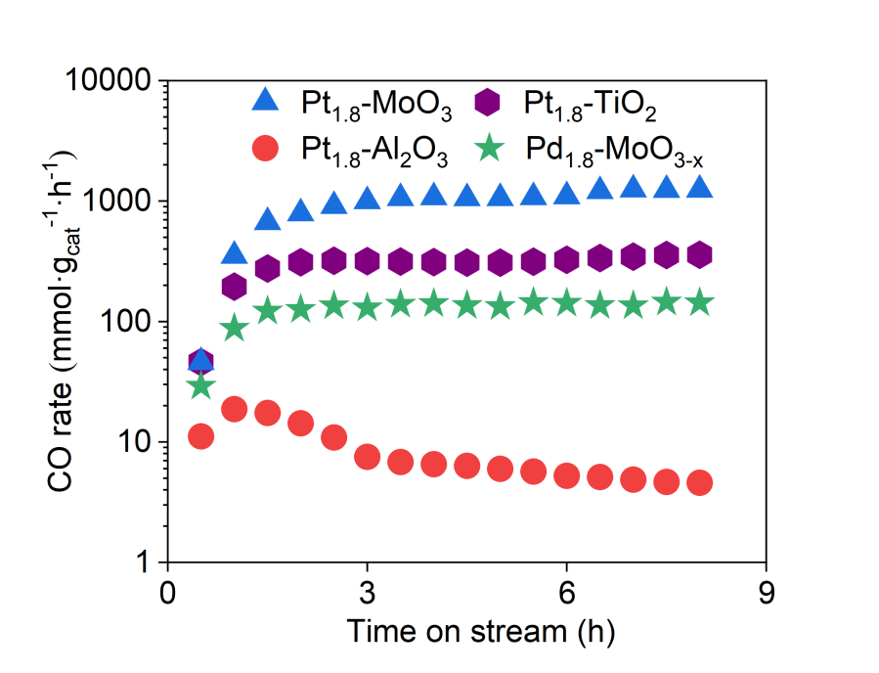
Supplementary Figure 20. CO production rate of Pt-based catalysts supported on different carriers and Pd-MoO_{3-x}.

Supplementary Figure 21. XPS of (a) Mo 3d regions for MoO₃ and MoO_{3-x} and (b) O 1s regions for fresh and spent Pt-MoO₃.
Supplementary Figure 22. Schematic illustration of the ice-templating synthesis of Pt-MoO_{3-x}.

Supplementary Figure 23. SEM images of elemental mapping images of (a) Pd-Al₂O₃, (b) Pd-MoO_{3-x} and (c) Pt-Al₂O₃.
Supplementary Figure 24. STEM images of elemental mapping images of Pt-MoO_{3-x}.

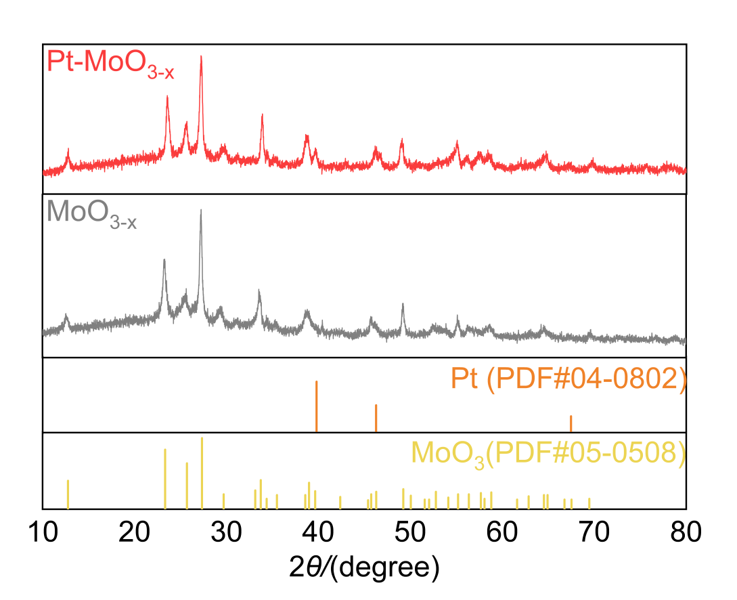
Supplementary Figure 25. XRD patterns of Pt-MoO_{3-x} and MoO_{3-x}.
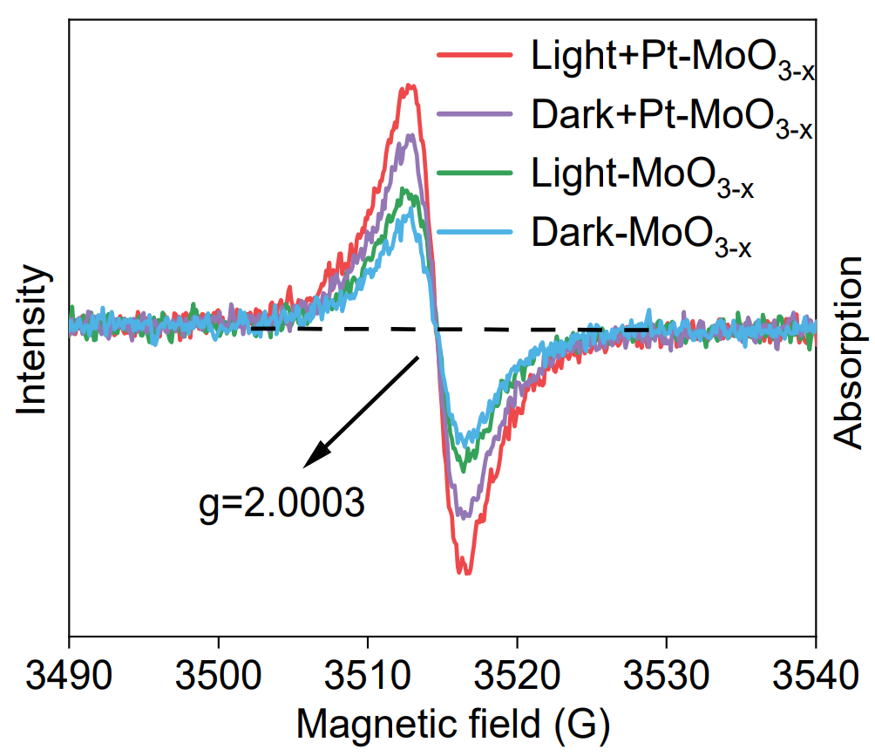
Supplementary Figure26. EPR spectra of different samples.

Supplementary Figure 27. In situ O 1s XPS spectra of Pt-MoO_{3-x} under light and dark conditions.

Supplementary Figure 28. H₂-temperature programmed desorption (H₂-TPD) profiles of Pt-MoO_{3-x} and MoO_{3-x}.

Supplementary Figure 29. H₂-temperature programmed reduction (H₂-TPR) profiles of Pt-MoO_{3-x} and MoO_{3-x}.

Supplementary Figure 30. CO₂-temperature programmed desorption (CO₂-TPD) profiles of Pt-MoO_{3-x} and MoO_{3-x}.

Supplementary Figure 31. Thermogravimetric analysis (TGA) curves of (a) MoO_{3-x} and (b) Pt-MoO_{3-x}.
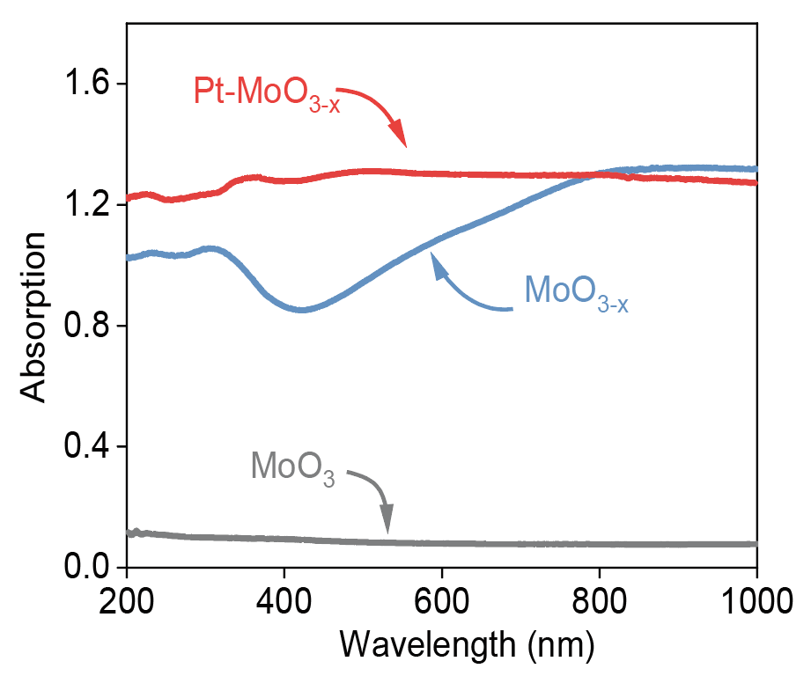
Supplementary Figure 32. UV–Vis–NIR diffuse reflectance spectra of different samples.

Supplementary Figure 33. Photographs of the in situ IR cell showing the catalyst temperature under dark and Light conditions.

Supplementary Figure 34. Continuous-flow CO-DRIFTS spectra of Pt-MoO_{3-x} under (a) light and (c) dark conditions, and of MoO_{3-x} under (b) light and (d) dark conditions.

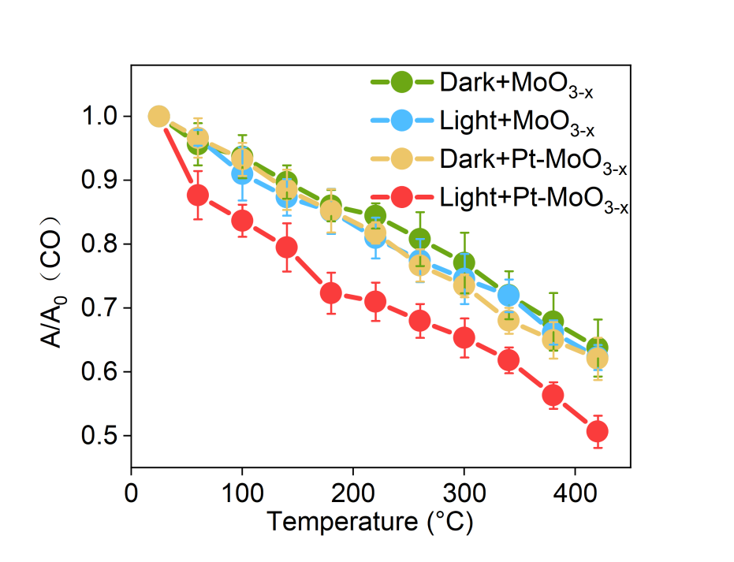
Supplementary Figure 35. Variation of CO surface coverage on Pt-MoO_{3-x} and MoO_{3-x} as a function of temperature during continuous-flow CO-DRIFTS experiments under dark and light conditions. (The error bars represent the standard error of the CO stretching area and temperature, measured from three different experiments).

Supplementary Figure 36 Quantitative comparison of normalized CO surface coverage on Pt-MoO_{3-x} and MoO_{3-x}, demonstrating a pronounced light-induced decrease only in the presence of Pt. (The black column represents the CO coverage on the catalyst surface at 420 °C in the dark, while the blue column represents the CO coverage on the catalyst surface at 420 °C under 0.5 W/cm² light irradiation).
Supplementary Figure 37. Temperature-dependent variation of surface CO coverage on Pt-MoO_{3-x} under illumination at different wavelengths, with a fixed light intensity of 0.4 W cm⁻².

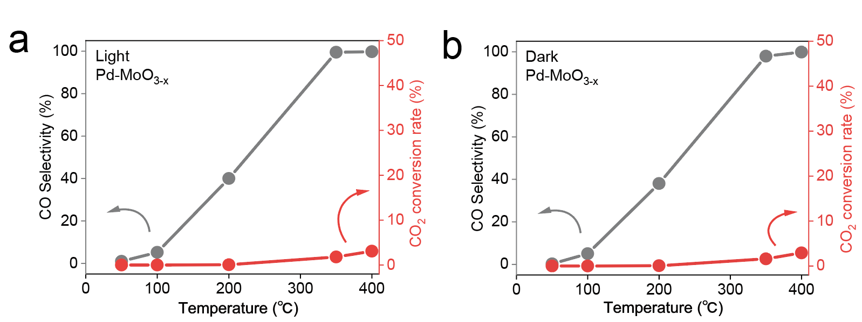
Supplementary Figure 38. CO selectivity (black line) and CO₂ (red line) conversion of Pd-MoO_{3-x} under photothermal catalytic (a) and thermal catalytic (b) conditions.

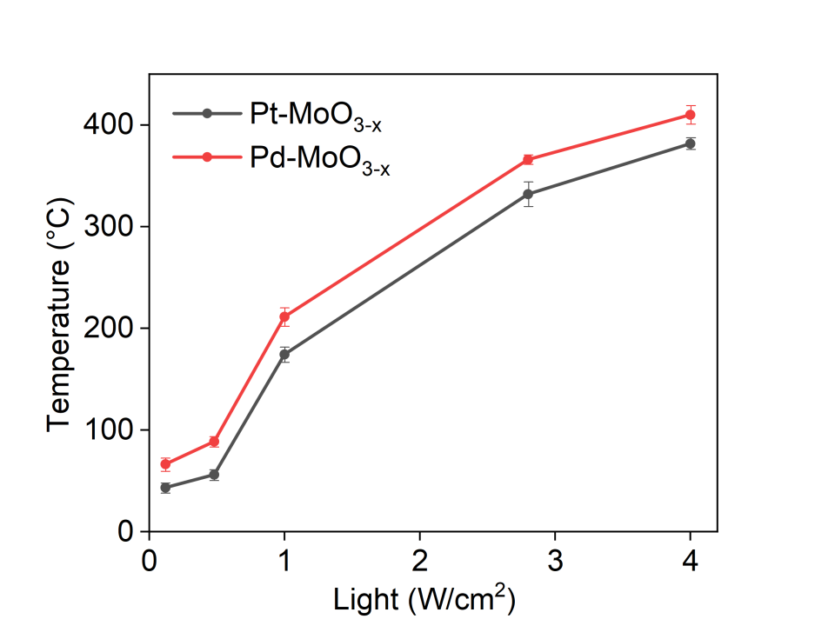
Supplementary Figure 39. Surface temperature variations of samples Pt-MoO_{3-x} and Pd-MoO_{3-x} under different light intensities.

Supplementary Figure 40. (a) Continuous-flow CO-DRIFTS spectra of Pd/Al₂O₃ under illuminated and dark conditions; (b) variation of surface CO coverage with temperature during the continuous-flow CO-DRIFTS experiments.

Supplementary Figure 41. Adsorption–purge DRIFTS spectra of Pd/Al₂O₃ under (a) dark and (b) light conditions.
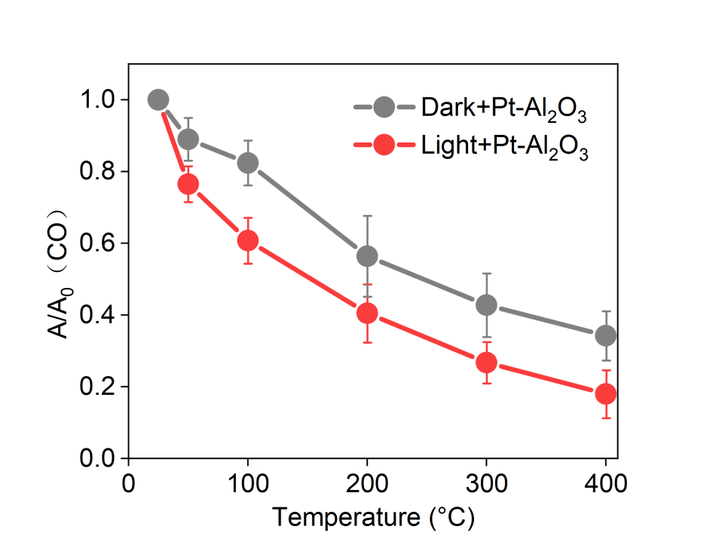
Supplementary Figure 42. Variation in CO surface coverage on Pt-Al₂O₃ as a function of temperature during adsorption–purge DRIFTS experiments under dark and light conditions.

Supplementary Figure 43. (a,b) Optimized structures of CO adsorbed on the Pt₄/MoO₃ model: (a) linear adsorption and (b) bridge adsorption. (c,d) Optimized structures of CO adsorbed on the Pt₄/MoO_{3−x} model: (c) linear adsorption and (d) bridge adsorption. Side and top views are shown for each configuration. Purple, red, white, and brown spheres represent Mo, O, Pt, and C atoms, respectively.

Supplementary Figure 44. PDOS of bridge-bonded CO on the two models.
Supplementary Figure 45. Transient sequential in situ DRIFTS spectra of Pt-MoO_{3-x} collected during RWGS-relevant gas switching (Ar → CO₂ → Ar → H₂).

Supplementary Figure 46. Kinetic isotope effect values for ¹⁶CO₂/¹⁸CO₂ substitution under dark and light conditions.

Supplementary Figure 47. Schematic diagram of intermediate and transition state structures of Pt-MoO_{3-x} during the RWGS reaction.

Table S1. Comparison of the photothermal CO₂ reduction reaction activity of reported photothermal catalysts under different reaction conditions.
Catalysts | Temperature (℃) | Product Yield (mmol gcat⁻¹ h⁻¹) | Long-term stability test (h) | Light  (W/cm²) | Product Selectivity (%) | Ref
Pt/MoO_{3-x} | 350 | 1060 | 200 | 2.8 | 99.9 | This work
Pt/MoO_{3-x} | 400 | 2548 | -- | 4 | 99.9 | This work
Mo₂N/MoO_{2-x} | 240 | 355 | 190 | 3 | 99 | 1
Ni₃N | 200 | 325 | 25 | 2.5 | -- | 2
Ni₁₂P₅/SiO₂ | 290 | 13.5 | 100 | 0.8 | 99 | 3
Ru/MoTiC₂ | 360 | 312 | 15 | 3.4 | 99.9 | 4
Ni/SiO₂ | 400 | 44.1 | 35 | 2.8 | -- | 5
TiN/TiO₂/In₂O_{3-x}(OH)_{y} | 300 | 13.04 | 40 | 1.6 | -- | 6
Black In₂O₃ | 300 | 1.87 | 70 | 2 | -- | 7
Ni/N-CeO₂ | 350 | 20.9 | 35 | -- | -- | 8

Table S2. Comparison of the thermal CO₂ reduction reaction activity of reported thermal catalysts under different reaction conditions.
Catalysts | Temperature (℃) | Product Yield (mmol gcat⁻¹ h⁻¹) | Long-term stability test (h) | Product Selectivity (%) | Ref
0.5Pt-MoO_{x}/Mo₂N | 300 | 619 | 300 | -- | 9
α-Mo₂C | 600 | 390 | 500 | 100 | 10
Ru-MoO_{x} | 450 | 70 | 100 | 98.1 | 11
Pd₁-MoC_{x} | 400 | 90 | 50 | 98.2 | 12
SP-Cu/LaTiO₂ | 600 | 40 | 500 | 100 | 13
Pd₁-FeO_{x} | 400 | 40 | 30 | 98 | 14
Na-Rh₁/ZrO₂ | 440 | 80 | 200 | 97.3 | 15
Ru/Ti/Mn | 400 | 90 | 25 | 100 | 16

Table S3. Net Bader charge change of Pt atoms in the electron-deficient model.
Pt sites | Δq
Pt₁ | +0.13 eV
Pt₂ | +0.26 eV
Pt₃ | +0.12 eV
Pt₄ | −0.11 eV
Total | +0.40 eV

Table S4. Net Bader charge change of Pt atoms in the electron-rich model.
Pt sites | Δq
Pt₁ | −0.02 eV
Pt₂ | +0.01 eV
Pt₃ | −0.41 eV
Pt₄ | −0.19 eV
Total | −0.61 eV
Table S5. ICOHP values of Pt–C interactions in different adsorption configurations.
Model | Adsorption mode | Pt₁–C ICOHP | Pt₂–C ICOHP | ΣICOHP
Electron-deficient | linear | −4.94 | — | −4.94
Electron-deficient | bridge | −4.15 | −2.23 | −6.38
Electron-rich | linear | −2.42 | — | −2.42
Electron-rich | bridge | −2.15 | −2.57 | −4.72

Reference
- X. Wan, Y. Li, Y. Chen, J. Ma, Y.-A. Liu, E.-D. Zhao, Y. Gu, Y. Zhao, Y. Cui, R. Li, D. Liu, R. Long, K. M. Liew, Y. Xiong, Nat. Commun. 2024, 15, 1273.
- S. Singh, R. Verma, N. Kaul, J. Sa, A. Punjal, S. Prabhu, V. Polshettiwar, Nat. Commun. 2023, 14, 2551.
- Y.-F. Xu, P. N. Duchesne, L. Wang, A. Tavasoli, F. M. Ali, M. Xia, J.-F. Liao, D.-B. Kuang, G. A. Ozin, Nat. Commun. 2020, 11, 5149.
- Z. Wu, J. Shen, C. Li, C. Zhang, K. Feng, Z. Wang, X. Wang, D. M. Meira, M. Cai, D. Zhang, S. Wang, M. Chu, J. Chen, Y. Xi, L. Zhang, T.-K. Sham, A. Genest, G. Rupprechter, X. Zhang, L. He, ACS Nano 2023, 17, 1550–1559.
- S. Wang, D. Zhang, W. Wang, J. Zhong, K. Feng, Z. Wu, B. Du, J. He, Z. Li, L. He, W. Sun, D. Yang, G. A. Ozin, Nat. Commun. 2022, 13, 5305.
- N. T. Nguyen, T. Yan, L. Wang, J. Y. Y. Loh, P. N. Duchesne, C. Mao, P.-C. Li, F. M. Ali, M. Xia, M. Ghoussoub, N. P. Kherani, Z.-H. Lu, G. A. Ozin, Small 2020, 16, 2005754.
- L. Wang, Y. Dong, T. Yan, Z. Hu, F. M. Ali, D. M. Meira, P. N. Duchesne, J. Y. Y. Loh, C. Qiu, E. E. Storey, Y. Xu, W. Sun, M. Ghoussoub, N. P. Kherani, A. S. Helmy, G. A. Ozin, Nat. Commun. 2020, 11, 2432.
- Z. Jia, S. Ning, Y. Tong, X. Chen, H. Hu, L. Liu, J. Ye, D. Wang, ACS Appl. Nano Mater. 2021, 4, 10485–10494.
- H.-X. Liu, J.-Y. Li, X. Qin, C. Ma, W.-W. Wang, K. Xu, H. Yan, D. Xiao, C.-J. Jia, Q. Fu, D. Ma, Nat. Commun. 2022, 13, 5800.
- M. A. Khoshooei, X. Wang, G. Vitale, F. Formalik, K. O. Kirlikovali, R. Q. Snurr, P. Pereira-Almao, O. K. Farha, Science 2024, 384, 540–546.
- M. D. Porosoff, X. Yang, J. A. Boscoboinik, J. G. Chen, Angew. Chem. Int. Ed. 2014, 53, 6705–6709.
- Y. Ma, Y. Ren, Y. Zhou, W. Liu, W. Baaziz, O. Ersen, C. Pham-Huu, M. Greiner, W. Chu, A. Wang, T. Zhang, Y. Liu, Angew. Chem. Int. Ed. 2020, 59, 21613–21619.
- J. Yu, X. Sun, X. Tong, J. Zhang, J. Li, S. Li, Y. Liu, N. Tsubaki, T. Abe, J. Sun, Nat. Commun. 2021, 12, 7209.
- P. Du, R. Qi, Y. Zhang, Q. Gu, X. Xu, Y. Tan, X. Liu, A. Wang, B. Zhu, B. Yang, T. Zhang, Chem 2022, 8, 3252–3262.
- S. Li, Y. Xu, H. Wang, B. Teng, Q. Liu, Q. Li, L. Xu, X. Liu, J. Lu, Angew. Chem. Int. Ed. 2023, 62, e202218167.
- H. Kang, L. Zhu, S. Li, S. Yu, Y. Niu, B. Zhang, W. Chu, X. Liu, S. Perathoner, G. Centi, Y. Liu, Nat. Catal. 2023, 6, 1062–1072.
[17] Kresse, G.; Furthmüller, J. Efficiency of Ab-Initio Total Energy Calculations for Metals and Semiconductors Using a Plane-Wave Basis Set. Comput. Mater. Sci. 1996, 6, 15−50.
[18] Kresse, G.; Furthmüller, J. Efficient Iterative Schemes for Ab Initio Total-Energy Calculations Using a Plane-Wave Basis Set. Phys. Rev. B 1996, 54, 11169−11186.
[19] Perdew, J. P.; Burke, K.; Ernzerhof, M. Generalized Gradient Approximation Made Simple. Phys. Rev. Lett. 1996, 77, 3865−3868.
[20] Kresse, G.; Joubert, D. From Ultrasoft Pseudopotentials to the Projector Augmented-Wave Method. Phys. Rev. B 1999, 59, 1758-1775.
[21] Blöchl, P. E. Projector Augmented-Wave Method. Phys. Rev. B 1994, 50, 17953−17979.
[22] Dudarev, S. L.; Botton, G. A.; Savrasov, S. Y.; Humphreys, C. J.; Sutton, A. P. Phys. Rev. B 1998, 57, 1505.
[23] Grimme, S.; Antony, J.; Ehrlich, S.; Krieg, H. A consistent and accurate ab initio parametrization of density functional dispersion correction (DFT-D) for the 94 elements H-Pu. J. Chem. Phys. 2010, 132, 154104.
[24] Henkelman, G.; Uberuaga, B. P.; Jonsson, H. J. Chem. Phys. 2000, 113, 9901.

