Supplementary information

Protein content of SEV differs between insulin-resistant and insulin-sensitive individuals
Among the total SEV-associated proteins, we selected the candidates with low variability (q <0.05) and high degree of regulation (absolute log FC between groups >0.5). For the baseline condition, this strategy showed that expression of 31 SEV proteins differed between T2D-R and the nondiabetic groups (IS-NR and IR-R) (Fig. S4b, Table S6), indicating diabetes-related functionality of these proteins. They include transferrin receptor protein 1 (TFRC), ceruloplasmin (CP) and adenylyl cyclase-associated protein 1 (CAP1), which mediates the pro-inflammatory effects of resistin in the liver. Importantly, the expression of 12 other SEV-derived proteins differed between IS-NR and the insulin-resistant groups (IR-R and T2D-R), including myeloperoxidase (MPO) and glycerol-3-phosphate dehydrogenase (GPD2) (Fig. S4b, Table S6). Lower expression in IS-NR was found for MPO, which is associated with insulin resistance and inflammation¹, and for GPD2, a proposed target for preventing insulin resistance² and regulator of skeletal muscle regeneration³. The latter represents a novel pathophysiologic marker for the early prediction of individual response of improved insulin sensitivity to exercising, as the reduction of this protein also attenuates exercise-mediated muscle mitochondrial biogenesis^{3,4}.

HIIT leads to enrichment of SEV proteins involved in cellular detoxification, lipid and glucose metabolism
Functional analysis of the 262 SEV proteins differentially regulated by HIIT, showed a significant enrichment of proteins related to innate immunity, inflammatory response, cellular detoxification, lipid and glucose metabolism (Fig. S5a and Table S7). We also found an enrichment in proteins of membrane raft assembly (Fig. S5b), indicating a release of SEV characterized by the presence of raft-like domains⁵. The 262 differentially expressed SEV proteins were also analyzed with the Ingenuity™ Pathway Analysis (IPA) software, which outlines the canonical pathways and the upstream regulators responsible for the expression pattern of the molecules present in a dataset and predict inhibition at a z-score <-2 or activation at a z-score >2. The top enriched categories of canonical pathways and the upstream molecules related to HIIT are summarized in figures S5c and d.
References
1. Gomez Garcia, A., Rivera Rodriguez, M., Gomez Alonso, C., Rodriguez Ochoa, D.Y. & Alvarez Aguilar, C. Myeloperoxidase is associated with insulin resistance and inflammation in overweight subjects with first-degree relatives with type 2 diabetes mellitus. Diabetes Metab J 39, 59-65 (2015).
2. Liu, J., et al. Targeting mitochondrial biogenesis for preventing and treating insulin resistance in diabetes and obesity: Hope from natural mitochondrial nutrients. Adv Drug Deliv Rev 61, 1343-1352 (2009).
3. Liu, X., et al. Mitochondrial glycerol 3-phosphate dehydrogenase promotes skeletal muscle regeneration. EMBO Mol Med 10(2018).
4. Bishop, D.J., et al. High-Intensity Exercise and Mitochondrial Biogenesis: Current Controversies and Future Research Directions. Physiology (Bethesda) 34, 56-70 (2019).
5. Valapala, M. & Vishwanatha, J.K. Lipid raft endocytosis and exosomal transport facilitate extracellular trafficking of annexin A2. J Biol Chem 286, 30911-30925 (2011).

Figure legends

Fig. S1. Flow diagram of participants’ recruitment

Fig. S2. (a) Representative western blot of PKCs levels in the cytosolic (C) and membrane fraction (M), (b) PKCε (*p=0.03 for T2D; #p=0.03 T2D vs IR NDM, p=0.07 T2D vs IS NDM) and (c) PKCθ (*p=0.04 for T2D) activation, (d) NF-κB (**p=0.003 for IR NDM; #p=0.01 T2D vs IS NDM) protein levels at baseline and after 12-week HIIT in persons with T2D, insulin-resistant (IR NDM) and insulin-sensitive non-diabetic persons (IS NDM). Data are presented as mean ± SEM.

Fig. S3. VO₂max (***p=0.0002 for T2D-R, ***p=7.1x10⁻⁵ for IR-R, *p=0.01 for IS-NR) (a), M value (**p=0.003 for T2D-R, ***p=0.0001 for IR-R, *p=0.01 for IS-NR) (b), hepatic insulin sensitivity (iEGP) (**p=0.002 for T2D-R; ##p=0.005 T2D-R vs IR-R, ###p=6.82x10⁻⁷ T2D-R vs IS-NR) (c), maximal uncoupled respiration (*p=0.03 for T2D-R, *p=0.01 for IR-R) (d), PKCɛ activation (e), NF-κB protein levels (*p=0.02 for IR-R) (f) in the representative subgroups of T2D-R (N=8), IR-R (N=8) and IS-NR (N=6). Data are presented as mean ± SEM.

Fig. S4. (a) Log2-fold change of SEV concentration after exercise intervention compared to baseline (&p=0.03 T2D-R vs IS-NR, &p=0.049 IR-R vs IS-NR) (b) Venn diagram showing the overlap of proteins differentially expressed between groups at baseline. Data are presented as mean ± SEM; p-value is based on unpaired t-test.

Fig. S5. (a) GO-BP and (b) GO-MF analysis of the 262 SEV proteins differentially expressed after 12-week HIIT with the percentage of proteins associated to each biological processes and function. (c) IPA analysis of pathways associated to the SEV-carried proteins regulated after exercise. Green color indicates a z-score >0; yellow color indicates a z-score <0; white bars indicate a z-score =0; gray bars indicate that the activation state cannot be predicted in IPA, despite a significant association of the molecules within the pathway. (d) Predicted upstream regulators with the highest p-value and a predicted z-score. Vertical red line indicates a B-H corrected p-value <0.05

Table S1. List of exosomes enriched proteins identified in the SEV preparations. All proteins are listed with protein name, gene symbol and UniProt ID.

Table S2. List of new SEV-carried proteins identified in the serum-derived SEV but not yet reported in Vesiclepedia. All proteins are listed with protein name, gene symbol and UniProt ID.

Table S3. List of proteins identified in the SEV preparations and showing a significant different expression after 12 weeks of training (absolute log FC 12-week HIIT vs baseline >0.5) in T2D-R, IR-R and IS-NR individuals. For each protein, the prediction of a secretory signal peptide (threshold >0.450) is given. For proteins without a SP, a score >0.6 identifies not classically secreted proteins (NCSP).

Table S4. List of SEV proteins differentially expressed after 12-week HIIT and overlapping with proteins regulated in skeletal muscle cells-derived SEV after EPS. All proteins are listed with protein name, gene symbol and UniProt ID.

Table S5. Gene ontology (GO) terms for biological process and molecular function and IPA pathway analysis of SEV proteins differentially expressed after 12-week HIIT in T2D-R, IR-R and IS-NR. For each enriched term and pathway, B-H corrected p-value <0.05 and the ratio of molecules present in the dataset/total molecules associated to the pathway are given. For IPA pathway, when possible only terms with a prediction of activation/inhibition (z-score) are given.

Table S6. List of SEV proteins differently expressed between groups, T2D-R, IR-R and IS-NR, at baseline. All proteins are listed with protein name, gene symbol and UniProt ID.

Table S7. List of SEV-associated proteins differentially expressed after HIIT and involved in glycolysis and/or antioxidant metabolism. FDR, false discovery rate; FC, fold change; GOBP, Gene onthology biological process.

Supplementary Fig. S1:

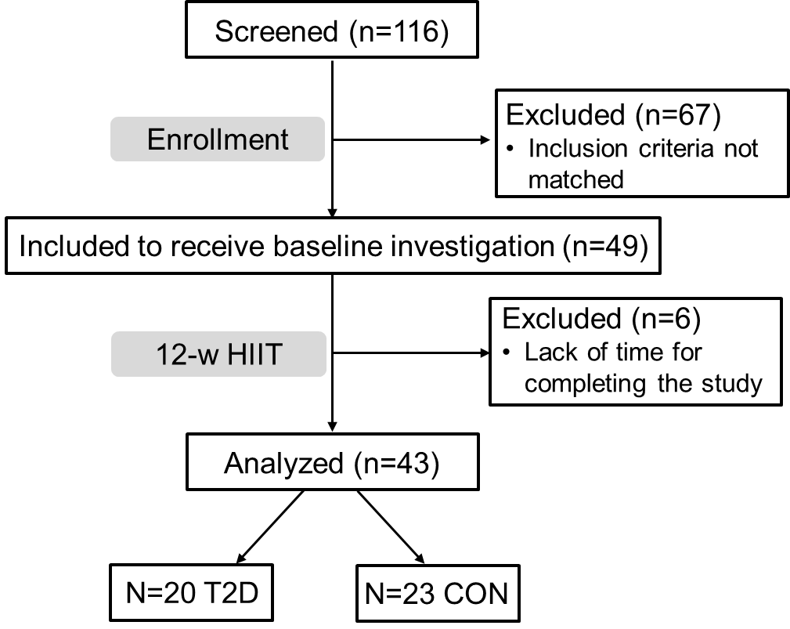

Supplementary Fig. S2. Related to Fig. 1

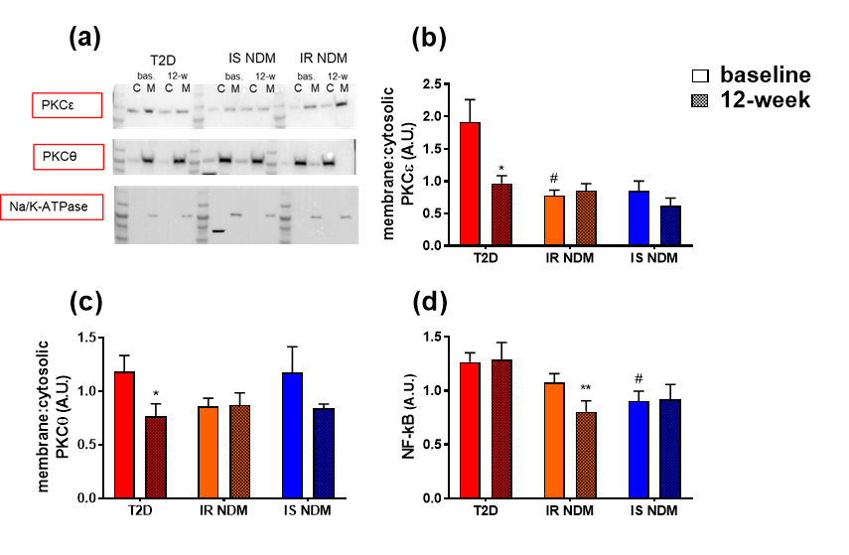

Supplementary Fig. S3: Related to Fig. 3

Supplementary Fig. S4: Related to Fig. 3 and 4

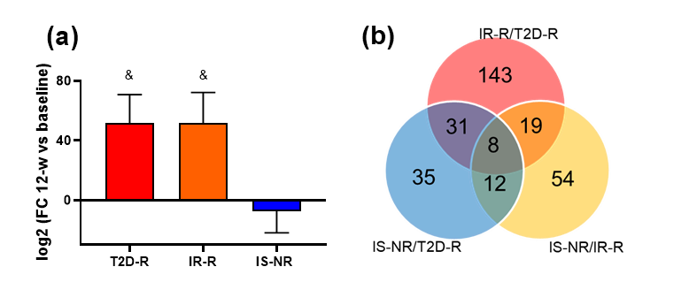

Supplementary Fig. S5: Related to Fig. 4

Table S1. Related to table S3.

Protein | Gene symbol | Uniprot ID
CD9 antigen | CD9 | P21926
Programmed cell death 6-interacting protein | PDCD6IP | Q8WUM4
Heat shock cognate 71 kDa protein | HSPA8 | P11142
Glyceraldehyde-3-phosphate dehydrogenase | GAPDH | P04406
Annexin A2 | ANXA2 | P07355
CD63 antigen | CD63 | P08962
Alpha-enolase | ENO1 | P06733
Heat shock protein HSP 90-alpha | HSP90AA1 | P07900
Tumor susceptibility gene 101 protein | TSG101 | Q99816
Pyruvate kinase PKM | PKM | P14618
L-lactate dehydrogenase A chain | LDHA | P00338
Elongation factor 1-alpha 1 | EEF1A1 | P68104
14-3-3 protein zeta/delta | YWHAZ | P63104
Phosphoglycerate kinase 1 | PGK1 | P00558
Elongation factor 2 | EEF2 | P13639
Fructose-bisphosphate aldolase A | ALDOA | P04075
Annexin A5 | ANXA5 | P08758
Peptidyl-prolyl cis-trans isomerase A | PPIA | P62937
Profilin-1 | PFN1 | P07737
Peroxiredoxin-1 | PRDX1 | Q06830
Cofilin-1 | CFL1 | P23528
Clathrin heavy chain 1 | CLTC | Q00610
Moesin | MSN | P26038
Triosephosphate isomerase | TPI1 | P60174

Table S2. Related to table S3 and fig. 4.

Protein | Gene symbol | Uniprot ID
Complement C4-B | C4B_2 | P0C0L5
Vascular non-inflammatory molecule 2 | VNN2 | O95498
Immunoglobulin J chain | JCHAIN | P01591
Adipocyte plasma membrane-associated protein | APMAP | Q9HDC9
Mast cell-expressed membrane protein 1 | MCEMP1 | Q8IX19
Dematin | DMTN | Q08495
Small integral membrane protein 1 | SMIM1 | B2RUZ4
Serine/threonine-protein kinase 26 | STK26 | Q9P289
Serine/threonine-protein kinase/endoribonuclease IRE1 | ERN1 | O75460
Nicotinate phosphoribosyltransferase | NAPRT | Q6XQN6
Thromboxane A2 receptor | TBXA2R | P21731
P2Y purinoceptor 12 | P2RY12 | Q9H244
Protein MTSS 1 | MTSS1 | O43312
Tenascin-N | TNN | Q9UQP3
Transport and Golgi organization protein 2 homolog | TANGO2 | Q6ICL3
Atypical chemokine receptor 1 | ACKR1 | Q16570
Cytochrome c oxidase subunit 2 | MT-CO2 | P00403
BMP/retinoic acid-inducible neural-specific protein 1 | BRINP1 | O60477
FERM domain-containing protein 4B | FRMD4B | Q9Y2L6
Nucleoside diphosphate-linked moiety X motif 13 | NUDT13 | Q86X67
Cytochrome P450 4F2 | CYP4F2 | P78329
Triokinase/FMN cyclase | TKFC | Q3LXA3
Membrane protein MLC1 | MLC1 | Q15049
Negative elongation factor B | NELFB | Q8WX92
Arginyl-tRNA--protein transferase 1 | ATE1 | O95260
Histone-lysine N-methyltransferase 2C | KMT2C | Q8NEZ4
Complement C4-B | ADGRE5 | P48960
Vascular non-inflammatory molecule 2 | MPL | P40238
Immunoglobulin J chain | TFAP2D | Q7Z6R9
Adipocyte plasma membrane-associated protein | EVA1B | Q9NVM1
Mast cell-expressed membrane protein 1 | NT5C3A | Q9H0P0
Dematin | TSPAN2 | O60636
Small integral membrane protein 1 | UPP2 | O95045
Serine/threonine-protein kinase 26 | RTCB | Q9Y3I0
Serine/threonine-protein kinase/endoribonuclease IRE1 | C2CD5 | Q86YS7
Nicotinate phosphoribosyltransferase | C4B_2 | P0C0L5
Thromboxane A2 receptor | VNN2 | O95498
P2Y purinoceptor 12 | JCHAIN | P01591
Protein MTSS 1 | APMAP | Q9HDC9

Table S3. Related to Fig. 4

Table S4. Related to Fig. 4.

Protein | Gene symbol | Uniprot ID
Immunoglobulin heavy variable 6-1 | HV601 | A0A0B4J1U7
CD5 antigen-like | CD5L | O43866
Haptoglobin | HPT | P00738
Complement C3 | CO3 | P01024
Kininogen-1 | KNG1 | P01042
Immunoglobulin heavy constant mu | IGHM | P01871
Immunoglobulin heavy constant alpha 1 | IGHA1 | P01876
Apolipoprotein A-I | APOA1 | P02647
Fibrinogen alpha chain | FIBA | P02671
Fibrinogen beta chain | FIBB | P02675
Fibrinogen gamma chain | FIBG | P02679
Complement C1q subcomponent subunit B | C1QB | P02746
Complement C1q subcomponent subunit C | C1QC | P02747
Fibronectin | FINC | P02751
C4b-binding protein alpha chain (Proline-rich protein) | C4BPA | P04003
Histidine-rich glycoprotein | HRG | P04196
Vitamin K-dependent protein S | PROS | P07225
Apolipoprotein(a) | APOA | P08519
60 kDa heat shock protein, mitochondrial | CH60 | P10809
Lipopolysaccharide-binding protein (LBP) | LBP | P18428
Moesin | MOES | P26038
Erythrocyte band 7 integral membrane protein | STOM | P27105
Elongation factor 1-delta | EF1D | P29692
Transgelin-2 | TAGL2 | P37802
Guanine nucleotide-binding protein G(q) subunit alpha | GNAQ | P50148
Alpha-centractin | ACTZ | P61163
Ras-related protein Rap-1b | RAP1B | P61224
Ras-related protein Rap-2b | RAP2B | P61225
Peptidyl-prolyl cis-trans isomerase A | PPIA | P62937
Tropomyosin alpha-4 chain | TPM4 | P67936
Actin, alpha skeletal muscle | ACTS | P68133
Hemoglobin subunit beta | HBB | P68871
Hemoglobin subunit alpha | HBA | P69905
T-complex protein 1 subunit beta | TCPB | P78371
Galectin-3-binding protein | LG3BP | Q08380
Multimerin-1 | MMRN1 | Q13201
Bleomycin hydrolase | BLMH | Q13867
Neutral amino acid transporter B(0) | AAAT | Q15758
Aldehyde dehydrogenase family 16 member A1 | A16A1 | Q8IZ83
Protein/nucleic acid deglycase DJ-1 | PARK7 | Q99497
Adipocyte plasma membrane-associated protein (Protein BSCv) | APMAP | Q9HDC9
T-complex protein 1 subunit alpha | TCP1 | P17987
Peroxiredoxin-2 | PRDX2 | P32119
Fermitin family homolog 3 | FERMT3 | Q86UX7

Table S5. Related to Fig. 5

 | Pathway | N molecules in dataset/total N of molecules in pathway | Fold enrichment | B-H corrected p-value
GO-BP T2D-R
GO:0007596 | Blood coagulation | 17/169 | 16.85 | 1.3E-12
GO:0002576 | Platelet degranulation | 17/124 | 22.97 | 1.22E-14
GO:0043312 | Neutrophil degranulation | 22/484 | 7.61 | 4.64E-10
GO:0006898 | Receptor-mediated endocytosis | 12/157 | 12.81 | 3.03E-07
GO:0044267 | Cellular protein metabolic process | 14/200 | 11.73 | 3.23E-08
GO:0006953 | Acute-phase response | 6/38 | 26.47 | 9.47E-05
GO:0045087 | Innate immune response | 16/483 | 5.55 | 3.74E-05
GO:0010951 | Negative regulation of endopeptidase activity | 6/52 | 19.35 | 0.000441
GO:0051592 | Response to calcium ion | 6/57 | 17.65 | 0.000641
GO:0007160 | Cell-matrix adhesion | 7/93 | 12.62 | 0.000747
GO:0034447 | VLDL particle clearance | 3/6 | 83.86 | 0.00185
GO:0050714 | Positive regulation of protein secretion | 5/44 | 19.06 | 0.002648
GO:0090277 | Positive regulation of peptide hormone secretion | 3/9 | 55.94 | 0.006681
GO: 0043687 | Post-translational protein modification | 11/344 | 5.84 | 0.000641
GO:0061621 | Canonical glycolysis | 4/27 | 24.86 | 0.007271
GO:0034374 | LDL particle remodeling | 3/13 | 38.74 | 0.017767
GO:0015701 | Bicarbonate transport | 4/34 | 19.74 | 0.015665
GO:0098869 | Cellular oxidant detoxification | 3/14 | 35.97 | 0.020906
GO:0030185 | Nitric oxide transport | 2/3 | 111.81 | 0.02799
GO:2000363 | Positive regulation of prostaglandin-E synthase activity | 2/3 | 111.81 | 0.02799
GO-BP IR-R
GO:0002576 | Platelet degranulation | 19/124 | 24.095 | 1.9E-17
GO:0043312 | Neutrophil degranulation | 31/484 | 10.06 | 1.86E-18
GO:0043687 | Post-translational protein modification | 21/344 | 9.59 | 2.07E-11
GO:0010498 | Proteasomal protein catabolic process | 8/23 | 54.70 | 2.98E-09
GO:0030449 | Regulation of complement activation | 11/112 | 15.44 | 1.84E-07
GO:0006521 | Regulation of cellular amino acid metabolic process | 8/52 | 24.20 | 1.42E-06
GO:0042730 | Fibrinolysis | 7/22 | 50.04 | 9.84E-08
GO:0038061 | NIK/NF-kappaB signaling | 8/59 | 21.33 | 3.42E-06
GO:0035722 | IL-12-mediated signaling | 6/46 | 20.52 | 0.000196
GO:0043488 | Regulation of mRNA stability | 11/113 | 15.30 | 1.84E-07
GO:0060071 | Wnt signaling pathway | 8/87 | 14.46 | 4.39E-05
GO:0070498 | IL-1-mediated signaling pathway | 8/95 | 13.24 | 8.06E-05
GO:0019430 | Removal of superoxide radicals | 4/12 | 52.47 | 0.000284
GO:0033209 | TNF-mediated signaling pathway | 8/115 | 10.94 | 0.000284
GO:0010951 | Negative regulation of endopeptidase | 6/52 | 18.16 | 0.000349
GO:0034599 | Cellular response to oxidative stress | 7/94 | 11.72 | 0.000785
GO:0050714 | Positive regulation of protein secretion | 5/44 | 17.89 | 0.002326
GO:0090277 | Positive regulation of peptide hormone secretion | 3/9 | 52.50 | 0.00533
GO:0051592 | Response to calcium ion | 5/57 | 13.81 | 0.007408
GO:0000165 | MAPK cascade | 9/250 | 5.66 | 0.007591
GO:0006098 | Pentose-phopshate shunt | 3/13 | 36.35 | 0.014687
GO:0034756 | Regulation of iron transport | 2/3 | 104.93 | 0.022849
GO-BP IS-NR
GO:0043312 | Neutrophil degranulation | 21/484 | 9.96 | 1.71E-11
GO:0044267 | Cellular protein metabolic process | 13/200 | 14.93 | 2.29E-08
GO:0043687 | Post-translational protein modification | 14/344 | 9.34 | 1.12E-06
GO:0010951 | Negative regulation of endopeptidase activity | 7/52 | 30.93 | 8.14E-06
GO:0002576 | Platelet degranulation | 8/124 | 14.82 | 0.000121
GO:0042744 | Hydrogen peroxide catabolic process | 5/27 | 42.57 | 0.00016
GO:0034374 | LDL particle remodeling | 4/13 | 70.74 | 0.000316
GO:0042158 | Lipoprotein biosynthetic process | 3/5 | 137.89 | 0.000645
GO:0019708 | Cholesterol metabolic process | 6/72 | 19.156 | 0.000645
GO:0034447 | VLDL particle clearance | 3/6 | 114.95 | 0.001205
GO:0042730 | Fibrinolysis | 4/22 | 41.81 | 0.001486
GO:0060628 | ER to Golgi vesicles-mediated transport | 8/191 | 9.62 | 0.001288
GO:0070328 | Triglyceride homeostasis | 4/28 | 32.85 | 0.003343
GO:0001523 | Retinoid metabolic process | 5/63 | 18.24 | 0.003931
GO:0033700 | Phospholipid efflux | 3/12 | 57.52 | 0.007179
GO:0015701 | Bicarbonate transport | 4/34 | 27.06 | 0.006143
GO:0034380 | HDL particle assembly | 3/13 | 53.10 | 0.008715
GO:0006953 | Acute-phase response | 4/38 | 24.21 | 0.008715
GO:0098869 | Cellular oxidant detoxification | 3/14 | 49.31 | 0.010696
GO:1904659 | Glucose transmembrane transport | 3/17 | 40.61 | 0.017594
GO-MF T2D-R
GO:0008201 | Heparin binding | 12/170 | 11.83 | 1.83E-06
GO:0005102 | Signaling receptor binding | 14/342 | 7.34 | 4.27E-06
GO:0045296 | Cadherin binding | 12/305 | 7.14 | 5.06E-05
GO:0030492 | Hemoglobin binding | 3/5 | 100.60 | 0.002153
GO:0005200 | Structural constituent of cytoskeleton | 7/102 | 11.50 | 0.0022
GO:0043177 | Organic acid binding | 3/10 | 50.35 | 0.014446
GO:0005093 | Rab GDP-dissociation inhibitor activity | 2/2 | 167.44 | 0.01494
GO:0002020 | Protease binding | 6/103 | 9.77 | 0.01494
GO:0005344 | Oxygen carrier activity | 3/13 | 38.74 | 0.018298
GO-MF IR-R
GO:0004175 | Endopeptidase activity | 10/70 | 22.46 | 4.6E-08
GO:0045296 | Cadherin binding | 14/305 | 7.21 | 8.79E-06
GO:0005102 | Signaling receptor binding | 13/342 | 5.97 | 0.000174
GO:0016209 | Antioxidant activity | 4/19 | 33.14 | 0.002618
GO:0008201 | Heparin binding | 9/170 | 8.32 | 0.000752
GO:0005093 | Rab GDP-dissociation inhibitor activity | 2/2 | 157.14 | 0.012926
GO:0005200 | Structural constituent of cytoskeleton | 6/102 | 9.25 | 0.014428
GO:0051020 | GTPase binding | 4/34 | 18.52 | 0.016363
GO:0008184 | Glycogen phosphorylase activity | 2/3 | 104.93 | 0.026421
GO-MF IS-NR
GO:0005200 | Structural constituent of cytoskeleton | 9/102 | 20.27 | 2.57E-06
GO:0008201 | Heparin binding | 9/170 | 12.16 | 0.000116
GO:0060228 | Phosphatidylcholine-sterol O-acyltransferase activator activity | 3/6 | 114.95 | 0.001324
GO:0120020 | Cholesterol transfer activity | 4/19 | 48.41 | 0.001297
GO:0043177 | Organic acid binding | 3/10 | 69.01 | 0.005604
GO:0005355 | Glucose transmembrane transporter activity | 3/13 | 53.10 | 0.009261
GO:0005344 | Oxygen carrier activity | 3/13 | 53.10 | 0.009261
GO:0031721 | Hemoglobin alpha binding | 2/3 | 153.27 | 0.018059
GO:0034185 | Apolipoprotein binding | 3/17 | 40.61 | 0.018059
GO:0016209 | Antioxidant activity | 3/19 | 36.34 | 0.021993
IPA | Canonical pathway | N of molecules/total N of molecules in pathway | z-score | B-H corrected p-value
T2D-R | Acute Phase Response Signaling | 18/178 | 1.508 | 4.27E-15
 | Coagulation System | 10/35 | 1.265 | 7.21E-13
 | LXR/RXR Activation | 14/121 | -0.277 | 1.02E-12
 | Complement System | 8/36 | -0.816 | 1.15E-09
 | Clathrin-mediated Endocytosis Signaling | 14/193 | NaN | 3.74E-10
 | Intrinsic prothrombin activation pathway | 8/41 | 1.134 | 3.10E-09
 | FXR/RXR Activation | 12/125 | NaN | 4.23E-10
 | Glycolysis I | 4/24 | -2.000 | 2.51E-04
 | Production of Nitric Oxide and Reactive Oxygen Species in Macrophages | 8/185 | -2.646 | 2.71E-04
 | G Beta gamma signaling | 6/122 | -2.449 | 1.31E-03
 | eNOS Signaling | 6/152 | -1.342 | 3.14E-03
 | p70S6K Signaling | 6/128 | -1.342 | 1.54E-03
 | PPARα/RXRα Activation | 5/178 | -1.000 | 1.92E-02
 | Insulin secretion signaling pathway | 7/238 | -1.134 | 4.84E-03
 | ERK/MAPK Signaling | 6/192 | -2.2326 | 7.11E-03
 | Protein Kinase A Signaling | 8/385 | -2.446 | 1.23E-02
 | Phospholipase C signaling | 4/246 | -2.000 | 1.09-01
IR-R | Acute phase response signaling | 23/178 | 0.577 | 2.23E-21
 | Coagulation system | 11/35 | 1.508 | 1.55E-14
 | LXR/RXR activation | 16/121 | -1.000 | 7.67E-15
 | Complement system | 11/36 | -0.378 | 1.67E-14
 | FXR/RXR Activation | 15/125 | NaN | 1.36E-13
 | Intrinsic Prothrombin Activation Pathway | 7/41 | 1.633 | 2.84E-07
 | Production of Nitric Oxide and Reactive Oxygen Species in Macrophages | 10/185 | 0.333 | 8.72E-06
 | Clathrin-mediated Endocytosis Signaling | 10/192 | NaN | 1.12E-05
 | HIF1α signaling | 8/201 | 0.707 | 8.19E-04
 | NRF2-mediated Oxidative Stress Response | 6/186 | 2.000 | 1.61E-02
 | Protein Kinase A signaling | 8/385 | 2.646 | 3.04E-02
 | Nitric Oxide Signaling in the Cardiovascular System | 4/94 | 1,000 | 3.01E-02
IS-NR | LXR/RXR Activation | 15/121 | -0.775 | 1.04E-15
 | FXR/RXR Activation | 14/125 | NaN | 3.16E-14
 | IL-12 Signaling and Production in Macrophages | 11/130 | NaN | 6.89E-10
 | Production of Nitric Oxide and Reactive Oxygen Species in Macrophages | 12/185 | -2.309 | 1.39E-09
 | Coagulation System | 7/35 | -0.378 | 6.20E-09
 | Acute Phase Response Signaling | 11/178 | NaN | 1.219E-08
 | Clathrin-mediated Endocytosis Signaling | 11/192 | NaN | 2.33E-08
 | Type I DM Signaling | 5/107 | NaN | 2.52E-03
 | Mitochondrial dysfunction | 5/165 | NaN | 1.58E-02
 | Role of NFAT in regulation of the immune response | 5/176 | -1.000 | 1.96E-02

Table S6. Related to Fig. S4

Protein | Gene symbol | Uniprot ID | Group
Ficolin-2 | FCN2 | Q15485 | T2D vs NDM
Ceruloplasmin | CERU | P00450 | T2D vs NDM
Platelet basic protein | CXCL7 | P02775 | T2D vs NDM
Ankyrin-1 | ANK1 | P16157 | T2D vs NDM
Bridging integrator 2 | BIN2 | Q9UBW5 | T2D vs NDM
Ficolin-3 | FCN3 | O75636 | T2D vs NDM
Phosphoglycerate kinase 1 | PGK1 | P00558 | T2D vs NDM
Transferrin receptor protein 1 | TFR1 | P02786 | T2D vs NDM
Adenylyl cyclase-associated protein 1 | CAP1 | Q01518 | T2D vs NDM
Rho GDP-dissociation inhibitor 2 | GDIR2 | P52566 | T2D vs NDM
Guanine nucleotide-binding protein subunit beta-2 | GBB2 | P62879 | T2D vs NDM
Ubiquitin-like modifier-activating enzyme 7 | UBA7 | P41226 | T2D vs NDM
Ras-related protein Rap-1b | RAP1B | P61224 | T2D vs NDM
cAMP-dependent protein kinase type I-alpha regulatory subunit | KAP0 | P10644 | T2D vs NDM
Platelet glycoprotein 4 | CD36 | P16671 | T2D vs NDM
Complement C1q subcomponent subunit C | C1QC | P02747 | T2D vs NDM
Ephrin-B1 | EFNB1 | P98172 | T2D vs NDM
Transgelin-2 | TAGL2 | P37802 | T2D vs NDM
Haptoglobin | HPT | P00738 | T2D vs NDM
Guanine nucleotide-binding protein G(q) subunit a | GNAQ | P50148 | T2D vs NDM
Delta-aminolevulinic acid dehydratase | HEM2 | P13716 | T2D vs NDM
Complement C1q subcomponent subunit B | C1QB | P02746 | T2D vs NDM
Beta-2-glycoprotein 1 | APOH | P02749 | T2D vs NDM
Zyxin | ZYX | Q15942 | T2D vs NDM
Tyrosine-protein kinase BTK | BTK | Q06187 | T2D vs NDM
T-complex protein 1 subunit gamma | TCPG | P49368 | T2D vs NDM
Rab GDP dissociation inhibitor beta | GDIB | P50395 | T2D vs NDM
Moesin | MOES | P26038 | T2D vs NDM
Annexin 5 | ANXA5 | P08758 | T2D vs NDM
14-3-3 protein zeta/delta | YWHAZ | P63104 | T2D vs NDM
Serotransferrin | TF | P02787 | T2D vs NDM
Histone H3.2 | H32 | Q71DI3 | IS-NR vs IR
Complement factor H | CFAH | P08603 | IS-NR vs IR
Keratinocyte proline-rich protein | KPRP | Q5T749 | IS-NR vs IR
Platelet glycoprotein Ib alpha chain | GP1BA | P07359 | IS-NR vs IR
Myeloperoxidase | PERM | P05164 | IS-NR vs IR
Glycerol-3-phosphate dehydrogenase, mitochondrial | GPDM | P43304 | IS-NR vs IR
Multimerin-1 | MMRN1 | Q13201 | IS-NR vs IR
Keratin, type I cytoskeletal 16 | K1C16 | P08779 | IS-NR vs IR
Keratin, type I cytoskeletal 14 | K1C14 | P02533 | IS-NR vs IR
Histone H4 | H4 | P62805 | IS-NR vs IR
60 kDa heat shock protein, mitochondrial | CH60 | P10809 | IS-NR vs IR
Desmoplakin | DESP | P15924 | IS-NR vs IR
Olfactomedin-4 | OLFM4 | Q6UX06 | IR-R vs IS-NR/T2D-R
Inter-alpha-trypsin inhibitor heavy chain H2 | ITIH2 | P19823 | IR-R vs IS-NR/T2D-R
Peroxisomal multifunctional enzyme type 2 | DHB4 | P51659 | IR-R vs IS-NR/T2D-R
Antithrombin-III | ANT3 | P01008 | IR-R vs IS-NR/T2D-R
Apolipoprotein E | APOE | P02649 | IR-R vs IS-NR/T2D-R
Coronin-1A | COR1A | P31146 | IR-R vs IS-NR/T2D-R
Integrin alpha-M | ITAM | P11215 | IR-R vs IS-NR/T2D-R
Calnexin | CALX | P27824 | IR-R vs IS-NR/T2D-R
HLA class I histocompatibility antigen, B alpha chain | HLAB | P01889 | IR-R vs IS-NR/T2D-R
Inter-alpha-trypsin inhibitor heavy chain H1 | ITIH1 | P19827 | IR-R vs IS-NR/T2D-R
Triosephosphate isomerase | TPIS | P60174 | IR-R vs IS-NR/T2D-R
Twinfilin-2 | TWF2 | Q6IBS0 | IR-R vs IS-NR/T2D-R
Prenylcysteine oxidase 1 | PCYOX | Q9UHG3 | IR-R vs IS-NR/T2D-R
Phosphatidylethanolamine-binding protein 1 | PEBP1 | P30086 | IR-R vs IS-NR/T2D-R
Apolipoprotein C-IV | APOC4 | P55056 | IR-R vs IS-NR/T2D-R
ADP-ribosylation factor 3 | ARF3 | P61204 | IR-R vs IS-NR/T2D-R
Heparin cofactor 2 | HEP2 | P05546 | IR-R vs IS-NR/T2D-R
Annexin 1 | ANXA1 | P04083 | IR-R vs IS-NR/T2D-R
Haptoglobin-related protein | HPTR | P00739 | IR-R vs IS-NR/T2D-R

Table S7. Related to Fig. S5.

Protein | Gene | Uniprot ID | Group | FDR | FC | GOBP
Alpha-enolase | ENO1 | P06733 | T2D-R | 3.7E-09 | 0.65 | Canonical glycolysis
L-lactate dehydrogenase B chain | LDHB | P07195 | T2D-R | 1.71E-05 | 0.61 | Carbohydrate metabolic process
Phosphoglycerate kinase 1 | PGK1 | P00558 | T2D-R | 9.9E-05 | 0.56 | Glycolytic process
Pyruvate kinase PKM | PKM | P14618 | T2D-R | 0.0031 | 0.66 | Canonical glycolysis
Triosephosphate isomerase;Isoform 2 of Triosephosphate isomerase | TPI1 | P60174 | T2D-R | 1.2E-06 | 0.61 | Glycolytic process
Dynamin-1-like protein;Isoform 2 of Dynamin-1-like protein | DNM1L | O00429 | T2D-R | 0.0412 | 0.30 | Mitochondrial fission
Glutathione S-transferase omega-1 | GSTO1 | P78417 | T2D-R | 0.0062 | 0.66 | Cellular oxidant detoxification
Glutathione S-transferase P | GSTP1 | P09211 | T2D-R | 0.0012 | 0.60 | Response to reactive oxygen species
Haptoglobin | HP | P00738 | T2D-R | 0.0045 | 1.60 | Cellular oxidant detoxification
Protein/nucleic acid deglycase DJ-1 | PARK7 | Q99497 | T2D-R | 0.0007 | 0.61 | Response to oxidative stress
Apolipoprotein E | APOE | P02649 | T2D-R | 1.24E-17 | 0.48 | Response to reactive oxygen species
Solute carrier family 2, facilitated glucose transporter member 1 | SLC2A1 | P11166 | T2D-R | 6.16E-07 | 2.58 | Glucose transport
Hemoglobin subunit beta | HBB | P68871 | T2D-R | 4.65E-08 | 2.02 | Cellular oxidant detoxification
Apolipoprotein E | APOE | P02649 | IR-R | 1.4E-05 | 2.15 | Response to reactive oxygen species
Catalase | CAT | P04040 | IR-R | 0.0013 | 1.59 | Response to reactive oxygen species
Serum albumin | ALB | P02768 | IR-R | 1.9E-21 | 0.58 | Cellular oxidant detoxification
Alpha-enolase | ENO1 | P06733 | IR-R | 5.2E-05 | 1.81 | Canonical glycolysis
Copper chaperone for superoxide dismutase | CCS | O14618 | IR-R | 0.0368 | 2.68 | Cellular response to oxidative stress
Glucose-6-phosphate 1-dehydrogenase;Isoform Long of Glucose-6-phosphate 1-dehydrogenase;Isoform 3 of Glucose-6-phosphate 1-dehydrogenase | G6PD | P11413 | IR-R | 0.0039 | 1.55 | Glucose metabolic process, cellular response to oxidative stress
Peroxiredoxin-1 | PRDX1 | Q06830 | IR-R | 0.0209 | 1.65 | Cellular response to oxidative stress
Peroxiredoxin-2 | PRDX2 | P32119 | IR-R | 0.0185 | 1.91 | Cellular response to oxidative stress
Superoxide dismutase [Mn], mitochondrial;Isoform 4 of Superoxide dismutase [Mn], mitochondrial | SOD2 | P04179 | IR-R | 0.0093 | 1.71 | Cellular response to oxidative stress
L-lactate dehydrogenase B chain | LDHB | P07195 | IR-R | 0.00026 | 1.50 | Carbohydrate metabolic process
Triosephosphate isomerase;Isoform 2 of Triosephosphate isomerase | TPI1 | P60174 | IR-R | 0.0189 | 1.86 | Glycolitic process
Dynamin-1-like protein;Isoform 2 of Dynamin-1-like protein | DNM1L | O00429 | IR-R | 1.4E-05 | 1.73 | Mitochondrial fission
Retinol-binding protein 4 | RBP4 | P02753 | IR-R | 0.00228 | 0.46 | Gluconeogenesis
Hexokinase-1 | HK1 | P19367 | IS-NR | 8.5E-04 | 1.75 | Glycolitic process
Isocitrate dehydrogenase [NADP] cytoplasmic | IDH1 | O75874 | IS-NR | 0.0332 | 2.66 | Response to oxidative stress
Nicotinate phosphoribosyltransferase;Isoform 3 of Nicotinate phosphoribosyltransferase | NAPRT | Q6XQN6 | IS-NR | 0.0139 | 1.83 | Response to oxidative stress
Delta-aminolevulinic acid dehydratase | ALAD | P13716 | IS-NR | 8.3E-05 | 2.11 | Response to oxidative stress
Cytochrome c | CYCS | P99999 | IS-NR | 0.0409 | 1.66 | Cellular response to oxidative stress
Hemoglobin subunit beta | HBB | P68871 | IS-NR | 3.6E-05 | 2.59 | Cellular oxidant detoxification
Hemoglobin subunit alpha | HBA1 | P69905 | IS-NR | 9.9E-06 | 2.57 | Cellular oxidant detoxification
Retinol-binding protein 4 | RBP4 | P02753 | IS-NR | 0.0205 | 1.93 | Gluconeogenesis
Solute carrier family 2, facilitated glucose transporter member 1 | SLC2A1 | P11166 | IS-NR | 1.6E-02 | 3.54 | Glucose transport
Solute carrier family 2, facilitated glucose transporter member 3 | SLC2A3 | P11169 | IS-NR | 3.2E-02 | 1.72 | Glucose transport
Apolipoprotein E | APOE | P02649 | IS-NR | 3.2E-36 | 0.48 | Response to ROS
Catalase | CAT | P04040 | IS-NR | 4.3E-05 | 1.85 | Response to ROS

