ONLINE RESOURCE 1
Supplementary Tables and Figures
Article title: Contrasting Shallow Spatial Structure and Deep Maternal Lineages in Two Schizothorax Fishes from the Yarlung Zangbo River
Journal: Environmental Biology of Fishes
Zhe Wang¹, Hongze Li¹, Jianzhang Lv¹, Hongwei Zhang², Huijuan Chen³, Weiwei Dong⁴, Yijun Xie⁵, and Xiaogang Wang¹*
¹ Nanjing Hydraulic Research Institute, Nanjing 210029, China
² Yalong River Hydropower Development Co., Ltd., Chengdu 210000, China
³ Jiangsu Ocean University, Lianyungang 222005, China
⁴ Institute of Hydroecology, Ministry of Water Resources and Chinese Academy of Sciences; Innovation Team of the Changjiang Water Resources Commission for River and Lake Ecosystem Restoration Key Technology, Wuhan 430079, China
⁵ Leshan Ecological Environmental Protection Technology Co., Ltd., Leshan 614099, China
* Corresponding author: Xiaogang Wang (xgwang@nhri.cn)
Contents
Table S1. Haplotype counts of Schizothorax macropogon by sampling locality
Table S2. Haplotype counts of Schizothorax waltoni by sampling locality
Fig. S3. Bayesian skyline plot for Schizothorax macropogon
Fig. S4. Bayesian skyline plot for Schizothorax waltoni
Fig. S5. Bayesian mitochondrial cytb tree for Schizothorax macropogon
Fig. S6. Bayesian mitochondrial cytb tree for Schizothorax waltoni

Table S1 Haplotype counts of Schizothorax macropogon among the Sangri (SR), Zangmu (ZM), and Milin (ML) sampling localities.
Haplotype | SR | ZM | ML | Total
Hap_1 | 1 | 1 | 1 | 3
Hap_2 |  | 2 | 1 | 3
Hap_3 | 42 | 20 | 30 | 92
Hap_4 | 9 | 4 | 5 | 18
Hap_5 | 1 | 3 |  | 4
Hap_6 | 3 | 1 |  | 4
Hap_7 | 19 | 9 | 16 | 44
Hap_8 |  | 1 | 1 | 2
Hap_9 |  | 1 |  | 1
Hap_10 |  | 3 | 1 | 4
Hap_11 | 1 | 1 |  | 2
Hap_12 |  | 2 | 1 | 3
Hap_13 | 5 | 3 | 2 | 10
Hap_14 | 5 | 1 | 1 | 7
Hap_15 | 2 | 1 |  | 3
Hap_16 |  | 1 |  | 1
Hap_17 |  | 2 |  | 2
Hap_18 |  | 1 |  | 1
Hap_19 | 2 | 1 |  | 3
Hap_20 |  | 2 | 2 | 4
Hap_21 |  |  | 1 | 1
Hap_22 |  |  | 1 | 1
Hap_23 | 1 |  | 2 | 3
Hap_24 |  |  | 1 | 1
Hap_25 |  |  | 1 | 1
Hap_26 | 1 |  | 3 | 4
Hap_27 |  |  | 1 | 1
Hap_28 |  |  | 1 | 1
Hap_29 |  |  | 1 | 1
Hap_30 |  |  | 3 | 3
Hap_31 |  |  | 1 | 1
Hap_32 |  |  | 1 | 1
Hap_33 | 2 |  | 1 | 3
Hap_34 | 2 |  | 1 | 3
Hap_35 |  |  | 1 | 1
Hap_36 |  |  | 2 | 2
Hap_37 |  |  | 1 | 1
Hap_38 |  |  | 1 | 1
Hap_39 | 2 |  | 1 | 3
Hap_40 | 1 |  |  | 1
Hap_41 | 3 |  |  | 3
Hap_42 | 4 |  |  | 4
Hap_43 | 2 |  |  | 2
Hap_44 | 1 |  |  | 1
Hap_45 | 1 |  |  | 1
Hap_46 | 1 |  |  | 1
Hap_47 | 1 |  |  | 1
Hap_48 | 1 |  |  | 1
Hap_49 | 1 |  |  | 1
Hap_50 | 1 |  |  | 1
Hap_51 | 1 |  |  | 1
Total | 116 | 60 | 86 | 262
Blank cells indicate that the haplotype was not observed at that locality.

Table S2 Haplotype counts of Schizothorax waltoni among the Sangri (SR), Zangmu (ZM), and Milin (ML) sampling localities.
Haplotype | SR | ZM | ML | Total
Hap_1 | 24 | 15 | 27 | 66
Hap_2 | 16 | 11 | 21 | 48
Hap_3 | 6 | 5 | 10 | 21
Hap_4 |  | 3 | 2 | 5
Hap_5 | 7 |  | 4 | 11
Hap_6 | 26 | 7 | 29 | 62
Hap_7 | 14 | 3 | 9 | 26
Hap_8 |  |  | 2 | 2
Hap_9 | 11 | 4 | 3 | 18
Hap_10 |  | 1 | 3 | 4
Hap_11 | 5 | 6 | 11 | 22
Hap_12 |  |  | 1 | 1
Hap_13 | 3 |  | 1 | 4
Hap_14 | 5 |  | 1 | 6
Hap_15 | 2 |  | 1 | 3
Hap_16 | 1 |  |  | 1
Hap_17 | 5 |  |  | 5
Hap_18 | 1 |  |  | 1
Hap_19 | 1 | 4 |  | 5
Hap_20 | 1 |  |  | 1
Hap_21 | 1 |  |  | 1
Hap_22 |  | 1 |  | 1
Total | 129 | 60 | 125 | 314
Blank cells indicate that the haplotype was not observed at that locality.

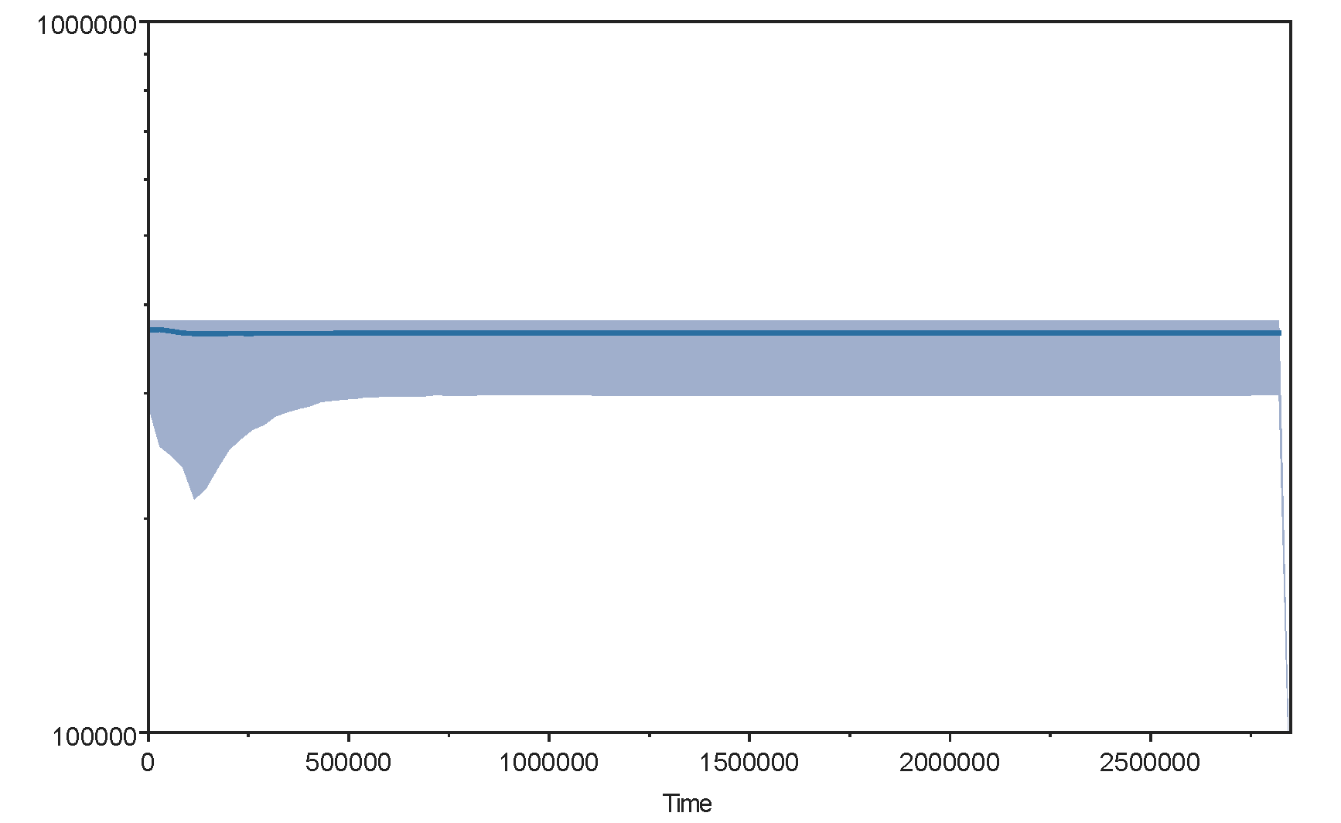
Fig. S3 All-haplotype Bayesian skyline plot for Schizothorax macropogon mitochondrial cytb. The blue line shows the median effective population-size estimate and the blue shading shows its 95% highest posterior density interval. The time axis is conditional on a strict clock fixed at 1.0 × 10⁻⁸ substitutions site⁻¹ year⁻¹ (1.0% Myr⁻¹). It is a rate-dependent exploratory estimate, not an independently calibrated chronology.

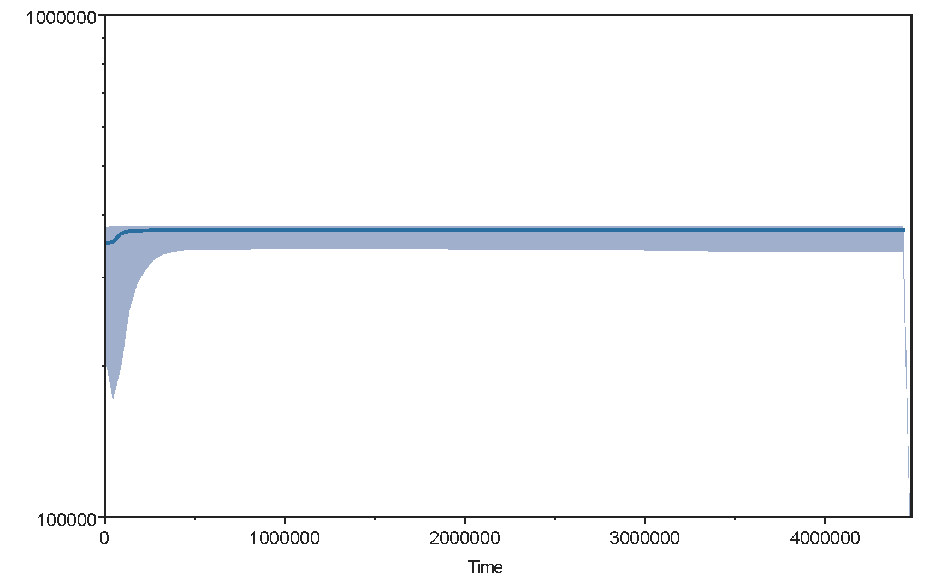
Fig. S4 All-haplotype Bayesian skyline plot for Schizothorax waltoni mitochondrial cytb. The blue line shows the median effective population-size estimate and the blue shading shows its 95% highest posterior density interval. The time axis is conditional on a strict clock fixed at 1.0 × 10⁻⁸ substitutions site⁻¹ year⁻¹ (1.0% Myr⁻¹). It is a rate-dependent exploratory estimate, not an independently calibrated chronology.

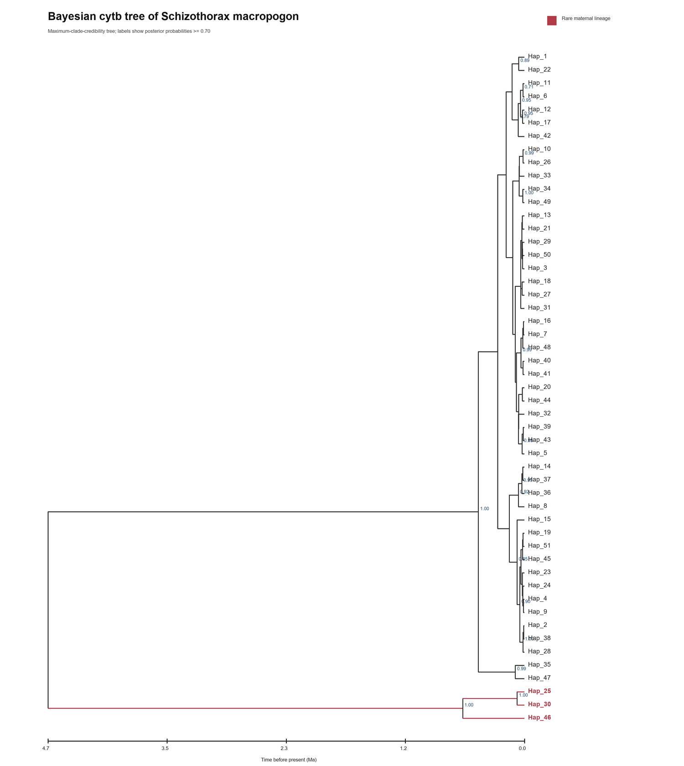
Fig. S5 Bayesian maximum-clade-credibility tree for Schizothorax macropogon mitochondrial cytb haplotypes. Rare Lineage A haplotypes are shown in red; internal labels are posterior probabilities ≥ 0.70. The horizontal scale shows time before present in Ma. The time axis is conditional on a strict clock fixed at 1.0 × 10⁻⁸ substitutions site⁻¹ year⁻¹ (1.0% Myr⁻¹). It is a rate-dependent exploratory estimate, not an independently calibrated chronology.

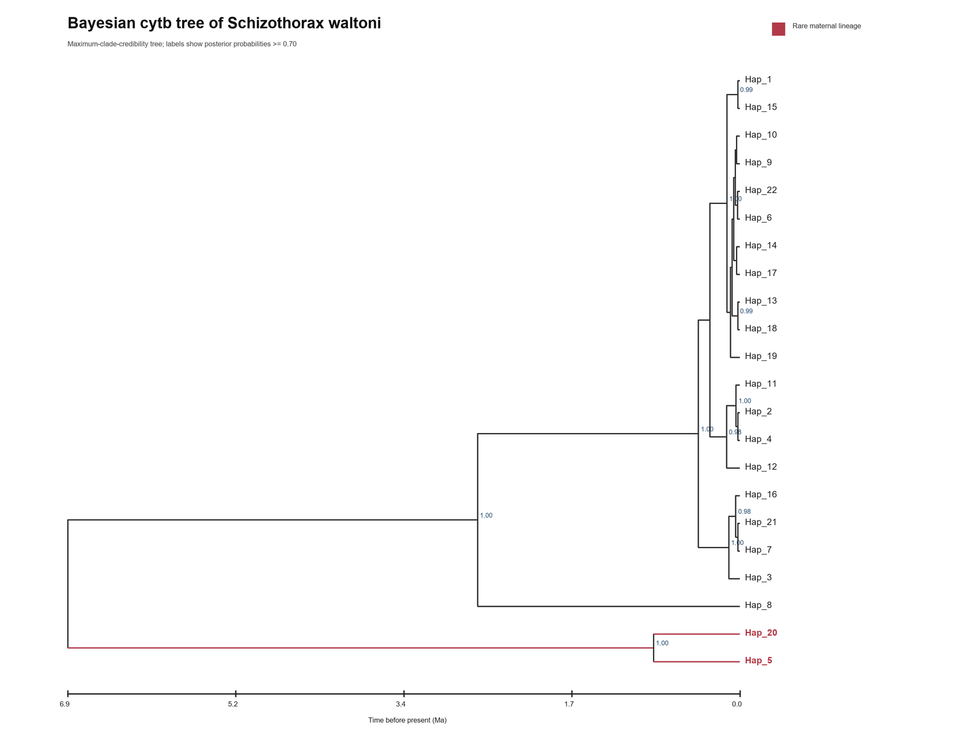
Fig. S6 Bayesian maximum-clade-credibility tree for Schizothorax waltoni mitochondrial cytb haplotypes. Rare Lineage a haplotypes are shown in red; internal labels are posterior probabilities ≥ 0.70. The horizontal scale shows time before present in Ma. The time axis is conditional on a strict clock fixed at 1.0 × 10⁻⁸ substitutions site⁻¹ year⁻¹ (1.0% Myr⁻¹). It is a rate-dependent exploratory estimate, not an independently calibrated chronology.

