Supplementary Appendix

Pairing absolute and relative inequality measures for maternal and child health equity monitoring across 83 countries, 2010-2023: a cross-national ecological study

List of Supplementary Items
All items numbered in order of first citation in the main text (Methods → Results → Discussion).
Item | Type | Title | First cited in main text
Fig S1 | Figure | Country selection flow diagram | Methods: Study sample; Results 3.1
Fig S2 | Figure | Absolute wealth-related gap by country and indicator (SII heatmap) | Results 3.2
Fig S3 | Figure | SII decomposition patterns by indicator and WHO region | Results 3.2
Fig S4 | Figure | P:R ratio category distribution by WHO region and income group | Results 3.3
Fig S5 | Figure | Residence disparity by region and indicator | Results 3.3
Fig S6 | Figure | DTW trajectory clusters of CRCS | Results 3.4
Fig S7 | Figure | Post-2020 CRCS changes by income group | Results 3.4
Fig S8 | Figure | Exploratory structural correlates of P:R category deterioration | Results 3.5
Table S1 | Table | Health service coverage indicators: codes, definitions, and data sources | Methods: Indicators
Table S2 | Table | Country-level covariates: sources, missingness, and imputation strategy | Methods: Covariates
Table S3 | Table | Complete list of 83 study countries with sub-analysis participation | Methods: Study sample; Results §3.1
Table S4 | Table | SII decomposition results by indicator | Methods: SII decomposition; Results §3.2
Table S5 | Table | Sex-based disparity by region and indicator | Methods: Fairness metrics; Results §3.3
Table S6 | Table | CRCS construction and weighting sensitivity | Methods: CES and trajectory
Table S7 | Table | Association-model specification and diagnostics | Methods: Association analysis
Table S8 | Table | Full pooled structural-correlate results | Methods: Association analysis; Results §3.5
Table S9 | Table | ITS-eligible countries: characteristics and post-pandemic equity change | Results §3.1; §3.4
Table S10 | Table | Operational concordance: P:R ratio versus RII | Results §3.3
Table S11 | Table | Double-burden classification for all 83 countries | Results §3.3
Text S1 | Text | Missing-not-at-random (MNAR) sensitivity analysis for Gini and literacy | Methods: Covariates; Discussion (Limitations)
Text S2 | Text | Threshold sensitivity analysis for P:R ratio classification | Methods: Fairness metrics; Results §3.3
Text S3 | Text | Outlier sensitivity analysis for SII extreme values | Methods: Double-burden; Results §3.3
Text S4 | Text | DTW trajectory cluster stability: bootstrap Jaccard analysis for k=2–4 | Methods: CES and trajectory; Results §3.4
Text S5 | Text | Sensitivity of ITS results to AR(1) correlation structure specification | Methods: ITS analysis
Text S6 | Text | Complete-case sensitivity analysis for association analysis | Methods: Association analysis; Results §3.5
Text S7 | Text | Sensitivity analysis: covariate values assigned at endpoint survey year | Methods: Association analysis
Text S8 | Text | Theoretical foundations of the fairness-informed equity framework | Discussion (paragraph 2)

Supplementary Figures
Fig S1 — Country selection flow diagram
Title: Selection of countries for the analysis of maternal and child health equity, 2010–2023
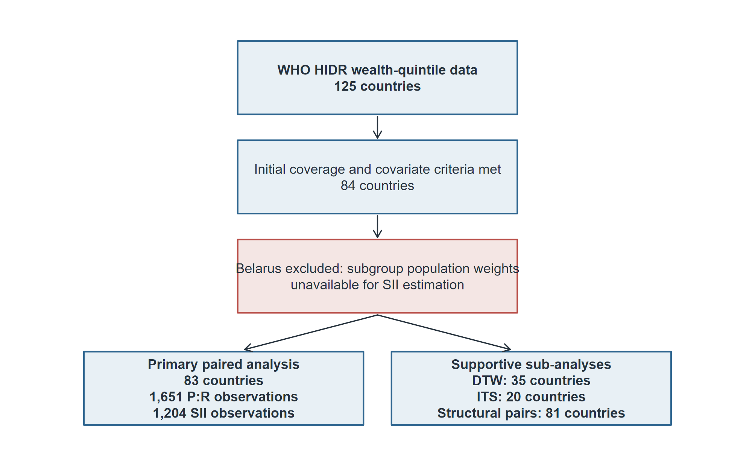
Description: Flow diagram showing country selection from WHO HIDR to the final 83-country paired analysis, with corrected sample sizes for P:R ratio, SII, DTW, ITS, and structural-correlate analyses.
Note: HIDR = WHO Health Inequality Data Repository; DTW = Dynamic Time Warping; ITS = Interrupted Time Series; SII = Slope Index of Inequality.

Fig S2 - SII heatmap by country and indicator
Title: Absolute wealth-related gap by country and indicator
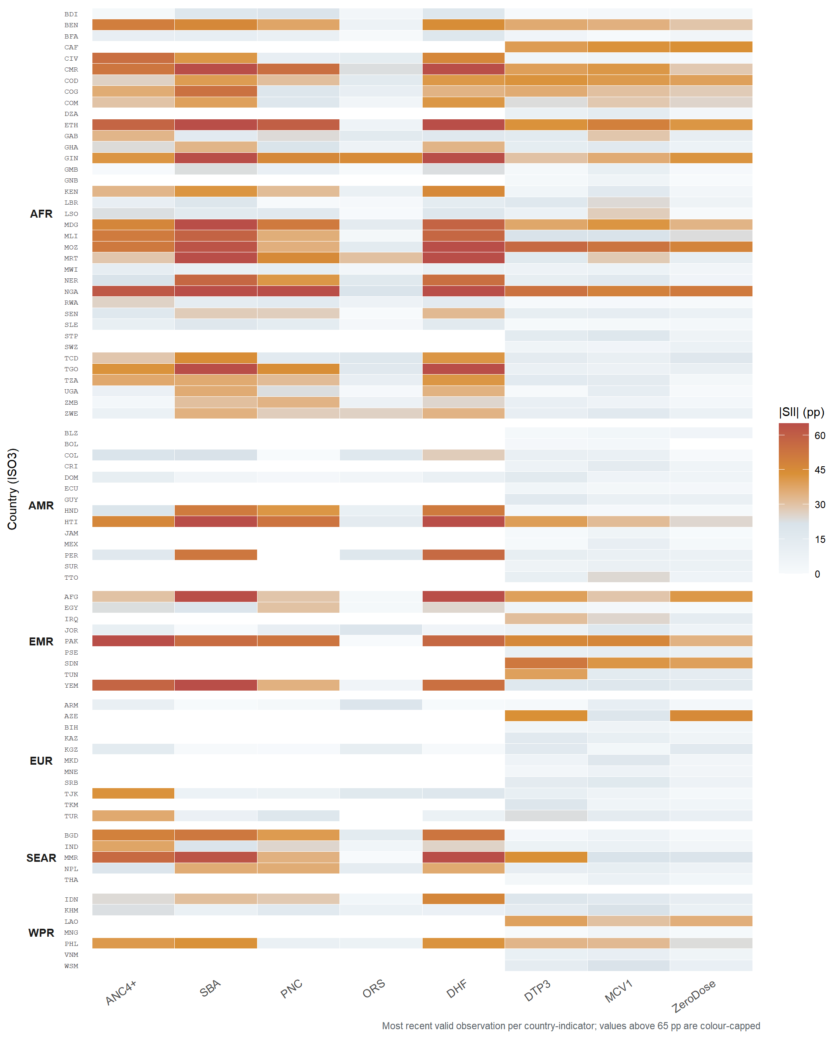
Description: Heatmap showing the most recent absolute SII magnitude (|SII|) for each available country-indicator combination. Higher values indicate larger wealth-related absolute gaps; values above 65 percentage points are colour-capped, and missing combinations are shown separately.

Fig S3 - SII decomposition patterns by indicator
Title: Distribution of SII decomposition patterns (A-D) by indicator and WHO region
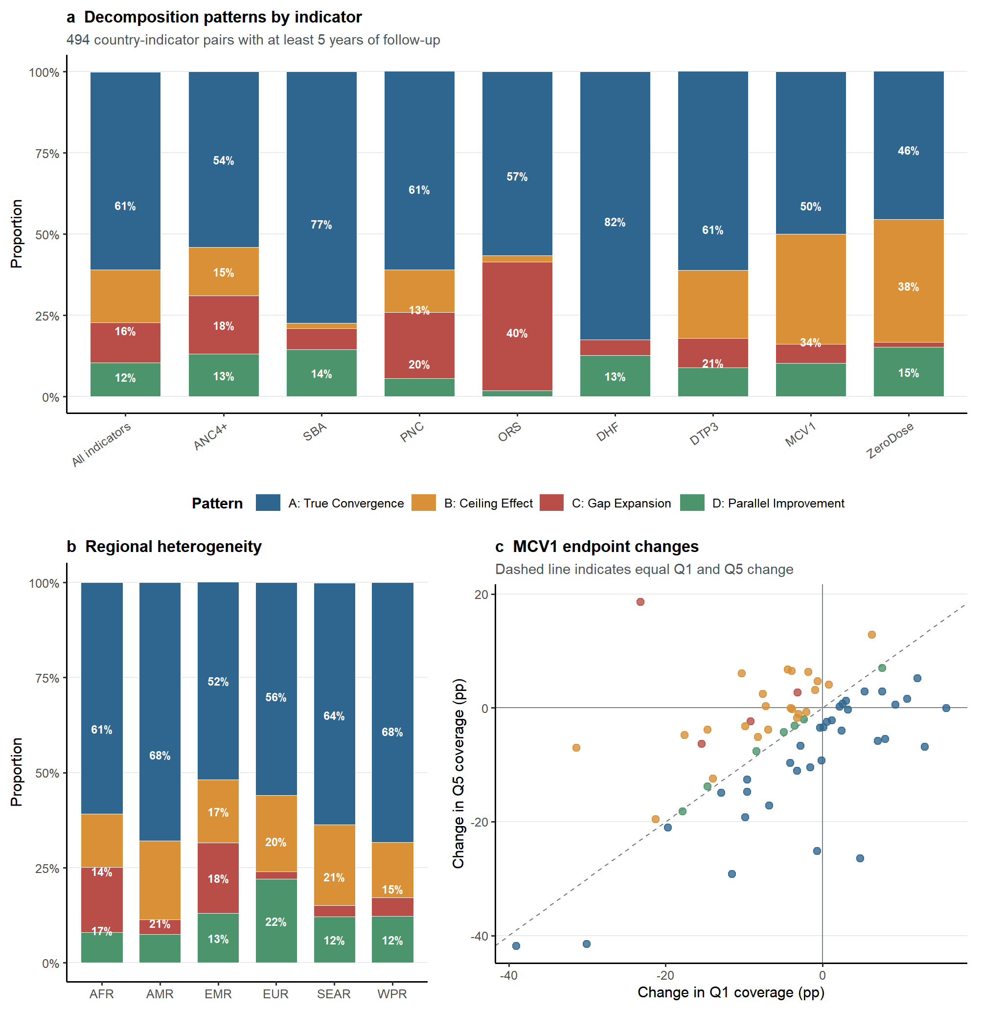
Description: Stacked bar showing the proportion of country-indicator pairs in each decomposition pattern: A = True Convergence; B = Ceiling Effect; C = Gap Expansion; D = Parallel Improvement.

Fig S4 - P:R ratio classification distribution by WHO region and income group
Title: Distribution of P:R ratio categories by WHO region and World Bank income group
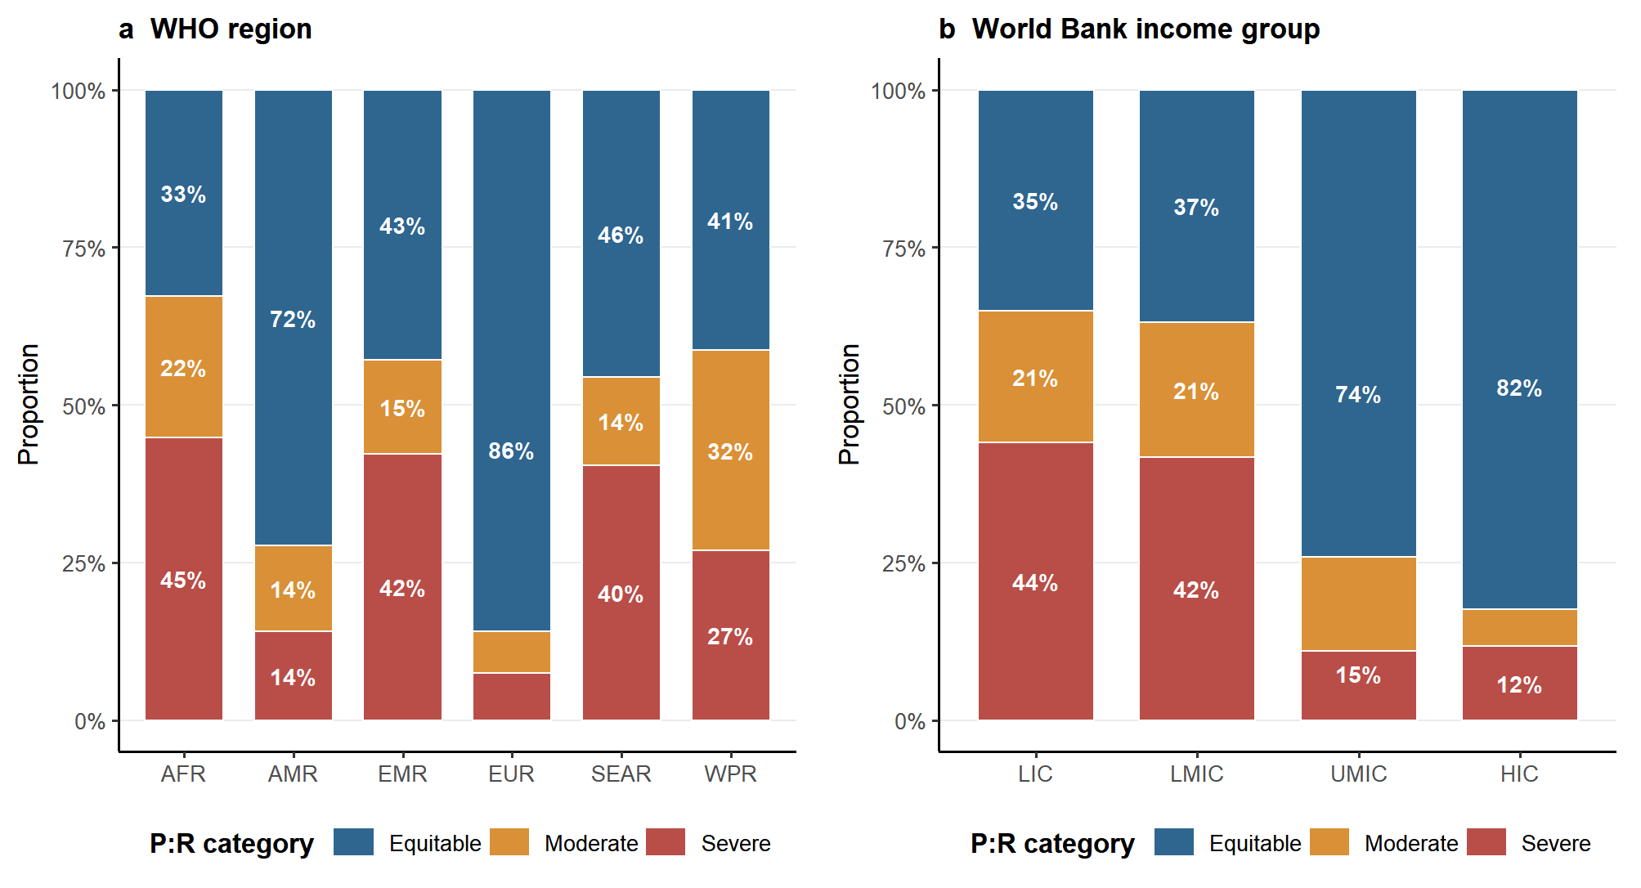
Description: Stacked bars show Equitable, Moderate, and Severe P:R categories across 1,651 country-indicator-year observations.

Fig S5 - Direction-harmonised residence disparity by region and indicator
Title: Direction-harmonised rural-urban disparity in health service coverage by WHO region and indicator, 2010-2023
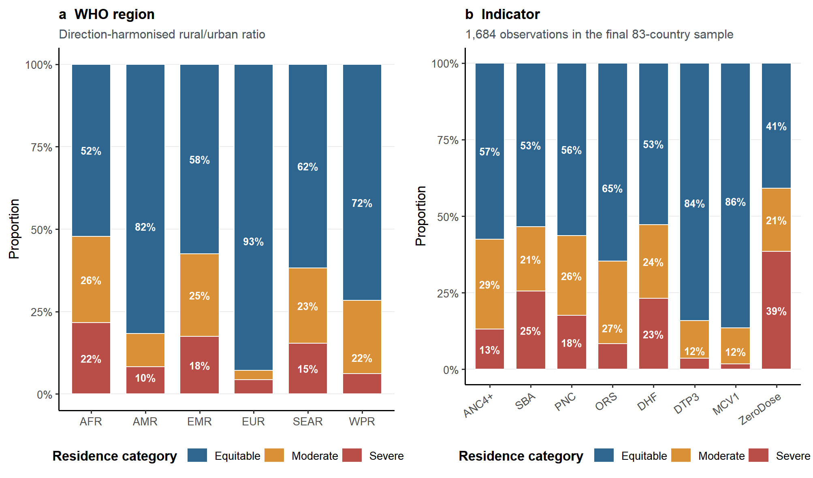
Description: Stacked bars show Equitable, Moderate, and Severe residence categories across 1,684 observations from the final 83-country sample. Ratios were rural/urban for favourable indicators and urban/rural for ZeroDose, so values below 0.80 consistently indicate rural disadvantage.

Fig S6 - Dynamic time-warping trajectory clusters of CRCS
Title: Dynamic time-warping trajectory clusters of the composite relative coverage score, 2010-2023
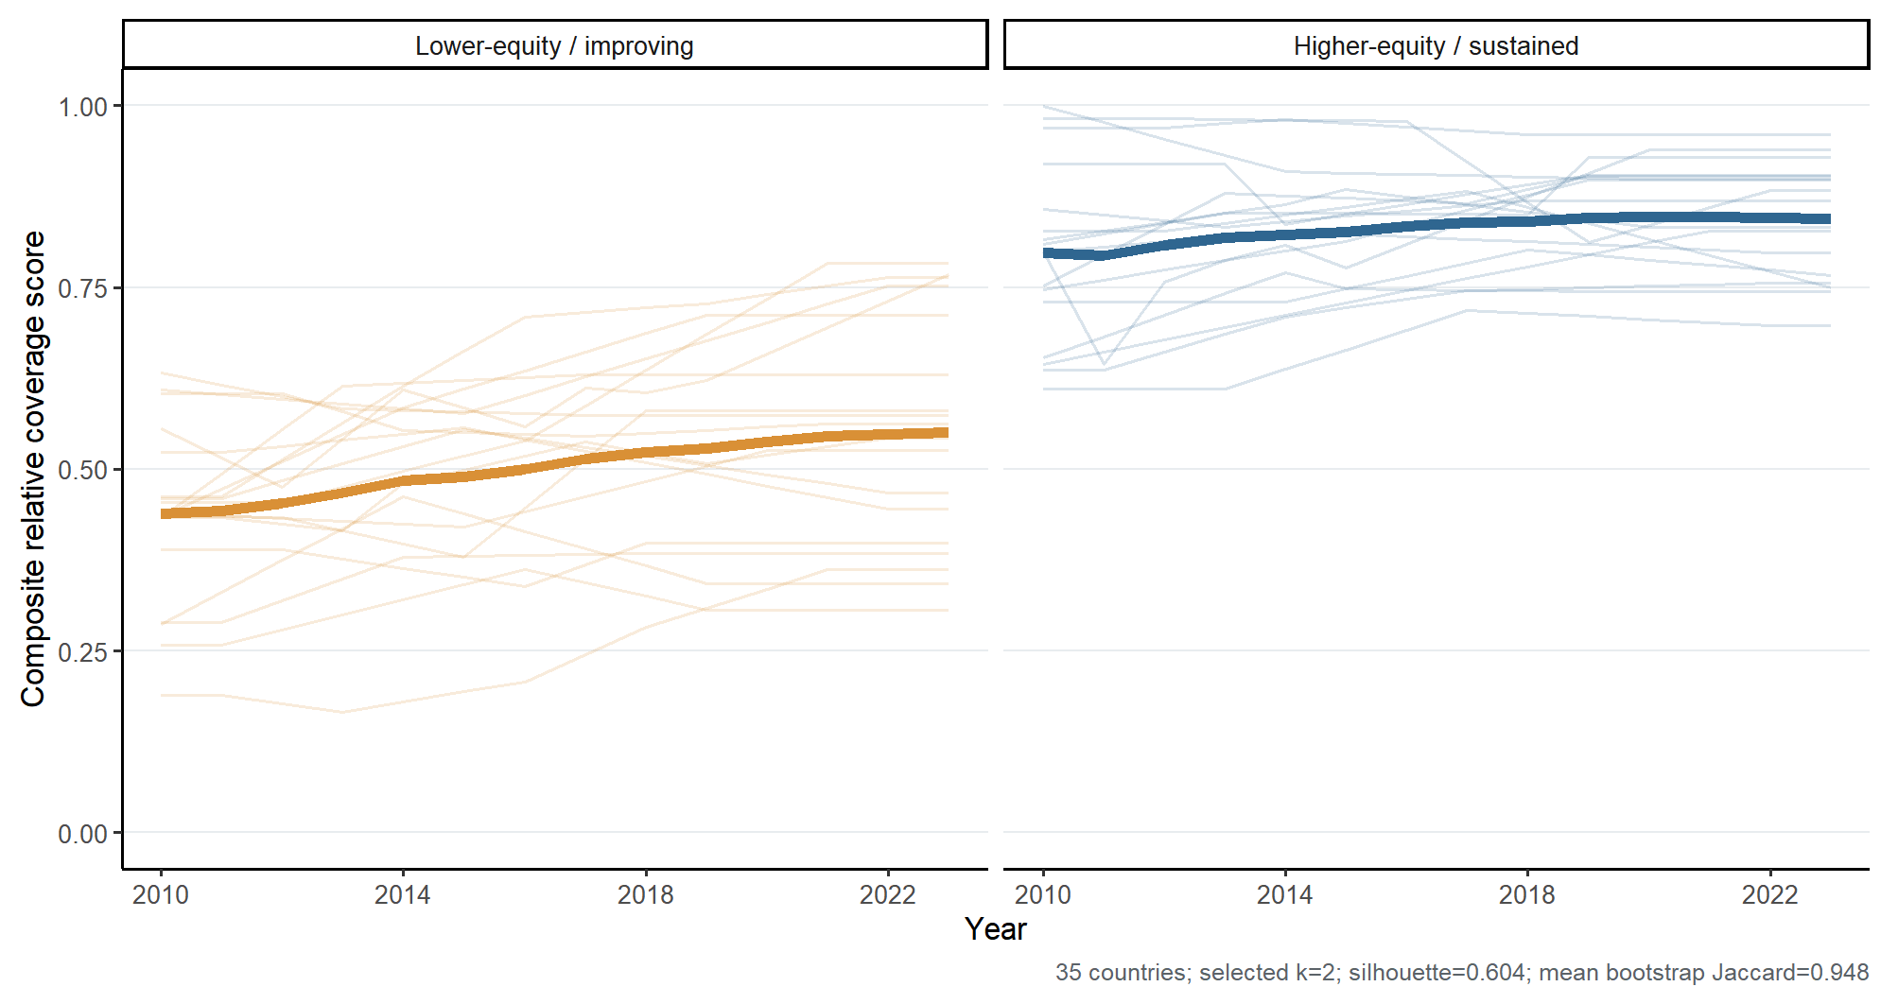
Description: DTW k-medoids clustering of CRCS trajectories in 35 countries with at least three valid survey years. The selected two-cluster solution had mean silhouette 0.604 and mean bootstrap Jaccard 0.948.
Note: CRCS = composite relative coverage score; DTW = dynamic time warping.
Fig S7 - Exploratory post-2020 CRCS changes by income group
Title: Interrupted time-series estimate and observed post-2020 changes by income group
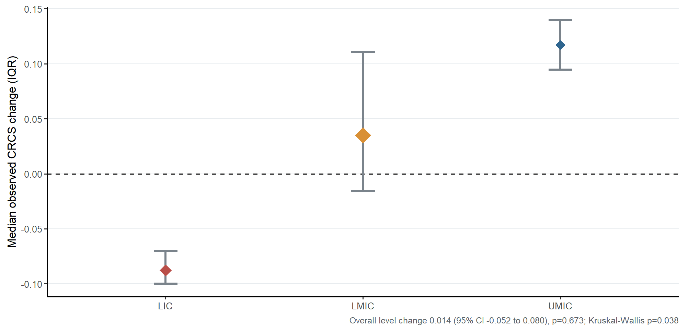
Description: The overall ITS level-change estimate was 0.014 (95% CI -0.052 to 0.080; p=0.673). Points and intervals show income-group medians and interquartile ranges of observed changes; subgroup sizes were LIC n=3, LMIC n=15, and UMIC n=2.

Fig S8 - Exploratory structural correlates of P:R category deterioration
Title: Pooled logistic regression with country-clustered robust covariance
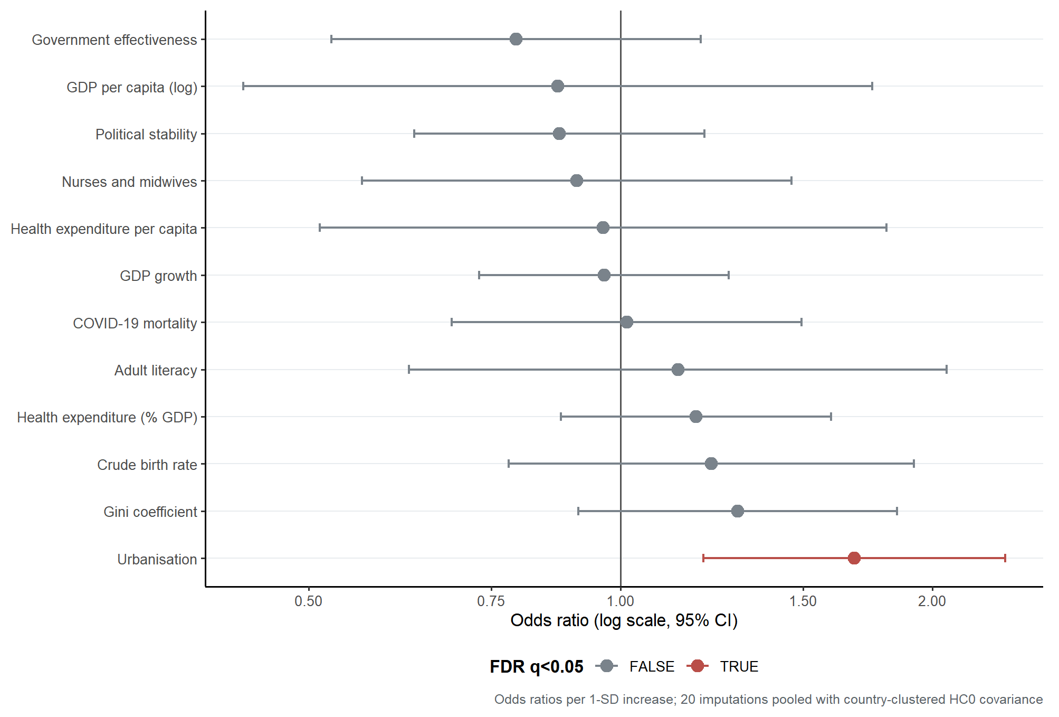
Description: Odds ratios and 95% confidence intervals from 20 imputed datasets, combined using Rubin's rules. Models used indicator fixed effects and country-clustered HC0 covariance. Urbanisation was the only FDR-significant association.

Supplementary Tables
Table S1 — Health service coverage indicators
Title: Definitions, HIDR codes, and measurement characteristics of the eight health service coverage indicators
# | Short name | Full definition | HIDR code | HIDR file | Indicator type | Survey period
1 | ANC4+ | Proportion of women aged 15–49 with a live birth who attended ≥4 antenatal care visits | RH_ANCN_W_N4P_2 | RMNCH | Favourable | 2010–2023
2 | SBA | Proportion of live births attended by a skilled birth attendant | RH_DELA_C_SKP_2 | RMNCH | Favourable | 2010–2023
3 | PNC | Proportion of women who received a postnatal care check within 2 days of delivery | RH_PCMT_W_DY2 | RMNCH | Favourable | 2010–2023
4 | ORS | Proportion of children under 5 with diarrhoea who received oral rehydration salts | CH_DIAT_C_ORS | RMNCH | Favourable | 2010–2023
5 | DHF | Proportion of live births delivered in a health facility | RH_DELP_C_DHF_2 | RMNCH | Favourable | 2010–2023
6 | DTP3 | Proportion of surviving infants who received three doses of DTP-containing vaccine | vdpt | Immunisation | Favourable | 2010–2023
7 | MCV1 | Proportion of surviving infants who received the first dose of measles-containing vaccine | vmsl | Immunisation | Favourable | 2010–2023
8 | ZeroDose | Proportion of children 12–23 months who received no vaccine doses (DTP1 not received) | vzdpt | Immunisation | Adverse† | 2010–2023
For ZeroDose, the P:R ratio is direction-harmonised as Q5/Q1 prevalence so that values below 1 consistently indicate higher zero-dose prevalence among the poorest quintile. When Q1=Q5=0, P:R is set to 1.
HIDR data stratifier: All estimates are disaggregated by economic status (wealth quintile using asset-based wealth index from Demographic and Health Surveys [DHS] or Multiple Indicator Cluster Surveys [MICS]).

Table S2 — Country-level covariates
Title: Sources, missingness rates, and imputation strategies for country-level covariates
Covariate | Source | World Bank code | Mean missingness | Imputation strategy | Used in regression
Log GDP per capita (constant 2015 USD) | WB WDI | NY.GDP.PCAP.KD | 8·3% | Linear interp. + LOCF/NOCB + MICE | Yes
GDP growth rate (% p.a.) | WB WDI | NY.GDP.MKTP.KD.ZG | 10·1% | Linear interp. + MICE | Yes
Gini coefficient | WB WDI | SI.POV.GINI | 40·2% | Linear interp. (gap ≤5 y) + MICE | Yes (sensitivity: excl.)
Health expenditure (% GDP) | WB WDI | SH.XPD.CHEX.GD.ZS | 12·4% | Linear interp. + MICE | Yes
Health expenditure per capita (USD) | WB WDI | SH.XPD.CHEX.PC.CD | 12·4% | Linear interp. + MICE | Yes
Urbanisation rate (%) | WB WDI | SP.URB.TOTL.IN.ZS | 0% | None needed | Yes
Nurses & midwives per 1,000 | WB WDI | SH.MED.NUMW.P3 | 38·6% | Linear interp. + MICE | Yes
Population growth rate (%) | WB WDI | SP.POP.GROW | 0% | None needed | No (VIF = 11·4; excluded)
Crude birth rate (per 1,000) | WB WDI | SP.DYN.CBRT.IN | 0% | None needed | Yes
Adult literacy rate (%) | WB WDI | SE.ADT.LITR.ZS | 58·2% | MICE only | Yes (sensitivity: excl.)
Political stability (PV.EST) | WB WGI | PV.EST | 4·8% | MICE | Yes
Government effectiveness (GE.EST) | WB WGI | GE.EST | 4·8% | MICE | Yes
COVID-19 mortality rate (per 100,000) | WHO HIDR | — | 18·2%* | Not imputed | Yes (degenerate; see Table S8†)
*COVID missingness reflects countries with surveys only before 2020.
†Complete numerical instability; see Table S8.
MICE settings: 20 completed datasets; predictive mean matching; seed=2025; maximum iterations=10. Year, WHO region, and income group were included as predictors. Models were fitted separately in each completed dataset and combined using Rubin's rules.
Abbreviations: WB = World Bank; WDI = World Development Indicators; WGI = Worldwide Governance Indicators; MICE = multiple imputation by chained equations; VIF = variance inflation factor; LOCF = last observation carried forward; NOCB = next observation carried backward.

Table S3 — Complete list of 83 study countries
Title: Countries included in the cross-national analysis, by WHO region and World Bank income classification
ISO3 | Country | WHO Region | Income Group (WB) | DTW | ITS
African Region (AFR, n=37)
BDI | Burundi | AFR | LIC | No | No
BEN | Benin | AFR | LMIC | Yes | Yes
BFA | Burkina Faso | AFR | LIC | No | No
CAF | Central African Republic | AFR | LIC | No | No
CIV | Côte d’Ivoire | AFR | LMIC | Yes | Yes
CMR | Cameroon | AFR | LMIC | Yes | No
COD | DR Congo | AFR | LIC | Yes | No
COG | Congo | AFR | LMIC | No | No
COM | Comoros | AFR | LMIC | No | No
DZA | Algeria† | AFR | UMIC | No | No
ETH | Ethiopia | AFR | NA‡ | Yes | No
GAB | Gabon | AFR | UMIC | No | No
GHA | Ghana | AFR | LMIC | Yes | Yes
GIN | Guinea | AFR | LMIC | Yes | No
GMB | Gambia | AFR | LIC | Yes | No
GNB | Guinea-Bissau | AFR | LIC | Yes | No
KEN | Kenya | AFR | LMIC | No | No
LBR | Liberia | AFR | LIC | No | No
LSO | Lesotho | AFR | LMIC | Yes | Yes
MDG | Madagascar | AFR | LIC | No | No
MLI | Mali | AFR | LIC | Yes | No
MOZ | Mozambique | AFR | LIC | Yes | Yes
MRT | Mauritania | AFR | LMIC | Yes | Yes
MWI | Malawi | AFR | LIC | Yes | Yes
NER | Niger | AFR | LIC | No | No
NGA | Nigeria | AFR | LMIC | Yes | Yes
RWA | Rwanda | AFR | LIC | Yes | No
SEN | Senegal | AFR | LMIC | Yes | Yes
SLE | Sierra Leone | AFR | LIC | Yes | No
STP | São Tomé and Príncipe | AFR | LMIC | No | No
SWZ | Eswatini | AFR | LMIC | Yes | Yes
TCD | Chad | AFR | LIC | Yes | No
TGO | Togo | AFR | LIC | Yes | No
TZA | Tanzania | AFR | LMIC | Yes | Yes
UGA | Uganda | AFR | LIC | No | No
ZMB | Zambia | AFR | LMIC | No | No
ZWE | Zimbabwe | AFR | LMIC | Yes | No
Americas (AMR, n=14)
BLZ | Belize | AMR | UMIC | No | No
BOL | Bolivia | AMR | LMIC | No | No
COL | Colombia | AMR | UMIC | No | No
CRI | Costa Rica | AMR | HIC | No | No
DOM | Dominican Republic | AMR | UMIC | Yes | No
ECU | Ecuador | AMR | UMIC | No | No
GUY | Guyana | AMR | HIC | No | No
HND | Honduras | AMR | LMIC | No | No
HTI | Haiti | AMR | LMIC | No | No
JAM | Jamaica | AMR | UMIC | No | No
MEX | Mexico | AMR | UMIC | No | No
PER | Peru | AMR | UMIC | Yes | Yes
SUR | Suriname | AMR | UMIC | No | No
TTO | Trinidad and Tobago | AMR | HIC | No | No
European Region (EUR, n=11)
ARM | Armenia | EUR | UMIC | No | No
AZE | Azerbaijan | EUR | UMIC | No | No
BIH | Bosnia and Herzegovina | EUR | UMIC | No | No
KAZ | Kazakhstan | EUR | UMIC | No | No
KGZ | Kyrgyzstan | EUR | LMIC | Yes | No
MKD | North Macedonia | EUR | UMIC | No | No
MNE | Montenegro | EUR | UMIC | No | No
SRB | Serbia | EUR | UMIC | No | No
TJK | Tajikistan | EUR | LMIC | No | No
TKM | Turkmenistan | EUR | UMIC | No | No
TUR | Turkey | EUR | UMIC | No | No
Eastern Mediterranean (EMR, n=9)
AFG | Afghanistan | EMR | LIC | Yes | Yes
EGY | Egypt | EMR | LMIC | No | No
IRQ | Iraq | EMR | UMIC | No | No
JOR | Jordan | EMR | LMIC | Yes | Yes
PAK | Pakistan | EMR | LMIC | No | No
PSE | Palestine | EMR | LMIC | Yes | Yes
SDN | Sudan | EMR | LIC | No | No
TUN | Tunisia | EMR | LMIC | No | No
YEM | Yemen | EMR | LIC | No | No
Western Pacific (WPR, n=7)
IDN | Indonesia | WPR | UMIC | No | No
KHM | Cambodia | WPR | LMIC | Yes | Yes
LAO | Lao PDR | WPR | LMIC | No | No
MNG | Mongolia | WPR | UMIC | Yes | No
PHL | Philippines | WPR | LMIC | Yes | Yes
VNM | Viet Nam | WPR | LMIC | No | No
WSM | Samoa | WPR | UMIC | No | No
South-East Asia (SEAR, n=5)
BGD | Bangladesh | SEAR | LMIC | Yes | Yes
IND | India | SEAR | LMIC | No | No
MMR | Myanmar | SEAR | LMIC | No | No
NPL | Nepal | SEAR | LMIC | Yes | Yes
THA | Thailand | SEAR | UMIC | Yes | Yes
†Algeria classified under WHO African Region in HIDR metadata.
‡Ethiopia income classification missing in World Bank 2023 dataset (reclassified LMIC effective 2024).
Regional summary: AFR n=37 | AMR n=14 | EUR n=11 | EMR n=9 | WPR n=7 | SEAR n=5. Income summary: LIC n=20 | LMIC n=35 | UMIC n=24 | HIC n=3 | Missing n=1 (ETH). DTW sub-analysis: n=35 | ITS sub-analysis: n=20.

Table S4 — SII decomposition results by indicator
Title: Pattern distribution of SII temporal change by indicator (country-indicator pairs with ≥5 years between first and last survey, n=494)
Indicator | N pairs | Pattern A: True Convergence | Pattern B: Ceiling Effect | Pattern C: Gap Expansion | Pattern D: Parallel Improvement | Notes
ANC4+ | 61 | 54.1% | 14.8% | 18.0% | 13.1% | -
SBA | 62 | 77.4% | 1.6% | 6.5% | 14.5% | -
PNC | 54 | 61.1% | 13.0% | 20.4% | 5.6% | -
ORS | 53 | 56.6% | 1.9% | 39.6% | 1.9% | Highest gap-expansion share
DHF | 63 | 82.5% | 0.0% | 4.8% | 12.7% | No ceiling-effect pairs
DTP3 | 67 | 61.2% | 20.9% | 9.0% | 9.0% | -
MCV1 | 68 | 50.0% | 33.8% | 5.9% | 10.3% | Ceiling effect in 33.8%
ZeroDose | 66 | 45.5% | 37.9% | 1.5% | 15.2% | Directions reversed
All combined | 494 | 60.9% | 16.2% | 12.3% | 10.5% | -
†MCV1 Pattern B: ceiling-driven expansion — median ΔQ1 = −1·2 pp, median ΔQ5 = −1·3 pp; SII expansion is a mathematical artefact of Q5 approaching saturation. Demand-side interventions are needed to close the remaining gap.
Pattern definitions: A = True Convergence (ΔQ1_dir > ΔQ5_dir + 1 pp); B = Ceiling Effect (Q5 baseline ≥80% and ΔQ5_dir > ΔQ1_dir + 1 pp); C = Gap Expansion (ΔQ5_dir > ΔQ1_dir + 1 pp, Q5 baseline <80%); D = Parallel Improvement (all other). For ZeroDose, ΔQ1_dir and ΔQ5_dir are sign-reversed.

Table S5 - Direction-harmonised sex-based coverage disparity by WHO region and indicator
Title: Direction-harmonised sex-based health service coverage disparity by WHO region and indicator, 2010-2023
Source: The direction-harmonised sex ratio was female/male coverage for favourable indicators and male/female prevalence for ZeroDose. Values below 1 therefore consistently denote female disadvantage. Sex-disaggregated data were available for 866 observations.
Part A — By WHO Region
WHO Region | N observations | Sex ratio <0.80, n (%) | Sex ratio <0.60, n (%) | Median direction-harmonised sex ratio
African | 442 | 35 (7.9%) | 5 (1.1%) | 0.993
Americas | 139 | 8 (5.8%) | 2 (1.4%) | 0.995
Eastern Mediterranean | 82 | 1 (1.2%) | 1 (1.2%) | 0.988
European | 69 | 8 (11.6%) | 3 (4.3%) | 1.004
South-East Asia | 66 | 8 (12.1%) | 2 (3.0%) | 0.977
Western Pacific | 68 | 4 (5.9%) | 2 (2.9%) | 0.991
Overall | 866 | 64 (7.4%) | 15 (1.7%) | 0.992
Part B — By Indicator
Indicator | Group | N observations | Sex ratio <0.80, % | Median direction-harmonised sex ratio
ZeroDose | Immunisation | 218 | 22.9% | 0.961
ORS | RMNCH | 206 | 6.8% | 0.977
DTP3 | Immunisation | 220 | 0.0% | 0.997
MCV1 | Immunisation | 222 | 0.0% | 0.995
Notes: A ratio below 0.80 denotes sex disadvantage and below 0.60 denotes Severe disadvantage. Sex-disaggregated data were unavailable for the maternal-specific indicators ANC4+, SBA, PNC, and DHF.

Table S6 - CRCS construction: indicator domains, weighting schemes, and sensitivity analysis
Title: Composite relative coverage score composition and weighting schemes
Table S6a. Indicator weights under three CES versions
Indicator | Abbreviation | Domain | Equal weight | Domain weight | Factor-analytic weight
ORS (child diarrhoea treatment) | ORS | Child health/immunisation | 0.125 | 0.125 | 0.074
Antenatal care >=4 visits | ANC4+ | RMNCH | 0.125 | 0.125 | 0.139
Skilled birth attendance | SBA | RMNCH | 0.125 | 0.125 | 0.144
Delivery in health facility | DHF | RMNCH | 0.125 | 0.125 | 0.144
Postnatal care within 2 days | PNC | RMNCH | 0.125 | 0.125 | 0.141
DTP3 (3rd dose) | DTP3 | Child health/immunisation | 0.125 | 0.125 | 0.138
Measles vaccine (1st dose) | MCV1 | Child health/immunisation | 0.125 | 0.125 | 0.138
Zero-dose DTP (reciprocal) | ZeroDose | Child health/immunisation | 0.125 | 0.125 | 0.082
Column sum |  |  | 1.000 | 1.000 | 1.000
RMNCH = reproductive, maternal, newborn, and child health. Domain-proportional weight = 0·5/4 = 0·125 per indicator within each of the two equally sized domains.
The eight-indicator set is balanced across two domains. Equal and domain-proportional weighting therefore assign 0.125 per indicator. The first factor explained 63.9% of component variance; loading-derived weights were examined as a sensitivity analysis.
Table S6b. Sensitivity analysis of alternative CRCS weighting schemes
Comparison | Spearman ρ | n observations
CRCS vs RMNCH-domain score | 0.926 | 206
CRCS vs child-health/immunisation-domain score | 0.804 | 207
CRCS vs domain-balanced CRCS | 0.991 | 203
CRCS vs factor-weighted CRCS | 0.992 | 210
Notes: Each direction-harmonised P:R component was capped at 1 before aggregation so that pro-poor values did not offset disadvantage in other indicators.

Table S7 - Association-model specification and diagnostics
Title: Prespecified model, singularity audit, and final robust specification
Dimension | Specification | Evidence | Sensitivity | Specificity | PPV | NPV | Decision
Analysis set | Full sample | 1,022 pairs; 73 events | — | — | — | — | Retain
Initial mixed model | Country + indicator random intercepts | 20/20 singular fits | — | — | — | — | Reject
Final model | Indicator fixed effects; country-clustered HC0 | 20/20 converged | — | — | — | — | Use for exploratory inference
The structural dataset contained 1,022 consecutive survey pairs, 73 deterioration events, and 81 countries. Prediction performance was not a study objective.
The initial country-plus-indicator random-intercept model was singular in all 20 imputations because country-level variance was approximately zero. The final model used the full sample, indicator fixed effects, and country-clustered HC0 covariance.
All 20 final models converged; estimates and covariance matrices were pooled using Rubin's rules.

Table S8 - Full exploratory structural-correlate results
Title: Pooled logistic regression results for all 12 country-level covariates
Analytic sample: 1,022 pairs; 73 events (7.1%); 81 countries; 8 indicators. Continuous covariates were standardised; ORs are per 1-SD increase.
# | Covariate | OR | 95% CI Lower | 95% CI Upper | p-value | BH-FDR q | Significance
1 | GDP per capita (log) | 0.870 | 0.433 | 1.749 | 0.6955 | 0.927
2 | GDP growth rate | 0.964 | 0.731 | 1.272 | 0.7953 | 0.944
3 | Gini index | 1.297 | 0.910 | 1.849 | 0.1498 | 0.817
4 | Health expenditure (% GDP) | 1.182 | 0.876 | 1.596 | 0.2739 | 0.817
5 | Health expenditure per capita | 0.962 | 0.512 | 1.807 | 0.9042 | 0.944
6 | Urbanisation rate | 1.681 | 1.202 | 2.352 | 0.0024 | 0.029 | **
7 | Nurses and midwives | 0.907 | 0.563 | 1.462 | 0.6883 | 0.927
8 | Crude birth rate | 1.224 | 0.780 | 1.920 | 0.3798 | 0.817
9 | Adult literacy rate | 1.136 | 0.625 | 2.064 | 0.6739 | 0.927
10 | Political stability | 0.873 | 0.632 | 1.205 | 0.4084 | 0.817
11 | Government effectiveness | 0.793 | 0.526 | 1.195 | 0.2667 | 0.817
12 | COVID-19 mortality | 1.014 | 0.687 | 1.495 | 0.9439 | 0.944
Model: unweighted logistic regression with indicator fixed effects and country-clustered HC0 robust covariance, fitted in each of 20 completed datasets and pooled with Rubin's rules. BH-FDR correction was applied across 12 covariates.
** indicates FDR q<0.05. All associations are exploratory and non-causal.

Table S9 - ITS-eligible countries and observed post-2020 CRCS change
Title: Survey timing and observed CRCS change in the 20 ITS-eligible countries
Overall ITS: post-2020 level change=0.014 (95% CI -0.052 to 0.080; p=0.673). The continuous-time AR(1) and discrete-time AR(1) specifications produced the same estimate.
Observed change differed by income group (Kruskal-Wallis p=0.038), but LIC and UMIC contained only three and two countries. These subgroup summaries are descriptive.
ISO3 | Country | WHO Region | Income Group | Pre year | Post year | Pre CRCS | Post CRCS | Change / DTW cluster
AFG | Afghanistan | EMR | LIC | 2015 | 2022 | 0.555 | 0.467 | -0.088; cluster 1
MOZ | Mozambique | AFR | LIC | 2015 | 2022 | 0.557 | 0.445 | -0.112; cluster 1
MWI | Malawi | AFR | LIC | 2015 | 2020 | 0.885 | 0.833 | -0.052; cluster 2
BEN | Benin | AFR | LMIC | 2017 | 2021 | 0.546 | 0.562 | +0.016; cluster 1
BGD | Bangladesh | SEAR | LMIC | 2019 | 2022 | 0.508 | 0.543 | +0.035; cluster 1
CIV | Côte d’Ivoire | AFR | LMIC | 2016 | 2021 | 0.539 | 0.783 | +0.245; cluster 1
GHA | Ghana | AFR | LMIC | 2017 | 2022 | 0.745 | 0.756 | +0.011; cluster 2
JOR | Jordan | EMR | LMIC | 2017 | 2023 | 0.883 | 0.750 | -0.133; cluster 2
KHM | Cambodia | WPR | LMIC | 2014 | 2021 | 0.712 | 0.828 | +0.116; cluster 2
LSO | Lesotho | AFR | LMIC | 2018 | 2023 | 0.802 | 0.767 | -0.035; cluster 2
MRT | Mauritania | AFR | LMIC | 2015 | 2020 | 0.420 | 0.525 | +0.105; cluster 1
NGA | Nigeria | AFR | LMIC | 2018 | 2021 | 0.282 | 0.362 | +0.080; cluster 1
NPL | Nepal | SEAR | LMIC | 2019 | 2022 | 0.728 | 0.764 | +0.036; cluster 1
PHL | Philippines | WPR | LMIC | 2017 | 2022 | 0.719 | 0.697 | -0.021; cluster 2
PSE | State of Palestine | EMR | LMIC | 2014 | 2020 | 0.909 | 0.898 | -0.010; cluster 2
SEN | Senegal | AFR | LMIC | 2019 | 2023 | 0.622 | 0.768 | +0.146; cluster 1
SWZ | Eswatini | AFR | LMIC | 2014 | 2022 | 0.827 | 0.798 | -0.029; cluster 2
TZA | United Republic of Tanzania | AFR | LMIC | 2015 | 2022 | 0.577 | 0.752 | +0.175; cluster 1
PER | Peru | AMR | UMIC | 2015 | 2020 | 0.777 | 0.940 | +0.162; cluster 2
THA | Thailand | SEAR | UMIC | 2019 | 2022 | 0.811 | 0.883 | +0.072; cluster 2
Notes: Change=first post-2020 CRCS minus last pre-2020 CRCS; negative values indicate deterioration.

Table S10 - Operational concordance: P:R ratio versus RII classification
Title: Cross-tabulation of P:R and RII categories across matched observations, 2010-2023
The P:R ratio uses Q1 and Q5 endpoints; RII uses the full socioeconomic gradient. Both were direction-harmonised and classified into comparable Equitable, Moderate, and Severe categories.
Metric | Equitable | Moderate | Severe
P:R ratio (all indicators, direction-harmonised) | >=0.80 | 0.60 to <0.80 | <0.60
RII (favourable indicators) | <=1.25 | >1.25 to <=1.67 | >1.67
RII (ZeroDose, direction-harmonised) | >=0.80 | 0.60 to <0.80 | <0.60
Interpretation | Screening category | Screening category | Screening category
Primary validation used all observations with valid P:R and RII estimates.
Part A - Cross-tabulation (n=1,202 matched observations)
 | RII: Equitable | RII: Moderate | RII: Severe | Row total
P:R: Equitable | 445 | 67 | 5 | 517
P:R: Moderate | 6 | 151 | 84 | 241
P:R: Severe | 4 | 9 | 431 | 444
Column total | 455 | 227 | 520 | 1202
Linearly weighted Cohen's kappa=0.896 (95% CI 0.879-0.913); exact agreement=85.4%.
Part B - Threshold sensitivity
Comparison | Weighted kappa | Exact agreement | Interpretation
Primary vs lenient | 0.907 | 91.2% | Near-perfect
Primary vs strict | 0.878 | 88.3% | Near-perfect
Primary scheme | >=0.80 / 0.60-<0.80 / <0.60 | — | Retained
Purpose | Category robustness | — | Not a clinical threshold
Primary versus lenient weighted kappa=0.907; exact agreement=91.2%.
Primary versus strict weighted kappa=0.878; exact agreement=88.3%.
These comparisons assess category robustness and do not redefine the primary thresholds.
Part C - Directional asymmetry of Severe-category discordance
RII was more stringent in 89 observations; the P:R ratio was more stringent in 13.
Part D - Incremental data coverage
Discordance direction | n | % of matched | Interpretation
RII Severe; P:R not Severe | 89 | 7.4% | RII captures full-gradient information
P:R Severe; RII not Severe | 13 | 1.1% | Endpoint and gradient shapes differ
The P:R ratio added 447 eligible observations relative to RII (1,651 vs 1,204).
Dataset | Valid observations | Countries
P:R ratio (Q1 and Q5) | 1,651 | 83
RII (full-gradient estimate) | 1,204 | 83
Incremental P:R yield | +447 | 0 additional countries
Interpretation: high concordance supports use of the endpoint ratio as a transparent companion measure, while asymmetric discordance confirms that it cannot replace RII.

Table S11 - Double-burden classification for all 83 countries
Title: Paired absolute and relative inequality profiles using the most recent indicator observations
SII_mean is the cross-indicator mean absolute SII. Severe P:R % is the proportion of available indicators in the Severe category. Primary double burden requires SII_mean at least 20 percentage points and Severe P:R % at least 50%.
ISO3 | Country | WHO Region | Income | Mean |SII| (pp) | Severe P:R (%) | Double burden | Divergence
AFG | Afghanistan | EMR | LIC | 37.96 | 75.0% | YES | No
ARM | Armenia | EUR | UMIC | 6.04 | 14.3% | No | No
AZE | Azerbaijan | EUR | UMIC | 35.87 | 0.0% | No | No
BDI | Burundi | AFR | LIC | 8.34 | 12.5% | No | No
BEN | Benin | AFR | LMIC | 35.66 | 50.0% | YES | No
BFA | Burkina Faso | AFR | LIC | 7.56 | 0.0% | No | No
BGD | Bangladesh | SEAR | LMIC | 27.27 | 62.5% | YES | YES
BIH | Bosnia and Herzegovina | EUR | UMIC | 5.27 | 16.7% | No | No
BLZ | Belize | AMR | UMIC | 3.79 | 0.0% | No | No
BOL | Bolivia | AMR | LMIC | 2.54 | 0.0% | No | No
CAF | Central African Republic | AFR | LIC | 42.07 | 87.5% | YES | No
CIV | Côte d’Ivoire | AFR | LMIC | 22.30 | 25.0% | No | No
CMR | Cameroon | AFR | LMIC | 49.01 | 87.5% | YES | YES
COD | DR Congo | AFR | LIC | 34.56 | 62.5% | YES | No
COG | Congo | AFR | LMIC | 31.02 | 25.0% | No | No
COL | Colombia | AMR | UMIC | 13.50 | 0.0% | No | No
COM | Comoros | AFR | LMIC | 26.31 | 25.0% | No | No
CRI | Costa Rica | AMR | HIC | 8.98 | 12.5% | No | No
DOM | Dominican Republic | AMR | UMIC | 7.42 | 0.0% | No | No
DZA | Algeria | AFR | UMIC | 8.76 | 12.5% | No | No
ECU | Ecuador | AMR | UMIC | 3.50 | 0.0% | No | No
EGY | Egypt | EMR | LMIC | 13.67 | 12.5% | No | No
ETH | Ethiopia | AFR | NA† | 50.61 | 87.5% | YES | YES
GAB | Gabon | AFR | UMIC | 20.07 | 25.0% | No | No
GHA | Ghana | AFR | LMIC | 19.44 | 12.5% | No | No
GIN | Guinea | AFR | LMIC | 47.69 | 100.0% | YES | No
GMB | Gambia | AFR | LIC | 8.98 | 0.0% | No | No
GNB | Guinea-Bissau | AFR | LIC | 2.81 | 37.5% | No | No
GUY | Guyana | AMR | HIC | 11.38 | 14.3% | No | No
HND | Honduras | AMR | LMIC | 22.21 | 0.0% | No | No
HTI | Haiti | AMR | LMIC | 42.94 | 75.0% | YES | No
IDN | Indonesia | WPR | UMIC | 22.59 | 25.0% | No | No
IND | India | SEAR | LMIC | 16.80 | 12.5% | No | No
IRQ | Iraq | EMR | UMIC | 23.15 | 25.0% | No | No
JAM | Jamaica | AMR | UMIC | 2.52 | 16.7% | No | No
JOR | Jordan | EMR | LMIC | 9.75 | 25.0% | No | No
KAZ | Kazakhstan | EUR | UMIC | 10.64 | 0.0% | No | No
KEN | Kenya | AFR | LMIC | 23.36 | 12.5% | No | No
KGZ | Kyrgyzstan | EUR | LMIC | 7.86 | 0.0% | No | No
KHM | Cambodia | WPR | LMIC | 13.88 | 12.5% | No | No
LAO | Lao PDR | WPR | LMIC | 34.82 | 75.0% | YES | YES
LBR | Liberia | AFR | LIC | 11.76 | 12.5% | No | No
LSO | Lesotho | AFR | LMIC | 13.63 | 12.5% | No | No
MDG | Madagascar | AFR | LIC | 44.21 | 87.5% | YES | YES
MEX | Mexico | AMR | UMIC | 4.68 | 0.0% | No | No
MKD | North Macedonia | EUR | UMIC | 9.55 | 0.0% | No | No
MLI | Mali | AFR | LIC | 33.86 | 50.0% | YES | YES
MMR | Myanmar | SEAR | LMIC | 38.07 | 62.5% | YES | No
MNE | Montenegro | EUR | UMIC | 5.10 | 0.0% | No | No
MNG | Mongolia | WPR | UMIC | 1.92 | 12.5% | No | No
MOZ | Mozambique | AFR | LIC | 48.62 | 87.5% | YES | YES
MRT | Mauritania | AFR | LMIC | 38.32 | 75.0% | YES | No
MWI | Malawi | AFR | LIC | 8.29 | 12.5% | No | No
NER | Niger | AFR | LIC | 27.94 | 37.5% | No | No
NGA | Nigeria | AFR | LMIC | 57.12 | 100.0% | YES | YES
NPL | Nepal | SEAR | LMIC | 21.40 | 12.5% | No | No
PAK | Pakistan | EMR | LMIC | 45.92 | 87.5% | YES | YES
PER | Peru | AMR | UMIC | 24.56 | 12.5% | No | No
PHL | Philippines | WPR | LMIC | 29.14 | 12.5% | No | No
PSE | Palestine | EMR | LMIC | 10.65 | 12.5% | No | No
RWA | Rwanda | AFR | LIC | 9.91 | 0.0% | No | No
SDN | Sudan | EMR | LIC | 43.99 | 75.0% | YES | No
SEN | Senegal | AFR | LMIC | 17.09 | 12.5% | No | No
SLE | Sierra Leone | AFR | LIC | 8.11 | 0.0% | No | No
SRB | Serbia | EUR | UMIC | 12.57 | 16.7% | No | No
STP | São Tomé and Príncipe | AFR | LMIC | 13.02 | 12.5% | No | No
SUR | Suriname | AMR | UMIC | 8.21 | 0.0% | No | No
SWZ | Eswatini | AFR | LMIC | 6.42 | 12.5% | No | No
TCD | Chad | AFR | LIC | 23.74 | 75.0% | YES | YES
TGO | Togo | AFR | LIC | 35.69 | 62.5% | YES | YES
THA | Thailand | SEAR | UMIC | 5.19 | 0.0% | No | No
TJK | Tajikistan | EUR | LMIC | 14.02 | 12.5% | No | No
TKM | Turkmenistan | EUR | UMIC | 9.78 | 0.0% | No | No
TTO | Trinidad and Tobago | AMR | HIC | 13.80 | 0.0% | No | No
TUN | Tunisia | EMR | LMIC | 22.09 | 12.5% | No | No
TUR | Turkey | EUR | UMIC | 17.05 | 14.3% | No | No
TZA | Tanzania | AFR | LMIC | 23.73 | 12.5% | No | No
UGA | Uganda | AFR | LIC | 14.71 | 0.0% | No | No
VNM | Viet Nam | WPR | LMIC | 8.80 | 28.6% | No | No
WSM | Samoa | WPR | UMIC | 14.83 | 0.0% | No | No
YEM | Yemen | EMR | LIC | 33.92 | 50.0% | YES | YES
ZMB | Zambia | AFR | LMIC | 15.02 | 12.5% | No | No
ZWE | Zimbabwe | AFR | LMIC | 20.77 | 12.5% | No | No
Divergence requires SII improvement greater than 10 percentage points in at least one indicator while at least half of the latest P:R classifications remain Severe.

Supplementary Texts
Text S1 — Missing-not-at-random (MNAR) sensitivity analysis for Gini and literacy
Title: Assessment of missing-at-random (MAR) assumption for Gini index and adult literacy rate imputation
Background: Multiple imputation by chained equations (MICE) assumes data are missing at random (MAR). Gini and literacy data had 40·2% and 58·2% observation-level missingness, respectively. We formally tested whether the missing-data pattern was systematically related to country characteristics. Missing not at random (MNAR) was considered the alternative hypothesis.
Methods: Country-level complete missingness was defined as all observations for a country having missing values. Gini-missing countries (n=15/83; 18·1%) and literacy-missing countries (n=16/83; 19·3%) were compared with non-missing countries on: (1) income group (Fisher’s exact test); (2) country-mean SII (Wilcoxon rank-sum test).
Results:
Table S1a. Missing data pattern for Gini and literacy in the 83-country analytic sample
 | Non-missing | Missing | Fisher p (income group) | Wilcoxon p (vs SII)
Gini | 68 countries | 15 countries | 0·016 | 0·42
Literacy | 67 countries | 16 countries | 0·085 | 0·059
Table S1b. Mean country-level SII by missing-data status
Variable | Non-missing: mean SII | Missing: mean SII | Direction
Gini | 18·3 pp | 13·9 pp | Missing countries have lower SII
Literacy | 19·1 pp | 11·0 pp | Missing countries have lower SII
Interpretation: The Gini Fisher p = 0·016 reflects disproportionate absence of high-income country data from the DHS/MICS-based HIDR (high-income countries constituted 7 of 10 countries with missing Gini), rather than systematic exclusion of high-inequity settings. Countries with missing Gini and literacy had, if anything, lower mean SII (13·9 and 11·0 pp respectively vs 18·3 and 19·1 pp in non-missing countries), indicating that any MNAR-related bias would push estimates towards the null rather than inflating them. These findings support the validity of MICE-based inference for the primary analyses.

Text S2 - Threshold sensitivity analysis for P:R ratio classification
Title: Robustness of P:R categories under alternative threshold schemes
Methods: Three threshold schemes were evaluated:
Scheme A (primary): Equitable ≥0·80; Moderate 0·60–0·80; Severe <0·60
Scheme B (lenient): Equitable ≥0·75; Moderate 0·55–0·75; Severe <0·55
Scheme C (strict): Equitable ≥0·85; Moderate 0·65–0·85; Severe <0·65
Results:
Comparison | Weighted kappa | Exact agreement | Interpretation
Primary vs lenient | 0.907 | 91.2% | Near-perfect agreement
Primary vs strict | 0.878 | 88.3% | Near-perfect agreement
Role | Sensitivity | Sensitivity | Primary scheme retained
Agreement with the primary scheme remained high: weighted kappa=0.907 for the lenient scheme and 0.878 for the strict scheme.
Conclusion: the broad three-category pattern was robust to plausible alternative cut-points.

Text S3 — Outlier sensitivity analysis for SII extreme values
Title: Sensitivity of inequality trend findings to exclusion of SII outlier observations
Methods: Outlier flagging: |SII| >30 pp AND |SII| >2 × |gap_(Q5−Q1)| (dual criterion). Primary analyses retained all observations; sensitivity excluded flagged observations.
Results: Under the dual criterion, 0 observations met both conditions simultaneously. The more lenient single-criterion threshold (|SII| >30 pp alone) flagged 87 observations (8·6%). Sensitivity analysis excluding n=87 produced:
Regional pattern distribution: unchanged
Country-level SII mean ranking: Spearman ρ = 0·973 vs primary analysis
Double-burden classification: 20/21 countries retained
The SII-specific outlier analysis did not refit the corrected structural-correlate model.
Conclusion: country-level SII ranking and double-burden geography were not materially altered.
Sensitivity analysis: data-driven 75th-percentile SII threshold
A second sensitivity analysis replaced the primary >=20 pp double-burden threshold with the data-driven 75th-percentile mean absolute SII threshold (>=30.08 pp), retaining the >=50% Severe P:R criterion:
Nineteen countries met both criteria. Two countries from the primary 21-country list fell below the higher threshold: Bangladesh (mean |SII| 27.27 pp) and Chad (23.74 pp).
Regional concentration: AFR n=12, EMR n=4, SEAR n=1, WPR n=1, AMR n=1. The dominant concentration in AFR and EMR was unchanged.
Income gradient: LIC 45.0% (9/20), LMIC 25.7% (9/35), UMIC and HIC 0%; Ethiopia, which lacked a 2023 income classification, was also identified (Fisher's exact p<0.001 among classified countries).
Conclusion: The double-burden geographic pattern is robust to the choice of SII threshold. All 19 countries identified at the 75th-percentile threshold were contained within the primary 21-country set; the higher threshold excludes only borderline cases.

Text S4 - DTW trajectory cluster stability
Title: Silhouette selection and bootstrap stability for two to five DTW clusters
Methods: Among 35 countries with at least three valid CRCS survey years, k=2-5 partitioning-around-medoids solutions were compared by mean silhouette. Stability used 100 iterations of 80% country subsampling and Jaccard similarity.
Table S4a. Silhouette coefficients by candidate k
k | Mean silhouette | Minimum silhouette | Mean Jaccard | Minimum Jaccard
2 | 0.604 | -0.053 | 0.948 | 0.533
3 | 0.554 | -0.291 | — | —
4 | 0.581 | 0.028 | — | —
5 | 0.503 | -0.003 | — | —
Table S4b. Cluster-specific Jaccard stability for the selected k=2 solution
Cluster | Descriptive label | n countries | Mean Jaccard | Minimum Jaccard
1 | Lower-equity / improving | 18 | 0.950 | 0.533
2 | Higher-equity / sustained | 17 | 0.947 | 0.650
Overall | Selected k=2 | 35 | 0.948 | 0.533
Conclusion: k=2 had the highest mean silhouette (0.604). Mean Jaccard values were 0.950 and 0.947 (overall mean 0.948); minimum resample values were 0.533 and 0.650.

Text S5 - Sensitivity of ITS results to AR(1) correlation specification
Title: Continuous-time versus discrete-time autoregressive correlation
The primary level-change model used continuous-time AR(1) residual correlation for irregular survey intervals. A discrete-time AR(1) model was fitted as sensitivity analysis.
Both specifications estimated the post-2020 level change as 0.0139 with p=0.673.
Table S5a. Post-2020 estimate under corCAR1 and corAR1
Stratum / specification | n countries | Estimate or median change | 95% CI / IQR | p-value | Interpretation
Overall corCAR1 | 20 | 0.0139 | -0.0519 to 0.0797 | 0.6735 | No overall level change
Overall corAR1 | 20 | 0.0139 | same as corCAR1 | 0.6735 | Sensitivity unchanged
Low-income | 3 | -0.088 | -0.100 to -0.070 | — | Observed change
Lower-middle-income | 15 | 0.035 | -0.016 to 0.111 | — | Observed change
Upper-middle-income | 2 | 0.117 | 0.095 to 0.140 | — | Observed change
Conclusion: the null overall ITS conclusion was insensitive to correlation specification.

Text S6 - Association-model specification audit
Title: Random-effects singularity and selection of country-clustered robust inference
The initial model included country and indicator random intercepts in each of 20 completed datasets. All fits were singular and country-level variance was approximately zero.
The final specification therefore used indicator fixed effects and country-clustered HC0 covariance, retaining all 1,022 pairs without class weighting.
All 20 final models converged.
Diagnostic | Corrected specification | Result | Implication
Completed datasets | 20 separate fits | 20/20 converged | Pooling valid
Initial random-effects model | Country + indicator intercepts | 20/20 singular | Rejected
Final covariance | Country-clustered HC0 | 81 country clusters | Retained
Multiplicity | BH-FDR across 12 tests | Urbanisation q=0.029 | Only supported association
Only urbanisation remained FDR-significant after corrected pooling (OR=1.68, 95% CI 1.20-2.35; q=0.029).
Conclusion: the stable robust specification supports exploratory association, not prediction or causation.

Text S7 - Multiple-imputation pooling and uncertainty propagation
Title: Separate model fitting within 20 completed datasets and Rubin pooling
Each completed dataset was analysed separately after standardising continuous covariates. Coefficients and full covariance matrices were then combined using Rubin's rules.
This approach replaced the legacy practice of averaging completed datasets, which does not propagate between-imputation uncertainty.
Final sample size was 1,022 pairs with 73 events in every completed dataset.
All 20 final models converged.
Component | Legacy approach | Corrected approach | Consequence
Imputation | Averaged completed data | Separate fits + Rubin pooling | Between-imputation uncertainty retained
Sampling | Training subset | Full 1,022-pair sample | All eligible evidence retained
Weighting | Class weights | Unweighted association model | Descriptive target preserved
Inference | Model-based SE | Country-clustered robust SE | Within-country dependence addressed
Country-clustered HC0 covariance addressed repeated observations within countries.
False-discovery-rate correction was applied once to the 12 pooled covariate tests.
Conclusion: corrected pooling materially changed which structural associations were supported.

Text S8 - Interpretation of endpoint and gradient-based inequality measures
Title: Why the P:R ratio complements rather than replaces SII and RII
S8.1 Endpoint-ratio interpretation
The P:R ratio is a descriptive comparison of poorest- and richest-quintile coverage. It is not an individual-level fairness estimand and does not identify causal access mechanisms.
S8.2 Proportional parity and absolute coverage
A ratio near 1 can occur when both endpoint groups have uniformly low coverage. The ratio must therefore be interpreted alongside absolute coverage and SII.
S8.3 Endpoint versus full-gradient information
SII and RII incorporate the socioeconomic distribution, whereas the P:R ratio uses only Q1 and Q5. The endpoint measure gains data availability and interpretability but can miss non-linear gradients.
S8.4 Relationship to WHO inequality monitoring
Weighted kappa of 0.896 shows that the P:R ratio and RII usually classify observations similarly. The 447-observation yield advantage supports companion reporting, while discordance supports continued use of gradient-based measures.
References (Text S8 internal):
1. Hardt M, Price E, Srebro N. Equality of Opportunity in Supervised Learning. Advances in Neural Information Processing Systems. 2016;29.
2. Wagstaff A, Paci P, van Doorslaer E. On the measurement of inequalities in health. Soc Sci Med. 1991;33(5):545-557. doi:10.1016/0277-9536(91)90212-u
3. Barocas S, Hardt M, Narayanan A. Fairness and Machine Learning: Limitations and Opportunities. MIT Press. Published online 2023. Accessed June 17, 2026. https://fairmlbook.org/
4. Poz MRD, World Health Organization, World Bank, United States, eds. Handbook on Monitoring and Evaluation of Human Resources for Health: With Special Applications for Low- and Middle-Income Contries. World Health Organization; 2009.
5. Hosseinpoor AR, Bergen N, Schlotheuber A. Promoting health equity: WHO health inequality monitoring at global and national levels. Global Health Action. 2015;8(1):29034. doi:10.3402/gha.v8.29034

