Supplementary Information
Carried but Conditionally Used: A Frozen Held-Out Audit of Whether Chirality-Aware Molecular Fingerprints Predict Measured Same-Assay Enantioselectivity
All supplementary tables and figures are generated directly from the hashed frozen artifacts by gen_supp.py, make_figs.py, and null_regen.py; no values are transcribed. Hashes are listed in §S12.

S1. Cohort-filtering flow and target eligibility
Filtering funnel (Table S1, STable_funnel.csv): 827,880 tightened IC50 activities (IC50/=/nM/binding/confidence-9/single-protein, valid, non-duplicate) → 511,596 distinct compounds → 134,564 fully-defined chiral compounds → 1,967 structural enantiomer pairs → 14 qualifying targets. Target eligibility (frozen, data-only): ≥80 unique structural pairs; ≥40 Bemis–Murcko scaffold groups; ≥5 source documents; ≥50 scaffold groups for 5-fold support. No criterion referenced |Δy| or performance. Target nomenclature: figures and tables use compact gene-symbol labels; the four targets with common synonyms are ERK2 (MAPK1), ROR-γ (RORC), KCNH2 (hERG/Kv11.1), and PI3Kδ (PIK3CD). Immutable identities for all fourteen targets (ChEMBL target ID, official ChEMBL preferred name, gene symbol, UniProt accession, organism, target type) are tabulated in target_metadata_14.csv/.json. For clarity, KCNH2/hERG (tid 165, CHEMBL240, UniProt Q12809) is a Homo sapiens voltage-gated potassium channel (Kv11.1); it is not a Kir/KCNJ inwardly-rectifying channel — the "inwardly rectifying" wording in ChEMBL's preferred-name string is a database-label artifact, and the authoritative identity is fixed by the ChEMBL ID, gene, and UniProt accession. KCNH2/hERG carries slightly negative held-out predictive skill (S_Δ = −0.007) and is not a positive target.
stage | count
tightened IC50 activities (single-protein) | 827880
distinct molregnos | 511596
eligible fully-defined chiral molregnos | 134564
structural enantiomer pairs (14 targets) | 1967
qualifying targets | 14

S2. Enantiomer-pair definition and validation
A retained pair has identical non-stereochemical connectivity and complete inversion of every genuine stereogenic centre (InChI /m-flag construction, /t retained → diastereomers and E/Z excluded; isotopes excluded), with both members fully-specified single stereoisomers. Stratified manual audit of 200 pairs (oversampling multi-stereocentre, macrocyclic, salt-stripped, and extreme/near-zero-Δy cases): 0 pairing errors, 95% Wilson CI [0.0%, 1.9%].

S3. Four-stage label construction
- collapse repeated measurements of a compound within one assay to their median pChEMBL; (2) within each shared assay compute Δy = pChEMBL(A) − pChEMBL(B); (3) aggregate assay-level Δy for the same target–pair by median; (4) retain one Δy per target–pair. Result: 1,967 labels (cohort_pairs.csv).

S4. Repeat-provenance and measurement variability
Provenance classes among 17,676 repeated (compound, assay) groups (Table S2, STable_provenance.csv): 72.2% non-identical but sharing a source record (not independent); 15.2% (2,688) provenance-distinct, non-identical repeated-measurement groups (distinct records and values); 10.8% identical/same-record; 1.7% identical/distinct-record. From the provenance-distinct groups the robust global single-measurement SD was 0.318 log (median), giving σ(Δy) ≈ 0.45 as an approximate secondary reference (assumes independence and a paired-error correlation; secondary use only, never for filtering). Per-target replication was too sparse for stratified error models (median 2 provenance-distinct groups per target).

S5. Controls
- Antisymmetry: the symmetrized estimator satisfies max |f(A,B)+f(B,A)| = 4×10⁻¹⁶ (exact).
- Chirality-strip (collision floor): the achiral fingerprint gives δ ≡ 0 for every enantiomer pair → Δ̂ ≡ 0 → S_Δ exactly equals the zero-Δ baseline.
- Orientation: per-pair orientation randomization (seed 7); real metrics invariant (antisymmetry + symmetric augmentation), nulls correctly centred.
- Sign-flip null centring: mean −0.041 (range −0.077…−0.017), expected for a normalized skill score under scrambled labels; uncorrelated with cluster imbalance (ρ=−0.07) and target size (ρ=−0.26).
- Ties: exact ties |Δy| ≤ 10⁻⁹ excluded from balanced directional accuracy only; retained in S_Δ and Spearman.

S6. Empirical null-distribution panels (all 14 targets)
Figure S-nulls (SFig_nulls.png): per-target histogram of the scaffold-cluster sign-flip null S_Δ with the observed S_Δ marked. Regenerated by null_regen.py (300 reps, primary RF) as a faithful realization of the frozen null procedure; regenerated mean/upper-quantile validated against the stored 2,000-rep summary in cohort_results.json (see null_arrays.json).
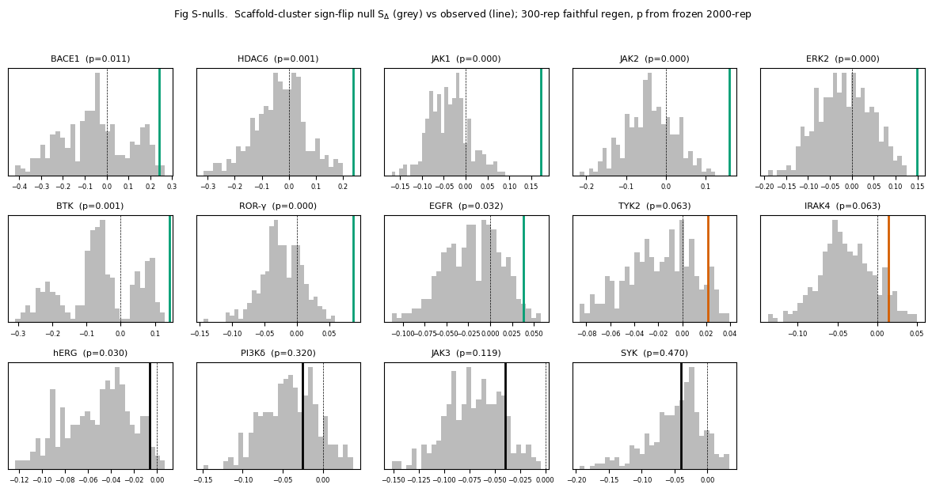

S7. Scaffold-bootstrap confidence intervals
Per-target S_Δ 95% CIs (Fig 3): scaffold clusters resampled with replacement (matched count), member pairs pooled, S_Δ recomputed on the fixed out-of-fold predictions, 2.5/97.5 percentiles over 2,000 resamples.

S8. Interpolation vs extrapolation
Table/Fig S-split (S_interp_vs_extrap.json, SFig_interp_extrap.png): connectivity-grouped interpolation vs scaffold-grouped extrapolation, per-target real S_Δ. Interpolation was marginally easier (median gap +0.017); the positive targets remained positive under the harder scaffold-extrapolation split used for all primary inference.
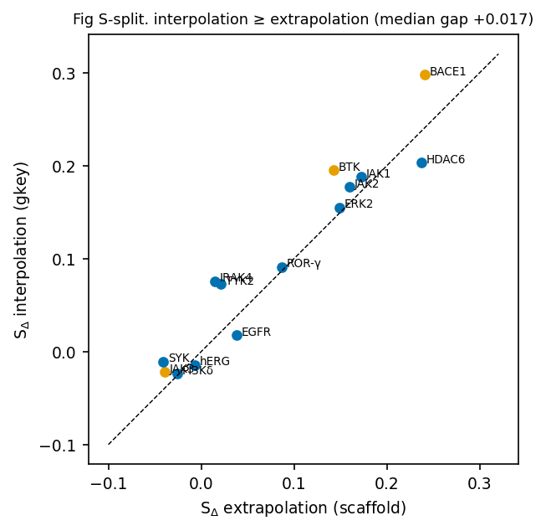

S9. Full fingerprint collision audit
Table S-collision (STable_collision.csv, SFig_collision.png): per-target collision rate at radius 2 and 3. For all 14 targets the collision rate was identical across 1,024/2,048/4,096/8,192 bits, count fingerprints, and unhashed identifiers (config-invariant = True), excluding finite hashing; collisions fell substantially from radius 2 to 3 (e.g., BACE1 17.8→5.1%, BTK 3.5→0%). Manual classification of BACE1's radius-2 collisions: 15/21 radius-limited (resolved at r3), 6/21 genuine encoding (~5%), 0 hashing.
target | coll_r2_pct | coll_r3_pct | config_invariant(bits/count/unhashed identical)
BTK | 3.4 | 0.0 | True
JAK1 | 1.0 | 0.0 | True
ROR-γ | 27.9 | 9.0 | True
JAK2 | 1.0 | 0.0 | True
IRAK4 | 0.0 | 0.0 | True
JAK3 | 1.4 | 0.0 | True
hERG | 0.0 | 0.0 | True
BACE1 | 17.9 | 5.4 | True
ERK2 | 0.0 | 0.0 | True
PI3Kδ | 0.0 | 0.0 | True
TYK2 | 2.1 | 0.0 | True
HDAC6 | 2.4 | 1.2 | True
EGFR | 0.0 | 0.0 | True
SYK | 0.0 | 0.0 | True
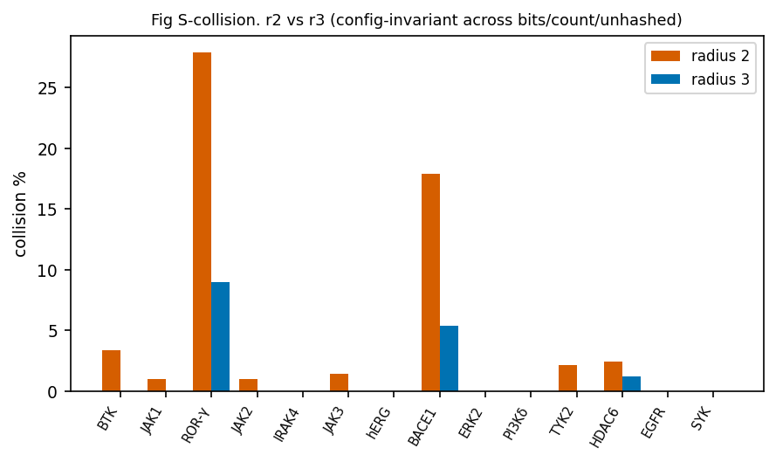

S10. Complete target-level results and ridge-vs-RF
Table S-full (STable_target_full.csv): per target — held-out flag, n, scaffolds, tie fraction, r3 collision, S_Δ (RF and ridge), Spearman, primary and secondary empirical p, q(14-family), q(11-held-out-family), R_t. Paired ridge−RF difference: median +0.005, 95% CI [−0.032,+0.019], Wilcoxon p=0.76 (Fig 4).
target | held_out | n | scaffolds | tie_frac | coll_r3 | S_rf | S_ridge | spearman | p_primary | p_secondary | q14 | q11 | Rt
BACE1 | False | 112 | 59 | 0.009 | 0.054 | 0.241 | 0.298 | 0.53 | 0.011 | 0.001 | 0.022 |  | 4.0
HDAC6 | True | 83 | 53 | 0.048 | 0.012 | 0.237 | 0.216 | 0.32 | 0.0015 | 0.001 | 0.0035 | 0.0033 | 0.67
JAK1 | True | 207 | 119 | 0.126 | 0.0 | 0.172 | 0.14 | 0.43 | 0.0005 | 0.001 | 0.0017 | 0.0014 | 1.33
JAK2 | True | 199 | 117 | 0.161 | 0.0 | 0.16 | 0.178 | 0.4 | 0.0005 | 0.001 | 0.0017 | 0.0014 | 1.07
ERK2 | True | 102 | 64 | 0.02 | 0.0 | 0.149 | 0.215 | 0.38 | 0.0005 | 0.001 | 0.0017 | 0.0014 | 3.18
BTK | False | 266 | 114 | 0.056 | 0.0 | 0.142 | 0.124 | 0.48 | 0.001 | 0.001 | 0.0028 |  | 1.34
ROR-γ | True | 201 | 119 | 0.01 | 0.09 | 0.087 | 0.085 | 0.28 | 0.0005 | 0.001 | 0.0017 | 0.0014 | 1.67
EGFR | True | 82 | 64 | 0.122 | 0.0 | 0.038 | -0.008 | 0.17 | 0.032 | 0.015 | 0.0498 | 0.0503 | 0.82
TYK2 | True | 95 | 51 | 0.295 | 0.0 | 0.021 | 0.037 | 0.22 | 0.063 | 0.1009 | 0.0801 | 0.077 | 1.07
IRAK4 | True | 172 | 82 | 0.076 | 0.0 | 0.015 | 0.026 | 0.22 | 0.063 | 0.0609 | 0.0801 | 0.077 | 1.02
hERG | True | 129 | 95 | 0.054 | 0.0 | -0.007 | -0.116 | 0.09 | 0.0305 | 0.034 | 0.0498 | 0.0503 | 0.47
PI3Kδ | True | 98 | 57 | 0.102 | 0.0 | -0.026 | -0.007 | 0.32 | 0.3198 | 0.2338 | 0.3444 | 0.3518 | 0.71
JAK3 | False | 139 | 78 | 0.345 | 0.0 | -0.039 | -0.013 | 0.09 | 0.1194 | 0.3706 | 0.1393 |  | 0.42
SYK | True | 82 | 52 | 0.098 | 0.0 | -0.041 | -0.108 | 0.13 | 0.4698 | 0.5904 | 0.4698 | 0.4698 | 0.73

S11. Signal-to-variability: frozen vs exploratory (clearly distinguished)
- Frozen (protocol): R_t = median|Δy|/0.45. Association with S_Δ: all-14 ρ=0.62 (p=0.018); held-out ρ=0.42 (p=0.20, not significant). Reported in the main text as a suggestive, unconfirmed trend.
- Exploratory (post hoc, not frozen): a tail-aware statistic (upper-quartile|Δy|/0.45) correlates far more strongly — all-14 ρ=0.81; held-out ρ=0.77. This was chosen after observing the HDAC6 counterexample and is not confirmatory evidence; it is a concrete hypothesis, specifiable in advance, for future confirmatory work (Table S-Rt STable_Rt.csv, SFig_Rt.png).
target | held_out | S_delta | Rt_frozen(median/0.45) | Rt_exploratory(UQ/0.45) | frac|dy|>0.45
BTK | False | 0.142 | 1.34 | 2.27 | 0.6
JAK1 | True | 0.172 | 1.33 | 2.49 | 0.61
ROR-γ | True | 0.087 | 1.67 | 3.18 | 0.7
JAK2 | True | 0.16 | 1.07 | 2.23 | 0.51
IRAK4 | True | 0.015 | 1.02 | 1.86 | 0.5
JAK3 | False | -0.039 | 0.42 | 2.01 | 0.39
hERG | True | -0.007 | 0.47 | 0.89 | 0.19
BACE1 | False | 0.241 | 4.0 | 5.17 | 0.85
ERK2 | True | 0.149 | 3.18 | 4.46 | 0.82
PI3Kδ | True | -0.026 | 0.71 | 1.99 | 0.39
TYK2 | True | 0.021 | 1.07 | 2.22 | 0.51
HDAC6 | True | 0.237 | 0.67 | 2.62 | 0.43
EGFR | True | 0.038 | 0.82 | 1.97 | 0.48
SYK | True | -0.041 | 0.73 | 1.56 | 0.41
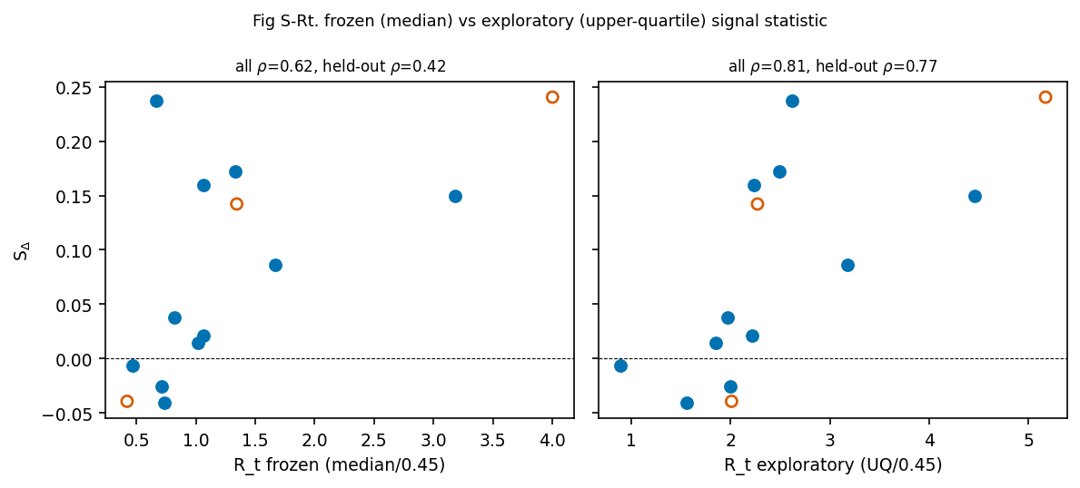

S12. Artifact, seed, software, and command manifest
- Software: Python 3.12, RDKit 2026.03.3 (version-specific archive Zenodo doi:10.5281/zenodo.20446949; concept doi:10.5281/zenodo.591637), InChI software 1.07.3 (RDKit inchi.GetInchiVersion), scikit-learn 1.7.2, NumPy/SciPy, matplotlib; data from ChEMBL 37 (SQLite; dataset doi:10.6019/CHEMBL.database.37).
- Seeds: orientation-symmetrization 7; cohort nulls 202; supplement null regeneration 303; stereo-audit sample 20260711.
- Frozen models: RF (80 trees, min_leaf 3), ridge (α=10); r3/4096 binary chiral Morgan.
- Commands: manifest_enumerate.py → manifest; build_cohort.py → cohort_pairs.csv; cohort_run.py → cohort_results.json + checkpoints; BH recompute → FINAL_RESULTS.json; make_figs.py → Fig 1–5 + Tables 1–2; gen_supp.py → supplement tables/figures; null_regen.py → null_arrays.json → Fig S-nulls.
- Target identifiers: target_metadata_14.csv/.json (tid, ChEMBL target ID, official preferred name, gene symbol, UniProt accession, organism, target type, manuscript display name, development/held-out flag, and counts) and confirmatory_manifest.json (immutable identifiers + eligibility counts). The manifest's exact bytes are covered by the detached checksum confirmatory_manifest.json.sha256 (regenerate/verify with shasum -a 256 -c confirmatory_manifest.json.sha256).
- Hashes: all in FROZEN_ARTIFACTS.json (main) plus the supplement-artifact hashes appended after the consistency audit (§ below).

