Supplementary Material
Localized co-delivery of SERCA2a and Cx43 genes combined with Bone Marrow Mesenchymal Stem Cells restores rat ischemic cardiac mechano-electrical function
Ultrasound imaging
Biotinylated microbubbles (BMBs) were prepared and loaded into self-made 2% agarose phantoms (Fig. S1 left). Imaging was performed and recorded using a Vevo2100® (High-Resolution Micro-Imaging System, Visual Sonics, Canada) at 18 MHz. After in vitro assessment, 100 μl BMBs (1×10⁸/ml) were injected into rat under isoflurane anesthesia through the tail vein, and the enhanced images of left ventricular cavity and myocardium were recorded immediately after injection until the end of the enhancement (Fig. S1 right). PBS was used as negative control during above procedure.
Isolation culture and identification of BMSCs
SD rats at 4 weeks of age were sacrificed by over anesthesia. Then, bilateral tibial and femoral bones were dissected from body trunk and stored on ice in 75% alcohol. Subsequently, femurs and tibias were separated and both ends of each femur or tibia were cut, and a 22-gauge needle attached to a 10cc syringe containing complete medium was then inserted into the spongy bone exposed by removal of the growth plate. The marrow plug is then flushed from the bone with 5 ml of complete medium and collected in a 50 ml conical tube. Cells were then cultured in T‐75 cell culture flask, with a cell concentration of 1×10⁵/mL, using Mouse Mesenchymal Stem Cell Growth Medium (Cyagen, China). BMSCs were then purified and passaged by attachment method. Cells were incubated under standard cell culture conditions with 5% CO₂, at 37°C and 95% relative humidity. The medium was changed every three days, and BMSCs were passaged when 80%‐90% confluency was reached (Fig. S2a). BMSC identity was confirmed on the basis of morphological criteria, plastic adherence, and specific surface antigen expression: CD29(+), CD90(+), CD45(−) (Fig. S2b).
Cell viability assay and in vivo biocompatibility
Cell viability was measured immediately after the gene transfection using a Cell Counting Kit-8 (CCK-8) according to the manufacturer’s protocol (Dojindo, Japan) to determine the possible cell damage caused by ultrasound-targeted microbubble destruction (UTMD). Relative cell viability (RCV) was assessed using CCK-8 assay and then determined in a 96-well plate reader (BioTek Synergy 4) at 450 nm wavelength with the equation RCV (%) = At − Anc/Apc − Anc × 100% (Fig. S3a-b). Furthermore, to evaluate the in vivo biocompatibility of the BMBs, healthy SD rats were intravenously injected with FITC/GFP labeled SERCA2a-adenovirus (Ad) loaded BMBs (named as S-BMBs), BMBs carrying Rhodamine-labeled Cx43-Ad (named as C-BMBs) and BMBs carrying both (S/C-BMBs). On the 15th day post-injection, fresh blood samples (1.0 mL) were obtained by cardiac puncture from the rats for serum biochemistry study. Subsequently, the major organs such as lungs liver, spleen, and kidneys of the rats were carefully collected for H&E staining histology analysis. Healthy rats without any intervention were used as the control (Fig. S3c-g).
Animal models preparation
The experimental protocol was approved by the Animal Ethics Committee of the First Affiliated Hospital of Xinjiang Medical University (approval number of IACUC-20160218-057). All procedures conformed to the Directive 2010/63/EU of the European Parliament. Male or female healthy Sprague-Dawley (SD) rats (8~10 weeks old, weight 200-260 g) were purchased from Beijing Vital River Laboratory Animal Technology Co., Ltd. The experimental animals were well housed under standard conditions of room temperature and dark-light cycles with sufficient water and food. On the first day of the experiment, rats were induced for anesthesia with Dexmedetomidine (0.3 mg/kg body weight, Sigma-Aldrich Inc., USA)/midazolam (4.0 mg/kg bw, Sigma-Aldrich Inc., USA)/butorphanol (5.0 mg/kg bw, Sigma-Aldrich Inc., USA) via intraperitoneal injection once [1]. Then, the rats were intubated with a 16G intravenous catheter (Introcan 16G, Braun Medical Co., Ltd., Germany) and ventilated with a rodent ventilator (HX-100E, Taimeng Software Co., Ltd., Chengdu, China). Left anterior descending artery (LAD) ligation was performed as previously described [2]. The rat’s heart was fully exposed by thoracotomy. Finding the coronary vein as a landmark, then permanently ligated the LAD approximately 2~3 mm distal from its origin with a depth of 0.5 mm by a 5/0 suture. Evidence of an MI was confirmed by pale and hypokinesia in the left ventricular anterior wall and ST-segment elevation on an electrocardiogram (Fig. S4a-b). Penicillin 160,000 u was intraperitoneal injected for 3 days after the surgery. Echocardiography was performed before and four weeks after ligation (Fig. S4c-f). Subsequently, the heart was harvested for Masson’s staining (Fig. S4g-h).
Statistical analysis
All data are summarized as mean ± standard deviation. The data were analyzed using SPSS 21.0. Comparisons among multiple groups were tested by ANOVA, and follow-up comparisons between two groups were performed through least significant difference (LSD) method. P < 0.05 was considered statistically significant. One-way analyses of variance-ANOVA with post-hoc multiple comparison using the LSD test for unpaired parametric comparisons.

References
1. Kirihara Y, M Takechi, K Kurosaki, Y Kobayashi and T Kurosawa. Anesthetic effects of a mixture of medetomidine, midazolam and butorphanol in two strains of mice. Exp Anim 2013; 62:173-80.
2. Hou Y, C Huang, X Cai, J Zhao and W Guo. Improvements in the establishment of a rat myocardial infarction model. J Int Med Res 2011; 39:1284-92.

Figure legends
Fig. S1. Ultrasound imaging by self-assembled BMBs.
Fig. S2. Morphology and surface marker antigens of bone marrow derived mesenchymal stem cells. (a) Appearance of the cultured BMSCs (magnification, ×100). (b) Flow cytometric analysis of CD29, CD45 and CD90.
Fig. S3. Biosafety testing in vitro and in vivo. (a) Illustration of UTMD on BMSCs in vitro. (b) Cell viability in different groups for BMSCs. (c-f) Serum biochemistry analysis from the rats on the 15th day post-injection. Data expressed as mean ± SD, with the number of rats (N=5) shown in the figure. (g) H&E images of major organs from the rats on the 15th day post-injection showed no distinct damages or inflammation in the gene transfection groups and Control group. Scale bar = 50 μm.
Fig. S4. The myocardial infarction model was successfully made. (a-b) Normal electrocardiogram at baseline and ST-segment elevated on an electrocardiogram after LAD ligation. (c-d) The M-mode echocardiography at baseline and MI 28 D, Sale bar = 0.1 s and 1.5 mm. (E) Comparison of the thickness of LVAWd and LVEDd at baseline and MI 28 D, N=10. (f) Comparison of LVEF and LVFS at baseline and MI 28 D. N=10, *P<0.05. (g) The heart paled in the left ventricular anterior wall 28 days after LAD ligation. (h) Representative images of Masson’s staining, Sale bar = 1000 μm. LVAWd: left ventricular end-diastolic anterior wall; LVEDd: left ventricular end-diastolic dimension; LVEF: left ventricular ejection fraction; LVFS: left ventricular shortening fraction.

Fig. S1.
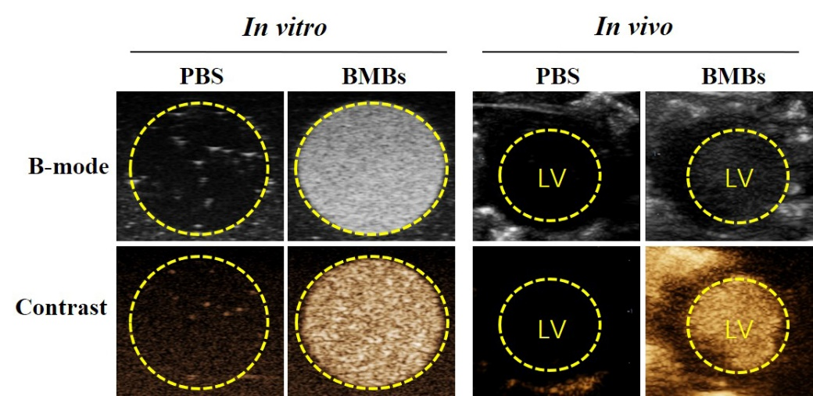

Fig. S2.

Fig. S3.

Fig. S4.

