Supplementary Material

Facile extraction and Characterization of Calcium Hydroxide from Paper Mill Waste Sludge of Bangladesh

Mohammad Robel Molla^{1⸸}, Most. HosneyAra Begum^{1,⸸*}, Syed Farid Uddin Farhad^{1,*} A. S. M. Asadur Rahman², Nazmul Islam Tanvir¹, Muhammad Shahriar Bashar³, Riyadh Hossen Bhuiyan⁴, Md. Sha Alam⁵, Mohammad Sajjad Hossain¹, and Mir Tamzid Rahman⁶

⸸ Contributed equally to this work.

¹BCSIR Laboratories, Dhaka, Bangladesh Council of Scientific and Industrial Research, Dhaka-1205 Bangladesh
²Department of Chemistry, Comilla University, Cumilla-3506
³Institute of Fuel Research and Development, Bangladesh Council of Scientific and Industrial Research, Dhaka-1205 Bangladesh
⁴Fiber and Polymer Research Division, Bangladesh Council of Scientific and Industrial Research, Dhaka-1205 Bangladesh
⁵Institute of Mining, Mineralogy & Metallurgy, Bangladesh Council of Scientific and Industrial Research, Joypurhat-5900, Bangladesh
⁶Department of Chemistry, Jahangirnagar University, Savar, Dhaka-1342, Bangladesh

*Correspondence address:
Dr. Hosne Ara Begum, CSO
& Dr. Syed Farid Uddin Farhad, PSO
Industrial Physics Division,
BCSIR Laboratories, Dhaka, BCSIR, Dhaka-1205
Email: hosneyara@gmail.com ; s.f.u.farhad@bcsir.gov.bd
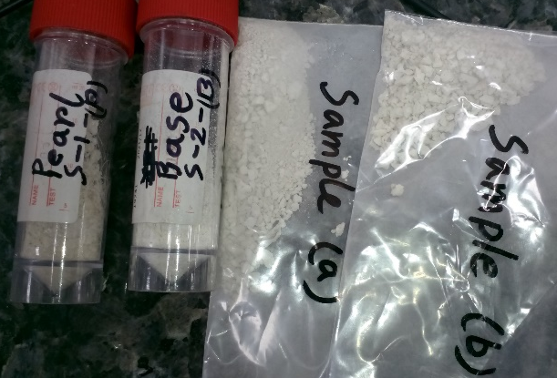
Figure S1: Photographs of two representative raw samples (in polybags) and products (in plastic vials) of PMS collected from two different sources.

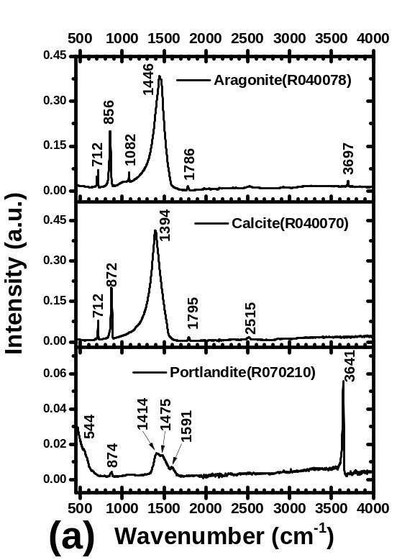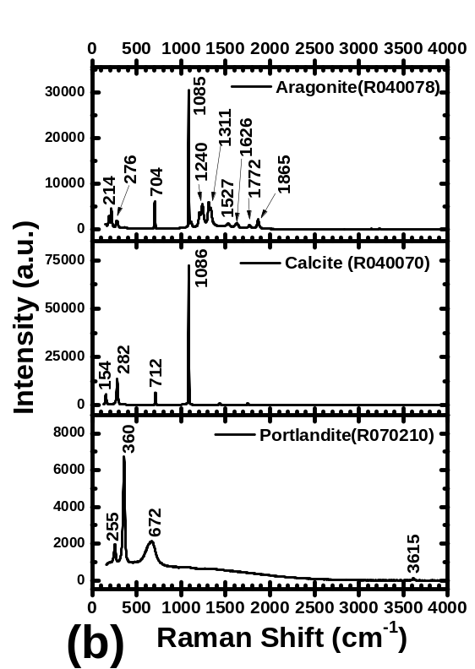
Figure S2: Reference FTIR (a) and Raman (b) spectra of portlandite, calcite, and aragonite from RRUFF database. The corresponding data ID is included in the parenthesis of the curve legends.
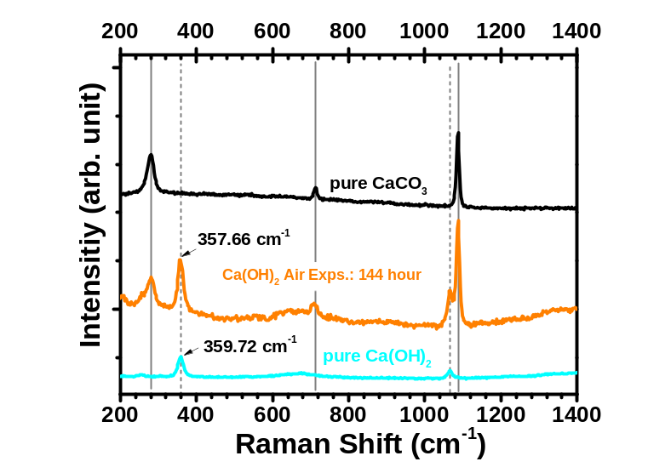
Figure S3: Room temperature Raman spectra of pure Ca(OH)₂ and the same Ca(OH)₂ sample after exposure to the air in 144 h to monitor the CaCO₃ formation. The room temperature Raman spectra of pure CaCO₃ is also included in the graph for comparison. Major Raman peak of Ca(OH)₂ is slightly red-shifted from 359.72 cm⁻¹ to 357.66 cm⁻¹ presumably due to the strain generation in the sample understudy owing to the formation of CaCO₃ in the air-exposed Ca(OH)₂ sample.

Table S1: Acid and base treatment of dried raw sludge at approximately constant pH value

Acid and Base treatment of dry sludge
Batch Number | Weight of taken sample (g) | Volume of water added in sample | 1M HCl (mL) | pH (in HCl) | 3M NaOH (mL) | pH (in NaOH) | Weight of Product, Ca(OH)₂ (g) | Weight of Pulp Residue  (g) | Loss of Product  (g)
S-a A | 2.01 | 130 mL | 40 mL | 1.95 | 105 mL | 13.494 | 1.20 | 0.37 | 0.43
S-a B | 4.01 | 250 mL | 70 mL | 1.72 | 210 mL | 13.483 | 2.20 | 0.75 | 1.05
S-a C | 6.03 | 300 mL | 80 mL | 2.32 | 210 mL | 13.482 | 3.28 | 1.49 | 1.23
S-a D | 8.01 | 350 mL | 150 mL | 2.34 | 280 mL | 13.432 | 4.57 | 1.76 | 1.67
S-a E | 10.01 | 450 mL | 180 mL | 2.25 | 330 mL | 13.493 | 6.50 | 1.91 | 1.59
S-b A | 2.00 | 130 mL | 35 mL | 2.00 | 90 mL | 13.429 | 1.13 | 0.25 | 0.62
S-b B | 4.01 | 200 mL | 75 mL | 2.17 | 170 mL | 13.484 | 2.65 | 0.45 | 0.90
S-b C | 6.01 | 350 mL | 130 mL | 2.12 | 380 mL | 13.472 | 4.28 | 1.57 | 0.15
S-b D | 8.01 | 450 mL | 280 mL | 2.15 | 400 mL | 13.489 | 6.14 | 1.68 | 0.18
S-b E | 10.01 | 600 mL | 260 mL | 2.13 | 410 mL | 13.487 | 7.75 | 1.73 | 1.26

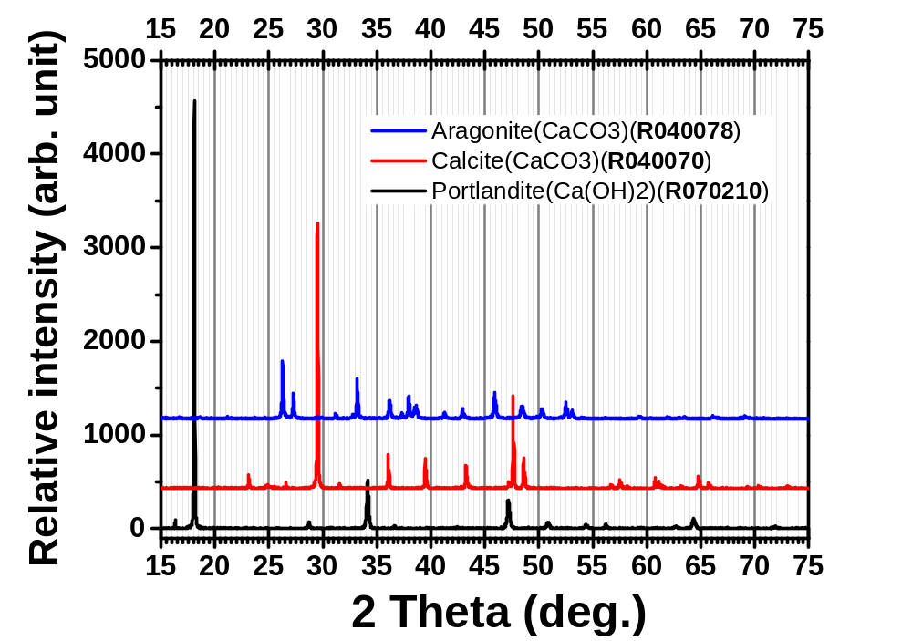
Figure S4: Reference X-ray diffractograms of portlandite, calcite, and aragonite from the RRUFF database of same data presented in Figure S2. The corresponding data ID is included in the parenthesis of the curve legends.
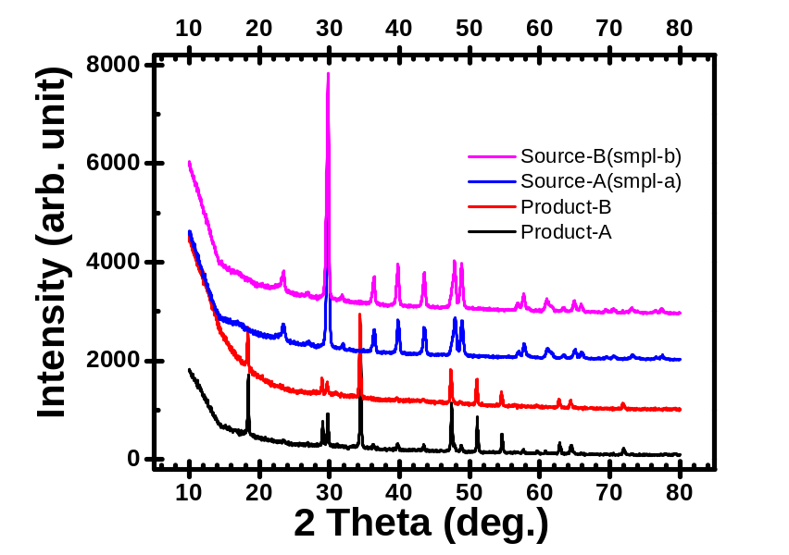
Figure S5: X-ray diffractograms (wide 2θ scanning range) of two representative source and synthesized samples.

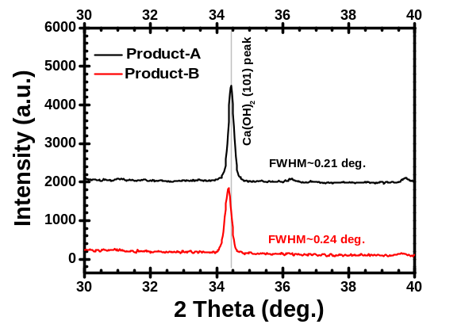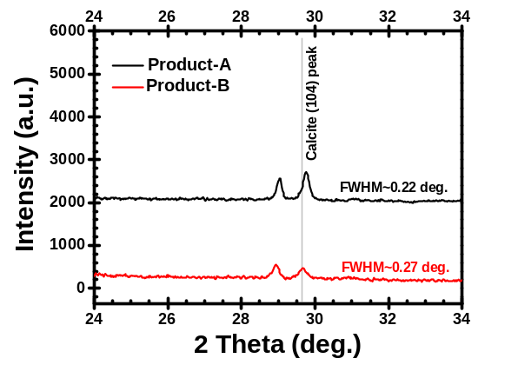
Figure S6: Predominant Bragg peak (101) of Ca(OH)₂ and (104) of CaCO₃ from XRD data were utilized to extract different diffraction parameter of the product-A and product-B.

Table S2: Extracted diffraction parameters from XRD data of product-A and product-B
Sample | X_{c} ± 0.005 | FWHM (deg.) | Area  (a.u.) | Prdc. ratio | Crystallite Size (nm) | Micro- strain | Comments
Product-A | 34.43 | 0.207±0.002 | X1: 520.48 | X1/X2:  3.67 | 41.96 | 2.92E-03
Product-B | 34.35 | 0.238±0.002 | Y1: 417.47 | X1/X2:  3.67 | 36.49 | 3.36E-03 | 6.77/3.67 = 1.84
Product-A | 29.76 | 0.219±0.005 | X2: 141.86 | Y1/Y2:  6.77 | 39.20 | 3.60E-3
Product-B | 29.67 | 0.267±0.010 | Y2: 61.68 | Y1/Y2:  6.77 | 32.15 | 4.40E-3

