Molecular Docking
Three-dimensional structures of NOX4 (UniProt: Q9NPH5), CYP11A1 (UniProt: P05108), and 3β-HSD (UniProt: P26439) were retrieved from the AlphaFold Protein Structure Database (AlphaFold v2). Structural quality was assessed using Ramachandran plot analysis and MolProbity validation metrics prior to docking studies.

Supplementary Table S6.1. Structural Validation of Protein Models Used for Docking
Protein | UniProt ID | Source | Ramachandran Favored (%) | GMQE | MolProbity | ERRAT | Verify3D
NOX4 | Q9NPH5 | AlphaFold v2 | 94.10 | 0.87 | 1.22 | 93.5 | 91.8
CYP11A1 | P05108 | AlphaFold v2 | 94.22 | 0.92 | 1.24 | 95.1 | 92.6
3β-HSD | P26439 | AlphaFold v2 | 97.03 | 0.95 | 0.84 | 97.8 | 95.4

Supplementary Table S6.2. 2D interaction diagrams of tangeretin toward target pathways
 | A
Keap1/Klech | 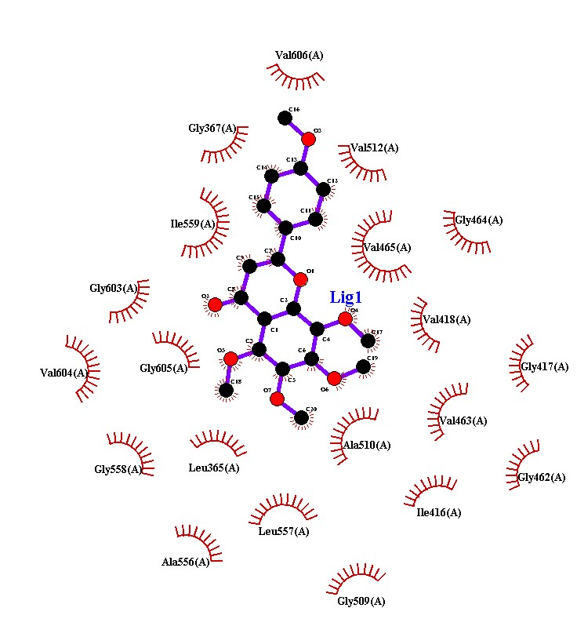
NOX4 | 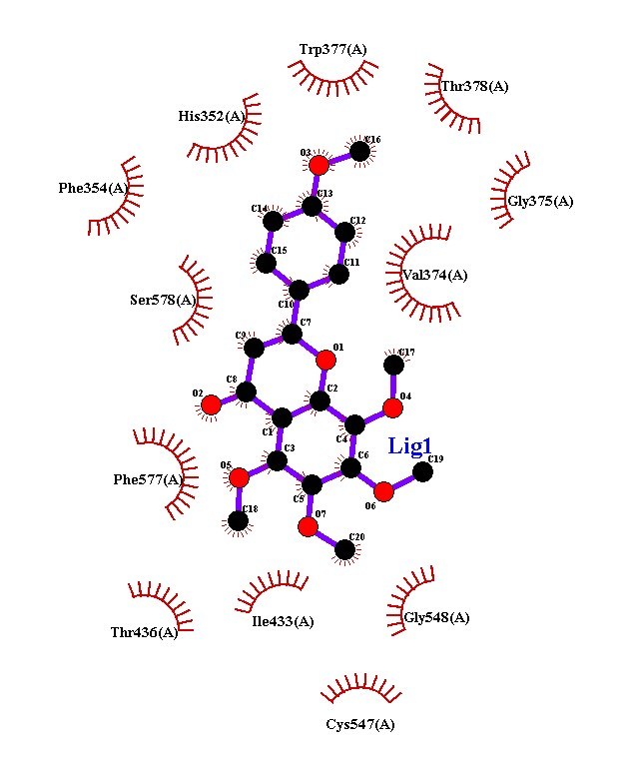
CYP11A1 | 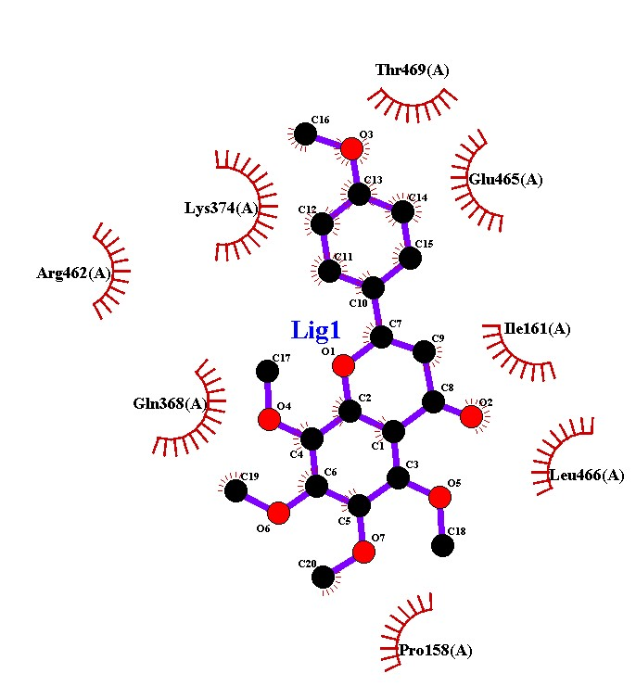
StAR | 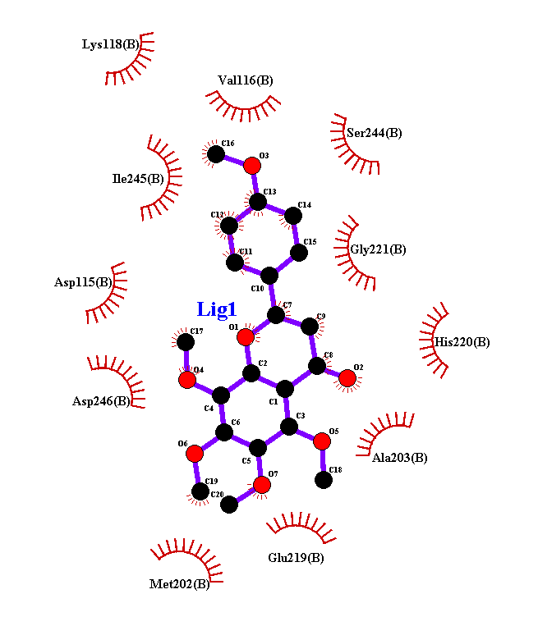
3β-HSD | 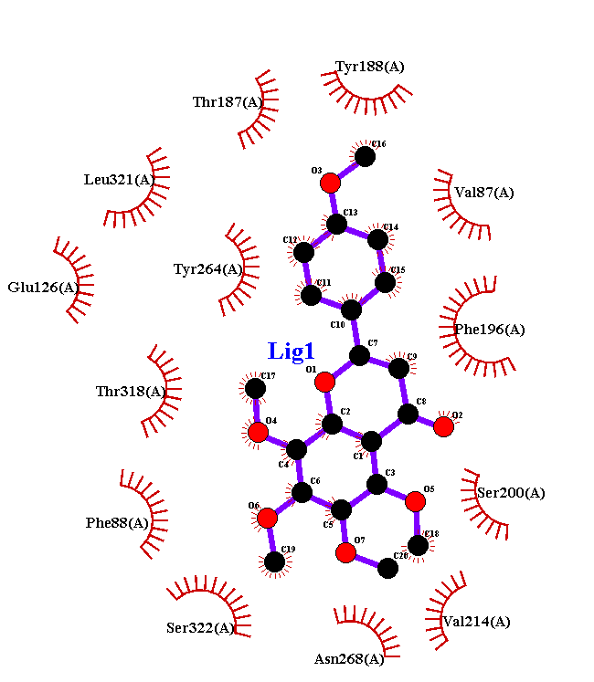

Molecular Docking Analysis
According to molecular docking study (Table 12, Figure 10), tangeretin exhibits good binding with important regulators of oxidative stress and steroidogenesis, showing the highest binding affinity ranging between −6.1 and −8.3 kcal/mol. Particularly, strong ligand-protein interactions were detected with the Keap1-Kelch domain (−7.1 kcal/mol), with hydrogen bonds and salt bridges involving residues such as ARG336, ARG380, and TYR572. The most favorable interaction was noted for the NOX4 protein (−7.5 kcal/mol) due to hydrogen bonds (ASN351, SER305, ARG301, TYR408) and electrostatic interactions. Besides that, tangeretin was found to bind moderately with StAR (−6.2 kcal/mol), with several hydrogen bonds being formed at key residues such as ASP246, LYS118, GLU219, and ASN150. The residue contact map revealed that a ligand-protein hotspot (ASP246, VAL179, ILE245, and GLY221) is present in this protein with significant interaction frequencies. Moreover, tangeretin forms multiple hydrogen bonds with essential amino acids of 3β-HSD protein, including Ser200, Thr318, and Asp35, with a distance of 3.05–3.47 Å and binding energy of -8.3 Kcal/mol. Additionally, interaction frequency analysis showed contacts with Thr318 (51), Phe196 (44), Tyr264 (39), and Val214 (39). 2-D Plots for Protein-ligand interaction are provided in supplementary file 6. Molecular docking was employed as experimental and hypothesis-generation technique to aid in the interpretation of biological responses rather than defining the interactions between ligands and their respective target molecules.

