Soil volatile organic compound fingerprint breadth tracks toxic-metal contamination at urban illegal dumping sites: a screening tool for prioritization in Jackson, Mississippi
Cristina Nica¹, Sai Venkat Mandalapu¹, Kelsey Mathews¹, Craig Klevan², Erica D. Walker^{1,*}
Corresponding author: Erica D. Walker (erica_walker@brown.edu), Community Noise Lab, Department of Epidemiology, Brown University School of Public Health, Providence, RI 02903, USA

Supplementary Material
Supplementary Tables
Table S1 Full site inventory: ward, address, site perimeter, degree of contamination (Cdeg) and class, and visible waste categories, for the 44 sites. Site 38 yielded soil VOC data only and has no associated site metadata.
Site | Ward | Address | Perimeter (m) | Cdeg | Cdeg class | Visible waste categories
1 | 5 | 160 Minerva Street | 88.0 | 60.53 | High | Tires; Furniture; Domestic; Construction
2 | 7 | 198 Hartfield Street | 102.2 | 23.46 | Considerable | Tires; Furniture; Domestic; Construction; Chemicals; E-waste; Yard
3 | 2 | 816 Claiborne Avenue | 127.7 | 89.96 | High | Tires; Furniture; Domestic; Construction
4 | 5 | 1539 W Capitol St | 108.0 | 40.10 | High | Tires; Domestic; Construction; Chemicals; Yard
5 | 4 | Byrd Drive | 250.0 | 15.96 | Moderate | Tires; Furniture; Domestic; Construction; Chemicals; E-waste
6 | 5 | West Capitol Street | 168.0 | 51.96 | High | Tires; Domestic; Construction
7 | 6 | 1044 Glen Erin Street | 250.0 | 8.04 | Moderate | Tires; Furniture; Construction
8 | 6 | 3211 Meadow Lane | 100.0 | 19.32 | Considerable | Tires; Domestic; Construction
9 | 5 | 3645 US-80 | 265.0 | 11.96 | Moderate | Tires; Furniture; Domestic; Construction; Chemicals; E-waste; Yard
10 | 6 | Teresa Dr | 191.3 | 15.57 | Moderate | Tires; Domestic; Construction; Chemicals
11 | 6 | Revere St | 130.2 | 29.62 | Considerable | Tires; Furniture; Domestic; Construction; Chemicals
12 | 6 | 937 Cooper Rd | 288.5 | 29.07 | Considerable | Tires; Furniture; Domestic; Construction; Chemicals; E-waste
13 | 6 | 3545 Forest Hill Rd | 424.3 | 12.27 | Moderate | Tires; Domestic; Construction; Chemicals
14 | 6 | 1219 Mccluer Rd | 88.1 | 11.82 | Moderate | Tires; Furniture; Domestic; Construction; Chemicals; E-waste
15 | 5 | 4704 Robinson Rd | 100.0 | 8.37 | Moderate | Tires; Furniture; Domestic; Construction
16 | 5 | Barnett Dr | 343.0 | 11.22 | Moderate | Tires; Furniture; Domestic; Construction; Chemicals; E-waste; Yard
17 | 5 | 349 N Prentiss St | 110.8 | 32.27 | High | Tires; Furniture; Domestic; Chemicals
18 | 5 | Long St | 260.2 | 18.34 | Considerable | Tires; Furniture; Domestic; Chemicals
19 | 5 | 118 Bon Air St | 146.9 | 34.48 | High | Tires; Furniture; Domestic; Chemicals; E-waste
20 | 3 | Collier Ave | 50.0 | 33.83 | High | Tires; Domestic
23 | 7 | John R Lynch St | 60.4 | 49.73 | High | Tires; Furniture; Domestic; E-waste
24 | 7 | Clifton St | 112.0 | 163.44 | High | Tires; Furniture; Domestic; Construction
25 | 7 | Hooker St | 286.0 | 97.23 | High | Tires; Furniture; Domestic; Construction
26 | 2 | West County Line Rd | 365.0 | 10.85 | Moderate | Domestic; Construction; E-waste
27 | 2 | Brown Street | 384.0 | 10.30 | Moderate | Tires; Furniture; Domestic; Chemicals
29 | 2 | Highway 49 | 178.6 | 27.89 | Considerable | Tires; Furniture; Domestic; Construction
32 | 5 | Winter St | 175.0 | 28.54 | Considerable | Furniture; Domestic; Construction; Chemicals
33 | 5 | Cleary St | 70.0 | 36.86 | High | Tires; Furniture; Construction; E-waste
34 | 3 | Medgar Evers Blvd | 117.4 | 13.00 | Moderate | Tires; Furniture; Domestic; Construction; Chemicals; E-waste
35 | 3 | 2643 Medgar Evers Blvd | 267.0 | 25.99 | Considerable | Tires; Construction; Chemicals; E-waste
36 | 3 | Johnson St | 17.3 | 13.76 | Moderate | Tires; Domestic
38 | n/a | n/a | n/a | n/a | Not determined | n/a
39 | 7 | 1147 W McDowell Rd | 48.4 | 28.16 | Considerable | Tires; Furniture; Domestic; Construction; Chemicals; Yard
42 | 5 | 1233 Florence Ave | 35.0 | 15.56 | Moderate | Tires; Domestic; Construction; Chemicals
49 | 4 | 3846 Sunray Dr | 139.0 | 48.99 | High | Domestic; Construction
50 | 3 | Percy V Simpson Dr | 372.0 | 26.84 | Considerable | Tires; Furniture; Domestic
51 | 7 | 422 Kingswood Ave | 170.0 | 32.61 | High | Tires; Furniture; Domestic; Yard
52 | 7 | 2844 La Salle St | 431.0 | 24.74 | Considerable | Furniture; Construction; Chemicals; E-waste
53 | 5 | Rose St | 86.0 | 20.82 | Considerable | Domestic
55 | 2 | 3775 W County Line Road | 74.0 | 25.19 | Considerable | Domestic; Construction
56 | 2 | 6255 Brown St | 66.7 | 27.04 | Considerable | Tires; Furniture; Domestic; Construction
57 | 3 | 4825 N State St | 38.7 | 11.35 | Moderate | Furniture; Domestic; Construction
61 | 5 | 1420 Shirley Ave | 50.5 | 44.12 | High | Tires; Furniture; Domestic; Chemicals; E-waste
62 | 2 | 1198 Hilda Dr | 1257.0 | 22.76 | Considerable | Tires; Domestic; Construction

Table S2 Calibrated compounds and calibration performance. Retention times are the mean across calibration standards. The detection window applied in the fingerprinting was ±3 s (strong-match ±1.5 s), independent of the calibration windows below, and estimated soil concentrations incorporate a sample-to-soil factor of 102. BTEX response models are provisional.
Compound | Target group | Mean retention time (s) | Model | R² | Calibration min | Calibration max | Standards (n)
Naphthalene | Naphthalene | 298.81 | Quadratic | 0.9999 | 2 | 2000 | 4
Benzene | BTEX | 104.17 | Linear | 0.9769 | 2 | 2000 | 4
Toluene | BTEX | 213.11 | Linear (provisional) | 0.9950 | 20 | 2000 | 3
Ethylbenzene | BTEX | 407.22 | Linear (provisional) | 0.9928 | 20 | 2000 | 3
m,p-Xylene | BTEX | 419.20 | Linear (provisional) | 0.9937 | 40 | 4000 | 3
o-Xylene | BTEX | 444.69 | Linear (provisional) | 0.9956 | 20 | 2000 | 3
Alpha-pinene | Alpha-pinene | 250.00 | Linear | 0.9983 | 25 | 100 | 4
Acetophenone | Acetophenone | 231.89 | Quadratic | 1.0000 | 5 | 5000 | 3
2-(Perfluorobutyl)ethanol | Fluorotelomer | 120.11 | Linear | 0.9903 | 25 | 100 | 3
Beta-pinene | Beta-pinene | 260.37 | Linear | 0.9858 | 25 | 100 | 4
1,1-Dichloroethene | 1,1-Dichloroethene | 48.42 | Linear | 0.9460 | 2 | 2000 | 4

Table S3 Retention-time reproducibility of the calibration standards. The retention-time range across standards stays within ±1.5 s (half-range below 1.5 s) for every compound except acetophenone (range 3.75 s), which is why acetophenone alone required the wider ±3 s candidate window. "Within 1 s" and "within 2 s" give the percentage of standards whose retention time fell within those half-widths of the mean.
Compound | Standards (n) | Mean retention time (s) | SD (s) | Range (s) | Within 1 s (%) | Within 2 s (%)
Benzene | 4 | 104.17 | 0.13 | 0.33 | 100 | 100
1,1-Dichloroethene | 4 | 48.42 | 0.88 | 1.91 | 75 | 100
Toluene | 3 | 213.11 | 0.56 | 1.00 | 100 | 100
Alpha-pinene | 4 | 250.00 | 0.28 | 0.59 | 100 | 100
Beta-pinene | 4 | 260.37 | 0.22 | 0.50 | 100 | 100
2-(Perfluorobutyl)ethanol | 3 | 120.11 | 1.06 | 1.91 | 67 | 100
o-Xylene | 3 | 444.69 | 0.99 | 1.75 | 67 | 100
Ethylbenzene | 3 | 407.22 | 1.11 | 2.00 | 67 | 100
m,p-Xylene | 3 | 419.20 | 1.14 | 2.08 | 67 | 100
Naphthalene | 4 | 298.81 | 1.03 | 2.33 | 50 | 100
Acetophenone | 3 | 231.89 | 1.93 | 3.75 | 33 | 67

Table S4 Retention-time window sensitivity: number of the 44 sites with a candidate detection for each compound at candidate windows of ±2, 3, 5, and 10 s. The ±3 s window (used throughout) is the second data column; wider windows inflate detections through co-elution, most sharply for benzene.
Compound | ±2 s | ±3 s | ±5 s | ±10 s
Benzene | 14 | 17 | 44 | 44
Naphthalene | 35 | 38 | 41 | 43
Toluene | 35 | 38 | 40 | 43
1,1-Dichloroethene | 17 | 26 | 32 | 42
Acetophenone | 27 | 34 | 37 | 40
2-(Perfluorobutyl)ethanol | 8 | 10 | 21 | 39
Alpha-pinene | 26 | 31 | 36 | 39
o-Xylene | 5 | 8 | 20 | 37
m,p-Xylene | 12 | 21 | 27 | 28
Beta-pinene | 7 | 13 | 22 | 24
Ethylbenzene | 12 | 13 | 23 | 24

Table S5 Per-site fingerprint profiles and prioritization tier for all 44 sites, ordered by breadth. Breadth is the number of discriminating bands (the ranking axis), strength the number of strong-match bands, and recurrence the mean number of runs per band. Tiers are the terciles of breadth (14 high, 14 moderate, 16 low). Strength and candidate richness are given as secondary descriptors; both are lower-precision across a site's two depths (Table S9), which is why the ranking uses breadth, itself reproducible across a site's two depths (rho 0.83, Table S9). Site 38 is the VOC-only site.
Site | Breadth (bands) | Strong-match bands | Candidate richness | Total clusters | Unresolved bands | Recurrence | Tier
23 | 46 | 8 | 7 | 174 | 151 | 3.02 | High
24 | 38 | 7 | 6 | 163 | 147 | 3.29 | High
17 | 38 | 6 | 7 | 153 | 136 | 3.53 | High
19 | 36 | 4 | 5 | 137 | 126 | 3.53 | High
1 | 35 | 11 | 8 | 170 | 148 | 3.69 | High
25 | 34 | 5 | 5 | 157 | 140 | 3.18 | High
32 | 34 | 5 | 4 | 163 | 149 | 3.12 | High
35 | 33 | 5 | 7 | 162 | 142 | 3.76 | High
20 | 32 | 5 | 4 | 156 | 146 | 3.50 | High
18 | 30 | 2 | 6 | 153 | 141 | 3.77 | High
34 | 26 | 3 | 5 | 139 | 124 | 3.50 | High
27 | 25 | 5 | 4 | 158 | 144 | 3.60 | High
29 | 24 | 5 | 6 | 108 | 94 | 2.54 | High
53 | 18 | 2 | 4 | 116 | 110 | 2.83 | High
10 | 17 | 8 | 8 | 179 | 164 | 2.65 | Moderate
14 | 17 | 3 | 5 | 150 | 140 | 3.06 | Moderate
33 | 14 | 6 | 6 | 111 | 102 | 2.43 | Moderate
16 | 14 | 4 | 6 | 114 | 104 | 2.36 | Moderate
39 | 12 | 9 | 8 | 176 | 151 | 2.67 | Moderate
8 | 12 | 4 | 6 | 108 | 99 | 2.33 | Moderate
6 | 11 | 6 | 5 | 94 | 85 | 2.45 | Moderate
3 | 11 | 2 | 4 | 105 | 100 | 2.45 | Moderate
11 | 11 | 2 | 4 | 74 | 68 | 2.18 | Moderate
49 | 10 | 5 | 5 | 111 | 104 | 2.60 | Moderate
55 | 10 | 5 | 6 | 116 | 108 | 2.10 | Moderate
12 | 10 | 4 | 3 | 91 | 87 | 2.30 | Moderate
4 | 9 | 5 | 5 | 93 | 82 | 2.33 | Moderate
38 | 9 | 4 | 6 | 108 | 96 | 2.44 | Moderate
7 | 8 | 21 | 9 | 163 | 135 | 2.62 | Low
42 | 8 | 14 | 8 | 207 | 187 | 2.12 | Low
9 | 8 | 1 | 4 | 88 | 83 | 2.75 | Low
52 | 7 | 6 | 4 | 80 | 71 | 2.43 | Low
61 | 7 | 4 | 5 | 104 | 97 | 2.29 | Low
51 | 7 | 3 | 7 | 90 | 80 | 2.14 | Low
56 | 6 | 8 | 5 | 99 | 88 | 2.33 | Low
36 | 5 | 11 | 9 | 145 | 127 | 2.20 | Low
26 | 5 | 7 | 6 | 132 | 122 | 2.00 | Low
15 | 5 | 4 | 5 | 88 | 79 | 3.80 | Low
2 | 5 | 2 | 5 | 84 | 77 | 2.80 | Low
50 | 4 | 4 | 5 | 82 | 74 | 2.25 | Low
13 | 3 | 3 | 4 | 91 | 83 | 2.67 | Low
57 | 2 | 6 | 8 | 102 | 85 | 2.00 | Low
5 | 2 | 5 | 4 | 102 | 96 | 3.50 | Low
62 | 2 | 4 | 6 | 79 | 70 | 3.00 | Low

Table S6 Per-site within-range concentrations for the 21 sites with within-range detections (quality-control only). Back-calculated soil concentrations are physically implausible for the most responsive compounds (for example, acetophenone up to about 117,979 mg/kg, close to 12% of sample mass), which is why detection frequency, not concentration, is reported in the main text.
Site | Within-range records | Compound(s) | Min (mg/kg) | Max (mg/kg)
1 | 1 | Naphthalene | 5038.8 | 5038.8
6 | 4 | Acetophenone | 27387.0 | 117979.3
7 | 1 | Acetophenone | 1927.9 | 1927.9
8 | 1 | Naphthalene | 6591.2 | 6591.2
11 | 2 | Naphthalene | 16561.7 | 17042.2
12 | 2 | Acetophenone | 1393.3 | 8139.6
14 | 1 | Acetophenone | 6603.5 | 6603.5
15 | 2 | Acetophenone | 1400.5 | 11766.7
20 | 1 | Alpha-pinene | 5931.3 | 5931.3
25 | 2 | Naphthalene | 4778.7 | 10431.5
26 | 1 | Naphthalene | 6806.8 | 6806.8
29 | 2 | Naphthalene | 4752.2 | 52171.0
33 | 1 | Acetophenone | 1327.0 | 1327.0
34 | 1 | Acetophenone | 2014.5 | 2014.5
36 | 2 | Naphthalene | 5759.2 | 57341.1
42 | 1 | Alpha-pinene | 7311.5 | 7311.5
49 | 2 | Acetophenone; Alpha-pinene | 3560.8 | 18887.3
52 | 3 | Naphthalene | 15420.4 | 22058.5
55 | 1 | Naphthalene | 26699.5 | 26699.5
56 | 2 | Naphthalene | 28212.2 | 31769.9
62 | 1 | Alpha-pinene | 4277.9 | 4277.9

Table S7 Comparisons by visible waste category and by sampling depth. (a) For each waste category, the median strength and breadth of sites with and without the category, and the Kruskal-Wallis p-value; no category differed significantly (p 0.15 to 0.97). (b) Number of sites at which each compound was detected at the shallow depth, the deep depth, and both depths.
(a) Waste-category comparison
Waste category | Sites with category (n) | Median strength (with) | Median strength (without) | Median breadth (with) | Median breadth (without) | p (strength) | p (breadth)
Tires | 36 | 5.0 | 5.0 | 11.5 | 9.5 | 0.712 | 0.337
Furniture | 29 | 5.0 | 5.0 | 12.0 | 10.0 | 0.415 | 0.270
Domestic waste | 39 | 5.0 | 6.0 | 11.0 | 9.0 | 0.190 | 0.897
Construction debris | 32 | 5.0 | 4.0 | 10.5 | 21.5 | 0.379 | 0.220
Electronic waste | 14 | 4.0 | 5.0 | 12.0 | 11.0 | 0.236 | 0.970
Yard waste | 6 | 3.5 | 5.0 | 8.5 | 11.0 | 0.146 | 0.304

Chemical containers were recorded in the site inventory (Table S1) but were not among the categories compared here.
(b) Depth comparison
Compound | Shallow only | Deep only | Both depths | Shallow (total) | Deep (total)
Toluene | 3 | 9 | 26 | 29 | 35
Naphthalene | 14 | 6 | 18 | 32 | 24
Acetophenone | 9 | 9 | 16 | 25 | 25
Alpha-pinene | 7 | 11 | 13 | 20 | 24
1,1-Dichloroethene | 10 | 9 | 7 | 17 | 16
m,p-Xylene | 8 | 8 | 5 | 13 | 13
Benzene | 7 | 2 | 8 | 15 | 10
Ethylbenzene | 7 | 3 | 3 | 10 | 6
Beta-pinene | 6 | 5 | 2 | 8 | 7
2-(Perfluorobutyl)ethanol | 4 | 1 | 5 | 9 | 6
o-Xylene | 4 | 3 | 1 | 5 | 4

Table S8 Realized retention-time spread within discriminating bands. Bands are formed with a 3 s clustering window, so the within-band spread is bounded by construction; this table reports how far inside that window the spread fell, measured across every site holding each band. The realized spreads were well inside the 3 s window and comparable to the retention-time reproducibility of the clean calibration standards (median standard SD about 1 s, Table S3), so the binning did not stretch bands to their limit. This is a check on the binning rather than an independent validation of band identity.
Measure | Value
Discriminating bands assessed | 92
Bands in the contamination matrix (pinene and fluorotelomer excluded) | 59
Within-band member-peak RT SD across sites, median | 0.76 s
Within-band member-peak RT SD, interquartile range | 0.66 to 0.85 s
Within-band member-peak RT SD, maximum | 1.11 s
Bands with RT SD at or below 1.0 s | 91 of 92 (99%)
Bands with RT SD at or below 1.5 s | 92 of 92 (100%)

Table S9 Metric reliability. (a) Depth concordance: Spearman correlation of each site-level fingerprint metric between the site's shallow (2.5 cm) and deep (15 cm) samples (n = 44 sites with both depths). Breadth, the ranking axis, and total-cluster complexity are highly reproducible; the sparse counts (strong-match bands, candidate richness) are not. (b) Convergent validity: Spearman intercorrelations among the site-level metrics, showing they track a common signal.
(a) Depth concordance (shallow versus deep)
Metric | Spearman rho | p
Total clusters | 0.89 | <0.001
Breadth (discriminating bands) | 0.83 | <0.001
Candidate richness | 0.19 | 0.205
Strong-match bands | 0.11 | 0.496

(b) Convergent validity (site-level metric intercorrelations)
 | Strong-match bands | Candidate richness | Total clusters
Strong-match bands | 1.00 | 0.58 | 0.54
Candidate richness | 0.58 | 1.00 | 0.48
Total clusters | 0.54 | 0.48 | 1.00

Table S10 Multiple-comparison correction for the soil VOC versus trace-metal associations in Table 3 (five VOC metrics against Cdeg and seven metals). Four cells reached raw significance, all in the breadth row; one, breadth versus arsenic, survived Benjamini-Hochberg correction (40 tests; smallest adjusted q 0.009).
Measure | Value
Tests (5 VOC metrics x 8 inorganic measures) | 40
Tests with raw p < 0.05 | 4 (all breadth: As, Cdeg, Zn, Pb)
Smallest raw p | <0.001 (breadth vs As)
Smallest Benjamini-Hochberg adjusted q | 0.009 (breadth vs As)
Associations significant after Benjamini-Hochberg | 1 (breadth vs As)

Supplementary figures
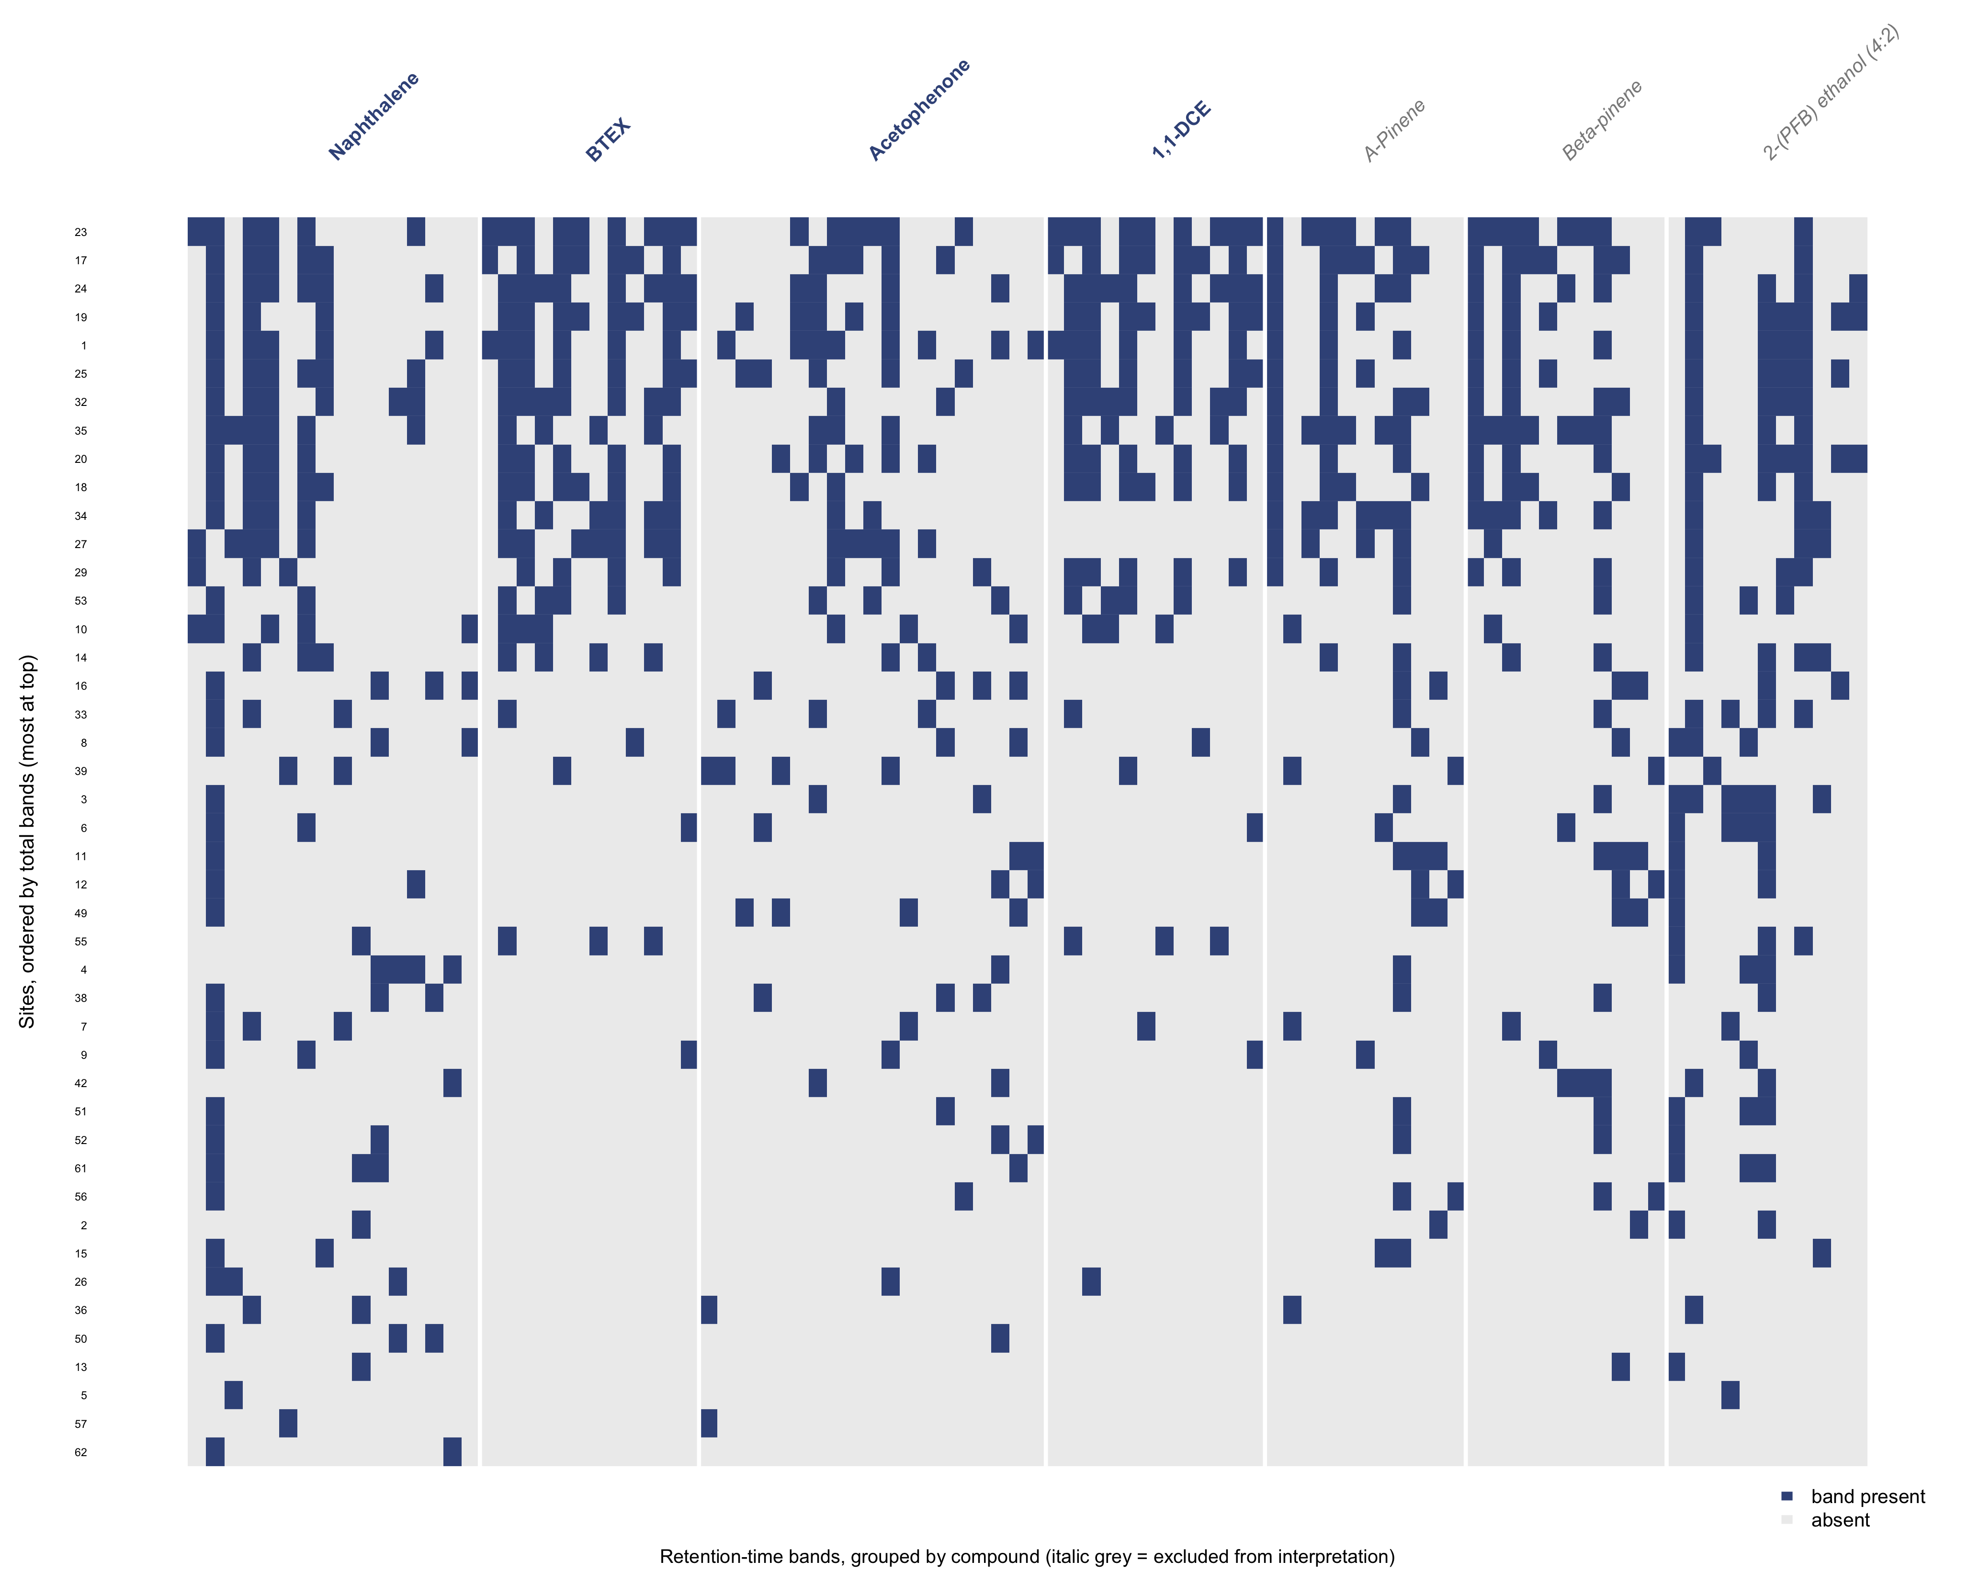Fig. S1 Full site-by-band presence matrix for the 44 sites, grouped by compound. The pinene and fluorotelomer groups are shown in grey and italic to indicate that they were excluded from the contamination interpretation and from the multivariate analysis
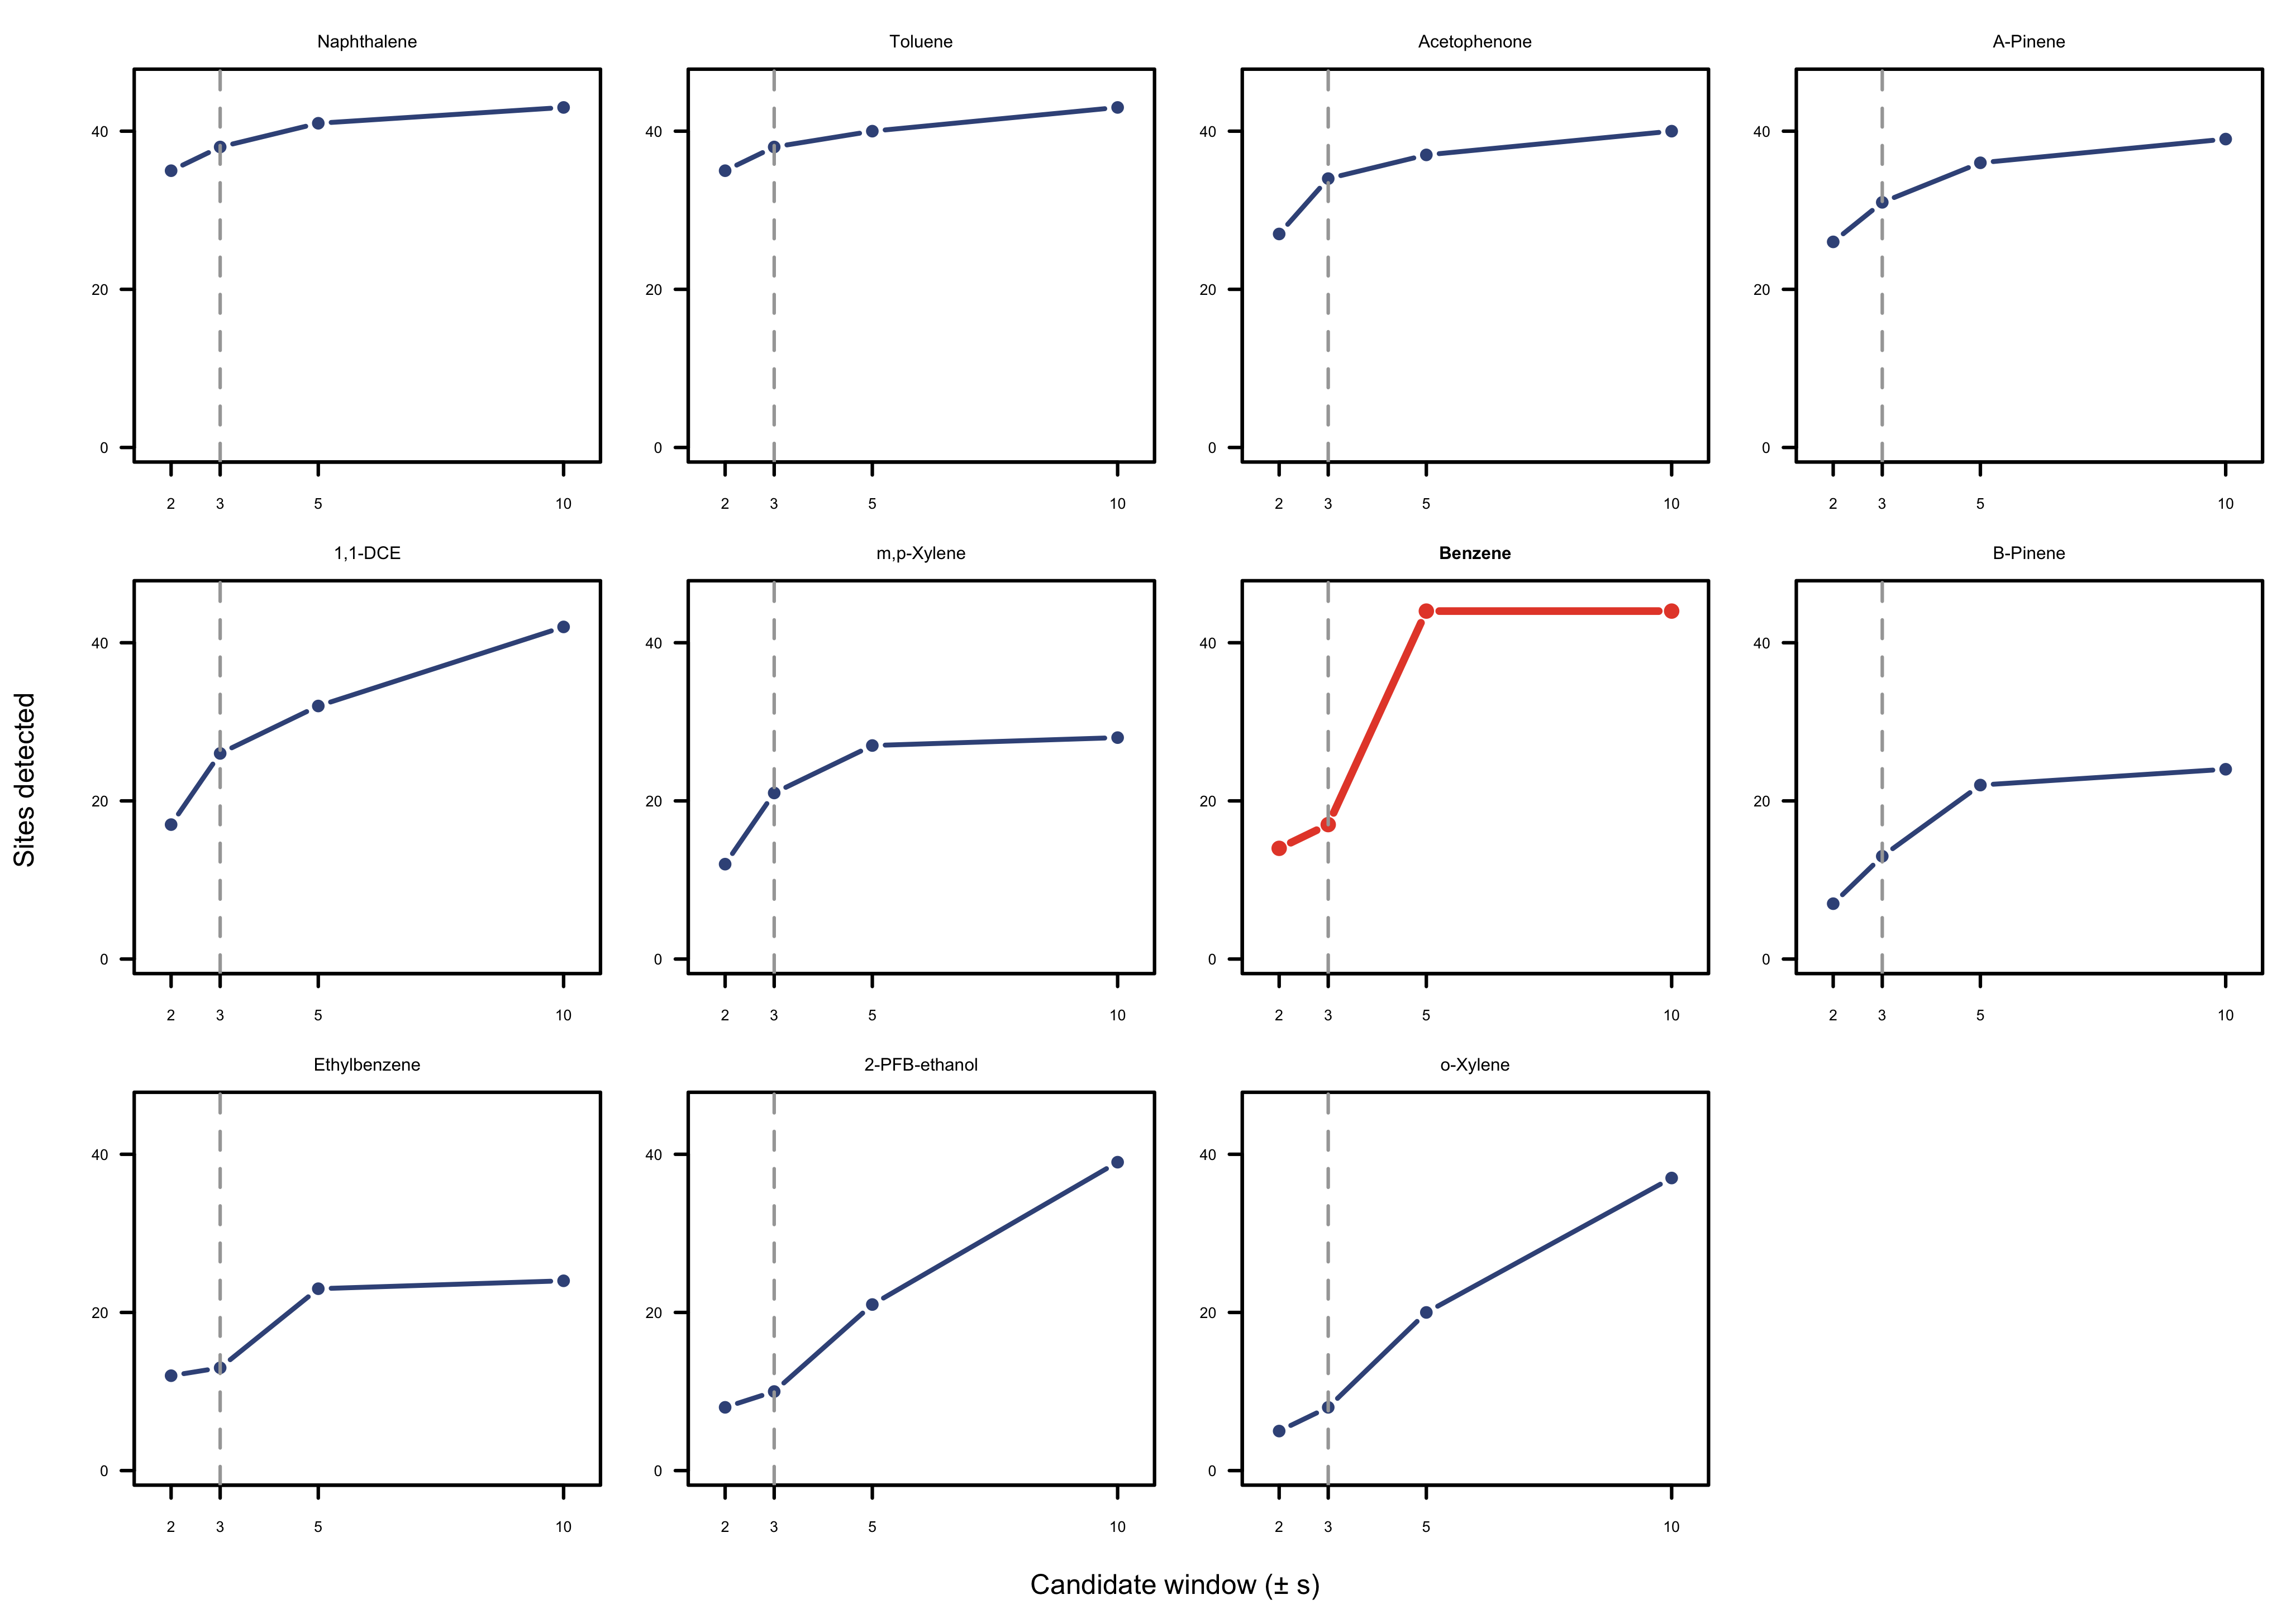Fig. S2 Retention-time window sensitivity across the 11 calibrated compounds, shown as small multiples of the number of sites detected against candidate window (±2, 3, 5, and 10 s), with benzene highlighted
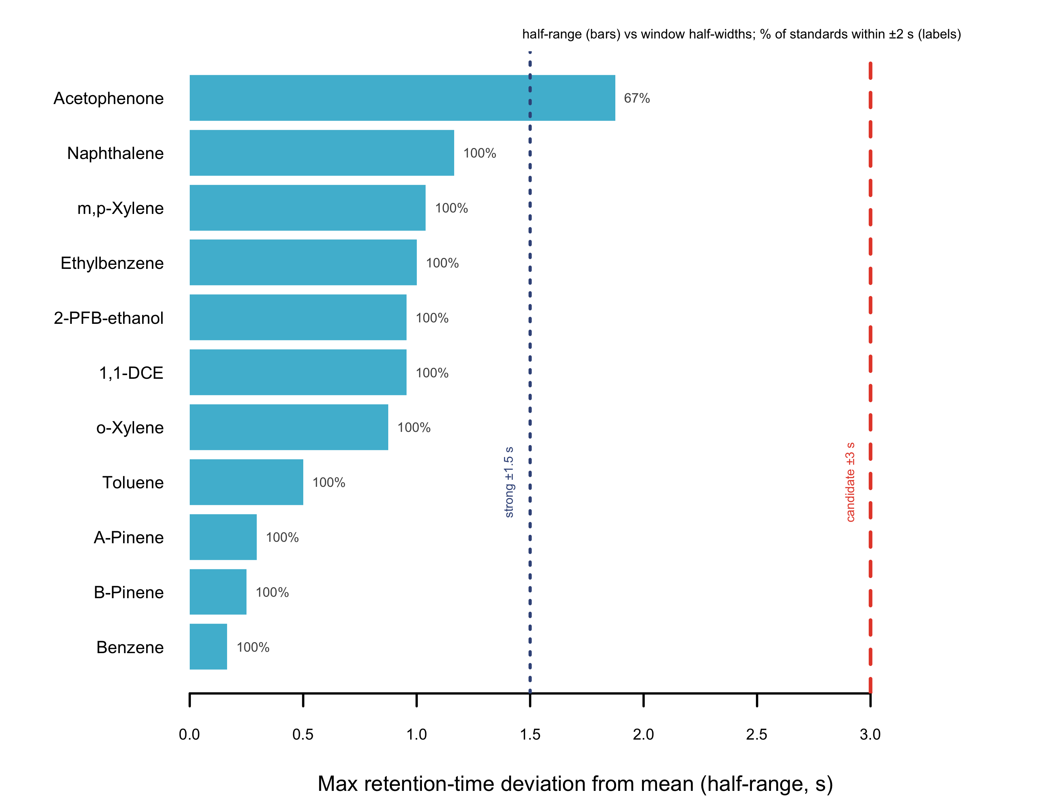Fig. S3 Retention-time reproducibility of the calibration standards: the half-range of retention time per compound against the ±1.5 s (strong-match) and ±3 s (candidate) window half-widths. Acetophenone falls between the two window lines; all other compounds fall within ±1.5 s
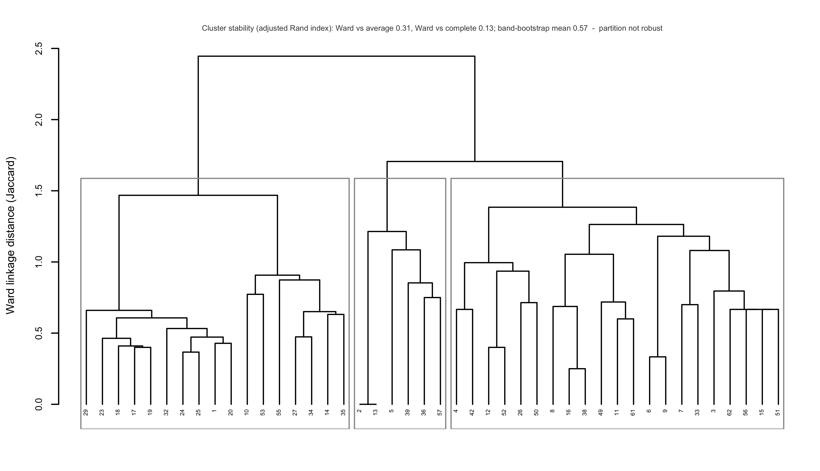Fig. S4 Ward hierarchical dendrogram of the 44 sites on Jaccard distances (pinene and fluorotelomer bands excluded), with the illustrative three-cluster cut marked. The partition is not robust: agreement with average and complete linkage gave adjusted Rand indices of 0.31 and 0.13 respectively, and band-resampling gave a mean adjusted Rand index of 0.57

