Supplementary Information for
MDFitML: Using machine learning to predict potency from molecular simulations
Xue Zong¹, Ahmet Mentes², Barmak Mostofian¹, Keith Jones¹, David R Stevens¹, Greg Bakken¹, Sirish Kaushik Lakkaraju²
¹ OpenEye, Cadence Molecular Sciences, Santa Fe, NM 87508
² Discovery & Development Sciences, Bristol Myers Squibb, Princeton, NJ 08548

Complete list of considered interaction types
To comprehensively capture protein-ligand interactions, the following interaction types were generated using OEChem TK and considered in this work: contact, hydrogen bond, chelator, covalent, clash, salt-bridge, T and Pi-stacking, cation-Pi, halogen bond, non-ideal hydrogen bond, unpaired ligand atom, and unpaired protein atom.
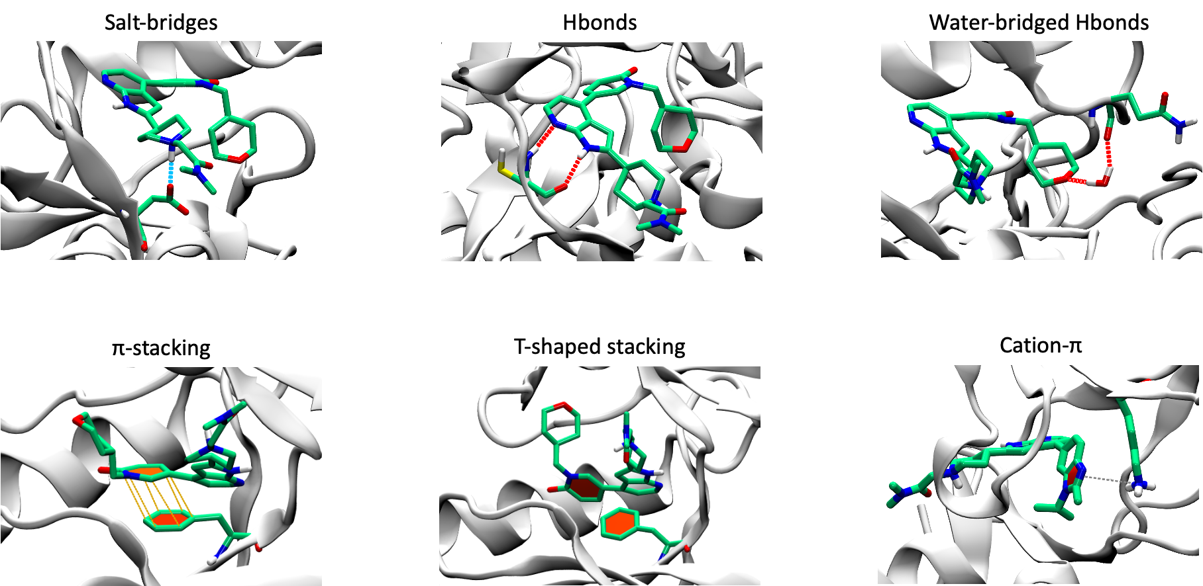
Figure S1. Visualizations of example interactions

Random forest model on CDK9 dataset
During exploratory analysis, we evaluated Random Forest as an alternative to our two-step Lasso + linear regression framework. Hyperparameters were optimized using nested leave-one-molecule-out cross-validation (LOMO-CV), with an inner LOMO-CV loop performing a grid search over number of estimators (10, 50, 100, 200), maximum tree depth (unconstrained, 10, 20), minimum samples per split (2, 5, 10), and a minimum samples per leaf (1, 2, 4), optimizing for mean squared error. Despite this thorough hyperparameter search, learning curve analysis revealed pronounced overfitting inherent to the Random Forest model in our data regime. As shown in Figure S2, training R2 score remained consistently high across all training set sizes, while test R2 score began near -0.2 at the smallest training sizes and improved only gradually to 0.35 at the largest size examined. The persistent, wide gap between training and test performance, accompanied by the large confidence intervals across 50 shuffle-split replicates, indicates that the model memorizes training data rather than learning generalizable structure-activity relationships.
This behavior is a direct consequence of model complexity relative to our dataset size. Random Forest’s ensemble of decision trees can partition the high-dimensional SimFP feature space arbitrarily finely, capturing noise rather than signal when the number of features substantially exceeds the number of compounds. Importantly, even at the largest training set sizes, there is no sign of convergence between training and test R2 scores, suggesting that the overfitting is not simply a data quantity problem but more structural. These complex models are fundamentally mismatched to the low-sample, high-dimensional regime typical of early drug discovery. These findings motivated our adoption of the simpler, regularized two-step modeling strategy described in the main text, which imposes the inductive biases needed for robust generalization while preserving interpretability through a compact set of selected interaction features.
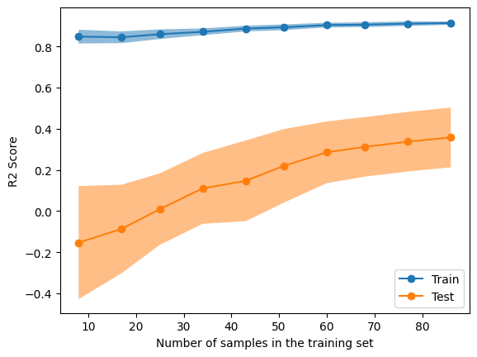
Figure S2. Learning curve analysis from the optimized Random Forest model.

Table S1. ML model performance across investigated systems. RMSE in kcal/mol for datasets with DG response. 95% confidence intervals were calculated via bootstrapping.
 | Docked Poses + ML |  |  | MDFitML (MD + ML)
Protein target (PDB ID) | No. interactions | CoD | RMSE | No. interactions | CoD | RMSE
CDK2 (1H1Q) | 27 | 0.57 (0.04, 0.82) | 0.77 (0.58, 1.02) | 136 | 0.90 (0.81, 0.94) | 0.38 (0.90, 0.97)
CDK9 (7NWK) | 53 | 0.68 (0.50, 0.84) | 0.63 (0.48, 0.83) | 227 | 0.48 (0.24, 0.71) | 0.81 (0.60, 1.15)
MCL-1(4HW3) | 25 | 0.10 (-0.20, 0.39) | 1.00 (0.86, 1.27) | 166 | 0.70 (0.54, 0.81) | 0.58 (0.48, 0.70)
BACE1 (4DJW) | 34 | 0.30 (-0.26, 0.58) | 0.66 (0.54, 0.83) | 162 | 0.77 (0.58, 0.90) | 0.38 (0.31, 0.46)
Hif-2α (5TBM) | 31 | 0.24 (-0.21, 0.57) | 0.98 (0.80, 1.19) | 208 | 0.34 (0.01, 0.61) | 0.91 (0.69, 1.29)
Tyk2 | 53 | 0.46 (0.06, 0.75) | 0.58 (0.38, 0.85) | 184 | 0.5 (0.62,0.84) | 0.6 (0.72, 1.43)
BMS internal target-Chemotype A | 70 | 0.34 (0.16, 0.50) | 0.77 (0.67, 0.91) | 289 | 0.42 (0.22, 0.56) | 0.76 (0.62, 0.84)
BMS internal target-Chemotype B | 65 | 0.29 (0.08, 0.49) | 0.62 (0.51, 0.77) | 296 | 0.65 (0.45, 0.79) | 0.43 (0.34, 0.54)

Table S2. Performance comparison of Lasso and Linear regression models across five public protein targets. Lasso models were trained on the complete dataset with all interaction features, while Linear regression models were trained using only the top 10 features selected based on regression coefficients. Performance metrics include coefficient of determination (CoD) and root mean squared error (RMSE).
 | Lasso |  | Linear with Top 10 Interactions
Protein Target | CoD | RMSE | CoD | RMSE
CDK2 | 0.28 (-1.71, 0.73) | 1.00 (0.65, 1.74) | 0.90 (0.81, 0.94) | 0.38 (0.90, 0.97)
CDK9 | -0.37 (-0.85, 0.05) | 1.32 (1.09, 1.66) | 0.48 (0.24, 0.71) | 0.81 (0.60, 1.15)
BACE1 | -3.16 (-10.92, 0.56) | 1.63 (0.46, 3.51) | 0.77 (0.58, 0.90) | 0.38 (0.31, 0.46)
Hif-2α | -0.57 (-3.21, 0.31) | 1.41 (0.97, 2.10) | 0.34 (0.01, 0.61) | 0.91 (0.69, 1.29)
MCL-1 | 0.34 (-0.12, 0.57) | 0.85 (0.69, 1.10) | 0.70 (0.54, 0.81) | 0.58 (0.48, 0.70)

Table S3. Y-scrambling experiment results on five public systems. Numbers in parentheses represent the 95% confidence interval.
 | MDFitML Results |  | Scramble Experiments Results
System | CoD | RMSE | CoD | RMSE
CDK2 | 0.90 (0.81, 0.94) | 0.38 (0.90, 0.97) | 0.32 (0.23, 0.41) | 0.93 (0.87, 0.99)
CDK9 | 0.48 (0.24, 0.72) | 0.81 (0.60, 1.15) | 0.27 (0.21, 0.32) | 0.95 (0.92, 0.98)
BACE1 | 0.77 (0.58, 0.90) | 0.38 (0.31, 0.46) | 0.21 (0.17, 0.24) | 0.70 (0.69, 0.72)
Hif-2α | 0.34 (0.01, 0.61) | 0.91 (0.69, 1.29) | 0.21 (0.17, 0.25) | 0.99 (0.97, 1.02)
MCL-1 | 0.70 (0.54, 0.81) | 0.58 (0.48, 0.70) | 0.17 (0.13, 0.22) | 0.95 (0.93, 0.97)

Table S4. Summary of model performance when applying different cutoff thresholds across five public systems. Performance metrics include coefficient of determination (CoD) and root mean squared error (RMSE). Numbers in brackets are 95% confidence interval calculated from bootstrapping.
Systems | Cutoff | No. Interactions | CoD | RMSE
CDK2 | 0 | 136 | 0.90 [0.81, 0.94] | 0.38 [0.29, 0.47]
CDK2 | 10% | 61 | 0.86 [0.27, 0.97] | 0.44 [0.24, 0.84]
CDK2 | 20% | 48 | 0.78 [-0.1, 0.95] | 0.54 [0.30, 1.02]
CDK9 | 0 | 227 | 0.48 [0.24, 0.72] | 0.81 [0.60, 1.14]
CDK9 | 10% | 99 | 0.23 [0.01, 0.48] | 0.98 [0.82, 1.24]
CDK9 | 20% | 76 | 0.42 [0.15, 0.65] | 0.86 [0.65, 1.13]
BACE1 | 0 | 166 | 0.77 [0.58, 0.90] | 0.38 [0.31, 0.46]
BACE1 | 10% | 73 | 0.56 [0.26, 0.74] | 0.53 [0.42, 0.65]
BACE1 | 20% | 57 | 0.61 [0.36, 0.82] | 0.50 [0.41, 0.60]
Hif-2α | 0 | 162 | 0.34 [0.01, 0.61] | 0.91 [0.69, 1.29]
Hif-2α | 10% | 59 | 0.45 [0.08, 0.67] | 0.83 [0.66, 1.16]
Hif-2α | 20% | 50 | 0.59 [0.27, 0.76] | 0.73 [0.56, 1.10]
MCL-1 | 0 | 208 | 0.70 [0.54, 0.81] | 0.58 [0.48, 0.70]
MCL-1 | 10% | 86 | 0.53 [0.10, 0.71] | 0.72 [0.55, 1.04]
MCL-1 | 20% | 62 | 0.73 [0.59, 0.83] | 0.54 [0.45, 0.66]

