Supplementary Material
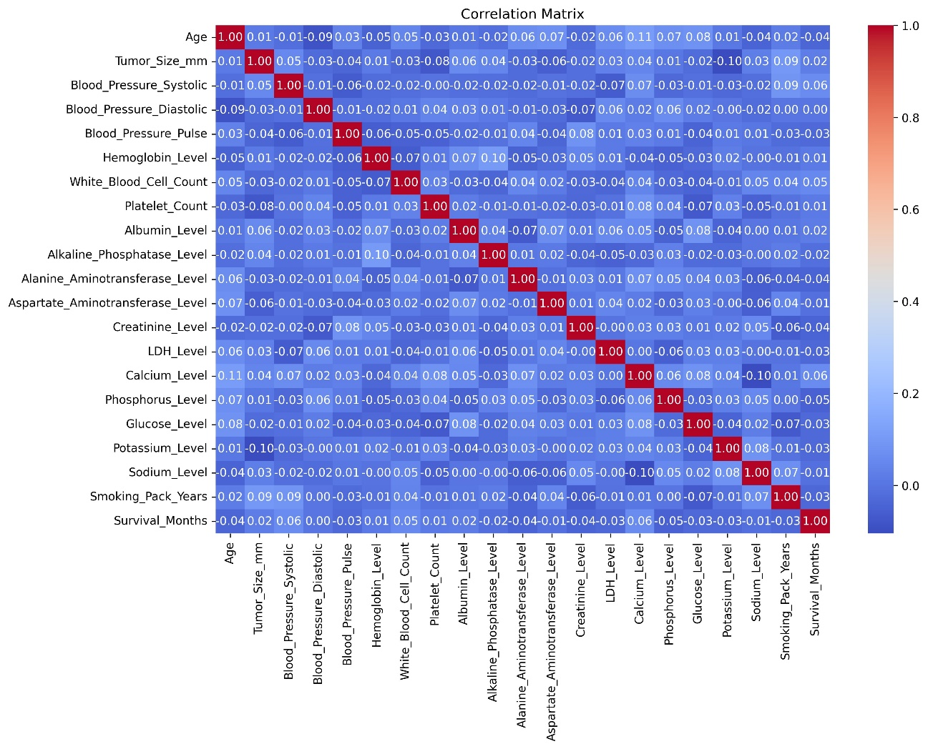
(Insert figure S1 here)
Figure S1 shows a correlation matrix heatmap displaying relationships across various patient clinical and demographic covariates.

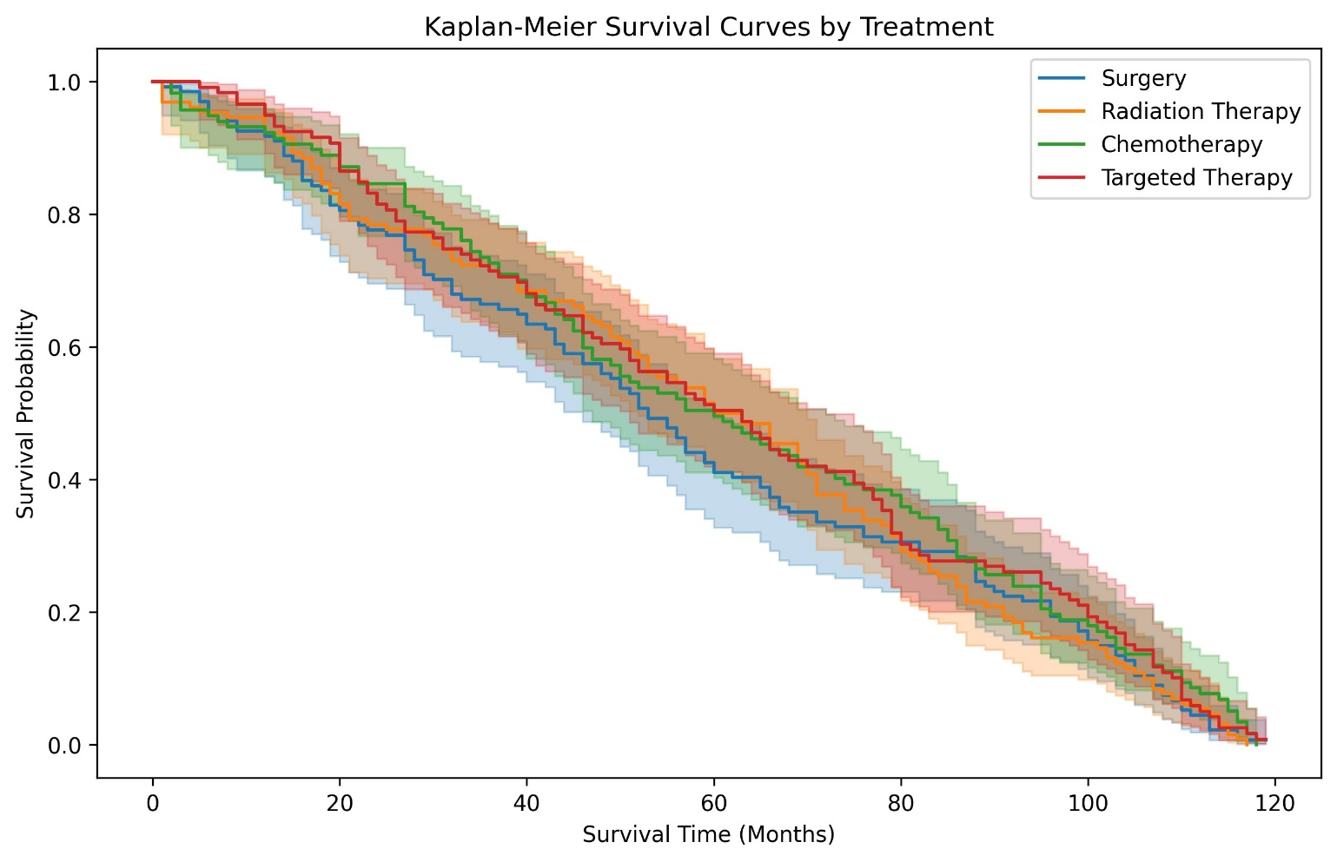
(Insert figure S2 here)

Figure S2 shows Kaplan–Meier survival curves by treatment and subgroup to illustrate patient variability.

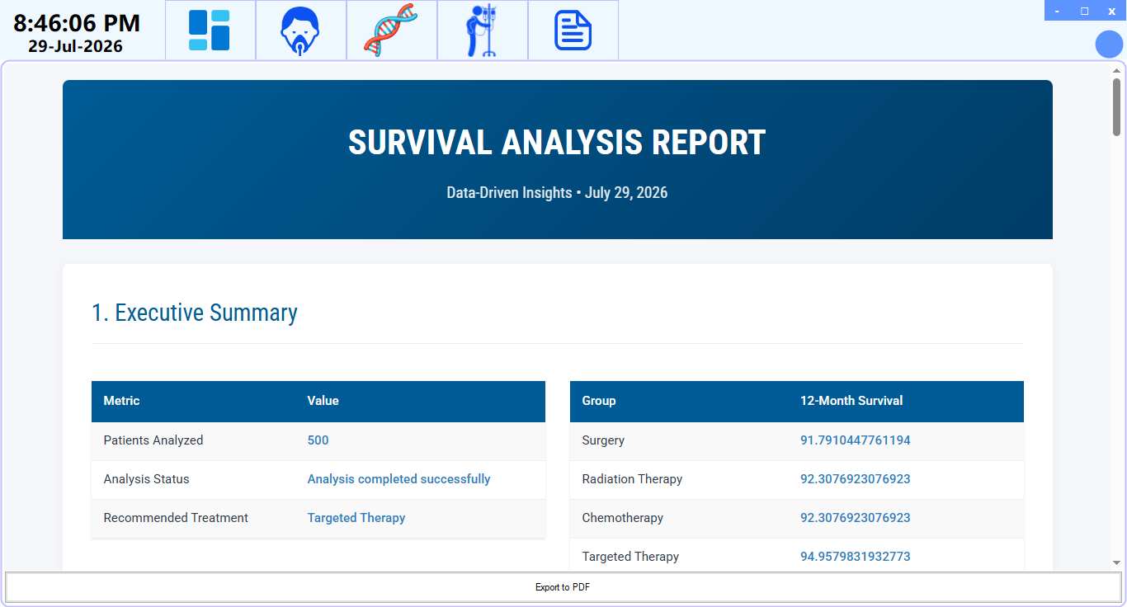
(Insert figure S3 here)
Figure S3 displays WPF interface screenshot highlighting clinical usability through visualizations, recommendations, and narrative summaries.
(Insert figure S2 here)
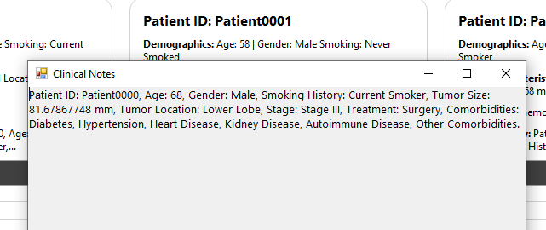
Figure S4 displays clinician user interface elements showcasing structured patient demographics, histories, and text clinical notes

Table S1 presents complete Cox regression results, including hazard ratios and confidence intervals for all covariates.
Covariate | Coef | Exp(Coef) | SE(Coef) | 95% CI Lower | 95% CI Upper | z | p-value | Significance
Age | -0.0009 | 0.9991 | 0.0032 | -0.0072 | 0.0053 | -0.2969 | 0.7665 | ns
Tumor_Size_mm | 0.0008 | 1.0008 | 0.0017 | -0.0025 | 0.0041 | 0.4883 | 0.6253 | ns
Blood_Pressure_Systolic | -0.0026 | 0.9974 | 0.0018 | -0.0062 | 0.0010 | -1.4182 | 0.1561 | ns
Blood_Pressure_Diastolic | -0.0008 | 0.9992 | 0.0031 | -0.0069 | 0.0054 | -0.2406 | 0.8098 | ns
Blood_Pressure_Pulse | 0.0020 | 1.0020 | 0.0038 | -0.0055 | 0.0094 | 0.5162 | 0.6057 | ns
Hemoglobin_Level | -0.0194 | 0.9808 | 0.0204 | -0.0593 | 0.0206 | -0.9496 | 0.3423 | ns
White_Blood_Cell_Count | -0.0246 | 0.9757 | 0.0247 | -0.0729 | 0.0237 | -0.9984 | 0.3181 | ns
Platelet_Count | 0.0002 | 1.0002 | 0.0005 | -0.0008 | 0.0012 | 0.4539 | 0.6499 | ns
Albumin_Level | -0.0099 | 0.9902 | 0.0780 | -0.1626 | 0.1429 | -0.1266 | 0.8993 | ns
Alkaline_Phosphatase_Level | -0.0002 | 0.9998 | 0.0016 | -0.0035 | 0.0030 | -0.1419 | 0.8872 | ns
Alanine_Aminotransferase_Level | 0.0025 | 1.0025 | 0.0047 | -0.0068 | 0.0118 | 0.5282 | 0.5974 | ns
Aspartate_Aminotransferase_Level | -0.0030 | 0.9970 | 0.0040 | -0.0109 | 0.0049 | -0.7504 | 0.4530 | ns
Creatinine_Level | 0.0757 | 1.0786 | 0.1505 | -0.2193 | 0.3707 | 0.5028 | 0.6151 | ns
LDH_Level | 0.0008 | 1.0008 | 0.0010 | -0.0012 | 0.0028 | 0.7872 | 0.4312 | ns
Calcium_Level | -0.0918 | 0.9123 | 0.0681 | -0.2252 | 0.0416 | -1.3481 | 0.1776 | ns
Phosphorus_Level | 0.0231 | 1.0233 | 0.0622 | -0.0988 | 0.1449 | 0.3710 | 0.7107 | ns
Glucose_Level | 0.0015 | 1.0015 | 0.0019 | -0.0022 | 0.0053 | 0.7985 | 0.4246 | ns
Potassium_Level | 0.0592 | 1.0609 | 0.1005 | -0.1379 | 0.2562 | 0.5884 | 0.5563 | ns
Sodium_Level | -0.0030 | 0.9970 | 0.0159 | -0.0341 | 0.0281 | -0.1888 | 0.8503 | ns
Smoking_Pack_Years | 0.0013 | 1.0013 | 0.0016 | -0.0019 | 0.0045 | 0.7823 | 0.4340 | ns
Gender_Male | -0.0480 | 0.9531 | 0.0919 | -0.2282 | 0.1322 | -0.5221 | 0.6016 | ns
Smoking_History_Former Smoker | -0.1728 | 0.8413 | 0.1103 | -0.3890 | 0.0434 | -1.5664 | 0.1173 | ns
Smoking_History_Never Smoked | -0.2036 | 0.8158 | 0.1072 | -0.4138 | 0.0065 | -1.8992 | 0.0575 | †
Tumor_Location_Middle Lobe | 0.1350 | 1.1445 | 0.1066 | -0.0741 | 0.3440 | 1.2655 | 0.2057 | ns
Tumor_Location_Upper Lobe | 0.2257 | 1.2532 | 0.1065 | 0.0170 | 0.4344 | 2.1192 | 0.0341 | *
Stage_Stage II | -0.0112 | 0.9888 | 0.1262 | -0.2586 | 0.2361 | -0.0891 | 0.9290 | ns
Stage_Stage III | -0.2559 | 0.7742 | 0.1258 | -0.5025 | -0.0094 | -2.0348 | 0.0419 | *
Stage_Stage IV | -0.2739 | 0.7604 | 0.1200 | -0.5092 | -0.0386 | -2.2815 | 0.0225 | *
Treatment_Radiation Therapy | 0.1572 | 1.1702 | 0.1194 | -0.0768 | 0.3912 | 1.3165 | 0.1880 | ns
Treatment_Surgery | 0.1294 | 1.1382 | 0.1201 | -0.1060 | 0.3649 | 1.0772 | 0.2814 | ns
Treatment_Targeted Therapy | 0.0424 | 1.0434 | 0.1252 | -0.2030 | 0.2879 | 0.3390 | 0.7346 | ns
Ethnicity_Asian | -0.0413 | 0.9595 | 0.1281 | -0.2923 | 0.2097 | -0.3225 | 0.7471 | ns
Ethnicity_Caucasian | -0.1438 | 0.8661 | 0.1346 | -0.4076 | 0.1200 | -1.0682 | 0.2854 | ns
Ethnicity_Hispanic | -0.1790 | 0.8361 | 0.1301 | -0.4340 | 0.0759 | -1.3765 | 0.1687 | ns
Ethnicity_Other | -0.1882 | 0.8285 | 0.1322 | -0.4473 | 0.0710 | -1.4229 | 0.1548 | ns
Insurance_Type_Medicare | 0.0500 | 1.0512 | 0.1223 | -0.1898 | 0.2898 | 0.4084 | 0.6830 | ns
Insurance_Type_Other | 0.0073 | 1.0074 | 0.1169 | -0.2218 | 0.2364 | 0.0627 | 0.9500 | ns
Insurance_Type_Private | 0.0219 | 1.0222 | 0.1253 | -0.2236 | 0.2675 | 0.1752 | 0.8610 | ns
Family_History_Yes | -

