SUPPORTING INFORMATION FOR

Condensed phase isomerization through tunneling gateways

Authors: Arnab Choudhury^{1,2}, Jessalyn A. DeVine², Shreya Sinha³, Jascha A. Lau^{1,2,a}, Alexander Kandratsenka², Dirk Schwarzer², Peter Saalfrank³ and Alec M. Wodtke^{1,2}*
Affiliations:
¹Institute for Physical Chemistry, Georg-August University; Goettingen, Germany.
²Dept. of Dynamics at Surfaces, Max-Planck-Institute for biophysical Chemistry; Goettingen, Germany.
³Dept. of Chemistry, University of Potsdam, Potsdam, Germany
ªCurrent address: Department of Chemistry, University of California, Berkeley, California 94720, USA

*Corresponding author. Email: alec.wodtke@mpibpc.mpg.de.

- Experimental Methods
Figure S1 shows a schematic diagram of the experimental apparatus used in the current work. The molecular beam dosing procedure used for sample preparation has been described previously ¹⁶. Briefly, a fixed number of molecular beam pulses of CO gas (¹²C¹⁶O: Sigma-Aldrich; 99.99% ¹²C and 99.95% ¹⁶O, 99.9% chemical purity, ¹³C¹⁸O: Sigma-Aldrich; 99.9% ¹³C and 99.2% ¹⁸O, 99.8% chemical purity and ¹³C¹⁶O: Sigma-Aldrich; 99.07% ¹³C and 97.2% ¹⁶O, 99.99%) were directed onto a UHV-cleaved NaCl(100) crystal surface held at 25K to form the isotopically pure monolayer. After monolayer dosing, samples were cooled to 22K and ~100 layers of ¹²C¹⁶O were added. Cryogenic temperatures were achieved by coupling the sample to a dual-stage helium cryo-cooler (RDK-408D2, Sumitomo), and the sample was held inside a liquid nitrogen-cooled cold shield during measurements to limit warming due to room-temperature surfaces in the laboratory. The sample temperature was monitored and controlled using a Model 335 Lakeshore cryogenic temperature control unit. Sample characterization was performed using a Fourier Transform Infrared (FTIR) spectrometer (VERTEX 70V, Bruker) operating in external mode using either an InSb or an MCT detector cooled by liquid nitrogen.
Following sample preparation and characterization, a pulsed infrared laser fixed at 2138.6 cm⁻¹ was used to induce the v = 0 to v = 1 vibrational excitation in the ¹²C¹⁶O overlayer ³² and the vibrational energy was efficiently transported to the the ¹³C¹⁶O or ¹³C¹⁸O monolayer ¹⁷. For the ¹²C¹⁶O monolayer buried beneath a ¹²C¹⁶O overlayer, vibrational energy transport is not possible; here, the monolayer was pumped directly with IR laser light at 2152.5 cm⁻¹. A voltage pulse-activated shutter controlled the number of laser shots used to pump the sample. The excitation light was generated by a difference frequency mixing setup wherein the output of a tuneable dye laser pumped by the second harmonic of a seeded 10 Hz Nd:YAG laser mixes with the 1064nm Nd:YAG fundamental light in a LiIO₃ crystal. The induced changes in the absorption spectra were observed in the minutes following excitation using the Bruker FTIR spectrometer equipped with the Rapid-Scan functionality, the light source of which was aligned to be collinear with the excitation laser. From these measurements, the sample absorption spectrum was obtained as a function of time. Changes in the spectrum were determined by using the absorption spectrum of the unexcited sample as the reference channel. These experiments were performed for three different monolayer isotopes as well as various surface temperatures.

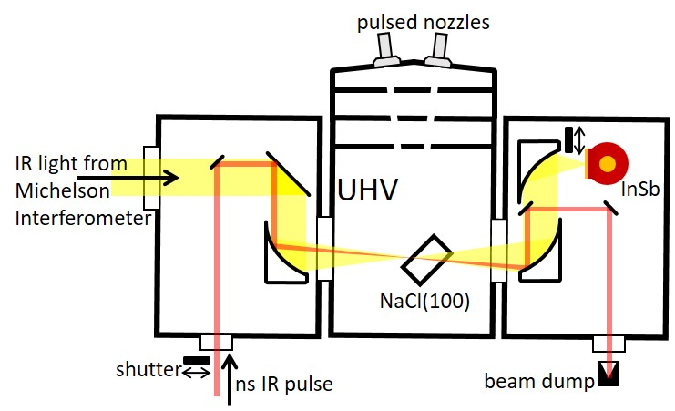
Figure S1. Experimental setup. The NaCl(100) crystal is attached to a 4D translation stage within the UHV chamber. The sample is moved between the position for pulsed molecular beam dosing and laser excitation/FTIR spectral acquisition.

To ensure that there was no influence of exposure to the FTIR light source on the resultant decay of O-down population, a set of two experiments were carried out where FTIR spectra were acquired at ~90 second intervals following excitation of the sample. In one set of experiments, it was ensured that the glow bar was only illuminating the sample during spectral acquisition (~30 seconds per spectrum). Thus, the effective exposure to the FTIR light source was reduced to ¼ of that characteristic for the other measurement, where the FTIR light source was always irradiating the sample. As shown in figure S2 the two kinetic traces are indistinguishable, demonstrating that exposure to the glow bar does not influence the measured lifetimes of O-down molecules.
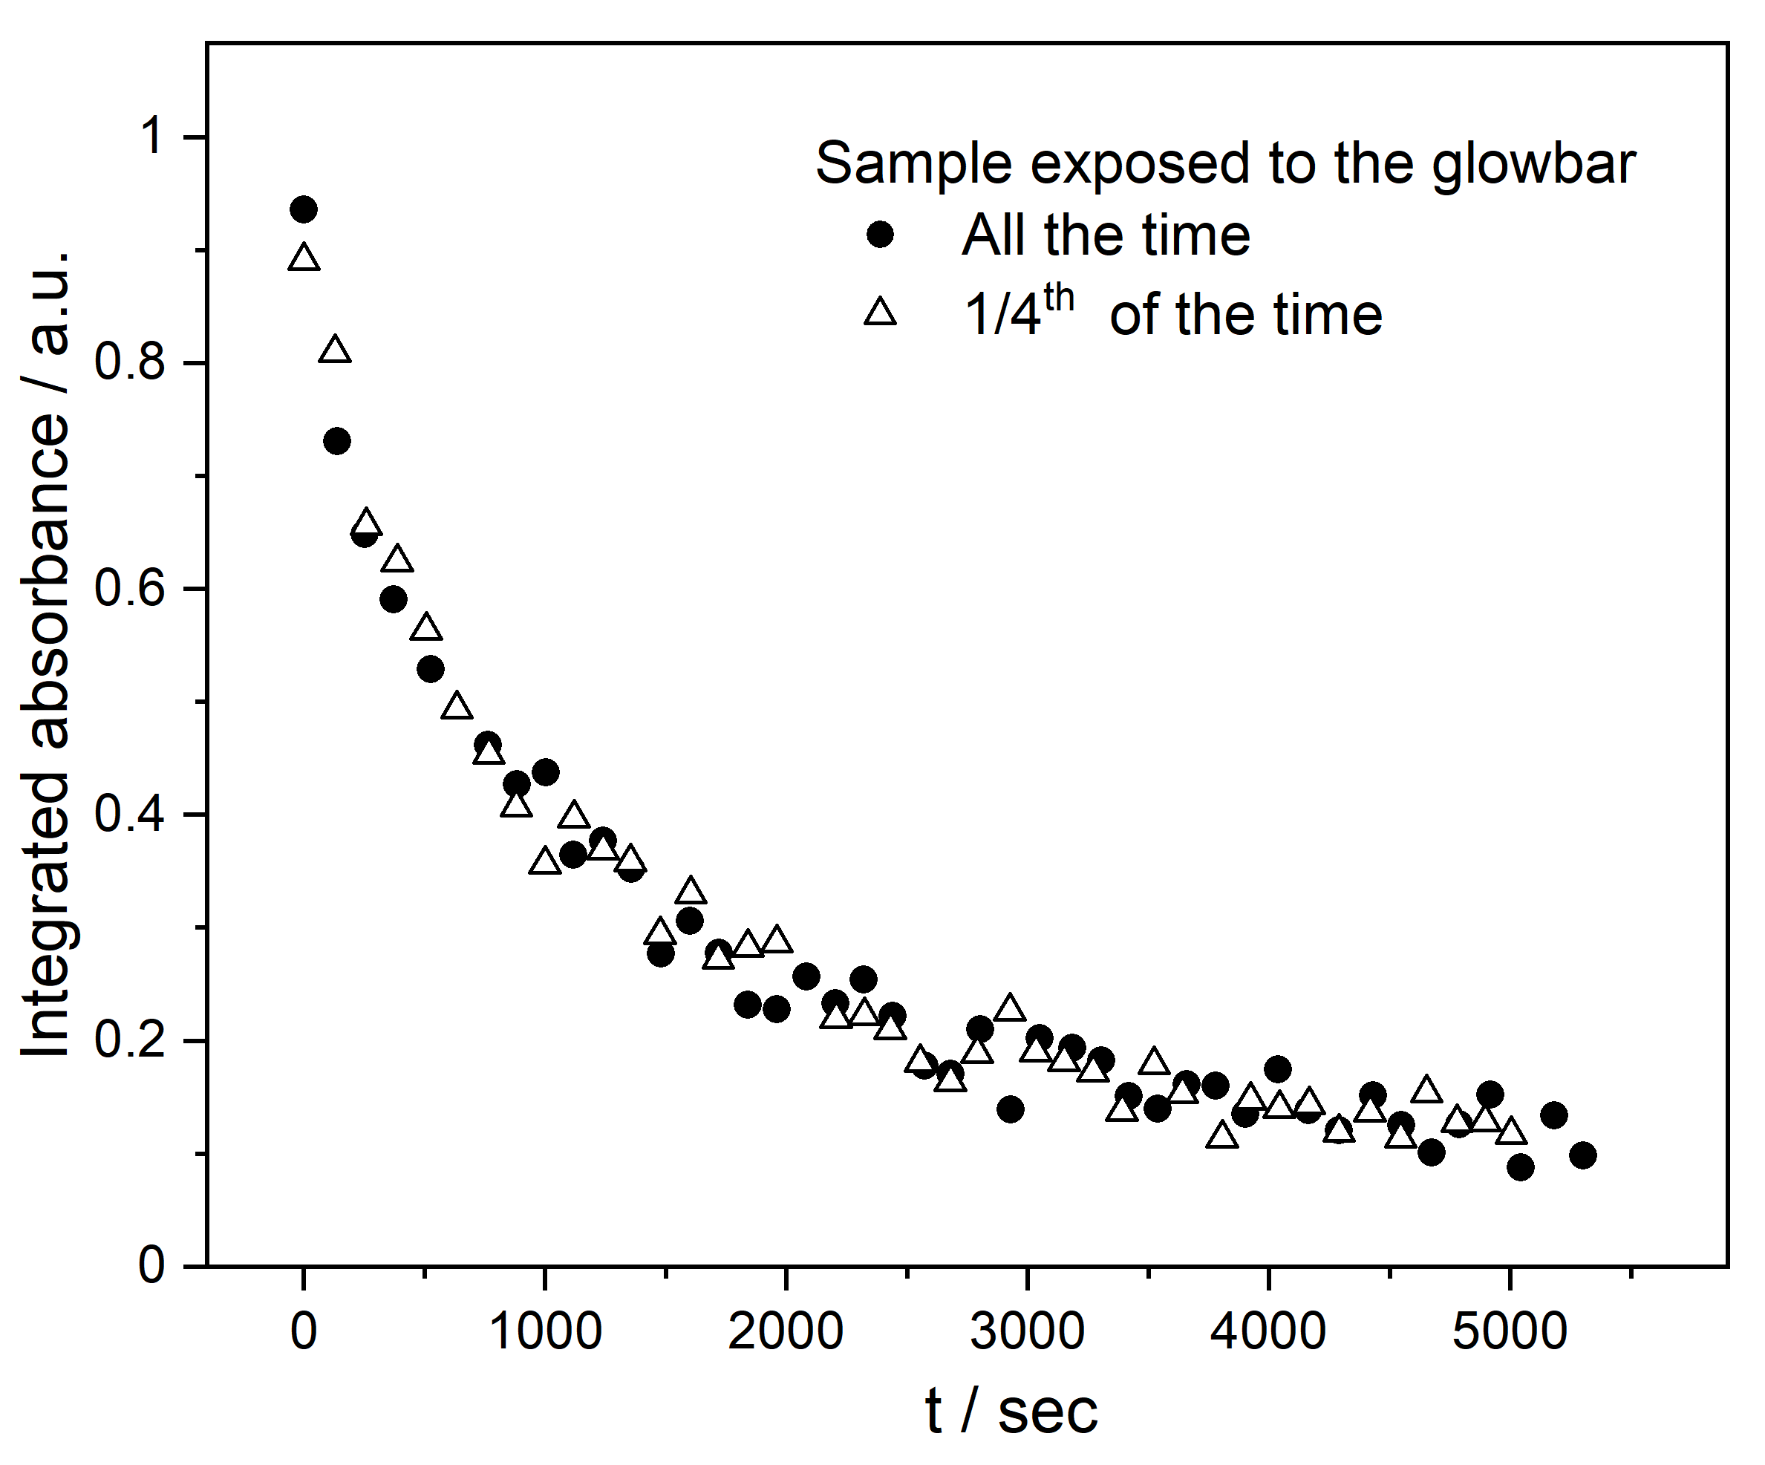
Figure S2: Effect of FTIR glow bar light on the decay of the O-down population. Kinetic traces of O-down population (see section S2) in a buried ¹³C¹⁸O monolayer at 21.5K following laser excitation of the ¹²C¹⁶O overlayer at 2138.6 cm⁻¹. Solid circles correspond to a sample that was exposed to a 4 times higher glow bar light dose compared to the sample represented by the open triangles.

- Data Analysis
In this section we describe in detail how FTIR absorbance spectra are used to obtain the time dependent concentrations of O-down CO on NaCl(100). We first perform a baseline correction (section S2a). We then consider how to extract from the spectral data the peak integrals that are related to the O-down population at each time step (section S2b), and relate the obtained peak areas to O-down population using an exciton model (section S2c).
  - Baseline correction
The baseline of the obtained absorbance spectra shifts over the course of a lifetime measurement which can last many hours, hence a baseline correction must be implemented. To achieve this, a straight line was fitted through the baseline of spectra obtained at different times in the measured decay and subtracted. Figure S3 shows examples of two experimentally obtained spectra without (black) and with (orange) this baseline correction.

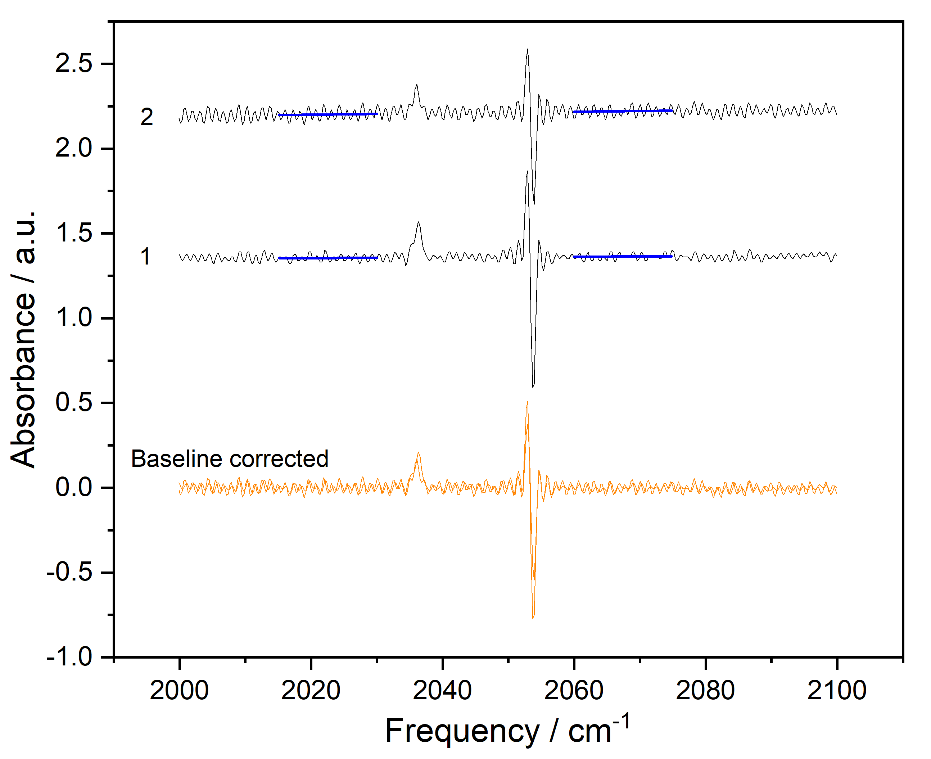
Figure S3: Illustration of baseline correction of FTIR spectra. The raw spectra (black) correspond to a buried ¹³C¹⁸O monolayer following excitation of the ¹²C¹⁶O overlayer at 2138.6 cm⁻¹, where spectrum 2 was obtained at a later time than spectrum 1. The thick blue lines denote the range of the fitted straight line and the two background-subtracted spectra are shown in orange.

  - Relative O-Down Concentrations
The relative fraction of O-down molecules in the monolayer can be obtained from the difference absorbance spectrum (see Figure S4) by determining the area A under the O-down peak (method 1). It can also be calculated from the decrease in the C-down fraction relative to the unexcited sample by integrating the whole C-down feature (method 2). Since its shape arises from a drop in absorption intensity as well as a broadening and red-shift of the band, the integral of the difference spectrum consists of a positive (area B) and a negative (area C) contribution and is given by the area C – B. These two methods give essentially the same result (A $≈$ C – B), as the decreased C-down fraction is equal to the increased O-down fraction.

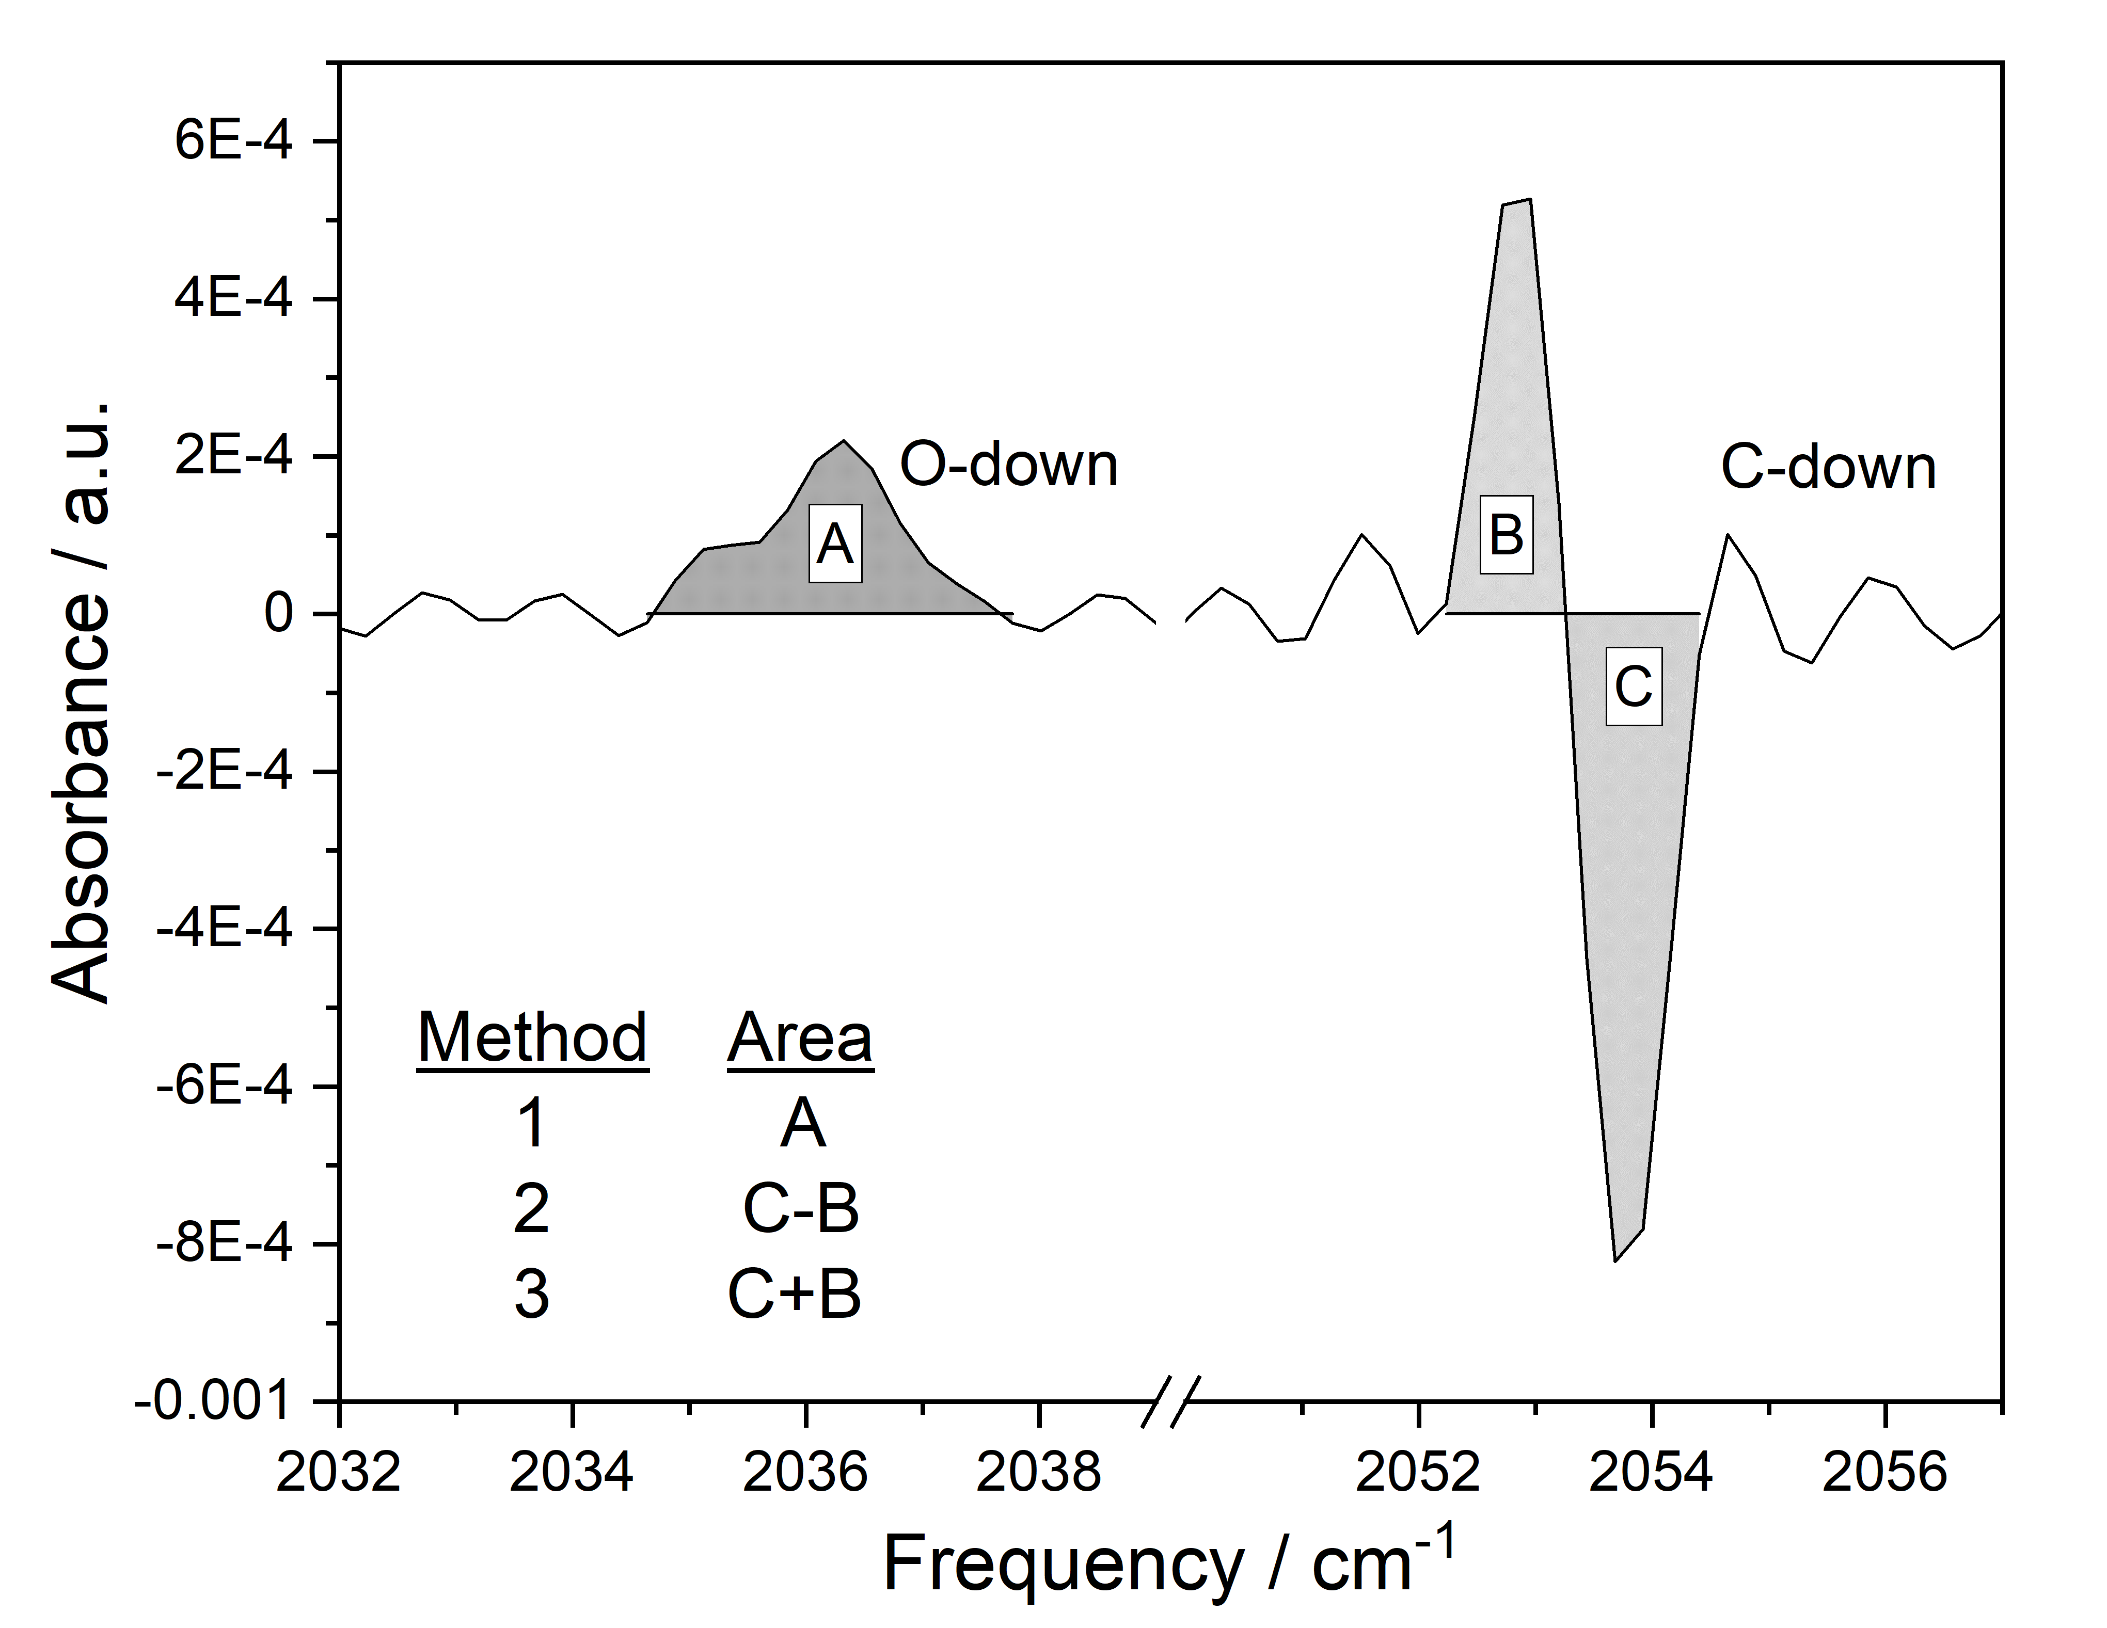
Figure S4: Illustration of methods for determining the relative population of O-down ¹³C¹⁸O from the difference absorbance spectra. For methods 1 and 2 integrals over the O-down (area A) and C-down feature (area C – B) are calculated, respectively. For method 3 the area B + C is evaluated.

It is obvious from figure S4 that the integral over the absolute value of the C-down feature (area B + C) is considerably larger than area C – B and hence produces kinetic traces with larger signal-to-noise ratios. In the following section we will show that area B + C (method 3) is in fact proportional to the O-down concentration, and analyzing the time dependence from the kinetic traces using B + C gives more reliable time constants than methods 1 and 2, in particular when the rate of flipping is very high (e.g. at $T>23$K) or the laser excitation efficiency was low (e.g., ¹²C¹⁶O monolayer samples).
  - Exciton Model
It is necessary to show that the absorbance of CO molecules in the sample is linearly proportional to their population. To do this, we simulate absorbance spectra for a simplified matrix of CO molecules with the help of a well-known exciton model ^{33,34}. The monolayer is taken to have a $1×1$ unit cell, where CO monomers are either aligned vertically upward (C-down) or downward (O-down). The position of O-down molecules were chosen randomly. From the simulated spectra (fig. S5) we determine the correlation between the fraction of C-down molecules and the integrated absorbances calculated by the three methods discussed above. We show that for O-down fractions generated in our experiments, all three methods give integrals which are linear in the O-down population (fig. S6). We find that the integrated absorbances obtained by method 3 discussed above give better signal-to-noise in the kinetic traces (fig. S7).
The monolayer is considered to be a collection of N molecules, where the ground and first-excited vibrational state of isolated molecule i are given by $ϕ_{i}$ and $ϕ_{i}^{'}$, respectively, where the relative energy of the first excited state is given by $hc{\tilde{ν}}_{0}$. The zeroth-order collective N-molecule states are then perturbed by their pairwise dipole-dipole interactions.
In the ground state, the collective zeroth-order wavefunction is given by
$$\begin{aligned}{ψ_{0}}_{v=0}=ϕ_{1}ϕ_{2}ϕ_{3}… ϕ_{N}. \#\left(1\right)\end{aligned}$$
The collective single-excitation wavefunctions, where a single adsorbate is in its first excited state, form an N-fold degenerate sub-space with energy$hc{\tilde{ν}}_{0}$ (in the case that all molecules have the same orientation), so that the l^{th} single excitation exciton wavefunction is given by
$${ψ_{l}}_{v=1} =C_{l1}ϕ_{1}^{'}ϕ_{2}ϕ_{3}⋯ϕ_{N} + C_{l2}ϕ_{1}ϕ_{2}^{'}ϕ_{3}⋯ϕ_{N}+ \\ \begin{aligned}{ C}_{l3}ϕ_{1} ϕ_{2}ϕ_{3}^{'}⋯ϕ_{N} +⋯+ C_{lN}ϕ_{1}ϕ_{2}ϕ_{2}⋯ϕ_{N}^{'} \#\left(2\right)\end{aligned}$$
where l = 1, 2, 3, …, N. The i^{th} component in (2) then corresponds to the zeroth-order single excitation state where molecule i is in its first vibrational excited state.
To determine the true (coupled) excitonic wavefunctions and eigenvalues, we must diagonalize the perturbation Hamiltonian in the basis consisting of the individual terms included in (1) and (2); i.e., $ψ_{0}$ and the N single-excitation $ψ_{l}$, where $C_{li}=δ_{li}$ is the Kronecker delta. Neglecting electrostatic interactions beyond electric dipole-dipole, the perturbation Hamiltonian is written as
$$\begin{aligned}H^{\left(1\right)}=\sum_{i=1}^{N}{\sum_{j>1}^{N}{u_{i}u_{j} f_{ij}} } where \#\left(3\right)\end{aligned}$$
$$\begin{aligned}f_{ij}=\frac{1}{4πϵ_{0}R_{ij}^{3}}\left[e_{i}.e_{j}-3\left(e_{i}.r_{ij}\right)\left(e_{j}.r_{ij}\right)\right] .\#\left(4\right)\end{aligned}$$
Here, $u_{i}$ and $e_{i}$ are the magnitude and unit vector of the dipole moment of molecule$i$, respectively, $r_{ij}$is the unit vector from molecule $i$ to molecule $j$, and $R_{ij}$ is the intermolecular distance. For a polar diatomic molecule, the dipole moment is parallel to the bond axis of the molecule, so $e_{i}$ also indicates the orientation of the molecule$i$.
The diagonal element of the perturbation matrix associated with the 0th vibrational ground state (1) is given by
$$\begin{aligned}H_{G}^{\left(1\right)}=〈ψ_{0}\left|H^{\left(1\right)}\right|ψ_{0}〉=μ^{00}μ^{00}\sum_{i=1}^{N}{\sum_{j<i}^{N}{f_{ij}}} ,\#\left(5\right)\end{aligned}$$
and those associated with each excited state k represented in (2) may be written as
$$\begin{aligned}H_{kk}^{\left(1\right)}=〈ψ_{k}\left|H^{\left(1\right)}\right|ψ_{k}〉=μ^{00}μ^{00}\sum_{i=1,i≠ k}^{N}{\sum_{j<i,j≠ k}^{N}{f_{ij}}}+μ^{00}μ^{11}\sum_{i=1,i≠ k}^{N}{f_{ik}} \#\left(6\right)\end{aligned}$$
$$\begin{aligned}=H_{G}^{(1)}+ΔH_{kk}^{(1)} with ΔH_{kk}^{\left(1\right)}=\frac{\left(μ^{11}-μ^{00}\right)μ^{00}}{hc}\sum_{i=,i≠ k}^{N}{f_{ik}}.\#\left(7\right)\end{aligned}$$
Here, $μ^{00}$ (-0.112 Debye) and $μ^{11}$ (-0.087 Debye) ³³ are the permanent dipole moments of a CO molecule in vibrational state $v=0$ and $v=1$, respectively. The off-diagonal elements of the perturbation are given by
$$\begin{aligned}H_{ij}^{\left(1\right)}=〈ψ_{i}\left|H^{\left(1\right)}\right|ψ_{j}〉=μ^{01}μ^{01} f_{ij} \#\left(8\right)\end{aligned}$$
where $μ^{01}$ is $v=0→1$ transition dipole moment (0.105 Debye) ³³.
We now apply N-fold degenerate perturbation theory to calculate the first-order energy corrections $E_{l}^{\left(1\right)}$,
$$\begin{aligned}\sum_{l=1}^{N}{\left[H_{αβ}^{\left(1\right)}-E_{l}^{\left(1\right)}δ_{αβ}\right]}=0, \#\left(9\right)\end{aligned}$$
where $H_{αβ}^{\left(1\right)}=〈ψ_{β}\left|H^{\left(1\right)}\right|ψ_{α}〉 \left(α,β=1,⋯N\right)$ are the matrix elements from Eqs. (6) through (8), and $δ_{αβ}$ is the Kronecker delta. Diagonalization of $H^{\left(1\right)}$ gives N eigenvalues, $E_{l}^{\left(1\right)}=Δ{\tilde{ν}}^{\left(l\right)}hc,$as well as the associated eigenvectors $Ψ_{l}$, whose total energy is given by$E_{l}=hc{({\tilde{ν}}_{0}+Δ\tilde{ν}}^{\left(l\right)})=hc{\tilde{ν}}^{\left(l\right)}$. We note that this applies to the case where all adsorbates have the same orientation. For a monolayer with m flipped molecules, the same derivations apply, but there are now two degenerate sub-spaces; the N – m C-down subspace, and the m O-down subspace.
The integrated absorption cross-section for excitation of the monolayer to the l^{th} single-excitation exciton state obtained from the diagonalization discussed above is given by
$$\begin{aligned}{\overline{σ}}^{\left(l\right)}=\frac{8π^{3}{\tilde{ν}}^{\left(l\right)}}{Nhc}{\left|\sum_{j=1}^{N}{〈Ψ_{l}\left|μ_{j}\right|ψ_{0}〉}\right|}^{2}.\#\left(10\right)\end{aligned}$$
The absorption spectrum of chosen monolayer geometry $S\left(\tilde{ν}\right)$ was then calculated as a Gaussian convolution of the discrete stick spectrum $\left[∆{\tilde{ν}}^{\left(l\right)},{\overline{σ}}^{\left(l\right)}\right]$associated with the N coupled single-excitation exciton states. Simulations were performed using a 30$×$30 grid of CO molecules; increasing the grid size was not found to substantially change the resultant spectra. Resulting difference absorbance spectra, $∆S\left(\tilde{ν}\right)=S\left(\tilde{ν}\right)-S_{0}\left(\tilde{ν}\right)$ where $S_{0}\left(\tilde{ν}\right)$ is the spectrum for the 100% C-down monolayer, are shown for various O-down coverages in figure S5.
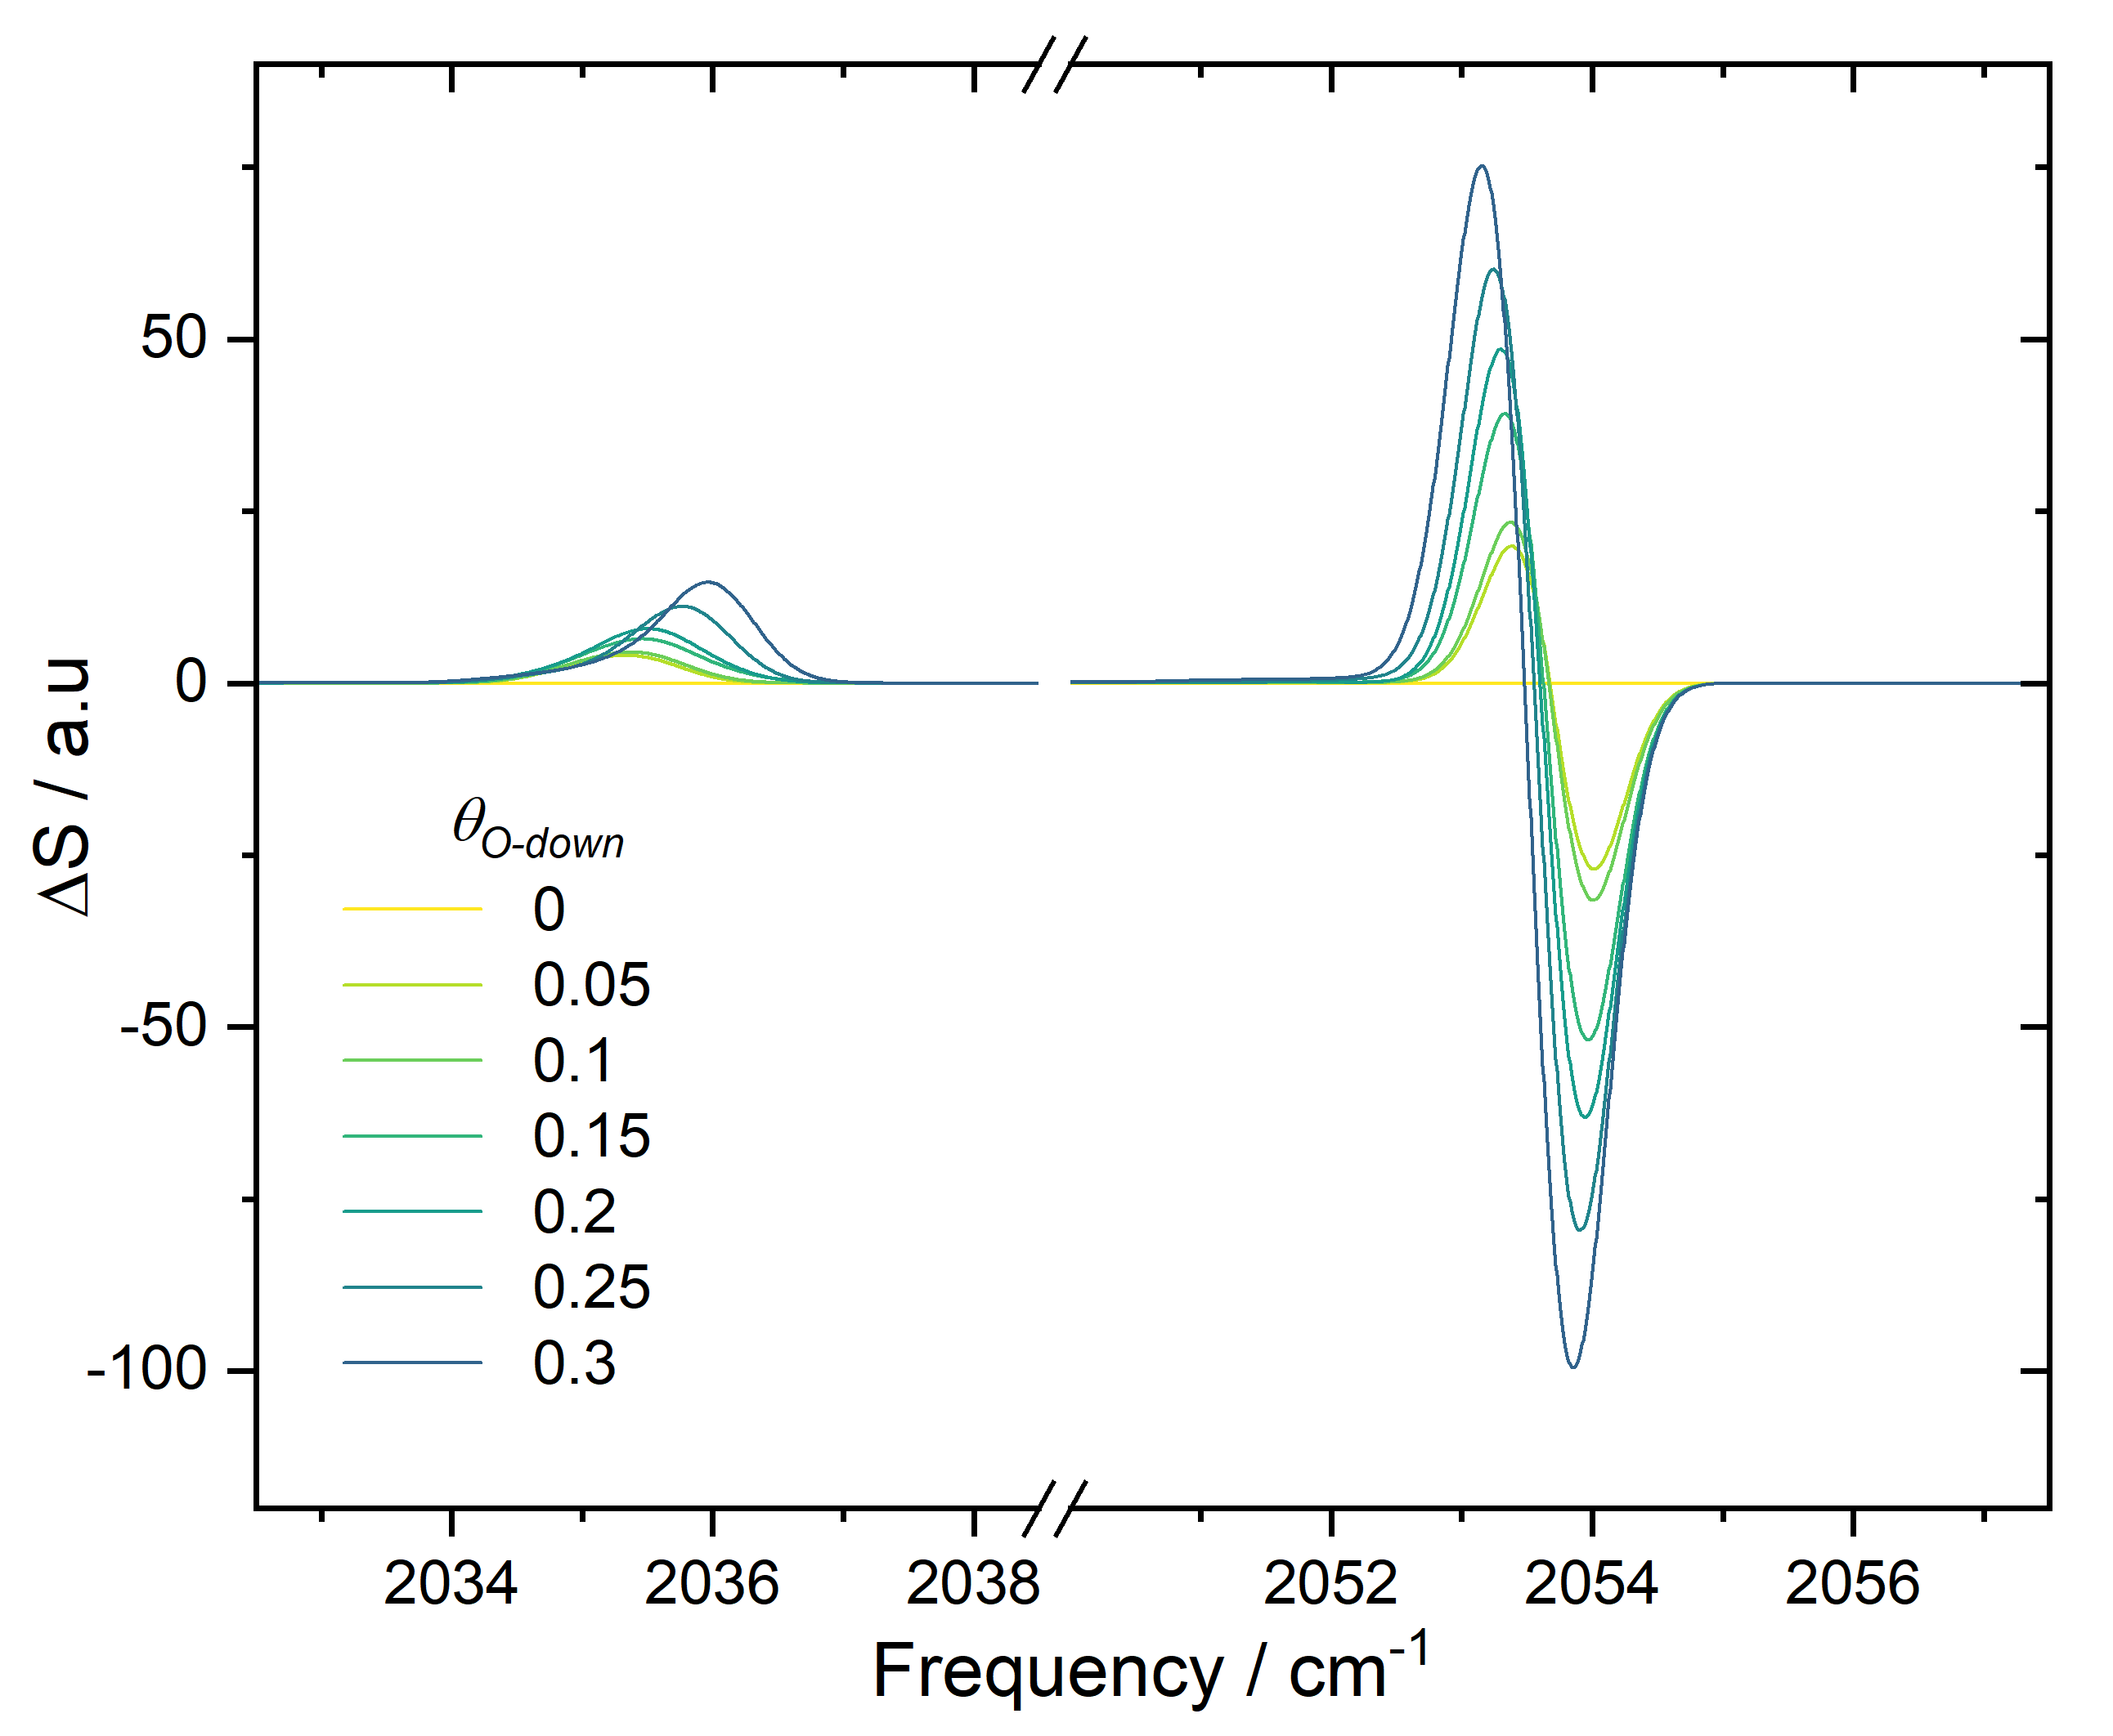
Figure S5: Difference absorbance spectra derived from the exciton model. $∆S\left(\tilde{ν}\right)$ is calculated for various fractions of O-down population ($θ_{O-down}$), where the positions of the O-down molecules are chosen randomly in a 30$×$30 grid. For these spectra, the chosen $hc{\tilde{ν}}_{0}$ values were those of the ¹³C¹⁸O monolayer isomers, so that these results may be compared to experimental spectra obtained following overlayer excitation in a buried ¹³C¹⁸O monolayer sample.
From this model, we can determine the relationship between integrated absorbances and the percentage of molecules flipped in the monolayer, by calculating
$A_{1}=\int_{2030{cm}^{-1}}^{2040{cm}^{-1}}{ΔS\left(\tilde{ν}\right) d\tilde{ν}}$ (method 1)
$A_{2}=-\int_{2050{cm}^{-1}}^{2055{cm}^{-1}}{ΔS\left(\tilde{ν}\right) d\tilde{ν}}$ (method 2)
$A_{3}=\int_{2050{cm}^{-1}}^{2055{cm}^{-1}}{\left|ΔS\left(\tilde{ν}\right)\right| d\tilde{ν}}$ (method 3)
for grids with varying fractional O-down populations. The results of applying the three methods to the simulated spectra are shown in Figure S6A.
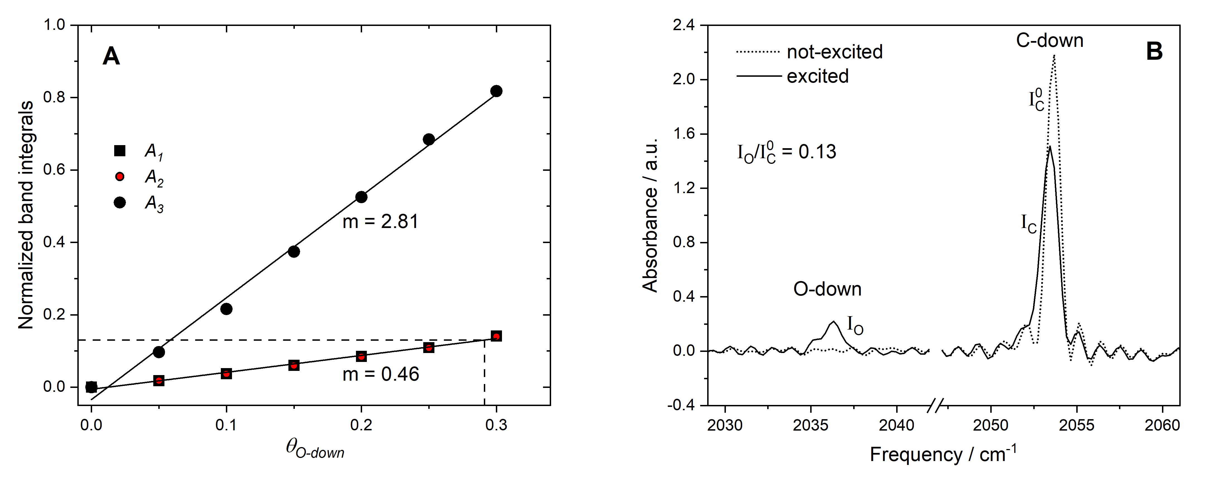
Figure S6: Comparison of different analysis methods for determining the coverage of O-down ¹³C¹⁸O molecules. (A) Relation between the simulated integrated absorbance and the fraction ($θ_{O-down}$) of molecules flipped in the exciton model. The integrated band absorbances $(A_{1-3}$as defined above) are normalized to the integral of the C-down peak in the unexcited sample ($I_{C}^{0})$. (B) Experimental absorbance spectra prior to (dotted line) and immediately after (solid line) laser excitation from a typical lifetime measurement. Given the $I_{O}/I_{C}^{0}$ value of 0.13, we may use the results of method 1 to estimate from panel (A) that ~30% of the molecules are flipped (dashed lines).

Lifetime measurements were limited to samples where not more than $≈$30% of the molecules were flipped. An example of a typical lifetime measurement experiment is shown in fig. S6B, where we can clearly see that the O-down peak area ($I_{O})$ is $∼$0.13 fraction of the full monolayer ($I_{C}^{0}$), indicating that ~30% of the molecules were flipped. The integrated absorbances calculated from method 3 were then used to determine the concentration of O-down molecules for the reasons discussed above.
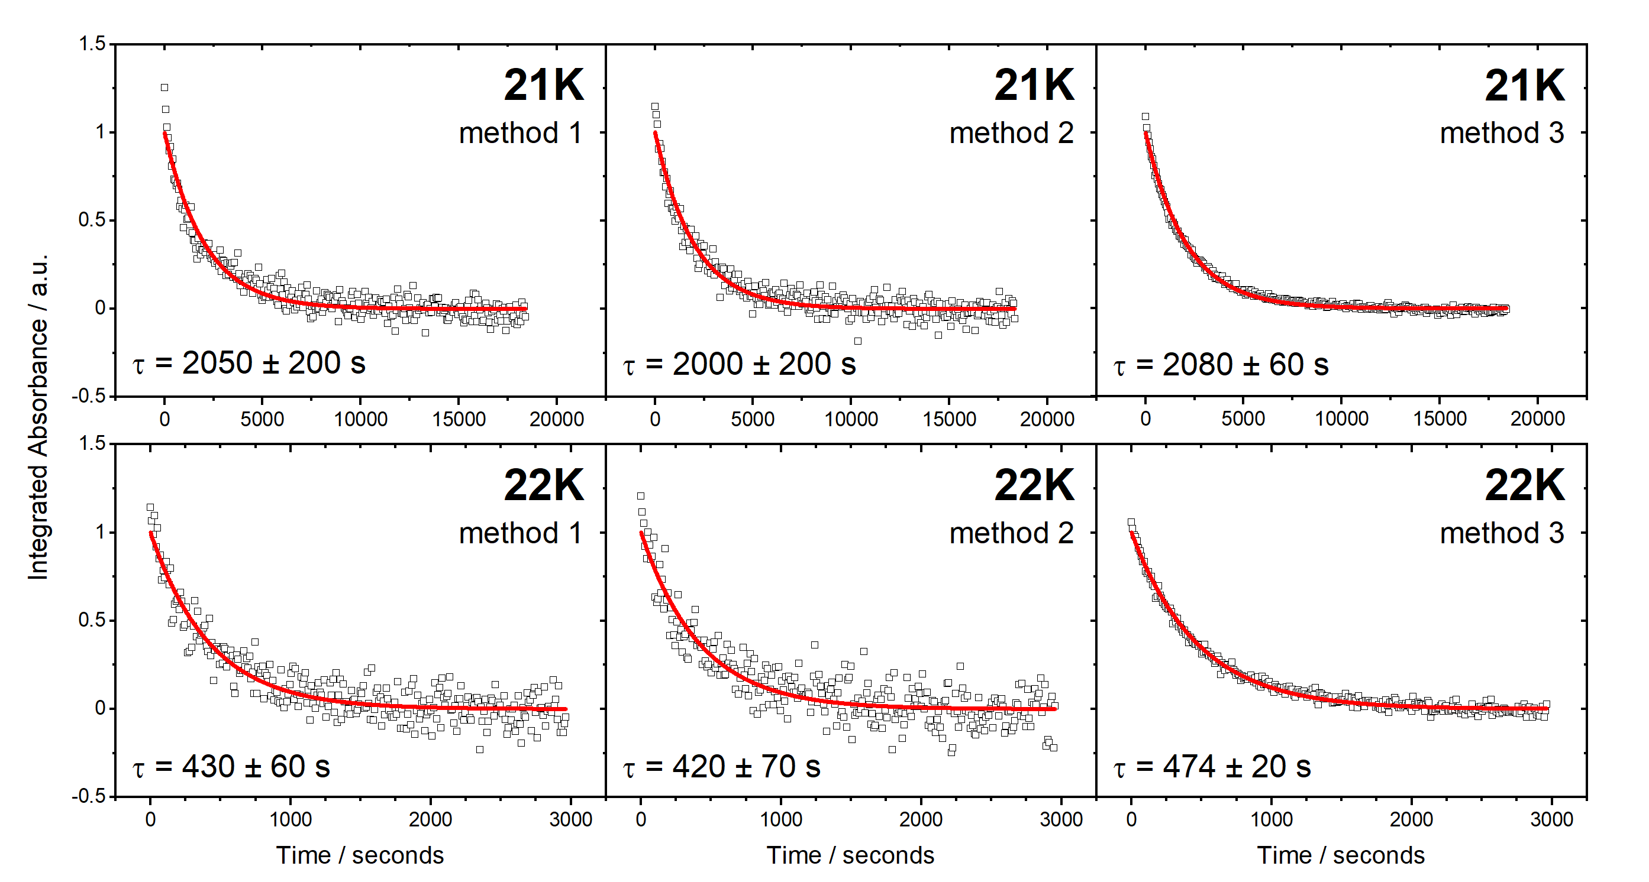
Figure S7. Comparison between the integrated absorbances obtained from the different analysis methods. Methods 1 (left), 2 (middle) and 3 (right) are applied to the data obtained from a ¹³C¹⁸O monolayer sample covered by ¹²C¹⁶O at 21 K (top) and 22 K (bottom). The red lines show the fitted exponential decays, and the resultant decay constants are also shown. The error is calculated with 95% confidence interval. Note that the kinetic traces shown here correspond to a single measurement; the Arrhenius plot (Fig. 2) and table S1 show the average of values obtained from several such experiments.

- Table of Lifetimes
Table S1 provides the flipping lifetimes obtained for all samples studied in this work. The lifetimes are obtained by fitting the O-down population data, calculated as described in the previous section, to a single exponential decay and then averaging the resultant fit parameters over several experiments. The uncertainties are estimated with 95% confidence interval.
Table S1. Flipping lifetimes$τ_{obs}$ for all CO monolayer isotopes across all temperatures studied. Temperatures could be reproduced within $±$0.003 K; the absolute accuracy is estimated to be better than $±$0.05 K.
T (K) | Decay Constant (s)
T (K) | ¹³C¹⁸O | ¹³C¹⁶O | ¹²C¹⁶O
19.00 | - | 8700 ± 400 | 10500 ± 1500
19.25 | - | - | 7800 ± 750
19.50 | - | 4100 ± 200 | 6300 ± 900
19.75 | - | - | 4350 ± 600
20.00 | 9600 ± 600 | 2200 ± 150 | 3700 ± 750
20.25 | 5700 ± 600 | - | 2700 ± 700
20.50 | 4200 ± 120 | 960 ± 110 | 1650 ± 650
20.75 | 3100 ± 600 | - | -
21.00 | 2200 ± 350 | 490 ± 90 | -
21.25 | 1500 ± 300 | - | -
21.50 | 1100 ± 250 | 310 ± 30 | -
21.75 | 600 ± 100 | - | -
22.00 | 500 ± 100 | 160 ± 20 | -
22.25 | 310 ± 50 | - | -
22.50 | 210 ± 35 | 100 ± 15 | -
22.75 | 170 ± 20 | - | -
23.00 | 106 ± 6 | 55 ± 15 | -
23.25 | 80 ± 12 | - | -
23.50 | 50 ± 15 | - | -
24.00 | 30 ± 15 | 28 ± 12 | -

- Transition State Theory
The rate constant for a chemical reaction as a function of temperature can be obtained using Eyring’s transition state theory (TST) expression,
$$\begin{aligned}k\left(T\right)=\frac{k_{B}T}{h}e^{-{ΔG^{‡}\left(T\right)}/{k_{B}T}},\#\left(11\right)\end{aligned}$$
where $ΔG^{‡}\left(T\right)$ is the difference in free energy between the reactants and the transition state. This may be calculated from $ΔG^{‡}\left(T\right)=E_{0,class}+ΔG_{vib}\left(T\right)$, where $E_{0,class}$ is the classical barrier to reaction and $ΔG_{vib}\left(T\right)=G_{vib}^{‡}-G_{vib}^{r}$is the change in Gibbs free energy associated with the differences in vibrational structure at the transition state compared to the reactant.
The value of $E_{0}$ is based on a previously reported two-dimensional ($Z$,$θ$) DFT calculation for the naked monolayer ¹⁹, where $Z$ represents CO center-of-mass motion perpendicular to the NaCl surface and $θ$ is the polar angle of the CO bond axis relative to the surface normal. The vibrational Gibbs free energies are given by
$$G_{vib}^{‡}\left(T\right)=\sum_{i}{\left[\frac{hν_{i}^{‡}}{2}+\frac{hν_{i}^{‡}}{e^{\frac{hν_{i}^{‡}}{k_{B}T}}-1}-k_{B}T\left(\frac{1}{k_{B}T}\frac{hν_{i}^{‡}}{e^{\frac{hν_{i}^{‡}}{k_{B}T}}-1}-\ln\left(1-e^{-\frac{hν_{i}^{‡}}{k_{B}T}}\right)\right)\right]}$$
(12)
$$G_{vib}^{r}\left(T\right)=\sum_{i}{\left[\frac{hν_{i}^{r}}{2}+\frac{hν_{i}^{r}}{e^{\frac{hν_{i}^{r}}{k_{B}T}}-1}-k_{B}T\left(\frac{1}{k_{B}T}\frac{hν_{i}^{r}}{e^{\frac{hν_{i}^{r}}{k_{B}T}}-1}-\ln\left(1-e^{-\frac{hν_{i}^{r}}{k_{B}T}}\right)\right)\right]}$$

for the transition state $G_{vib}^{‡}\left(T\right)$ and reactant $G_{vib}^{r}\left(T\right)$, respectively. Here, the sum is taken over the i vibrational modes (internal stretch, frustrated rotation, and frustrated translation) and includes zero-point, enthalpic, and entropic contributions. We treat all vibrations as simple harmonic oscillators. Harmonic frequencies $ν_{i}^{‡}$ and $ν_{i}^{r}$ were obtained from Ref. ¹⁹ for the ¹²C¹⁶O isotope of CO on the NaCl(100) surface. For the other isotopes, the harmonic frequencies were scaled using the appropriate reduced mass $μ$, i.e.
$$\begin{aligned}ν_{i,2}=ν_{i,1}\sqrt{\frac{μ_{1}}{μ_{2}}} .\#\left(13\right)\end{aligned}$$
Putting this all together, we obtain activation energies $E_{a}^{TST}$ and prefactors $A_{TST}$by fitting the 19-24 K TST predictions of the rate constants to an Arrhenius form. $E_{a}^{TST}$ and $A_{TST}$ are temperature independent over the range relevant to this work and are isotope specific. See Table 1 of the main text. The isotope effect on the derived lifetimes (given by 1/k) shows a small and monotonic increase in lifetime with mass. Specifically, at 20K we see a 13% increase in the TST lifetime in going from ¹³C¹⁶O to ¹³C¹⁸O. The isotope effect decreases to 10% at 24K. Similar results were seen when comparing ¹³C¹⁶O to ¹²C¹⁶O.
- WKB Theory
A commonly employed model used to consider tunneling through a barrier is the semi-classical Wentzel-Kramers-Brillouin (WKB) approximation. Equation (14) shows the tunneling rate in the WKB approximation for a chosen tunneling path $s$, represented in mass weighted coordinates,
$$\begin{aligned}k_{WKB}\left(E\right)=ν exp\left(-\frac{2\sqrt{2}}{ℏ}\int_{s_{1}}^{s_{2}}{ds \sqrt{V\left(s\right)-E}}\right).\#\left(14\right)\end{aligned}$$
Here, $ν$ is the attempt frequency (taken here to be the frequency of the frustrated rotation), $V\left(s\right)$ is the potential energy along a chosen path, and the integration limits $s_{1}$and$s_{2}$ are the turning points at energy E on each side of the barrier. Using the 2D PES from Ref. ¹⁹, we calculated the ground-state tunneling rate $k_{WKB}(E_{ZPE})$, where $E_{ZPE}$ is the zero-point energy of the O-down isomer. We performed the WKB integrals numerically along the minimum energy path (MEP) and along a corner cutting pathway ²¹ shown in fig. S8; both of these pathways were extracted from the same 2D PES mentioned above. From the ZPE level we could easily calculate $s_{1}$ and $s_{2}$. The results are shown in Table 2 of the main text.
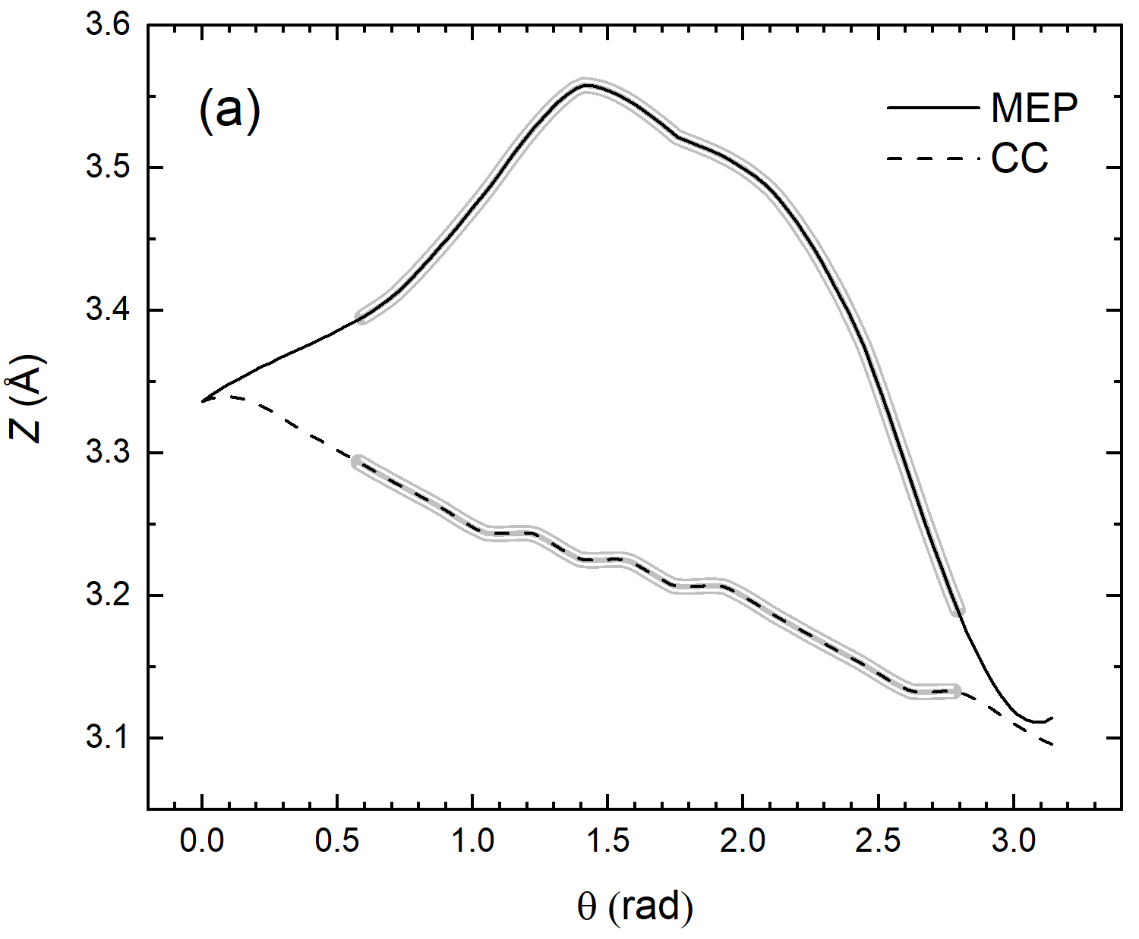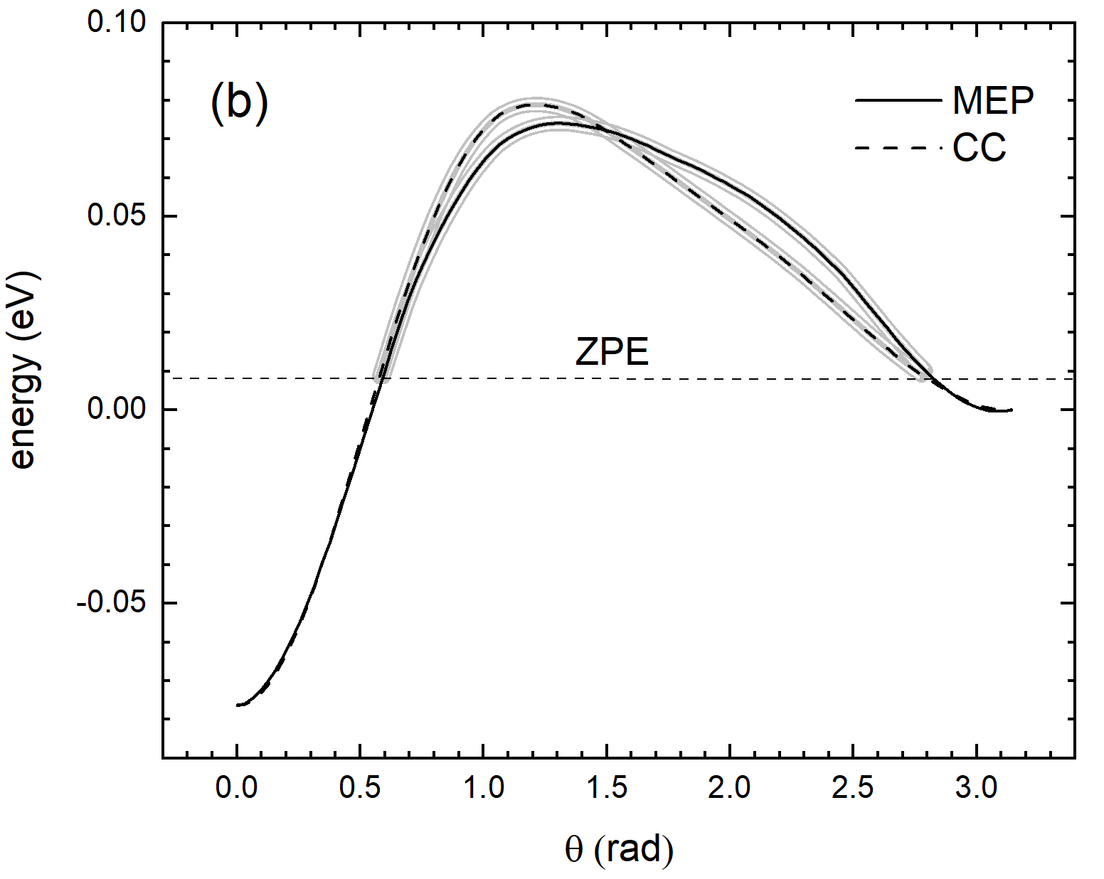
Figure S8: WKB tunneling pathways. Panel (a) shows the minimum energy path (MEP) and the corner cutting (CC) path used for the WKB calculations. Panel (b) shows the corresponding energy profiles along the two paths. The energy is relative to the classical O-down minimum. The region of integration between turning points is shown as thickened grey line for ground state tunneling of the ¹²C¹⁶O, whose ZPE is also indicated.
We emphasize that in these ground state rate calculations, we have used the two-dimensional ZPE associated with the lowest eigenstates of the isotopomers defined by the PES of Ref. ¹⁹. Thus the WKB tunneling rates presented in Table 1 of the main text are an upper limit to the WKB prediction as the ZPE associated with the Z-coordinate is not effective at promoting isomerization. Therefore we also calculated the WKB rates assuming only ZPE of the frustrated rotation. In this case the ZPEs in Table 2 are reduced by about a factor of two and the tunneling rates are ~100 times slower.
We also used the WKB model to simulate thermally activated tunneling on the same PES used for the FGR model described in section S6. Referring to Eq. (26), we replaced the sum over the FGR state-to-state rate constants with the WKB tunneling rate at the energy of the $m^{th}$ O-down state,
$$\begin{aligned}k_{m}\left(T\right)=e^{-β(E_{m}-E_{0})} k_{WKB}\left(E_{m}\right).\#\left(15\right)\end{aligned}$$
Again, $β=1/k_{B}T$ and $E_{0}$ is the zero-point energy in the “O-down” well. The total rate constant is given then by $k\left(T\right)=\sum_{m}{k_{m}(T)}$. The thermal WKB rate constants obtained using both the MEP and corner-cutting path appear in fig. S9, where they are compared to experimental rate constants. Results are shown for both the 1D ($θ$) and 2D ($Z,θ$) zero-point energies, signified by the gray and black data, respectively. Again, we emphasize that the use of a 1D vibrational energy results in a further decreased estimation of thermal tunneling rates.
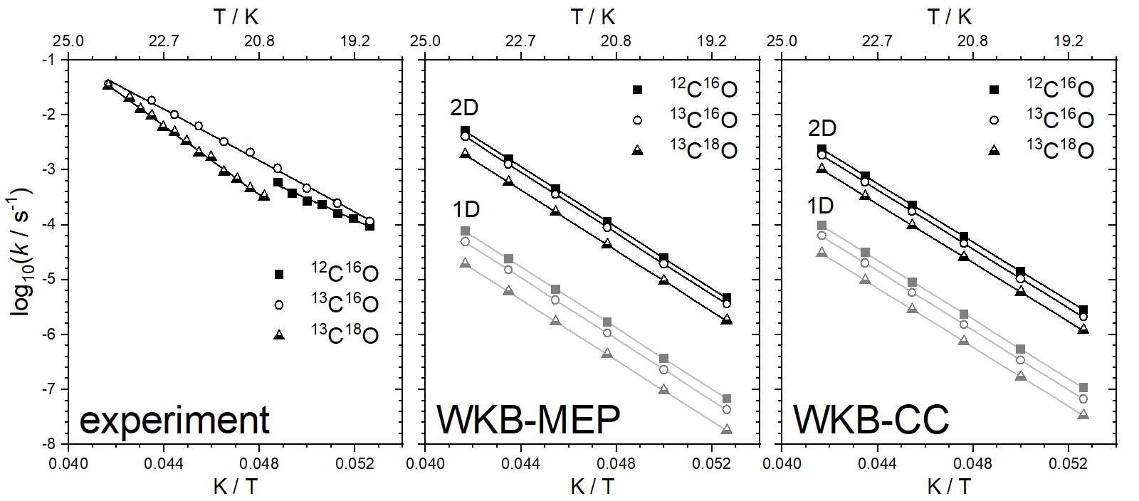
Figure S9: Thermally activated WKB tunneling rates and comparison to experiment. WKB-MEP and WKB-CC indicated use of the minimum energy path or the corner-cutting path, respectively, shown in fig. S8. The black and gray data show the results obtained when considering the 2D and 1D ZPE levels, respectively. Experimental rate constants are reproduced from Fig. 2 of the main text for comparison. All rate constants are shown as base-10 logarithms.

The isotope-dependent thermal WKB rate constants were fit to an Arrhenius form—those fitted parameters are reported in Table 1 of the main text for the cases where the 2D vibrational energy was used. These results are also given in table S2, alongside the Arrhenius parameters obtained when the 1D vibrational energy is considered. In each case, WKB predicts a conventional mass dependence where heavier isotopomers tunnel more slowly than lighter ones and Arrhenius activation energies that are nearly unchanged with isotopic substitution.
Table S2. Arrhenius parameters for the thermally-activated WKB rates. Results of both the MEP and CC methods are given, where either the 1D or 2D ZPEs are used.
 | WKB-MEP |  |  |  | WKB-CC
 | 1D ZPE |  | 2D ZPE |  | 1D ZPE |  | 2D ZPE
 | $A$ (s⁻¹) | $E_{a}$ (cm⁻¹) | $A$ (s⁻¹) | $E_{a}$ (cm⁻¹) | $A$ (s⁻¹) | $E_{a}$ (cm⁻¹) | $A$ (s⁻¹) | $E_{a}$ (cm⁻¹)
¹²C¹⁶O | 2.9$×$10⁷ | 445.0 | 1.9$×$10⁹ | 444.2 | 1.6$×$10⁷ | 431.2 | 3.2$×$10⁸ | 427.4
¹³C¹⁶O | 2.0$×$10⁷ | 446.5 | 1.6$×$10⁹ | 445.6 | 1.2$×$10⁷ | 433.8 | 2.9$×$10⁸ | 430.2
¹³C¹⁸O | 6.3$×$10⁶ | 442.4 | 6.0$×$10⁸ | 441.6 | 4.9$×$10⁶ | 430.8 | 1.4$×$10⁸ | 427.6

- Quantum Rate Theory: One-phonon Assisted Thermal Rates
  - Model
Fermi’s Golden Rule (FGR) combined with system-bath approaches is a widely used formulation to study vibrational relaxation dynamics in condensed-phase systems. Here, we utilize it to determine the phonon-bath driven transition rates for our system, CO on NaCl(100). In this system-bath approach, our system (an inverting CO molecule) is treated in two dimensions (2D), considering the important vibrational adsorbate modes involved in the isomerization reaction, namely $θ$ and $Z$. One-phonon assisted state-to-state transition rates are calculated for the back-flipping reaction, i.e., from “O-down” localized initial states to “C-down” localized final states, below the classical activation barrier, in the studied temperature range (19-24 K). The system modes are coupled to a harmonic bath comprising NaCl(100) surface phonons as well as the vibrational modes of the neighboring CO adsorbates, to mimic the experimental situation of a monolayer CO coverage.
The model Hamiltonian of the total system is
$$\begin{aligned}\hat{H}={\hat{H}}_{S}+{\hat{H}}_{B}+{\hat{H}}_{SB}\#\left(16\right)\end{aligned}$$
where ${\hat{H}}_{S}={\hat{H}}_{S}^{2D}$ is the 2D adsorbate Hamiltonian, ${\hat{H}}_{B}$ describes the phonon bath, and ${\hat{H}}_{SB}$ the coupling between adsorbate system and bath. The 2D system Hamiltonian is given by
$$\begin{aligned}{\hat{H}}_{S}^{2D}=-\frac{ℏ^{2}}{2M}\frac{∂^{2}}{∂Z^{2} }-\frac{ℏ^{2}}{2I}\frac{∂^{2}}{∂θ^{2} }+V(Z,θ;r,ϕ,X,Y)\#\left(17\right)\end{aligned}$$
where $M$ and $I=μr_{CO}^{2}$ are the total CO mass and moment of inertia, respectively, and fixed coordinates are indicated in the potential, $V$. The definitions of the remaining coordinates can be found in Ref. ¹⁹.
As mentioned earlier, this 2D Hamiltonian describes the perpendicular CO-surface motion and frustrated CO rotation on a NaCl(100) surface. For the potential, $V(Z,θ)$, we adopt a function which was calculated from gradient-corrected density functional theory (DFT) with dispersion corrections for a coverage of ¼ ML as obtained in Ref. ¹⁹. Details about the anharmonic potential are described in that reference. In particular, one finds a separation of “O-down” and “C-down” configurations of about 613 cm⁻¹, with a classical barrier (for “O-down” to “C-down” reaction) of 574 cm⁻¹ (see below). Note that for the experimental coverage (one ML, buried under an overlayer), slightly different potential parameters are expected, an effect which we neglect in the present theoretical model.
In Ref. ¹⁹, corresponding 2D system eigenfunctions were calculated by diagonalizing the system Hamiltonian in Eq. (17). The 2D system eigenstates correspond to bending and CO-surface stretching vibration levels, which when excited, will relax due to the system-bath coupling. “Relaxation” refers here to “O-down” to “C-down transitions – all relevant eigenstates to be considered below correspond to either “O-down” or “C-down” configurations. These eigenstates are computed for all three CO isotopomers under study.
The bath Hamiltonian is formulated as a sum of $N$ uncoupled harmonic oscillators,
$$\begin{aligned}{\hat{H}}_{B}=\sum_{b}^{N}{\left(-\frac{ℏ^{2}}{2}\frac{∂^{2}}{∂q_{b}^{2}}+\frac{1}{2}ω_{b}^{2}q_{b}^{2}\right)},\#\left(18\right)\end{aligned}$$
where $q_{b}=\sqrt{m_{b}} x_{b}$ are mass-weighted coordinates of the bath modes (which need, like masses $m_{b}$ and Cartesian coordinates $x_{b}$, not be further specified in what follows), and $ω_{b}$ is the harmonic frequency of mode b. Further, we assume a bilinear system-bath interaction by allowing only single-phonon excitations / relaxations in the bath, which can be written as
$$\begin{aligned}{\hat{H}}_{SB}=\sum_{b=1}^{N}{λ_{b}\left(Z,θ\right)q_{b}}.\#\left(19\right)\end{aligned}$$
Here, $λ_{b}(Z,θ)$ are the coordinate dependent system-bath coupling functions, assumed to be linear in both system modes,
$$\begin{aligned}λ_{b}\left(Z,θ\right)=c_{b}^{Z}(Z-Z_{0})+c_{b}^{θ}r_{eq}(θ-θ_{0}),\#\left(20\right)\end{aligned}$$
where $c_{b}^{Z/θ}$ represent the coupling constants of the corresponding degrees of freedom (DoFs) to the bath modes, and $r_{eq}$ is the equilibrium CO bond length (1.141 Å). $Z_{0}$ and $θ_{0}$ are reference coordinates which, again, need not be specified because they have no influence on the matrix elements entering the rate expressions below.
The coupling constants $c_{b}^{Z/θ}$ could, in principle, also be calculated from multi-dimensional system-bath potentials and Taylor expansion to first order ³⁵, but here we make two simple approximations instead. First, we set
$$c_{b}^{Z}=c_{b}^{θ}=c_{b},$$
i.e. we assume that both system modes couple equally to the phonon modes. A general procedure to obtain $c_{b}$ makes use of the so-called spectral density, $J(ω_{b})$; in a discretized form (with $Δω$ being a frequency spacing), the $c_{b}$ are then obtained as ³⁶
$$\begin{aligned}c_{b}=\sqrt{\frac{2}{π}J\left(ω_{b}\right)ω_{b}Δω}\#\left(21\right)\end{aligned}$$
where $ω_{b}=bΔω=bω_{f}/N$ are now equally spaced frequencies of the phonon bath up to a cutoff frequency $ω_{f}$, i.e., the Debye frequency of the NaCl(100) surface, 222 cm⁻¹.
The second approximation we make is to take the spectral density as proportional to the vibrational density of states (VDOS), $ρ_{VDOS}$, of the coupling phonons,
$$\begin{aligned}J\left(ω_{b}\right)=ερ_{VDOS}\left(ω_{b}\right),\#\left(22\right)\end{aligned}$$
where $ε$ is a proportionality constant. The use of $ε$ is two-fold. It serves as a correction term for proper units of the coupling constants – i.e., energy/(mass^{1/2}distance²) – and also as an adjusting parameter to scale the thermal rates with respect to the experimental values for one of the isotopomers. In the present calculations, we choose $ε$ = 10⁻⁸ in atomic units; for the ¹³C¹⁸O isotopomer, this choice leads to an isomerization rate at T = 20 K which agrees with the experimental value to within an order of magnitude.
The VDOS is taken to be that of a monolayer of CO molecules on a NaCl(100) surface, with one “O-down” CO. It is evaluated from ab inito molecular dynamics (AIMD) calculations at 30 K, using periodic DFT with the Perdew Becke Ernzerhof (PBE) functional and Grimme’s D2 dispersion correction – the same as used in Ref. ¹⁹. The VDOS is then calculated from the velocity-velocity autocorrelation function in an approach similar to ³⁷ after projecting out the contribution from the flipping CO and only including NaCl phonons and vibrations of neighboring CO molecules. Specifically, a $2\sqrt{2}×2\sqrt{2}×3$ slab model was used with four CO molecules per unit cell, and only the uppermost NaCl layer and the CO molecules were allowed to move in the AIMD calculations. The contribution of one CO molecule in the cell to the VDOS was projected out. The resulting VDOS, up to the Debye frequency of the NaCl surface, is shown in fig. S10. Also shown are the discretized values used in this work, at N=100 points ranging from $Δω$=2.22 cm⁻¹ up to $ω_{f}$.

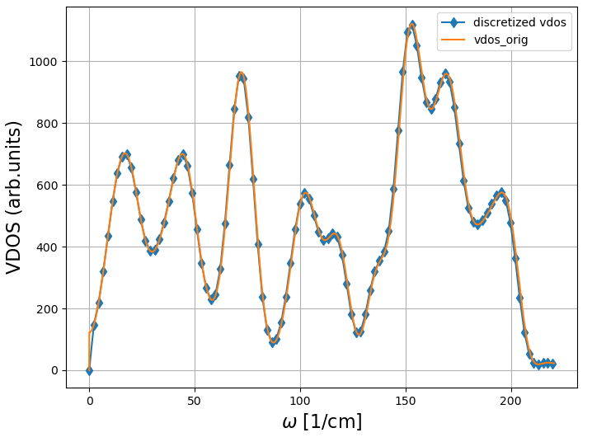
Figure S10. Projected VDOS accounting for the neighboring CO adsorbates and NaCl(100) phonons in 1 ML CO:NaCl(100) at 30K. The blue dots represent the discretized VDOS at the corresponding equally spaced bath frequencies.

Once we have the coupling functions and the 2D system eigenstates, we can evaluate the one-phonon coupling matrix elements to get transition rates between pairs of “O-down” and “C-down” eigenstates, using Fermi’s Golden Rule:
$$\begin{aligned}k_{if}=\frac{2π}{ℏ}{\left|\left\langle Φ_{i} | {\hat{H}}_{SB} | Φ_{f}\right\rangle \right|}^{2}δ\left(E_{f}-E_{i}\right).\#\left(23\right)\end{aligned}$$
Here, initial and final states, $Φ_{i}$ and $Φ_{f}$ respectively, are products of the anharmonic system states $\left.|n\right\rangle$ and $N$ uncoupled harmonic bath states, with $E_{i}$ and $E_{f}$ being the initial and final total energies of this zeroth order (uncoupled) system-bath Hamiltonian.
Plugging in the system-bath coupling Hamiltonian from (19), integrating out the bath modes, and summing over final bath states, one obtains the one phonon upward ($↑$) and downward ($↓$) rate for transition from system state $\left.|m\right\rangle$ to $\left.|n\right\rangle$ as given in Eqs. (24) and (25) ³⁸.
$$\begin{aligned}k_{mn}^{↑}=π\sum_{b}^{N}{{\left|\left\langle n | λ_{b}\left(Z,θ\right) | m\right\rangle \right|}^{2}}\frac{〈n_{b}〉}{ω_{b}}δ(E_{m}-E_{n}+ℏω_{b}) \#\left(24\right)\end{aligned}$$
$$\begin{aligned}k_{mn}^{↓}=π\sum_{b}^{N}{{\left|\left\langle n | λ_{b}\left(Z,θ\right) | m\right\rangle \right|}^{2}}\frac{〈n_{b}〉+1}{ω_{b}}δ(E_{m}-E_{n}-ℏω_{b}) \#\left(25\right)\end{aligned}$$
The “upward”(“downward”) rates lead to the system being excited (relaxed) from a “O-down” state with a lower (higher) energy, $E_{m}$, to a “C-down” state with higher (lower) energy, $E_{n}$, following absorption (emission) of a single phonon of frequency $ω_{b}$. The Bose-Einstein factors, $〈n_{b}〉=1/\left[exp⁡(hω_{b}/k_{b}T)-1\right]$, give the thermally-averaged quantum number of the b-th phonon mode. In our case we are interested in transitions from “O-down” states $\left.|m\right\rangle$ to “C-down” states $\left.|n\right\rangle$ only, i.e. in transitions between states in different wells of the double-well potential.
The thermal (Boltzmann-weighted) rate for transitions originating in initial (“O-down”) state $\left.|m\right\rangle$ is then given by
$$\begin{aligned}k_{m}\left(T\right)=e^{-β(E_{m}-E_{0})}\sum_{n}{k_{mn}}.\#\left(26\right)\end{aligned}$$
Here, $β=1/k_{B}T$ and $E_{0}$ is the zero-point energy in the “O-down” well. From these, the total temperature-dependent rate for transitions from “O-down” to “C-down” states is given by
$$\begin{aligned}k\left(T\right)=\sum_{m}{k_{m}(T)}.\#\left(27\right)\end{aligned}$$
The $k_{mn}$ included in Eq. (26) are either upward ($k_{mn}^{↑}$) or downward rates ($k_{mn}^{↓}$), depending on whether the energy of “O-down” state, $\left.|m\right\rangle$, is below or above the energy of the “C-down” state, $\left.|n\right\rangle$.
A suitable representation of the Dirac delta function is achieved by using Lorentzians ³⁸,
$$\begin{aligned}δ\left(x\right)≈\frac{1}{π}\frac{γ}{x^{2}+γ^{2}}.\#\left(28\right)\end{aligned}$$
Here, $γ$ is an adjustable parameter which can be chosen within physically reasonable ranges, in our case, $γ$= 2 cm⁻¹. At T=0 K, only downward transitions are possible, because $〈n_{b}〉=0$, i.e.
$$\begin{aligned}k_{mn}^{↓}=π\sum_{b}^{N}{{\left|\left\langle n | λ_{b}\left(Z,θ\right) | m\right\rangle \right|}^{2}}\frac{1}{ω_{b}}δ\left(E_{m}-E_{n}-ℏω_{b}\right) and k_{mn}^{↑}=0.\#\left(29\right)\end{aligned}$$
The zero-temperature ground state tunneling rates obtained in this way can be compared to the semi-classical WKB rates.
We note (again) that our model contains a number of simplifications, which could be improved in future work. The most important approximations are as follows. (i) The spectral density is a rather idealized one, treating every phonon mode as being essentially equally capable to couple to both system modes; of course, in reality different phonons will couple differently to the individual system modes. (ii) No two-phonon and higher contributions to the rates are included, excluding therefore also contributions of elastic scattering events which could arise from absorption and emission of the same phonon, connecting initial and final system states of the same energy, i.e., connect pairs of (near-)degenerate system states. (iii) A bilinear coupling model (Eqs. 17 & 18) was used, which is certainly only very approximate for the double-well potential along the $θ$ coordinate. (iv) No other DoFs of the molecule were considered. Despite these and further simplifications, our minimal model already accounts for the qualitative effects seen in experiment. Specifically, it predicts: an Arrhenius dependence of tunneling rates with effective activation energies lower than the bare barrier height and with small prefactors; the dominance of single or few, “gateway states”; and large isotope effects.
  - Results
Initial-state and total isomerization rates from “O-down” to “C-down” were calculated for all three isotopomers in the 19-24 K temperature range according to Eqs. (26) and (27). In fig. S11 (left panels), we show initial-state selected rates $k_{m}$ at T=20 K, as a function of initial energy, $E_{m}$. In fig. S11 (right panels), the contributions $k_{mn}$ from each individual transition originating in several initial states is represented by showing the ratio $k_{mn}$(T=20K)/$k$(T=20K) for various $m$ as a function of final-state energies $E_{n}$.
All energies in fig. S11 are given with respect to the classical minimum of the “C-down” configuration, so that the classical energy of the “O-down” configuration is 613 cm⁻¹ and the classical isomerization barrier is at an energy of 1187 cm⁻¹, corresponding to an O-down to C-down barrier of 574 cm⁻¹. From the left panels it is seen that indeed, one “gateway state” well below the classical barrier dominates the phonon-mediated isomerization. For instance, in case of ¹²C¹⁶O (fig. S11a) this is state 47, with an energy of 880 cm⁻¹; for ¹³C¹⁶O and ¹³C¹⁸O (figs. S11b and c), the dominating states are state 52 (at energy 899 cm⁻¹) and state 69 (at energy 951 cm⁻¹), respectively. Note that all state energies are isotopomer-dependent.
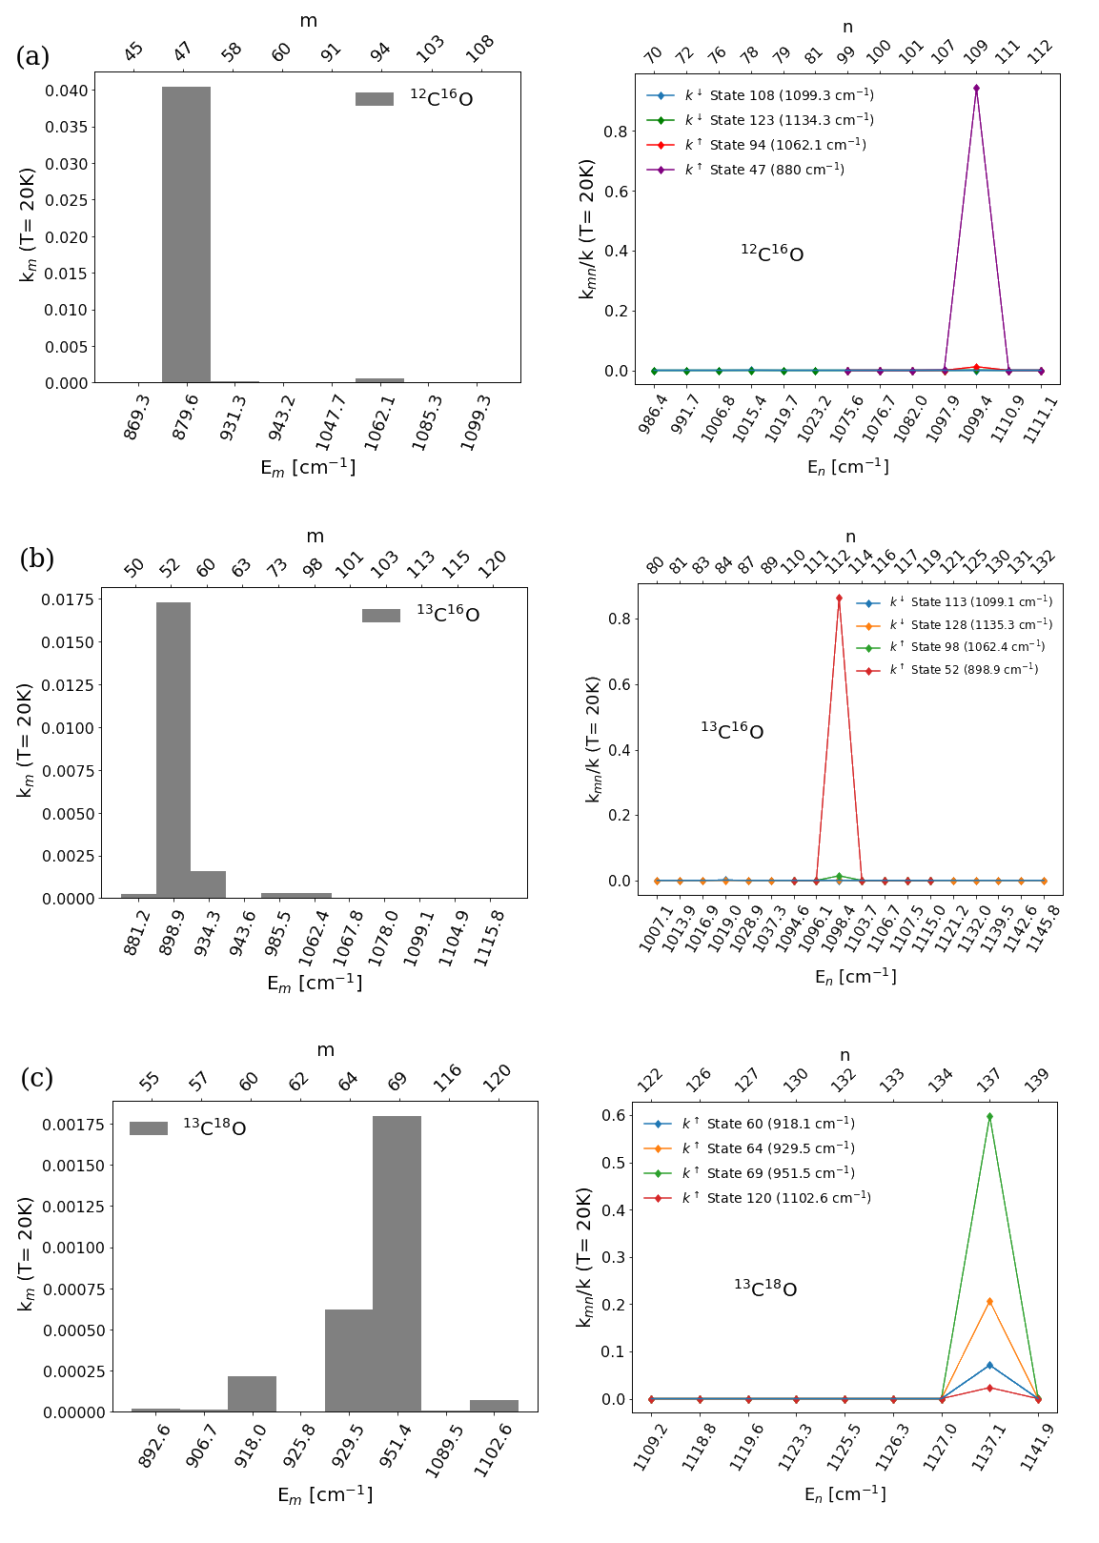
Figure S11. Initial state-selected upward/downward rates (in s⁻¹) at 20 K for ¼ ML. (a) ¹²C¹⁶O (b) ¹³C¹⁶O (c) ¹³C¹⁸O on NaCl(100) vs. initial “O-down” states $\left.|m\right\rangle$ (left panels) and fractional contribution to total rates of transitions from selected initial “O-down” states $\left.|m\right\rangle$ to selected final “C-down” states $\left.|n\right\rangle$ at 20 K (right panels). All energies are with respect to the classical minimum of the “C-down” configuration. The barrier height is 1187 cm⁻¹ on this scale and the lowest energy “O-down” states are at 685, 684 and 682 cm⁻¹ for the three isotopomers.

From fig. S11, we note that the transitions from “O-down” to “C-down” are dominated by processes with a single state-to-state transition from the “O-down” gateway state to a particular “C-down” state. For example, for ¹²C¹⁶O, state 47 (the initial “O-down” state) tunnels predominantly to state 109. Other transitions play basically no/very minor role in this case. State 109 has an energy of 1099 cm⁻¹, 219 cm⁻¹ higher than the initial state 47, i.e., this is an upward transition by which a phonon of this energy has to be emitted by the bath. For ¹³C¹⁶O and ¹³C¹⁸O, the dominant transitions are 52$→$112 and 49$→$137, respectively, with respective transition energy differences of 191 and 186 cm⁻¹. The wavefunctions of the corresponding gateway pairs $\left\{m,n\right\}$ are shown in Fig. 3 of the main text.
Note that in the present model, the dominating transitions are all “upward”, which may come as a surprise but is allowed by energy conservation. A refined model may weigh different phonon contributions differently, an effect which was not accounted for here. We note, however, that introducing an artificial cutoff energy for available phonon energies can lead to situations where lower-energy phonons (around 40 cm⁻¹) dominate and / or downward transitions gain importance. In all cases studied, the qualitative features remain largely unaffected, while the dominant gateway states can be different.
We performed FGR rate calculations for all three isotopomers, in the temperature range considered by experiment. See fig. 3 of the main text. For the temperature range shown, Arrhenius fits can be carried out to obtain the corresponding prefactors, $A_{FGR}$, and effective activation barrier energies, $E_{a}^{FGR}$, which we report in Table 1 of the main text. We find that the prefactors are quite low, and increase with mass of the isotopomer, just as in experiment. The effective activation energies are of the order ¹²C¹⁶O < ¹³C¹⁶O < ¹³C¹⁸O, and clearly lower than the classical activation energy of 574 cm⁻¹. Large isotope effects are found in qualitative agreement with experiment.
Quantitatively, deviations between experiment and our model emerge, which is not unexpected due to the simplifications made in the model. Most notably, the changes in the two parameters are not as high with changing isotopes as in experiment. For instance, the $E_{a}^{FRG}$ values of ¹²C¹⁶O are only 25 cm⁻¹ and 73 cm⁻¹ lower than that of ¹³C¹⁶O and ¹³C¹⁸O, respectively, in contrast to the experimentally derived values where the differences in $E_{a}^{obs}$ are 100 cm⁻¹ and 200 cm⁻¹ for the same, respectively. Also, the effective activation energies derived from our model are generally lower than in experiment, suggesting the participation of higher-lying gateway “O-down” states in experiment. As mentioned above, however, higher initial gateway states may gain importance in a more refined model for the phonon bath and its coupling to system modes. Also, the effective activation energies derived from our model are generally lower than in experiment, suggesting the participation of higher-lying gateway “O-down” states in experiment. As mentioned above, however, higher initial gateway states may gain importance in a more refined model for the phonon bath and its coupling to system modes.
Finally, the ground state tunneling rates at 0 K according to Eq. (29) are found to be ~ 10⁶ - 10⁷ times smaller, depending on the isotopomer, than the vibrationally excited state-to-state transition rates around T=20 K. With respect to the scaling of our model, the lifetimes of the ZPE-corrected “O-down” ground state for the three isotopomers are in the order of 8-20 years; the lifetime of the heaviest isotope, ¹³C¹⁸O, is lower than the other two, thereby showing a non-intuitive inverse mass dependence. As emphasized in the main text, this is in contrast to ground state lifetimes obtained from semiclassical theories like WKB, where the usual mass dependence (the heaviest isotope having the longest lifetime) is predicted.

- Attempted Measurement of the Ground State Tunneling Lifetime for ¹³C¹⁸O
To determine the rate of ground-state flipping from O-down to C-down, the O-down sample was prepared as described in section S1 at a surface temperature of 7K and monitored for about 120 hours (fig. S12). The change in integrated absorbance within this time is only $∼$3%. Based on this, we calculate a lifetime on the order of 1 year, which should be considered a lower limit.

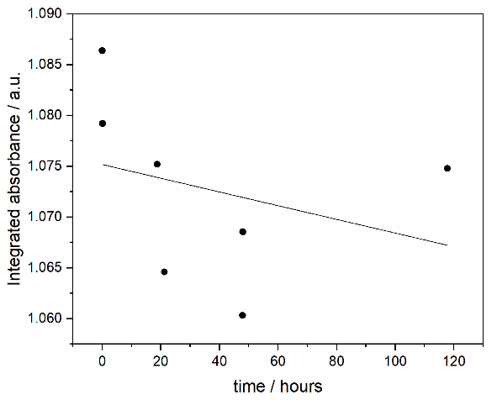
Figure S12: Long time measurement of the absorbance of O-down ¹³C¹⁸O at $T=$7K. The points show results of measurements and the line is a best fit exponential corresponding to 2 year lifetime. As we cannot rule out that this is noise, the measurements are only useful to put a lower limit on the lifetime of the ground state O-down isomer.

