Supplementary
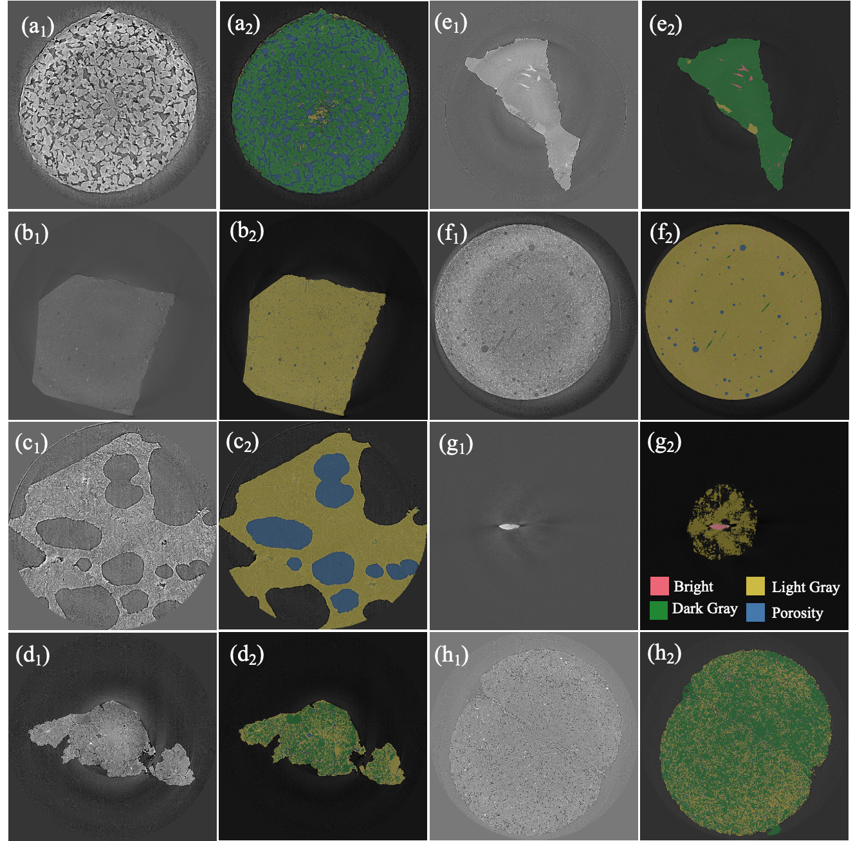
Supplementary Fig. S1. Original reconstructed images and their corresponding mask overlays for different micro-CT samples. (a) Titanium alloy with green and yellow masks overlay solid Titanium particles and blue mask overlays pores. (b) Red clay and its light and dark gray phases. (c) Basaltic ash from East African Virunga volcanic province. Yellow mask overlays ash particles, blue mask overlays pores. (d) Lunar regolith simulants. (e) Albite with light- and dark-gray attenuation phases, including possible fractures, pores, or mica-rich regions. (f) Fiber-reinforced cement paste. Green mask overlays hydrated cement paste matrix, pink mask overlays dehydrated cement grains, blue masks overlay porosity in both capillary pores and entrapped air voids, and yellow mask overlays fibers which have been added to the cement paste to improve its strength. (g) Coltan inside a wooden sample holder. Pink mask overlays Coltan sample, yellow mask overlays wooden sample holder. (h) Sand sandwiched between rocks.

