Supplementary Information for

Increased Moisture Amplifies Hazardous Humid-Heat in Africa’s Great Green Wall

Cascade Tuholske, Catherine Ivanovich, Emily L. Williams, Radley M. Horton , Shraddhanand Shukla, Chris Funk, Kwaw Andam, Christopher L. Kibler, Edmund I. Yamba, Andrew Zimmer, Nina Brooks

Corresponding author: Cascade Tuholske, cascade.tuholske1@montana.edu

The PDF file includes:

Figs. S1 to S12
Tables S1

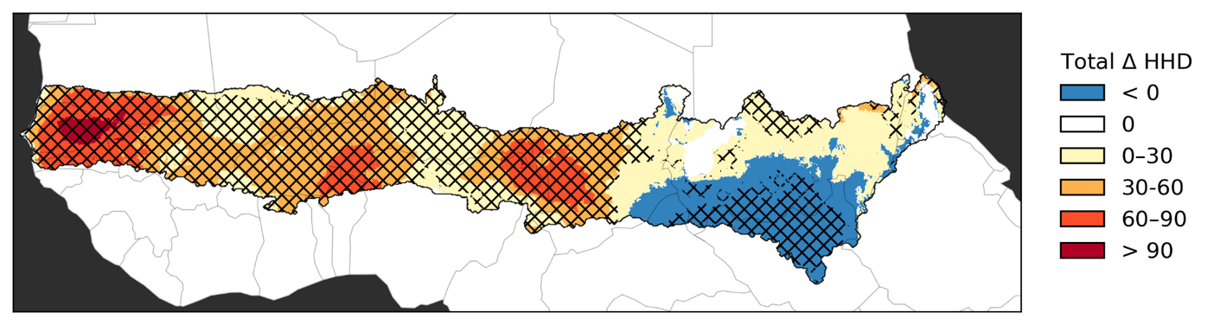
Fig. S1 Binned Changes in HHD
Total change in number of hazardous heat days (HHD) per year from 1983–2016, estimated by Theil-Sen trend estimator. Hatched areas show statistically significant (p<0.05; Mann-Kendall test). HHD are days where daily maximum heat index (HImax) > 40.6°C.

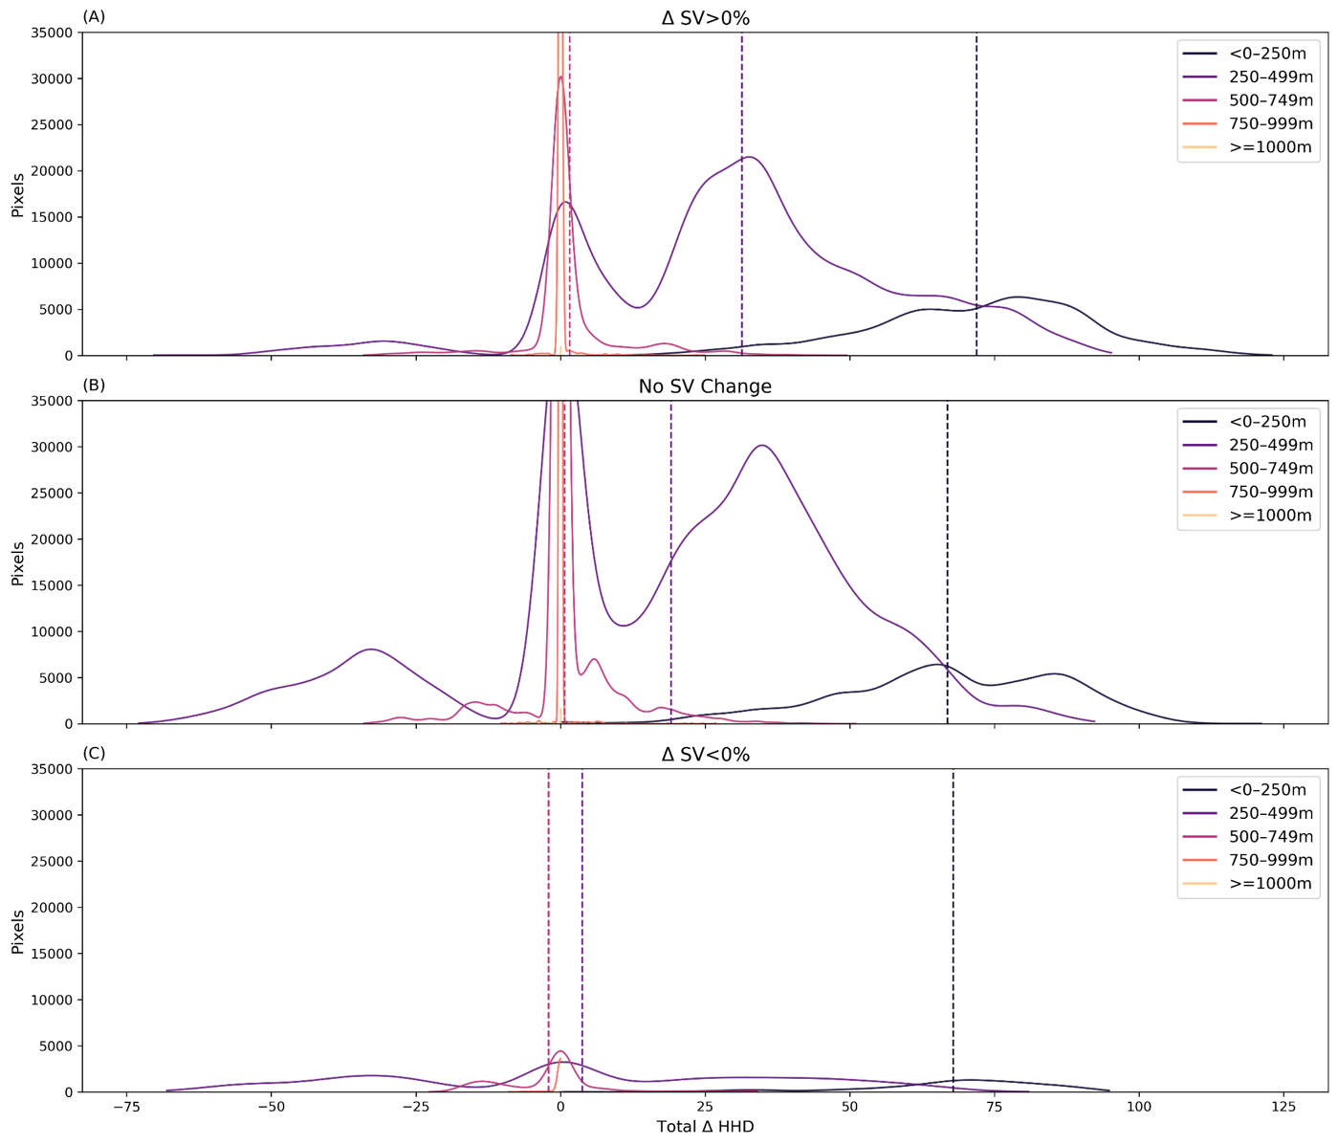
Fig. S2 Change in HH across Vegetation Categories by Elevation
Distribution of pixel-level total change in hazardous heat days (HHD) 1983–2016, estimated by Theil-Sen trend estimator binned by elevation gradients for areas where total short vegetation (A) increased, (B) did not change, and (C) decreased. Vertical lines show mean values for <0-250m, 250-499m, and 500-749m elevation bins. HHD are days where daily maximum heat index (HImax) > 40.6°C. Note that all pixels where total change in HHD is not statistically significant (p>0.05; Kendall's tau test) are set to zero before plotting.

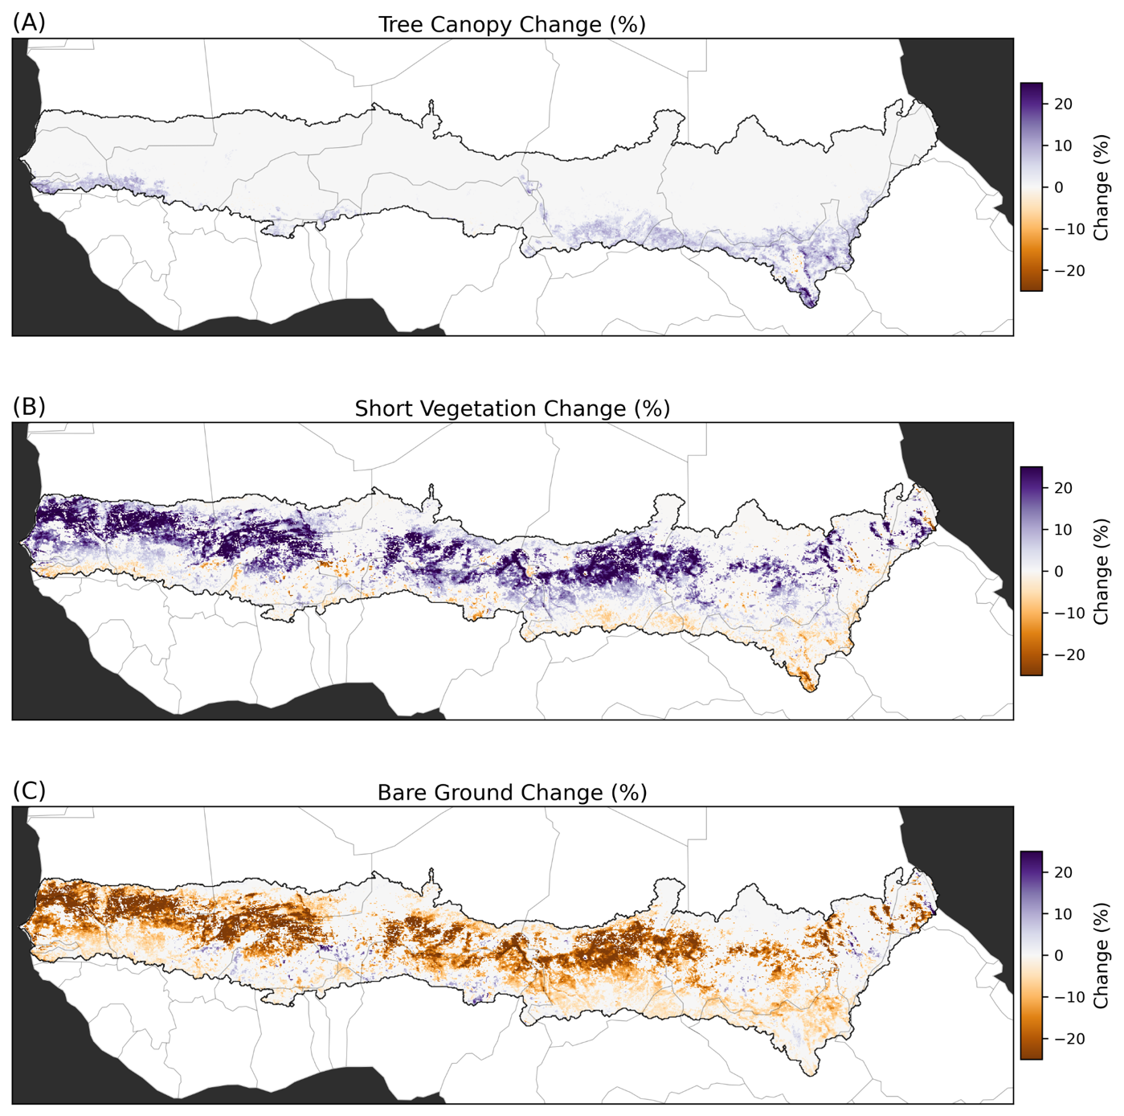
Fig. S3 Total Land-Cover and Land-Use Change Across the Sahel
(A) The percent change in tree canopy (TC), (B) short vegetation (SV), and (C) bare ground (BG) for the Sahel during 1982–2016.

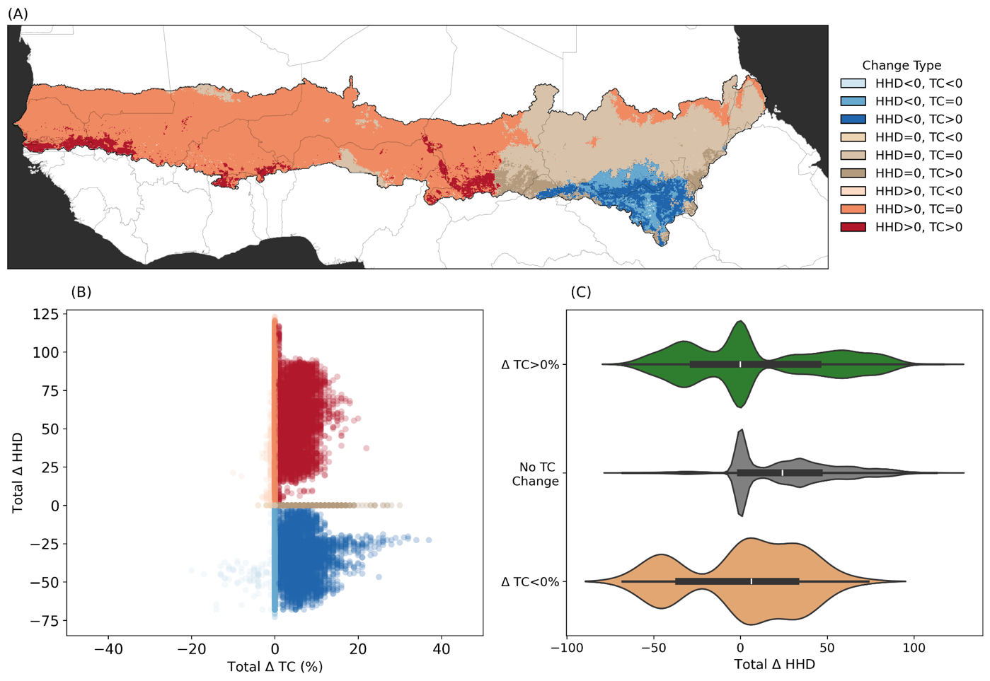
Fig. S4 Fig. 1 Total Change in HHD Frequency and Tree Canopy
(A) Paired categories of total HHD change and tree canopy (TC) percent change during study period. (B) Pixel-level relationship between total fitted change (slope multiplied by 34 years) in number of annual hazardous heat days (HHD) from 1983–2016 estimated by multiplying the Theil-Sen slope (HHD/year) by the 34-year study period and panel (A), correlating total HHD change with total TC change. (C) Distribution of total change in HHD binned by total SV change categories: TC>0% or total TC increase (green), no change (grey), and TC<0% or total TC decrease (tan). Kruskal-Wallis test show significantly different distributions among SV categories (p<0.001) in (C). Pairwise MannWhitney U tests show significantly different distributions in TC > 0% vs. No Change and No Change vs TC < 0%, but not TC > 0% vs. TC < 0% in (C).

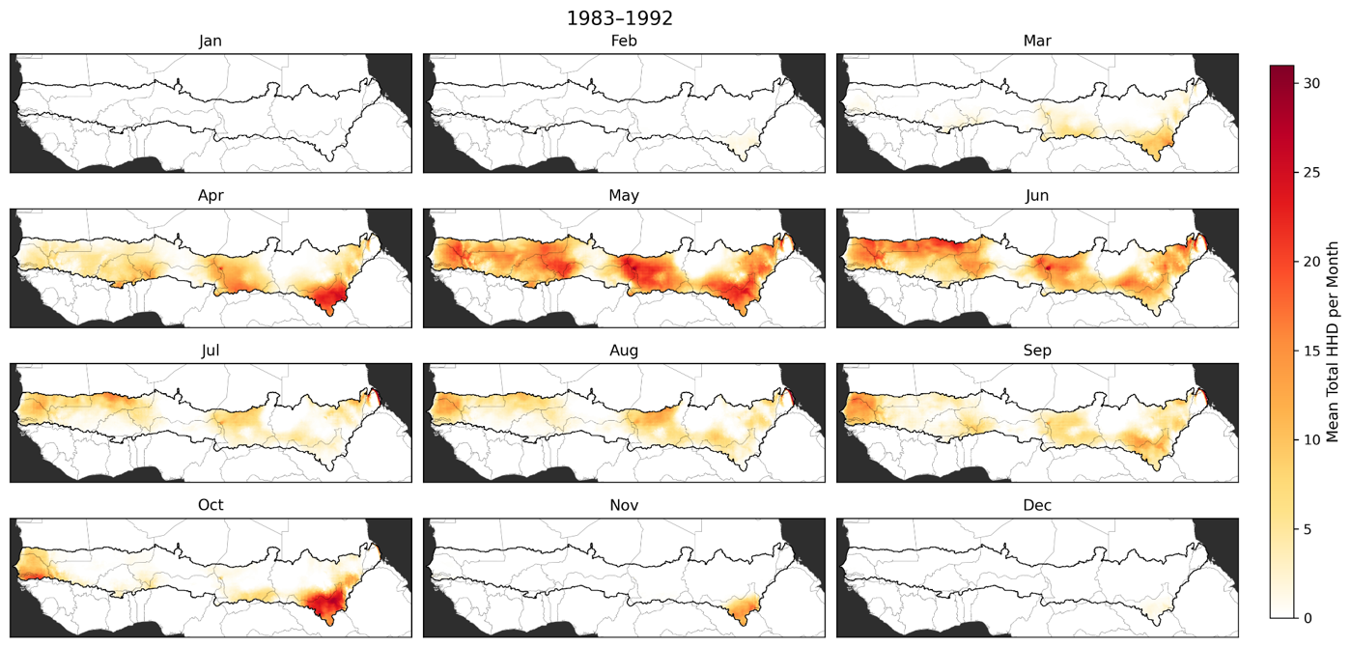
Fig. S5 Total HHD per Month
Mean total HHD per month during 1983-1992, the first decade of the study period. HHD are days where HImax > 40.6°C.

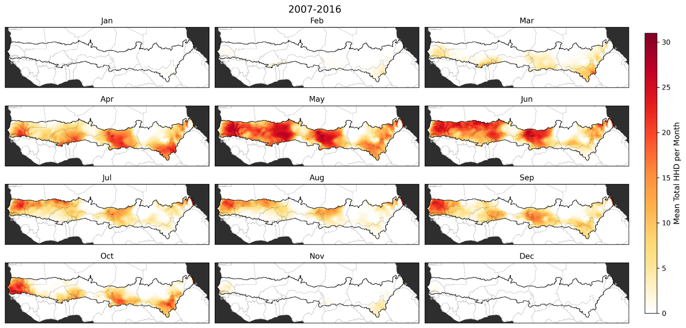
Fig. S6 Total HHD per Month
Figure S6 Mean total HHD per month during 2007-2016, the last decade of the study period. HHD are days where HImax > 40.6°C.

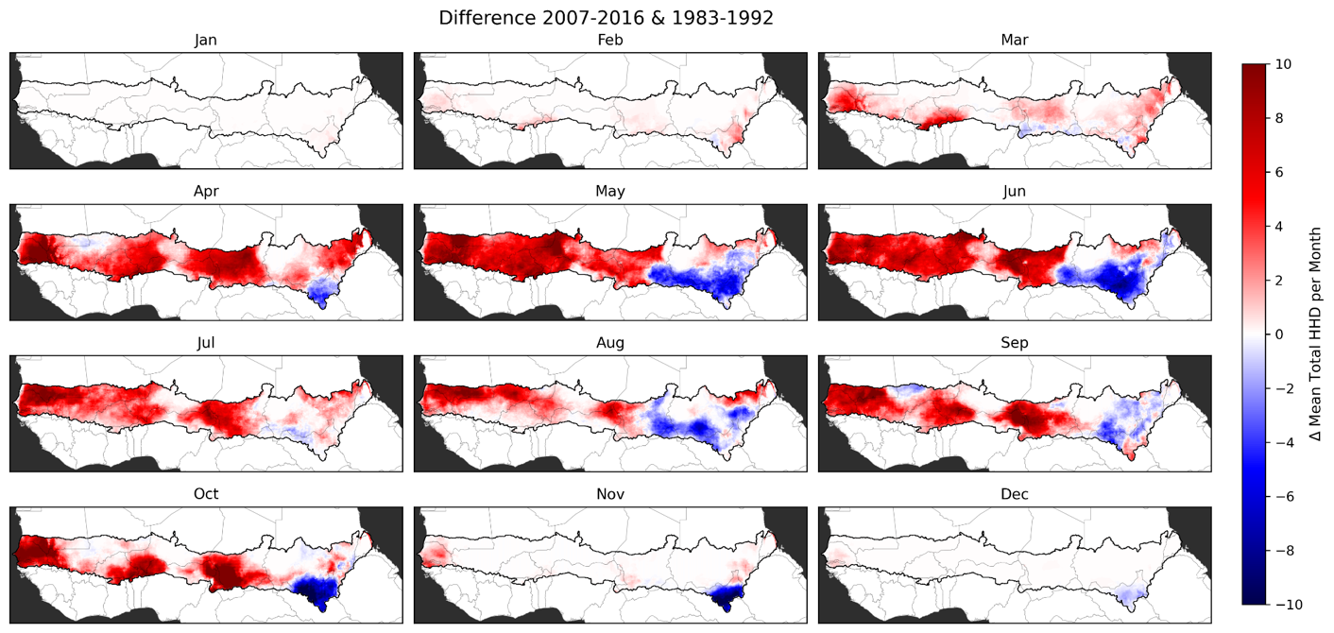
Fig. S7 Change in HHD per Month
Difference between mean total HHD per month during 2007-2016, the last decade of the study period, shown in Figure S4 and 1983-1992, the first decade of the study period shown in Figure S3. HHD are days where HImax > 40.6°C.

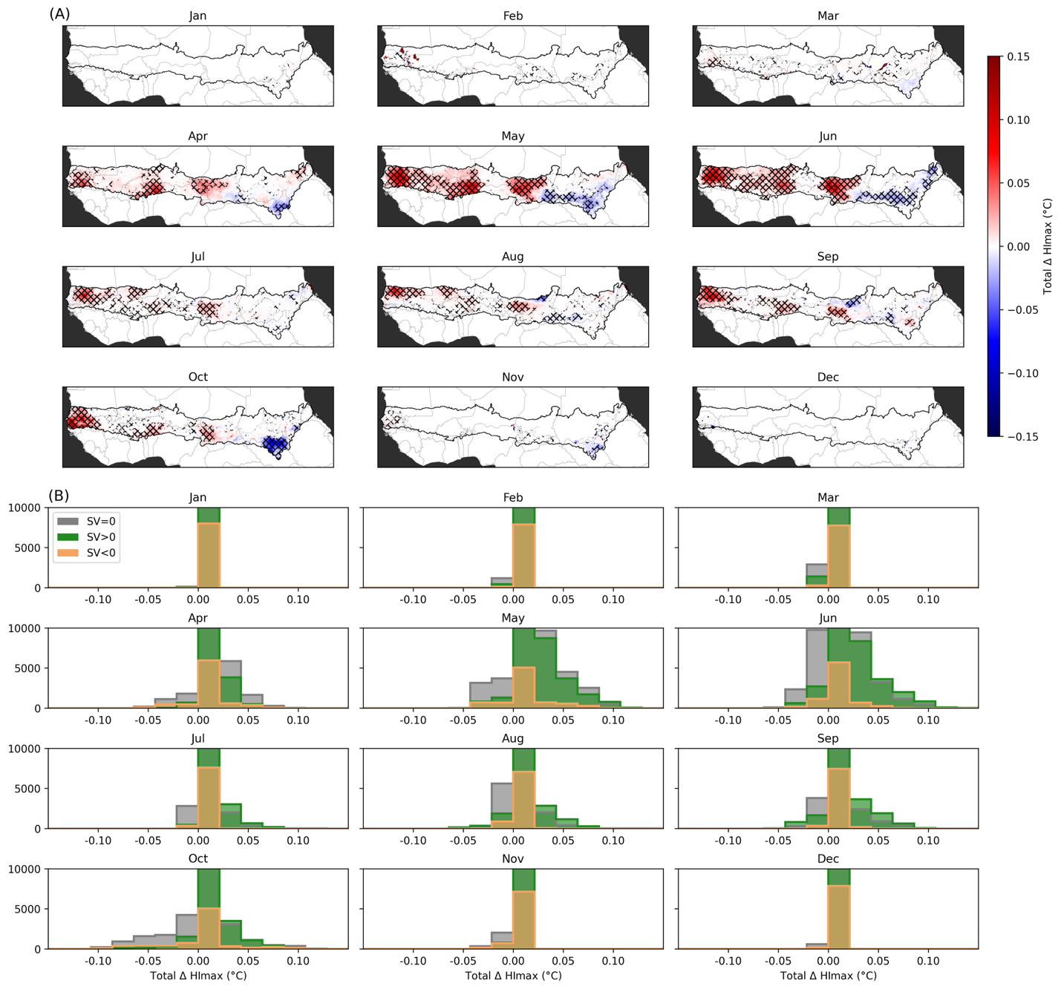
Fig. S8 Change in HImax during HHD
Spatial distribution of total fitted change in HImax during HHD for each month between 1983-2016 for the African Sahel. Hatching demarcates where fitted trends are significant at p<0.05 (Materials and Methods). (B) Distributions of map area shown in (A) binned by total short vegetation change. Kruskal-Wallis test and pairwise MannWhitney U tests both show significantly different distributions among SV categories (p<0.001) for all months except September for SV=0 vs. SV<0 pairwise test. Note that all non-statistically significant values in (A) are set to zero in (B).

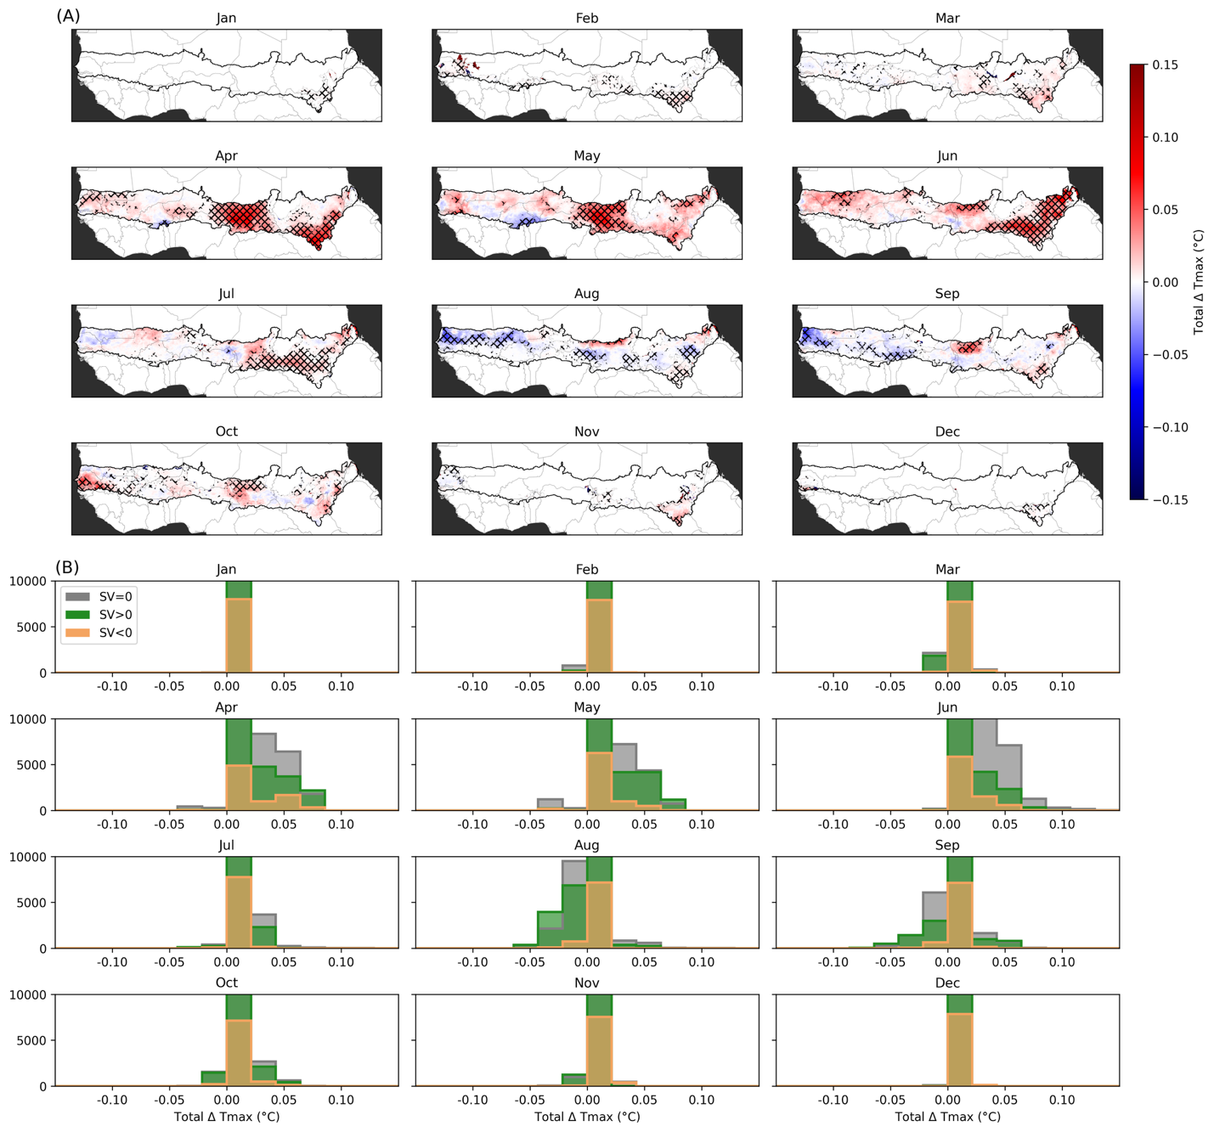
Fig. S9 Change in Tmax during HHD
Spatial distribution of total fitted change in Tmax during HHD for each month between 1983-2016 for the African Sahel. Hatching demarcates where fitted trends are significant at p<0.05 (Materials and Methods). (B) Distributions of map area shown in (A) binned by total short vegetation change. Kruskal-Wallis test and pairwise MannWhitney U tests both show significantly different distributions among SV categories (p<0.001) for all months except May and October for SV>0 vs. SV<0 pairwise tests. Note that all non-statistically significant values in (A) are set to zero in (B).

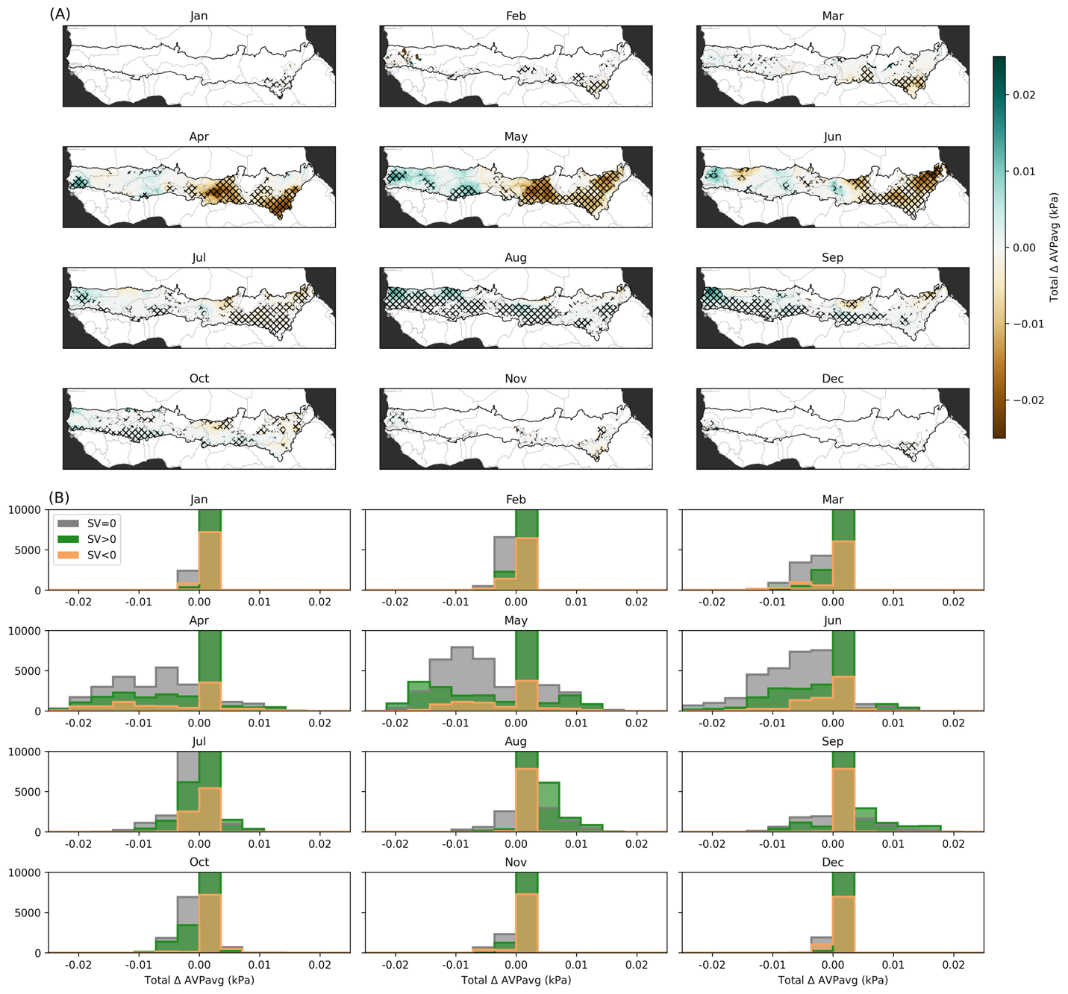
Fig. S10 Change in AVPavg during HHD
Spatial distribution of total fitted change in AVPavg during HHD for each month between 1983-2016 for the African Sahel. Hatching demarcates where fitted trends are significant at p<0.05 (Materials and Methods). (B) Distributions of map area shown in (A) binned by total short vegetation change. Kruskal-Wallis test and pairwise MannWhitney U tests both show significantly different distributions among SV categories (p<0.001) for all months except April for SV=0 vs. SV>0, as well as June, July and August SV=0 vs. SV>0 pairwise tests. Note that all non-statistically significant values in (A) are set to zero in (B).

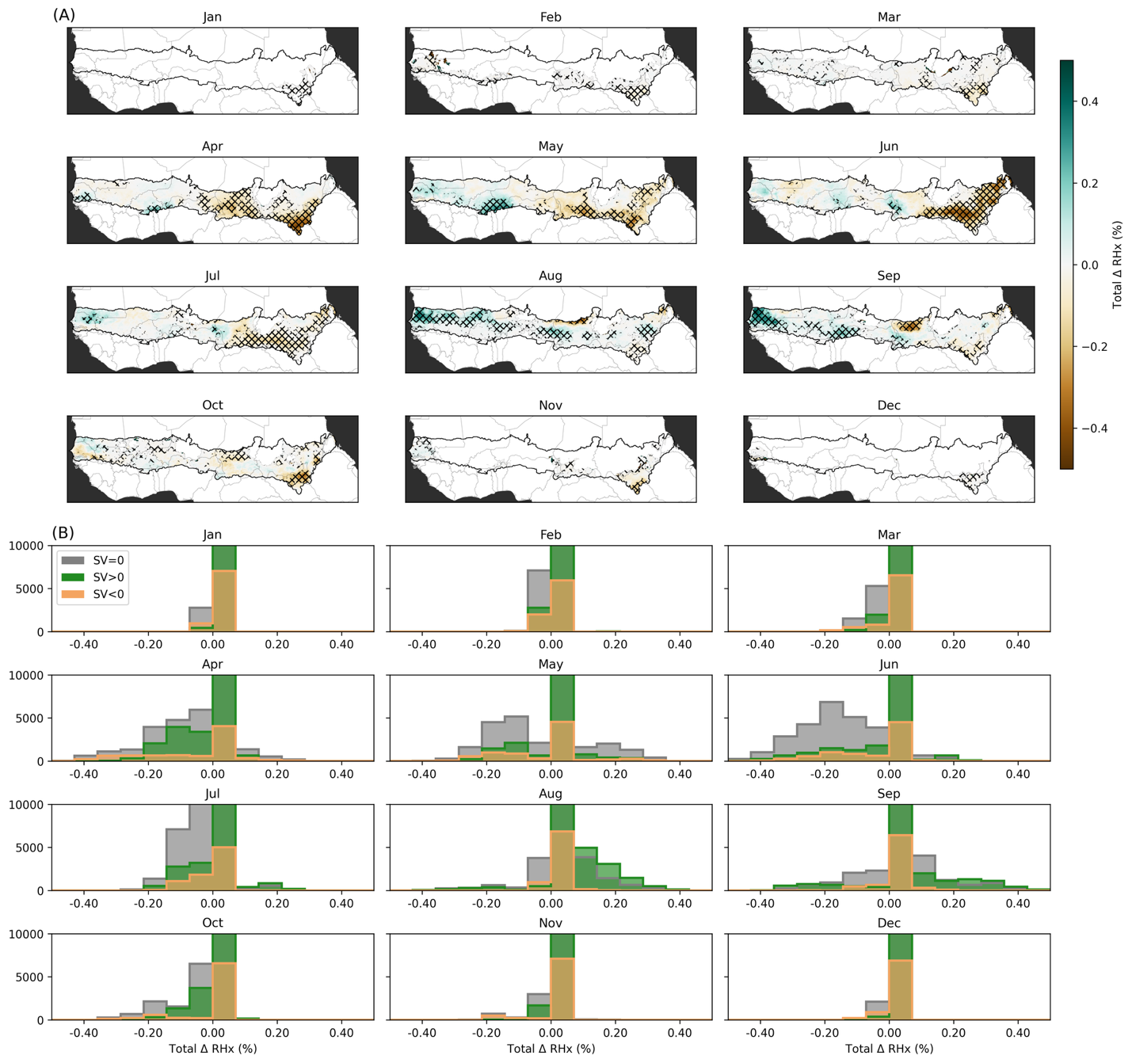
Fig. S11 Change in RHx during HHD
Spatial distribution of total fitted change in RHx during HHD for each month between 1983-2016 for the African Sahel. Hatching demarcates where fitted trends are significant at p<0.05 (Materials and Methods). (B) Distributions of map area shown in (A) binned by total short vegetation change. Kruskal-Wallis test and pairwise MannWhitney U tests both show significantly different distributions among SV categories (p<0.001) for all months except April for SV=0 vs. SV>0 pairwise test. Note that all non-statistically significant values in (A) are set to zero in (B).

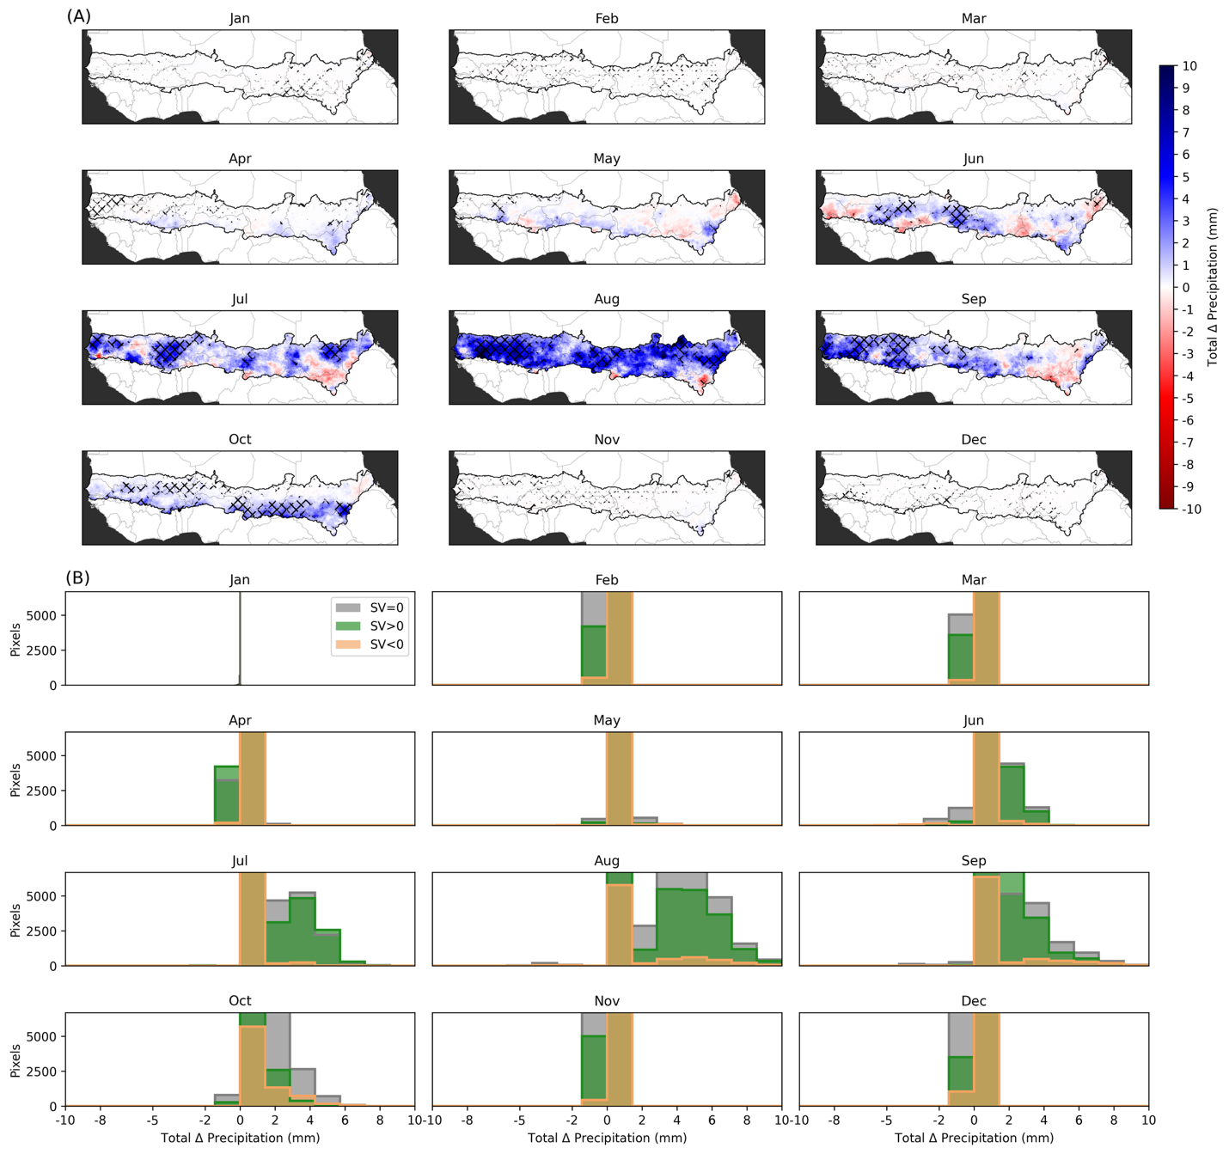
Fig. S12 Change in Total Precipitation
(A) Total fitted change in total monthly precipitation (mm) from 1983–2016, estimated by multiplying the Theil-Sen annual trend (mm/month) by the 34-year study period. Hatched areas show statistically significant (p<0.05; Mann-Kendall test). (B) Distributions of map area shown in (A) binned by total short vegetation change. Kruskal-Wallis test and pairwise MannWhitney U tests both show significantly different distributions among SV categories (p<0.001) for all months except April for SV=0 vs. SV<0, May for SV<0 vs. SV=0 and S><0 vs. SV=0, and October Sv>0 vs. SV=0 pairwise tests. Note that all non-statistically significant values in (A) are set to zero in (B).

Table S1: Trend statistics for HImax, Tmax, AVPavg, and RHx during hazardous humid-heat days (HHD) from 1983–2016 by short vegetation (SV) change category. For each metric and SV category, the table reports the OLS trend estimate, intercept, coefficient of determination (R²), p-value, standard error, 95% confidence interval, number of HHD days, total number of pixel-level HHD observations, and total change (Slope multiplied by # HHD, as in Figure 3) used in the analysis.

Metric | SV  Category | Slope  (10⁻³) | Intercept  (10⁻³) | R²  (10⁻³) | p-value | # HHD | Pixel-HDD  (10⁶) | Total  Change
HImax (°C) | SV>0 | 0.034 | 41.871 | 0.009 | <0.000 | 9,424 | 78.122 | 0.316
 | SV=0 | 0.015 | 41.935 | 0.002 | <0.000 | 9,654 | 117.711 | 0.145
 | SV<0 | 0.003 | 42.113 | 0.000 | <0.000 | 9,507 | 14.627 | 0.026
Tmax (°C) | SV>0 | 0.003 | 40.149 | 0.000 | <0.000 | 9,424 | 78.122 | 0.03
 | SV=0 | 0.036 | 39.543 | 0.002 | <0.000 | 9,654 | 117.711 | 0.352
 | SV<0 | 0.04 | 38.207 | 0.002 | <0.000 | 9,507 | 14.627 | 0.384
AVPavg (kPa) | SV>0 | 0.002 | 2.172 | 0.000 | <0.000 | 9,424 | 78.123 | 0.016
 | SV=0 | -0.007 | 2.306 | 0.002 | <0.000 | 9,654 | 117.711 | -0.072
 | SV<0 | -0.008 | 2.552 | 0.003 | <0.000 | 9,507 | 14.627 | -0.076
RHx (%) | SV>0 | 0.091 | 27.724 | 0.001 | <0.000 | 9,424 | 78.122 | 0.857
 | SV=0 | -0.105 | 30.504 | 0.001 | <0.000 | 9,654 | 117.711 | -1.01
 | SV<0 | -0.162 | 37.133 | 0.002 | <0.000 | 9,507 | 14.627 | -1.542

