Preferred Retinal Locus Location, Fixation Stability and Visual Function in Stargardt Disease and Age-Related Macular Degeneration
Juan E Cedrún-Sánchez^{1,2}; Carla Otero-Currás¹; Ainhoa M Armas-González¹; Amina Benserghine-Karmossi¹; Ricardo Bernárdez-Vilaboa¹; F. Javier Povedano-Montero^{1,3*}
¹ Department of Optics and Optometry, Faculty of Optics and Optometry, Universidad Complutense de Madrid, 28037 Madrid, Spain; jcedrun@ucm.es (J.E.C.-S.) ; ricardob@ucm.es (R.B.-V.) ; laursa24@ucm.es (L.S.-A.); mmedin13@ucm.es (M.M.-G); carlaote@ucm.es (C.O-C.); franpove@ucm.es (F.J.P.-M.)
² Applied Vision Research Group, Faculty of Optics and Optometry, Universidad Complutense de Madrid, 28037 Madrid, Spain.
³ Hospital Doce de Octubre Research Institute(i+12), 28041 Madrid, Spain
* Correspondence: franpove@ucm.es

Supplementary Material
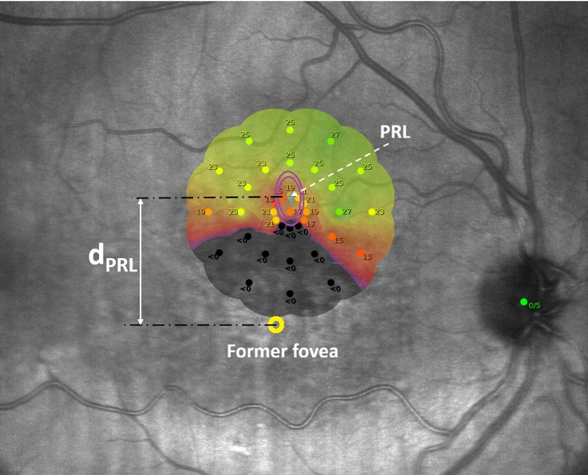
Online Resource 1 Example of preferred retinal locus identification and eccentricity measurement using MAIA microperimetry in an eye with Stargardt disease. The estimated former foveal location is indicated by the yellow marker, and the active preferred retinal locus (PRL) is shown by the fixation cluster. The distance between the former foveal location and the PRL ($d_{PRL}$) was 7°. The inner and outer purple ellipses represent the bivariate contour ellipse areas containing 63% (BCEA63) and 95% (BCEA95) of the fixation points, respectively. The numerical values indicate retinal sensitivity in decibels, whereas points with sensitivity below the measurable range delineate the central scotoma.

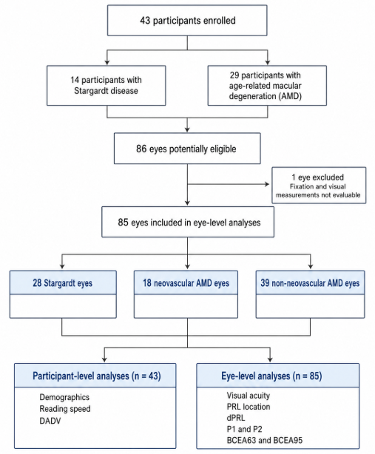
Online Resource 2 Flow diagram of participant and eye inclusion. A total of 43 participants were enrolled, including 14 with Stargardt disease and 29 with age-related macular degeneration (AMD), corresponding to 86 potentially eligible eyes. One eye was excluded because fixation and visual measurements were not evaluable. The final eye-level sample comprised 85 eyes: 28 with Stargardt disease, 18 with neovascular AMD, and 39 with non-neovascular AMD. Participant-level analyses included demographic characteristics, reading speed, and DADV score, whereas eye-level analyses included visual acuity, preferred retinal locus location, PRL eccentricity (dPRL), P1, P2, BCEA63, and BCEA95.

