Additional file 1
Supplementary information
Evaluating missing-data workflows under hospital-structured missingness: a simulation-calibrated study in eICU and MIMIC-IV
Jiancheng Zhang; Jianying Dai; Qingjiang Lyu*
* Correspondence: 20194040@zcmu.edu.cn

Supplementary Methods 1. Cohort implementation
For MIMIC-IV, ICU stays were ranked by intime within each hospital admission (hadm_id); the earliest stay was retained. Age at admission was reconstructed from anchor age and anchor year. Recorded race labels beginning with WHITE, BLACK, HISPANIC, or ASIAN were mapped to the four analysis groups. For eICU, records with unitvisitnumber = 1 were retained, age > 89 was represented as 90 years, and the source ethnicity values Caucasian, African American, Hispanic, and Asian were mapped to the harmonized labels. In both databases, patients younger than 18 years, records without known hospital discharge status, and records without female or male recorded sex were excluded.
The earliest numerical laboratory result within 0 to less than 24 hours after ICU entry was retained for each measure. MIMIC-IV laboratory item identifiers and eICU laboratory names are provided in Table S1. Broad plausibility filters were applied before missingness was assigned.

Supplementary Methods 2. Outcome-model transformations
The logistic outcome model contained an intercept, three recorded race/ethnicity indicators, age centered at 60 years and scaled per 10 years, recorded female sex, and eight laboratory terms. White blood cell count, platelets, blood urea nitrogen, creatinine, glucose, and total bilirubin were natural-log transformed. Sodium was transformed to absolute deviation from 140 mmol/L. Albumin was retained on its original scale. Laboratory terms were standardized using dataset-specific observed-data moments fixed before imputation.
For a comparison group g, predicted mortality was calculated after setting the group indicators to g for every member of the method-specific analysis population. The standardized risk was the mean predicted probability, or the stabilized-weighted mean for IPW. Risk differences were differences in standardized risks. Risk ratios were ratios of standardized risks. Delta-method gradients were used for within-analysis variance, and Rubin's rules combined within- and between-imputation variance.

Supplementary Methods 3. Multiple imputation
The chained-equation matrix included the eight incomplete laboratory values, age, recorded sex, in-hospital mortality, and race/ethnicity indicators. Each imputation used posterior sampling, median initialization, five chained-equation iterations, and prespecified minimum and maximum values. Twenty completed datasets were analyzed in the real-data study.
For eICU hospital-context MICE, two auxiliary values were added for every laboratory: the hospital-specific observed mean and the hospital-specific proportion observed. A global median replaced a hospital mean when no values were observed. These summaries were not included in the substantive mortality model. They were designed to inform imputation, not to estimate a hospital effect.

Supplementary Methods 4. Inverse-probability weighting
Joint completeness for the eight core laboratories was modeled with logistic regression. Predictors were age, recorded sex, in-hospital mortality, recorded race/ethnicity group, ICU unit type, and hospital. Predicted probabilities were bounded at 0.01 and 0.99. Stabilized weights used the overall complete-case proportion in the numerator and were truncated at their 1st and 99th percentiles. Effective sample size was calculated as the squared sum of weights divided by the sum of squared weights.

Supplementary Methods 5. Delta-adjusted MNAR scenarios
After MICE, originally missing values were shifted by 0.25 or 0.50 observed standard deviations toward greater severity. Directions were prespecified: higher white blood cell count, absolute sodium deviation, blood urea nitrogen, creatinine, glucose, and total bilirubin, and lower platelets and albumin. Shifted values were clipped to the same plausibility bounds used during cohort creation. The delta was applied only to values originally missing.

Supplementary Methods 6. ADEMP simulation specification

Aims
The simulation evaluated how patient-level, hospital-context, weighting, complete-case, and formal two-level imputation workflows recovered a replicate-specific standardized mortality risk difference and quantified uncertainty under clustered missingness.

Data-generating mechanisms
Each generated dataset contained 60 hospitals with 30 patients per hospital. Hospital context h was drawn from a standard normal distribution and affected the probability of belonging to the simulated Black group. Age was a truncated standard normal variable and sex was Bernoulli with hospital-context dependence. Two biomarkers were generated from correlated residuals (correlation 0.45), recorded group, age, and hospital context. Mortality followed a logistic model with coefficients 0.22 for recorded group, 0.42 for age, 0.22 for sex, 0.48 for biomarker 1, and -0.38 for biomarker 2.
Missingness was imposed under MCAR, individual MAR, hospital-structured MAR, or MNAR. Individual MAR depended on age, mortality, and recorded group. Hospital-structured MAR additionally depended on hospital context with opposite directions for the two biomarkers. MNAR additionally depended on the unobserved biomarker. Moderate missingness targeted 35% and 45% missingness; high missingness targeted 58% and 62%. Intercepts were numerically calibrated within every generated dataset. Two hundred datasets were generated for each of the eight mechanism-by-burden cells.

Estimand
The truth in each generated dataset was the mean predicted mortality difference after setting the recorded-group indicator to 1 versus 0 while holding the complete generated age, sex, and biomarker values fixed. The truth therefore varied slightly with the replicate-specific generated covariate distribution and averaged approximately 2.4 percentage points.

Methods
The compared methods were complete-case analysis, median imputation with indicators, IPW complete-case analysis, patient-level MICE, hospital-context MICE, and two-level MICE. The first five followed the main-text definitions. All substantive outcome models used the same unpenalized logistic regression and finite-sample hospital-cluster sandwich covariance.
Two-level MICE used a Bayesian Gaussian random-intercept regression for each incomplete biomarker. Each conditional model included the other biomarker, age, sex, recorded group, mortality, and a hospital random intercept. Fixed coefficients had independent normal priors with variance 100. Residual and random-intercept variances used inverse-gamma conditional updates with shape and scale hyperparameters of 2 and 1. Ten chained-equation cycles were run, and missing values were sampled from the posterior predictive distribution. Five completed datasets were analysed and combined using Rubin's rules.

Reproducibility controls
Random seeds were deterministic functions of mechanism and replicate number. A numerical failure was recorded when the substantive model failed to converge or produced a non-finite estimate or standard error. The unpenalized logistic solver and cluster sandwich covariance were independently checked against statsmodels; maximum absolute differences in a test replicate were below 3 x 10^-13 for coefficients and 2 x 10^-14 for covariance elements.

Supplementary Methods 7. Simulation performance measures
For successful replicates, bias was the mean of estimate minus replicate-specific truth. RMSE was the square root of mean squared error. Empirical standard deviation was the standard deviation of estimates. Mean estimated standard error summarized model-based uncertainty, and the standard-error calibration ratio divided it by the empirical standard deviation. Coverage was the proportion of nominal 95% confidence intervals containing the replicate-specific truth. Mean confidence-interval width and numerical failure rate were also reported.
MCSE for bias was the standard deviation of replicate-specific errors divided by the square root of the number of successful replicates. MCSE for RMSE used the delta method applied to the Monte Carlo variance of squared errors. MCSE for empirical standard deviation was the empirical standard deviation divided by the square root of twice the successful replicate count minus two. MCSEs for coverage and failure used the binomial formula. These calculations follow the ADEMP guidance of Morris and colleagues.

Supplementary tables
Table S1. Variable definitions, source fields, time window, and plausibility ranges.
Table S2. Complete set of standardized risk-difference and risk-ratio estimates.
Table S3. Inverse-probability weighting diagnostics.
Table S4. Missing-data workflow assumptions and principal limitations.
Table S5. Cohort flow by database.
Table S6A. Point-estimation performance under high missingness.
Table S6B. Interval and numerical performance under high missingness.
Table S7. Selected simulation performance by missingness burden.

Supplementary figure legends
Fig. S1. Complete-case retention by database and recorded race and ethnicity. Points show the percentage complete for all eight core laboratories. Horizontal bars show exact 95% binomial confidence intervals.
Fig. S2. Hospital-by-laboratory availability in eICU. Each row is one hospital and each column is one laboratory. Hospitals are ordered by mean availability across the ten displayed measures. Colour indicates the percentage of eligible patients with an observed value within 24 hours.
Fig. S3. Standardized in-hospital mortality risk ratios across missing-data workflows. Panels show Black versus White in MIMIC-IV (a) and eICU (b), Hispanic versus White in MIMIC-IV (c) and eICU (d), and Asian versus White in MIMIC-IV (e) and eICU (f). Points show standardized risk ratios and horizontal lines show 95% confidence intervals. The vertical reference is 1.
Fig. S4. Inverse-probability weighting diagnostics. (a) The 1st percentile, median, and 99th percentile of predicted joint-completeness probabilities. (b) The corresponding percentiles of truncated stabilized weights.
Fig. S5. Simulation performance by missingness burden. Bias under moderate (a) and high (b) missingness, and empirical 95% confidence-interval coverage under moderate (c) and high (d) missingness. Error bars show MCSE. The coverage reference is 95%.

Supplementary note on reproducibility and privacy
Additional file 2 contains the complete simulation code, scripts for the credentialed observational analyses, aggregate table and figure source data, simulated replicate-level results, the protocol, and an environment specification. It excludes the derived patient-level cohorts and all patient-level source data. Reproducing eICU and MIMIC-IV results requires credentialed PhysioNet access and acceptance of the applicable data-use agreements.

Embedded supplementary tables
Table S1. Variable definitions and harmonization
variable | label | MIMIC-IV source | eICU source | time rule | plausibility range
wbc | White blood cell count | MIMIC labevents itemid 51301 | eICU labname 'WBC x 1000' | First valid 0-24 h | 0.1-500
platelets | Platelet count | MIMIC itemid 51265 | eICU 'platelets x 1000' | First valid 0-24 h | 1-2000
sodium | Sodium | MIMIC itemid 50983 | eICU 'sodium' | First valid 0-24 h | 100-200
bun | Blood urea nitrogen | MIMIC itemid 51006 | eICU 'BUN' | First valid 0-24 h | 1-300
creatinine | Creatinine | MIMIC itemid 50912 | eICU 'creatinine' | First valid 0-24 h | 0.1-30
glucose | Glucose | MIMIC itemid 50931 | eICU 'glucose' | First valid 0-24 h | 10-2000
albumin | Albumin | MIMIC itemid 50862 | eICU 'albumin' | First valid 0-24 h | 0.5-6
bilirubin | Total bilirubin | MIMIC itemid 50885 | eICU 'total bilirubin' | First valid 0-24 h | 0.1-50
ph | pH | MIMIC itemid 50820 | eICU 'pH' | First valid 0-24 h; descriptive | 6.5-8.0
lactate | Lactate | MIMIC itemid 50813 | eICU 'lactate' | First valid 0-24 h; descriptive | 0.1-30

Table S2. Complete standardized estimates
Database | Method | Comparison | Estimand | Estimate (95% CI) | N | m
MIMIC-IV | Complete case | Black vs White | Risk difference, pp | -0.32 (-1.88, 1.25) | 17009 | 1
MIMIC-IV | Complete case | Black vs White | Risk ratio | 0.98 (0.89, 1.08) | 17009 | 1
MIMIC-IV | Complete case | Hispanic vs White | Risk difference, pp | -0.35 (-2.91, 2.20) | 17009 | 1
MIMIC-IV | Complete case | Hispanic vs White | Risk ratio | 0.98 (0.83, 1.15) | 17009 | 1
MIMIC-IV | Complete case | Asian vs White | Risk difference, pp | -1.25 (-3.91, 1.42) | 17009 | 1
MIMIC-IV | Complete case | Asian vs White | Risk ratio | 0.92 (0.77, 1.10) | 17009 | 1
MIMIC-IV | Median + missing indicators | Black vs White | Risk difference, pp | -0.44 (-1.09, 0.20) | 71818 | 1
MIMIC-IV | Median + missing indicators | Black vs White | Risk ratio | 0.96 (0.89, 1.02) | 71818 | 1
MIMIC-IV | Median + missing indicators | Hispanic vs White | Risk difference, pp | -0.53 (-1.60, 0.54) | 71818 | 1
MIMIC-IV | Median + missing indicators | Hispanic vs White | Risk ratio | 0.95 (0.85, 1.06) | 71818 | 1
MIMIC-IV | Median + missing indicators | Asian vs White | Risk difference, pp | 1.21 (0.03, 2.39) | 71818 | 1
MIMIC-IV | Median + missing indicators | Asian vs White | Risk ratio | 1.12 (1.01, 1.24) | 71818 | 1
MIMIC-IV | IPW complete case | Black vs White | Risk difference, pp | -0.39 (-1.73, 0.95) | 17009 | 1
MIMIC-IV | IPW complete case | Black vs White | Risk ratio | 0.96 (0.84, 1.10) | 17009 | 1
MIMIC-IV | IPW complete case | Hispanic vs White | Risk difference, pp | -0.54 (-2.76, 1.69) | 17009 | 1
MIMIC-IV | IPW complete case | Hispanic vs White | Risk ratio | 0.95 (0.76, 1.19) | 17009 | 1
MIMIC-IV | IPW complete case | Asian vs White | Risk difference, pp | -1.51 (-3.68, 0.66) | 17009 | 1
MIMIC-IV | IPW complete case | Asian vs White | Risk ratio | 0.86 (0.67, 1.09) | 17009 | 1
MIMIC-IV | Patient-level MICE | Black vs White | Risk difference, pp | -0.31 (-0.98, 0.36) | 71818 | 20
MIMIC-IV | Patient-level MICE | Black vs White | Risk ratio | 0.97 (0.91, 1.04) | 71818 | 20
MIMIC-IV | Patient-level MICE | Hispanic vs White | Risk difference, pp | -0.04 (-1.17, 1.09) | 71818 | 20
MIMIC-IV | Patient-level MICE | Hispanic vs White | Risk ratio | 1.00 (0.89, 1.11) | 71818 | 20
MIMIC-IV | Patient-level MICE | Asian vs White | Risk difference, pp | 1.34 (0.14, 2.54) | 71818 | 20
MIMIC-IV | Patient-level MICE | Asian vs White | Risk ratio | 1.13 (1.02, 1.26) | 71818 | 20
MIMIC-IV | Delta MNAR (+0.25 SD toward higher severity) | Black vs White | Risk difference, pp | -0.61 (-1.27, 0.05) | 71818 | 20
MIMIC-IV | Delta MNAR (+0.25 SD toward higher severity) | Black vs White | Risk ratio | 0.94 (0.88, 1.01) | 71818 | 20
MIMIC-IV | Delta MNAR (+0.25 SD toward higher severity) | Hispanic vs White | Risk difference, pp | -0.14 (-1.27, 0.99) | 71818 | 20
MIMIC-IV | Delta MNAR (+0.25 SD toward higher severity) | Hispanic vs White | Risk ratio | 0.99 (0.88, 1.10) | 71818 | 20
MIMIC-IV | Delta MNAR (+0.25 SD toward higher severity) | Asian vs White | Risk difference, pp | 1.28 (0.07, 2.49) | 71818 | 20
MIMIC-IV | Delta MNAR (+0.25 SD toward higher severity) | Asian vs White | Risk ratio | 1.13 (1.01, 1.25) | 71818 | 20
MIMIC-IV | Delta MNAR (+0.50 SD toward higher severity) | Black vs White | Risk difference, pp | -0.72 (-1.38, -0.07) | 71818 | 20
MIMIC-IV | Delta MNAR (+0.50 SD toward higher severity) | Black vs White | Risk ratio | 0.93 (0.87, 0.99) | 71818 | 20
MIMIC-IV | Delta MNAR (+0.50 SD toward higher severity) | Hispanic vs White | Risk difference, pp | -0.18 (-1.31, 0.95) | 71818 | 20
MIMIC-IV | Delta MNAR (+0.50 SD toward higher severity) | Hispanic vs White | Risk ratio | 0.98 (0.88, 1.10) | 71818 | 20
MIMIC-IV | Delta MNAR (+0.50 SD toward higher severity) | Asian vs White | Risk difference, pp | 1.26 (0.05, 2.46) | 71818 | 20
MIMIC-IV | Delta MNAR (+0.50 SD toward higher severity) | Asian vs White | Risk ratio | 1.12 (1.01, 1.25) | 71818 | 20
eICU | Complete case | Black vs White | Risk difference, pp | -0.79 (-2.67, 1.09) | 51823 | 1
eICU | Complete case | Black vs White | Risk ratio | 0.93 (0.78, 1.11) | 51823 | 1
eICU | Complete case | Hispanic vs White | Risk difference, pp | -2.01 (-4.36, 0.34) | 51823 | 1
eICU | Complete case | Hispanic vs White | Risk ratio | 0.83 (0.65, 1.05) | 51823 | 1
eICU | Complete case | Asian vs White | Risk difference, pp | -0.90 (-2.49, 0.68) | 51823 | 1
eICU | Complete case | Asian vs White | Risk ratio | 0.92 (0.80, 1.07) | 51823 | 1
eICU | Median + missing indicators | Black vs White | Risk difference, pp | 0.19 (-0.91, 1.29) | 145971 | 1
eICU | Median + missing indicators | Black vs White | Risk ratio | 1.02 (0.90, 1.15) | 145971 | 1
eICU | Median + missing indicators | Hispanic vs White | Risk difference, pp | 0.01 (-2.21, 2.24) | 145971 | 1
eICU | Median + missing indicators | Hispanic vs White | Risk ratio | 1.00 (0.78, 1.29) | 145971 | 1
eICU | Median + missing indicators | Asian vs White | Risk difference, pp | 0.02 (-1.07, 1.12) | 145971 | 1
eICU | Median + missing indicators | Asian vs White | Risk ratio | 1.00 (0.89, 1.13) | 145971 | 1
eICU | IPW complete case | Black vs White | Risk difference, pp | -0.26 (-1.78, 1.27) | 51823 | 1
eICU | IPW complete case | Black vs White | Risk ratio | 0.97 (0.82, 1.15) | 51823 | 1
eICU | IPW complete case | Hispanic vs White | Risk difference, pp | -1.44 (-3.94, 1.07) | 51823 | 1
eICU | IPW complete case | Hispanic vs White | Risk ratio | 0.84 (0.61, 1.16) | 51823 | 1
eICU | IPW complete case | Asian vs White | Risk difference, pp | -0.76 (-2.04, 0.52) | 51823 | 1
eICU | IPW complete case | Asian vs White | Risk ratio | 0.92 (0.79, 1.07) | 51823 | 1
eICU | Patient-level MICE | Black vs White | Risk difference, pp | 0.09 (-0.94, 1.11) | 145971 | 20
eICU | Patient-level MICE | Black vs White | Risk ratio | 1.01 (0.90, 1.13) | 145971 | 20
eICU | Patient-level MICE | Hispanic vs White | Risk difference, pp | -0.62 (-2.62, 1.38) | 145971 | 20
eICU | Patient-level MICE | Hispanic vs White | Risk ratio | 0.93 (0.73, 1.18) | 145971 | 20
eICU | Patient-level MICE | Asian vs White | Risk difference, pp | -0.08 (-1.19, 1.04) | 145971 | 20
eICU | Patient-level MICE | Asian vs White | Risk ratio | 0.99 (0.87, 1.12) | 145971 | 20
eICU | Hospital-context MICE | Black vs White | Risk difference, pp | 0.16 (-0.94, 1.26) | 145971 | 20
eICU | Hospital-context MICE | Black vs White | Risk ratio | 1.02 (0.90, 1.15) | 145971 | 20
eICU | Hospital-context MICE | Hispanic vs White | Risk difference, pp | -0.39 (-2.43, 1.65) | 145971 | 20
eICU | Hospital-context MICE | Hispanic vs White | Risk ratio | 0.96 (0.75, 1.21) | 145971 | 20
eICU | Hospital-context MICE | Asian vs White | Risk difference, pp | 0.16 (-0.99, 1.31) | 145971 | 20
eICU | Hospital-context MICE | Asian vs White | Risk ratio | 1.02 (0.90, 1.16) | 145971 | 20
eICU | Delta MNAR (+0.25 SD toward higher severity) | Black vs White | Risk difference, pp | 0.21 (-0.93, 1.35) | 145971 | 20
eICU | Delta MNAR (+0.25 SD toward higher severity) | Black vs White | Risk ratio | 1.02 (0.90, 1.16) | 145971 | 20
eICU | Delta MNAR (+0.25 SD toward higher severity) | Hispanic vs White | Risk difference, pp | -0.20 (-2.37, 1.96) | 145971 | 20
eICU | Delta MNAR (+0.25 SD toward higher severity) | Hispanic vs White | Risk ratio | 0.98 (0.76, 1.25) | 145971 | 20
eICU | Delta MNAR (+0.25 SD toward higher severity) | Asian vs White | Risk difference, pp | 0.32 (-0.85, 1.48) | 145971 | 20
eICU | Delta MNAR (+0.25 SD toward higher severity) | Asian vs White | Risk ratio | 1.04 (0.91, 1.18) | 145971 | 20
eICU | Delta MNAR (+0.50 SD toward higher severity) | Black vs White | Risk difference, pp | 0.29 (-0.87, 1.45) | 145971 | 20
eICU | Delta MNAR (+0.50 SD toward higher severity) | Black vs White | Risk ratio | 1.03 (0.91, 1.17) | 145971 | 20
eICU | Delta MNAR (+0.50 SD toward higher severity) | Hispanic vs White | Risk difference, pp | -0.03 (-2.30, 2.24) | 145971 | 20
eICU | Delta MNAR (+0.50 SD toward higher severity) | Hispanic vs White | Risk ratio | 1.00 (0.77, 1.29) | 145971 | 20
eICU | Delta MNAR (+0.50 SD toward higher severity) | Asian vs White | Risk difference, pp | 0.43 (-0.74, 1.60) | 145971 | 20
eICU | Delta MNAR (+0.50 SD toward higher severity) | Asian vs White | Risk ratio | 1.05 (0.92, 1.19) | 145971 | 20

Table S3. Inverse-probability weighting diagnostics
Diagnostic | MIMIC-IV | eICU
Complete-case prevalence | 0.237 | 0.355
Predicted probability: minimum | 0.082 | 0.010
Predicted probability: 1st percentile | 0.090 | 0.010
Predicted probability: median | 0.249 | 0.349
Predicted probability: 99th percentile | 0.454 | 0.750
Predicted probability: maximum | 0.527 | 0.906
Truncated weight: 1st percentile | 0.504 | 0.441
Truncated weight: median | 0.843 | 0.862
Truncated weight: 99th percentile | 2.546 | 2.866
Effective sample size | 14,006 | 43,681

Table S4. Missing-data workflow assumptions and limitations
approach | identifying or working assumption | principal limitation
Complete case | Complete-case selection is independent of the outcome conditional on analysis covariates for the target association | Targets the selected complete-case population; low precision when joint completeness is low
Median + missing indicators | Single-value replacement plus explicit missingness flags adequately captures the association | Can distort continuous covariate relationships and understate imputation uncertainty
IPW complete case | The completeness model is correct, probabilities are positive, and conditioning variables suffice for MAR | Unstable weights and low effective sample size; inference must account for estimated weights
Patient-level MICE | MAR conditional on included patient-level variables and compatible conditional models | Ignores residual hospital structure; extrapolates under high missingness
Hospital-context MICE | MAR conditional on patient variables plus hospital means and availability summaries | Pragmatic contextual augmentation, not a formal multilevel random-effects imputation model
Delta-adjusted MNAR | The specified direction and magnitude describe a plausible departure from MAR | Sensitivity scenario only; the delta is not identifiable from observed data

Table S5. Cohort flow
database | step | n
MIMIC-IV | First ICU stay per hospital admission | 85242
MIMIC-IV | Age >=18 years | 85242
MIMIC-IV | Known mortality and recorded female/male sex | 85242
MIMIC-IV | Four harmonized recorded race/ethnicity groups | 71818
MIMIC-IV | Complete for all eight core laboratories | 17009
eICU | First unit visit per hospital stay | 158442
eICU | Age >=18 years | 157883
eICU | Known mortality and recorded female/male sex | 156404
eICU | Four harmonized recorded race/ethnicity groups | 145971
eICU | Complete for all eight core laboratories | 51823

Table S6A. Point-estimation performance under high missingness
Scenario | Method | Mean truth, pp | Mean estimate, pp | Bias, pp (MCSE) | RMSE, pp (MCSE) | Mean complete, %
Hospital-structured MAR | Complete case | 2.45 | 0.35 | -2.10 (0.28) | 4.40 (0.18) | 11.6
Hospital-structured MAR | Hospital-context MICE | 2.45 | 4.30 | 1.85 (0.16) | 2.91 (0.14) | 11.6
Hospital-structured MAR | IPW complete case | 2.45 | 0.48 | -1.96 (0.57) | 8.17 (0.34) | 11.6
Hospital-structured MAR | Median + missing indicators | 2.45 | 7.19 | 4.74 (0.14) | 5.13 (0.14) | 11.6
Hospital-structured MAR | Patient-level MICE | 2.45 | 3.91 | 1.47 (0.17) | 2.81 (0.14) | 11.6
Hospital-structured MAR | Two-level MICE | 2.45 | 3.83 | 1.38 (0.17) | 2.83 (0.14) | 11.6
Individual MAR | Complete case | 2.44 | 1.55 | -0.89 (0.28) | 3.98 (0.18) | 16.0
Individual MAR | Hospital-context MICE | 2.44 | 3.64 | 1.20 (0.15) | 2.47 (0.14) | 16.0
Individual MAR | IPW complete case | 2.44 | 2.29 | -0.16 (0.52) | 7.31 (0.38) | 16.0
Individual MAR | Median + missing indicators | 2.44 | 7.48 | 5.03 (0.14) | 5.43 (0.14) | 16.0
Individual MAR | Patient-level MICE | 2.44 | 3.61 | 1.17 (0.16) | 2.55 (0.14) | 16.0
Individual MAR | Two-level MICE | 2.44 | 2.83 | 0.39 (0.16) | 2.30 (0.12) | 16.0
MCAR | Complete case | 2.43 | 2.62 | 0.19 (0.31) | 4.45 (0.23) | 16.0
MCAR | Hospital-context MICE | 2.43 | 3.50 | 1.08 (0.14) | 2.24 (0.14) | 16.0
MCAR | IPW complete case | 2.43 | 2.74 | 0.31 (0.33) | 4.74 (0.24) | 16.0
MCAR | Median + missing indicators | 2.43 | 7.74 | 5.31 (0.14) | 5.68 (0.15) | 16.0
MCAR | Patient-level MICE | 2.43 | 3.30 | 0.87 (0.15) | 2.23 (0.15) | 16.0
MCAR | Two-level MICE | 2.43 | 2.81 | 0.38 (0.14) | 2.03 (0.13) | 16.0
MNAR | Complete case | 2.45 | 1.41 | -1.03 (0.27) | 3.64 (0.18) | 14.4
MNAR | Hospital-context MICE | 2.44 | 5.94 | 3.51 (0.16) | 4.21 (0.16) | 14.3
MNAR | IPW complete case | 2.45 | 2.01 | -0.44 (0.61) | 7.91 (0.38) | 14.4
MNAR | Median + missing indicators | 2.44 | 5.85 | 3.41 (0.13) | 3.87 (0.13) | 14.3
MNAR | Patient-level MICE | 2.44 | 6.63 | 4.20 (0.17) | 4.84 (0.17) | 14.3
MNAR | Two-level MICE | 2.44 | 5.95 | 3.51 (0.17) | 4.28 (0.17) | 14.3

Table S6B. Interval and numerical performance under high missingness
Scenario | Method | Empirical SD, pp (MCSE) | Mean estimated SE, pp | SE ratio | Coverage, % (MCSE) | Mean CI width, pp | Successful / 200 | Failure, % (MCSE)
Hospital-structured MAR | Complete case | 3.87 (0.20) | 3.84 | 0.99 | 80.8 (2.8) | 15.06 | 198 / 200 | 1.0 (0.7)
Hospital-structured MAR | Hospital-context MICE | 2.26 (0.11) | 2.04 | 0.91 | 83.5 (2.6) | 8.02 | 200 / 200 | 0.0 (0.0)
Hospital-structured MAR | IPW complete case | 7.96 (0.40) | 7.09 | 0.89 | 85.9 (2.5) | 27.78 | 198 / 200 | 1.0 (0.7)
Hospital-structured MAR | Median + missing indicators | 1.98 (0.10) | 1.91 | 0.96 | 29.0 (3.2) | 7.47 | 200 / 200 | 0.0 (0.0)
Hospital-structured MAR | Patient-level MICE | 2.41 (0.12) | 2.16 | 0.90 | 88.5 (2.3) | 8.49 | 200 / 200 | 0.0 (0.0)
Hospital-structured MAR | Two-level MICE | 2.48 (0.12) | 2.41 | 0.97 | 92.5 (1.9) | 9.47 | 200 / 200 | 0.0 (0.0)
Individual MAR | Complete case | 3.89 (0.20) | 3.45 | 0.89 | 88.4 (2.3) | 13.53 | 198 / 200 | 1.0 (0.7)
Individual MAR | Hospital-context MICE | 2.18 (0.11) | 1.95 | 0.90 | 88.0 (2.3) | 7.65 | 200 / 200 | 0.0 (0.0)
Individual MAR | IPW complete case | 7.33 (0.37) | 6.33 | 0.86 | 89.9 (2.1) | 24.81 | 198 / 200 | 1.0 (0.7)
Individual MAR | Median + missing indicators | 2.06 (0.10) | 1.92 | 0.93 | 26.0 (3.1) | 7.53 | 200 / 200 | 0.0 (0.0)
Individual MAR | Patient-level MICE | 2.28 (0.11) | 2.08 | 0.91 | 90.0 (2.1) | 8.14 | 200 / 200 | 0.0 (0.0)
Individual MAR | Two-level MICE | 2.28 (0.11) | 2.21 | 0.97 | 92.5 (1.9) | 8.65 | 200 / 200 | 0.0 (0.0)
MCAR | Complete case | 4.46 (0.22) | 4.46 | 1.00 | 92.0 (1.9) | 17.47 | 200 / 200 | 0.0 (0.0)
MCAR | Hospital-context MICE | 1.99 (0.10) | 1.92 | 0.96 | 91.5 (2.0) | 7.53 | 200 / 200 | 0.0 (0.0)
MCAR | IPW complete case | 4.74 (0.24) | 4.95 | 1.04 | 94.0 (1.7) | 19.39 | 200 / 200 | 0.0 (0.0)
MCAR | Median + missing indicators | 2.06 (0.10) | 1.97 | 0.96 | 25.0 (3.1) | 7.74 | 200 / 200 | 0.0 (0.0)
MCAR | Patient-level MICE | 2.08 (0.10) | 2.02 | 0.97 | 93.0 (1.8) | 7.90 | 200 / 200 | 0.0 (0.0)
MCAR | Two-level MICE | 2.02 (0.10) | 2.10 | 1.04 | 96.5 (1.3) | 8.21 | 200 / 200 | 0.0 (0.0)
MNAR | Complete case | 3.49 (0.19) | 3.72 | 1.06 | 89.3 (2.4) | 14.57 | 169 / 200 | 15.5 (2.6)
MNAR | Hospital-context MICE | 2.35 (0.12) | 2.06 | 0.88 | 59.0 (3.5) | 8.06 | 200 / 200 | 0.0 (0.0)
MNAR | IPW complete case | 7.91 (0.43) | 7.51 | 0.95 | 89.9 (2.3) | 29.45 | 169 / 200 | 15.5 (2.6)
MNAR | Median + missing indicators | 1.84 (0.09) | 1.84 | 1.00 | 54.5 (3.5) | 7.20 | 200 / 200 | 0.0 (0.0)
MNAR | Patient-level MICE | 2.43 (0.12) | 2.18 | 0.90 | 52.5 (3.5) | 8.55 | 200 / 200 | 0.0 (0.0)
MNAR | Two-level MICE | 2.47 (0.12) | 2.41 | 0.98 | 68.5 (3.3) | 9.46 | 200 / 200 | 0.0 (0.0)

Table S7. Selected simulation performance by missingness burden
Burden | Scenario | Method | Bias, pp (MCSE) | RMSE, pp (MCSE) | Coverage, % (MCSE) | SE ratio | Failure, %
High missingness | Hospital-structured MAR | Complete case | -2.10 (0.28) | 4.40 (0.18) | 80.8 (2.8) | 0.99 | 1.0
High missingness | Hospital-structured MAR | Hospital-context MICE | 1.85 (0.16) | 2.91 (0.14) | 83.5 (2.6) | 0.91 | 0.0
High missingness | Hospital-structured MAR | IPW complete case | -1.96 (0.57) | 8.17 (0.34) | 85.9 (2.5) | 0.89 | 1.0
High missingness | Hospital-structured MAR | Median + missing indicators | 4.74 (0.14) | 5.13 (0.14) | 29.0 (3.2) | 0.96 | 0.0
High missingness | Hospital-structured MAR | Patient-level MICE | 1.47 (0.17) | 2.81 (0.14) | 88.5 (2.3) | 0.90 | 0.0
High missingness | Hospital-structured MAR | Two-level MICE | 1.38 (0.17) | 2.83 (0.14) | 92.5 (1.9) | 0.97 | 0.0
High missingness | Individual MAR | Complete case | -0.89 (0.28) | 3.98 (0.18) | 88.4 (2.3) | 0.89 | 1.0
High missingness | Individual MAR | Hospital-context MICE | 1.20 (0.15) | 2.47 (0.14) | 88.0 (2.3) | 0.90 | 0.0
High missingness | Individual MAR | IPW complete case | -0.16 (0.52) | 7.31 (0.38) | 89.9 (2.1) | 0.86 | 1.0
High missingness | Individual MAR | Median + missing indicators | 5.03 (0.14) | 5.43 (0.14) | 26.0 (3.1) | 0.93 | 0.0
High missingness | Individual MAR | Patient-level MICE | 1.17 (0.16) | 2.55 (0.14) | 90.0 (2.1) | 0.91 | 0.0
High missingness | Individual MAR | Two-level MICE | 0.39 (0.16) | 2.30 (0.12) | 92.5 (1.9) | 0.97 | 0.0
High missingness | MCAR | Complete case | 0.19 (0.31) | 4.45 (0.23) | 92.0 (1.9) | 1.00 | 0.0
High missingness | MCAR | Hospital-context MICE | 1.08 (0.14) | 2.24 (0.14) | 91.5 (2.0) | 0.96 | 0.0
High missingness | MCAR | IPW complete case | 0.31 (0.33) | 4.74 (0.24) | 94.0 (1.7) | 1.04 | 0.0
High missingness | MCAR | Median + missing indicators | 5.31 (0.14) | 5.68 (0.15) | 25.0 (3.1) | 0.96 | 0.0
High missingness | MCAR | Patient-level MICE | 0.87 (0.15) | 2.23 (0.15) | 93.0 (1.8) | 0.97 | 0.0
High missingness | MCAR | Two-level MICE | 0.38 (0.14) | 2.03 (0.13) | 96.5 (1.3) | 1.04 | 0.0
High missingness | MNAR | Complete case | -1.03 (0.27) | 3.64 (0.18) | 89.3 (2.4) | 1.06 | 15.5
High missingness | MNAR | Hospital-context MICE | 3.51 (0.16) | 4.21 (0.16) | 59.0 (3.5) | 0.88 | 0.0
High missingness | MNAR | IPW complete case | -0.44 (0.61) | 7.91 (0.38) | 89.9 (2.3) | 0.95 | 15.5
High missingness | MNAR | Median + missing indicators | 3.41 (0.13) | 3.87 (0.13) | 54.5 (3.5) | 1.00 | 0.0
High missingness | MNAR | Patient-level MICE | 4.20 (0.17) | 4.84 (0.17) | 52.5 (3.5) | 0.90 | 0.0
High missingness | MNAR | Two-level MICE | 3.51 (0.17) | 4.28 (0.17) | 68.5 (3.3) | 0.98 | 0.0
Moderate missingness | Hospital-structured MAR | Complete case | -1.23 (0.21) | 3.19 (0.14) | 88.0 (2.3) | 0.91 | 0.0
Moderate missingness | Hospital-structured MAR | Hospital-context MICE | 0.78 (0.14) | 2.09 (0.11) | 93.0 (1.8) | 0.99 | 0.0
Moderate missingness | Hospital-structured MAR | IPW complete case | -0.43 (0.32) | 4.56 (0.23) | 91.0 (2.0) | 0.91 | 0.0
Moderate missingness | Hospital-structured MAR | Median + missing indicators | 3.04 (0.13) | 3.57 (0.13) | 66.5 (3.3) | 0.97 | 0.0
Moderate missingness | Hospital-structured MAR | Patient-level MICE | 1.12 (0.15) | 2.39 (0.12) | 91.5 (2.0) | 0.95 | 0.0
Moderate missingness | Hospital-structured MAR | Two-level MICE | 0.32 (0.14) | 2.02 (0.11) | 93.5 (1.7) | 1.02 | 0.0
Moderate missingness | Individual MAR | Complete case | -1.08 (0.20) | 2.97 (0.15) | 85.0 (2.5) | 0.90 | 0.0
Moderate missingness | Individual MAR | Hospital-context MICE | 0.83 (0.14) | 2.19 (0.13) | 91.5 (2.0) | 0.93 | 0.0
Moderate missingness | Individual MAR | IPW complete case | -0.31 (0.30) | 4.26 (0.22) | 91.0 (2.0) | 0.90 | 0.0
Moderate missingness | Individual MAR | Median + missing indicators | 3.39 (0.14) | 3.92 (0.14) | 57.5 (3.5) | 0.92 | 0.0
Moderate missingness | Individual MAR | Patient-level MICE | 0.84 (0.15) | 2.29 (0.14) | 91.5 (2.0) | 0.92 | 0.0
Moderate missingness | Individual MAR | Two-level MICE | 0.12 (0.15) | 2.09 (0.13) | 92.5 (1.9) | 0.94 | 0.0
Moderate missingness | MCAR | Complete case | 0.55 (0.23) | 3.28 (0.19) | 90.5 (2.1) | 0.92 | 0.0
Moderate missingness | MCAR | Hospital-context MICE | 0.68 (0.13) | 1.95 (0.12) | 94.0 (1.7) | 1.01 | 0.0
Moderate missingness | MCAR | IPW complete case | 0.55 (0.24) | 3.42 (0.20) | 92.0 (1.9) | 0.91 | 0.0
Moderate missingness | MCAR | Median + missing indicators | 3.57 (0.14) | 4.05 (0.14) | 55.0 (3.5) | 0.97 | 0.0
Moderate missingness | MCAR | Patient-level MICE | 0.52 (0.13) | 1.96 (0.12) | 94.5 (1.6) | 1.00 | 0.0
Moderate missingness | MCAR | Two-level MICE | 0.06 (0.13) | 1.87 (0.11) | 95.0 (1.5) | 1.01 | 0.0
Moderate missingness | MNAR | Complete case | -1.62 (0.17) | 2.95 (0.13) | 82.5 (2.7) | 1.00 | 0.0
Moderate missingness | MNAR | Hospital-context MICE | 2.39 (0.14) | 3.14 (0.14) | 75.5 (3.0) | 0.95 | 0.0
Moderate missingness | MNAR | IPW complete case | -1.11 (0.34) | 4.90 (0.22) | 92.0 (1.9) | 0.98 | 0.0
Moderate missingness | MNAR | Median + missing indicators | 1.76 (0.13) | 2.51 (0.12) | 84.5 (2.6) | 0.97 | 0.0
Moderate missingness | MNAR | Patient-level MICE | 3.47 (0.15) | 4.10 (0.15) | 63.0 (3.4) | 0.96 | 0.0
Moderate missingness | MNAR | Two-level MICE | 2.25 (0.15) | 3.09 (0.14) | 82.0 (2.7) | 0.98 | 0.0

Supplementary figures
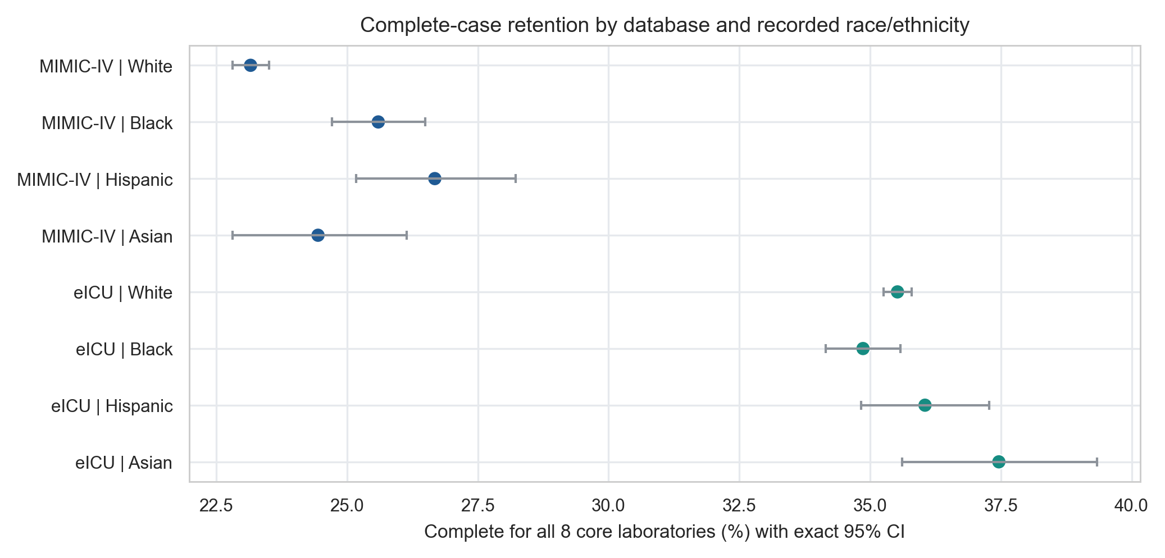
Fig. S1. Complete-case retention by database and recorded race and ethnicity.

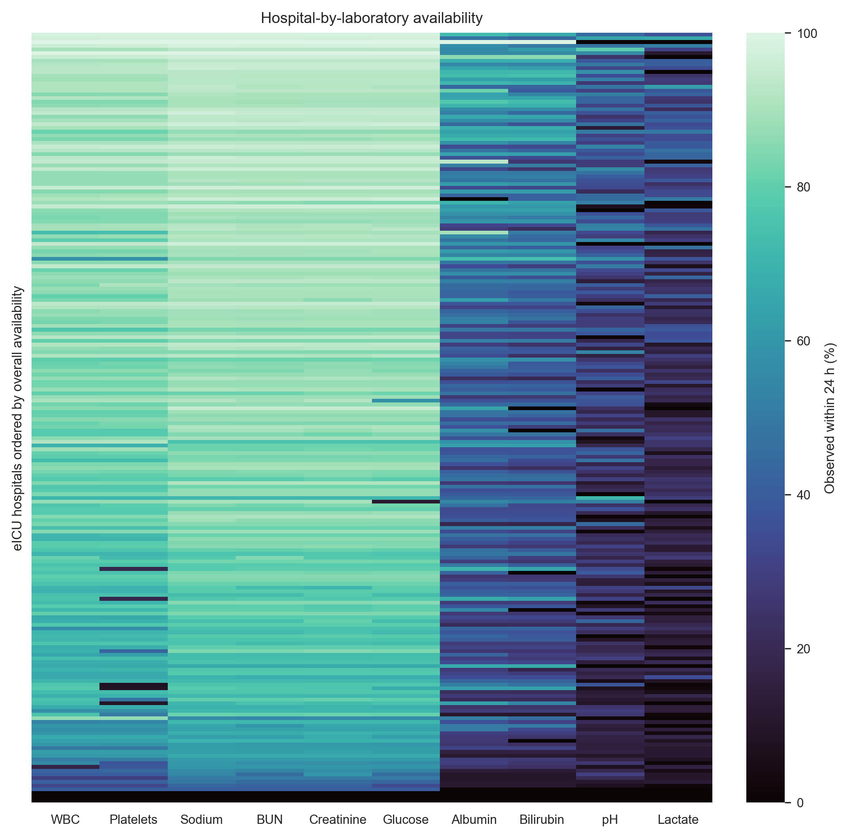
Fig. S2. Hospital-by-laboratory availability in eICU.

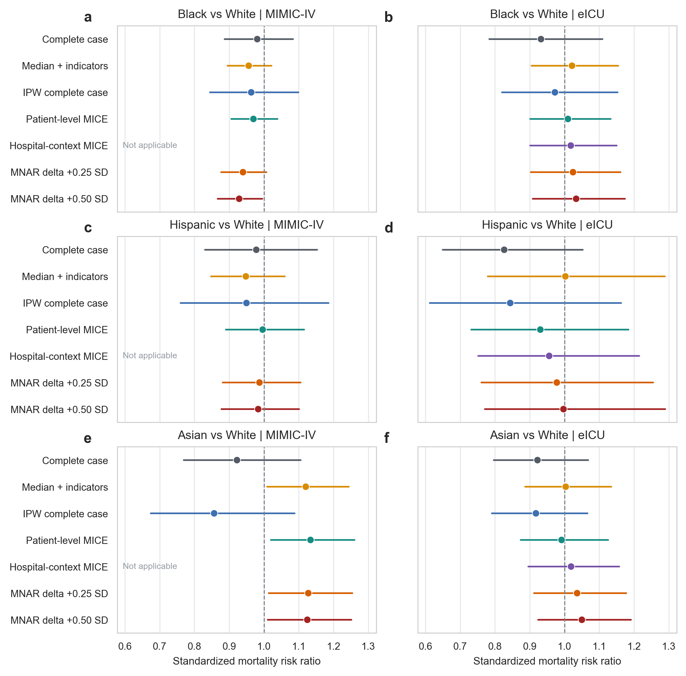
Fig. S3. Standardized mortality risk ratios across missing-data workflows.

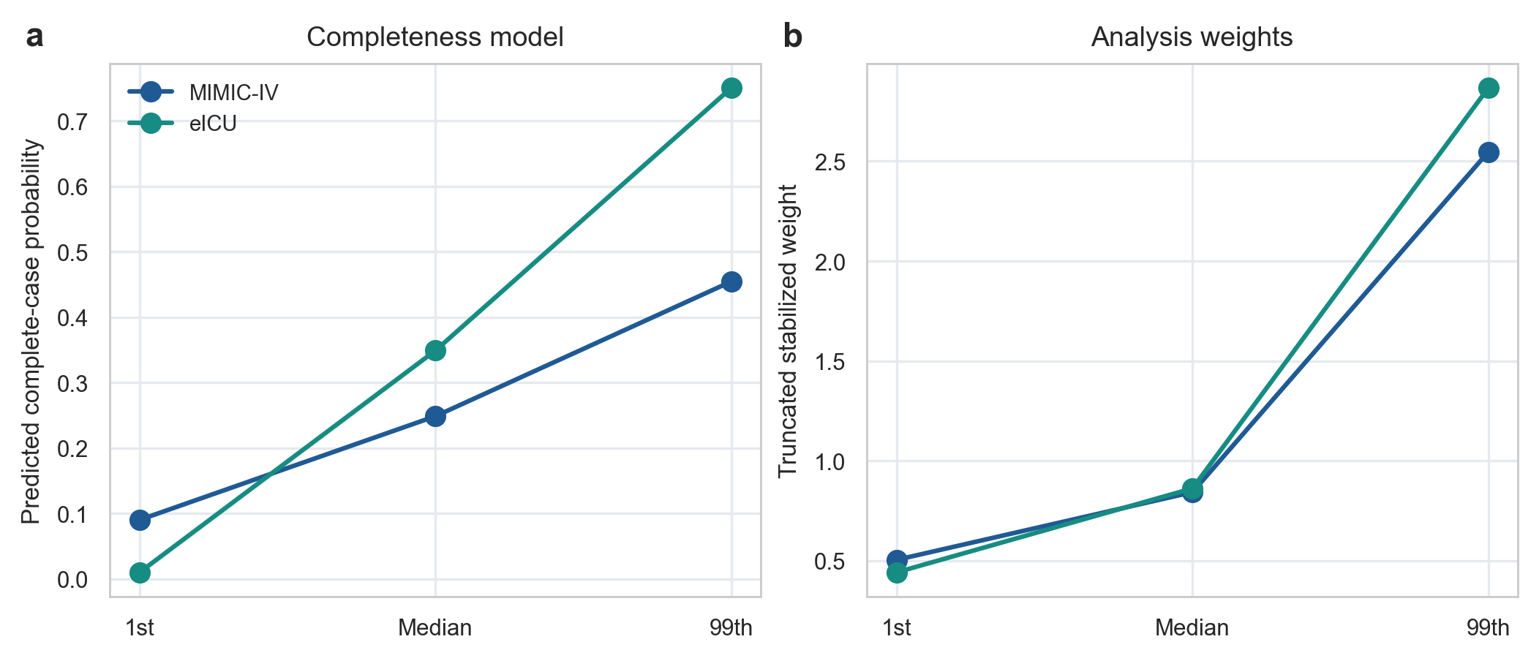
Fig. S4. Inverse-probability weighting diagnostics.

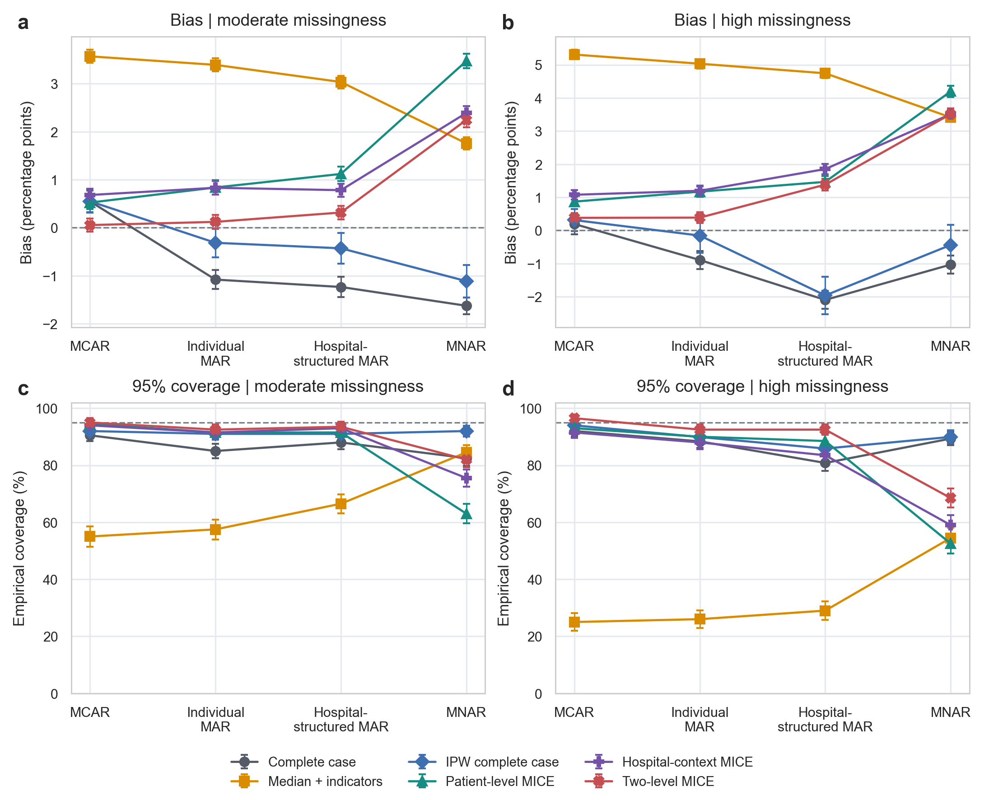
Fig. S5. Simulation performance by missingness burden.

