SUPPLEMENTARY MATERIAL
Supplementary Table S1. Database search strategies used for each electronic database.

Database | Search Strategy | Results
PubMed | ('hematologic malignancy' OR 'hematologic neoplasm' OR 'blood cancer') AND ('adjuvant chemotherapy' OR 'chemotherapy') AND ('hospitalization' OR 'hospitalisation') AND ('body composition' OR 'anthropometry' OR 'dietary intake' OR 'food intake' OR 'muscle mass' OR 'nutritional assessment' OR 'nutrition screening') | 1766
LILACS/BVS | ("neoplasias hematológicas" OR "câncer do sangue" OR "câncer hematológico") AND ("quimioterapia adjuvante" OR "quimioterapia") AND ("composição corporal" OR "antropometria" OR "ingestão alimentar" OR "massa muscular" OR "avaliação nutricional" OR "triagem nutricional") | 19
Embase | ('hematologic malignancy' OR 'hematologic neoplasm' OR 'blood cancer') AND ('adjuvant chemotherapy' OR 'chemotherapy') AND ('hospitalization' OR 'hospitalisation') AND ('body composition' OR 'anthropometry' OR 'dietary intake' OR 'food intake' OR 'muscle mass' OR 'nutritional assessment' OR 'nutrition screening') | 244
Scopus | ("hematologic malignancy" OR "hematologic neoplasm" OR "blood cancer") AND ("adjuvant chemotherapy" OR "chemotherapy") AND ("body composition" OR "anthropometry" OR "dietary intake" OR "food intake" OR "muscle mass" OR "nutritional assessment" OR "nutrition screening") | 111
EBSCO | ("hematologic malignancy" OR "blood cancer" OR "hematologic neoplasm") AND ("adjuvant chemotherapy" OR "chemotherapy") AND ("body composition" OR "anthropometry" OR "dietary intake" OR "food intake" OR "muscle mass" OR "nutritional assessment" OR "nutrition screening") | 68
SciELO / Google Scholar | ("neoplasias hematológicas" OR "câncer do sangue" OR "câncer hematológico" OR "hematologic neoplasms" OR "blood cancer" OR "hematologic cancer" OR "cáncer de la sangre" OR "cáncer hematológico") AND ("quimioterapia adjuvante" OR "quimioterapia" OR "adjuvant chemotherapy" OR "chemotherapy" OR "quimioterapia adjuvante") AND ("composição corporal" OR "antropometria" OR "ingestão alimentar" OR "massa muscular" OR "avaliação nutricional" OR "triagem nutricional" OR "body composition" OR "anthropometry" OR "dietary intake" OR "muscle mass" OR "nutritional assessment" OR "nutrition screening" OR "composición corporal" OR "antropometría" OR "ingesta alimentaria" OR "masa muscular" OR "evaluación nutricional" OR "cribado nutricional") | 246
Authors (2026)

Supplementary Figure S1. Prevalence of nutritional assessment methods and tools used in the included studies (n = 13). Each color represents a specific methodological domain. The most frequently reported assessment methods were serum albumin (n = 12), body weight (n = 10), and 24-hour dietary recall (n = 8).
Figure S1.A
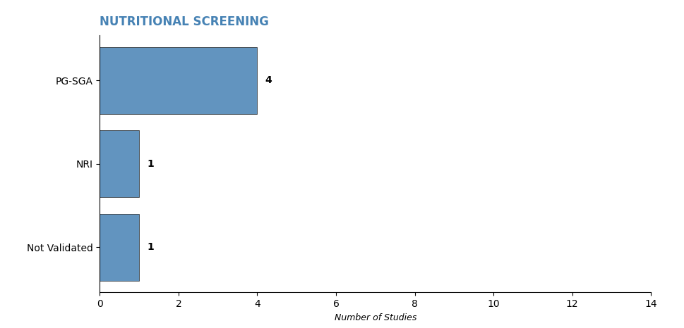Figure S1.B

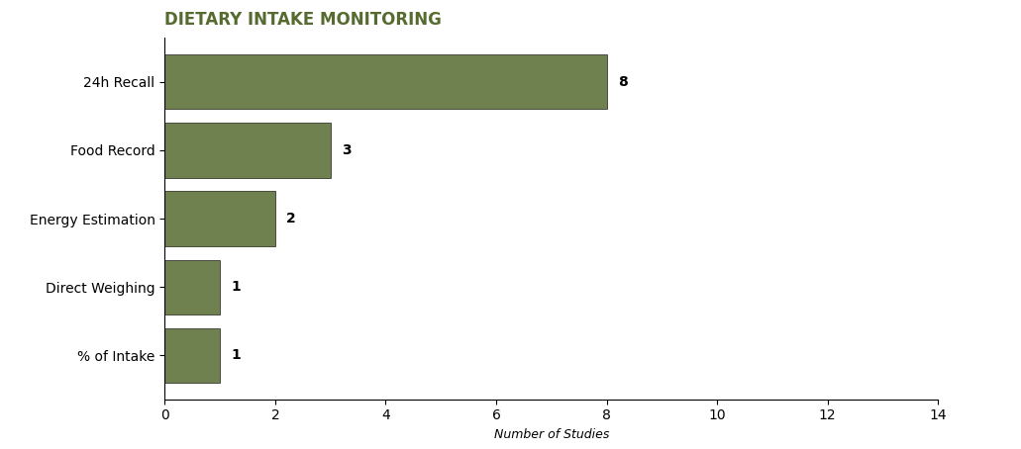Figure S1.C
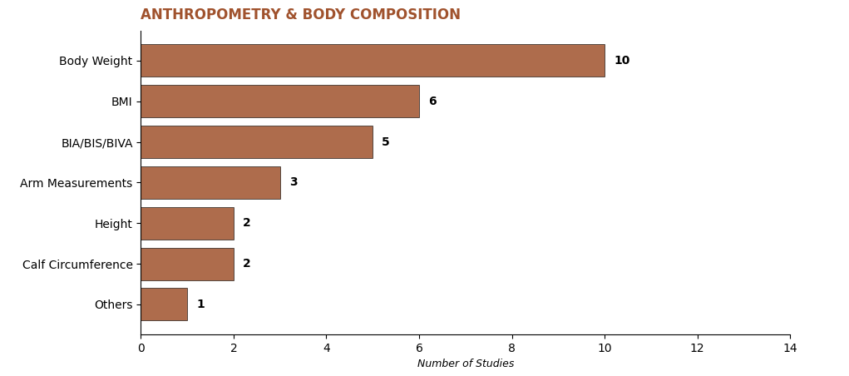

Figure S1.D
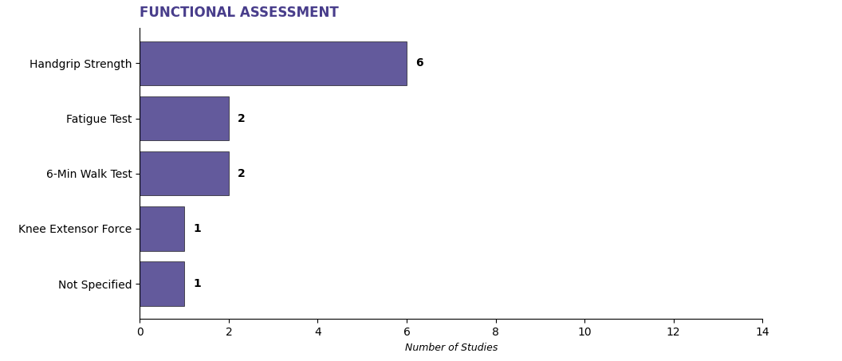Figure S1.E
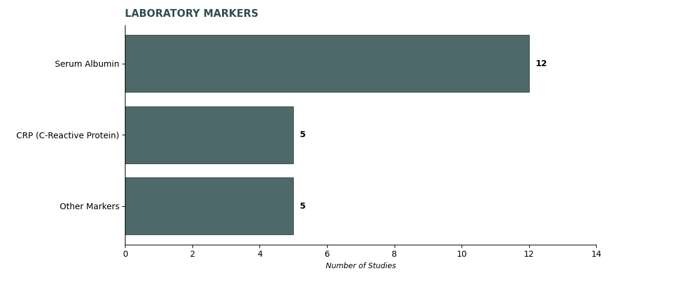
Note: Each color represents a specific methodological domain. Predominant tools: Serum Albumin (n=12), Body Weight (n=10), and 24h Recall (n=8).

Supplementary Figure S2. Proposed model for nutritional assessment and monitoring in patients with hematological malignancies.
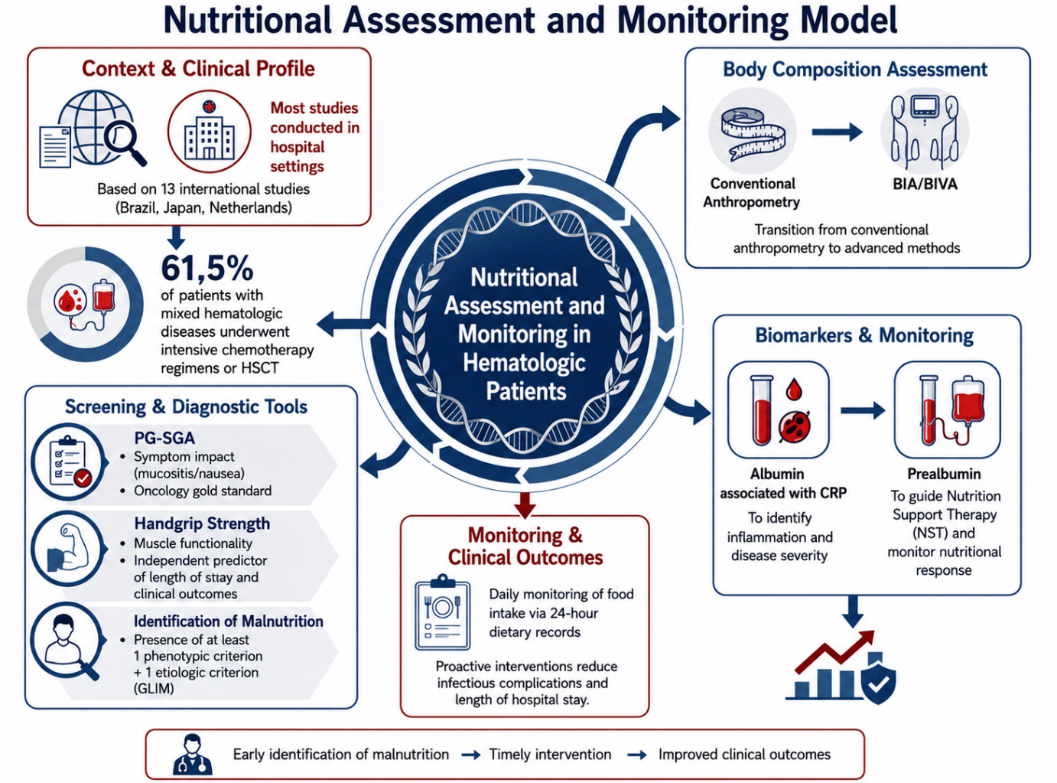
Fig S2 The model summarizes the main domains identified in this scoping review, including the clinical context, nutritional screening and assessment tools, body composition assessment, biomarkers and nutritional monitoring, as well as clinical outcomes related to nutritional status. The figure illustrates how these components are integrated into the nutritional care of patients with hematologic diseases, highlighting the importance of early identification of malnutrition and timely nutritional intervention to improve clinical outcomes.
Note: This figure was created by the authors with the assistance of generative artificial intelligence (ChatGPT, OpenAI) for the visual design and layout of the conceptual model. The scientific content, evidence synthesis, and interpretation of the findings were developed and critically reviewed entirely by the authors.

