Salt Chemistry Regulates Habitable Microenvironments in Brinicles: Implications for Icy Ocean Worlds
Madeline Garner, Marika Feduschak, Heidi Smith, Scott Perl, Christine Foreman*

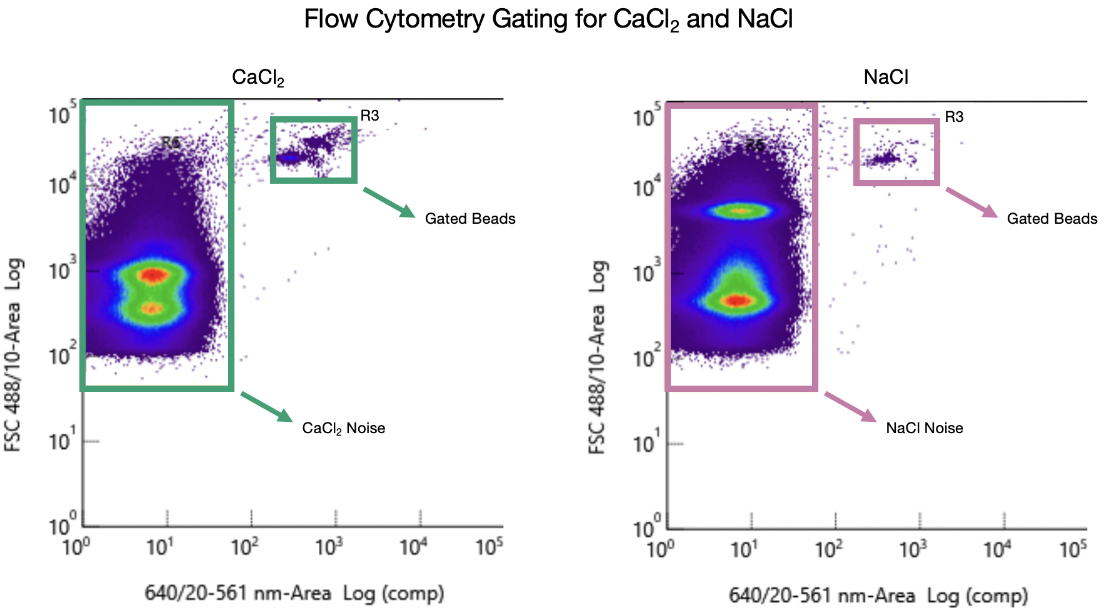
\
Figure S1. Example gating for CaCl₂ salt noise and spiked beads (left) and NaCl Salt noise and spiked beads (right).

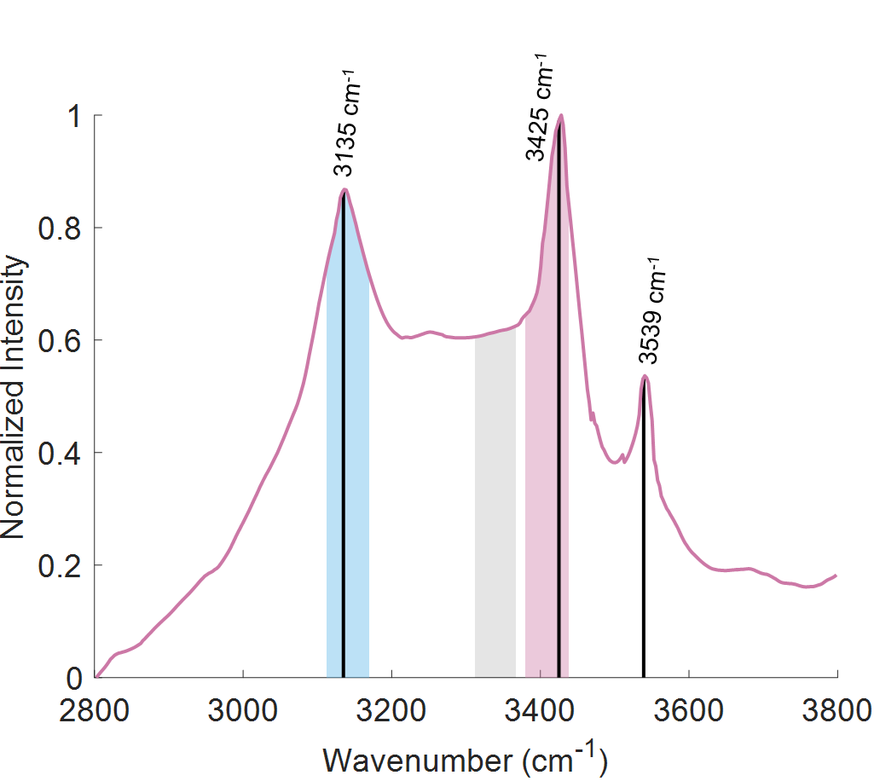
Figure S2. Raman spectra of hydrohalite with its characteristic peaks identified and labeled. The integration ranges used for salt pixel analysis are shaded and applied to the identification criteria outlined in the main text.

Salt Hydrate Identification Scheme
Identified in S2, the integration ranges used for hydrohalite and antarcticite identification were 3110-3170 cm−1 (ΔIice, blue) and 3380-3440 cm−1 (ΔIsalt, pink). A third range just before the sharp salt peak from 3310-3370 cm−1 (ΔIval, gray) was chosen as a “valley” region for comparison. Pixels were identified as salt hydrates if ΔIice > ΔIval and ΔIsalt > ΔIval, similar to previous work [29], but unlike their single-wavenumber intensities we integrated over more broad spectral regions to maintain consistency with the SD calculations and accommodate spectral variability. 1.3% of pixels in the below-eutectic maps were unable to be classified as either salt hydrate or ice given the identification ratio criteria. In this case, spectra were manually sorted into ice, salt hydrate, or discarded categories, after which the subsequent surface area fraction calculations were performed. Most maps required no or very little (1-2 pixels) manual classification.

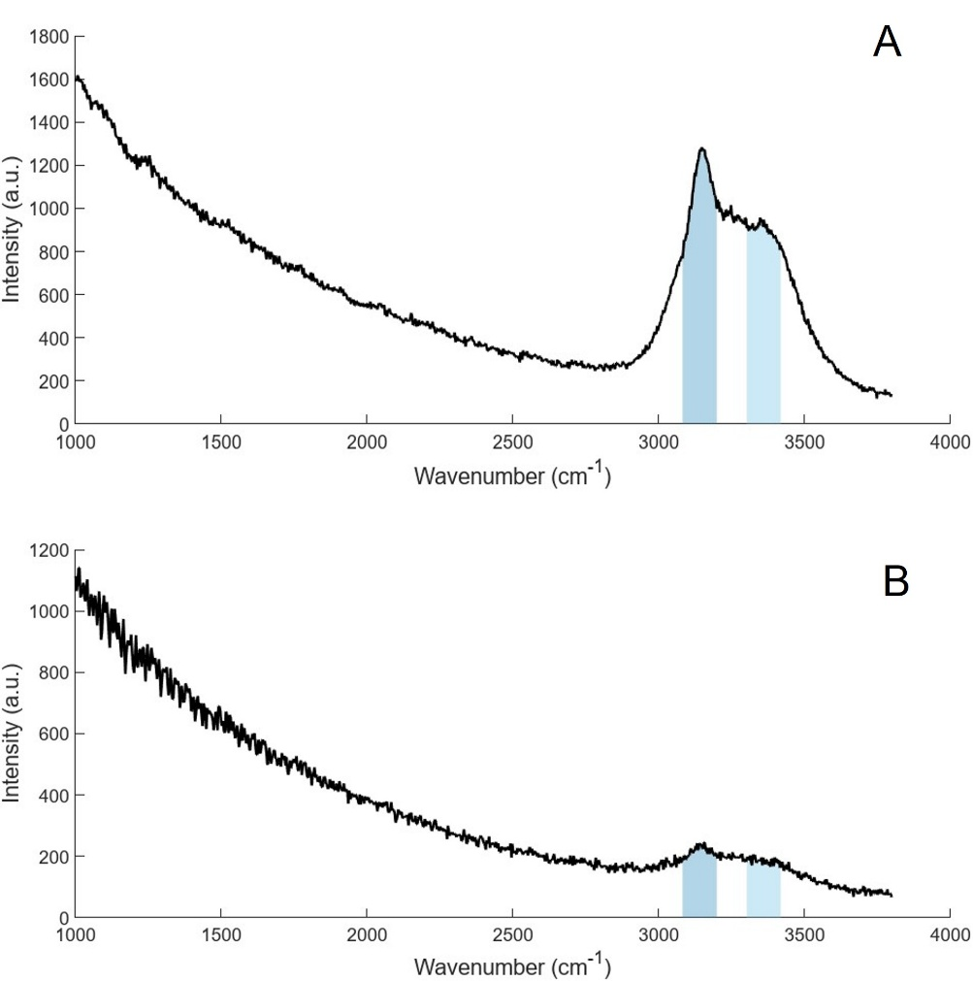
Figure S3: Raman spectra of pixels marked as fluorescent based on their intensity at 1000 cm-1. A) At the range of our measurement peaks, the fluorescence effect has diminished enough that this spectrum can also be classified as ice. B) The intensities of the characteristic peaks are not prominent enough against the fluorescence background, so this spectrum is not double counted.

Fluorescence Analysis
As described in the main text, spectra with clear elevation of intensity at low wavenumbers were characteristic of fluorescence due to the presence of the microspheres. In some cases, this fluorescence was powerful enough to mask or corrupt any signal from our high-wavenumber ranges, but in others, the effect was depleted enough at that point that spectra could still be evaluated for ice, brine, or salt hydrate classification. For all pixels identified as being fluorescent, the following test was applied: if the intensity of the spectra at 2800 cm⁻¹ (before the characteristic peaks for ice, brine, and salt hydrates) was less than 20% of its intensity at 3150 cm⁻¹ (well into the peak shape), then the pixel was retained and classified accordingly, thus included in both the fluorescence and composition analysis and subsequent surface area fraction calculations. If this requirement failed, the pixel was used only for fluorescence calculations. S3 demonstrates this, with A representing a spectrum that was classified as both fluorescent and ice, while B failed the test and was classified only as fluorescent. In both cases, the general shape of an ice peak (like those shown in Figure 3) is apparent, with ΔI_{sym} and ΔI_{asym} identified as dark blue and light blue, respectively. However, in B the fluorescence background is still strong enough at the ice peak range that it is removed from further composition analysis. This approach was used to improve the accuracy of evaluating the co-localization of microspheres with brine and salt.

Table S1: Overview of statistical significance across measurements: bead distribution, liquid fraction, hydrated salt fraction, and fluorescence fraction. The table summarizes effects of location alone, composition alone, and their interaction, assessed separately along the vertical and radial axes where applicable. Green indicates a significant effect (p<0.05). Red indicates a non-significant effect. Recorded to the right are interpretive summaries for each measurement.

