Supplementary materials
Supplementary Figure 1. Patient flowchart

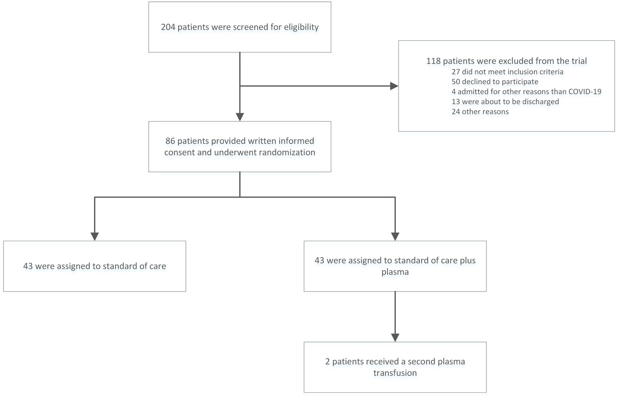
Supplementary figure 2
Cumulative incidence curves of the sub-distribution of the probability of discharge (blue line) and death (red line) as competing risks for the two treatment groups (SoC: dotted line, ConvP: solid line) after enrollment (D=1).
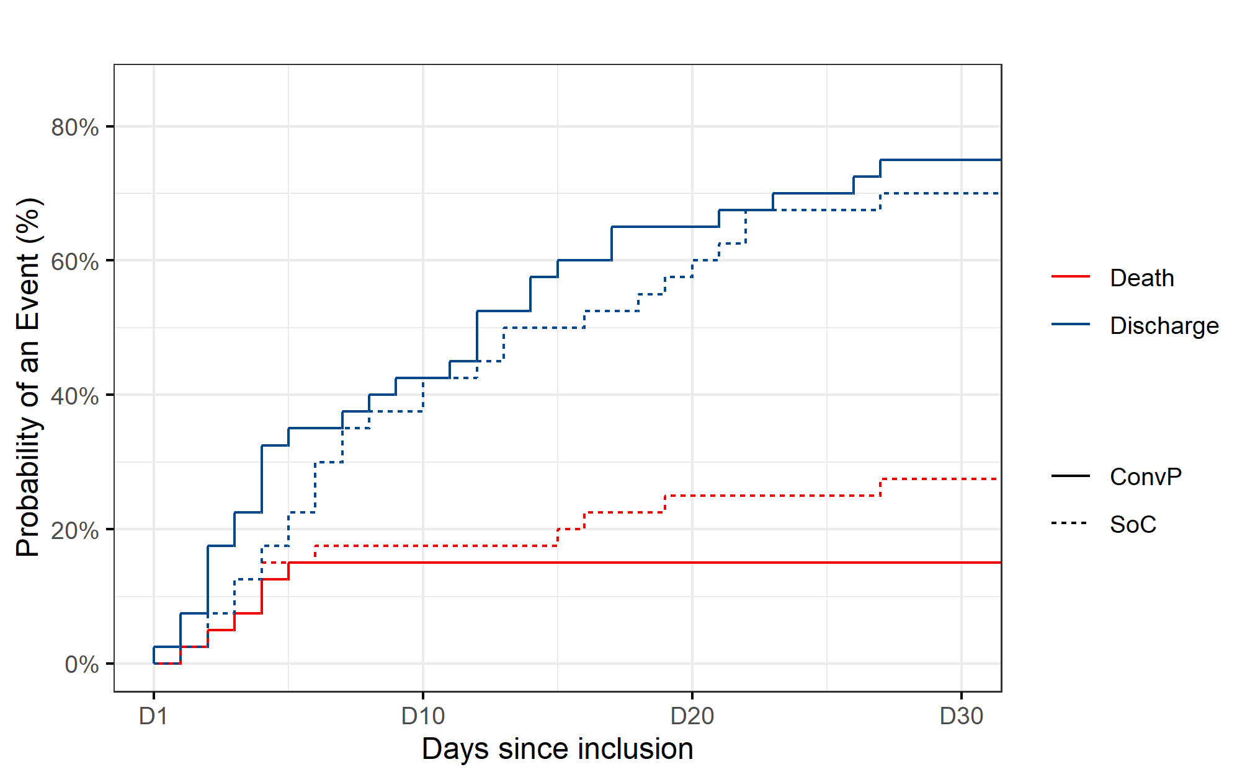

Supplementary figure 3
Correlation (solid line) and 95% CI (shaded area) between PRNT50 titer measured on day 1 of enrollment and days of symptoms at time of enrollment in COVID-19 patients with available PRNT50 titers (N=56).

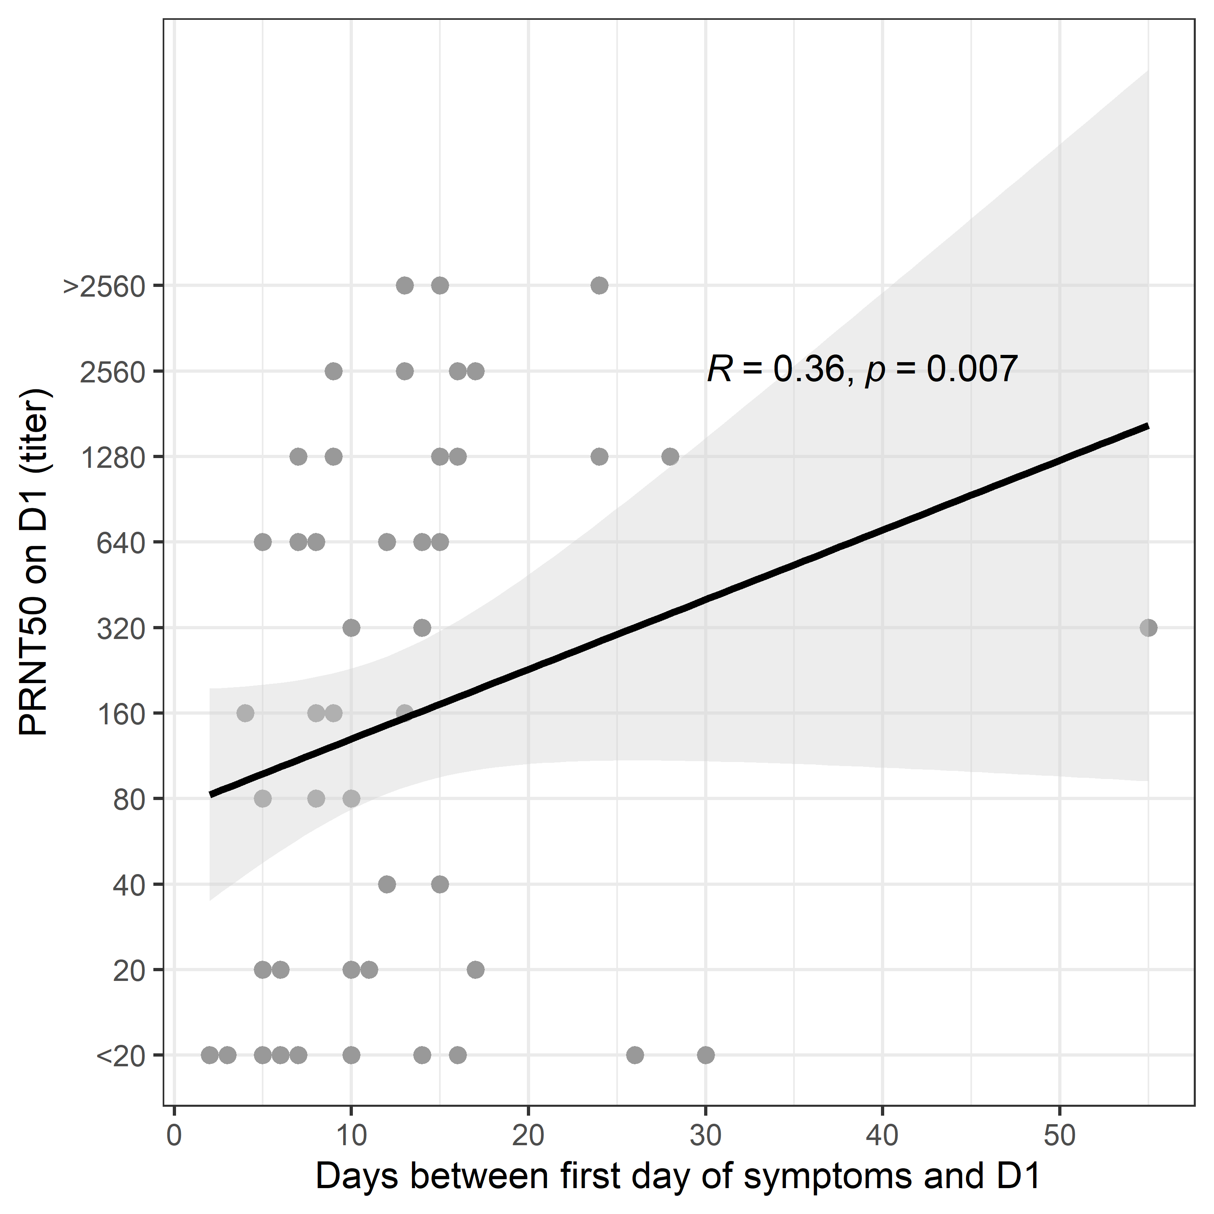

Supplementary figure 4
Anti-SARS-CoV-2 total Ig and IgM against the receptor binding domain (RBD) measured by Wantai ELISA were evaluated in the serum of COVID-19 patients admitted for COVID19 in the weeks preceding the start of the study (N=37) and from whom serum was available. Serum was collected on the day of admission to the hospital. Box indicates median and IQR. Dashed line indicates the positive cutt-off at 1.0 OD ratio.
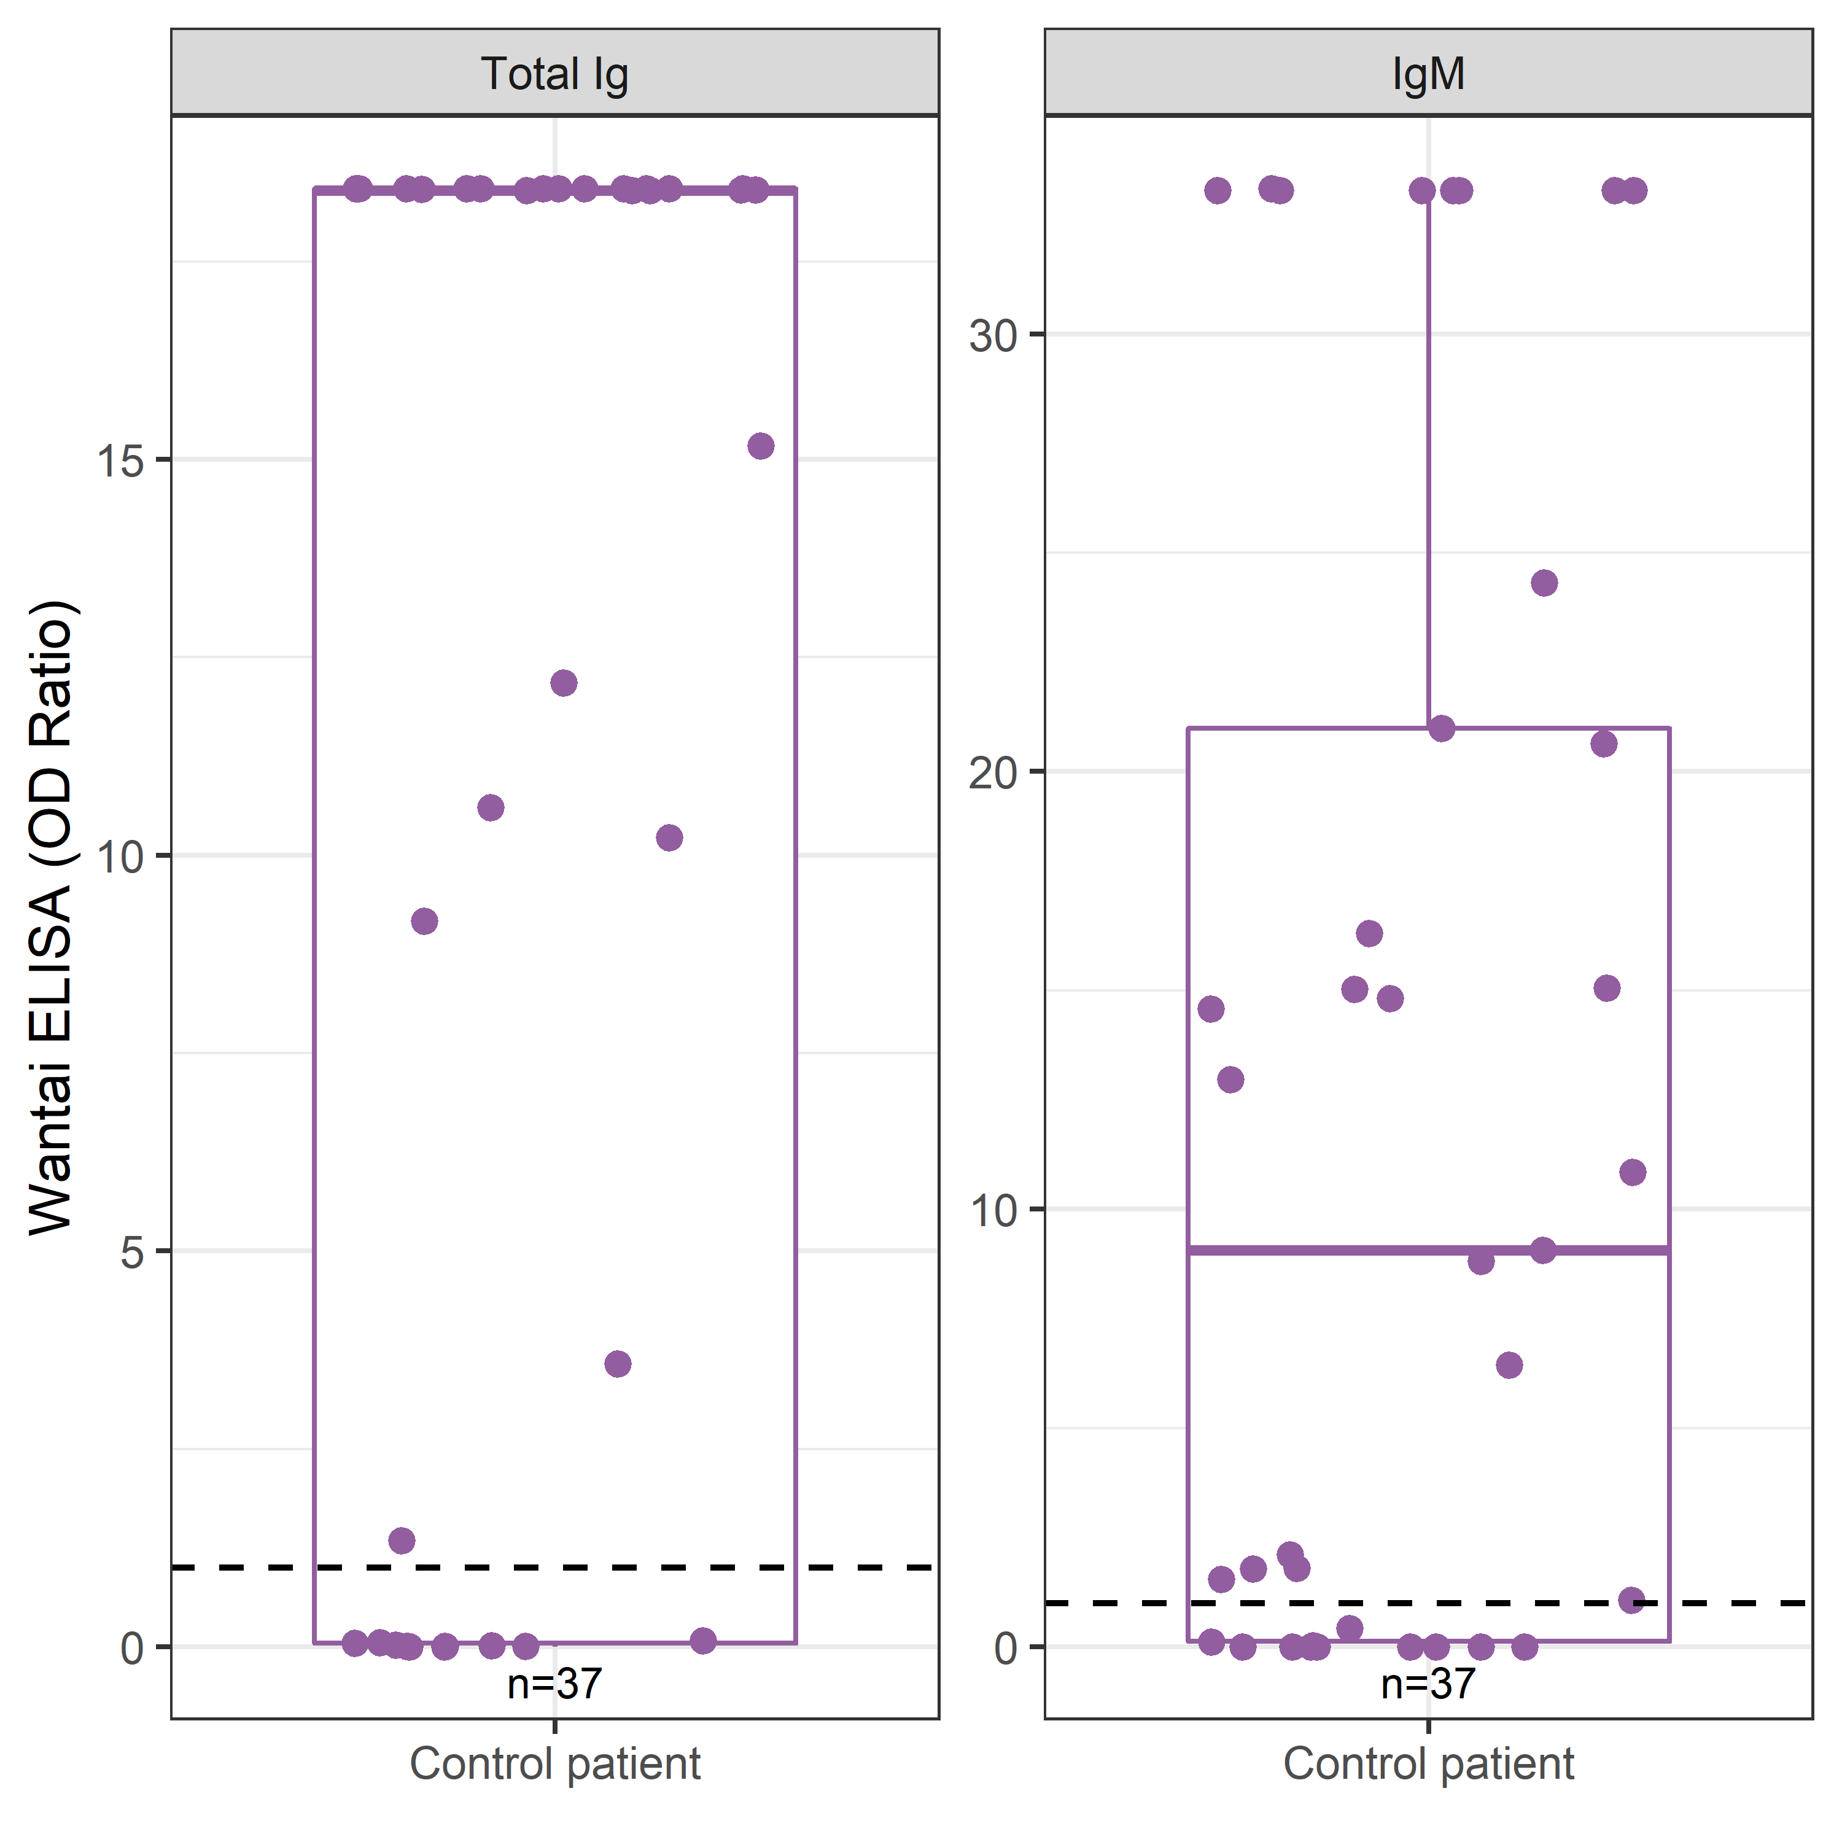

Supplementary table 1
Baseline characteristics of COVID-19 patients of whom serum could be analyzed for ELISA and PRNT50 titer.
Analysed for: | Wantai Ig and IgM ELISA |  |  | PRNT50 titer
 | SoC  (n=32) | ConvP  (n=34) | Total  (n=66) | Total  (n=56)
Male sex, n (%) | 23 (72) | 22 (65) | 45 (68) | 40 (71)
Age (years), median (IQR) | 63  (55 – 73) | 61  (56 – 69) | 63  (55 – 72) | 61  (54 – 68)
Duration of symptoms at inclusion (days), median (IQR) | 12  (6 – 17) | 9  (7 – 14) | 10  (6 – 15) | 10  (7 – 15)
Number of comorbidities, n (%)
Diabetes Mellitus | 6 (19) | 11 (32) | 17 (26) | 11 (20)
Hypertension | 9 (28) | 9 (27) | 18 (27) | 13 (23)
Cardiac | 7 (22) | 7 (21) | 14 (21) | 11 (20)
Pulmonary | 9 (28) | 12 (35) | 21 (32) | 18 (32)
Cancer | 1 (3) | 4 (12) | 5 (8) | 4 (7)
Immunodeficiency | 5 (16) | 3 (9) | 8 (12) | 6 (11)
Chronic kidney disease | 5 (16) | 1 (3) | 6 (9) | 5 (9)
Liver cirrhosis | 0 | 1 (3) | 1 (2) | 0
CRP (mg/L), median (IQR) | 113  (73 – 209) | 86  (50 – 134) | 100  (51 – 163) | 96  (49 – 134)
Ferritin (µg/L), median (IQR) | 825  (644 – 1722) | 522  (355 – 1051) | 702  (445 – 1063) | 721  (459 – 1062)
LDH (U/L), median (IQR) | 386  (294 – 525) | 336  (252 – 439) | 366 (  288 – 478) | 374  (273 – 497)
Lymphocytes (x10⁹/L), median (IQR) | 0.95  (0.80 – 1.30) | 1.10  (0.80 – 1.50) | 1.00  (0.80 – 1.43) | 1.00  (0.80 – 1.50)
Bilirubin (µmol/L), median (IQR) | 9  (6 – 14) | 8  (5 – 12) | 8  (6 – 13) | 9  (6 – 14)
WHO COVID-19 disease severity score⁽¹⁾, n (%)  ≤2  3  4-5  6-7 | 0  0  25 (78)  7 (22) | 0  6 (18)  24 (81)  4 (12) | 0  6 (9)  49 (74)  11 (17) | 0  5 (9)  42 (75)  9 (16)
⁽¹⁾ WHO 8 point COVID-19 disease severity score (at study inclusion for patients and highest score ever during disease course for donors) in which 0 is no clinical or virological evidence of infection, 1 is no limitation of activities, 2 is limitation of activities, 3 is hospitalized, no oxygen, 4 is oxygen by mask or nasal prongs, 5 is non-invasive ventilation or high-flow oxygen, 6 is intubation and mechanical ventilation, 7 is ventilation and additional organ support (vasopressors, renal replacement therapy, ECMO) and 8 is death.

Supplementary table 2:
Odds ratios and 95% CIs from unadjusted and adjusted analysis of mortality.
 | Unadjusted  OR (95% CI) | Adjusted  OR (95% CI) | P-value
ConvP | 0.472 (0.148; 1.384) | 0.948 (0.195; 4.670) | 0.95*
Age | - | 1.097 (1.034; 1.179) | 0.005
Female sex | - | 0.717 (0.118; 3.932) | 0.70
ICU on admission | - | 6.701 (0.209; 142.602) | 0.22
CRP on admission | - | 1.000 (0.991; 1.009) | 0.93
Lymphocyte count on admission | - | 0.114 (0.013; 0.609) | 0.023
Fi02 on admission | - | 1.022 (0.994; 1.054) | 0.13
Bilirubine | - | 0.873 (0.727; 0.986) | 0.078
*P-value from multivariable adjusted logistic regression
Supplementary table 3:
Odds Ratios and 95% CIs from Unadjusted and Adjusted Logistic Regression for 8-point WHO COVID disease severity scale changes at day 15.
 | Unadjusted  OR (95% CI) | Adjusted  OR (95% CI) | P-value
ConvP | 0.585 (0.273; 1.239) | 1.300 (0.519; 3.318) | 0.58*
Age | - | 1.054 (1.017; 1.095) | 0.006
Female sex | - | 0.991 (0.345; 2.834) | 0.99
ICU on admission | - | 8.990 (1.566; 59.097) | 0.017
CRP on admission | - | 1.004 (0.998; 1.010) | 0.16
Lymphocyte count on admission | - | 0.189 (0.060; 0.546) | 0.003
Fi02 on admission | - | 1.030 (1.012; 1.050) | 0.001
Bilirubin | - | 0.982 (0.930; 1.036) | 0.50
*P-value from multivariable adjusted logistic regression

Supplementary table 4:
Odds Ratios and 95% CIs from Unadjusted and Adjusted Logistic Regression for 8-point WHO COVID disease severity scale changes at day 30.
 | Unadjusted  OR (95% CI) | Adjusted  OR (95% CI) | P-value
ConvP | 0.555 (0.256; 1.189) | 1.211 (0.497; 2.988) | 0.67*
Age | - | 1.061 (1.024; 1.103) | 0.002
Female sex | - | 0.594 (0.203; 1.728) | 0.34
ICU on admission | - | 2.473 (0.283; 21.28) | 0.41
CRP on admission | - | 1.002 (0.996; 1.009) | 0.45
Lymphocyte count on admission | - | 0.152 (0.046; 0.457) | 0.001
Fi02 on admission | - | 1.023 (1.004; 1.043) | 0.019
Bilirubin | - | 0.946 (0.885; 1.009) | 0.098
*P-value from multivariable adjusted logistic regression

Supplementary table 5:
Hazard Ratios and 95% CIs from Unadjusted Fine & Gray Regression for Time-to-Discharge
 | Unadjusted  HR (95% CI) | Adjusted  HR (95% CI) | P-value
ConvP | 1.332 (0.811; 2.187) | 0.883 (0.487; 1.603) | 0.68*
Age | - | 0.965 (0.947; 0.985) | <.001
Female sex | - | 1.166 (0.593; 2.290) | 0.66
ICU on admission | - | 0.218 (0.069; 0.694) | 0.010
CRP on admission | - | 0.998 (0.994; 1.002) | 0.27
Lymphocyte count on admission | - | 3.028 (1.495; 6.135) | 0.002
Fi02 on admission | - | 0.980 (0.968; 0.992) | 0.002
Bilirubin | - | 1.025 (0.991; 1.061) | 0.15
*P-value from multivariable adjusted logistic regression

Supplementary table 6
Baseline characteristics of COVID-19 patients who were alive after 60 days and those who died during the study.
 | Total Alive  (n=69) | Total Death  (n=17) | SoC Death (n=11) | ConvP Death (n=6)
Male sex, n (%) | 50 (73) | 12 (71) | 9 (82) | 3 (50)
Age (years), median (IQR) | 61 (53 – 69) | 69 (63 – 84) | 69 (63 – 81) | 74 (64 – 87)
Duration of symptoms at inclusion (days), median (IQR) | 10 (7 – 14) | 6 (4 – 24) | 6 (4 - 22) | 6 (3 – 25)
Number of comorbidities, n (%)
Diabetes Mellitus | 15 (22) | 6 (35) | 2 (18) | 4 (67)
Hypertension | 16 (23) | 6 (35) | 4 (36) | 4 67)
Cardiac | 13 (19) | 7 (41) | 4 (36) | 3 (50)
Pulmonary | 20 (29) | 3 (18) | 3 (27) | 0
Cancer | 6 (9) | 2 (12) | 1 (9) | 1 (17)
Immunodeficiency | 10 (15) | 1 (6) | 0 | 1 (17)
Chronic kidney disease | 5 (7) | 2 (12) | 2 (18) | 0
Liver cirrhosis | 1 (1) | 0 | 0 | 0
CRP (mg/L), median (IQR) | 97 ( 50 – 148) | 126 (59 – 196 | 135 (73 – 241) | 85 (48 – 159)
Ferritin (µg/L), median (IQR) | 712  (425 – 1102) | 532  (485 – 1026) | 532  (487 – 1228) | 622  (475 – 829)
LDH (U/L), median (IQR) | 331  (266 – 454) | 369  (299 – 534) | 362  (293 – 540) | 382  (296 – 503)
Lymphocytes (x10⁹/L), median (IQR) | 1.00  (0.88 – 1.50) | 0.80  (0.55 – 1.15) | 0.90  (0.50 – 1.00) | 1.20  (0.63 – 1.40)
Bilirubin (µmol/L), median (IQR) | 9 (6 – 14) | 8 (5 – 10) | 8 ( 5 – 11) | 6 ( 5 – 9)
WHO COVID-19 disease severity score⁽¹⁾  ≤2  3  4-5  6-7 | 0  8 (12%)  50 (72%)  11 (16%) | 0  0  15 (88%)  2 (12%) | 0  0  9 (82%)  2 (18%) | 0  0  6 (100%)  0
Supplementary table 7
The median CRP, ferritin and lymphocyte count at enrollment (day 1) and the median of the highest values of all CRP, ferritin and the median of the lowest values of all absolute lymphocyte counts between day 2-7 and day 8-14 after enrollment in both treatment groups. Data on CRP and ferritin were available in all patients, data on absolute lymphocyte counts were available in 34 patients.

 | SoC (n=43) | ConvP (n=43) | p-value
CRP day 1, median (IQR) | 109 (70 – 165) | 84 (50 – 133) | 0.04
CRP day 2-7, median (IQR) | 117 (50 – 261) | 92 (44 – 237) | 0.64
CRP day 8-14, median (IQR) | 100 (34 – 156) | 33 (17 – 146) | 0.33
Ferritin day 1, median (IQR) | 709 (525 – 1311) | 702 (406 – 1060) | 0.32
Ferritin day 2-7, median (IQR) | 989 (525 – 2383) | 1054 (737 – 1962) | 0.68
Ferritin day 8-14, median (IQR)  Lymphocytes day 1 , median (IQR) | 716 (334 – 1686)  0.90 (0.74 – 1.30) | 672 (466 – 1595)  1.28 (1.00 – 1.67) | 0.75  0.015
Lymphocytes day 2-7, median (IQR) | 1.05 (0.70 – 1.68) | 1.30 (9.2 – 1.57) | 0.57
Lymphocytes day 8-14, median (IQR) | 1.40 (0.82 – 2.24) | 1.80 (1.55 – 2.50) | 0.28

Supplementary table 8
Baseline characteristics of (selected) donors.
 | Donors⁽²⁾  (n=115) | Donors selected for ConvP  (n=19)
Male sex, n (%) | 105 (91) | 19 (100)
Age (years), median (IQR) | 43 (31 – 52) | 49 (38 – 54)
Duration after symptom resolution (days), median (IQR) | 34  (22 – 42) | 20  (15 – 25)
Number of comorbidities, n (%)
Diabetes Mellitus | 1 (1) | 0
Hypertension | 5 (5) | 1 (6)
Cardiac | 1 (1) | 0
Pulmonary | 6 (6) | 0
Cancer | 0 | 0
Immunodeficiency | 1 (1) | 0
Chronic kidney disease | 0 | 0
Liver cirrhosis | 0 | 0
WHO COVID-19 disease severity score⁽¹⁾  ≤2  3  4-5  6-7 | 88 (88)  2 (2)  10 (10)  0 | 19 (100)  0  0  0
⁽¹⁾ WHO 8 point COVID-19 disease severity score (at study inclusion for patients and highest score ever during disease course for donors) in which 0 is no clinical or virological evidence of infection, 1 is no limitation of activities, 2 is limitation of activities, 3 is hospitalized, no oxygen, 4 is oxygen by mask or nasal prongs, 5 is non-invasive ventilation or high-flow oxygen, 6 is intubation and mechanical ventilation, 7 is ventilation and additional organ support (vasopressors, renal replacement therapy, ECMO) and 8 is death.
⁽²⁾Donors of whom PRNT50 titer was determined
Supplementary table 9
Baseline characteristics of control patients whose samples were collected in a databank.
Total
(n=37)
Male sex, n (%) | 22 (60)
Age (years), median (IQR) | 65 (55 – 74)
Duration of symptoms at inclusion (days), median (IQR) | 10 (4 – 13)
Number of comorbidities, n (%)
Diabetes Mellitus | 7 (19)
Hypertension | 14 (38)
Cardiac | 12 (32)
Pulmonary | 10 (27)
Cancer | 6 (16)
Immunodeficiency | 5 (14)
Chronic kidney disease | 2 (5)
Liver cirrhosis | 0
CRP (mg/L), median (IQR) | 127 (38 – 241)
Ferritin (µg/L), median (IQR) | 673 (467 – 870)
LDH (U/L), median (IQR) | 331 (269 – 457)
Lymphocytes (x10⁹/L), median (IQR) | 0.91 (0.62 – 1.40)
Bilirubin (µmol/L), median (IQR) | 8 (6 – 11)
WHO COVID-19 disease severity score⁽¹⁾  ≤2  3  4-5  6-7 | 1 (3)  6 (16)  27 (73)  3 (8)
⁽¹⁾ WHO 8 point COVID-19 disease severity score (at study inclusion for patients and highest score ever during disease course for donors) in which 0 is no clinical or virological evidence of infection, 1 is no limitation of activities, 2 is limitation of activities, 3 is hospitalized, no oxygen, 4 is oxygen by mask or nasal prongs, 5 is non-invasive ventilation or high-flow oxygen, 6 is intubation and mechanical ventilation, 7 is ventilation and additional organ support (vasopressors, renal replacement therapy, ECMO) and 8 is death.

Supplementary table 10: Cytokine concentrations in serum of Covid-19 patients
 | Day 1 |  | Day 7 |  | Day 14 |  | Healthy controls
 | SoC | ConvP | SoC | ConvP | SoC | ConvP
IL-1β (pg/ml), mean (SD) | 0.50  (± 0.08*) | 0.46  (± 0.08) | 0.56  ( ± 0.12) | 0.42  ( ± 0.10) | 0.60  (± 0.25) | 0.49  (± 0.15) | ND
IL-2 (pg/ml), mean (SD) | 0.94  (± 0.17) | 0.73  (± 0.09) | 0.70  (± 0.06) | 0.81  (± 0.17) | ND | 0.78  (± 0.14) | ND
IL-4 (pg/ml), mean (SD) | ND^ | ND | ND | ND | ND | ND | ND
IL-10 (pg/ml), mean (SD) | 21.43  (± 6.20) | 25.49  (± 13.49) | 9.95  (± 1.46) | 14.50  (± 5.72) | 6.91  (± 1.47) | 12.97  (± 6.03) | 2.21  (± 0.23)
IL-12p70 (pg/ml), mean (SD) | ND | ND | ND | 0.62  (± 0.16) | ND | ND | ND
Repeated measures of IL-1 β, IL-2, IL4, IL-10 and IL-12p70 in both treatments (SoC: N=10, ConvP: N=9) and in healthy controls.
^ ND: not detected (below lower limit of quantitation)

Supplementary table 11
Mixed model
Estimates (95% CI) and p-values from the multivariable mixed-effects model for log(viral load) in log(copies/ml). The number of copies per ml was log-transformed in order to avoid deviations from normality assumptions. The value of 0.001 was added to zero values of viral load before the transformation to avoid minus infinity values after the log transformation.
 | Estimate | P-value
(Intercept) | 9.699 (0.379; 19.02) | 0.042
Time | -0.811 (-1.107; -0.516) | <0.01
ConvP | -5.507 (-9.920; -1.093) | 0.016
Age | -0.058 (-0.177; 0.061) | 0.33
Female sex | 0.457 (-2.97; 3.885) | 0.79
ICU on admission | 0.619 (-4.453; 5.691) | 0.81
CRP on admission | -0.016 (-0.037; 0.006) | 0.15
Lymphocyte count on admission | -0.19 (-3.69; 3.31) | 0.91
Fi02 on admission | 0.039 (-0.017; 0.096) | 0.17
Bilirubin | -0.095 (-0.261; 0.072) | 0.26
Interaction between Time and ConvP | 0.407 (0.011; 0.803) | 0.044

