Supplementary Material
Diagnosis of significant liver fibrosis in patients with chronic hepatitis B by using a deep learning-based data integration network

Supplementary Methods

Model in Branch-1 of DI-Net
The model in Branch-1 of DI-Net is backboned by the ResNet50 network¹, which mainly consists of five convolutional blocks (CBs) from CB-1 to CB-5. CB-1 is composed by a convolutional layer (CL) and a max pooling layer, while each of the remaining CBs comprises a convolutional building block (CBB) followed by a number of identity building blocks (IBBs). CBB and IBB are functional blocks designed for residual learning and their structures are shown in Supplementary Figure 1. There are three CLs in the main thread of CBB or IBB. Unlike the identity mapping of IBB, the residual thread of CBB contains a CL which adjusts the dimension of the input to be matched with that of the output, and hence the features can be added together for residual learning. The detailed settings of the network parameters for the model in Branch-1 are presented in Supplementary Table 2. Different from the original configuration of ResNet50, the channel numbers for the CBBs from CBB-1 to CBB-5 were reduced to be 32, 64, 128, 256 and 512, respectively, with the aim to reduce the number of model parameters and hence to mitigate the overfitting problem. Moreover, the feature maps outputted from the last CBB, CBB-5, were pooled by using the method of global average pooling (GAP)² to yield a feature vector with length of 512. GAP has no parameters to be learned, which also contributes to the reduction of model parameters.

Detailed Training Procedure of DI-Net
For the training of DI-Net, since the number of data samples in our dataset is small, which may not be sufficient to train a well-behaved deep learning model if the model is trained from scratch, we employed the transfer learning³ and data augmentation strategies for better training The detailed training procedure is as follows. First, we linked the model in Branch-1 (see Figure 2 in the main text) with a FC layer comprising 1000 neurons and trained the resulted model on a large-scale dataset of ImageNet⁴ which contains a huge number of natural images with quality-controlled and human-annotated labels. Then, the model in Branch-1 was linked to the fusion unit of FU-1 followed by the last fully connected (LFC) layer to composite a trainable model. By initializing the weight parameters of Branch-1 with those of the model trained on the large-scale natural image dataset and then freezing the weight parameters of the first three CBs, CB-1 to CB-3, the newly composited model was trained on our internal training data. During the training, online data augmentation (randomly left-right flipping or rotating the images in a vertical angle range between -10° and +10°) was employed. Similar to the model assembling we did for Branch-1, we linked Branch-2 with the feature fusion unit of FU-2 followed by the LFC layer to form another trainable network, and trained the composited model on the internal training data. Finally, by initializing the weight parameters of Branch-1, FU-1 and FU-2 of the DI-Net with those of the above-trained models, the entire model was trained by first training the last two FC layers and then fine-tuning the model on the training data. The model of DI-Net was trained and validated five times on the internal dataset by following the procedure of five-fold cross-validation.

Comparative Methods and Evaluation Metrics
The diagnostic performance of DI-Net was compared against the following methods: 1) single-source data-based models, i.e. the models trained with single-source data of B-mode images, liver stiffness values, or patients’ clinical parameters. Here, the model with B-mode images was a deep learning model composed by Branch-1+LFC, while the model with liver stiffness values or clinical data was established based on the support-vector-machine (SVM)⁵. 2) fibrosis biomarkers^{6,7}, including APRI = [(AST/upper limit of normal AST)×100]/PLT and FIB-4 = (age × AST)/(PLT × 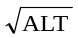). For the calculation of the APRI index, the upper limit of normal AST was set to a widely accepted value, i.e. 40 U/L. 3) radiologist’s interpretations. In the comparison, two skilled radiologists, who were totally blinded to the results of P-SWE and pathological examinations, evaluated the liver surface, parenchymal texture, hepatic vein contour and spleen texture in the B-mode images, and provided fibrosis scores according to a commonly used US scoring system^{8,9}. The diagnostic performance of each method was assessed by the receiver operating characteristic (ROC) curve and the area under the ROC curve (AUC). The Youden index¹⁰, defined as J = sensitivity + specificity -1, was maximized to identify the optimal cut-off point on the ROC curve, such that the accuracy, sensitivity, specificity corresponding to the cut-off point could be computed.

Supplementary References

1. He KM, Zhang XY, Ren SQ, et al. Deep Residual Learning for Image Recognition. IEEE Conf Comput Vision Pattern Recognit; 2016; Las Vegas, NV, USA.
2. Zhou B, Khosla A, Lapedriza A, et al. Learning deep features for discriminative localization. Paper presented at: Proceedings of the IEEE conference on computer vision and pattern recognition2016.
3. Shin H-C, Roth HR, Gao M, et al. Deep convolutional neural networks for computer-aided detection: CNN architectures, dataset characteristics and transfer learning. IEEE Trans Med Imaging. 2016;35(5):1285-1298.
4. Krizhevsky A, Sutskever I, Hinton GE. Imagenet classification with deep convolutional neural networks. Adv Neural Inf Process Syst. 2012;25:1097-1105.
5. Suykens JA, Vandewalle J. Least squares support vector machine classifiers. Neural processing letters. 1999;9(3):293-300.
6. Wai CT, Greenson JK, Fontana RJ, et al. A simple noninvasive index can predict both significant fibrosis and cirrhosis in patients with chronic hepatitis C. Hepatology. 2003;38(2):518-526.
7. Sterling RK, Lissen E, Clumeck N, et al. Development of a simple noninvasive index to predict significant fibrosis in patients with HIV/HCV coinfection. Hepatology. 2006;43(6):1317-1325.
8. Hung CH, Lu SN, Wang JH, et al. Correlation between ultrasonographic and pathologic diagnoses of hepatitis B and C virus-related cirrhosis. J Gastroenterol. 2003;38(2):153-157.
9. Wang J-H, Changchien C-S, Hung C-H, et al. FibroScan and ultrasonography in the prediction of hepatic fibrosis in patients with chronic viral hepatitis. J Gastroenterol. 2009;44(5):439-446.
10. Youden WJ. Index for rating diagnostic tests. Cancer. 1950;3(1):32-35.

Supplementary Table 1. Performance of various DCNN models: single-source data input of US B-mode images versus the input of multi-source data.
Supplementary Table 2. Model parameters for Branch-1 of the proposed DI-Net.

Supplementary Figure 1. Architectures of CBB and IBB for Branch-1 of DI-Net. CBB, convolutional building block; IBB, identity building block; CL, convolutional layer; ReLU, rectified linear unit
Supplementary Table 1. Performance of various DCNN models: single-source data input of US B-mode images versus the input of multi-source data.
Validation type | Methods | AUC | ACC | SEN | SPE | PPV | NPV
Cross-validation | ResNet50 (B) | 0.873 (0.808-0.919) | 0.794 (0.721-0.854) | 0.839 (0.745-0.909) | 0.735 (0.614-0.835) | 0.802 (0.706-0.878) | 0.781 (0.660-0.875)
Cross-validation | RestNet50 (B+S+C) | 0.943 (0.893-0.973) | 0.871 (0.808-0.919) | 0.862 (0.772-0.927) | 0.882 (0.781-0.948) | 0.904 (0.819-0.958) | 0.833 (0.727-0.911)
Cross-validation | VGG16 (B) | 0.773 (0.700-0.837) | 0.755 (0.679-0.820) | 0.816 (0.719-0.891) | 0.676 (0.552-0.785) | 0.763 (0.664-0.845) | 0.742 (0.615-0.845)
Cross-validation | VGG16 (B+S+C) | 0.908 (0.853-0.950) | 0.852 (0.786-0.904) | 0.874 (0.785-0.935) | 0.824 (0.712-0.905) | 0.864 (0.774-0.928) | 0.836 (0.725-0.915)
Cross-validation | InceptionV3 (B) | 0.845 (0.778-0.898) | 0.806 (0.735-0.865) | 0.805 (0.706-0.882) | 0.809 (0.695-0.894) | 0.843 (0.747-0.914) | 0.764 (0.649-0.856)
Cross-validation | InceptionV3 (B+S+C) | 0.919 (0.861-0.955) | 0.852 (0.786-0.904) | 0.862 (0.772-0.927) | 0.838 (0.729-0.916) | 0.872 (0.783-0.934) | 0.826 (0.716-0.907)
Cross-validation | DenseNet121 (B) | 0.870 (0.808-0.919) | 0.787 (0.714-0.849) | 0.770 (0.668-0.854) | 0.809 (0.695-0.894) | 0.838 (0.738-0.911) | 0.733 (0.619-0.829)
Cross-validation | DenseNet121 (B+S+C) | 0.922 (0.869-0.959) | 0.852 (0.786-0.904) | 0.897 (0.813-0.952) | 0.794 (0.679-0.883) | 0.848 (0.758-0.914) | 0.857 (0.746-0.933)
External validation | ResNet50 (B) | 0.806 (0.727-0.870) | 0.755 (0.668-0.824) | 0.759 (0.636-0.870) | 0.740 (0.624-0.835) | 0.694 (0.563-0.804) | 0.806 (0.691-0.892)
External validation | RestNet50 (B+S+C) | 0.901 (0.834-0.945) | 0.813 (0.736-0.877) | 0.816 (0.696-0.911) | 0.808 (0.699-0.891) | 0.767 (0.640-0.866) | 0.855 (0.750-0.928)
External validation | VGG16 (B) | 0.702 (0.619-0.782) | 0.690 (0.603-0.768) | 0.755 (0.616-0.856) | 0.644 (0.523-0.753) | 0.618 (0.492-0.733) | 0.770 (0.645-0.868)
External validation | VGG16 (B+S+C) | 0.865 (0.797-0.921) | 0.809 (0.727-0.870) | 0.838 (0.717-0.924) | 0.781 (0.669-0.869) | 0.746 (0.621-0.847) | 0.864 (0.757-0.936)
External validation | InceptionV3 (B) | 0.763 (0.677-0.831) | 0.722 (0.635-0.796) | 0.733 (0.597-0.842) | 0.712 (0.594-0.812) | 0.661 (0.530-0.777) | 0.776 (0.658-0.869)
External validation | InceptionV3 (B+S+C) | 0.875 (0.806-0.927) | 0.810 (0.727-0.870) | 0.829 (0.696-0.911) | 0.795 (0.684-0.880) | 0.754 (0.627-0.855) | 0.853 (0.746-0.927)
External validation | DenseNet121 (B) | 0.804 (0.727-0.870) | 0.729 (0.643-0.803) | 0.712 (0.578-0.827) | 0.740 (0.624-0.835) | 0.678 (0.544-0.794) | 0.771 (0.656-0.863)
External validation | DenseNet121 (B+S+C) | 0.889 (0.825-0.939) | 0.821 (0.745-0.883 | 0.867 (0.759-0.948) | 0.781 (0.669-0.869) | 0.754 (0.631-0.852) | 0.891 (0.788-0.955)
Note. Data in parenthesis are 95% confidence intervals. The ResNet50 model with B+S+C corresponds to the DI-Net developed in this study. The AUC values of the models with the multi-source data input of B+S+C was significantly higher than the corresponding models with single-source data input of B (all Ps < 0.01, DeLong test). Abbreviations: AUC, area under the receiver-operating-characteristic curve; ACC, accuracy; SEN, sensitivity; SPE, specificity; PPV, positive predictive value; NPV, negative predictive value; B, B-mode image; S, liver stiffness values; C, clinical data.
Supplementary Table 2. Model parameters for Branch-1 of the proposed DI-Net.
Blocks | Layers | Filters | Output size
CB-1 (CL+MPL) | conv1 (1) | 7×7, stride 2 | 112×112, 32
CB-1 (CL+MPL) | max pooling (1) | 3×3, stride 2 | 56×56, 32
CB-2 (CBB+IBB×2) | conv2, x (9) | 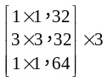 | 56×56, 64
CB-3 (CBB+IBB×3) | conv3, x (12) | 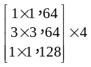 | 28×28, 128
CB-4 (CBB+IBB×5) | conv4, x (18) | 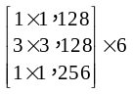 | 14×14, 256
CB-5 (CBB+IBB×2) | conv5, x (9) | 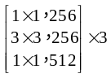 | 7×7, 512
\ | Global average pooling | - | 1×1, 512
Note. CB-1 was composed by a convolutional layer (CL, conv1) and a max pooling layer (MPL), while each of the remaining CBs consisted of a convolutional building block (CBB) followed by a number of identity building blocks (IBBs). Data in parenthesis for the second column were the number of layers, and the total number was 50. There were 3, 4, 6 and 3 building blocks (BBs) in CB-2, CB-4 and CB-5, respectively, and each BB contained three interlinked CLs whose parameters were shown in the square brackets of the third column. Down-sampling was performed for conv3,1, conv4,1 and conv5,1, with a stride of 2, and this also applied for the CLs in the residual branch of the CBBs in CB-3, CB-4, CB-5. The filter size and channel number for the CL in the residual branch of CBB were identical to those of the bottom layer in the main branch. Abbreviations: CB, convolutional block; CL, convolutional layer; MPL, max pooling layer; CBB, convolutional building block; IBB, identity building block; BB, building block.

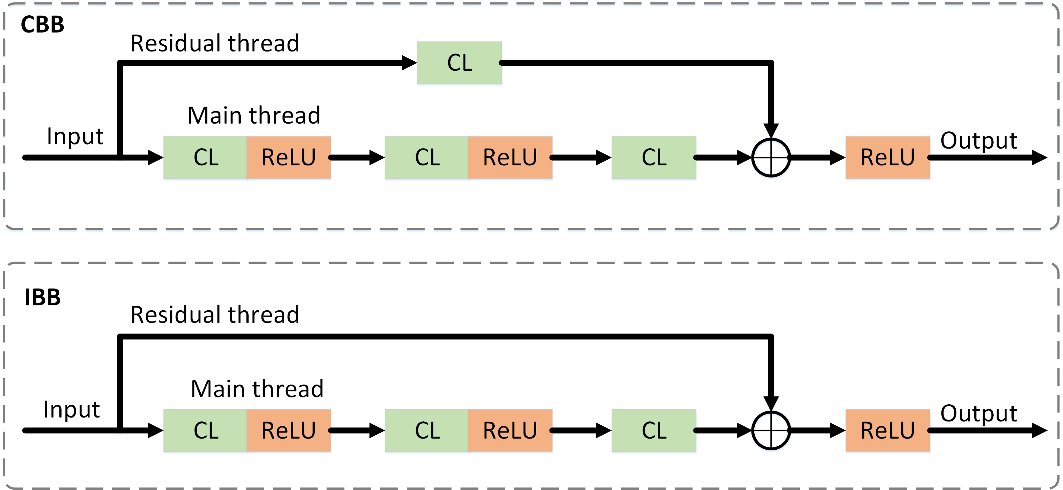
Supplementary Figure 1. Architectures of CBB and IBB for Branch-1 of DI-Net. CBB, convolutional building block; IBB, identity building block; CL, convolutional layer; ReLU, rectified linear unit

