Supplementary appendix
Figure S1: Nomogram of the simplified three-predictor model
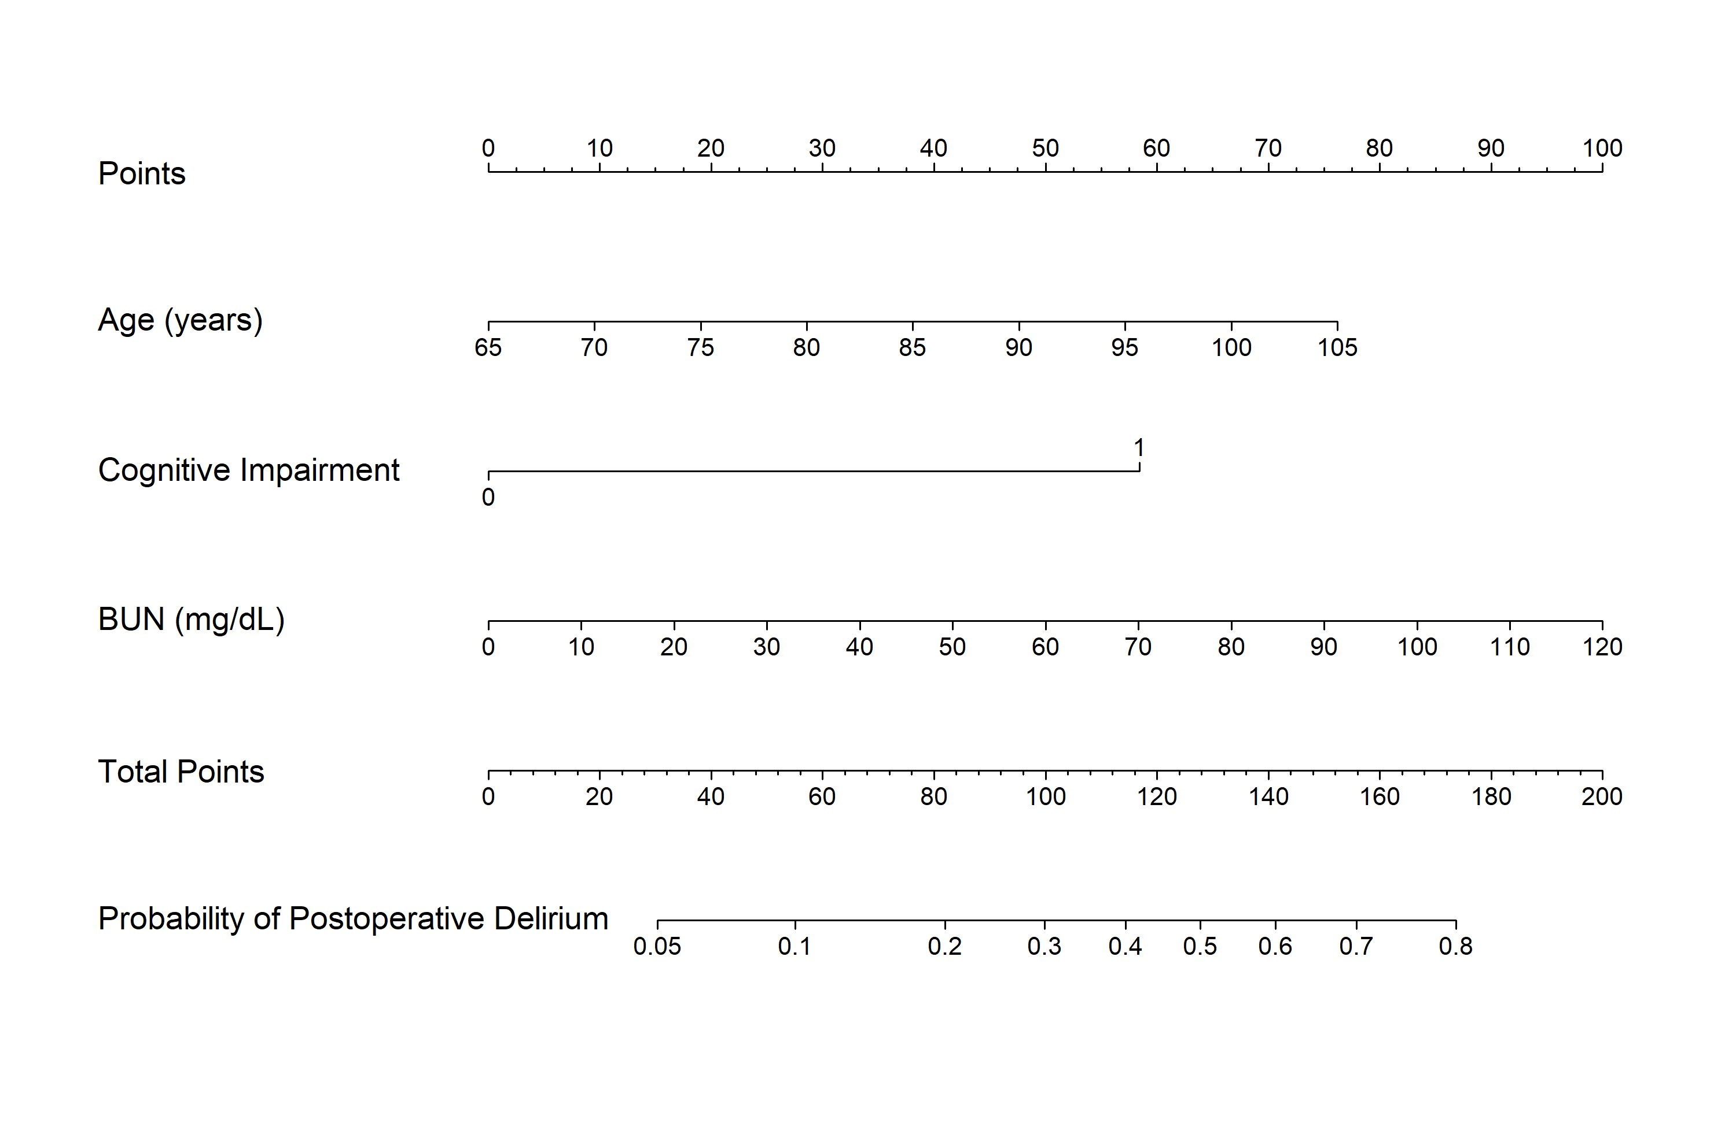
Figure S1. Nomogram of the simplified three-predictor model (age, cognitive impairment, BUN). Discrimination on temporal validation was equivalent to the full model (AUC 0.78; DeLong p = 0.81).

Figure S2: Penalised-regression selection check
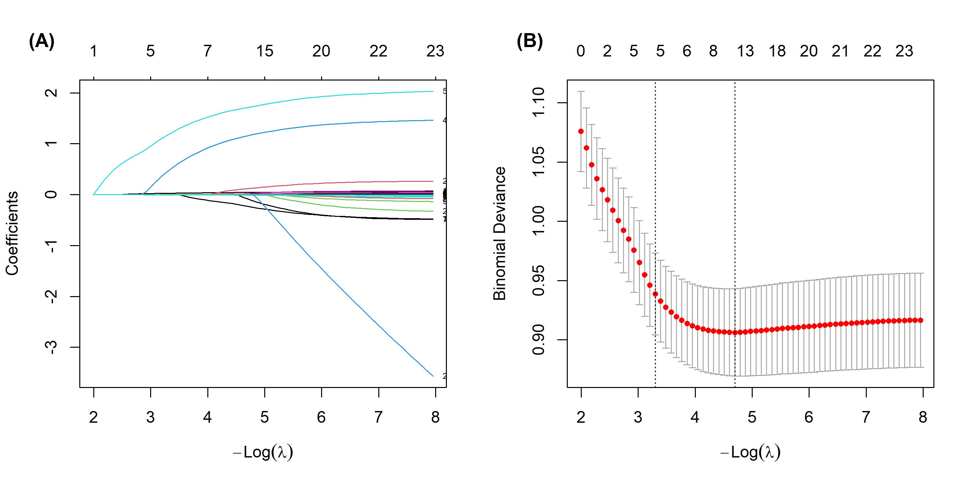
Figure S2. Sensitivity check using LASSO penalised logistic regression. (A) Coefficient paths and (B) cross-validated binomial deviance versus –log(λ). Penalised screening consistently retained the strongest preoperative predictors (age, cognitive status, and BUN), supporting the prespecified core predictor set.

Supplementary methods: full model equation
The predicted probability of 7-day postoperative delirium from the final whole-cohort model is:
probability = 1 / (1 + e^{–L}), where
L = –6.833 + 0.056×age(years) + 1.720×cognitive impairment + 0.028×BUN(mg/dL) – 0.243×albumin(g/dL) + 0.047×CFS
Cognitive impairment = 1 if mild cognitive impairment or dementia, otherwise 0. BUN=blood urea nitrogen. CFS=Clinical Frailty Scale. This equation reproduces the nomogram (figure 5) and can be used for external validation.

Table S1: Model discrimination in prespecified subgroups
Subgroup | Patients, n | Events, n (%) | AUC
Women | 790 | 171 (21.6) | 0.79
Men | 230 | 62 (27.0) | 0.75
Normal cognition / subjective decline | 529 | 44 (8.3) | 0.72
Mild cognitive impairment | 150 | 42 (28.0) | 0.61
Dementia | 341 | 147 (43.1) | 0.64
AUC=area under the curve. Discrimination is preserved in both sexes. Within-stratum discrimination is lower because conditioning on cognitive status—the dominant predictor—removes its contribution; the model is intended for whole-population triage.

Table S2: Coefficients of the categorised whole-cohort model used to derive the integer point score
Predictor (category) | β (categorised whole-cohort model) | Integer points
Pre-existing cognitive impairment (MCI or dementia) | 1.583 | 6
Age 75–84 years | 0.698 | 2
Age ≥85 years | 1.247 | 4
BUN >20 mg/dL | 0.575 | 2
Clinical Frailty Scale ≥5 | 0.432 | 2
Serum albumin <3.5 g/dL (reference unit) | 0.286 | 1
Coefficients are from a logistic-regression model refitted on the whole cohort (n=1020) with predictors entered at the categorised thresholds shown (age reference <75 years). Integer points were obtained by dividing each category’s coefficient by the smallest coefficient (serum albumin <3.5 g/dL) and rounding to the nearest integer; the resulting points reproduce table 5. The model intercept was −3.676. BUN=blood urea nitrogen. CFS=Clinical Frailty Scale. MCI=mild cognitive impairment.

Table S3: Baseline characteristics of the development and temporal-validation cohorts
Characteristic | Development (n=593) | Validation (n=427) | p value
Age, years, mean (SD) | 81.0 (7.5) | 81.7 (7.6) | 0.15
Male sex, n (%) | 133 (22.4%) | 97 (22.7%) | 0.97
Cognitive impairment (MCI or dementia), n (%) | 260 (43.8%) | 231 (54.1%) | <0.001
Clinical Frailty Scale ≥5, n (%) | 369 (62.2%) | 286 (67.0%) | 0.13
ASA class ≥3, n (%) | 358 (60.4%) | 236 (55.3%) | 0.12
BUN, mg/dL, median (IQR) | 17.3 (13.0–22.7) | 17.4 (13.6–23.4) | 0.42
BUN >20 mg/dL, n (%) | 219 (36.9%) | 167 (39.1%) | 0.52
Albumin, g/dL, mean (SD) | 3.8 (0.5) | 3.7 (0.5) | 0.08
Albumin <3.5 g/dL, n (%) | 145 (24.5%) | 110 (25.8%) | 0.69
Delirium within 7 days, n (%) | 124 (20.9%) | 109 (25.5%) | 0.10
Data are mean (SD), median (IQR), or n (%). p values are from the t test, Mann–Whitney U test, or χ² test as appropriate. The validation cohort had a higher prevalence of pre-existing cognitive impairment (54.1% vs 43.8%; p <0.001); the difference in 7-day delirium incidence was not statistically significant (25.5% vs 20.9%; p = 0.10).

