Supporting Information

Highlighting additional lighting effects to improve the photovoltaic performance of monocrystalline Si solar cells: A light with only wave-like properties should be called a wave, and then it must be a medium through which energy flows, providing extra energy

Ivana Lj. Validžić*
Vinca Institute of Nuclear Sciences, University of Belgrade, P.O. Box 522, 11001 Belgrade, Serbia

*Correspondingauthor. E-mail: validzic@vin.bg.ac.rs (Ivana Validžić);

Content:
Figure S1. Photos and characteristics of the monocrystalline silicon solar cells used. Photos and characteristics of the cells used in the work are provided by the company from which they were purchased.

Video S1 and VideoS2. We have attached two videos demonstrating how optics influence the measured values, Isc (Voc=0), and Voc (Isc=0), for the commercial Si monocrystalline solar cells KXOB22-01X8F and KXOB25-05X3F purchased from IXYS and tested under artificial xenon light. Our previous publications explored how different artificial lights affect the performance of monocrystalline Si solar cells, while these videos specifically illustrate the effect of the WFL optical system. The first video, S1, shows a significant increase in Isc when the optics are applied at Voc=0; it features the KXOB25-05X3F cell. The second video, S2, demonstrates the rise in Voc upon introducing optics at Isc=0; it features the KXOB22-01X8F cell.

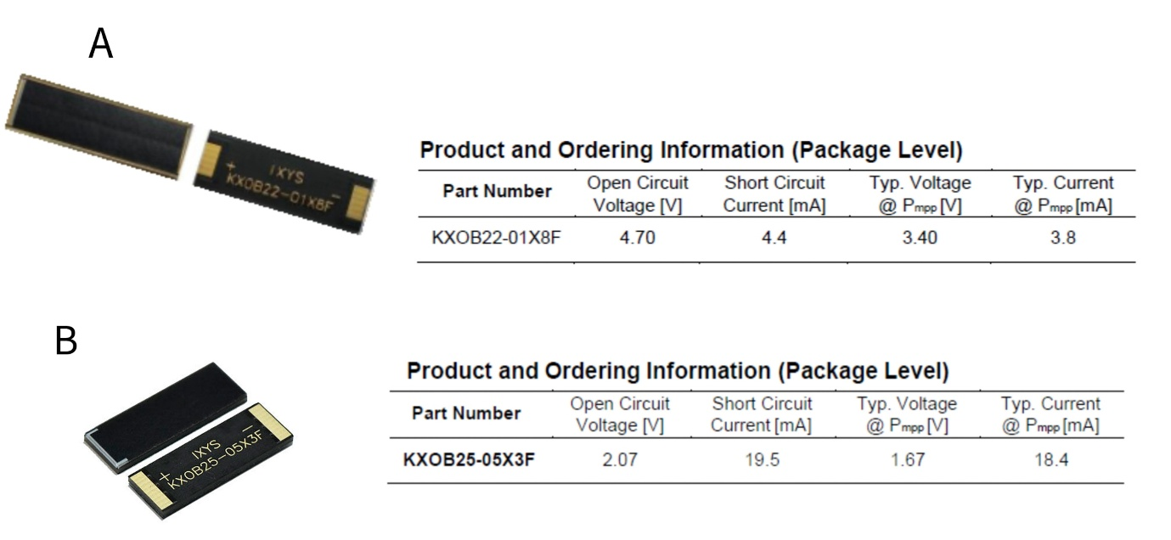
Figure S1. The figure presents the photos as well as the characteristics of the monocrystalline silicon solar cells, KXOB22-01X8F (A) and KXOB25-05X3F (B), purchased from IXYS Korea.

