Supporting Information
Isolation and Anti-Ferroptotic Activity of the New Tetrahydrocannabilactolvarin and Cannabinol Derivatives from a ∆⁹-THCV chemotype of Cannabis sativa L.

Stefano Salamone^{1,†}, Giuseppina Chianese^{2,†}, Laura Bertarini³, Aurora Camola¹, Matilde Marani³, Domenico Nucera¹, Paolo Luciano², Orazio Taglialatela Scafati², Andreas Koeberle⁴, Solveigh C. Koeberle^{4*}, Federica Pellati³, Federica Pollastro¹*

¹ Department of Pharmaceutical Sciences, University of Eastern Piedmont, Largo Guido Donegani 2, 28100 Novara, Italy
² Department of Pharmacy, School of Medicine and Surgery, University of Naples Federico II, Via D. Montesano 49, 80131 Napoli, Italy
³ Department of Life Sciences, University of Modena and Reggio Emilia, Via Giuseppe Campi 103, Modena 41125, Italy
⁴ Institute of Pharmaceutical Sciences/Pharmacognosy and Excellence Field BioHealth, NAWI Graz, University of Graz, 8010 Graz, Austria

†These authors contributed equally to this work
*To whom correspondence should be addressed: Federica Pollastro (federica.pollastro@uniupo.it), Solveigh C. Koeberle (solveigh.koeberle@uni-graz.at)
Contents
Table 1: Conformational analysis of the stereoisomers in the CHCl₃ solution
Table 2: Calculation results of compound THCLV (5), with mean absolute errors (MAE) values and DP4+ probabilities
Table 3: Calculated and experimental ¹³C NMR values for 5-a and 5-b
Table 4: Quantitative analysis of acidic and neutral cannabinoids by HPLC-UV/Vis, expressed as mg/g ± standard deviation (SD, n = 4)
Figure 1: ¹H NMR 400 MHz of Δ⁹-THC (1) in CDCl₃
Figure 2: ¹H NMR 400 MHz of CBN (2) in CDCl₃
Figure 3: ¹H NMR 400 MHz of CBNV (3) in CDCl₃
Figure 4: ¹H NMR 400 MHz of CBNVA (4) in CDCl₃
Figure 5: ¹³C NMR 200 MHz of CBNVA (4) in CDCl₃
Figure 6: ¹H NMR 400 MHz of THCLV (5) in CDCl₃
Figure 7: ¹³C NMR 200 MHz of THCLV (5) in CDCl₃
Figure 8: HMBC of THCLV (5) in CDCl₃
Figure 9: NOESY of THCLV (5) in CDCl₃
Figure 10: ¹H NMR 400 MHz of CBNVA-methyl ester (9) in CDCl₃
Figure 11: ¹³C NMR 200 MHz of CBNVA-methyl ester (9) in CDCl₃
Figure 12: ¹H NMR 400 MHz of CBNA-methyl ester (12) in CDCl₃
Figure 13: ¹³C NMR 200 MHz of CBNA-methyl ester (12) in CDCl₃

Table 1: Conformational analysis of the stereoisomers in the CHCl₃ solution
 | MAE Value (ppm) |  | ¹³C Data DP4+ Probability
 | ¹³C MAE | ¹³C CMAE | sDP4+ | uDP4+ | DP4+
5-a-SSRS | 2.09 | 1.45 | 73.6% | 100.00% | 100.00%
5-b-RSSR | 2.45 | 1.66 | 26.4% | 0.00% | 0.00%

Table 2: Calculation results of compound THCLV (5), with mean absolute errors (MAE) values and DP4+ probabilities
5 SSRS |  | DEª | DG^{b} | P%^{c}
 | DM16E a-1 | 0.00 | 0.00 | 90.8
 | DM16E a-2 | 1.36 | 5.68 | 9.2
5 RSSR
 | DM16E b-1 | 0.00 | 0.00 | 99.4
 | DM16E b-2 | 3.06 | 12.79 | 0.6
ªRelative energy (kcal/mol). ^{b}Relative Gibbs free energy (kcal/mol). ^{c}Boltzman Conformational distribution.

Table 3: Calculated and experimental ¹³C NMR values for 5-a and 5-b
Carbon | 5-a | 5-b | Experimental
1 | 152.3 | 152.2 | 155.6
2 | 104.8 | 105.3 | 110.4
3 | 138.2 | 138.4 | 146.6
4 | 106.5 | 106.8 | 110.6
5 | 150.9 | 150.9 | 154.1
6 | 78.1 | 76.7 | 77.8
6a | 48.6 | 37.6 | 45.2
7 | 19.1 | 19.2 | 19.2
8 | 35.1 | 32.5 | 34.5
9 | 106.0 | 105.4 | 106.9
10 | 96.1 | 95.2 | 96.8
10a | 81.2 | 81.2 | 84.2
10b | 99.8 | 101.4 | 103.5
11 | 25.4 | 25.9 | 24.7
12 | 21.7 | 20.7 | 21.8
13 | 28.7 | 28.3 | 28.6
1’ | 38.0 | 37.9 | 37.8
2’ | 24.9 | 24.8 | 23.8
3’ | 13.9 | 14.0 | 13.8

Table 4: Quantitative analysis of acidic and neutral cannabinoids by HPLC-UV/Vis, expressed as mg/g ± standard deviation (SD, n = 4)
Compound |  | Plant material  (mg/g) |  | Acetonic extract  (mg/g, dry weight)
THCLV |  | 0.6* |  | 5.0*
CBDVA |  | <LOD |  | <LOD
CBDV |  | <LOD |  | <LOD
CBDA |  | <LOD |  | <LOD
CBNV |  | 2.5* |  | 25.3±0.1
CBGA |  | <LOD |  | <LOD
CBGA |  | <LOD |  | <LOD
CBG |  | <LOD |  | <LOD
CBD |  | <LOD |  | <LOD
CBNVA |  | 1.2* |  | 8.2±0.2
Δ⁹-THCV |  | <LOD |  | <LOD
Δ⁹-THCVA |  | 0.5* |  | <LOQ
CBN |  | 2.1* |  | 19.7±0.2
CBNA |  | 0.9* |  | 5.9±0.5
Δ⁹-THC |  | <LOD |  | <LOD
CBC |  | <LOD |  | <LOD
Δ⁹-THCA |  | <LOQ |  | <LOQ
CBCA |  | <LOD |  | <LOD
*SD<0.05

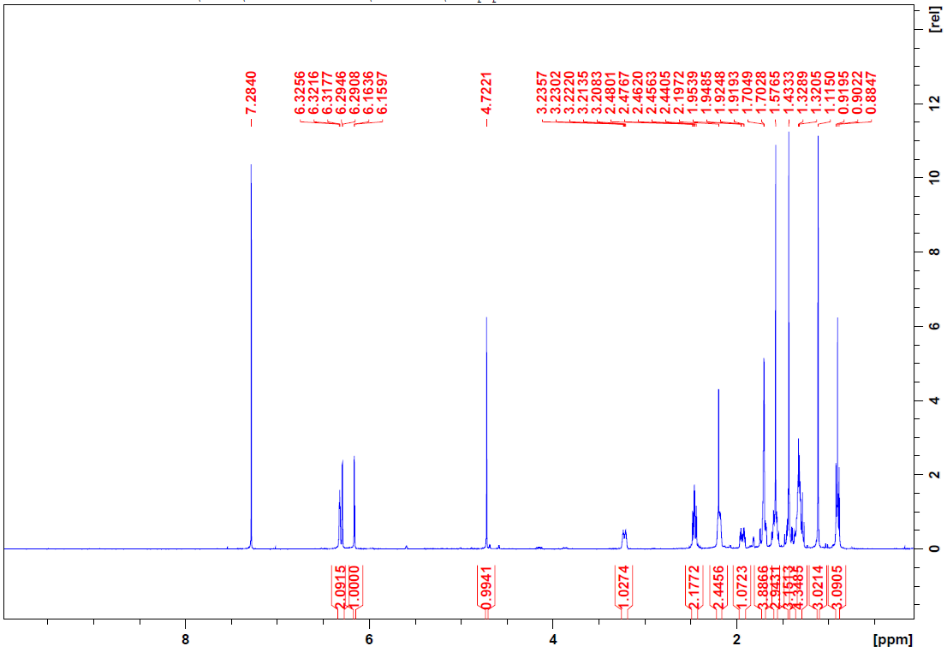
Figure 1: ¹H NMR 400 MHz of Δ⁹-THC (1) in CDCl₃
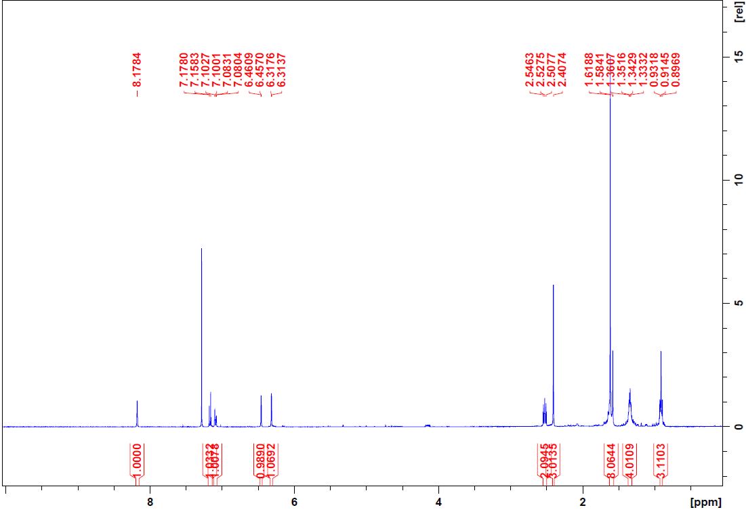
Figure 2: ¹H NMR 400 MHz of CBN (2) in CDCl₃
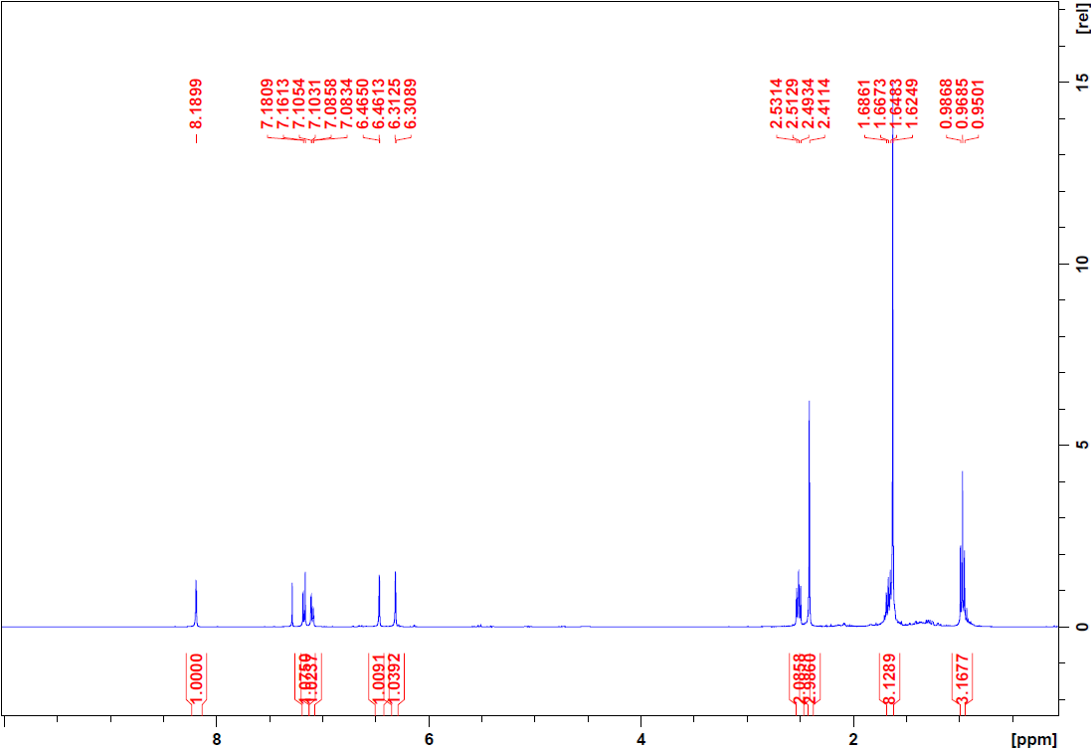
Figure 3: ¹H NMR 400 MHz of CBNV (3) in CDCl₃
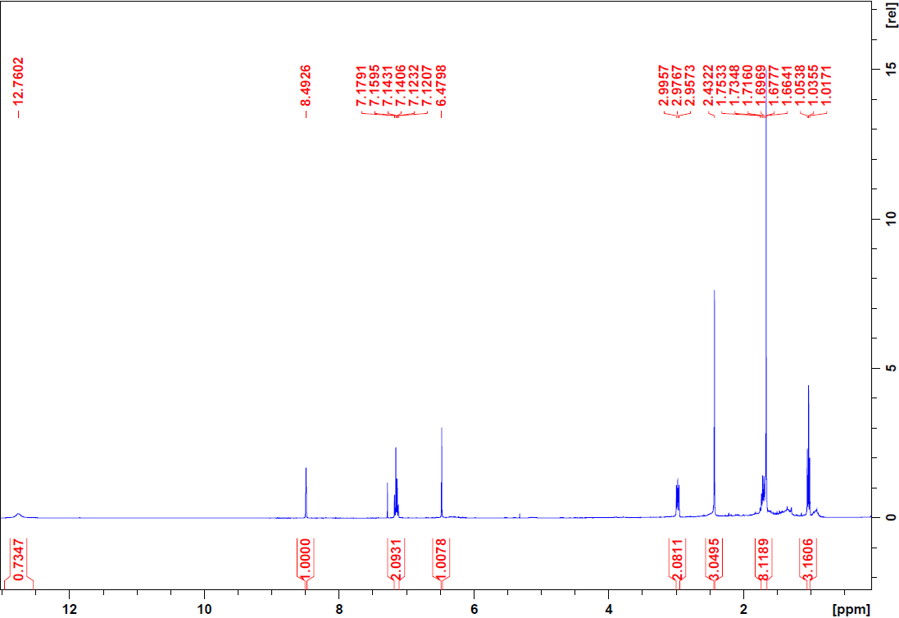
Figure 4: ¹H NMR 400 MHz of CBNVA (4) in CDCl₃
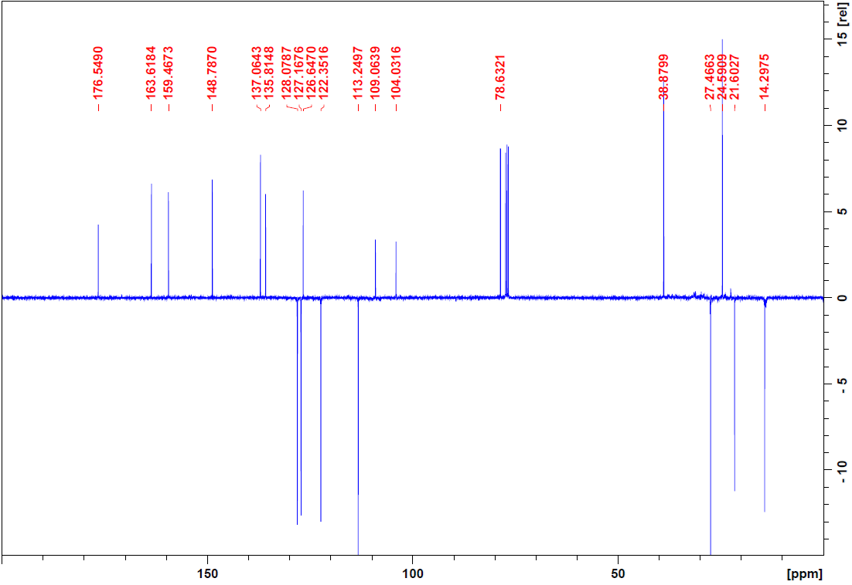
Figure 5: ¹³C NMR 200 MHz of CBNVA (4) in CDCl₃
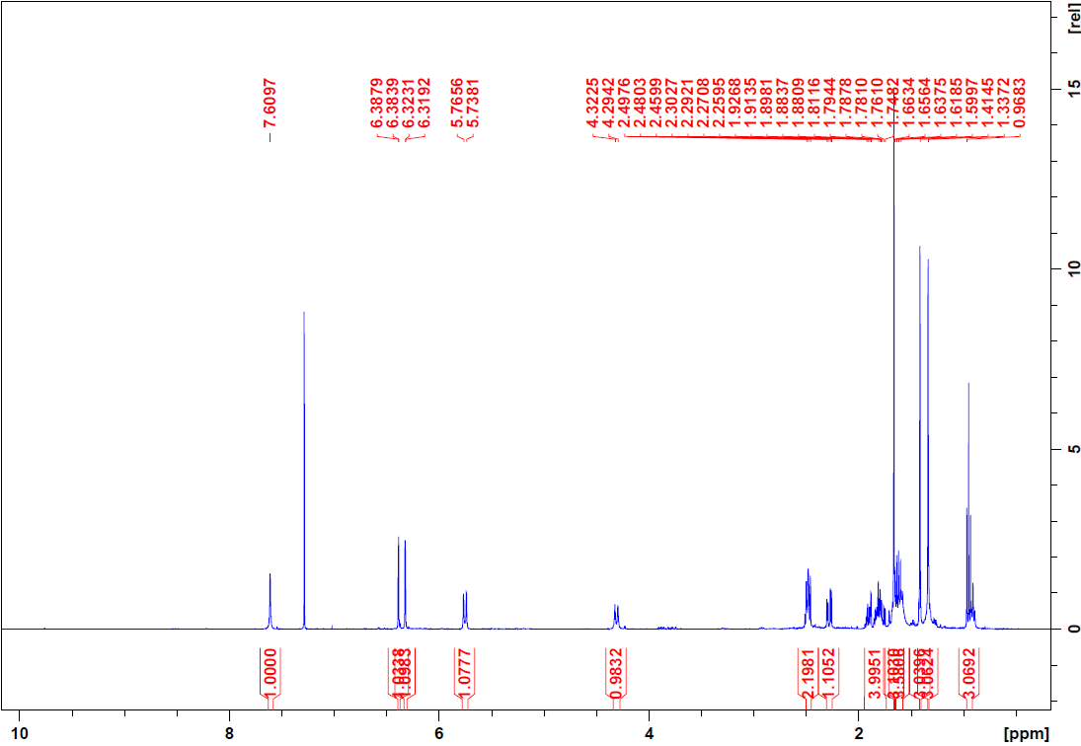
Figure 6: ¹H NMR 400 MHz of THCLV (5) in CDCl₃
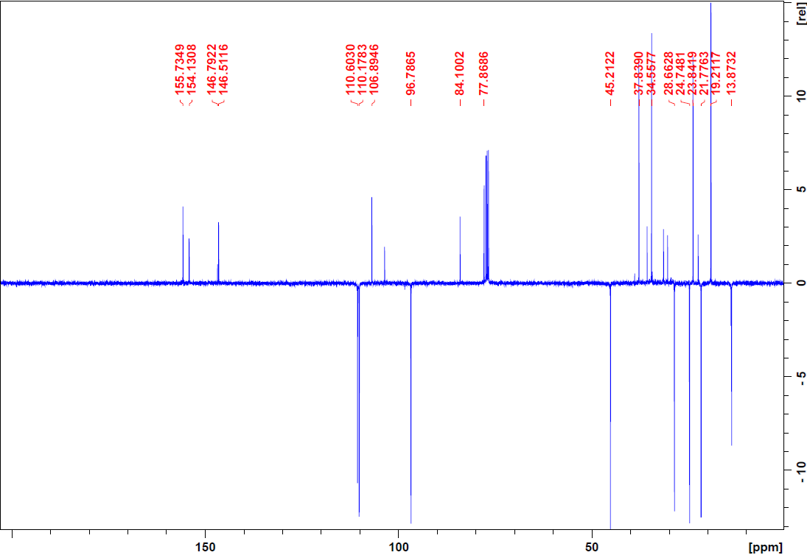
Figure 7: ¹³C NMR 200 MHz of THCLV (5) in CDCl₃
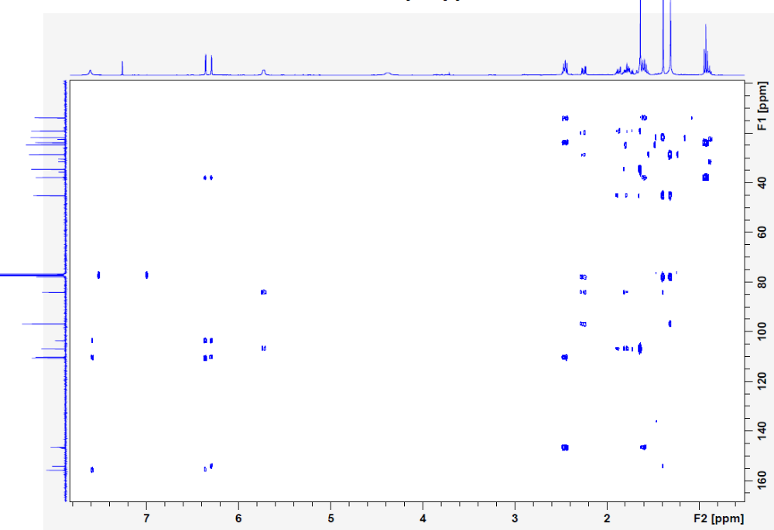
Figure 8: HMBC of THCLV (5) in CDCl₃
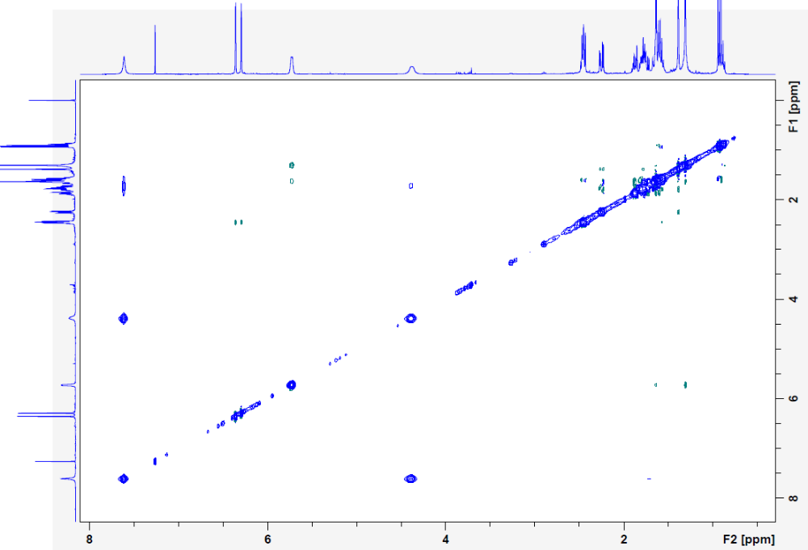
Figure 9: NOESY of THCLV (5) in CDCl₃
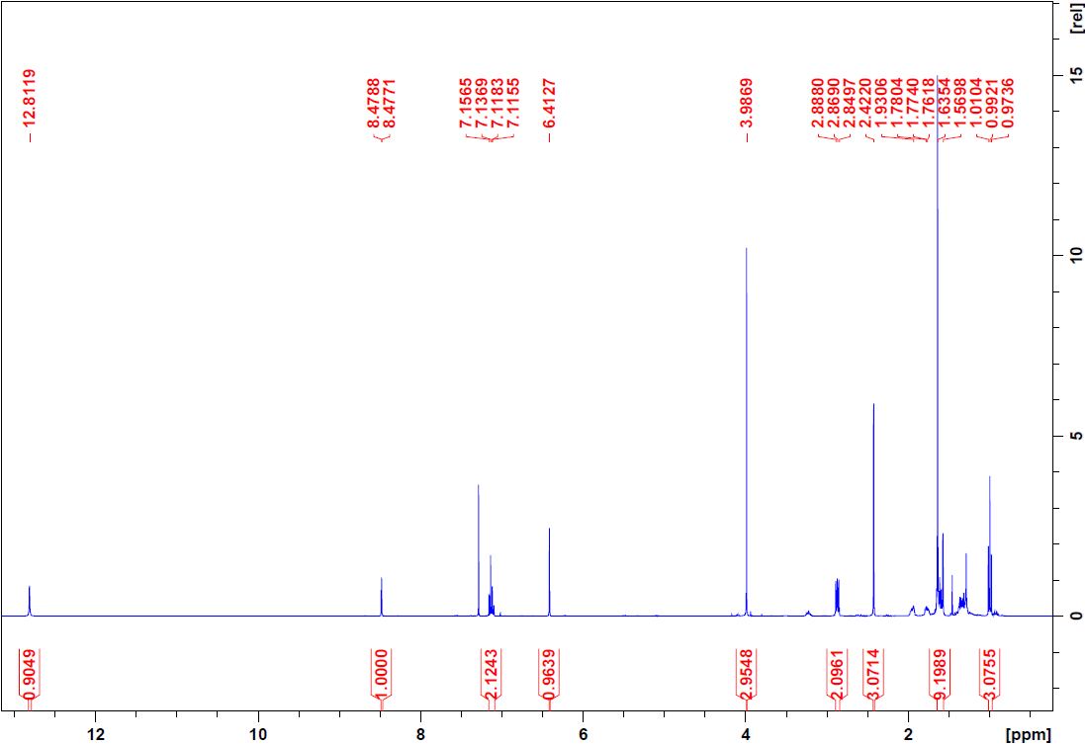
Figure 10: ¹H NMR 400 MHz of CBNVA-methyl ester (9) in CDCl₃
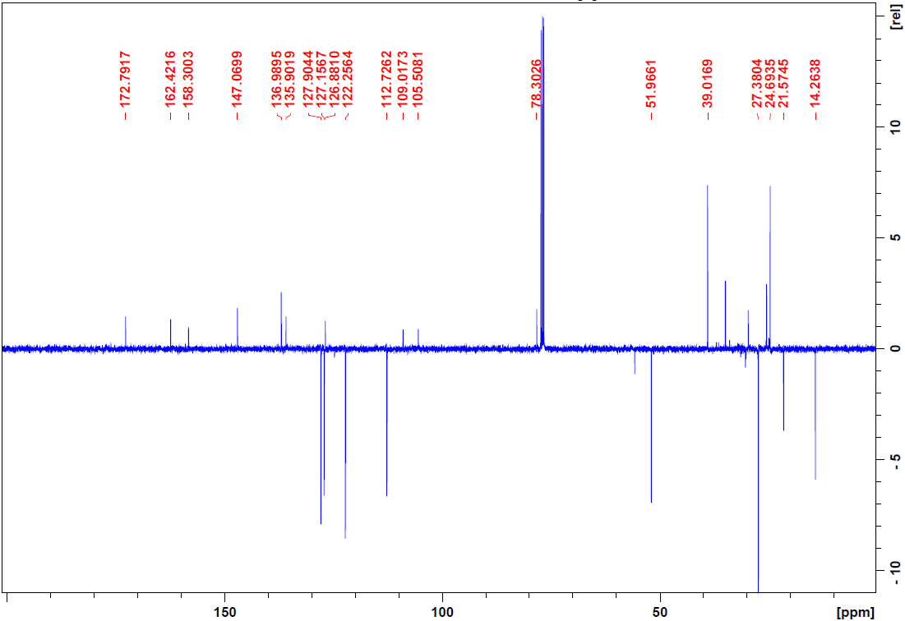
Figure 11: ¹³C NMR 200 MHz of CBNVA-methyl ester (9) in CDCl₃
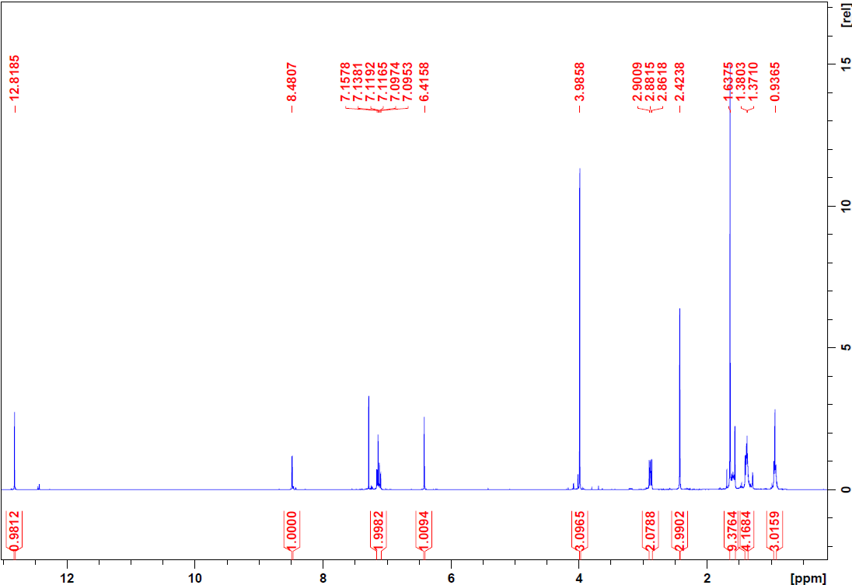
Figure 12: ¹H NMR 400 MHz of CBNA-methyl ester (12) in CDCl₃
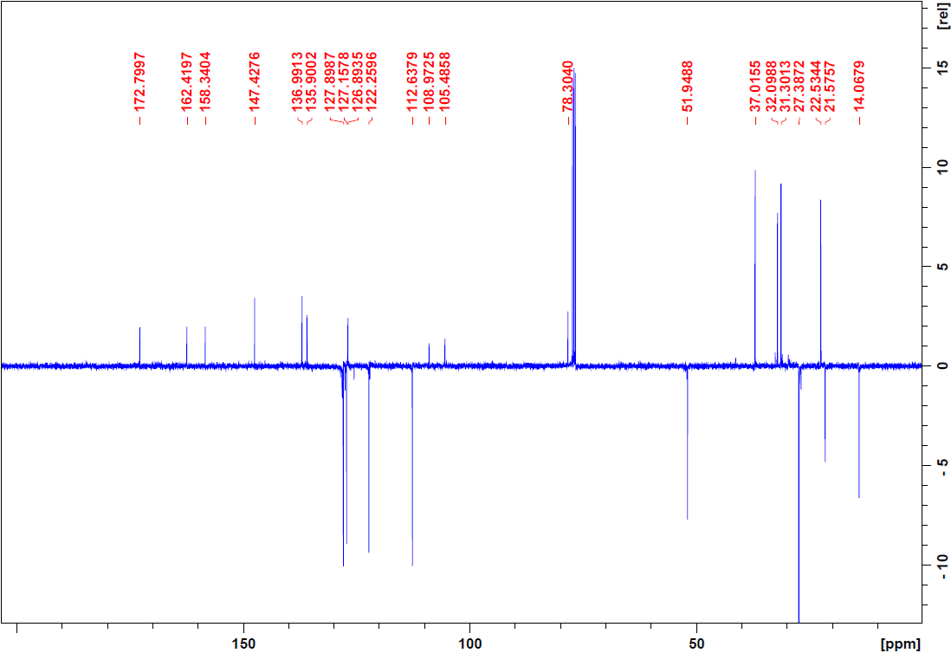
Figure 13: ¹³C NMR 200 MHz of CBNA-methyl ester (12) in CDCl₃

