Supplementary Figure 1. Subgroup analyses for the metabolome-wide associations of animal and plant protein intake. a) Associations with animal protein intake by baseline age. b) Associations with animal protein intake by sex. c) Associations with animal protein intake by case/control status. d) Associations with plant protein intake by baseline age. e) Associations with plant protein intake by sex. f) Associations with plant protein intake by case/control status.
p < 0.05 and ∗∗p < 0.001.

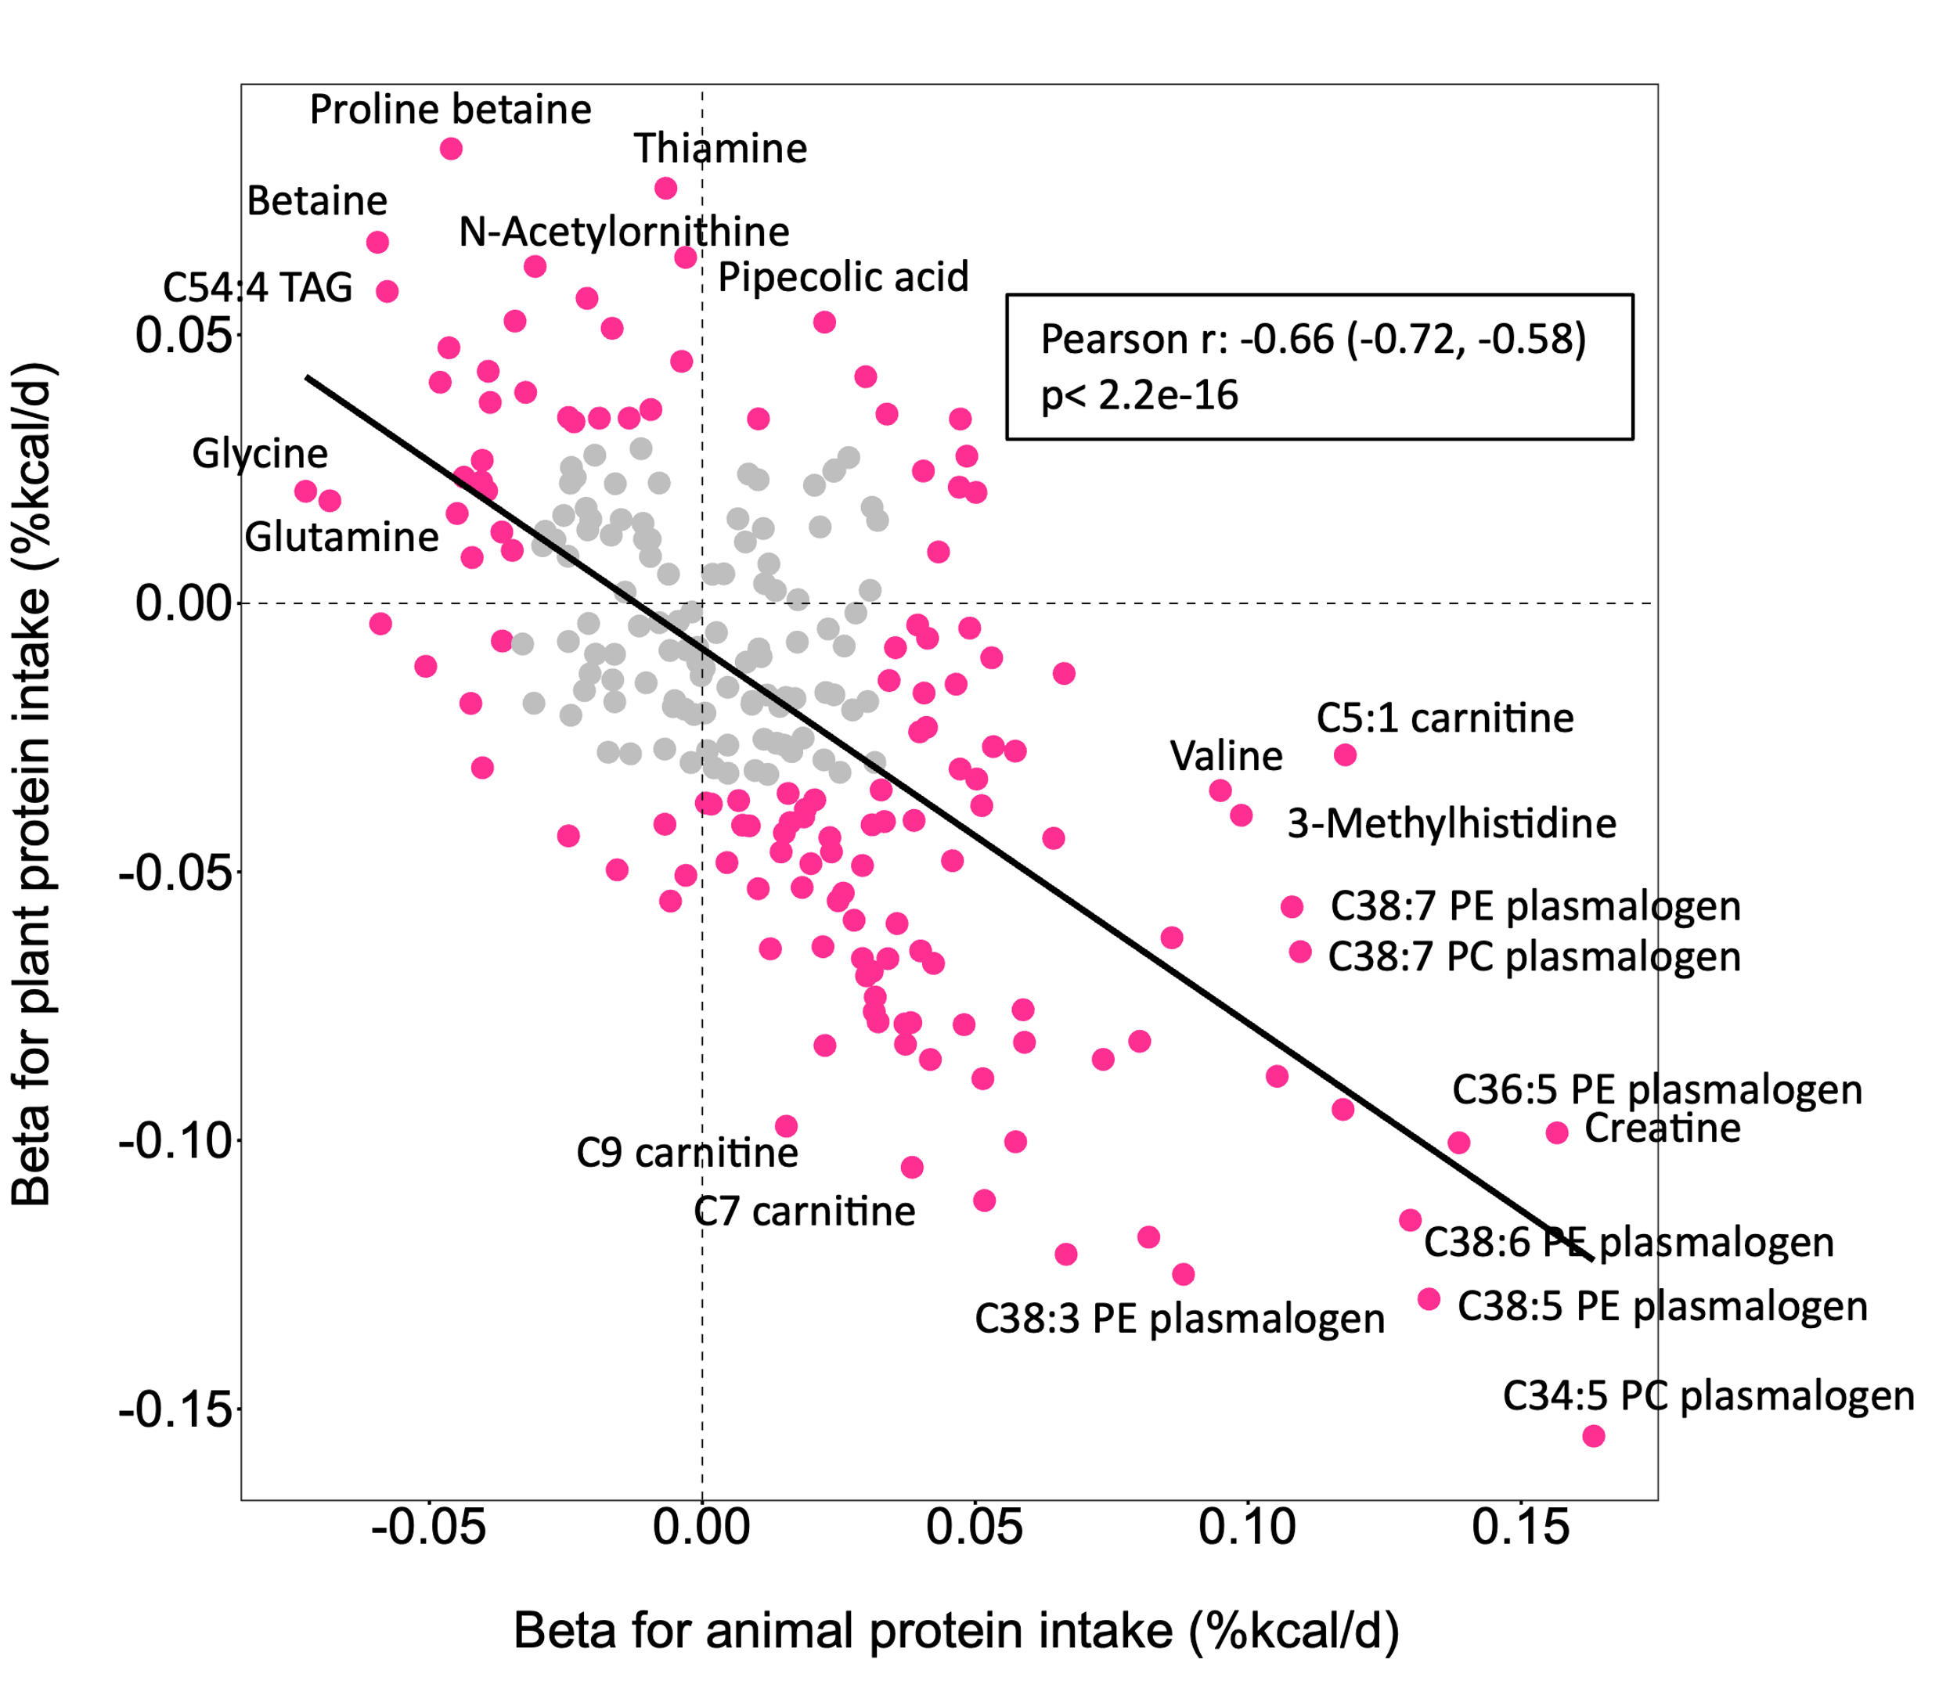
Supplementary Figure 2. Metabolome-wide correlation between β coefficients for individual metabolites and their associations with plant protein and animal protein intake.
Beta coefficients are from multivariable linear regression stratified for age, study cohorts, original substudies and the case/control status within the original substudy, and adjusted for fasting status, ethnicity, multivitamin use, diabetes, hypertension, antihypertensive medication use, hypercholesterolemia, lipid-lowering medication use, total energy intake, BMI, alcohol intake, modified AHEI, smoking and physical activity level. Pink dots represent metabolites that are significantly associated with both animal and plant protein intake after Bonferroni correction (p<0.05). Grey dots are non-significant.

Supplementary Table 1. Associations of the self-reported plant protein intake with T2D in NHS, NHSII, HPFS, and WHI.

 | NHS, NHSII, HPFS |  | WHI
 | Protein intake (% energy) per 1SD increment |  | Protein intake (% energy) per 1SD increment
 | HR (95%CI) | P value | HR (95%CI) | P value
Plant-protein
Age-adjusted | 0.92 (0.85, 1.00) | 0.05 | 1.02 (0.93, 1.13) | 0.668
MV | 0.96 (0.87, 1.06) | 0.358 | 0.90 (0.80, 1.02) | 0.108
MV+mutual adjustment | 0.98 (0.89, 1.08) | 0.665 | 0.94 (0.83, 1.06) | 0.317
Animal protein
Age-adjusted | 1.15 (1.07, 1.25) | <0.001 | 1.12 (1.02, 1.23) | 0.022
MV | 1.10 (1.01, 1.21) | 0.037 | 1.08 (0.96, 1.22) | 0.179
MV+mutual adjustment | 1.07 (0.98, 1.18) | 0.136 | 1.04 (0.93, 1.17) | 0.487
Plant-to-animal protein ratio
Age-adjusted | 0.84 (0.77, 0.93) | <0.001 | 0.93 (0.84, 1.03) | 0.176
MV | 0.91 (0.82, 1.01) | 0.07 | 0.92 (0.81, 1.04) | 0.197
MV+mutual adjustment | 0.93 (0.84, 1.03) | 0.183 | 0.96 (0.84, 1.09) | 0.514
HRs are per 1-SD increment. Model 1 was adjusted for fasting status and stratified by baseline age, study cohorts, original substudies, and case-control status within the original substudy. Model 2 was further adjusted for race/ethnicity, multivitamin use, diabetes, hypertension, antihypertensive medication use, hypercholesterolemia, lipid-lowering medication use, socioeconomic status, total energy intake, BMI, alcohol intake, modified AHEI, smoking and physical activity level. Model 3 further included adjustment for the the respective metabolomic signature score to examine association independence. SD, standard deviation; HR, hazard ratio; CI, confidence interval; T2D, type 2 diabetes;

