Ecological momentary assessment studies exploring substance use in clinical samples of youth: A systematic review
SUPPLEMENTARY MATERIALS
SM1. Search Strategy
SM2. PRISMA Flow Chart
SM3. Study Characteristics (Table 1) grouped by clinical setting
SM4. Linear regressions predicting average adherence
SM5. Distribution of Risk of Bias
SM Figure 6. Distribution of substance-related behaviours in observational studies, grouped by clinical setting
SM Figure 7. Distribution of substance-related behaviours in intervention studies, grouped by clinical setting
SM Figure 8. Distribution of all momentary antecedents and consequences in observational studies, grouped by clinical setting.
SM Figure 9. Micro assay of all momentary antecedents grouped by higher order domains.
SM Figure 10. Harvest plots
SM Figure 10A: Harvest Plot of substance use antecedents
SM Figure 10B: Harvest Plot of affect and cognition antecedents
SM Figure 10C: Harvest Plot of environmental context antecedents
SM Figure 10D: Harvest Plot of social context antecedents

SM1. Search Strategy¹
Date: April 9, 2026
Databases: Ovid MEDLINE (1946 onward), Psychinfo (1806 onward), Scopus
- Ecological Momentary Assessment/
- Biosensing Techniques/
- Cell Phone/
- Telemedicine/
- Mobile Applications/
- ecological momentary intervention.mp.
- EMA.mp.
- EMI.mp.
- momentary sampling.mp.
- real time data.mp.
- mobile phone.mp.
- smartphone.mp.
- smartphone application.mp.
- smartphone app.mp.
- passive sensing.mp.
- activity recognition.mp.
- ambulatory research.mp.
- Monitoring, Ambulatory/
- idiographic research.mp.
- ambulatory assessment.mp.
- nomothetic.mp.
- experience sampling method.mp.
- experience sampling.mp.
- digital phenotyping.mp.
- event-contingent recording.mp.
- real-time data capture.mp.
- Wearable Electronic Devices/
- self-monitoring.mp.
- intensive longitudinal assessment.mp.
- daily diary approach.mp.
- sensor data.mp.
- Substance-Related Disorders/
- drinking behavior/ or drug-seeking behavior/ or health behavior/ or "marijuana use"/ or "recreational drug use"/
- Cannabis/
- Alcohol Drinking/ or Alcoholism/ or Alcoholic Intoxication/
- N-Methyl-3,4-methylenedioxyamphetamine/
- Hallucinogens/
- Cigarette Smoking/ or Smoking/ or Tobacco Smoking/
- Electronic Nicotine Delivery Systems/
- MDMA.mp.
- Methamphetamine/
- electronic cigarettes.mp.
- e-cigarettes.mp.
- vape.mp.
- vaping.mp.
- ecstasy.mp.
- 1 or 2 or 3 or 4 or 5 or 6 or 7 or 8 or 9 or 10 or 11 or 12 or 13 or 14 or 15 or 16 or 17 or 18 or 19 or 20 or 21 or 22 or 23 or 24 or 25 or 26 or 27 or 28 or 29 or 30 or 31
- 32 or 33 or 34 or 35 or 36 or 37 or 38 or 39 or 40 or 41 or 42 or 43 or 44 or 45 or 46
- 47 and 48
¹ The initial title and abstract screening up to January 31, 2023 was done as part of this parent review. As such, many papers reviewed at the full text-stage were excluded due to age and setting. The search was updated April 9, 2026 specifically for this sub-review, where older and non-clinical samples were screened out during title/abstract screening.

SM2. PRISMA Flow Chart
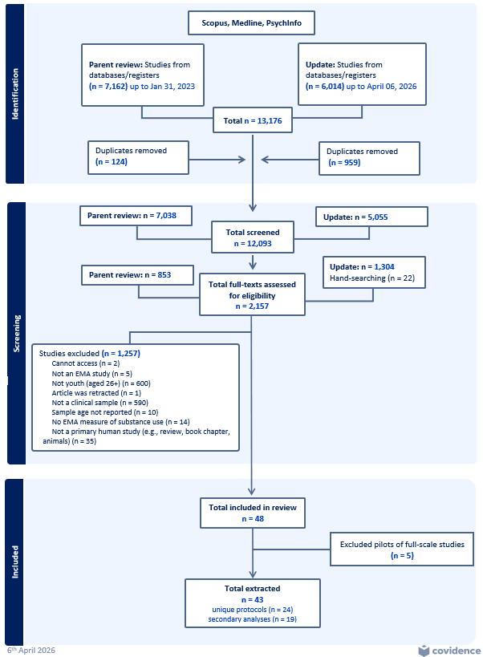
SM3: Study Characteristics (Table 1) by clinical setting
Study Characteristics | Emergency Department  n=7 | Medical Outpatient  n=6 | Substance Use  Program  n = 6 | Mental Health Program  n=5
Sample characteristics
Country n (%)
USA | 7 (100%) | 5 (83%) | 4 (80%) | 5 (100%)
Australia | 0 (0%) | 1 (17%) | 0 (0%) | 0 (0%)
France | 0 (0%) | 0 (0%) | 1 (20%) | 0 (0%)
Iran | 0 (0%) | 0 (0%) | 1 (20%) | 0 (0%)
Study Type
Observational | 4 (57.1%) | 5 (83%) | 2 (40%) | 4 (80%)
Intervention | 3 (42.9%) | 1 (17%) | 4 (80%) | 1 (20%)
Sample size at baseline
Mean (SD) | 371 (425.6) | 87.3 (91.9) | 65.2 (67) | 40.6 (18.8)
Median [min-max] | 296 [10-1131] | 57 [8-248] | 35.5 [28-200] | 33 [20-66]
Age
Mean (SD) | 22.6 (0.8) | 17.2 (3.0) | 18.1 (2.9) | 18.5 (2.3)
Median (min-max) | 22.1 [18-29] | 18.4 [12-25] | 16.4 [13-24] | 18.2 [12-25]
Adolescent sample n(%) | 0 (0%) | 5 (83.3%) | 4 (66.7%) | 3 (60%)
Emerging adult sample n(%) | 7 (100%) | 1 (16.7%) | 2 (33.3%) | 2 (40%)
% Female Median [min-max] | 65.3 [50-70] | 59.5 [56-75] | 30 [12.9-53] | 64.5 [52-86.7]
% Race¹ Median [min-max]
White | 49.2 [0-60] | 6.4 [0-85] | 3.3 [0-98] | 72.7 [18-86.7]
Black | 38.8 [0-60] | 50.5 [0-89] | 0 [0-91] | 9.1 [0-37]
East/Southeast Asian | 0 [0-5.3] | 0 [0-0] | 0 [0-0] | 0 [0-0]
Hispanic | 0 [0-8] | 0 [0-31] | 1.0 [0-93] | 6.7 [0-37]
Multiracial | 0 [0-9.8] | 0 [0-11.7] | 0 [0-24] | 0 [0-8]
Other* | 0 [0-20] | 0 [0-3.6] | 0 [0-7] | 12.1 [0-87.1]
Substance(s) of interest⁴ n(%)
Alcohol | 7 (100%) | 3 (50%) | 3 (50%) | 5 (100%)
Cannabis | 4 (57.1%) | 5 (83.3%) | 3 (50%) | 4 (80%)
General substance use | 2 (28.6%) | 3 (50%) | 3 (50%) | 2 (40%)
Nicotine/Tobacco (including cigarettes) | 3 (42.9%) | 2 (33.3%) | 1 (16.7%) | 2 (40%)
Opioids | 2 (28.6%) | 0 (0%) | 1 (16.7%) | 1 (20%)
Stimulants (cocaine/prescription stimulants, MDMA, meth) | 0 (0%) | 0 (0%) | 1 (16.7%) | 2 (40%)
Psychedelics (LSD/acid) | 0 (0%) | 0 (0%) | 1 (16.7%) | 1 (20%)
Sedatives | 0 (0%) | 0 (0%) | 0 (0%) | 1 (20%)
EMA Characteristics
Study duration (Target assessment period in days)²
Mean (SD) | 23.7 (27.6) | 10.3 (3.4) | 25.8 (10.6) | 22.4 (11.5)
Median [min-max] | 14 [4-84] | 10 [7-14] | 27 [14-42] | 21 [14-42]
Number of assessments per data collection day
Mean (SD) | 1.4 (1.1) | 5.7 (0.8) | 2.7 (2.1) | 4.6 (1.7)
Median [min-max] | 1 [1-4] | 6 [4-6] | 2 [1-6] | 5 [2-6]
EMA sampling design n(%)
Burst design | 4 weekly (57.1%) | 2 monthly (33.3%) | 2 monthly (33.3%) | 0 (0%)
Daily consecutive sampling | 1 (14.3%) | 4 (66.7%) | 4 (66.7%) | 5 (100%)
Combined | 2 weekly (28.6%) | 0 (0%) | 0 (0%) | 0 (0%)
EMA delivery n(%)
Text-based | 3 (42.9%) | 3 (50%) | 3 (50%) | 0 (0%)
App-based | 3 (42.9%)  1 both (14.3%) | 3 (50%) | 3 (50%) | 5 (100%)
Personal phone | 7 (100%) | 1 (17%) | 2 (33%) | 2 (40%)
Study phone | 0 (0%) | 5 (83%) | 4 (67%) | 3 (60%)
Training on EMA n (%)
Received training | 5 (71.4%) | 5 (83.3%) | 4 (66.7%) | 4 (80%)
Did not receive training | 1 (14.3%) | 0 (0%) | 0 (0%) | 0 (0%)
Not stated | 1 (14.3%) | 1 (16.7%) | 2 (33.3%) | 1 (20%)
Personalized Feedback n (%)
Received feedback | 3 (42.9%) | 1 (16.7%) | 1 (16.7%) | 1 (20%)
Did not receive feedback | 3 (42.9%) | 0 (0%) | 2 (33.3%) | 0 (0%)
Not stated | 1 (14.3%) | 5 (83.3%) | 3 (50%) | 4 (80%)
EMA sampling methods⁴ n (%)
Time Contingent | 7 (100%) | 2 (33.3%) | 4 (66.7%) | 4 (80%)
Signal Contingent | 1 (14.3%) | 6 (100%) | 4 (66.7%) | 4 (80%)
Event Contingent | 0 (0%) | 1 (16.7%) | 2 (33.3%) | 4 (80%)
Passive Monitoring | 2 (28.6%) | 1 (16.7%) | 0 (0%) | 0 (0%)
Adherence (% completion)
Mean (SD) | 65 (19) | 62 (19) | 81 (10) | 67 (19)
Median [min-max] | 73.8 [32-83] | 66.3 [30.4-82] | 82.7 [64-90] | 70.4 [34-83.3]
Renumeration³ ($USD)
Mean (SD) | 127 (135) | 103 (62) | 125 (178) | 138 (32)
Median [min-max] | 76 [30-420] | 120 [22-175] | 25 [0-400] | 130 [100-180]
Statistical Analyses - All Studies | n = 14 | n = 11 | n = 11 | n = 7
Statistical Model⁴ n (%)
Mixed effect/Multilevel models | 5 (35.7%) | 2 (18.2%) | 5 (45.5%) | 4 (57.1%)
Structural equation modelling | 1 (7.1%) | 0 (0%) | 1 (9.1%) | 2 (28.6%)
Time varying equational modelling | 1 (7.1%) | 0 (0%) | 2 (18.2%) | 1 (14.3%)
Logistic regression | 1 (7.1%) | 3 (27.3%) | 3 (27.3%) | 1 (14.3%)
Poisson regression | 2 (14.3%) | 0 (0%) | 0 (0%) | 1 (14.3%)
Linear regressions/GLMM/GEE | 0 (0%) | 4 (36.4%) | 1 (9.1%) | 1 (14.3%)
Machine Learning | 4 (28.6%) | 0 (0%) | 0 (0%) | 0 (0%)
Other (ANOVA, Mann-Whitney, t-tests) | 4 (28.6%) | 2 (18.2%) | 1 (9.1%) | 1 (14.3%)
Level of aggregation⁴ n (%)
Within-person | 6 (42.9%) | 9 (81.8%) | 7 (63.6%) | 7 (100%)
Between-person | 6 (42.9%) | 1 (9.1%) | 3 (27.3%) | 3 (42.9%)
Aggregated | 4 (28.6%) | 4 (36.4%) | 3 (27.3%) | 0 (0%)
Missing data strategy n (%)
FIML | 2 (14.3%) | 0 (0%) | 0 (0%) | 2 (28.6%)
Multiple imputation | 3 (21.4%) | 1 (9.1%) | 2 (18.2%) | 0 (0%)
None - Complete case | 5 (35.7%) | 7 (63.6%) | 6 (54.5%) | 2 (28.6%)
Not stated | 4 (28.6%) | 3 (27.3%) | 3 (27.3%) | 3 (42.9%)
*Other races included: American Indian/Alaska Native, Non-Hispanic/Latino, or Asian or Pacific Islander.
¹If not stated in study, imputed as 0 for calculations. ²Minimum target assessment period (minimum study duration as per study protocol); ³ Most studies reported max $USD renumeration, with one study converted from AUD to USD according to the exchange rate in year of data collection, one study reporting the minimum guaranteed reimbursement, and three not reporting reimbursements; ⁴Sub-categories are not mutually exclusive

SM4. Linear regressions predicting average adherence rates across primary studies (k = 24)
 | Estimate | Confidence Interval | p-value
Sample Size | 0.01 | [-0.02, 0.04] | 0.377
Age | 0.03 | [-2.44, 2.49] | 0.983
Mean | -0.39 | [-2.25, 1.46] | 0.663
Maximum
Emerging Adult (k = 16) | - | - | -
Adolescent (k = 8) | 3.56 | [-12.53, 19.66] | 0.651
Clinical Context
Emergency Department (k=7) | - | - | -
Outpatient Medical Clinic (k=6) | -3.89 | [-23.82, 16.04] | 0.688
Mental Health (k=5) | 1.83 | [-19.14, 22.81] | 0.857
Substance Use (k=6) | 15.12 | [-4.81, 35.05] | 0.129
Sex
Male | - | - | -
Female | -0.28 | [-0.67, 0.11] | 0.151
Race
White | 0.08 | [-0.15, 0.31] | 0.495
Black | 0.1 | [-0.14, 0.35] | 0.397
Asian | 0.8 | [-6.13, 7.74] | 0.812
Hispanic | 0.21 | [-0.15, 0.57] | 0.248
Multiracial | 0.61 | [-0.72, 1.94] | 0.354
Other | -0.26 | [-0.59, 0.06] | 0.103
Substances
General (k=10) | 6.34 | [-8.87, 21.55] | 0.397
Alcohol (k=18) | -3.16 | [-20.71, 14.39] | 0.712
Cannabis (k=16) | 0.56 | [-15.6, 16.73] | 0.943
Nicotine (k=8) | 1.74 | [-14.41, 17.9] | 0.825
Other (1) | 9.98 | [-27.92, 47.87] | 0.59
Target # of days | 0.32 | [-0.11, 0.76] | 0.14
EMA collection frequency
Daily consecutive (k=13) | - | - | -
Burst (k=8) | 1.89 | [-14.82, 18.61] | 0.816
Combined (k=2) | 11.39 | [-17.11, 39.9] | 0.415
Minimum Assessments per day | -2.06 | [-6.5, 2.38] | 0.346
Low (1) (k=9) | 8.85 | [-7.56, 25.26] | 0.275
High (>=5) (k=3) | 2.04 | [-21.98, 26.06] | 0.862
Med (2-4) (k=12) | - | - | -
Training
No/NA (6) | - | - | -
Yes (k=18) | -2.12 | [-19.7, 15.46] | 0.805
Feedback
Missing (k=13) | - | - | -
Yes (k=6) | 7.56 | [-11.05, 26.16] | 0.408
No (k=5) | 2.83 | [-17, 22.67] | 0.769
Sampling Method
Univariable models
Time (vs. No time) (k=17) | -6.24 | [-22.79, 10.3] | 0.442
Event (vs. No event) (k=7) | 2.36 | [-14.38, 19.1] | 0.773
Signal (vs. No signal) (k=15) | -8.14 | [-23.47, 7.19] | 0.283
Sensor (vs. No sensor) (k=3) | -13.25 | [-35.54, 9.05] | 0.231
Time only (k = 6; reference not only time) | 10.51 | [-6.48, 27.49] | 0.213
Multivariable model
Signal only (k=7; reference time only) | -2.29 | [-19.03, 14.45] | 0.778
Time and Signal (k=8; reference time only) | -19.23 | [-35.97, -2.5] | 0.0264
Passive (k = 3; reference no passive) | -20.47 | [-41.74, 0.8] | 0.0584
EMA Delivery
App (k=14) | - | - | -
Text (k=9) | 2.86 | [-12.91, 18.62] | 0.71
Both (k=1) | -21.22 | [-59.41, 16.98] | 0.261
Device
Study (k=12) | - | - | -
Personal (k=12) | -2.74 | [-17.94, 12.46] | 0.712
Renumeration (max) | 0.05 | [-0.02, 0.13] | 0.141

SM5. Distribution of Risk of Bias
Quality 1—rationale for the EMA design | n (%) ALL  (n = 43) | Parent  (n = 24) | Secondary  (n = 19)
Weak | 0 (0%) | 0 (0%) | 0 (0%)
Moderate | 3 (7%) | 2 (8.3%) | 1 (5.3%)
Strong | 40 (93%) | 22 (91.7%) | 18 (94.7%)
Quality 2—whether an a priori power analysis had been conducted
NA | 11 (25.6%) | 7 (29.2%) | 4 (21.1%)
Weak | 30 (69.8%) | 15 (62.5%) | 15 (78.9%)
Moderate | 0 (0%) | 0 (0%) | 0 (0%)
Strong | 3 (7%) | 3 (12.5%) | 0 (0%)
Quality 3—adherence to the EMAs
Weak | 13 (30.2%) | 9 (37.5%) | 4 (21.1%)
Moderate | 25 (58.1%) | 11 (45.8%) | 14 (73.7%)
Strong | 5 (11.6%) | 4 (16.7%) | 1 (5.3%)
Quality 4—treatment of missingness
Weak | 26 (60.5%) | 13 (54.2%) | 13 (68.4%)
Moderate | 8 (18.6%) | 4 (16.7%) | 4 (21.1%)
Strong | 9 (20.9%) | 7 (29.2%) | 2 (10.5%)

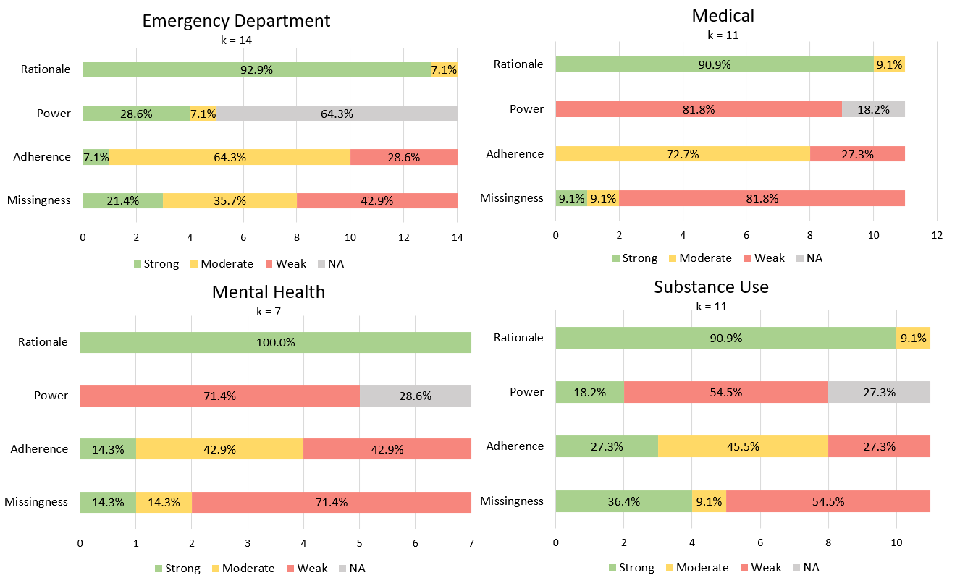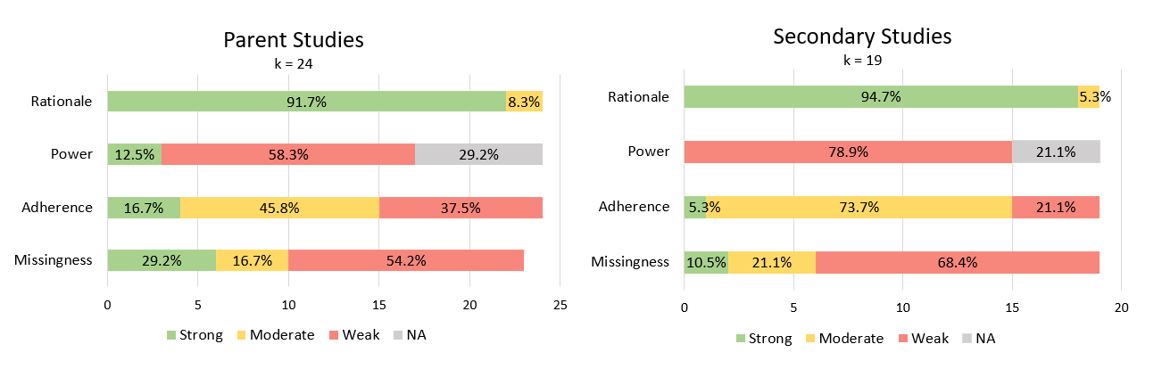

SM Figure 6. Distribution of substance-related behaviours across observational studies (k=26)
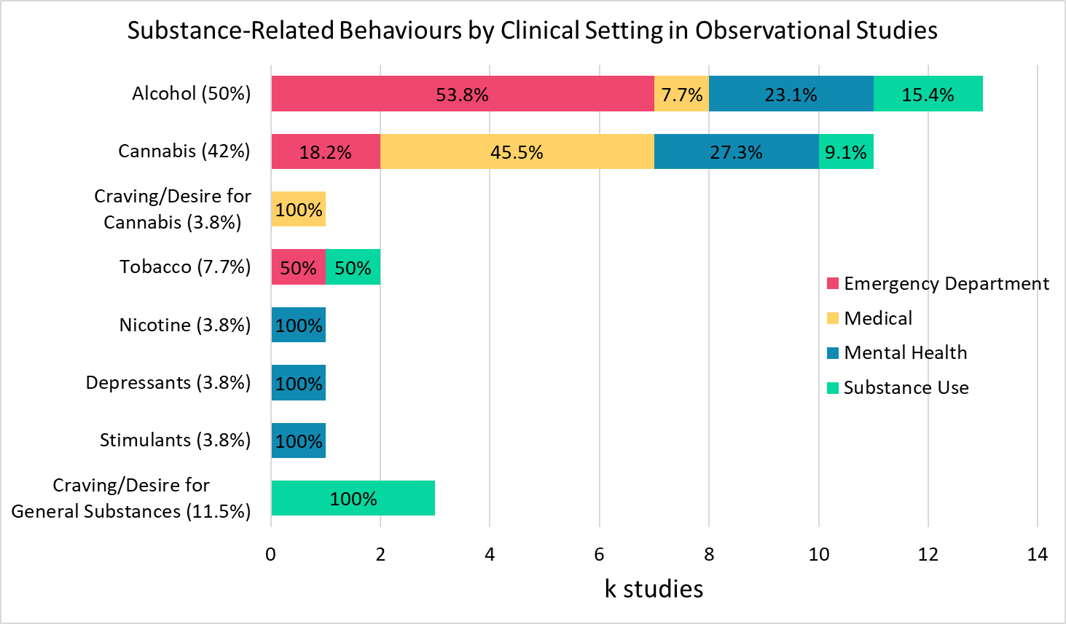
SM Figure 6 caption. This stacked bar graph displays the number of observational studies (k, horizontal axis) categorized different substance-related behaviours. Percentages on the x-axis are out of all observational studies with a substance use behaviour as the target outcome (k=26) while percentages on bars were calculated out of the number of variables within substance-specific subgroups.

SM Figure 7. Distribution of substance-related behaviours across intervention studies (k = 15)
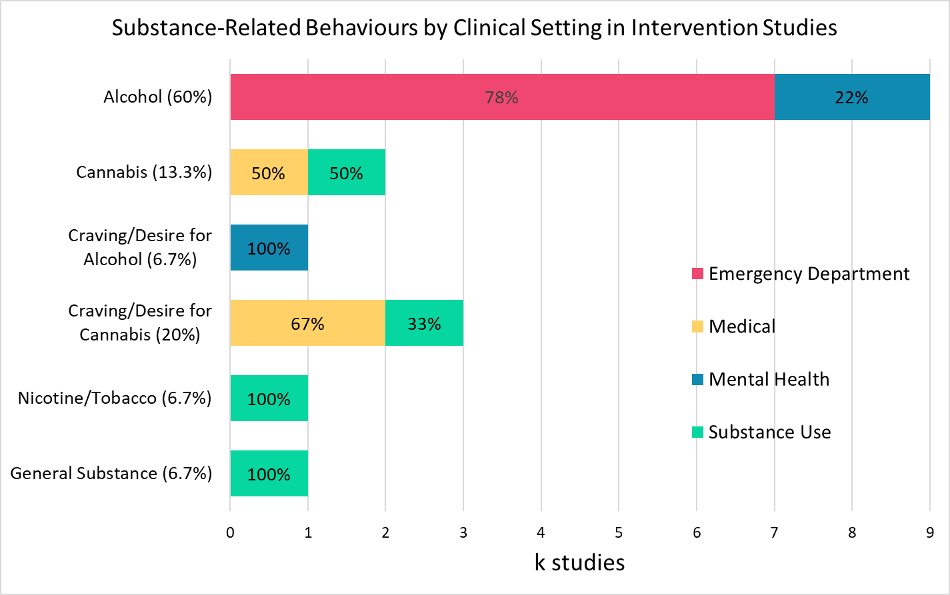
SM Figure 7 caption. This stacked bar graph displays the number of intervention studies (k, horizontal axis) categorized different substance-related behaviours. Percentages on the x-axis are out of all intervention studies with a substance use-related behaviour as the target outcome (k = 15) while percentages on bars were calculated out of the number of variables within substance-specific subgroups.
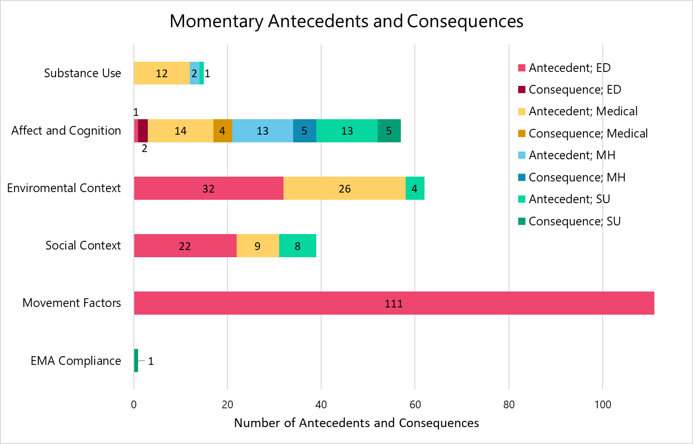
SM Figure 8. Distribution of all antecedents and consequences in observational studies, grouped by broad themes (total n=287).

SM Figure 8 caption. This stacked bar graph displays the number of antecedents and consequences (n, horizontal axis) categorized broad themes of momentary antecedents, and consequences.

SM Figure 9. Microassay of all momentary antecedents grouped by higher order domains. 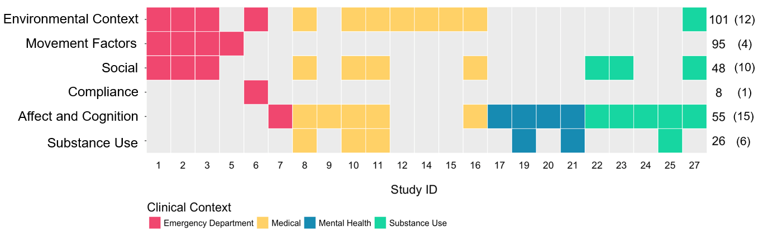
SM Figure 9 caption. All momentary antecedents in observational studies with substance-use related behaviours. Numbers on the x-axis refer to the study ID, and numbers on the secondary y-axis correspond to total number of antecedents and (number of studies) within each higher order domain. All antecedents are reported here, including antecedents from machine learning studies and antecedents with descriptively or non-reported behaviours.

SM Figure 10: Harvest Plots
SM Figure 10 Caption. Harvest plots of substance use (A), affect and cognition (B), environmental context (C) and social (D) antecedents. Plots are grouped by direction of reported substance-related behaviours. The name of the antecedent is labelled on each bar, and the corresponding behaviour is listed in the caption below the plot, in order from left to right, grouped study ID number in square brackets.

SM Figure 10A: Substance Use
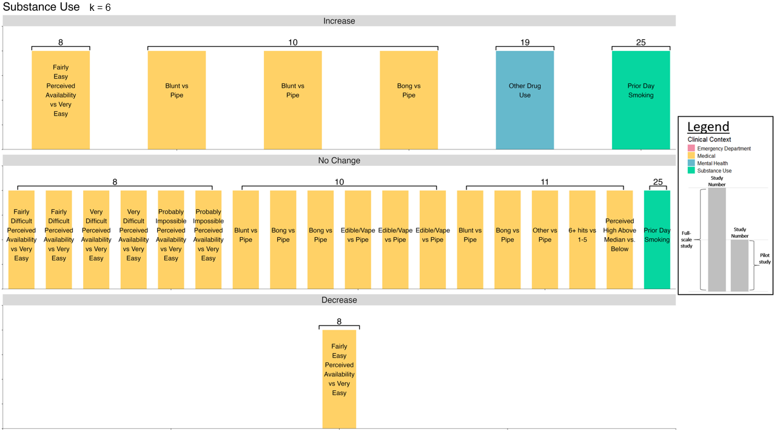
Increase (6): [8: desire for use], [10: dose, highest high, dose], [19: cannabis use], [25: tobacco use]; No Change (18): [8: desire for use, strength of desire, desire for use, strength of desire, desire for use, strength of desire], [10: duration, highest high, duration, dose, highest high, duration], [11: change in reason for cannabis use - all], [25: craving]; Decrease (1): [8: strength of desire]

SM Figure 10B: Affect and Cognition
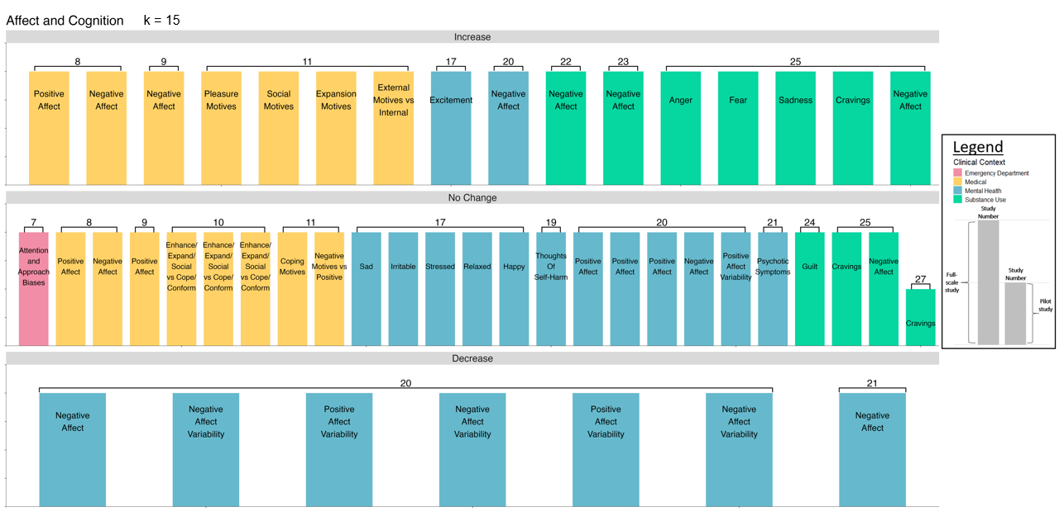
Increase (16): [8: strength of desire, strength of desire], [9: cannabis use events], [11: change in reason for cannabis use – all], [17: alcohol use], [20: any substance use event], [22: cravings], [23: cravings], [25: cravings – all]; No Change (25): [7: binge drinking], [8: desire for use, desire for use], [9: cannabis use events], [10: dose, highest high, duration], [11: change in reason for cannabis use, change in reason for cannabis use], [17: alcohol use – all], [19: cannabis use], [20: any substance use event, cannabis use event, alcohol use event, alcohol use event, alcohol use event], [21: general substance use], [24: cravings], [25: tobacco use], [27: substance use event]; Decrease (7): [20: cannabis use event, alcohol use event, cannabis use event, cannabis use event, any substance use event, any substance use event], [21: any substance use]

SM Figure 10C: Environmental Context
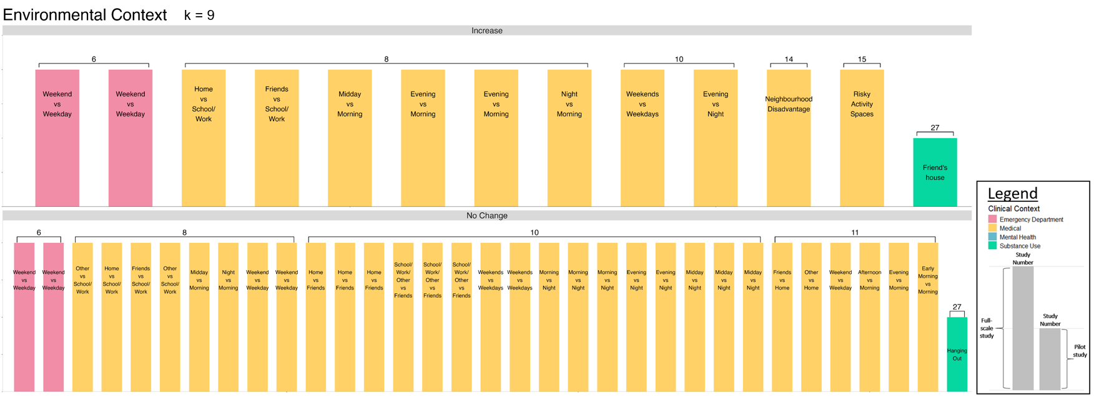
Increase (13): [6: alcohol use, alcohol quantity], [8: desire for use, desire for use, strength of desire, desire for use, strength of desire, strength of desire], [10: dose, dose], [14: substance use], [15: substance use], [27: substance use]; No Change (33): [6: cannabis use, cannabis quantity], [8: desire for use, strength of desire, strength of desire, strength of desire, desire for use, desire for use, desire for use, strength of desire], [10: dose, highest high, duration, dose, highest high, duration, highest high, duration, dose, highest high, duration, highest high, duration, dose, highest high, duration], [11: change in reason for cannabis use], [27: substance use]

SM Figure 10D: Social Context
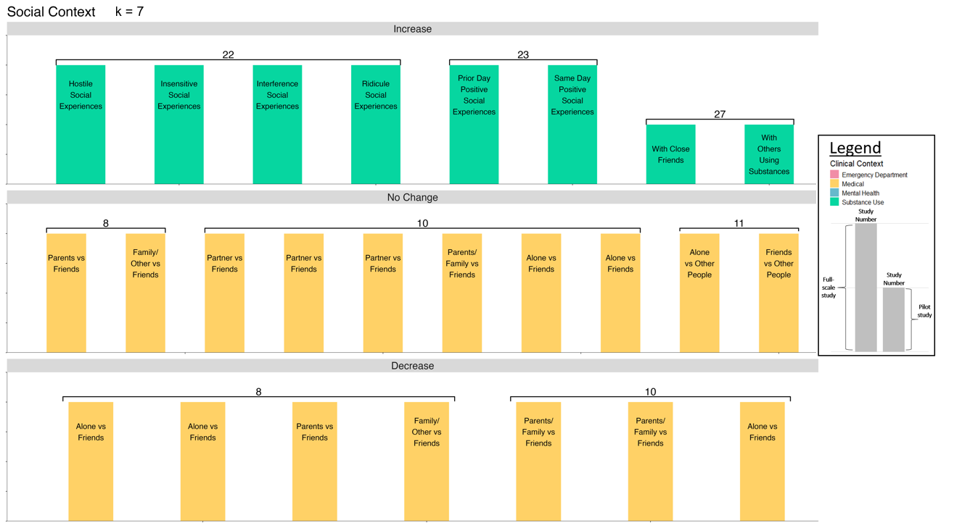
Increase (8): [22: cravings], [23: cravings], [27: substance use event]; No Change (10): [8: strength of desire, desire for use], [10: dose, highest high, duration, dose, dose, highest high], [11: change in reason for cannabis use]; Decrease (7): [8: desire for use, strength of desire, desire for use, strength of desire], [10: highest high, duration, duration]

