SUPPLEMENTARY FILES
FIGURE S1. Map of study area, with emphasis on gill net catch areas along channels near the ALUMAR private use terminal. Source: Authors.
TABLE S2. Fish species recorded in Coqueiros Strait, within the area of influence of the ALUMAR private use terminal, including abundance, biomass, and percentage contribution of sampled individuals by species.
FIGURE S3 Temporal variation in Shannon diversity index in area of influence of Alumar private use terminal. B. Spatial variation in Shannon diversity index in area of influence of Alumar private use terminal.
FIGURE S4 Temporal variation in Pielou’s evenness index in area of influence of Alumar private use terminal. B. Spatial variation of the Pielou evenness index in area of influence of Alumar private use terminal.
FIGURE S5 Temporal profile of Hill’s diversity of the fish assemblage in Coqueiros Strait. 7b. Spatial profile of Hill’s diversity of the fish assemblage in Coqueiros Strait.
FIGURE S6 PERMANOVA results for fish assemblage abundance and biomass as a function of sampling sites, seasonality, and the interaction between these factors.
FIGURE S7 Rarefaction curves of fish assemblage species richness across the different sampling sites (P1, P2, P3, and P4) as a function of the number of specimens collected.
FIGURE S8 Abundance curves of species Coqueiros Strait considering capture months.

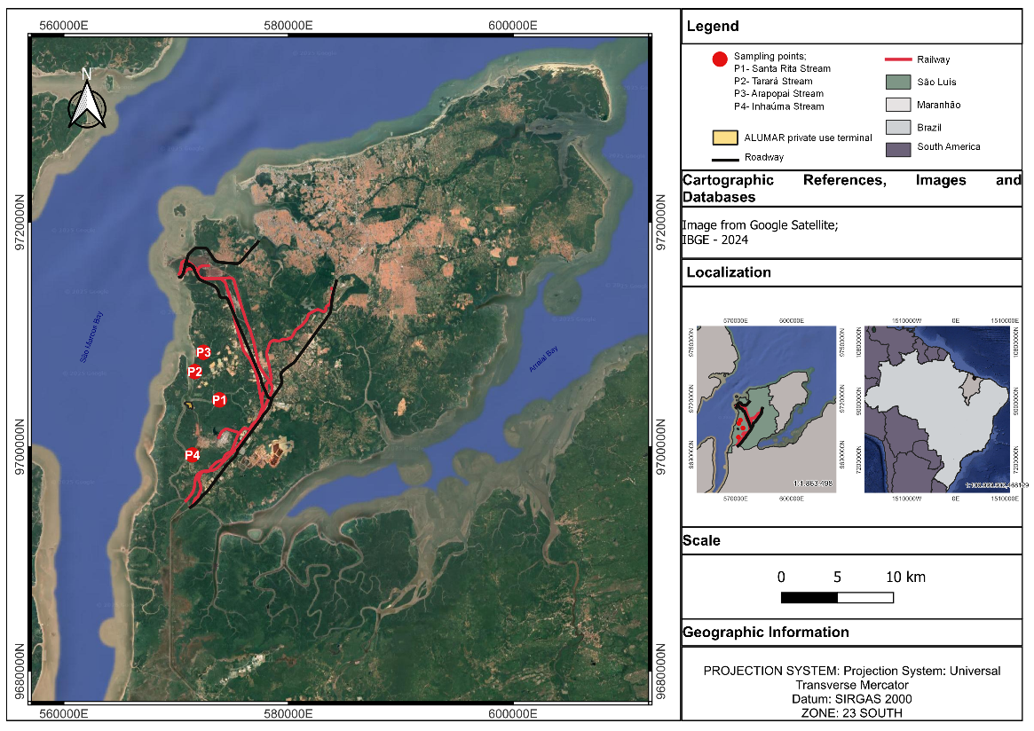

FIGURE S1. Map of study area, with emphasis on gill net catch areas along channels near the ALUMAR private use terminal. Source: Authors.
3507 x 2480 mm (300 x 300 DPI)

SPECIES |  | N | % | BIOMASS | %
 | ACANTHURIFORMES
 | Lobotidae
1 | Lobotes surinamensis (Bloch, 1790) | 1 | 0,01% | 213,12 | 0,03%
 | ANGUILLIFORMES
 | Muraenidae
2 | Gymnothorax funebris (Ranzani, 1839) | 4 | 0,05% | 2785,46 | 0,37%
 | BATRACHOIDIFORMES
 | Batrachoidiformes
3 | Batrachoides surinamensis (Bloch & Schneider,1801) | 71 | 0,88% | 21161,85 | 2,78%
 | BELONIFORMES
 | Belonidae
4 | Strongylura timucu (Walbaum, 1792) | 1 | 0,01% | 562,17 | 0,07%
 | CICHLIFORMES
 | Cichlidae
5 | Oreochromis niloticus (Linnaeus, 1758 | 2 | 0,02% | 66,71 | 0,01%
 | CLUPEIFORMES
 | Clupeidae
6 | Sardinella brasiliensis (Steindachner, 1879) | 81 | 1,00% | 1885,19 | 0,25%
 | Engraulidae
7 | Cetengraulis edentulus (Cuvier, 1829) | 14 | 0,17% | 603,87 | 0,08%
8 | Pterengraulis atherinoides (Linnaeus, 1766) | 143 | 1,77% | 1719,4 | 0,23%
 | CYPRINODONTIFORMES
 | Anablepidae
9 | Anableps anableps (Linnaeus, 1758) | 1254 | 15,55% | 68000,84 | 8,93%
 | ELOPIFORMES
 | Elopidae
10 | Elops saurus (Linnaeus, 1766) | 17 | 0,21% | 694,69 | 0,09%
 | MUGILIFORMES
 | Mugilidae
11 | Mugil curema (Valenciennes, 1836) | 463 | 5,74% | 24181,14 | 3,18%
12 | Mugil gaimardianus (Desmarest,1831) | 605 | 7,50% | 23006,35 | 3,02%
 | PERCIFORMES
 | Carangidae
13 | Caranx latus (Agassiz,1831) | 32 | 0,40% | 1013,62 | 0,13%
14 | Chloroscombrus chrysurus (Linnaeus, 1766) | 1 | 0,01% | 9,8 | 0,00%
15 | Oligoplites palometa (Cuvier, 1832) | 1 | 0,01% | 2730,8 | 0,36%
16 | Selene setapinnis (Mitchill, 1815) | 74 | 0,92% | 14,67 | 0,00%
 | Centropomidae
17 | Centropomus undecimalis (Bloch, 1792) | 110 | 1,36% | 19239,66 | 2,53%
 | Ephippidae
18 | Chaetodipterus faber (Broussonet, 1782) | 20 | 0,25% | 2234,49 | 0,29%
 | Gerreidae
19 | Diapterus rhombeus (Cuvier, 1829) | 103 | 1,28% | 2279,26 | 0,30%
 | Gobiidae
20 | Gobioides broussonnetii (Lacepède, 1800) | 2 | 0,02% | 65,55 | 0,01%
 | Haemulidae
21 | Genyatremus luteus (Bloch, 1790) | 340 | 4,22% | 12197,11 | 1,60%
 | Lutjanidae
22 | Lutjanus jocu (Bloch & Schneider, 1801) | 8 | 0,10% | 338,91 | 0,04%
 | Sciaenidae
23 | Bairdiella ronchus (Cuvier, 1830) | 82 | 1,02% | 2226,5 | 0,29%
24 | Cynoscion acoupa (Lacepède, 1801) | 679 | 8,42% | 48559,79 | 6,38%
25 | Cynoscion leiarchus (Cuvier, 1830) | 10 | 0,12% | 379,27 | 0,05%
26 | Macrodon ancylodon (Bloch & Schneider, 1801) | 168 | 2,08% | 16647,91 | 2,19%
27 | Micropogonias furnieri (Desmarest, 1823) | 8 | 0,10% | 194,96 | 0,03%
28 | Plagioscion squamosissimus (Heckel, 1840) | 77 | 0,95% | 4650,18 | 0,61%
29 | Stellifer naso (Jordan, 1889) | 26 | 0,32% | 604,6 | 0,08%
30 | Stellifer rastrifer (Jordan, 1889) | 1 | 0,01% | 29,21 | 0,00%
31 | Stellifer stellifer (Bloch, 1790) | 37 | 0,46% | 656,67 | 0,09%
 | Polynemidae
32 | Polydactylus virginicus (Linnaeus, 1758) | 50 | 0,62% | 1469,03 | 0,19%
 | PLEURONECTIFORMES
 | Achiridae
33 | Achirus lineatus (Linnaeus, 1758) | 42 | 0,52% | 6456,96 | 0,85%
 | Cyclopsettidae
34 | Symphurus plagusia (Bloch & Schneider, 1801) | 1 | 0,01% | 19,91 | 0,00%
 | MYLIOBATIFORMES
 | Dasyatidae
35 | Fontitrygon geijskesi (Boeseman, 1948) | 1 | 0,01% | 6000 | 0,79%
 | SCOMBRIFORMES
 | Scombridae
36 | Scomberomorus brasiliensis (Collette, Russo & Zavala-Camin, 1978) | 1 | 0,01% | 11,01 | 0,00%
 | Trichiuridae
37 | Trichiurus lepturus (Linnaeus, 1758) | 46 | 0,57% | 3087,58 | 0,41%
 | SILURIFORMES
 | Ariidae
38 | Amphiarius rugispinis (Valenciennes, 1840) | 22 | 0,27% | 1600,28 | 0,21%
39 | Bagre bagre (Linnaeus, 1766) | 51 | 0,63% | 2845,63 | 0,37%
40 | Cathorops agassizii (Eigenmann & Eigenmann, 1888) | 134 | 1,66% | 7068,53 | 0,93%
41 | Cathorops spixii (Agassiz, 1829) | 31 | 0,38% | 1153,8 | 0,15%
42 | Sciades couma (Valenciennes, 1840) | 1 | 0,01% | 5150 | 0,68%
43 | Sciades herzbergii (Bloch, 1794) | 2059 | 25,54% | 298977,29 | 39,27%
44 | Sciades proops (Valenciennes, 1840) | 9 | 0,11% | 4283,7 | 0,56%
 | Auchenipteridae
45 | Pseudauchenipterus nodosus (Bloch, 1794) | 12 | 0,15% | 577,39 | 0,08%
 | Loricariidae
46 | Hypostomus plecostomus (Linnaeus, 1758) | 2 | 0,02% | 168,05 | 0,02%
 | TETRAODONTIFORMES
 | Tetraodontidae
47 | Colomesus psittacus (Bloch & Schneider, 1801) | 1166 | 14,46% | 163466,33 | 21,47%

TABLE S2. Fish species recorded in Coqueiros Strait, within the area of influence of the ALUMAR private use terminal, including abundance, biomass, and percentage contribution of sampled individuals by species.

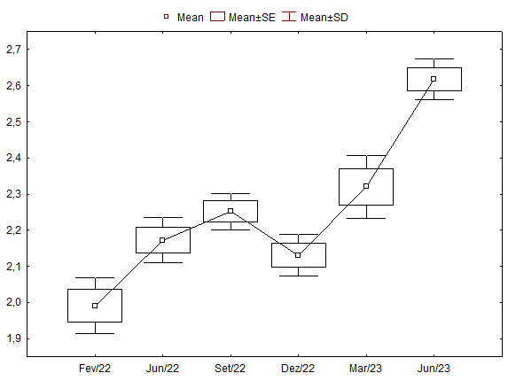
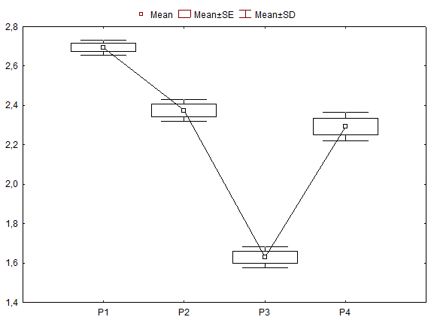
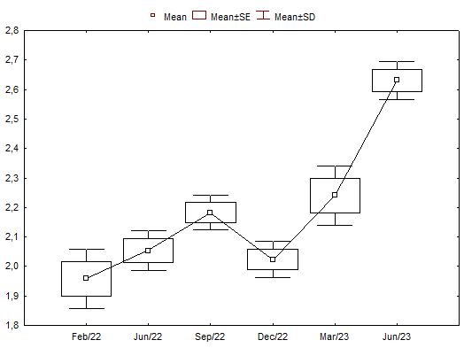

A
B
A

FIGURE S3 Temporal variation in Shannon diversity index in area of influence of Alumar private use terminal. B. Spatial variation in Shannon diversity index in area of influence of Alumar private use terminal.
2087 x 788 mm (96 x 96 DPI)

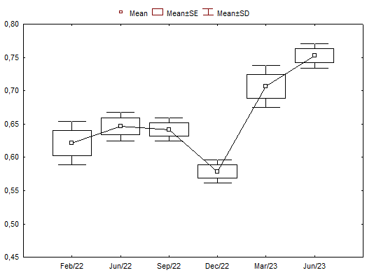
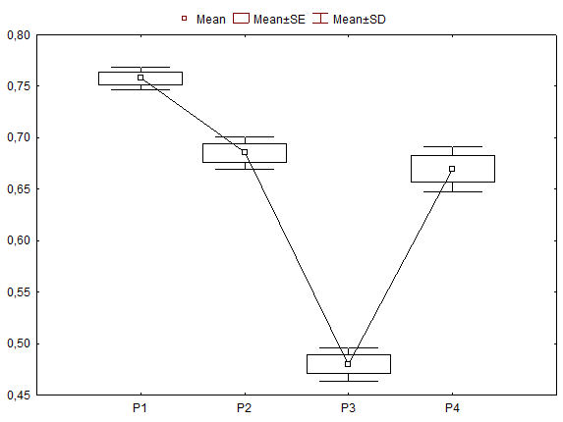
B
A

FIGURE S4 Temporal variation in Pielou’s evenness index in area of influence of Alumar private use terminal. B. Spatial variation of the Pielou evenness index in area of influence of Alumar private use terminal.
2087 x 788 mm (96 x 96 DPI)

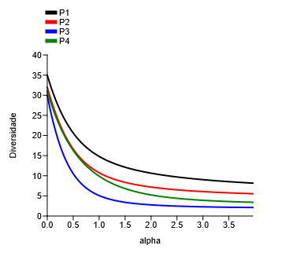
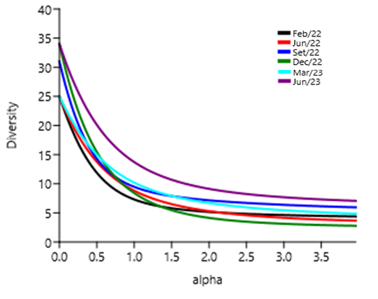

B

A

FIGURE S5 Temporal profile of Hill’s diversity of the fish assemblage in Coqueiros Strait. 7b. Spatial profile of Hill’s diversity of the fish assemblage in Coqueiros Strait.
2146 x 815 mm (330 x 320 DPI)

Forms os variation | Abundance and Biomass
Forms os variation | GL | SQ | F | P
Sampling sites | 3 | 0,1636 | 0,6435 | 0,0001
Seasonality | 3 | 0,2264 | 0,8908 | 0,0151
Interaction | 9 | -0,0621 | -0,2445 | 0,8321

TABLE S6 PERMANOVA results for fish assemblage abundance and biomass as a function of sampling sites, seasonality, and the interaction between these factors.

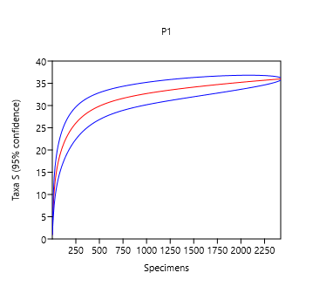
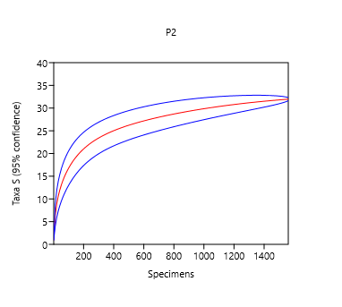
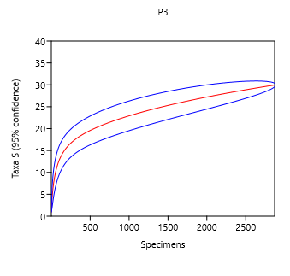
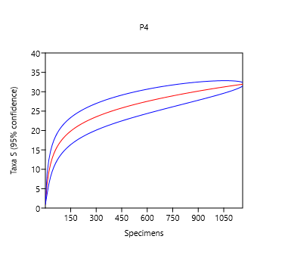
FIGURE S7 Rarefaction curves of fish assemblage species richness across the different sampling sites (P1, P2, P3, and P4) as a function of the number of specimens collected.
1984 x 1900 mm (330 x 320 DPI)

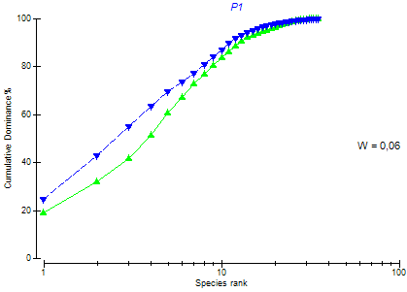
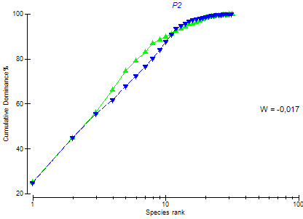
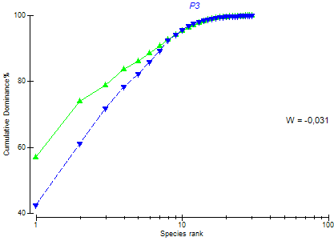
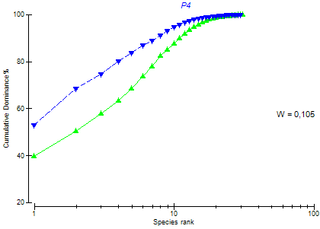
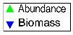

FIGURE S8: Abundance curves of species Coqueiros Strait considering capture months.
2101 x 1451 mm (330 x 330 DPI)

