Environmental Drivers of Foliar Particulate Accumulation, Leaf Structural and Biochemical Responses in Urban Trees in Delhi, India
Authors: Nitin Joshi¹ (ORCiD: 0000-0002-0010-135X; nitinjoshi6644@gmail.com), Vaibhav Sharma¹ (vaibhav2611sh@gmail.com), Vineet Kumar Singh¹ (ORCiD: 0009-0007-2837-2702; vineetkumarsingh@andc.du.ac.in), Charu Khosla Gupta^{1*} (ORCiD: 0000-0002-8652-8310; charukhoslagupta@andc.du.ac.in)
Department of Botany, Acharya Narendra Dev College, University of Delhi, New Delhi 110019, India
*Corresponding author: Charu Khosla Gupta
Email: charukhoslagupta@andc.du.ac.in
Supplementary Tables and Figures
Table S1: Biochemical parameters, Leaf traits and APTI (Summer Season)
Species | Location | TChl (mg/g) | TCar (mg/g) | AA (mg/g) | RWC (%) | Proline (mg/g) | Leaf pH | SLA (mm²/mg) | LDMC (mg/g) | Leaf Thickness (mm) | TSS (mg/g) | APTI | Coarse PM (10-100 µm/cm²) | Fine PM (2.5-10 µm/cm²)
Azadirachta indica | AS | 2.32 | 0.15 | 0.29 | 77.60 | 0.70 | 6.40 | 2.57 | 365.50 | 0.23 | 16.88 | 8.01 | 55.04 | 4.54
Azadirachta indica | DW | 1.84 | 0.26 | 0.10 | 101.42 | 3.22 | 5.69 | 2.18 | 391.13 | 0.19 | 14.68 | 10.21 | 40.55 | 1.19
Azadirachta indica | KNR | 2.24 | 0.30 | 0.08 | 84.49 | 1.69 | 6.58 | 1.42 | 336.67 | 0.21 | 13.32 | 8.51 | 12.21 | 1.63
Azadirachta indica | TKB | 2.69 | 0.29 | 0.02 | 43.96 | 1.75 | 6.30 | 1.85 | 387.03 | 0.18 | 13.99 | 4.42 | 90.02 | 2.95
Aegle marmelos | AS | 1.77 | 0.11 | 0.18 | 83.58 | 0.43 | 6.04 | 1.62 | 313.91 | 0.24 | 7.11 | 8.50 | 67.12 | 20.14
Aegle marmelos | DW | 2.28 | 0.32 | 0.21 | 106.54 | 2.50 | 5.67 | 2.28 | 317.20 | 0.18 | 2.15 | 10.82 | 46.81 | 2.98
Aegle marmelos | KNR | 2.06 | 0.29 | 0.63 | 81.26 | 0.99 | 6.16 | 3.59 | 258.19 | 0.19 | 2.38 | 8.64 | 17.46 | 3.16
Aegle marmelos | TKB | 1.44 | 0.28 | 0.17 | 78.77 | 0.60 | 6.28 | 1.32 | 272.70 | 0.24 | 4.38 | 8.01 | 190.90 | 8.41
Alstonia scholaris | AS | 1.90 | 0.14 | 0.16 | 78.27 | 0.09 | 5.64 | 0.90 | 291.06 | 0.38 | 7.68 | 7.95 | 176.26 | 23.46
Alstonia scholaris | DW | 1.92 | 0.17 | 0.02 | 64.98 | 0.15 | 5.49 | 0.97 | 312.10 | 0.32 | 8.52 | 6.51 | 118.02 | 2.96
Alstonia scholaris | KNR | 2.22 | 0.21 | 0.13 | 67.63 | 0.57 | 5.78 | 1.18 | 272.59 | 0.28 | 4.48 | 6.87 | 24.86 | 5.11
Alstonia scholaris | TKB | 2.26 | 0.18 | 0.16 | 78.25 | 0.12 | 5.89 | 1.34 | 272.70 | 0.29 | 5.46 | 7.95 | 157.16 | 5.82
Cassia fistula | AS | 3.38 | 0.26 | 1.83 | 63.70 | 0.95 | 6.16 | 1.81 | 405.36 | 0.18 | 24.43 | 8.11 | 224.36 | 9.34
Cassia fistula | DW | 4.03 | 0.70 | 0.43 | 83.48 | 2.93 | 6.08 | 2.52 | 366.88 | 0.17 | 13.95 | 8.78 | 240.86 | 4.17
Cassia fistula | KNR | 2.88 | 0.44 | 0.11 | 71.99 | 0.41 | 6.29 | 1.51 | 429.31 | 0.20 | 13.10 | 7.30 | 28.58 | 8.30
Cassia fistula | TKB | 3.03 | 0.46 | 0.20 | 78.58 | 0.71 | 6.12 | 1.21 | 439.89 | 0.22 | 8.76 | 8.04 | 86.12 | 2.27
Ficus benghalensis | AS | 1.14 | 0.19 | 0.72 | 92.74 | 0.06 | 8.53 | 0.77 | 396.49 | 0.38 | 5.32 | 9.96 | 142.87 | 6.75
Ficus benghalensis | DW | 1.70 | 0.23 | 0.13 | 91.78 | 0.13 | 7.67 | 0.70 | 302.22 | 0.35 | 9.58 | 9.29 | 222.10 | 2.00
Ficus benghalensis | KNR | 1.39 | 0.12 | 0.21 | 92.38 | 0.15 | 7.39 | 0.61 | 390.93 | 0.30 | 13.23 | 9.42 | 25.01 | 6.45
Ficus benghalensis | TKB | 1.11 | 0.14 | 0.45 | 90.33 | 0.13 | 9.17 | 0.63 | 401.97 | 0.34 | 8.75 | 9.50 | 287.75 | 4.55
Ficus religiosa | AS | 1.17 | 0.23 | 0.08 | 90.11 | 0.25 | 7.65 | 1.39 | 301.44 | 0.26 | 13.03 | 9.08 | 56.29 | 4.47
Ficus religiosa | DW | 2.01 | 0.29 | 0.12 | 85.95 | 1.64 | 7.37 | 1.40 | 331.22 | 0.17 | 6.36 | 8.71 | 178.56 | 2.55
Ficus religiosa | KNR | 1.77 | 0.14 | 0.07 | 88.10 | 0.21 | 7.95 | 1.30 | 328.53 | 0.22 | 4.26 | 8.88 | 18.08 | 2.61
Ficus religiosa | TKB | 1.31 | 0.21 | 0.13 | 88.51 | 0.16 | 8.83 | 1.00 | 335.23 | 0.27 | 12.24 | 8.98 | 153.02 | 6.94
Ficus virens | AS | 1.28 | 0.33 | 0.12 | 85.52 | 0.09 | 7.73 | 0.97 | 336.21 | 0.33 | 12.25 | 8.65 | 75.85 | 5.38
Ficus virens | DW | 2.10 | 0.25 | 0.17 | 87.93 | 0.40 | 8.09 | 1.25 | 309.16 | 0.31 | 11.94 | 8.97 | 55.97 | 3.31
Ficus virens | KNR | 1.60 | 0.17 | 0.85 | 72.04 | 0.32 | 7.06 | 1.63 | 478.24 | 0.18 | 5.31 | 7.95 | 30.79 | 6.62
Ficus virens | TKB | 1.68 | 0.20 | 0.15 | 88.20 | 0.11 | 8.79 | 1.27 | 301.57 | 0.28 | 11.64 | 8.97 | 101.55 | 3.68
Mangifera indica | AS | 2.80 | 0.36 | 0.43 | 86.98 | 0.06 | 5.68 | 1.04 | 487.08 | 0.19 | 17.82 | 9.05 | 338.76 | 14.49
Mangifera indica | DW | 2.94 | 0.46 | 0.10 | 74.95 | 0.13 | 5.21 | 1.71 | 435.70 | 0.19 | 9.50 | 7.58 | 143.64 | 4.87
Mangifera indica | KNR | 2.68 | 0.38 | 0.91 | 87.26 | 0.14 | 5.57 | 0.92 | 504.03 | 0.21 | 12.21 | 9.47 | 26.17 | 3.15
Mangifera indica | TKB | 3.12 | 0.47 | 0.30 | 89.38 | 0.16 | 5.88 | 0.77 | 489.15 | 0.34 | 11.58 | 9.22 | 121.50 | 2.55
Plumeria alba | AS | 1.78 | 0.49 | 0.09 | 83.46 | 0.07 | 5.87 | 1.36 | 191.63 | 0.28 | 19.55 | 8.42 | 145.99 | 31.40
Plumeria alba | DW | 2.42 | 0.27 | 0.08 | 92.27 | 0.14 | 5.82 | 1.17 | 200.11 | 0.28 | 15.62 | 9.29 | 153.68 | 1.95
Plumeria alba | KNR | 2.48 | 0.31 | 0.10 | 86.28 | 0.18 | 6.08 | 1.08 | 163.94 | 0.30 | 16.33 | 8.71 | 65.57 | 3.42
Plumeria alba | TKB | 1.74 | 0.23 | 0.02 | 88.44 | 0.12 | 6.24 | 1.12 | 180.15 | 0.32 | 14.98 | 8.86 | 169.21 | 5.11
Syzygium cumini | AS | 2.72 | 0.56 | 0.88 | 69.56 | 0.07 | 5.33 | 1.11 | 506.27 | 0.26 | 22.51 | 7.66 | 208.12 | 34.30
Syzygium cumini | DW | 2.29 | 0.25 | 0.42 | 83.27 | 0.17 | 4.71 | 1.73 | 385.22 | 0.23 | 13.26 | 8.62 | 25.51 | 3.88
Syzygium cumini | KNR | 2.03 | 0.29 | 0.52 | 61.04 | 0.13 | 5.24 | 0.80 | 492.68 | 0.23 | 9.63 | 6.48 | 41.71 | 3.36
Syzygium cumini | TKB | 2.99 | 0.43 | 0.29 | 71.47 | 0.19 | 6.26 | 0.68 | 442.08 | 0.32 | 6.25 | 7.42 | 168.10 | 2.64

Table S2: Biochemical parameters, Leaf traits and APTI (Winter Season)
Species | Location | TChl (mg/g) | TCar (mg/g) | AA (mg/g) | RWC (%) | Proline (mg/g) | Leaf pH | SLA (mm²/mg) | LDMC (mg/g) | Leaf Thickness (mm) | TSS (mg/g) | APTI | Coarse PM (10-100 µm/cm²) | Fine PM (2.5-10 µm/cm²)
Azadirachta indica | AS | 2.75 | 0.42 | 0.48 | 57.06 | 2.43 | 6.23 | 2.31 | 383.08 | 0.13 | 17.77 | 6.14 | 200.26 | 7.09
Azadirachta indica | DW | 1.44 | 0.20 | 0.29 | 79.91 | 3.54 | 5.93 | 1.15 | 394.47 | 0.21 | 18.28 | 8.20 | 442.84 | 39.28
Azadirachta indica | KNR | 2.33 | 0.13 | 0.30 | 75.40 | 1.33 | 6.10 | 2.12 | 312.35 | 0.18 | 14.36 | 7.79 | 71.63 | 10.08
Azadirachta indica | TKB | 1.47 | 0.18 | 0.23 | 93.18 | 1.94 | 6.30 | 1.48 | 295.58 | 0.20 | 25.37 | 9.50 | 136.27 | 10.95
Aegle marmelos | AS | 0.82 | 0.06 | 0.39 | 70.20 | 0.79 | 6.29 | 1.28 | 376.51 | 0.16 | 9.18 | 7.30 | 210.75 | 14.89
Aegle marmelos | DW | 2.89 | 0.15 | 0.76 | 64.58 | 1.38 | 6.24 | 1.24 | 412.73 | 0.16 | 20.56 | 7.15 | 265.44 | 53.83
Aegle marmelos | KNR | 1.33 | 0.08 | 0.63 | 57.11 | 1.61 | 6.24 | 1.55 | 410.20 | 0.17 | 10.27 | 6.18 | 90.10 | 6.89
Aegle marmelos | TKB | 1.65 | 0.19 | 0.80 | 85.66 | 2.01 | 6.28 | 0.64 | 409.03 | 0.29 | 21.93 | 9.18 | 117.54 | 24.43
Alstonia scholaris | AS | 1.39 | 0.07 | 0.65 | 54.82 | 0.10 | 5.80 | 0.72 | 403.37 | 0.30 | 10.21 | 5.96 | 674.82 | 19.24
Alstonia scholaris | DW | 2.77 | 0.04 | 0.25 | 61.63 | 0.32 | 5.68 | 0.86 | 385.83 | 0.30 | 17.00 | 6.37 | 730.13 | 27.32
Alstonia scholaris | KNR | 1.76 | 0.05 | 0.22 | 66.95 | 0.14 | 6.04 | 0.99 | 373.34 | 0.25 | 10.04 | 6.86 | 187.77 | 22.35
Alstonia scholaris | TKB | 2.18 | 0.13 | 0.33 | 72.25 | 0.17 | 5.89 | 1.41 | 199.27 | 0.28 | 22.61 | 7.85 | 527.30 | 41.21
Cassia fistula | AS | 1.75 | 0.45 | 3.00 | 20.98 | 1.50 | 6.43 | 1.99 | 669.55 | 0.13 | 11.69 | 4.55 | 692.29 | 49.69
Cassia fistula | DW | 1.84 | 0.36 | 2.44 | 75.56 | 2.79 | 6.11 | 1.06 | 520.13 | 0.18 | 23.76 | 9.50 | 318.74 | 23.26
Cassia fistula | KNR | 3.75 | 0.32 | 2.66 | 43.80 | 0.84 | 5.96 | 1.17 | 612.95 | 0.15 | 21.60 | 6.96 | 89.19 | 9.64
Cassia fistula | TKB | 3.14 | 0.62 | 1.29 | 72.67 | 1.80 | 6.12 | 1.38 | 456.16 | 0.14 | 11.99 | 8.44 | 477.95 | 27.98
Ficus benghalensis | AS | 1.22 | 0.12 | 0.42 | 92.48 | 0.08 | 7.98 | 0.65 | 383.36 | 0.32 | 13.41 | 9.64 | 621.52 | 16.81
Ficus benghalensis | DW | 1.70 | 0.01 | 0.58 | 92.49 | 0.10 | 8.35 | 0.67 | 339.80 | 0.30 | 16.66 | 9.83 | 527.77 | 15.19
Ficus benghalensis | KNR | 1.76 | 0.03 | 0.31 | 91.67 | 0.19 | 9.23 | 0.93 | 326.51 | 0.24 | 14.47 | 9.51 | 87.39 | 6.25
Ficus benghalensis | TKB | 1.19 | 0.09 | 0.52 | 94.88 | 0.12 | 9.17 | 0.73 | 370.86 | 0.32 | 11.42 | 10.03 | 914.53 | 65.78
Ficus religiosa | AS | 1.26 | 0.08 | 0.64 | 74.42 | 0.16 | 8.99 | 0.78 | 411.05 | 0.20 | 9.27 | 8.09 | 320.57 | 26.48
Ficus religiosa | DW | 1.66 | 0.05 | 0.44 | 81.82 | 1.86 | 9.17 | 1.05 | 408.53 | 0.19 | 17.26 | 8.65 | 883.55 | 31.46
Ficus religiosa | KNR | 1.41 | 0.09 | 0.38 | 74.40 | 0.32 | 8.72 | 1.03 | 379.23 | 0.18 | 10.66 | 7.82 | 70.36 | 19.27
Ficus religiosa | TKB | 1.33 | 0.11 | 0.20 | 85.57 | 0.97 | 8.83 | 0.80 | 412.80 | 0.21 | 18.31 | 8.76 | 304.38 | 9.81
Ficus virens | AS | 1.51 | 0.06 | 0.25 | 80.40 | 0.08 | 8.61 | 1.01 | 298.26 | 0.25 | 8.43 | 8.29 | 211.07 | 21.40
Ficus virens | DW | 2.07 | 0.11 | 0.57 | 81.10 | 0.12 | 8.53 | 1.06 | 317.44 | 0.29 | 12.54 | 8.71 | 329.60 | 14.67
Ficus virens | KNR | 1.49 | 0.07 | 0.57 | 81.30 | 0.33 | 7.61 | 1.29 | 434.68 | 0.15 | 7.72 | 8.65 | 148.38 | 37.69
Ficus virens | TKB | 1.79 | 0.08 | 0.14 | 92.36 | 0.09 | 8.79 | 0.97 | 282.78 | 0.30 | 14.31 | 9.38 | 498.27 | 50.54
Mangifera indica | AS | 3.44 | 0.26 | 0.65 | 87.15 | 0.10 | 5.64 | 1.00 | 465.47 | 0.16 | 13.19 | 9.30 | 333.55 | 25.43
Mangifera indica | DW | 2.43 | 0.18 | 0.88 | 97.40 | 0.10 | 5.78 | 0.73 | 449.13 | 0.22 | 20.30 | 10.47 | 271.65 | 23.32
Mangifera indica | KNR | 2.26 | 0.13 | 1.12 | 87.83 | 0.11 | 5.76 | 1.15 | 446.30 | 0.19 | 14.54 | 9.68 | 211.03 | 19.45
Mangifera indica | TKB | 2.95 | 0.17 | 0.33 | 98.97 | 0.10 | 5.88 | 1.08 | 443.48 | 0.25 | 12.01 | 10.19 | 556.16 | 24.10
Plumeria alba | AS | 0.85 | 0.07 | 0.44 | 91.56 | 0.08 | 6.50 | 1.07 | 217.93 | 0.27 | 18.51 | 9.48 | 890.39 | 37.03
Plumeria alba | DW | 1.12 | 0.03 | 0.30 | 86.59 | 0.13 | 6.11 | 1.06 | 194.38 | 0.32 | 20.64 | 8.88 | 853.89 | 39.61
Plumeria alba | KNR | 1.95 | 0.02 | 0.20 | 92.54 | 0.11 | 6.33 | 0.75 | 177.44 | 0.30 | 16.88 | 9.42 | 245.16 | 6.48
Plumeria alba | TKB | 2.00 | 0.08 | 0.25 | 89.90 | 0.15 | 6.24 | 0.70 | 271.98 | 0.32 | 25.66 | 9.19 | 630.73 | 39.76
Syzygium cumini | AS | 2.05 | 0.14 | 2.08 | 83.36 | 0.12 | 5.41 | 0.99 | 413.04 | 0.23 | 15.60 | 9.89 | 1001.11 | 33.24
Syzygium cumini | DW | 2.06 | 0.17 | 1.11 | 87.16 | 0.16 | 5.19 | 0.85 | 427.18 | 0.27 | 21.43 | 9.55 | 362.42 | 22.38
Syzygium cumini | KNR | 2.22 | 0.07 | 0.96 | 64.07 | 0.13 | 5.53 | 1.24 | 439.34 | 0.18 | 10.66 | 7.19 | 159.78 | 37.91
Syzygium cumini | TKB | 3.41 | 0.18 | 1.11 | 85.42 | 0.10 | 6.26 | 0.56 | 413.36 | 0.29 | 14.16 | 9.85 | 251.55 | 17.79
Abbreviations-
AS- Ashram (Roadside) | TChl- Total chlorophyll | SLA- Specific leaf area
DW- Dwarka (Residential site) | AA- Ascorbic acid | APTI- Air pollution tolerance index
KNR- Kamla Nehru Ridge (Green belt) | RWC- Relative water content | LDMC- Leaf dry matter content
TKB- Tughlakabad (Industrial site) | TCar- Total carotenoids | TSS- Total soluble sugars

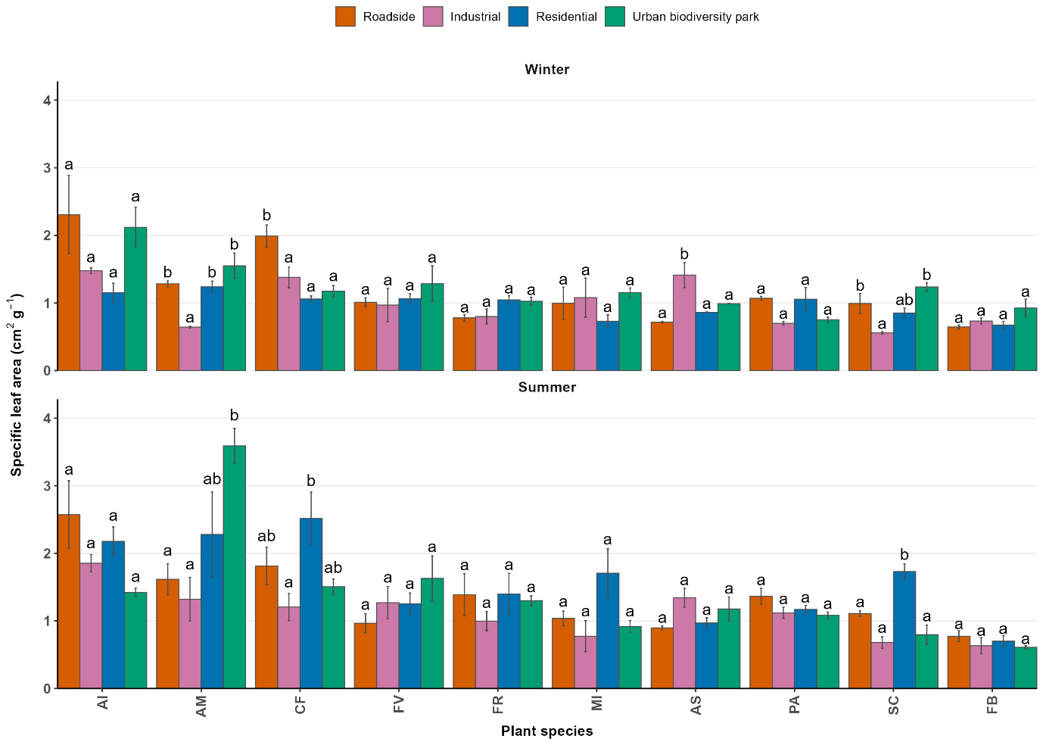 Fig. S1: Mean and standard error values of Specific leaf area across species and locations.
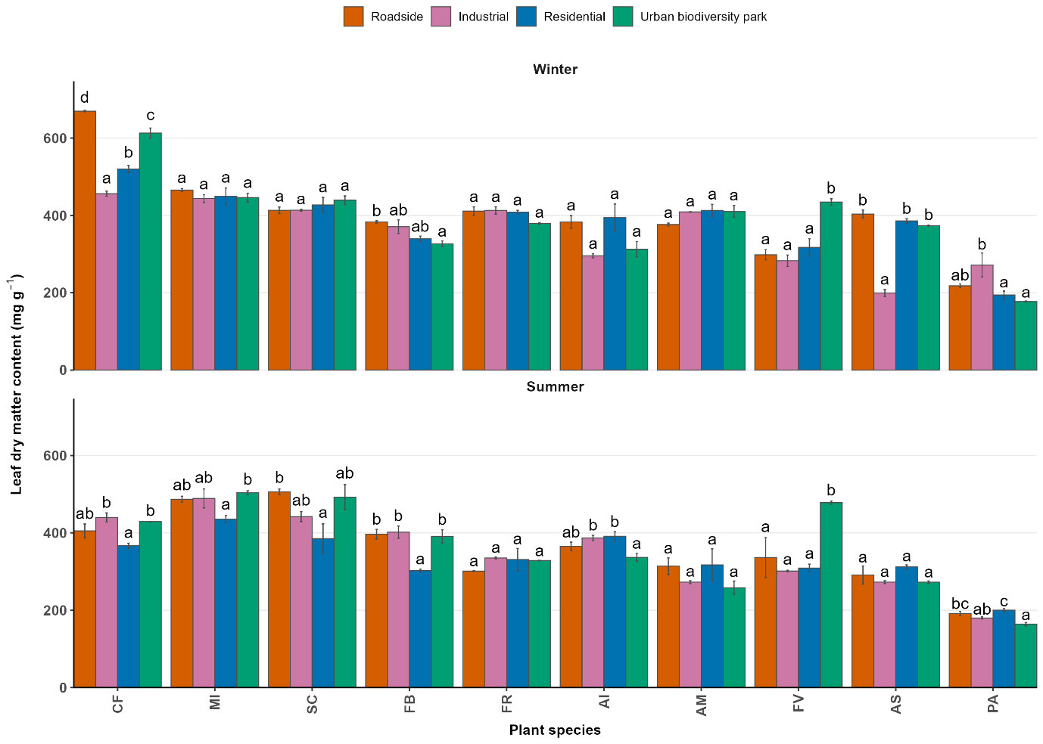Fig. S2: Mean and standard error values of Leaf dry matter content across species and locations.
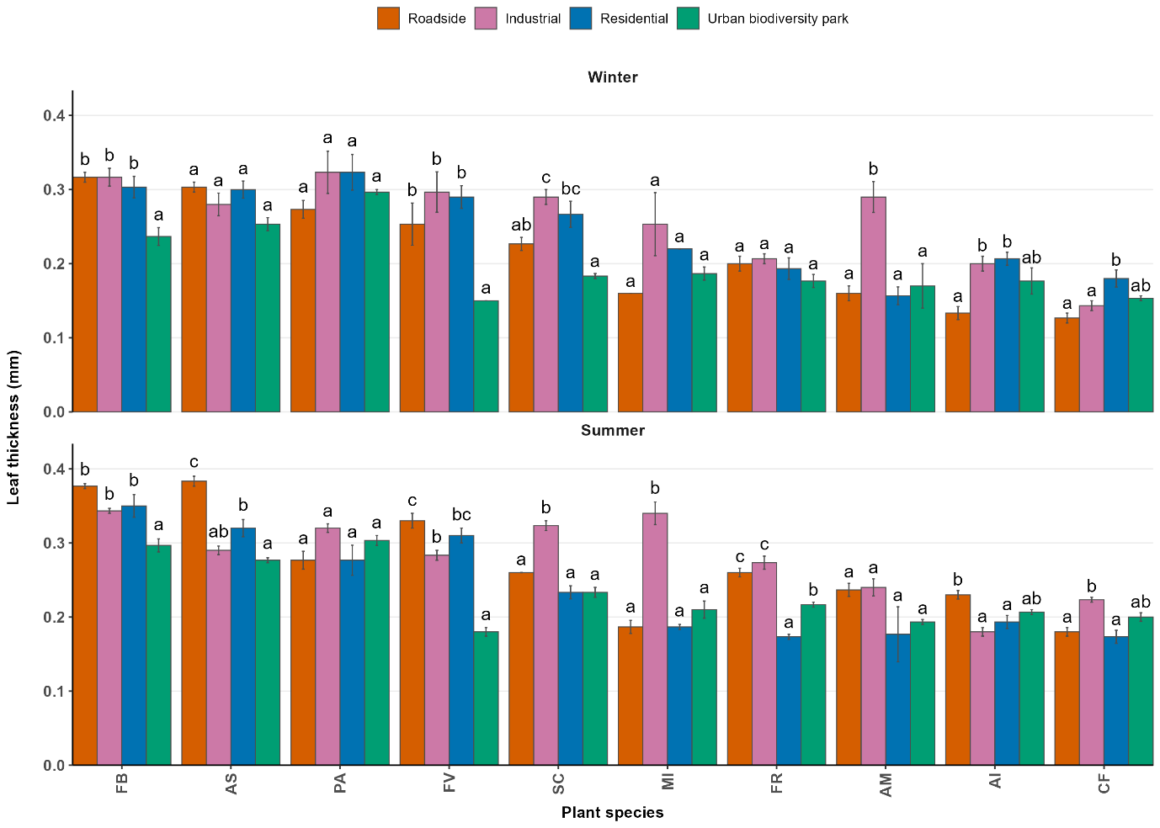 Fig. S3: Mean and standard error values of Leaf thickness across species and locations.
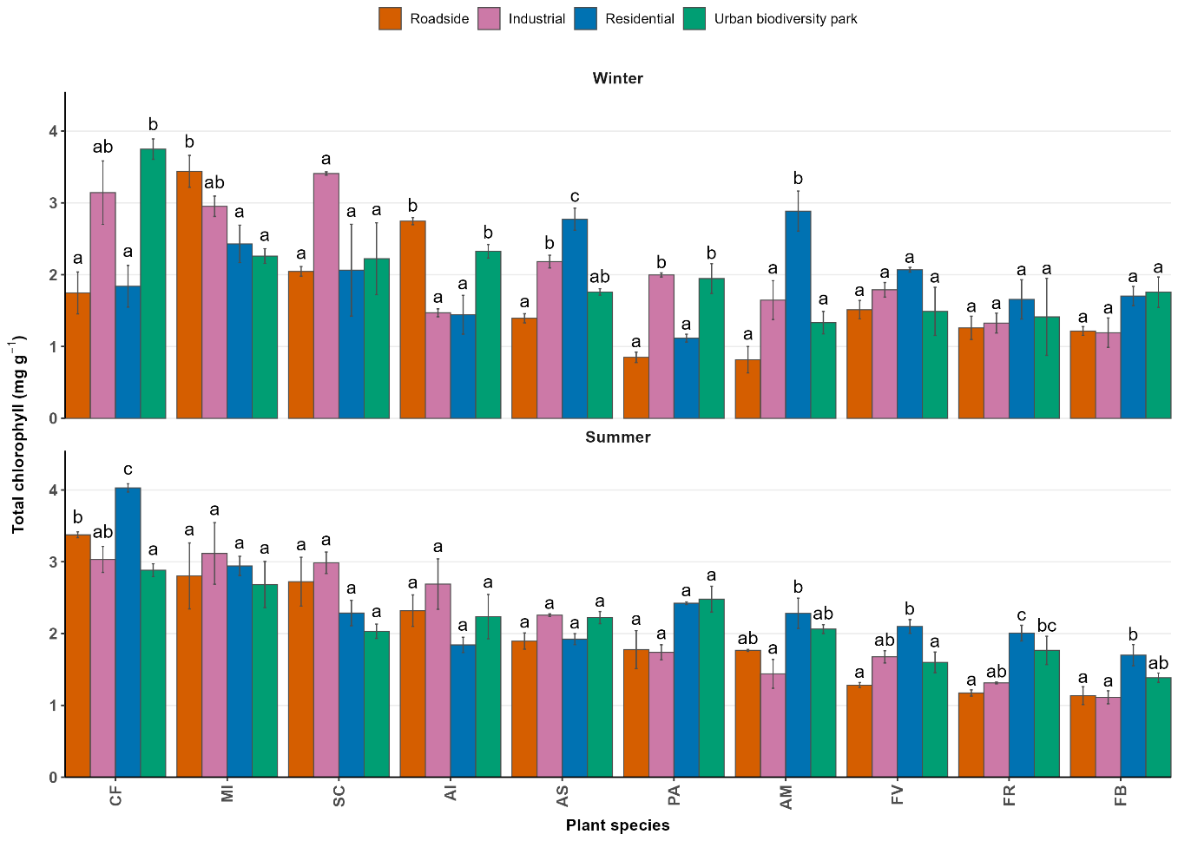 Fig S4: Mean and standard error values of Total chlorophyll across species and locations.
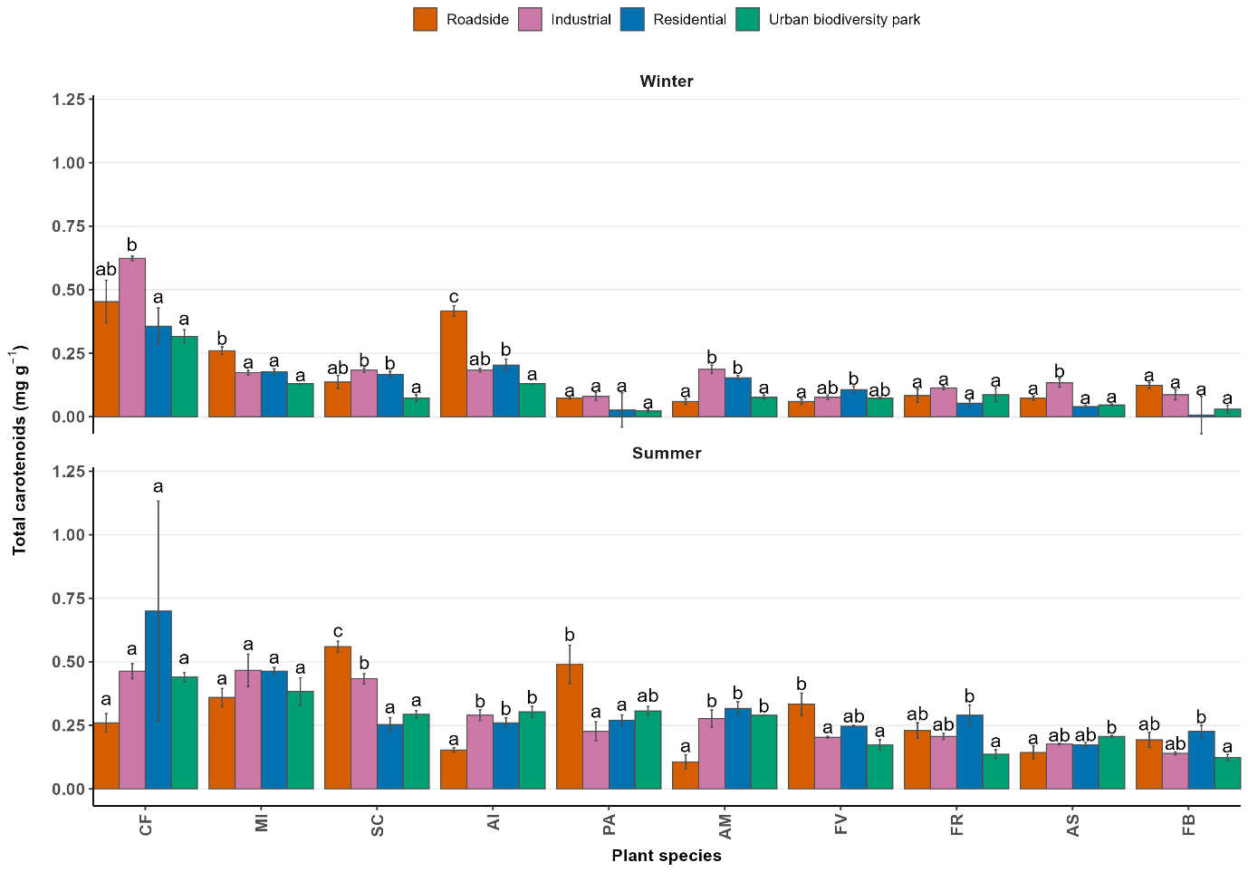 Fig S5: Mean and standard error value of Total carotenoids across species and locations.
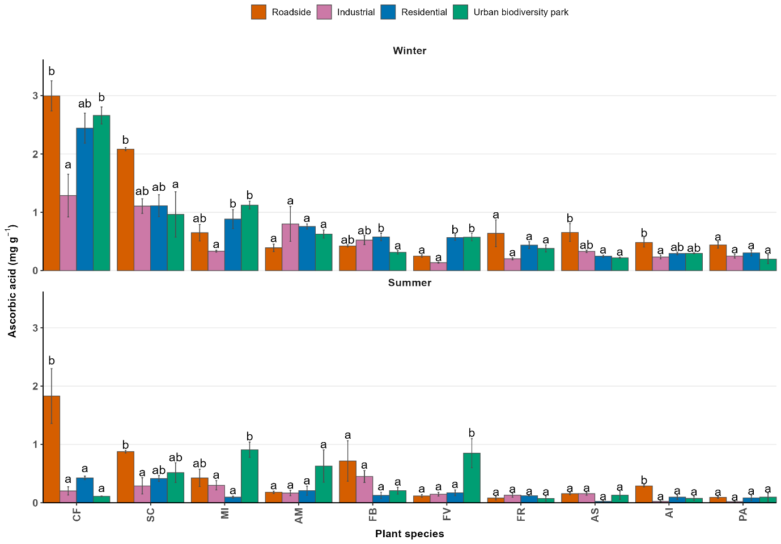
Fig. S6: Mean and standard error values of Ascorbic Acid across species and locations
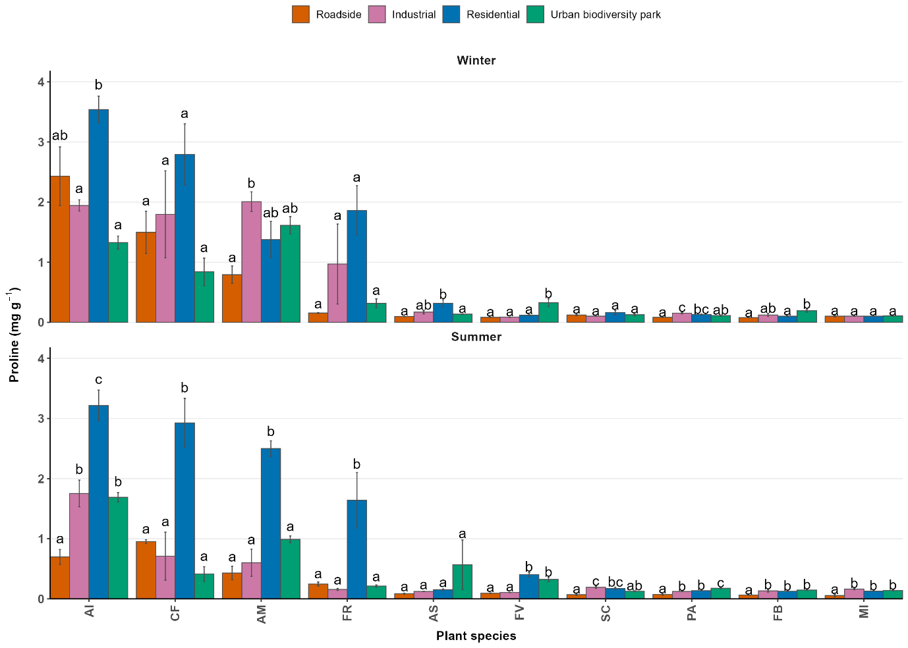 Fig. S7: Mean and standard error value of Proline across species and locations
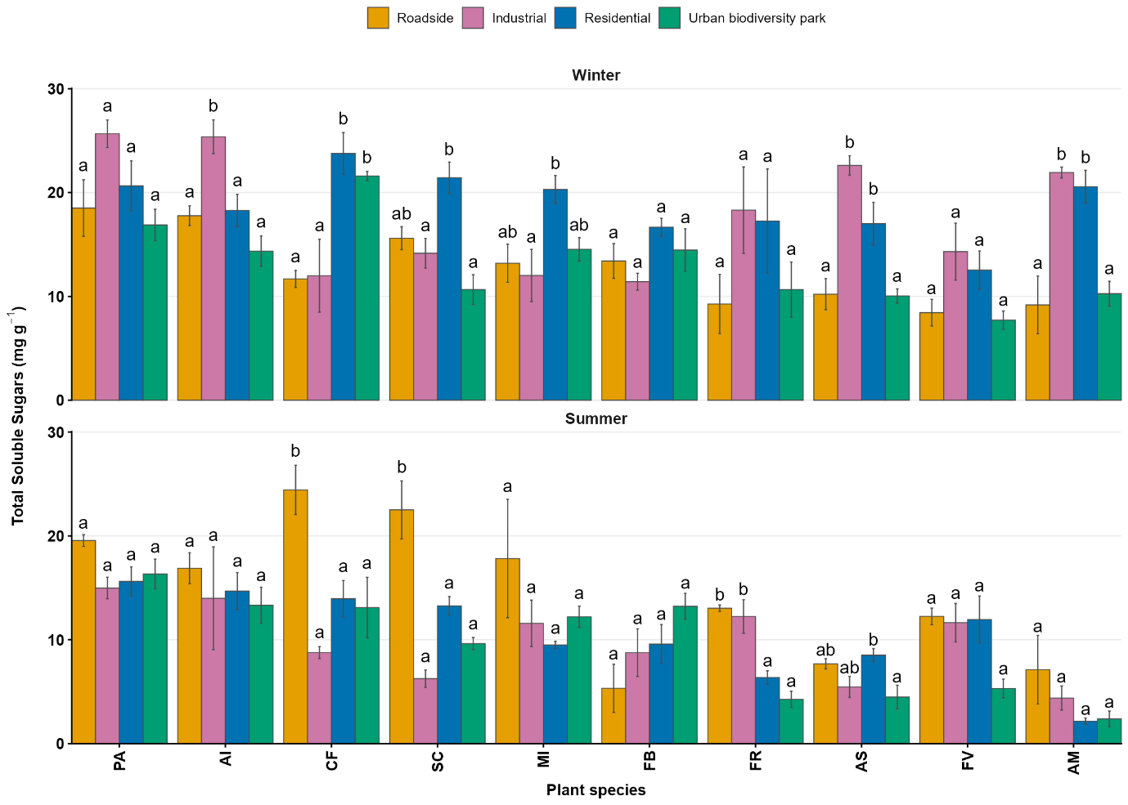Fig. S8: Mean and standard error value of total soluble sugars across species and locations.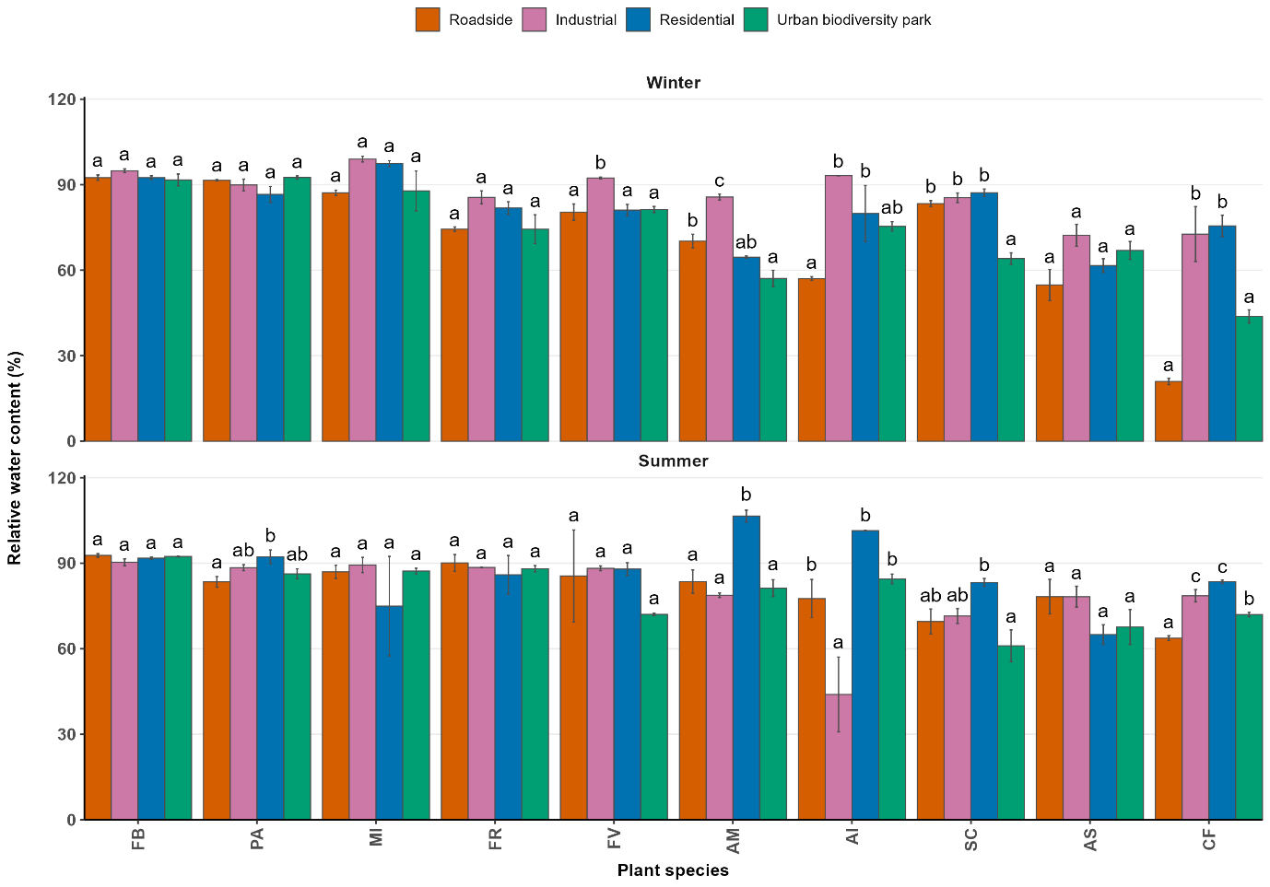 Fig. S9: Mean and standard error values of Relative Water Content across species and locations.
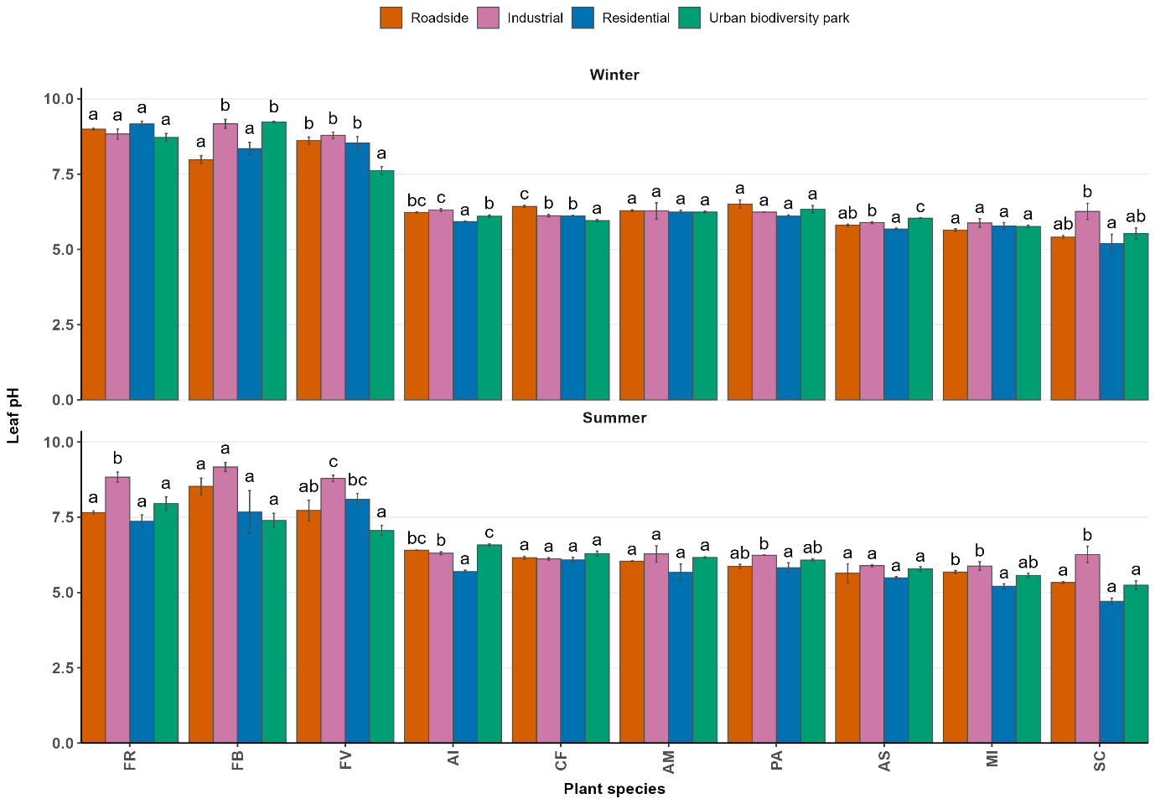 Fig. S10: Mean and standard error values of Leaf pH across species and locations.

