Additional file 1: Supplementary methods, tables, and figures
Reported pain-management patterns and later pain severity

Supplementary methods
The primary analysis used a proportional-odds model after 20 multiple imputations, the 2018 individual cross-sectional weight adjusted for household and individual nonresponse, and community-level clustering. Baseline Table 1 is unweighted and unimputed; missing values are visible in the denominators or summarized separately. Model 0 included pain-management pattern alone, Model 1 added age and sex, and Model 2 added the complete prespecified covariate set.
Loss to follow-up was assessed among all 5461 participants who met the baseline age, pain-severity, musculoskeletal-site, and management-indicator criteria. Within each imputed dataset, a logistic model estimated the probability of a valid 2020 pain outcome from management pattern and the prespecified baseline covariates. The stabilized inverse probability-of-observation weight was truncated at the 1st and 99th percentiles and multiplied by the cross-sectional weight. The combined weight was normalized before the proportional-odds model was refitted. Untruncated, observation-weight-only, cross-sectional-weight-only, and unweighted models were also examined.
Other prespecified robustness analyses changed one design feature at a time: complete cases; inclusion of proxy interviews; inclusion of the other-containing pattern; lower and higher baseline pain thresholds; and generalized propensity-score overlap weighting. For overlap weighting, a multinomial-logit propensity model used the prespecified covariates in each imputed dataset. Balance was accepted when the maximum post-weighting absolute standardized mean difference (SMD) was at most 0.10. Exposure, outcome, survey weight, and cluster identifiers were not imputed.
All secondary outcome analyses were exploratory. No adjustment was made for multiple comparisons; global exposure tests were prioritized over individual contrasts.
In a post hoc exploratory analysis, effect modification by baseline pain severity (“somewhat,” “quite a bit,” or “very”) was assessed with a global management-pattern-by-severity interaction in the fully adjusted ordinal model. Stratum-specific models used the same covariate set except that baseline pain severity was constant within each stratum.

Table S1. Sequential models for ordinal pain severity
Model | Pain-management pattern | Cumulative OR | 95% CI | P value | Global P value
Model 0: management pattern only | Western medicine only | 1.65 | 1.38 to 1.98 | <0.001 | <0.001
Model 0: management pattern only | Traditional/complementary modalities without Western medicine | 1.06 | 0.80 to 1.40 | 0.694 | <0.001
Model 0: management pattern only | Integrative management | 2.01 | 1.66 to 2.44 | <0.001 | <0.001
Model 1: age and sex | Western medicine only | 1.62 | 1.37 to 1.92 | <0.001 | <0.001
Model 1: age and sex | Traditional/complementary modalities without Western medicine | 1.05 | 0.80 to 1.38 | 0.732 | <0.001
Model 1: age and sex | Integrative management | 1.96 | 1.62 to 2.36 | <0.001 | <0.001
Model 2: fully adjusted | Western medicine only | 1.33 | 1.13 to 1.57 | <0.001 | 0.002
Model 2: fully adjusted | Traditional/complementary modalities without Western medicine | 1.1 | 0.85 to 1.43 | 0.462 | 0.002
Model 2: fully adjusted | Integrative management | 1.3 | 1.08 to 1.57 | 0.006 | 0.002
The reference category is no reported pain-relief measure. Model 0 includes management pattern only; Model 1 adds age and sex; Model 2 adds all prespecified demographic, socioeconomic, pain, health, psychological, functional, and healthcare-use covariates. Model 2 is the primary model.

Table S2. Baseline comparison by observation of the 2020 pain outcome
Characteristic | Valid 2020 pain outcome | No valid 2020 pain outcome | Absolute SMD
Baseline IADL limitation count | 0.82 (1.28) | 1.46 (1.75) | 0.421
Residence: Rural | 3349 (68.9%) | 296 (49.4%) | 0.404
Residence: Urban | 1513 (31.1%) | 303 (50.6%) | 0.404
Baseline ADL limitation count | 0.80 (1.39) | 1.47 (1.97) | 0.399
Age, years | 62.62 (9.88) | 66.53 (11.88) | 0.357
Chronic-disease count | 2.39 (1.87) | 3.01 (2.17) | 0.308
Hospital admission in previous year: Yes | 1128 (23.2%) | 205 (34.4%) | 0.249
Hospital admission in previous year: No | 3729 (76.8%) | 391 (65.6%) | 0.249
Sex: Men | 1701 (35.0%) | 263 (43.9%) | 0.183
Sex: Women | 3161 (65.0%) | 336 (56.1%) | 0.183
Education: College or above | 34 (0.7%) | 16 (2.7%) | 0.154
Self-rated health: Very poor | 591 (12.9%) | 86 (18.0%) | 0.143
Musculoskeletal pain-site count | 5.21 (3.20) | 5.60 (3.43) | 0.116
Self-rated health: Fair | 1897 (41.3%) | 175 (36.7%) | 0.095
Doctor-diagnosed arthritis/rheumatism: No | 1800 (37.0%) | 246 (41.1%) | 0.083
Doctor-diagnosed arthritis/rheumatism: Yes | 3062 (63.0%) | 353 (58.9%) | 0.083
Baseline pain severity: Very | 1319 (27.1%) | 185 (30.9%) | 0.083
Pain-management pattern: Other-containing pattern | 1040 (21.4%) | 110 (18.4%) | 0.076
CESD-10 score | 11.74 (7.01) | 12.24 (7.22) | 0.07
Pain-management pattern: No reported pain-relief measure | 1157 (23.8%) | 156 (26.0%) | 0.052
Self-rated health: Good | 246 (5.4%) | 31 (6.5%) | 0.048
Baseline pain severity: Quite a bit | 1633 (33.6%) | 188 (31.4%) | 0.047
Education: No formal education | 1588 (32.7%) | 184 (30.7%) | 0.042
Self-rated health: Poor | 1730 (37.7%) | 171 (35.8%) | 0.038
Household wealth, transformed | 1.91 (2.44) | 1.99 (2.40) | 0.037
Education: High/vocational school | 322 (6.6%) | 45 (7.5%) | 0.035
Baseline pain severity: Somewhat | 1910 (39.3%) | 226 (37.7%) | 0.032
Pain-management pattern: Integrative management | 868 (17.9%) | 100 (16.7%) | 0.031
Education: Middle school | 749 (15.4%) | 86 (14.4%) | 0.029
Pain-management pattern: Traditional/complementary modalities without Western medicine | 488 (10.0%) | 65 (10.9%) | 0.027
Pain-management pattern: Western medicine only | 1309 (26.9%) | 168 (28.0%) | 0.025
Outpatient visit in previous month: Yes | 1196 (24.6%) | 144 (24.2%) | 0.011
Outpatient visit in previous month: No | 3661 (75.4%) | 452 (75.8%) | 0.011
Self-rated health: Very good | 130 (2.8%) | 14 (2.9%) | 0.006
Education: Primary or below | 2169 (44.6%) | 268 (44.7%) | 0.003
Values are n (%) or mean (SD), as appropriate. SMD denotes standardized mean difference. For categorical variables, the SMD is shown for each indicated level. Missingness was retained when summaries were computed.
Among the 599 participants without a valid 2020 pain outcome, 221 had a recorded death, 377 had no 2020 health interview and no known death record, and one completed the health interview but lacked a valid pain-severity outcome. Proxy and survey-weight exclusions are reported sequentially in Figure 1.

Table S3. Attrition-weight diagnostics
Diagnostic | Value
Observed outcome rate | 0.890
Minimum predicted probability | 0.257
1st percentile predicted probability | 0.547
Median predicted probability | 0.917
99th percentile predicted probability | 0.976
Maximum predicted probability | 0.985
Median observation weight | 0.965
99th percentile observation weight | 1.414
Maximum observation weight | 2.511
Observation-weight coefficient of variation | 0.101
Observation-weight effective sample size | 3427
Combined-weight coefficient of variation | 0.773
Combined-weight effective sample size | 2027
Untruncated combined-weight effective sample size | 1991
Diagnostics are medians across the 20 imputed datasets where the quantity varied by imputation. Effective sample size was calculated as $(∑w)^{2}/∑w^{2}$.

Table S4. Primary-model attrition-weight sensitivity analyses
Analysis | Pain-management pattern | Cumulative OR | 95% CI | P value | Global P value
Unweighted, fully adjusted MI (all primary participants) | Western medicine only | 1.22 | 1.05 to 1.41 | 0.009 | 0.032
Unweighted, fully adjusted MI (all primary participants) | Traditional/complementary modalities without Western medicine | 1.06 | 0.86 to 1.30 | 0.581 | 0.032
Unweighted, fully adjusted MI (all primary participants) | Integrative management | 1.22 | 1.03 to 1.44 | 0.022 | 0.032
2018 cross-sectional weight only | Western medicine only | 1.34 | 1.14 to 1.57 | <0.001 | 0.002
2018 cross-sectional weight only | Traditional/complementary modalities without Western medicine | 1.1 | 0.85 to 1.44 | 0.460 | 0.002
2018 cross-sectional weight only | Integrative management | 1.3 | 1.08 to 1.58 | 0.006 | 0.002
Observation-probability weight only | Western medicine only | 1.21 | 1.05 to 1.41 | 0.010 | 0.035
Observation-probability weight only | Traditional/complementary modalities without Western medicine | 1.04 | 0.85 to 1.28 | 0.708 | 0.035
Observation-probability weight only | Integrative management | 1.2 | 1.02 to 1.42 | 0.033 | 0.035
Combined cross-sectional and truncated observation weight | Western medicine only | 1.33 | 1.13 to 1.57 | <0.001 | 0.002
Combined cross-sectional and truncated observation weight | Traditional/complementary modalities without Western medicine | 1.08 | 0.83 to 1.41 | 0.578 | 0.002
Combined cross-sectional and truncated observation weight | Integrative management | 1.3 | 1.07 to 1.57 | 0.008 | 0.002
Combined cross-sectional and untruncated observation weight | Western medicine only | 1.33 | 1.13 to 1.57 | <0.001 | 0.002
Combined cross-sectional and untruncated observation weight | Traditional/complementary modalities without Western medicine | 1.06 | 0.81 to 1.40 | 0.663 | 0.002
Combined cross-sectional and untruncated observation weight | Integrative management | 1.29 | 1.07 to 1.56 | 0.009 | 0.002
The reference category is no reported pain-relief measure. MI denotes multiple imputation. The combined-truncated analysis multiplies the 2018 cross-sectional individual weight by the stabilized observation weight after 1st/99th-percentile truncation.

Table S5. Composition of the traditional/complementary and integrative patterns

Panel A. Marginal use of each reported pain-relief measure
Reported measure | n | % of primary cohort
No reported pain-relief measure | 1038 | 30
Western medicine | 1971 | 56.9
Chinese medicine | 795 | 23
Acupuncture | 543 | 15.7
Professional massage | 461 | 13.3
Percentages use the primary cohort (N = 3462) as the denominator. Measures were reported as separate multiple-response items; therefore, percentages are not mutually exclusive and do not sum to 100%.

Panel B. Mutually exclusive combinations within the grouped patterns
Pain-management pattern | Reported combination | n | % within pattern
Integrative management | Chinese medicine + Western medicine | 295 | 37.4
Traditional/complementary modalities without Western medicine | Chinese medicine | 189 | 41.7
Integrative management | Western medicine + Acupuncture | 111 | 14.1
Integrative management | Chinese medicine + Western medicine + Acupuncture + Professional massage | 110 | 14
Integrative management | Chinese medicine + Western medicine + Acupuncture | 99 | 12.6
Traditional/complementary modalities without Western medicine | Professional massage | 97 | 21.4
Integrative management | Western medicine + Acupuncture + Professional massage | 86 | 10.9
Integrative management | Western medicine + Professional massage | 62 | 7.9
Traditional/complementary modalities without Western medicine | Acupuncture | 61 | 13.5
Traditional/complementary modalities without Western medicine | Chinese medicine + Professional massage | 30 | 6.6
Traditional/complementary modalities without Western medicine | Acupuncture + Professional massage | 29 | 6.4
Traditional/complementary modalities without Western medicine | Chinese medicine + Acupuncture | 25 | 5.5
Integrative management | Chinese medicine + Western medicine + Professional massage | 25 | 3.2
Traditional/complementary modalities without Western medicine | Chinese medicine + Acupuncture + Professional massage | 22 | 4.9
Combinations are mutually exclusive within each pain-management pattern. Chinese medicine, Western medicine, acupuncture, and professional massage were reported as separate multiple-response items.

Table S6. Characterization of the other-containing pattern
Table S6a. Characteristics of the other-containing group
Characteristic | Value
Participants | 1040
Age, mean (SD) | 62.9 (9.9)
Women | 724 (69.6%)
Rural residence | 676 (65.0%)
Baseline pain: somewhat | 408 (39.2%)
Baseline pain: quite a bit | 363 (34.9%)
Baseline pain: very | 269 (25.9%)
Musculoskeletal pain-site count, mean (SD) | 5.5 (3.2)
Co-used Chinese medicine | 256 (24.6%)
Co-used Western medicine | 543 (52.2%)
Co-used acupuncture | 207 (19.9%)
Co-used professional massage | 193 (18.6%)
2020 pain: none | 168 (16.2%)
2020 pain: a little | 255 (24.5%)
2020 pain: somewhat | 178 (17.1%)
2020 pain: quite a bit | 216 (20.8%)
2020 pain: very | 223 (21.4%)
Baseline health-module proxy | 40 (3.8%)
Follow-up health-module proxy | 80 (7.7%)
Table S6b. Reported combinations containing the other-measure item
Reported combination containing other measure | n | %
Other measure | 358 | 34.4
Western medicine + Other measure | 244 | 23.5
Chinese medicine + Western medicine + Other measure | 99 | 9.5
Chinese medicine + Other measure | 48 | 4.6
Chinese medicine + Western medicine + Acupuncture + Professional massage + Other measure | 47 | 4.5
Western medicine + Acupuncture + Professional massage + Other measure | 41 | 3.9
Western medicine + Acupuncture + Other measure | 37 | 3.6
Professional massage + Other measure | 35 | 3.4
Chinese medicine + Western medicine + Acupuncture + Other measure | 28 | 2.7
Western medicine + Professional massage + Other measure | 28 | 2.7
Acupuncture + Other measure | 26 | 2.5
Chinese medicine + Western medicine + Professional massage + Other measure | 19 | 1.8
Acupuncture + Professional massage + Other measure | 15 | 1.4
Chinese medicine + Acupuncture + Other measure | 7 | 0.7
Chinese medicine + Acupuncture + Professional massage + Other measure | 6 | 0.6
Chinese medicine + Professional massage + Other measure | 2 | 0.2
The other-measure item was not further specified by CHARLS and therefore was not combined with clinically interpretable named modalities in the four-group primary exposure. The five-group sensitivity analysis restored this group.

Table S7. Prespecified sensitivity analyses for ordinal pain severity
Analysis | Pain-management pattern | Cumulative OR | 95% CI | P value
Primary: weighted multiple imputation | Western medicine only | 1.33 | 1.13 to 1.57 | <0.001
Primary: weighted multiple imputation | Traditional/complementary modalities without Western medicine | 1.1 | 0.85 to 1.43 | 0.462
Primary: weighted multiple imputation | Integrative management | 1.3 | 1.08 to 1.57 | 0.006
Unweighted multiply imputed | Western medicine only | 1.25 | 1.07 to 1.46 | 0.004
Unweighted multiply imputed | Traditional/complementary modalities without Western medicine | 1.06 | 0.85 to 1.31 | 0.612
Unweighted multiply imputed | Integrative management | 1.23 | 1.03 to 1.46 | 0.019
Survey-weighted complete case | Western medicine only | 1.51 | 1.22 to 1.86 | <0.001
Survey-weighted complete case | Traditional/complementary modalities without Western medicine | 1.2 | 0.87 to 1.67 | 0.272
Survey-weighted complete case | Integrative management | 1.32 | 1.04 to 1.66 | 0.020
Four groups, proxy interviews included | Western medicine only | 1.32 | 1.13 to 1.55 | <0.001
Four groups, proxy interviews included | Traditional/complementary modalities without Western medicine | 1.11 | 0.87 to 1.42 | 0.390
Four groups, proxy interviews included | Integrative management | 1.27 | 1.05 to 1.55 | 0.015
Five groups, other-containing pattern included | Western medicine only | 1.34 | 1.13 to 1.58 | <0.001
Five groups, other-containing pattern included | Traditional/complementary modalities without Western medicine | 1.12 | 0.86 to 1.46 | 0.388
Five groups, other-containing pattern included | Integrative management | 1.34 | 1.11 to 1.61 | 0.003
Five groups, other-containing pattern included | Other-containing pattern | 1.41 | 1.12 to 1.78 | 0.003
Baseline pain rated at least a little | Western medicine only | 1.43 | 1.20 to 1.71 | <0.001
Baseline pain rated at least a little | Traditional/complementary modalities without Western medicine | 1.21 | 1.01 to 1.45 | 0.037
Baseline pain rated at least a little | Integrative management | 1.54 | 1.32 to 1.81 | <0.001
Baseline pain rated at least quite a bit | Western medicine only | 1.27 | 1.04 to 1.55 | 0.019
Baseline pain rated at least quite a bit | Traditional/complementary modalities without Western medicine | 1.02 | 0.72 to 1.43 | 0.917
Baseline pain rated at least quite a bit | Integrative management | 1.35 | 1.06 to 1.72 | 0.016
Generalized overlap weighting | Western medicine only | 1.31 | 1.08 to 1.59 | 0.006
Generalized overlap weighting | Traditional/complementary modalities without Western medicine | 1.14 | 0.87 to 1.48 | 0.337
Generalized overlap weighting | Integrative management | 1.28 | 1.04 to 1.57 | 0.021
The reference category is no reported pain-relief measure. The other-containing contrast is shown only in the five-group sensitivity analysis.

Table S8. Binary cumulative cut-point diagnostics
Pain threshold | Pain-management pattern | Adjusted OR | 95% CI | P value
Pain >= 2 | Western medicine only | 1.27 | 0.96 to 1.68 | 0.093
Pain >= 2 | Traditional/complementary modalities without Western medicine | 0.91 | 0.64 to 1.30 | 0.599
Pain >= 2 | Integrative management | 1.22 | 0.87 to 1.71 | 0.250
Pain >= 3 | Western medicine only | 1.30 | 1.04 to 1.62 | 0.020
Pain >= 3 | Traditional/complementary modalities without Western medicine | 1.22 | 0.91 to 1.65 | 0.186
Pain >= 3 | Integrative management | 1.28 | 1.00 to 1.65 | 0.049
Pain >= 4 | Western medicine only | 1.34 | 1.08 to 1.65 | 0.007
Pain >= 4 | Traditional/complementary modalities without Western medicine | 1.24 | 0.89 to 1.72 | 0.208
Pain >= 4 | Integrative management | 1.33 | 1.04 to 1.69 | 0.022
Pain >= 5 | Western medicine only | 1.40 | 1.10 to 1.76 | 0.005
Pain >= 5 | Traditional/complementary modalities without Western medicine | 1.27 | 0.87 to 1.87 | 0.215
Pain >= 5 | Integrative management | 1.54 | 1.18 to 2.01 | 0.002
Each row comes from a separate survey-weighted binary logistic model using the same covariates and imputation strategy as the primary model. These are diagnostic summaries, not independent primary hypotheses.

Table S9. Covariate balance after generalized overlap weighting
Covariate | Median maximum SMD before | Median maximum SMD after | Maximum SMD after
msk_site_count_w4 | 0.480 | 0.016 | 0.020
cesd10 | 0.457 | 0.025 | 0.032
knee_painYes | 0.428 | 0.016 | 0.019
outpatient_last_monthYes | 0.406 | 0.028 | 0.032
ruralRural | 0.386 | 0.037 | 0.041
arthritisYes | 0.378 | 0.022 | 0.028
wealth_10k_asinh | 0.297 | 0.017 | 0.033
baseline_pain_severityVery | 0.321 | 0.017 | 0.023
baseline_adl_count | 0.288 | 0.023 | 0.029
self_rated_healthPoor | 0.249 | 0.021 | 0.028
neck_or_shoulder_painYes | 0.236 | 0.026 | 0.031
self_rated_healthFair | 0.196 | 0.024 | 0.032
chronic_disease_count | 0.199 | 0.052 | 0.055
hospital_last_yearYes | 0.182 | 0.022 | 0.031
self_rated_healthGood | 0.165 | 0.025 | 0.030
prior_bmi | 0.095 | 0.029 | 0.042
self_rated_healthVery poor | 0.158 | 0.018 | 0.025
age | 0.159 | 0.015 | 0.024
sexWomen | 0.151 | 0.037 | 0.042
baseline_iadl_count | 0.149 | 0.029 | 0.036
partneredMarried/partnered | 0.146 | 0.020 | 0.024
educationMiddle school | 0.145 | 0.045 | 0.048
educationCollege or above | 0.143 | 0.042 | 0.049
back_or_waist_painYes | 0.138 | 0.015 | 0.017
health_insuranceYes | 0.129 | 0.019 | 0.023
baseline_pain_severityQuite a bit | 0.122 | 0.035 | 0.040
educationHigh/vocational school | 0.096 | 0.072 | 0.076
educationPrimary or below | 0.092 | 0.067 | 0.072
The accepted analysis achieved a maximum post-weighting absolute SMD of 0.076; median effective sample size was approximately 1821.

Table S10. Missingness in prespecified analysis covariates
Variable | Missing n | Missing %
wealth_10k_asinh | 709 | 20.5
prior_bmi | 674 | 19.5
survey_weight | 225 | 6.5
cesd10 | 67 | 1.9
self_rated_health | 34 | 1.0
hospital_last_year | 4 | 0.1
outpatient_last_month | 4 | 0.1
health_insurance | 2 | 0.1
baseline_adl_count | 1 | 0.0
baseline_iadl_count | 1 | 0.0
age | 0 | 0.0
arthritis | 0 | 0.0
back_or_waist_pain | 0 | 0.0
baseline_pain_severity | 0 | 0.0
chronic_disease_count | 0 | 0.0
education | 0 | 0.0
knee_pain | 0 | 0.0
msk_site_count_w4 | 0 | 0.0
neck_or_shoulder_pain | 0 | 0.0
partnered | 0 | 0.0
rural | 0 | 0.0
sex | 0 | 0.0

Table S11. Exploratory effect modification by baseline pain severity
Baseline pain severity | Pain-management pattern | n | Adjusted cumulative OR | 95% CI | P value
Somewhat | Western medicine only | 400 | 1.49 | 1.12 to 1.98 | 0.006
Somewhat | Traditional/complementary modalities without Western medicine | 193 | 1.22 | 0.82 to 1.80 | 0.33
Somewhat | Integrative management | 220 | 1.2 | 0.85 to 1.70 | 0.305
Quite a bit | Western medicine only | 377 | 1.31 | 1.00 to 1.70 | 0.046
Quite a bit | Traditional/complementary modalities without Western medicine | 137 | 1.1 | 0.74 to 1.64 | 0.639
Quite a bit | Integrative management | 263 | 1.43 | 1.00 to 2.06 | 0.053
Very | Western medicine only | 338 | 1.22 | 0.89 to 1.69 | 0.221
Very | Traditional/complementary modalities without Western medicine | 90 | 0.9 | 0.48 to 1.69 | 0.752
Very | Integrative management | 248 | 1.23 | 0.83 to 1.84 | 0.304
The reference category within each stratum is no reported pain-relief measure. Models used the primary survey weight, 20 multiply imputed datasets, community clustering, and all primary-model covariates except baseline pain severity, which was constant within each stratum. The pooled 6-degree-of-freedom global management-pattern-by-baseline-severity interaction P value was 0.942. This analysis was post hoc and exploratory; stratum-specific P values should not be interpreted as evidence of between-stratum differences.

Figure S1. Sensitivity estimates
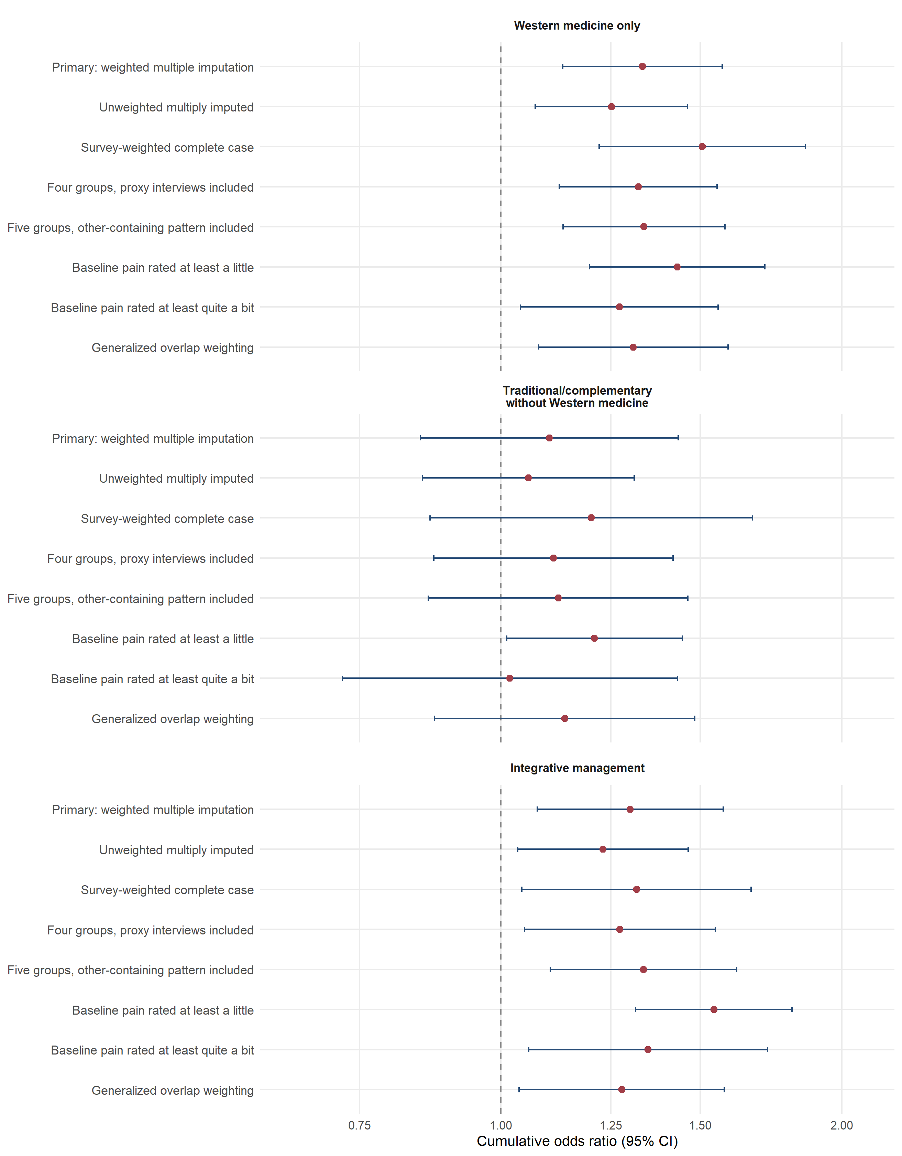
Figure S1. Adjusted cumulative odds ratios across prespecified sensitivity analyses.

Figure S2. Covariate balance after generalized overlap weighting
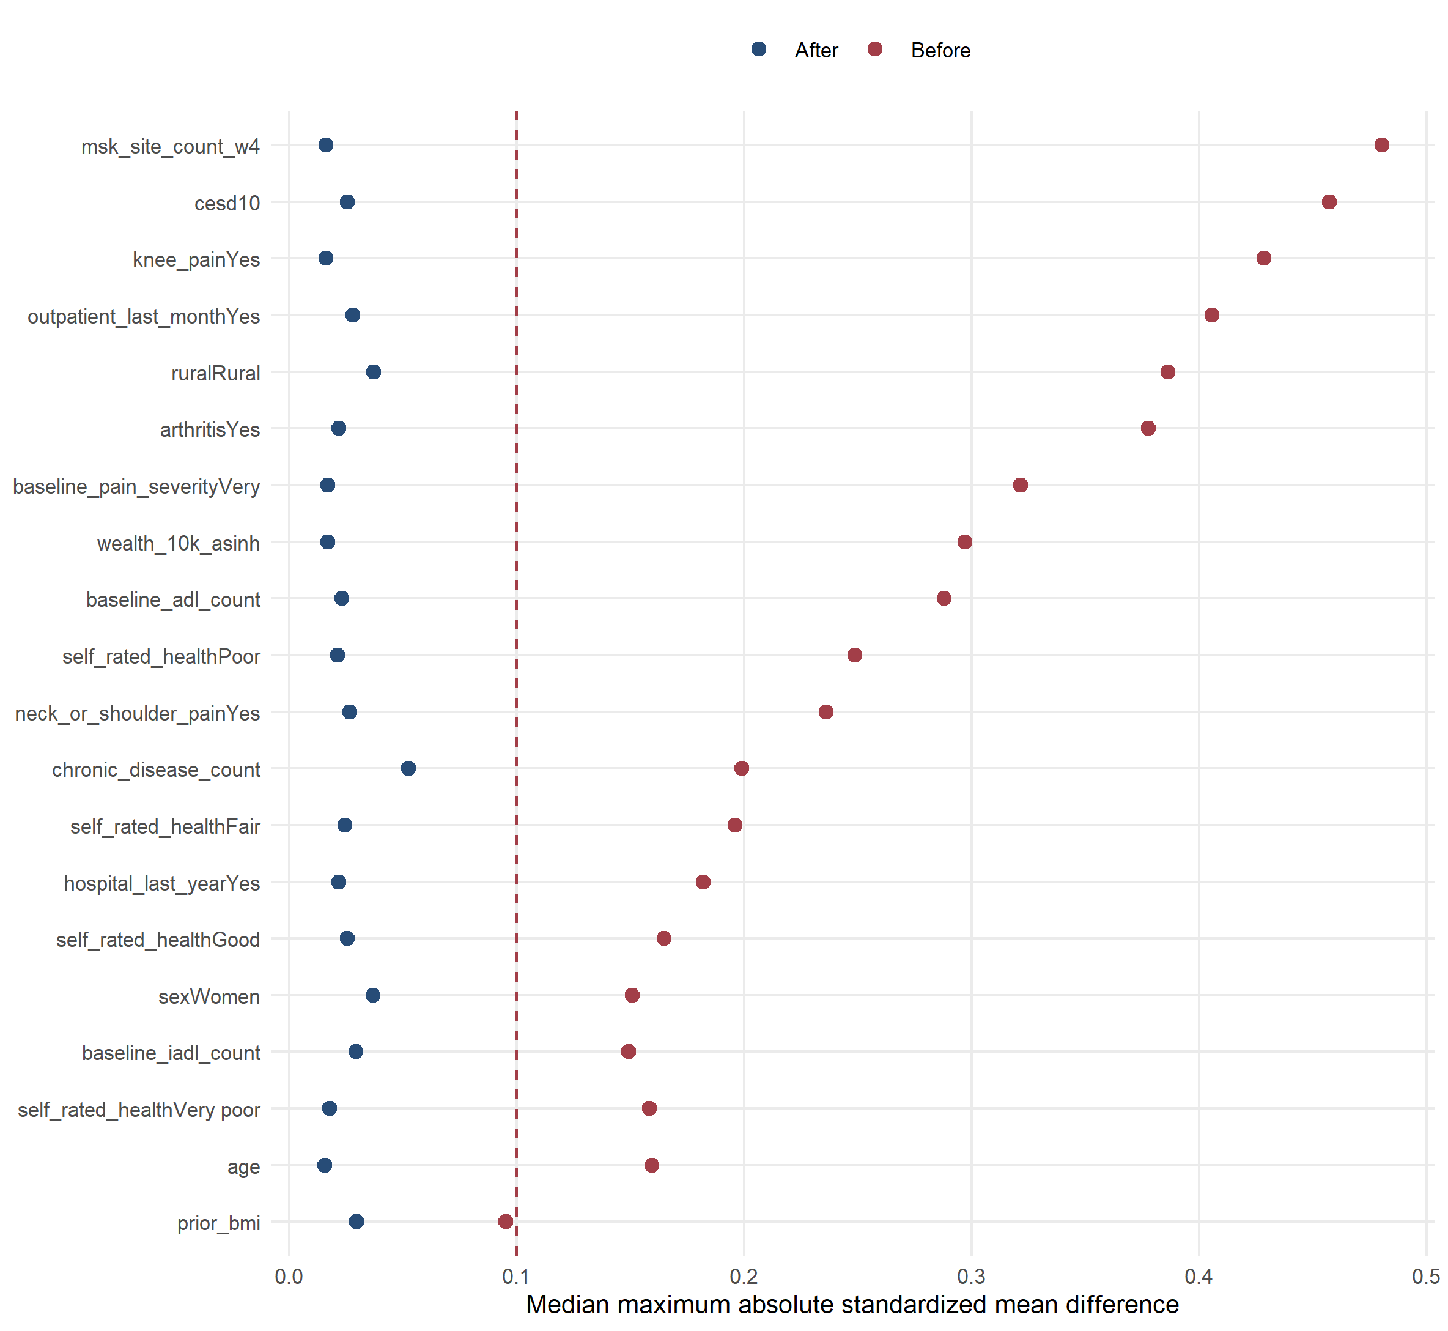
Figure S2. Covariate balance before and after generalized overlap weighting. The vertical dashed line marks an absolute standardized mean difference of 0.10.

Figure S3. Baseline differences by observation of the 2020 pain outcome
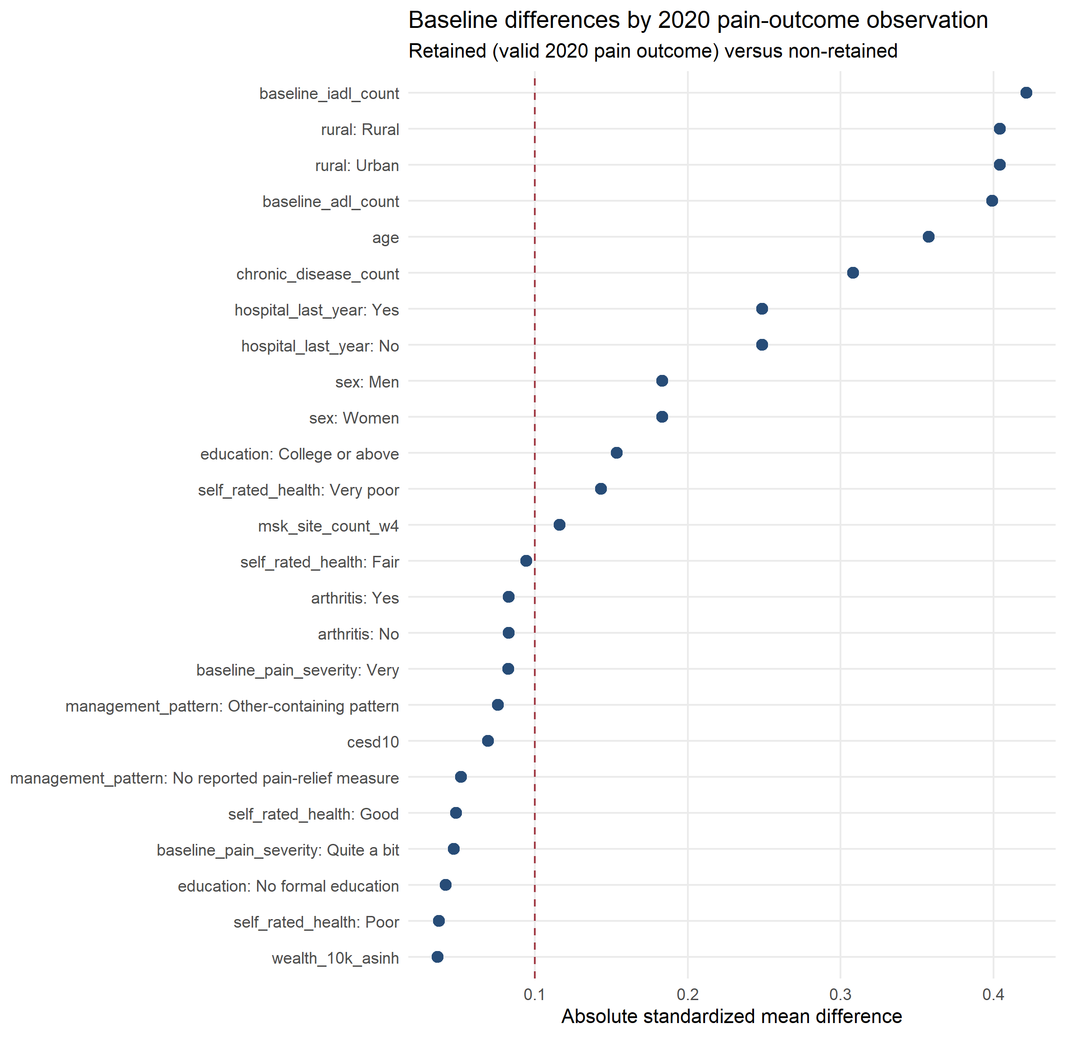
Figure S3. Absolute standardized mean differences comparing participants with and without a valid 2020 pain outcome.

