Supplementary data
Fig 1 C
WB: GPX4 1 GPX4 2 GPX4 3
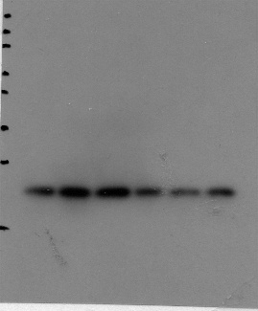
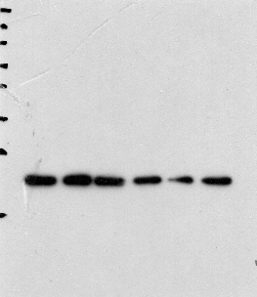
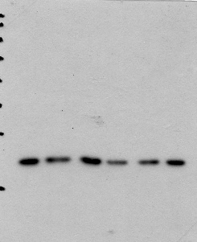
Sham AMI
1d 2d 3d 1d 2d3d
Sham AMI
1d 2d 3d 1d 2d3d
Sham AMI
1d 2d 3d 1d 2d3d

ACSL4 1 ACSL4 2 ACSL4 3
Sham AMI
1d 2d 3d 1d 2d 3d
Sham AMI
1d 2d 3d 1d 2d 3d
Sham AMI
1d 2d 3d 1d 2d 3d
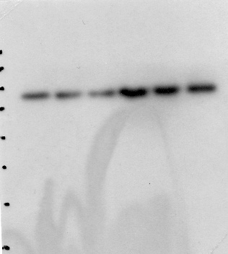
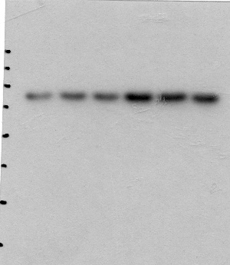
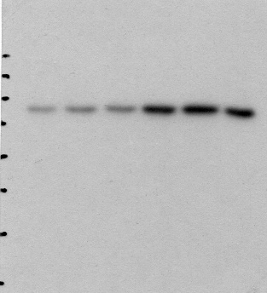

GAPDH 1 GAPDH 2 GAPDH 3
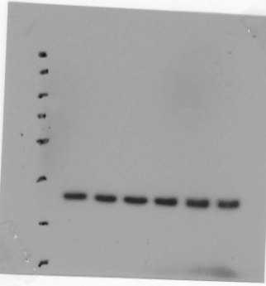
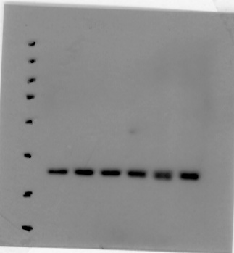
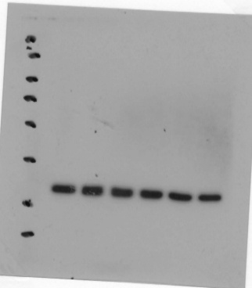
Sham AMI
1d 2d 3d 1d 2d 3d
Sham AMI
1d 2d 3d 1d 2d 3d
Sham AMI
1d 2d 3d 1d 2d 3d

Fig 3 D
WB
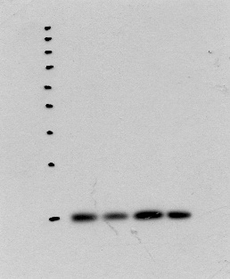
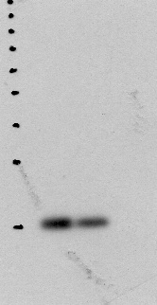
CKLF1 1 CKLF1 2 3

AMI AMI+CKLF1neutralizingantibody

AMI AMI+CKLF1neutralizing antibody

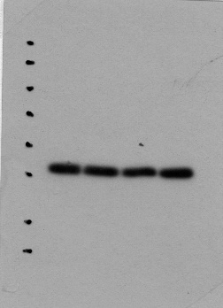
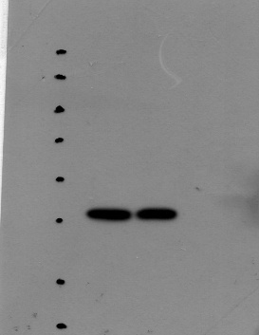
β-actin 1 β-actin 2 3

AMI AMI+CKLF1neutralizing antibody

AMI AMI+CKLF1neutralizing antibody

Fig 4 I
WB
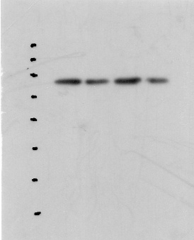
GPX4 1 GPX4 2 3 ACSL4 1 ACSL4 2 3
AMI AMI+CKLF1neutralizing antibody
AMI AMI+CKLF1neutralizing antibody
AMI AMI+CKLF1neutralizing antibody
AMI AMI+CKLF1neutralizing antibody
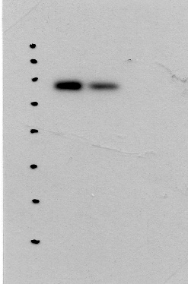
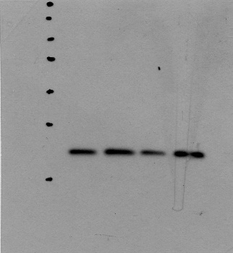
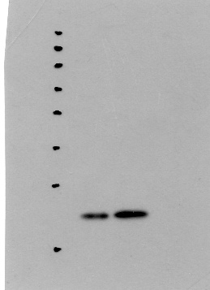
β-actin 1 β-actin 2 3

AMI AMI+CKLF1neutralizing antibody
AMI AMI+CKLF1neutralizing antibody

Fig 5 A
WB

HO-1 Keap1
AMI+CKLF1+neutralizing antibody

AMI+CKLF1+neutralizing antibody

AMI+CKLF1+neutralizing antibody

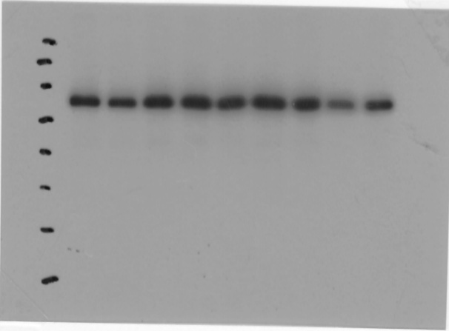
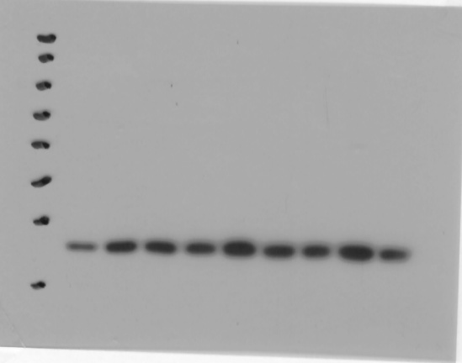
AMI
Sham
AMI
Sham
AMI
Sham
AMI+CKLF1+neutralizing antibody

AMI+CKLF1+neutralizing antibody

AMI+CKLF1+neutralizing antibody

AMI
Sham
AMI
Sham
AMI
Sham

Nrf 2 GAPDH
AMI+CKLF1+neutralizing antibody

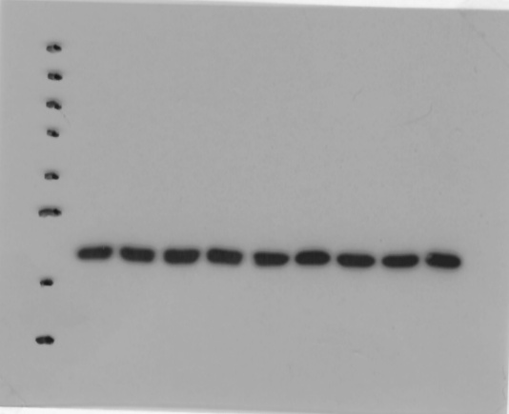
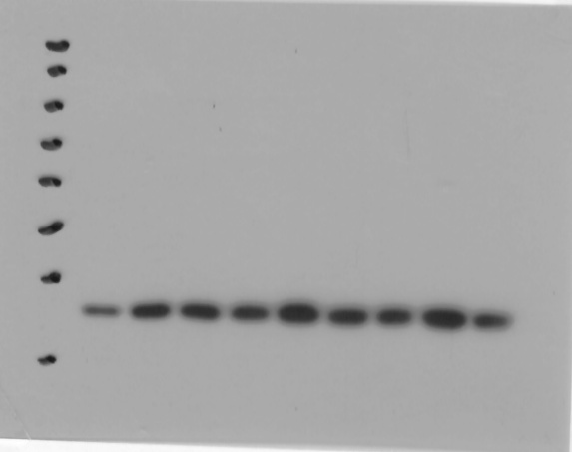
AMI+CKLF1+neutralizing antibody

AMI+CKLF1+neutralizing antibody

AMI+CKLF1+neutralizing antibody

AMI+CKLF1+neutralizing antibody

AMI+CKLF1+neutralizing antibody

Sham
AMI
AMI
Sham
AMI
Sham
Sham
Sham
Sham
AMI
AMI
AMI

Fig 6 I
WB
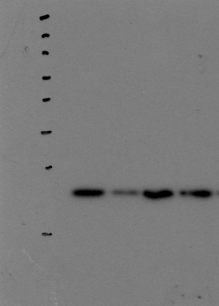
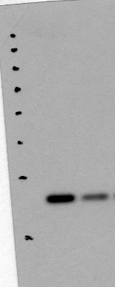
GPX4 1 GPX4 2 3 ACSL4 1 ACSL4 2 3
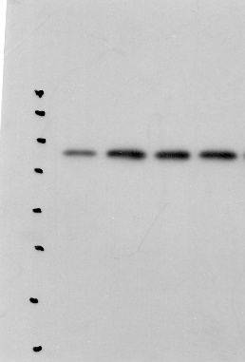
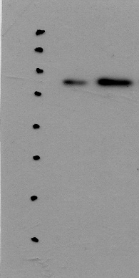
Control OGD
Control OGD
Control OGD
Control OGD
Control OGD
Control OGD

β-actin
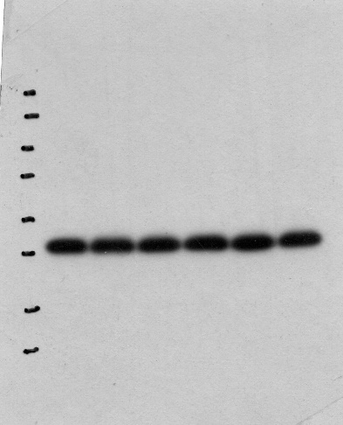

Control OGD
Control OGD
Control OGD

Fig 7 B
WB CKLF1
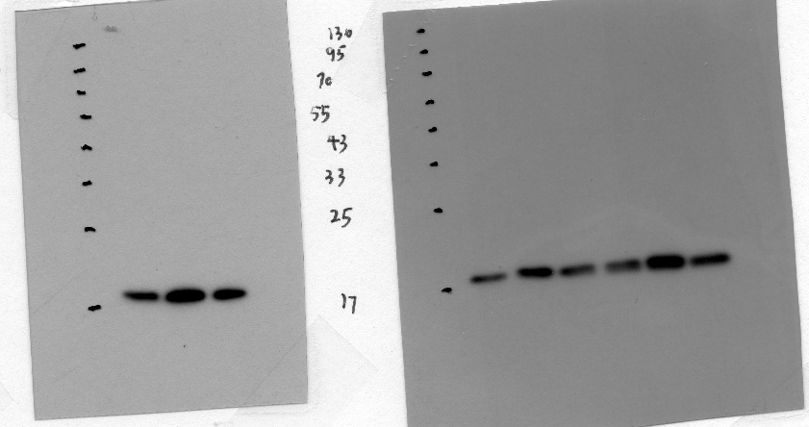

Control OGD C19
Control OGD C19
Control OGD C19

β-actin
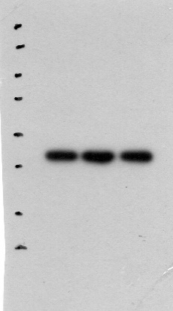
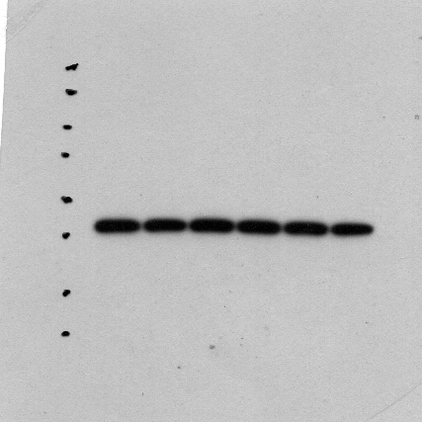
Control OGD C19
Control OGD C19
Control OGD C19

Fig 8 K
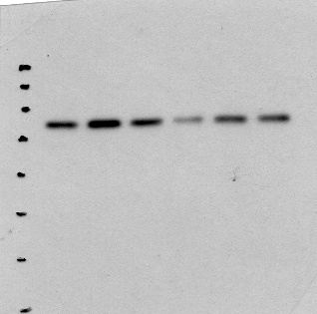
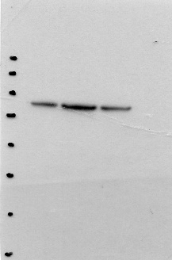
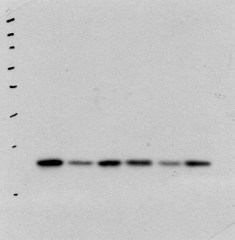
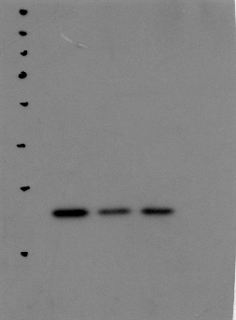
VWB GPX4 1 GPX4 2 3 ACSL4 1 ACSL4 2 3
Control OGD C19
Control OGD C19
Control OGD C19
Control OGD C19
Control OGD C19
Control OGD C19

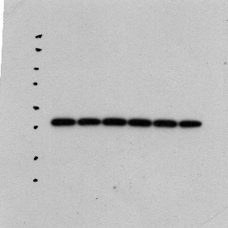
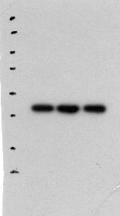
β-actin 1 β-actin 2 3
Control OGD C19
Control OGD C19
Control OGD C19

Fig 9 A
WB Keap1 1 Keap1 2 Keap1 3
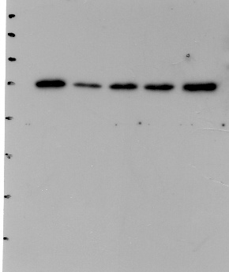
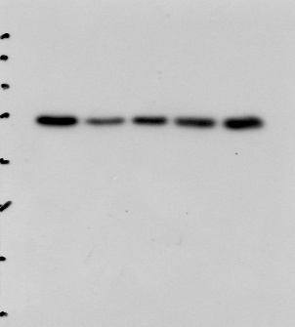
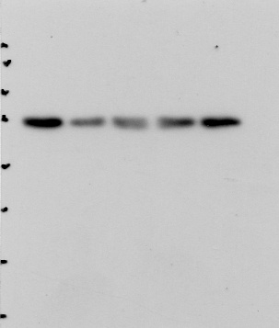
Control
OGD+C19

OGD

Control
OGD

OGD+C19+ML385

OGD+C19

OGD+ML385

OGD+C19+ML385

OGD+ML385

OGD+C19

OGD

Control
OGD+C19+ML385

OGD+ML385

HO-1 1 HO-1 2 HO-1 3
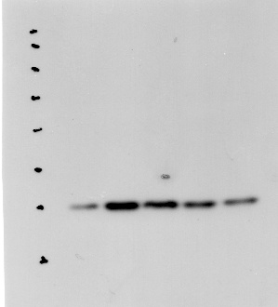
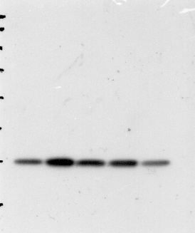
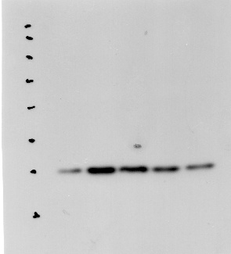
OGD+C19+ML385

OGD+C19+ML385

OGD+C19+ML385

OGD+ML385

OGD+ML385

OGD+ML385

OGD+C19

OGD+C19

Control
Control
OGD

OGD+C19

Control
OGD

OGD

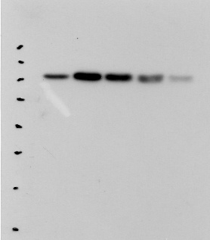
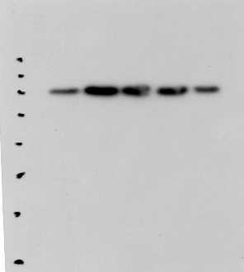
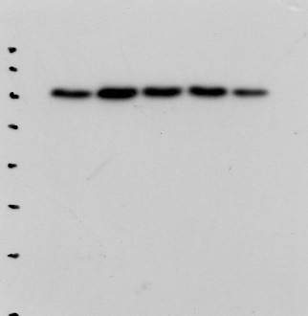
Nrf2 1 Nrf2 2 Nrf2 3

OGD+C19+ML385

OGD+C19+ML385

OGD+C19+ML385

OGD+ML385

OGD+ML385

OGD+ML385

OGD+C19

OGD+C19

OGD+C19

OGD

OGD

OGD

Control
Control
Control

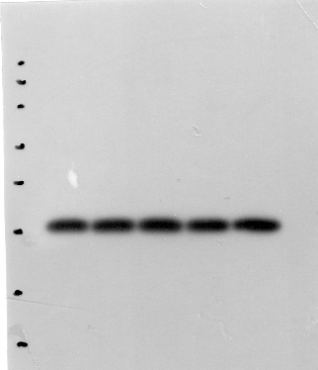
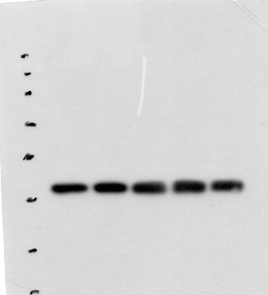
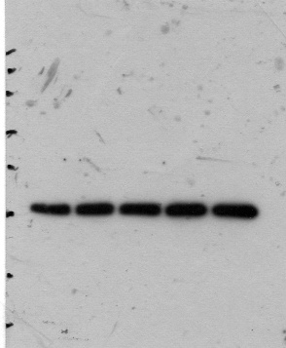
β-actin 1 β-actin 2 β-actin 3
OGD+C19+ML385

OGD+C19+ML385

OGD+C19+ML385

OGD+ML385

OGD+ML385

OGD+ML385

OGD+C19

OGD+C19

OGD+C19

OGD

Control
Control
Control
OGD

OGD

Fig 9 E
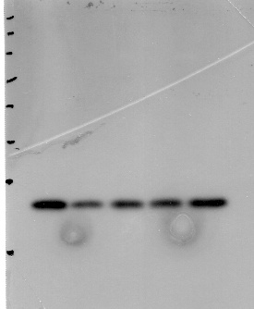
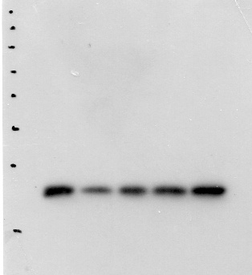
WB GPX4 1 GPX4 2 GPX4 3
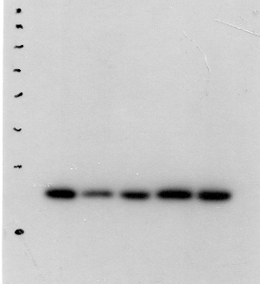
OGD+C19+ML385

OGD+C19+ML385

OGD+C19+ML385

OGD+ML385

OGD+ML385

OGD+ML385

OGD+C19

OGD+C19

OGD+C19

OGD

OGD

Control
Control
Control
OGD

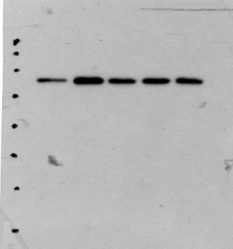
ACSL4 1 ACSL4 2 ACSL4 3
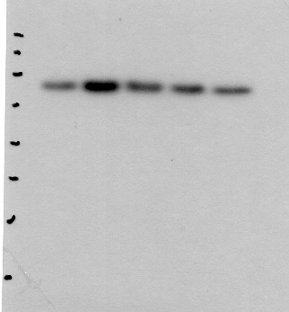
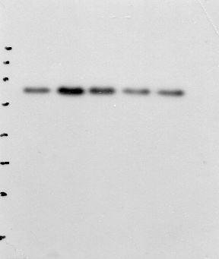
OGD+C19+ML385

OGD+C19+ML385

OGD+C19+ML385

OGD+ML385

OGD+ML385

OGD+ML385

OGD+C19

OGD+C19

OGD+C19

OGD

OGD

OGD

Control
Control
Control

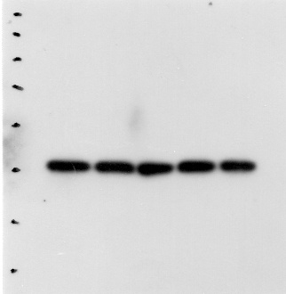
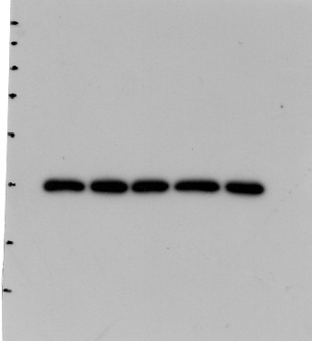
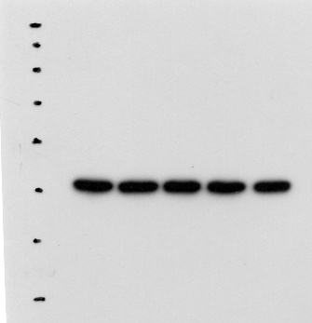
β-actin 1 β-actin 2
OGD+C19+ML385

OGD+C19+ML385

OGD+C19+ML385

OGD+ML385

OGD+ML385

OGD+ML385

OGD+C19

OGD+C19

OGD+C19

OGD

OGD

OGD

Control
Control
Control

