SUPPLEMENTARY INFORMATION
for

Urban renewal liabilities from ageing housing cohorts
Yu Chen¹, Jinming Yan^{1*}, Yumeng Li¹, Qi Zhang², Yang Zhou^{3*}
¹ School of Public Administration and Policy, Renmin University of China, Beijing, China
² Department of Geography and Environment, University of North Carolina at Chapel Hill, Chapel Hill, NC, USA
³ School of Agricultural Economics and Rural Development, Renmin University of China, Beijing, China
This Word file includes:
Supplementary Methods
Supplementary Figures 1–7
Supplementary Tables 1–15
Supplementary References

Contents
Supplementary Methods
S1. Study area and data sources
S2. Analytical framework
S3. Priority ranking module
S4. Scenario projection module
S5. Governance pressure quantification
S6. Pathway cost and carbon accounting
S7. Model assumptions and scenario settings
S8. Data availability for supplementary analyses
Supplementary Figures
Supplementary Fig. 1. Geographic context and administrative structure of the study area
Supplementary Fig. 2. Conceptual framework of the Comprehensive Urban Renewal Priority Index
Supplementary Fig. 3. Baseline urban and rural residential building stock, 1980–2020
Supplementary Fig. 4. Temporal evolution of structural composition in urban and rural residential buildings, 1980–2020
Supplementary Fig. 5. Structural composition of newly added residential buildings across construction periods, 1980–2020
Supplementary Fig. 6. Stage-specific structural composition of newly added urban residential buildings
Supplementary Fig. 7. Stage-specific structural composition of newly added rural residential buildings
Supplementary Tables
Supplementary Table 1. Indicator framework for the residential renewal priority
Supplementary Table 2. Baseline vulnerability coefficients assigned to residential building structural types
Supplementary Table 3. Parameter settings for the cohort-component population projection and demographic inputs to the Social Need Index
Supplementary Table 4. Baseline characteristics of urban and rural residential building stock by construction period, 1980–2020
Supplementary Table 5. Baseline characteristics of newly added urban and rural residential buildings by construction period, 1980–2020
Supplementary Table 6. Policy-calibrated renewal-pressure stock and pathway exposure in 2020, by urban and rural housing systems
Supplementary Table 7. Projected cumulative renewal-pressure stock under low-, medium- and high-population-growth scenarios, 2025–2050
Supplementary Table 8. Five-year additions to the renewal-pressure stock under low-, medium- and high-population-growth scenarios, 2020–2050
Supplementary Table 9. Projected cumulative urban renewal-pressure stock under low-, medium- and high-population-growth scenarios, 2020–2050
Supplementary Table 10. Projected cumulative rural renewal-pressure stock under low-, medium- and high-population-growth scenarios, 2020–2050
Supplementary Table 11. Crosswalk between census structure types and official rural replacement-value categories
Supplementary Table 12. Building newness coefficient used for rural residential compensation
Supplementary Table 13. Projected cumulative and five-year pathway costs under demolition and in situ renewal scenarios, 2020–2050
Supplementary Table 14. Carbon-emission exposure of newly entering renewal-pressure buildings by scenario and urban–rural group
Supplementary Table 15. Parameters used in in situ renewal cost and carbon accounting
Supplementary References

Supplementary Methods

S1. Study area and data sources

S1.1 Study area
Quanzhou is a prefecture-level city on the southeastern coast of Fujian Province, China, within a major coastal urbanization corridor (Supplementary Fig. 1). Export-oriented industrialization, population concentration and sustained construction since the reform era produced extensive residential development across urban districts, county-level centres, peri-urban corridors and rural settlements. Because much of this housing was built during concentrated development waves, the present stock displays pronounced cohort layering in construction age, morphology and structural type.
Quanzhou is analytically useful for three reasons. First, dense urban neighbourhoods, peri-urban development zones and extensive rural settlements coexist within one metropolitan administrative region, allowing the same diagnostic framework to be examined across contrasting settlement contexts. Second, successive construction waves since the 1980s make it possible to isolate the implications of synchronized cohort ageing. Third, the coexistence of state-owned urban land and collectively owned rural land creates distinct renewal, compensation and implementation regimes, making policy interpretation inseparable from tenure context.
The empirical domain covers the full administrative territory of Quanzhou and all identifiable residential buildings retained in the harmonized database. The analysis is restricted to residential buildings because housing is the most socially consequential component of the local built stock and because residential intervention directly implicates households, relocation, land reorganization and long-term public finance. The analytical architecture and core inputs are summarized in Supplementary Fig. 2 and Supplementary Tables 1–3.

S1.2 Administrative boundary data
Administrative boundary data were used to define the spatial extent of the study area, organize multi-scalar analysis and provide the geographic framework for linking heterogeneous datasets. The boundary dataset includes prefecture-level, county-level and village-level administrative units covering the full territory of Quanzhou. These units were used to support spatial aggregation, cross-sectional comparison and the assignment of socio-demographic attributes to individual residential buildings.
County-level boundaries were used to summarize renewal patterns and compensation costs across districts and counties, while village-level boundaries were used as the primary unit for linking census-based demographic information to buildings. The use of nested administrative units enables the analysis to connect building-scale observations with governance-relevant territorial scales. This is particularly important in China, where planning authority, fiscal responsibilities and redevelopment implementation are often structured through administrative hierarchies.
All administrative layers were transformed into a common projected coordinate system before analysis. Geometric validity checks were performed to identify missing polygons, sliver geometries, overlaps and boundary gaps. Where inconsistencies were detected across sources, the most recent official boundary definition was adopted as the reference layer for subsequent spatial matching and aggregation.

S1.3 Residential building data
Residential building data constitute the core empirical foundation of this study. The dataset was derived primarily from the First National Survey of Comprehensive Natural Disaster Risk, which provides building-level spatial and attribute information for the residential stock. After preprocessing and harmonization, the final database includes 1,527,878 residential buildings distributed across the full administrative territory of Quanzhou.
Each building record includes a spatial footprint and a set of key structural attributes, including construction year, structural type, number of storeys, building height (where available), number of dwelling units, floor area and land occupation area. Together, these variables capture the age structure, morphological characteristics and residential capacity of the housing stock. Construction year is particularly important because it enables the identification of housing cohorts and the simulation of future ageing trajectories. Structural type provides the basis for assigning vulnerability coefficients, while storeys and floor area capture differences in density and built intensity. The historical composition of the residential stock, including differences between urban and rural sectors in construction period and structural transition, is further summarized in Supplementary Figs. 3–7 and Supplementary Tables 4–5.
To reflect China’s dual land system, buildings were classified as urban residential buildings or rural residential buildings according to their land tenure context and spatial location. Urban residential buildings refer to residential structures located on state-owned urban land, whereas rural residential buildings refer to residential structures located on collectively owned rural land. This distinction is analytically important because the two categories differ in development history, settlement morphology, compensation rules and likely renewal pathways.
Duplicate records, incomplete geometries and implausible attribute values were screened and corrected during preprocessing. Buildings lacking minimum spatial integrity or essential identifiers were removed only when reliable correction was not possible. The resulting database provides a near-complete representation of the residential built environment at building resolution.

S1.4 Land-use and facility data
Land-use and facility data characterize the locational context of each residential building and provide the inputs to the Economic Potential Index. We compiled commercial land, public-service facilities and road networks from the Second and Third National Land Surveys and annual land-use change surveys. These harmonized layers provide consistent coverage of land use, amenities and transport infrastructure across the study area.
From the harmonized land-use layers, we extracted three classes of spatial features relevant to redevelopment feasibility and locational accessibility: commercial land, public service facilities and road networks. Commercial land captures proximity to economic activity and market potential. Public service facilities represent access to schools, healthcare, administrative services and other amenities that increase residential attractiveness and redevelopment value. Road networks capture transport accessibility and development connectivity.
For each residential building, Euclidean distance or nearest-network proximity measures (depending on data availability and feature type) were calculated to the nearest commercial land parcel, public facility and road segment. These indicators were subsequently standardized and incorporated into the Economic Potential Index. Because locational accessibility generally changes more slowly than building ageing over the projection horizon considered here, these variables were treated as structurally stable during scenario simulation.
Land-use layers were also used to verify settlement patterns and to support visual interpretation of the spatial distribution of renewal hotspots. By integrating building data with surrounding land-use structure, the analysis moves beyond physical building condition alone and captures the spatial-economic context in which renewal decisions are likely to occur.

S1.5 Population census and statistical data
Population census and statistical data characterize the social dimension and provide the baseline for future demographic change. The Seventh National Population Census (2020) supplies village-level resident population by sex and age group, which forms the starting population matrix for the cohort-component projection^{1,2}.
Village-level population information was used because it offers substantially finer spatial resolution than district- or county-level statistics and allows demographic conditions to be linked directly to the building stock. From the baseline census data, we derived total population, population aged 65 years and above, and age composition profiles for each village or community. Village-level total population and older-adult population were allocated to individual residential buildings in proportion to building floor area, so that building-scale demographic estimates preserve the village-level totals.
Additional parameters for demographic projection were compiled from official statistical sources, including the Quanzhou Statistical Yearbook and other publicly available demographic reports. These sources were used to estimate recent trends in fertility, mortality and migration. Age-specific fertility schedules were used to construct alternative fertility scenarios, while survival probabilities were derived from the 2025 China Life Insurance Industry Experience Life Table. Net migration rates were estimated from recent population change after accounting for natural increase.
The demographic database therefore combines high-resolution census baselines with scenario parameters describing future demographic uncertainty. This enables the simulation of how building-scale population size, older-adult population and housing-space pressure may evolve over time and influence future renewal demand. The parameterization of the cohort-component projection and the resulting demographic inputs to the Social Need Index are summarized in Supplementary Table 3.

S1.6 Data integration and preprocessing
Because the analysis combines multiple datasets collected by different institutions and at different spatial scales, a comprehensive integration workflow was implemented before modelling. The objective was to create a consistent, building-level geospatial database linking physical building attributes, locational indicators and demographic variables within a unified analytical framework.
First, all spatial datasets were transformed into a common coordinate reference system and subjected to topology checks. Invalid polygons, duplicated features, self-intersections and geometry gaps were corrected where possible. Second, attribute fields from different sources were standardized to consistent naming conventions, coding systems and measurement units. Temporal fields such as construction year were cleaned to ensure valid ranges and comparable formats.
Third, spatial overlay operations were used to assign each building to its corresponding village, county and urban–rural category. This created a stable relational key through which census indicators, land-use accessibility measures and administrative identifiers could be linked to every building record. Fourth, outliers and implausible values were screened using rule-based thresholds and distributional diagnostics. Examples include impossible floor counts, negative areas and inconsistent combinations of height and storeys.
where automated cleaning could not resolve conflicts, targeted manual verification and human–computer interactive checks were conducted for critical records and boundary cases. The final output of this workflow is a harmonized building-level database that supports reproducible estimation of renewal priority, scenario-based projection of renewal demand, governance pressure quantification and compensation cost accounting.

S2. Analytical framework

S2.1 Overview of the P4 framework
We developed the P4 framework—Priority, Projection, Pressure and Pathways—to trace how the historical formation of housing cohorts translates into future renewal exposure. The framework moves from building-level diagnosis to system-level estimates of spatial concentration, governance scale and pathway-specific fiscal and carbon accounts. It treats renewal pressure as an emergent property of an ageing housing system rather than as a collection of independent projects (Supplementary Fig. 2 and Supplementary Tables 1–3 and 6).
Priority ranks buildings using physical, locational and social indicators. The output is a relative diagnostic of where renewal pressure is concentrated in the baseline stock; it is not an engineering-safety judgement or a prediction that a particular building will be redeveloped.
Projection updates building age and demographic conditions to 2050 while retaining the observed building universe and a fixed policy-calibrated CPI threshold. This isolates the renewal pressure generated by ageing within the 2020 stock from uncertain future construction and redevelopment.
Pressure translates the annual diagnostic classification into four governance-relevant quantities: buildings, dwelling units, floor area and residential land area. These measures distinguish dispersed structural counts from concentrated household, built-area and territorial burdens.
Pathways applies two stylized intervention accounts to buildings in the renewal-pressure range. Demolition is represented by compensation exposure and one-off demolition-stage emissions; in situ renewal is represented by direct engineering investment and recurring baseline operational emissions. The accounts are intentionally kept separate because they differ in institutional content and temporal boundary.
Together, the modules identify where renewal pressure concentrates, how it evolves as cohorts age, what scale of coordination it may entail and which fiscal and carbon obligations are activated by alternative intervention pathways.

S2.2 Relationship between analytical modules and reported outcomes
The reported results follow the substantive sequence of the evidence rather than reproducing the mechanics of the P4 framework. Housing-cohort formation establishes the historical stock from which all later diagnostics are derived. The Priority module then maps where physical, locational and social pressures overlap.
The Projection and Pressure modules generate annual and five-year trajectories, revealing the extent to which future exposure is inherited from the 2020 stock rather than created by later threshold entrants. The Pathways module then evaluates the distinct fiscal and carbon accounts attached to demolition and retention.
This organization maintains a traceable link between method and result while keeping the scientific argument centred on four findings: cohort formation, metropolitan spatial concentration, baseline-dominated temporal exposure and pathway-dependent liabilities.

S2.3 Annual building-level workflow
The framework operates at the level of individual residential buildings and is implemented as an annual simulation from the baseline year to 2050. In each simulation year, every building is treated as a dynamic observation whose priority status can change as physical ageing and demographic conditions evolve.
The workflow begins with the harmonized baseline database described in Section S1. For each building, static attributes (for example structural type, footprint and initial location) are combined with dynamic attributes (for example building age and assigned demographic indicators). These variables are used to calculate the three component indices—Physical Potential Index (PPI), Economic Potential Index (EPI) and Social Need Index (SNI)—and the resulting Comprehensive Urban Renewal Priority Index (CPI).
Annual CPI values are compared with the fixed policy-calibrated threshold derived from Quanzhou’s 2020 implementation baseline. Urban buildings are ranked from highest to lowest CPI until cumulative dwelling units first reach the documented 56,000-household programme scale³. The resulting threshold is 0.41681972, corresponding to 56,009 urban dwelling units at the cutoff.
The resulting renewal-pressure set is aggregated by building count, dwelling units, floor area and land area. These quantities characterize different dimensions of planning and implementation exposure rather than constituting a project list.
Finally, pathway exposure is estimated for all buildings in the renewal-pressure range. The demolition pathway uses urban and rural compensation rules plus demolition-stage carbon accounting, whereas the in situ pathway uses locally calibrated retrofit costs and annual operational carbon accounting. Annual outputs are stored and aggregated to produce long-term trajectories of renewal demand, cost exposure and carbon implications.
Repeating this workflow for each year from the baseline to 2050 yields a temporally consistent building-level simulation of how the existing housing stock transitions from present-day conditions to future renewal systems. The annual structure of the model is essential because it captures gradual stock ageing, progressive demographic change and the cumulative emergence of renewal pressure rather than representing renewal as a single end-state forecast.

S3. Priority ranking module

S3.1 Conceptual basis of renewal priority
Urban renewal is multidimensional^{4,5}. Physical deterioration can elevate intervention priority⁶, but redevelopment incentives also depend on location⁷, and social need may be greatest where market incentives are weak⁸. Conversely, a well-located building may remain structurally serviceable⁹. A credible diagnostic must therefore integrate physical, locational and social information rather than rely on a single proxy^{5,10}.
We define renewal priority as the relative urgency and strategic relevance of further assessment or intervention within the wider housing system. It differs from observed redevelopment activity, which is also shaped by political negotiation, fiscal capacity, developer behaviour, ownership and resident preferences. The index therefore measures latent renewal pressure, not implementation probability.
The framework contains three complementary dimensions. Physical potential captures cohort age, structural vulnerability and building form. Economic potential represents locational accessibility and redevelopment feasibility. Social need captures allocated population, population ageing and housing-space pressure. Their combination separates the diagnostic bases of renewal while retaining a transparent overall ranking.
This framing is particularly appropriate for Quanzhou and similar metropolitan regions where urban and rural housing systems coexist. In such settings, renewal cannot be understood solely through land value logic or solely through physical deterioration. A multidimensional ranking allows buildings across heterogeneous settlement contexts to be assessed using a common analytical language while preserving differences in the drivers of renewal pressure.

S3.2 Indicator framework
Based on the conceptual framework above, we constructed a building-level indicator system comprising the Physical Potential Index (PPI), Economic Potential Index (EPI) and Social Need Index (SNI). Each dimension contains three indicators chosen to capture a distinct component of renewal pressure while maintaining interpretability and reproducibility.
The Physical Potential Index includes:
(1) Building age, representing lifecycle stage and cumulative depreciation;
(2) Structural vulnerability, representing intrinsic construction risk associated with structural type; and
(3) Number of storeys, representing building intensity and redevelopment complexity.
Together, these indicators characterize the material condition and structural profile of the residential stock.
The Economic Potential Index includes:
(4) Distance to commercial land, capturing proximity to economic activity and redevelopment opportunity;
(5) Distance to public service facilities, capturing access to urban amenities and public services; and
(6) Distance to the road network, capturing transport accessibility and development connectivity.
These indicators describe the locational attractiveness and feasibility of redevelopment under existing spatial conditions.
The Social Need Index includes:
(7) Building-scale population size, representing the scale of housing demand after village population is allocated to buildings by floor area;
(8) Building-scale older-adult population, representing the concentration of older residents and potential accessibility or safety needs; and
(9) Inverse per-capita residential floor area, representing housing-space pressure. Because this third indicator is expressed as the reciprocal of per-capita floor area, higher values indicate tighter housing conditions and therefore higher renewal priority.
The use of a parsimonious three-by-three structure balances conceptual breadth with operational transparency. It allows heterogeneous building, locational and demographic attributes to be translated into a unified ranking system while avoiding excessive model complexity. The full indicator definitions and baseline structural vulnerability assignments are reported in Supplementary Tables 1 and 2.

S3.3 Indicator normalization
Because the nine indicators have different units and ranges, each was standardized by min–max normalization using the minimum and maximum observed in the 2020 baseline stock. Fixing these bounds preserves a common scale for the 2020 baseline and all 2025–2050 projections.
For indicators positively associated with renewal priority, normalized values were calculated as:
$X_{i,t}^{'}=\frac{X_{i,t}−X_{min}}{X_{max}−X_{min}}$ (S1)
For indicators negatively associated with renewal priority, normalized values were calculated as:
$X_{i,t}^{'}=\frac{X_{max}−X_{i,t}}{X_{max}−X_{min}}$ (S2)
where the raw value of the indicator for building i in year t is standardized using the corresponding 2020 baseline minimum and maximum values.

S3.4 Comprehensive Urban Renewal Priority Index construction
After normalization, entropy-derived relative weights were estimated among the three indicators within each dimension and normalized to sum to one. Each within-dimension weight was then multiplied by one-third. The final weights reported in Supplementary Table 1 therefore sum to one-third within each dimension and to one across all nine indicators. PPI, EPI and SNI in equations S3–S5 are weighted dimension contributions, and the CPI in equation S6 is their sum.
The Physical Potential Index for building i was calculated as:
${PPI}_{i} = w_{1} × {Age}_{i} + w_{2} × {Vul}_{i} + w_{3} × {Floor}_{i}$ (S3)
where the normalized indicators represent building age, structural vulnerability and number of storeys, and the corresponding entropy-derived weights are reported in Supplementary Table 1.
The Economic Potential Index was calculated as:
${EPI}_{i} = w_{4} × {Com}_{i} + w_{5} × {Pub}_{i} + w_{6} × {Road}_{i}$ (S4)
where the normalized indicators represent distance to commercial land, public facilities and the road network, and the corresponding entropy-derived weights are reported in Supplementary Table 1.
The Social Need Index was calculated as:
${SNI}_{i} = w_{7} × {Pop}_{i} + w_{8} × {Older}_{i} + w_{9} × {AreaPerCap}_{i}$ (S5)
where the normalized indicators represent building-scale population, building-scale older-adult population and inverse per-capita residential floor area, and the corresponding entropy-derived weights are reported in Supplementary Table 1.
The three dimension scores were then combined into the Comprehensive Urban Renewal Priority Index:
$CPI_{i}={PPI}_{i}+{EPI}_{i}+{SNI}_{i}$ (S6)
Higher CPI values indicate greater overall renewal priority. This hierarchical structure preserves interpretability by allowing renewal pressure to be examined both at the overall level and by component dimension.

S3.5 Policy calibration and renewal-pressure classification
The CPI provides a continuous ranking, whereas long-term exposure analysis requires an operational boundary. We therefore calibrated the boundary to an observed 2020 municipal policy scale rather than selecting an internal quantile, natural break or arbitrary score.
The policy anchor is the 56,000 households documented for Quanzhou’s 2020 old residential community renovation programme³. Calibration is restricted to the urban residential reference pool because the anchor describes a formal urban programme. Buildings are ranked from highest to lowest CPI, and the score at which cumulative dwelling units first reach the anchor becomes the entry threshold. This procedure yields 0.41681972, with 56,009 urban dwelling units at the cutoff.
The fixed threshold is applied to the 2020 baseline and all 2025–2050 projections for both urban and rural residential buildings. Urban results are interpreted as policy-calibrated demand. Rural results represent latent settlement-renewal pressure under the same diagnostic standard, not inclusion in the formal urban programme. Holding the boundary constant ensures that intertemporal change reflects building ageing and demographic restructuring rather than annual reclassification.
The annual binary classification is the input to the Projection, Pressure and Pathways modules. It converts the continuous CPI into a reproducible diagnostic set that can be aggregated, mapped and subjected to scenario accounting. Baseline outcomes and the urban–rural composition of the above-threshold stock are reported in Supplementary Table 6.

S4. Scenario projection module

S4.1 Projection logic and stock-constant assumption
The projection module was developed to estimate how renewal demand may evolve as the existing housing stock continues to age under changing demographic conditions. The purpose of this module is not to forecast the total future volume of construction, but to identify how the internal composition of the current residential stock shifts over time as different housing cohorts move into higher renewal-priority states. The analytical focus is therefore on stock transition, rather than on future housing supply expansion.
All simulations use the complete residential building stock in the baseline year as the common starting point. We assume that the total number of residential buildings remains constant over the projection horizon to 2050. This assumption was adopted for two reasons. First, it isolates the structural effects of cohort ageing and demographic change from the uncertain and policy-dependent effects of future new construction. Second, it provides a conservative and transparent benchmark for comparing scenarios. Under this design, buildings can move into or out of higher priority states as their attributes evolve, but the overall stock universe remains fixed.
The projection therefore captures how latent renewal pressure accumulates within the existing built environment. In practical terms, it asks how much of today’s housing stock is likely to require intervention in future decades if buildings continue to age and local demographic conditions continue to change. This logic is especially relevant in rapidly urbanizing regions where large volumes of housing were built recently and where the key challenge may be the management of ageing stock rather than the creation of entirely new stock.
The simulation horizon extends from the baseline year to 2050, with annual updates used to maintain temporal continuity. Demographic scenarios are implemented through alternative assumptions about fertility and associated population change, while the locational structure of the city is treated as stable over the medium term. This allows the projection to distinguish the relative contribution of physical ageing and demographic dynamics to future renewal demand. Projected stock trajectories under alternative scenarios are summarized in Supplementary Tables 7–10.

S4.2 Updating the physical dimension
The physical dimension of renewal priority evolves primarily through the ageing of buildings. For each residential building, age in year $\text{t}$ was updated according to its construction year:
${Age}_{i,t}=t−{YearBuilt}_{t}$ (S7)
where ${YearBuilt}_{t}$ denotes the recorded construction year of building $\text{i}$. This specification allows all housing cohorts to progress through time simultaneously, thereby capturing the synchronized ageing process that underpins the emergence of future renewal demand.
Other physical attributes were held constant during the projection period. In particular, structural type and number of storeys were assumed not to change unless a building is renewed, which lies outside the scope of the stock-transition simulation. Structural vulnerability coefficients assigned at baseline were therefore retained over time:
${Vul}_{i,t}={Vul}_{i,0}$ (S8)
where ${Vul}_{i,0}$ is the baseline vulnerability coefficient associated with the structural type of building $\text{i}$. The number of storeys was also treated as fixed:
${Floor}_{i,t}={Floor}_{i,0}$ (S9)
This assumption reflects the fact that building height and structural system generally remain stable in the absence of reconstruction. Together, these specifications mean that the physical dimension changes through lifecycle ageing rather than through endogenous redevelopment. This is consistent with the objective of identifying when existing buildings are likely to enter higher-priority renewal states.
By updating age while holding structural form constant, the model isolates the temporal effect of housing cohorts reaching later lifecycle stages. This mechanism is central to the study’s interpretation of renewal demand as a delayed consequence of earlier construction waves.

S4.3 Updating the economic dimension
The economic dimension represents the locational feasibility and redevelopment attractiveness of each building under the prevailing urban spatial structure. It is measured using accessibility indicators based on proximity to commercial land, public service facilities and the road network. Unlike building age, these locational attributes typically evolve more gradually over the medium term and are less directly tied to the lifecycle of individual buildings.
To focus the simulation on stock ageing and demographic change, all three accessibility indicators were held constant at their baseline values throughout the projection period:
${Com}_{i,t}={Com}_{i,0}$ (S10)
${Pub}_{i,t}={Pub}_{i,0}$ (S11)
${Road}_{i,t}={Road}_{i,0}$ (S12)
where ${Com}_{i,0}$, ${Pub}_{i,0}$ and ${Road}_{i,0}$denote the baseline normalized accessibility values for building $\text{i}$.
This treatment does not imply that urban accessibility is immutable. Rather, it reflects a modelling choice to hold the broader spatial structure constant so that changes in renewal demand can be interpreted more clearly as the result of cohort ageing and demographic dynamics. Introducing endogenous land-use change or future infrastructure expansion would require an additional urban growth model and would confound the mechanisms that this study seeks to isolate.
The resulting projection should therefore be interpreted as a scenario of renewal demand under a stable locational framework. Buildings retain their relative accessibility advantages or disadvantages while other dimensions of renewal priority evolve over time.

S4.4 Updating the social dimension
The social dimension captures demographic pressure associated with residential renewal. Unlike the economic dimension, these variables can change substantially over time as population size, age structure and housing-space pressure evolve. The social dimension was therefore updated dynamically throughout the projection period using village-level demographic scenarios and building-level residential floor-area weights.
For each administrative village g, projected village-level total population and population aged 65 years and above were allocated to individual residential buildings according to each building's share of the village's total residential floor area. This area-weighted downscaling preserves village-level demographic totals while producing building-scale population variables for the Social Need Index.
For building i in village g and year t, building-level total population is calculated as:
${\text{Pop}}_{\text{i,t}}\text{=}{\text{Pop}}_{\text{g,t}}×{\text{A}}_{\text{i}}∕\sum_{\text{j}\text{∈}\text{g}}{{\text{A}}_{\text{j}}}$ (S13)
Building-level population aged 65 years and above is calculated using the same residential floor-area weight:
${\text{Old}}_{\text{i,t}}\text{=}{\text{Old}}_{\text{g,t}}×{\text{A}}_{\text{i}}∕\sum_{\text{j}\text{∈}\text{g}}{{\text{A}}_{\text{j}}}$ (S14)
The inverse of per-capita residential floor area, used to represent housing-space pressure, is calculated as:
${\text{InvPFA}}_{\text{i,t}}\text{=}\left({\text{Pop}}_{\text{g,t}}×{\text{A}}_{\text{i}}∕\sum_{\text{j}\text{∈}\text{g}}{{\text{A}}_{\text{j}}}\right)∕{\text{A}}_{\text{i}}$ (S15)
where $i$ identifies an individual residential building, $j$ denotes any residential building included in the village-level summation, $g$ denotes the administrative village, and $t$ denotes the projection year. ${\text{Pop}}_{\text{g,t}}$ is the projected total population of village $g$ in year $t$, and ${\text{Old}}_{\text{g,t}}$ is the projected population aged 65 years and above in that village and year; both are measured in persons. ${\text{Pop}}_{\text{i,t}}$ and ${\text{Old}}_{\text{i,t}}$ are the corresponding total and older-adult populations allocated to building $i$. Because these are area-weighted estimates rather than headcounts observed at individual buildings, they may take non-integer values. ${\text{A}}_{\text{i}}$ and ${\text{A}}_{\text{j}}$ denote the residential floor areas of buildings $i$ and$j$, respectively, measured in square metres (m²). The term $\sum_{\text{j}\text{∈}\text{g}}{{\text{A}}_{\text{j}}}$ is the total residential floor area of all residential buildings in village $g$, also measured in m². Accordingly, ${\text{A}}_{\text{i}}∕\sum_{\text{j}\text{∈}\text{g}}{{\text{A}}_{\text{j}}}$ is the dimensionless share of village residential floor area represented by building $i$ and is used as the population-allocation weight. These weights sum to one within each village, so the allocated building-level populations preserve the original village-level demographic totals. ${\text{InvPFA}}_{\text{i,t}}$ is the inverse per-capita residential floor area of building $i$ in year $t$. It is calculated by dividing the allocated building population by the building's residential floor area.
This design enables renewal priority to respond not only to physical ageing but also to changing social demand. For example, population decline may reduce pressure in some areas, whereas increasing building-scale older-adult population or higher inverse per-capita residential floor area may elevate the urgency of intervention in others. The social dimension therefore introduces spatially differentiated demographic trajectories into the projection of future renewal demand.

S4.5 Cohort-component population projection
Future village-level population and age structure were projected using the cohort-component method, implemented in five-year age groups and five-year time steps from the 2020 census baseline to 2050. This method updates the population through the three demographic components of change: births, deaths and net migration. Detailed demographic assumptions are reported in Supplementary Table 3.
For each projection interval, surviving cohorts were advanced according to age- and sex-specific survival probabilities. Births were generated by applying age-specific fertility rates to women of reproductive age and allocated by sex using the assumed sex ratio at birth. Net migration was added after natural change to represent local redistribution^{2,11,12}.
The population accounting identity can be expressed as:
$P_{g,t+5}={Survive}_{g,t,t+5}+{Birth}_{g,t,t+5}+{Mig}_{g,t,t+5}$ (S16)
where $P_{g,t+5}$ is the projected population of village 𝑔 at the end of the interval, and the three terms on the right-hand side denote surviving population, births and net migration.
Three demographic scenarios—low, medium and high—vary fertility while retaining the baseline age pattern. Mortality follows recent life-table estimates with gradual improvement, and net migration converges progressively towards zero by 2050. These assumptions bound demographic uncertainty without generating implausibly divergent long-run migration paths^{11,13,14}.
From the projected age structure, the population aged 65 years and above was extracted to calculate the older adult population:
${Older}_{g,t}=O_{g,t}$ (S17)
where $O_{g,t}$denotes the number of residents aged 65 years and above.
Per-capita residential floor area was then estimated as:
${AreaPerCap}_{g,t}=\frac{H_{g,0}}{P_{g,t}}$ (S18)
where $H_{g,0}$ is the baseline residential floor area in village $g$. Because population projections were generated at five-year intervals, annual values between benchmark years were derived using piecewise linear interpolation. This produced a continuous annual demographic series for use in the building-level simulation.

S4.6 Annual renewal-pressure classification
For each simulation year, updated physical and building-level social indicators were combined with fixed economic indicators to recalculate PPI, EPI, SNI and CPI for every building. Buildings can therefore move through the priority distribution as housing cohorts age and local demographic conditions change.
The updated CPI was compared with the fixed policy-calibrated threshold. Buildings exceeding the threshold constituted the renewal-pressure set for that year:
$R\left(t\right)=\left\{ i∣{CPI}_{i,t}≥τ \right\}$ (S19)
where Rₜ is the set of buildings in the renewal-pressure range in year t and τ is the fixed CPI threshold calibrated to the 2020 urban policy baseline.
The procedure was repeated annually through 2050 under each demographic scenario. The resulting building-level sets are the direct inputs to the Pressure and Pathways modules, where they are translated into governance exposure, pathway costs and carbon accounts.
Retaining building identity across time represents renewal pressure as a cumulative and path-dependent process. The 2020 baseline contains 521,235 above-threshold buildings; subsequent five-year additions are much smaller, declining from 1,810–1,812 in 2025 to 1,506–1,514 in 2050 (Supplementary Tables 7–10).

S5. Governance pressure quantification

S5.1 Definition of governance pressure
The number of buildings in the renewal-pressure range is only one dimension of implementation exposure. Governments may also need to coordinate households, land, infrastructure, financing and sequencing across space and time^{15,16}. We therefore define governance pressure as the potential administrative, planning and implementation workload associated with the diagnostic stock.
This concept extends beyond conventional measures of redevelopment activity that focus solely on project counts or investment values. A small number of large residential complexes may generate greater governance complexity than many scattered low-density buildings, while geographically dispersed rural renewal may impose different coordination burdens from compact urban redevelopment. Governance pressure must therefore be represented through multiple dimensions rather than a single metric.
In this study, governance pressure is quantified annually using four complementary indicators: building count, dwelling units, floor area and land area. Building count captures the number of individual structures requiring intervention. Dwelling units approximate the scale of affected households and potential relocation demand. Floor area measures the volume of built space to be renewed or replaced. Land area reflects the territorial footprint of renewal and the scale of land-use restructuring required.
This multidimensional definition enables projected renewal demand to be interpreted in governance terms. It also allows comparison between urban and rural renewal systems, where the same number of buildings may imply very different numbers of households, built intensity or land requirements.

S5.2 Annual aggregation of renewal-pressure stock
For each simulation year t, the renewal-pressure set Rₜ generated in Section S4.6 was aggregated. The total number of buildings in the diagnostic stock was calculated as:
$N_{t}=\sum_{i∈Rt}{1}$ (S20)
where Nₜ is the number of buildings above the fixed CPI threshold in year t. This aggregation converts building-level classification into a system-level indicator of potential governance workload.
Because the diagnostic set is recalculated annually, the series captures changes in the composition of above-threshold stock as cohorts age. The same aggregation was performed by administrative unit and urban–rural category to preserve spatial interpretation.
Annual aggregation is important because renewal exposure is path dependent: it accumulates as housing cohorts age rather than appearing at a single end point.

S5.3 Pressure indicators: buildings, dwelling units, floor area and land area
In addition to building count, three further indicators were calculated for each year to reflect the scale and character of renewal demand.
The total number of affected dwelling units was calculated as:
$U_{t}=\sum_{i∈R_{t}}{{Units}_{i}}$ (S21)
where $Units$ denotes the number of residential units in building $i$. This indicator approximates the number of households potentially affected by renewal and is therefore closely related to relocation demand and social management requirements.
The total floor area associated with renewal was calculated as:
$A_{t}=\sum_{i∈R_{t}}{{Area}_{i}}$ (S22)
where the variable denotes the floor area of building i. Floor area represents the built-space volume that would be implicated by demolition or retrofit.
The total land area associated with renewal was calculated as:
$L_{t}=\sum_{i∈R_{t}}{{Land}_{i}}$ (S23)
where the variable denotes the land occupation area of building i. Land area represents the territorial footprint of the diagnostic stock and distinguishes compact urban redevelopment from dispersed rural renewal.
Together, these four indicators provide a multidimensional account of governance pressure. Building count reflects administrative scope, dwelling units reflect social impact, floor area reflects implementation scale and land area reflects spatial restructuring demand. Their combined use allows renewal systems to be interpreted not only in terms of how many buildings require action, but also in terms of what kinds of governance capacity that action will require. The projected governance pressure indicators are reported for the total housing stock in Supplementary Tables 7-8, and separately for urban and rural housing systems in Supplementary Tables 9-10.

S6. Pathway cost and carbon accounting

S6.1 Principle of pathway estimation
Large-scale residential renewal can proceed through different intervention pathways¹⁷. We distinguish a demolition account from an in situ renewal account for buildings in the renewal-pressure range. Demolition is evaluated through compensation exposure and demolition-stage emissions; in situ renewal is evaluated through direct retrofit investment and annual baseline operational emissions.
This module does not predict negotiated project expenditure or realized emissions. It provides a consistent system-level accounting exercise that shows how the same diagnostic stock activates different obligations under contrasting pathways.
All monetary values are expressed in constant 2020 prices^{18–20}. This removes inflation and future nominal-price change from the comparison, so variation reflects the scale and composition of the renewal-pressure stock.
Because compensation institutions differ between urban and rural land systems, separate rules were applied to the two housing categories²¹. In situ renewal was instead represented as an engineering-investment account calibrated from approved local renovation projects. The accounting inputs and outputs are documented in Supplementary Tables 11–15.

S6.2 Demolition-mode compensation cost
Demolition-mode compensation costs were estimated separately for urban and rural residential buildings to account for differences in land tenure, housing characteristics and compensation regimes. For urban residential buildings, compensation was estimated directly from total building floor area and the corresponding unit compensation price. The lower-bound estimate was calculated as the product of building floor area and the applicable unit compensation price, whereas the upper-bound estimate incorporated a 10% uplift to account for uncertainty in property valuation and policy implementation. Urban compensation was not further decomposed into structural, depreciation or decoration components because compensation for urban housing generally follows market-based appraisal or district-level compensation benchmarks.
The urban compensation bounds were calculated as:
$\begin{matrix} & C_{i,b}^{dem}=A_{i}p_{i}κ_{b},κ_{b}=\left\{\begin{matrix}1.00, & b=L, \\ 1.10, & b=U,\end{matrix}\right.i∈Urban, & & \end{matrix}$(S24)
where $C_{i,b}^{dem}$is the demolition-mode compensation cost for building $i$under bound $b$, $A_{i}$is the total building floor area, $p_{i}$is the applicable urban unit compensation price, and $b∈\{L,U\}$denotes the lower and upper bounds, respectively.
For rural residential buildings, compensation was estimated using the itemized replacement-cost method specified in the Guiding Opinions on Land and Housing Expropriation, Demolition Compensation and Resettlement in the Quanzhou Taiwanese Investment Zone²¹. Rural compensation comprises homestead compensation, structural replacement compensation and indoor-decoration compensation. Homestead compensation was set at 900 yuan m⁻² of building footprint or recognized homestead area. Structural compensation was assigned by matching the census structure class to the official replacement-price interval and applying the age-specific newness coefficient ηᵢ. Because building-level decoration standards were unavailable, decoration compensation ranges from 0 to 900 yuan m⁻² (Supplementary Tables 11 and 12).
The rural compensation bounds were calculated as:
$\begin{matrix} & C_{i,b}^{dem}=900L_{i}+A_{i}\left[R_{b}(s_{i})η_{i}+D_{b}\right],\left\{\begin{aligned}R_{L}(s_{i})=R_{min}(s_{i}),D_{L}=0, \\ { R}_{U}(s_{i})=R_{max}(s_{i}),D_{U}=900,\end{aligned}\right.i∈Rural, & & \end{matrix}$(S25)
where $L_{i}$is the building footprint or recognized homestead area, $R_{min}(s_{i})$and $R_{max}(s_{i})$are the lower and upper official replacement prices for structural class $s_{i}$, respectively, as reported in Supplementary Table 11, and $η_{i}$is the age-specific newness coefficient reported in Supplementary Table 12. $D_{b}$denotes the assumed unit compensation for indoor decoration under the lower- or upper-bound condition. The resulting estimates represent standardized exposure to demolition-compensation liabilities under a consistent accounting framework and should not be interpreted as exact settlement amounts for individual redevelopment projects.

S6.3 In situ renewal cost
In situ renewal costs were estimated independently of demolition compensation. Unit costs were calibrated from government-approved old residential community renovation projects in Quanzhou by dividing approved investment by renovated building area. The observed minimum, the benchmark from the broadest Licheng District programme and the observed maximum are 47, 103 and 117 yuan m⁻², respectively. Project-level sources and calculations are documented in the accompanying source-data workbook.
For each residential building, direct in situ renewal investment was calculated as
$\begin{matrix} & C_{i,b}^{in situ}=A_{i}c_{b},c_{b}=\left\{\begin{matrix}47, & b=L \\ 117, & b=U\end{matrix}\right. & & \end{matrix}$ (S26)
where $C_{i,b}^{in situ}$is the direct in situ renewal cost of building $i$under bound $b$, $A_{i}$is the total building floor area, and $b∈\{L,U\}$denotes the lower and upper bounds, respectively. The corresponding unit costs, $c_{L}$and $c_{U}$, represent the observed minimum and maximum values derived from the comparable local renovation projects.
These bounds represent a locally calibrated range of potential renewal investment rather than the realized retrofit cost of an individual building. The interval captures observed variation in renovation intensity, site conditions and engineering scope across comparable projects. Because the parameter represents direct engineering investment rather than land or property compensation, the same unit-area cost range was applied to urban and rural residential buildings. Urban–rural differences therefore arise from the number, total floor area and spatial distribution of buildings identified as being under renewal pressure.

S6.4 Carbon accounting
Demolition-stage emissions were estimated from the empirical relationship in provincial building-carbon accounting guidance²². The relationship is used as a transparent approximation because Fujian-specific demolition coefficients and building-level records of machinery use, work shifts, waste transport and disposal were unavailable.
For each building, demolition-stage carbon emissions were calculated by multiplying total building floor area by an empirical emission intensity determined by the number of storeys:
$\begin{matrix} & E_{i}^{dem}=A_{i}\left(n_{i} + α_{dem}\right) & & \end{matrix}$ (S27)
where $E_{i}^{dem}$is the one-off demolition-stage carbon emission of building $i$, $A_{i}$is the total building floor area, $n_{i}$is the number of storeys, and $α_{dem}$is the empirical intercept specified in the adopted accounting guidance in Supplementary Table 15.
Operational emissions under the in situ pathway were estimated from Fujian residential energy-consumption data. For each demographic scenario and benchmark year, allocated building population was multiplied by provincial per-capita residential energy use and the national standard-coal CO₂ emission factor²³:
$\begin{matrix} & E_{i,s,t}^{op}=P_{i,s,t}q_{FJ}^{res}f_{CO_{2}} & & \end{matrix}$ (S28)
where $E_{i,s,t}^{op}$is the annual operational carbon emission associated with building $i$under demographic scenario $s$in year $t$, $P_{i,s,t}$is the population allocated to the building, $q_{FJ}^{res}$is per-capita residential energy consumption in Fujian Province, and $f_{CO_{2}}$is the carbon-emission factor for standard coal. The parameter values and their sources are reported in Supplementary Table 15.

S6.5 Annual, cumulative and new-cohort pathway outputs
Four principal outputs were quantified for the two renewal pathways. For the demolition pathway, these comprised lower- and upper-bound compensation costs and one-off demolition-stage carbon emissions. For the in situ renewal pathway, they comprised lower- and upper-bound direct renewal costs and annual operational carbon emissions. All outputs were calculated separately by demographic scenario, benchmark year and urban–rural group before being aggregated to the citywide level.
Demolition-compensation costs were calculated as
$\begin{matrix} & {DemCost}_{s,t,b}^{v}=\sum_{i∈Ω_{s,t}^{v}}{C_{i,b}^{dem}},b∈\{L,U\}. & & \end{matrix}$ (S29)
One-off demolition-stage carbon emissions were calculated as
$\begin{matrix} & {\text{DemCarbon}}_{\text{s,t}}^{\text{v}}\text{=}\sum_{\text{i}\text{∈}{\text{Ω}}_{\text{s,t}}^{\text{v}}}{{\text{E}}_{\text{i}}^{\text{dem}}}\text{.} & & \end{matrix}$ (S30)
Direct in situ renewal costs were calculated as
$\begin{matrix} & {\text{InSituCost}}_{\text{s,t,b}}^{\text{v}}\text{=}\sum_{\text{i}\text{∈}{\text{Ω}}_{\text{s,t}}^{\text{v}}}{{\text{C}}_{\text{i,b}}^{\text{in situ}}}\text{,b}\text{∈}\text{\{L,U\}.} & & \end{matrix}$ (S31)
Annual operational carbon emissions associated with the in situ renewal pathway were calculated as
$\begin{matrix} & {\text{OpCarbon}}_{\text{s,t}}^{\text{v}}\text{=}\sum_{\text{i}\text{∈}{\text{Ω}}_{\text{s,t}}^{\text{v}}}{{\text{E}}_{\text{i,s,t}}^{\text{op}}}\text{.} & & \end{matrix}$ (S32)
Here, $i$ indexes individual residential buildings; $s$ denotes the demographic scenario; $t$ denotes the benchmark year; $b∈\left\{L,U\right\}$ denotes the lower or upper cost bound; and $v∈\{all,new\}$ denotes the temporal accounting view. $Ω_{s,t}^{v}$ is the corresponding set of buildings included in the calculation. When $v=all$, the set contains all buildings within the renewal-pressure range under scenario $s$in year $t$; when $v=new$, it contains only buildings newly entering the renewal-pressure range since the preceding benchmark year. $C_{i,b}^{dem}$ and $C_{i,b}^{in situ}$ denote the building-level demolition-compensation and in situ renewal costs, respectively; $E_{i}^{dem}$ denotes the one-off demolition-stage carbon emission of building $i$; and $E_{i,s,t}^{op}$ denotes its annual operational carbon emission under scenario $s$in year $t$. Accordingly, ${DemCost}_{s,t,b}^{v}$, ${DemCarbon}_{s,t}^{v}$, ${InSituCost}_{s,t,b}^{v}$ and ${OpCarbon}_{s,t}^{v}$ denote the corresponding aggregate pathway outputs.
Snapshot outputs were calculated from all buildings within the renewal-pressure range at each benchmark year, whereas new-cohort outputs were calculated only from buildings entering the range during the corresponding five-year interval. Cumulative costs and one-off demolition emissions were obtained by progressively summing the outputs of successive new cohorts from the initial simulation year to each benchmark year. Annual operational carbon emissions were treated as recurring annual flows and were therefore not directly accumulated across benchmark years. Citywide estimates were obtained by summing the corresponding urban and rural outputs (Supplementary Tables 13 and 14).

S7. Model assumptions and scenario settings

S7.1 Baseline year and simulation horizon
The analytical framework uses 2020 as the baseline year because it is the most recent year for which high-resolution building stock data, village-level census information and harmonized land-use datasets can be jointly aligned. Using a common baseline year ensures internal consistency across the physical, spatial and demographic components of the model.
The projection horizon extends to 2050, providing a medium- to long-term time frame over which the consequences of housing cohort ageing can emerge clearly. This horizon is sufficiently long to capture the transition of major construction cohorts built during the rapid urbanization period into later lifecycle stages, while remaining close enough to current institutional and demographic conditions to support policy interpretation.
Although demographic projections are generated at five-year benchmark intervals, the building-level simulation is implemented annually. Annual updating allows gradual changes in building age and social indicators to be represented continuously rather than as discrete jumps between benchmark years. This is particularly important for identifying the timing of renewal acceleration and the accumulation of governance and fiscal pressure. The baseline year and simulation horizon should therefore be understood as a pragmatic balance between data availability, analytical relevance and long-term policy usefulness.

S7.2 Demographic scenarios
Future population may alter renewal pressure through population size, ageing and housing-space demand. We therefore construct low-, medium- and high-fertility scenarios around a common age-specific fertility pattern. Mortality improves gradually across all scenarios, and recent net-migration rates converge towards zero by 2050^{11,13,14}.
The three demographic scenarios are structured uncertainty bounds rather than forecasts of Quanzhou’s future population. They test the stability of renewal trajectories and pathway contrasts under plausible fertility conditions; they do not constitute a complete sensitivity analysis of every model component.

S7.3 Fixed and dynamic variables
To isolate the drivers of future renewal demand, model inputs were divided into fixed and dynamic variables. Fixed variables include building footprint, floor area, structural type, number of storeys, baseline land occupation and locational accessibility indicators derived from the 2020 spatial structure. Cost and carbon-accounting parameters were also held constant, including urban and rural compensation parameters, unit-area in situ renewal-cost bounds, the demolition-emission coefficient, provincial per-capita residential energy consumption and the standard-coal CO₂ emission factor. Costs were evaluated on a common constant-price basis without adjustment for future inflation or market-price changes.
Dynamic variables include building age, the age-dependent newness coefficient, building-level population, older-adult population and inverse per-capita residential floor area. These variables were updated annually or at benchmark intervals, allowing renewal priority and the set of buildings entering the renewal-pressure range to change over time.
Under this framework, aggregate costs and emissions change because the number and composition of buildings within the renewal-pressure range change, rather than because unit prices or emission coefficients vary. Operational emissions also respond to scenario-specific population change. The projections should therefore be interpreted as conditional estimates under a stable built form and consistent accounting assumptions, rather than as forecasts of future nominal prices, technological change or urban expansion.

S7.4 Scope and interpretive limits
The following assumptions define the analytical boundary and should be retained when interpreting the results.
First, the model follows the observed 2020 residential stock and does not simulate future construction, adaptive reuse or tenure change. It therefore estimates ageing-related pressure within the current stock, not the full future housing system.
Second, CPI is a relative diagnostic, not an engineering-safety assessment or a prediction of implementation. Actual projects depend on ownership, resident preferences, legal procedure, developer participation and fiscal capacity.
Third, locational accessibility is held at its 2020 spatial configuration. Future infrastructure investment, rezoning or shifts in urban centrality could alter economic potential in ways not represented here.
Fourth, costs and emissions are benchmark exposures rather than realized outcomes. Negotiated settlements, material reuse, retrofit depth, financing, household behaviour and energy-system change could materially alter project-level results. Demolition-stage and annual operational emissions also have different temporal boundaries and are not a comparative life-cycle assessment.
Finally, Quanzhou’s quantitative results are context specific. The transferable contribution is the mechanism and workflow: concentrated construction cohorts can produce synchronized ageing, spatially clustered renewal pressure and pathway-dependent fiscal and carbon accounts.

S8. Data availability for supplementary analyses
The supplementary analyses reported in this file were derived from the harmonized building-level database and associated spatial and demographic datasets described in Section S1. These data include building attributes, administrative boundary layers, land-use and facility indicators, and village-level demographic inputs used for scenario simulation.
Because several underlying datasets originate from government surveys or administrative statistical systems, redistribution of raw building-level records may be subject to data-use restrictions, privacy safeguards or institutional approval requirements. Aggregated outputs and derived indicators supporting the analyses, figures and tables reported in this study are organized in the accompanying data workbook and should be archived with the submitted materials where permitted.
All procedures required to reproduce the supplementary results are described in Sections S2–S7. The accompanying source-data workbook contains the policy threshold, baseline and projected stock, new-cohort outputs, pathway costs, carbon accounts, parameter provenance and table-ready results for Supplementary Tables 1–15.

Supplementary Figures
Supplementary Fig. 1 | Geographic context and administrative structure of the study area. a, Location of Fujian Province in China. b, Distribution of urban and rural residential buildings across Quanzhou. c, Administrative divisions of Quanzhou within Fujian Province.
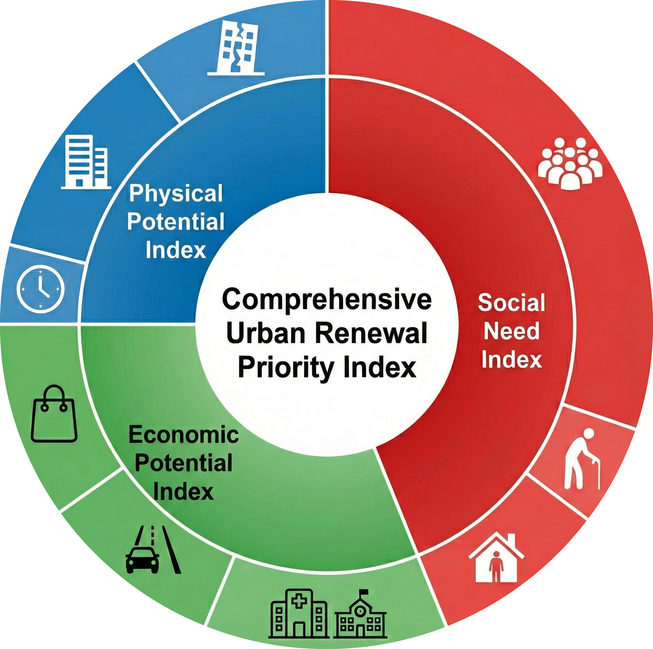
Supplementary Fig. 2 | Conceptual structure of the Comprehensive Urban Renewal Priority Index. The CPI combines physical potential, economic potential and social need. The outer ring lists the nine building-level indicators; entropy weights are estimated within dimensions and the three dimension scores receive equal weights in the final index.

Supplementary Fig. 3 | Baseline urban and rural residential building stock, 1980–2020. Panels compare construction-period distributions, building counts, land and floor area, mean height, mean storeys and structural composition for urban and rural housing.
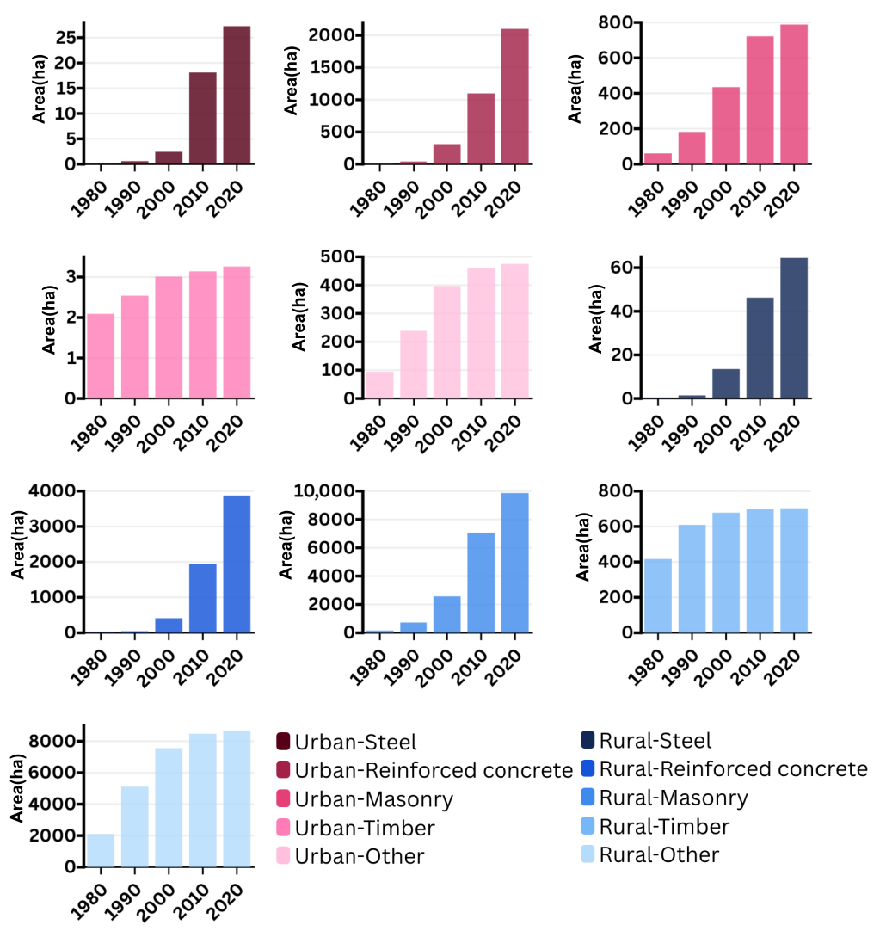
Supplementary Fig. 4 | Structural transition in urban and rural residential stock, 1980–2020. Panels show changes in the area of steel, reinforced-concrete, masonry, timber and other structures by settlement type.

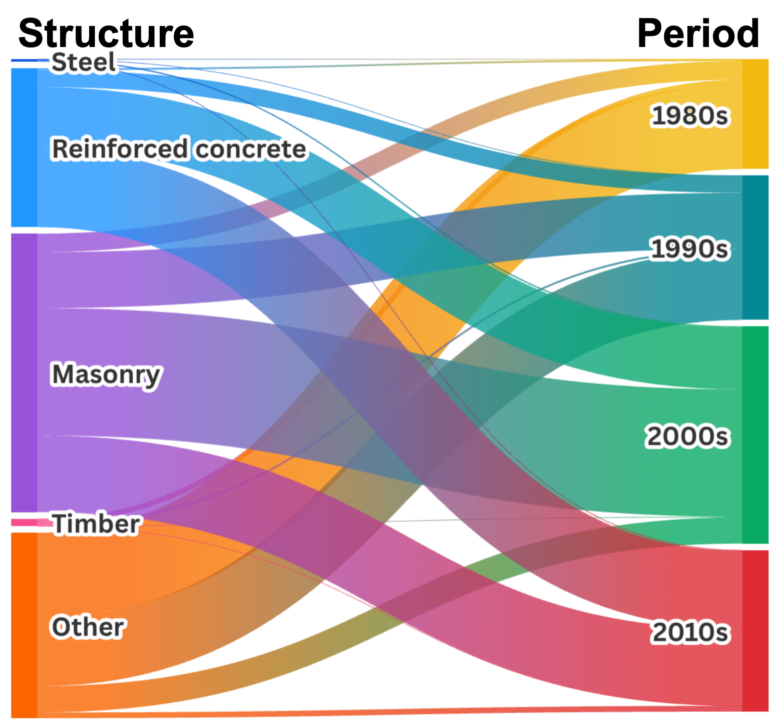
Supplementary Fig. 5 | Structural composition of newly added residential buildings by construction period. The Sankey diagram links construction decades to structural types and distinguishes the changing composition of successive housing cohorts from 1980 to 2020.

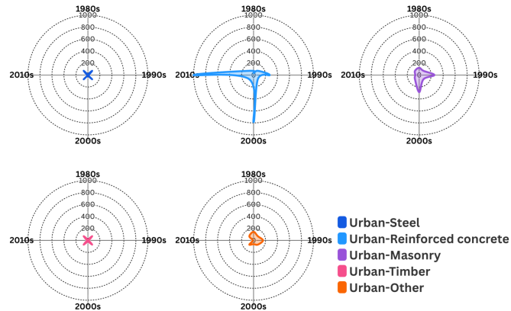
Supplementary Fig. 6 | Structural composition of newly added urban residential buildings. Polar panels compare steel, reinforced-concrete, masonry, timber and other structures across the 1980s, 1990s, 2000s and 2010s; radial magnitude represents newly added building area.

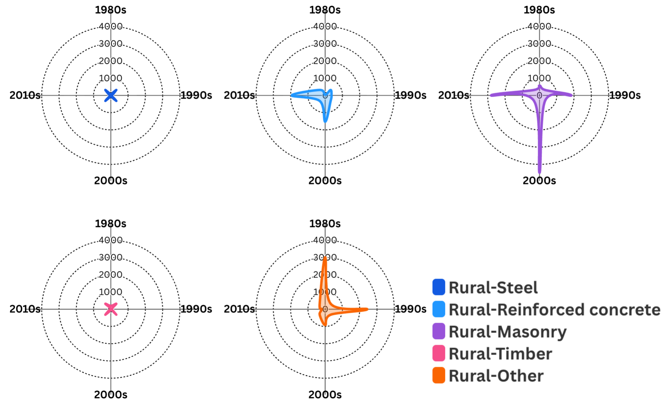
Supplementary Fig. 7 | Structural composition of newly added rural residential buildings. Polar panels compare steel, reinforced-concrete, masonry, timber and other structures across the 1980s, 1990s, 2000s and 2010s; radial magnitude represents newly added building area.

Supplementary Tables
Supplementary Table 1 | Indicator framework and final weights for residential renewal priority.
Dimension | Indicator | Definition | Unit | Weight | Direction | Rationale
Physical potential | Building age | Construction year converted to building age | years | 5.53% | + | Older buildings are more likely to require renewal
Physical potential | Structural vulnerability | Vulnerability coefficient by structural type | unitless | 11.72% | + | Greater vulnerability increases renewal urgency
Physical potential | Number of storeys | Building height intensity measured by storeys | storeys | 16.08% | + | Higher intensity may increase redevelopment value
Economic potential | Distance to commercial land | Distance to nearest commercial land parcel | m | 24.89% | – | Greater accessibility increases redevelopment feasibility
Economic potential | Distance to public facilities | Distance to nearest public service facility | m | 5.89% | – | Greater accessibility increases locational advantage
Economic potential | Distance to road network | Distance to nearest road | m | 2.55% | – | Better transport access increases redevelopment feasibility
Social need | Building-scale population size | Village-level population allocated to buildings in proportion to building floor area | persons | 15.16% | + | Greater allocated population indicates larger local housing demand
Social need | Building-scale older-adult population | Village-level population aged 65+ allocated to buildings in proportion to building floor area | persons | 10.72% | + | Older residents may face higher housing vulnerability and accessibility needs
Social need | Inverse per-capita residential floor area | Reciprocal of building-scale per-capita residential floor area after population allocation | 1/(m²/person) | 7.46% | + | Higher values indicate tighter housing-space conditions
Note: Final weights sum to one. Within each dimension, entropy-derived relative weights are scaled so that physical potential, economic potential and social need each contribute one-third to the CPI.

Supplementary Table 2 | Baseline vulnerability coefficients assigned to residential structural types.
Structural category | Structural description | Vulnerability coefficient | Relative risk interpretation
Steel | Steel-framed residential buildings | 0 | Lower structural vulnerability
Reinforced concrete | Reinforced concrete residential buildings | 0.0641 | Moderate baseline vulnerability
Masonry | Masonry residential buildings | 0.2391 | Higher baseline vulnerability
Timber | Timber residential buildings | 0.9534 | Highest structural vulnerability among common types
Other | Other or mixed structural types | 1 | Assigned according to baseline category definition
Note: Higher coefficients indicate greater baseline structural vulnerability. Values are held constant over the projection period and parameterize the structural-vulnerability indicator.

Supplementary Table 3 | Cohort-component population-projection parameters and demographic inputs to the Social Need Index.
Module | Parameter | Parameter setting | Spatial scale | Notes
Baseline population | Baseline population matrix (sex × five-year age group) | Constructed from the resident population of administrative villages in the Seventh National Population Census (2020). Population was organized by sex and five-year age groups (0–4, 5–9, …, 100+). | Village | Provides the baseline demographic structure for cohort advancement and demographic scenario simulation.
Fertility | Age-specific fertility rates (ASFR; ages 15–49) | Baseline fertility schedules were derived from district- and county-level age-specific fertility rates observed in the 2020 census. Where district- or county-level estimates were unavailable, city-level schedules were used as fallback values. | District / county | Used to preserve the age pattern of fertility across scenarios.
Fertility scenario | Low-, medium- and high-fertility assumptions | The medium scenario retained baseline fertility levels. The low scenario applied downward adjustments of −0.25, −0.40 and −0.50 to the baseline total fertility rate for 2020–2025, 2025–2030 and 2030 onwards, respectively. The high scenario applied corresponding upward adjustments of +0.25, +0.40 and +0.50. | District / county | Defines demographic uncertainty in future population trajectories.
Births | Sex ratio at birth (SRB) | Fixed at 120.1 male births per 100 female births, consistent with the city-level baseline. | City | Ensures internally consistent sex-specific population projection.
Mortality | Baseline life table | Derived from the China Life Insurance Industry Experience Life Table (4th edition), released in 2025. Age- and sex-specific survival probabilities were converted into five-year cohort survival ratios. | City | Provides baseline survival assumptions for cohort transition.
Mortality improvement | Annual mortality improvement rate | Following the ONS-style medium assumption: approximately 1.1% per year for ages 0–90, declining progressively at older ages and approaching zero at very advanced ages. | City | Introduces long-term survival improvement over the projection horizon.
Migration level | District- and county-level net migration pathway | Net migration rates were estimated from recent population change reported in the Quanzhou Statistical Yearbook after accounting for natural increase. Net migration was assumed to converge progressively towards zero by 2050. | District / county | Represents medium-term redistribution without implausible long-run divergence.
Migration allocation | Village allocation weight | Total district- or county-level net migration was distributed to villages in proportion to each village’s period-start population share within its parent administrative unit. | Village | Links higher-level migration assumptions to village-level projection.
Migration structure | Age and sex decomposition | Net in-migration followed a common age schedule, with the share aged 60 years and above fixed at 0.05. Net out-migration was deducted in proportion to the projected end-of-period population structure. Sex composition followed the village-specific age–sex structure subject to non-negativity constraints. | Village | Allows migration to affect both population size and age structure.
Output indicators | Demographic outputs for the Social Need Index (SNI) | Annual village-level total population, population aged 65 years and above, ageing rate and per-capita residential floor area. Five-year projection outputs were linearly interpolated to annual values before assignment to buildings. | Village | These outputs were linked to buildings and used to update SNI.
Note: Population is projected from the 2020 census baseline. Five-year outputs are interpolated annually before allocation to buildings and incorporation into the Social Need Index.

Supplementary Table 4 | Baseline characteristics of urban and rural residential stock by construction period, 1980–2020.
Region | Construction period | Building count | Land area  (ha) | Mean height (m) | Mean storeys | Land area of dominant structural type
 |  |  |  |  |  | Steel  (ha) | Reinforced concrete (ha) | Masonry  (ha) | Timber  (ha) | Other  (ha)
Urban | 1980 | 11789 | 162.41 | 5.33 | 1.73 | 0.06 | 5.46 | 60.55 | 2.09 | 94.24
Urban | 1990 | 32522 | 464.27 | 6.95 | 2.25 | 0.59 | 40.29 | 182.05 | 2.54 | 238.81
Urban | 2000 | 72857 | 1,147.67 | 8.94 | 2.90 | 2.44 | 310.65 | 434.85 | 3.01 | 396.71
Urban | 2010 | 118331 | 2,301.07 | 10.80 | 3.50 | 18.11 | 1,098.51 | 721.68 | 3.14 | 459.63
Urban | 2020 | 145369 | 3,393.29 | 13.72 | 4.45 | 27.27 | 2,099.86 | 788.00 | 3.26 | 474.91
Rural | 1980 | 150236 | 2,754.88 | 5.37 | 1.52 | 0.35 | 9.02 | 153.94 | 433.81 | 2,157.76
Rural | 1990 | 370963 | 6,627.58 | 5.93 | 1.74 | 1.52 | 50.76 | 720.44 | 630.78 | 5,224.08
Rural | 2000 | 657235 | 11,375.07 | 6.68 | 2.03 | 13.77 | 466.88 | 2,506.23 | 701.84 | 7,686.35
Rural | 2010 | 1084829 | 18,423.08 | 7.70 | 2.39 | 50.98 | 2,172.76 | 6,870.19 | 721.50 | 8,607.66
Rural | 2020 | 1382509 | 23,511.89 | 8.28 | 2.60 | 70.40 | 4,290.70 | 9,613.92 | 726.43 | 8,810.44
Note: Values describe the cumulative urban and rural residential stock by construction period. Structural areas are reported in hectares.

Supplementary Table 5 | Characteristics of newly added urban and rural residential buildings by construction period, 1980–2020.
Region | Construction period | Building count | Land area  (ha) | Mean height (m) | Mean storeys | Land area of dominant structural type (ha)
 |  |  |  |  |  | Steel | Reinforced concrete | Masonry | Timber | Other
Urban | 1980s | 20733 | 301.86 | 7.87 | 2.55 | 0.52 | 34.82 | 121.50 | 0.45 | 144.57
Urban | 1990s | 40335 | 683.40 | 10.55 | 3.43 | 1.86 | 270.37 | 252.80 | 0.47 | 157.91
Urban | 2000s | 45474 | 1,153.40 | 13.77 | 4.46 | 15.67 | 787.85 | 286.83 | 0.13 | 62.92
Urban | 2010s | 27038 | 1,092.22 | 26.51 | 8.59 | 9.15 | 1,001.35 | 66.32 | 0.12 | 15.27
Rural | 1980s | 220727 | 3,872.70 | 6.32 | 1.88 | 1.17 | 41.74 | 566.50 | 196.97 | 3,066.32
Rural | 1990s | 286272 | 4,747.49 | 7.66 | 2.40 | 12.26 | 416.11 | 1,785.79 | 71.06 | 2,462.27
Rural | 2000s | 427594 | 7,048.01 | 9.27 | 2.96 | 37.20 | 1,705.88 | 4,363.96 | 19.66 | 921.31
Rural | 2010s | 297680 | 5,088.81 | 10.39 | 3.33 | 19.42 | 2,117.94 | 2,743.73 | 4.93 | 202.78
Note: Values describe buildings newly added in each construction period and distinguish urban and rural cohort formation.

Supplementary Table 6 | Policy-calibrated renewal-pressure stock and pathway exposure in 2020.
Group | Buildings | Dwelling units | Floor area (million m²) | Land area (million m²) | Demolition compensation (billion yuan) | In situ investment (billion yuan) | Demolition emissions (ktCO₂) | Annual operational emissions (ktCO₂ yr⁻¹)
Urban | 34,193 | 56,009 | 12.5 | 4.8 | 140.8-154.9 | 0.6-1.5 | 159.0 | 498.8
Rural | 487,042 | 488,164 | 140.3 | 85.3 | 141.1-320.4 | 6.6-16.4 | 586.2 | 1709.8
Total | 521,235 | 544,173 | 152.8 | 90.1 | 281.9-475.3 | 7.2-17.9 | 745.2 | 2208.6
Note: Costs are billion yuan in constant 2020 prices. Demolition emissions are one-off estimates; operational emissions are annual baselines. Urban values represent policy-calibrated demand, whereas rural values are a diagnostic under the same threshold.

Supplementary Table 7 | Projected cumulative renewal-pressure stock under three demographic scenarios, 2025–2050.
Scenario | Indicator | 2025 | 2030 | 2035 | 2040 | 2045 | 2050
Low | Buildings | 523,045 | 524,734 | 526,400 | 527,970 | 529,552 | 531,066
Low | Dwelling units | 548,243 | 552,446 | 557,700 | 563,859 | 571,329 | 579,047
Low | Floor area | 154.4 | 155.2 | 157.1 | 159.1 | 160.3 | 162.1
Low | Land area | 90.5 | 90.8 | 91.2 | 91.5 | 91.8 | 92.1
Medium | Buildings | 523,047 | 524,736 | 526,403 | 527,970 | 529,566 | 531,072
Medium | Dwelling units | 548,344 | 552,684 | 558,143 | 563,859 | 572,876 | 579,453
Medium | Floor area | 154.4 | 155.2 | 157.6 | 159.1 | 160.5 | 162.1
Medium | Land area | 90.5 | 90.8 | 91.2 | 91.5 | 91.8 | 92.1
High | Buildings | 523,047 | 524,736 | 526,405 | 527,978 | 529,571 | 531,081
High | Dwelling units | 548,344 | 552,684 | 558,495 | 564,408 | 573,318 | 579,988
High | Floor area | 154.4 | 155.2 | 157.8 | 159.2 | 160.9 | 162.3
High | Land area | 90.5 | 90.8 | 91.2 | 91.5 | 91.8 | 92.1
Note: Floor area and land area are million m². Values are cumulative stocks at each benchmark year.

Supplementary Table 8 | Five-year additions to the renewal-pressure stock under three demographic scenarios, 2020–2050.
Scenario | Indicator | 2020–2025 | 2025–2030 | 2030–2035 | 2035–2040 | 2040–2045 | 2045–2050
Low | Buildings | 1,810 | 1,689 | 1,666 | 1,570 | 1,582 | 1,514
Low | Dwelling units | 4,070 | 4,203 | 5,254 | 6,159 | 7,470 | 7,718
Low | Floor area | 1.619 | 0.809 | 1.932 | 1.992 | 1.163 | 1.764
Low | Land area | 0.347 | 0.336 | 0.334 | 0.320 | 0.324 | 0.325
Medium | Buildings | 1,812 | 1,689 | 1,667 | 1,567 | 1,596 | 1,506
Medium | Dwelling units | 4,171 | 4,340 | 5,459 | 5,716 | 9,017 | 6,577
Medium | Floor area | 1.647 | 0.815 | 2.366 | 1.524 | 1.384 | 1.610
Medium | Land area | 0.349 | 0.335 | 0.336 | 0.318 | 0.333 | 0.320
High | Buildings | 1,812 | 1,689 | 1,669 | 1,573 | 1,593 | 1,510
High | Dwelling units | 4,171 | 4,340 | 5,811 | 5,913 | 8,910 | 6,670
High | Floor area | 1.647 | 0.815 | 2.510 | 1.428 | 1.690 | 1.377
High | Land area | 0.349 | 0.335 | 0.340 | 0.317 | 0.333 | 0.323
Note: Values are additions during each five-year interval rather than cumulative stocks. Floor area and land area are million m².

Supplementary Table 9 | Projected cumulative urban renewal-pressure stock under three demographic scenarios, 2020–2050.
Scenario | Indicator | 2020 | 2025 | 2030 | 2035 | 2040 | 2045 | 2050
Low | Buildings | 34,193 | 34,209 | 34,232 | 34,268 | 34,310 | 34,339 | 34,385
Low | Dwelling units | 56,009 | 58,281 | 60,803 | 64,413 | 69,033 | 74,792 | 81,042
Low | Floor area | 12.5 | 13.7 | 14.0 | 15.5 | 17.1 | 17.9 | 19.2
Low | Land area | 4.8 | 4.8 | 4.8 | 4.9 | 4.9 | 4.9 | 4.9
Medium | Buildings | 34,193 | 34,210 | 34,233 | 34,271 | 34,310 | 34,348 | 34,389
Medium | Dwelling units | 56,009 | 58,381 | 61,040 | 64,856 | 69,033 | 76,334 | 81,446
Medium | Floor area | 12.5 | 13.7 | 14.1 | 16.0 | 17.1 | 18.1 | 19.3
Medium | Land area | 4.8 | 4.8 | 4.8 | 4.9 | 4.9 | 4.9 | 4.9
High | Buildings | 34,193 | 34,210 | 34,233 | 34,273 | 34,313 | 34,351 | 34,394
High | Dwelling units | 56,009 | 58,381 | 61,040 | 65,208 | 69,577 | 76,774 | 81,977
High | Floor area | 12.5 | 13.7 | 14.1 | 16.1 | 17.2 | 18.4 | 19.4
High | Land area | 4.8 | 4.8 | 4.8 | 4.9 | 4.9 | 4.9 | 4.9
Note: Urban results are policy-calibrated renewal demand. Floor area and land area are million m².

Supplementary Table 10 | Projected cumulative rural renewal-pressure stock under three demographic scenarios, 2020–2050.
Scenario | Indicator | 2020 | 2025 | 2030 | 2035 | 2040 | 2045 | 2050
Low | Buildings | 487,042 | 488,836 | 490,502 | 492,132 | 493,660 | 495,213 | 496,681
Low | Dwelling units | 488,164 | 489,962 | 491,643 | 493,287 | 494,826 | 496,537 | 498,005
Low | Floor area | 140.3 | 140.7 | 141.2 | 141.6 | 142.0 | 142.4 | 142.8
Low | Land area | 85.3 | 85.7 | 86.0 | 86.3 | 86.6 | 86.9 | 87.2
Medium | Buildings | 487,042 | 488,837 | 490,503 | 492,132 | 493,660 | 495,218 | 496,683
Medium | Dwelling units | 488,164 | 489,963 | 491,644 | 493,287 | 494,826 | 496,542 | 498,007
Medium | Floor area | 140.3 | 140.7 | 141.2 | 141.6 | 142.0 | 142.4 | 142.8
Medium | Land area | 85.3 | 85.7 | 86.0 | 86.3 | 86.6 | 86.9 | 87.2
High | Buildings | 487,042 | 488,837 | 490,503 | 492,132 | 493,665 | 495,220 | 496,687
High | Dwelling units | 488,164 | 489,963 | 491,644 | 493,287 | 494,831 | 496,544 | 498,011
High | Floor area | 140.3 | 140.7 | 141.2 | 141.6 | 142.0 | 142.4 | 142.8
High | Land area | 85.3 | 85.7 | 86.0 | 86.3 | 86.6 | 86.9 | 87.2
Note: Rural results are latent settlement-renewal pressure under the common building diagnostic and do not imply formal programme inclusion. Floor area and land area are million m².

Supplementary Table 11 | Crosswalk between census structure types and official rural replacement-value categories.
Census code | Structure type | Lower replacement value, CNY m⁻² | Upper replacement value, CNY m⁻²
1100 | Brick–concrete, stone–concrete and stone structures | 650 | 930
1200 | Brick–timber, stone–timber and earth–timber structures | 520 | 720
1300 | Earth–timber and stone–timber structures | 540 | 720
1400 | Brick–timber, earth–timber, stone–timber, stone–concrete and brick–concrete structures | 520 | 930
1500 | Earth–timber structure | 540 | 620
1600 | Frame structure | 710 | 1030
1700 | Frame structure | 710 | 1030
9999 | Full ordinary residential structure range | 520 | 1030
Note: Official replacement-value intervals are used to construct lower and upper rural demolition-compensation bounds.

Supplementary Table 12 | Building newness coefficients used in rural residential compensation.
Building age | Newness coefficient
1–5 | 1.00
6–10 | 0.97
11–20 | 0.95
21–30 | 0.90
More than 30 | 0.85
Note: The coefficient ηᵢ adjusts the rural structural replacement-cost component for building age.

Supplementary Table 13 | Cumulative and five-year pathway costs under demolition and in situ renewal, 2020–2050.
Panel A. Cumulative pathway cost exposure by benchmark year (billion yuan)
Year/interval | Low demolition | Low in situ | Medium demolition | Medium in situ | High demolition | High in situ
2020 | 281.9–475.3 | 7.2–17.9 | 281.9–475.3 | 7.2–17.9 | 281.9–475.3 | 7.2–17.9
2025 | 291.8–486.8 | 7.3–18.1 | 292.1–487.0 | 7.3–18.1 | 292.1–487.0 | 7.3–18.1
2030 | 297.7–493.7 | 7.3–18.2 | 298.0–494.0 | 7.3–18.2 | 298.0–494.0 | 7.3–18.2
2035 | 315.3–513.5 | 7.4–18.4 | 317.8–516.3 | 7.4–18.4 | 320.3–519.0 | 7.4–18.5
2040 | 332.0–532.4 | 7.5–18.6 | 332.0–532.4 | 7.5–18.6 | 333.1–533.6 | 7.5–18.6
2045 | 346.8–549.1 | 7.5–18.8 | 349.8–552.4 | 7.5–18.8 | 351.9–554.7 | 7.6–18.8
2050 | 363.6–568.0 | 7.6–19.0 | 364.4–568.9 | 7.6–19.0 | 366.5–571.3 | 7.6–19.0
Panel B | Five-year cost exposure for newly entering cohorts (billion yuan)
Year/interval | Low demolition | Low in situ | Medium demolition | Medium in situ | High demolition | High in situ
2020–2025 | 9.95–11.47 | 0.08–0.19 | 10.21–11.76 | 0.08–0.19 | 10.21–11.76 | 0.08–0.19
2025–2030 | 5.83–6.91 | 0.04–0.09 | 5.91–7.01 | 0.04–0.10 | 5.91–7.01 | 0.04–0.10
2030–2035 | 17.62–19.88 | 0.09–0.23 | 19.78–22.27 | 0.11–0.28 | 22.24–24.97 | 0.12–0.29
2035–2040 | 16.71–18.82 | 0.09–0.23 | 14.20–16.06 | 0.07–0.18 | 12.81–14.54 | 0.07–0.17
2040–2045 | 14.81–16.75 | 0.05–0.14 | 17.80–20.04 | 0.07–0.16 | 18.82–21.17 | 0.08–0.20
2045–2050 | 16.76–18.88 | 0.08–0.21 | 14.56–16.46 | 0.08–0.19 | 14.65–16.55 | 0.06–0.16
Note: Values are lower–upper cost bounds. Low, medium and high denote demographic scenarios, not cost assumptions. Panel A reports cumulative exposure at each benchmark year; Panel B reports cohorts newly entering during the preceding five-year interval. Demolition values are compensation exposure and in situ values are direct engineering investment; they are not equivalent life-cycle costs.
Supplementary Table 14 | Carbon exposure of newly entering renewal-pressure cohorts by demographic scenario and urban–rural group.
Panel A | Low-population scenario
Five-year interval | Group | Newly entering buildings | Demolition emissions (ktCO₂) | Annual operational emissions (ktCO₂ yr⁻¹)
2020–2025 | Urban | 16 | 37.90 | 28.51
 | Rural | 1,794 | 1.77 | 10.02
 | Total | 1,810 | 39.68 | 38.53
2025–2030 | Urban | 23 | 13.12 | 40.05
 | Rural | 1,666 | 1.72 | 8.59
 | Total | 1,689 | 14.84 | 48.64
2030–2035 | Urban | 36 | 45.44 | 54.93
 | Rural | 1,630 | 1.74 | 26.60
 | Total | 1,666 | 47.18 | 81.53
2035–2040 | Urban | 42 | 45.85 | 57.72
 | Rural | 1,528 | 1.48 | 3.07
 | Total | 1,570 | 47.34 | 60.79
2040–2045 | Urban | 29 | 26.79 | 35.85
 | Rural | 1,553 | 1.57 | 17.29
 | Total | 1,582 | 28.36 | 53.14
2045–2050 | Urban | 46 | 44.27 | 50.94
 | Rural | 1,468 | 1.51 | 12.99
 | Total | 1,514 | 45.79 | 63.92
Panel B | Medium-population scenario
Five-year interval | Group | Newly entering buildings | Demolition emissions (ktCO₂) | Annual operational emissions (ktCO₂ yr⁻¹)
2020–2025 | Urban | 17 | 38.70 | 32.89
 | Rural | 1,795 | 1.77 | 10.09
 | Total | 1,812 | 40.47 | 42.98
2025–2030 | Urban | 23 | 13.71 | 37.22
 | Rural | 1,666 | 1.72 | 8.70
 | Total | 1,689 | 15.43 | 45.92
2030–2035 | Urban | 38 | 58.19 | 66.97
 | Rural | 1,629 | 1.74 | 27.34
 | Total | 1,667 | 59.93 | 94.31
2035–2040 | Urban | 39 | 31.72 | 49.69
 | Rural | 1,528 | 1.48 | 3.19
 | Total | 1,567 | 33.20 | 52.88
2040–2045 | Urban | 38 | 34.49 | 55.46
 | Rural | 1,558 | 1.59 | 20.95
 | Total | 1,596 | 36.08 | 76.41
2045–2050 | Urban | 41 | 38.30 | 47.05
 | Rural | 1,465 | 1.50 | 11.69
 | Total | 1,506 | 39.80 | 58.74
Panel C | High-population scenario
Five-year interval | Group | Newly entering buildings | Demolition emissions (ktCO₂) | Annual operational emissions (ktCO₂ yr⁻¹)
2020–2025 | Urban | 17 | 38.70 | 33.20
 | Rural | 1,795 | 1.77 | 10.16
 | Total | 1,812 | 40.47 | 43.36
2025–2030 | Urban | 23 | 13.71 | 38.05
 | Rural | 1,666 | 1.72 | 8.80
 | Total | 1,689 | 15.43 | 46.85
2030–2035 | Urban | 40 | 62.64 | 75.06
 | Rural | 1,629 | 1.74 | 28.09
 | Total | 1,669 | 64.38 | 103.16
2035–2040 | Urban | 40 | 28.65 | 57.09
 | Rural | 1,533 | 1.50 | 18.55
 | Total | 1,573 | 30.15 | 75.65
2040–2045 | Urban | 38 | 43.42 | 52.26
 | Rural | 1,555 | 1.59 | 10.76
 | Total | 1,593 | 45.01 | 63.02
2045–2050 | Urban | 43 | 32.30 | 52.47
 | Rural | 1,467 | 1.49 | 8.09
 | Total | 1,510 | 33.80 | 60.56
Note: Panels A–C report newly entering cohorts under low-, medium- and high-population scenarios. Demolition emissions are one-off removal-stage estimates. Operational emissions are recurring annual residential-energy baselines before realized retrofit savings; the two accounts do not share a common time horizon.

Supplementary Table 15 | Parameters used in in situ renewal-cost and carbon accounting.
Symbol | Parameter definition | Value
$$α_{dem}$$ | Empirical intercept in the unit-area demolition-emission relationship | 1.99
$$q_{FJ}^{res}$$ | Per-capita residential energy consumption in Fujian Province | 433.8
$$f_{CO_{2}}$$ | CO₂ emission factor for standard coal | 2.64
$$c_{L}$$ | Observed minimum unit-area in situ renewal cost among comparable local projects | 47
$$c_{U}$$ | Observed maximum unit-area in situ renewal cost among comparable local projects | 117
Note: The demolition intercept is in kgCO₂ m⁻²; residential energy use in kg standard-coal equivalent person⁻¹ yr⁻¹; the standard-coal factor in kgCO₂ per kg standard-coal equivalent; and renewal costs in yuan m⁻². The 47 and 117 yuan m⁻² values are observed bounds. Source-project calculations are provided in the accompanying workbook.

Supplementary References
- Whelpton, P. K. An empirical method of calculating future population. J. Am. Stat. Assoc. 31, 457–473 (1936).
- United Nations Department of Social Affairs. Manual III: Methods for Population Projections by Sex and Age. Population Studies No. 25 (United Nations, 1956).
- Quanzhou Municipal People’s Government Office. Action Plan for the Renovation of Old Residential Communities and Old Streets (Areas and Communities) in Quanzhou (Quan Zheng Ban [2020] No. 49, 2020).
- Zhao, X. et al. Unravelling the renewal priority of urban heritage communities through macro–micro assessment: a case study of Nanjing, China. Sustain. Cities Soc. 124, 106317 (2025).
- Cao, N., Sing, M. C. P. & Hou, C. H. Mapping urban renewal priorities for ageing residential districts: a spatial evaluation framework based on EWM–TOPSIS. J. Urban Manag. 15, 657–671 (2026).
- Begić, H. & Krstić, H. Comprehensive review and comparative analysis of building-condition assessment models. Results Eng. 22, 102176 (2024).
- Deng, Y. et al. Regulatory effect of China’s city hierarchy on urban redevelopment. Nat. Cities 3, 48–57 (2026).
- Jarzebski, M. P. et al. Ageing and population shrinking: implications for sustainability in the urban century. npj Urban Sustain. 1, 17 (2021).
- Chen, Y., Ye, J., Zhou, Y. & Yan, J. Fine-scale spatial optimization of rural residential land in rapidly urbanizing coastal China: a multi-scenario analysis of Jinjiang City, Fujian Province. Cities 174, 107059 (2026).
- Lu, Y., Zhai, G. & Zhai, W. Quantifying urban spatial resilience using multi-criteria decision analysis and a back-propagation neural network. Int. J. Disaster Risk Reduct. 111, 104694 (2024).
- United Nations Department of Economic and Social Affairs, Population Division. World Population Prospects: The 2017 Revision—Methodology of the United Nations Population Estimates and Projections (United Nations, 2017).
- Smith, S. K. Accounting for migration in cohort-component projections of state and local populations. Demography 23, 127–135 (1986).
- O’Neill, B. C., Balk, D., Brickman, M. & Ezra, M. A guide to global population projections. Demogr. Res. 4, 203–288 (2001).
- Raftery, A. E. & Ševčíková, H. Probabilistic population forecasting: short to very long term. Int. J. Forecast. 39, 73–97 (2023).
- Schorcht, M., Jehling, M. & Krueger, T. Where are cities under pressure? An indicator for measuring the impact of building changes on urban density. Ecol. Indic. 149, 110142 (2023).
- Chen, Y., Feng, S. & Li, M. Impact of housing conditions on resident willingness to withdraw from rural homesteads and preferences regarding compensation and resettlement mode: a dual-sample selection model. Habitat Int. 166, 103577 (2025).
- Peng, Y. & Tian, C. Removal and reconstruction: multi-period price effects on nearby housing from urban-village redevelopment. Land Use Policy 113, 105877 (2022).
- National Institute of Standards and Technology. Life Cycle Cost Manual for the Federal Energy Management Program (NIST Handbook 135-2020, NIST, 2020).
- International Organization for Standardization. ISO 15686-5:2017 Buildings and Constructed Assets—Service Life Planning—Part 5: Life-Cycle Costing (ISO, 2017).
- Royal Institution of Chartered Surveyors. Life Cycle Costing 1st edn (RICS, 2016).
- Quanzhou Taiwanese Investment Zone Administrative Committee. Guiding Opinions on Land and Housing Expropriation, Demolition Compensation and Resettlement in the Quanzhou Taiwanese Investment Zone (Quan Tai Guan [2020] No. 2, 2020).
- Department of Housing and Urban–Rural Development of Guangdong Province. Guideline for Building Carbon-Emission Accounting (Trial) (Yue Jian Ke [2021] No. 235, 2021).
- National Development and Reform Commission of the People’s Republic of China. Carbon Dioxide Emissions Accounting Method and Data Verification Table (2016).

