Supplementary Information for
Molecular capping arrests Ostwald ripening of interfacial zinc hydroxide sulfate for reversible zinc electrochemistry

Jun Wang,^{a,d} Lutong Shan, ^{c,d} Wenyu Zhang,ª Furong Qin,ª Zimo Huang,ª Mengran Wang,ª Simin Li,ª Bo Hong, ª Wei Zhang,^{a,b*} Yanqing Lai,^{a*}

- School of Metallurgy and Environment, National Energy Metal Resources and New Materials Key Laboratory, Engineering Research Center of the Ministry of Education for Advanced Battery Materials, Central South University, Changsha 410083, China
- Christopher Ingold Laboratory, Department of Chemistry, University College London, London WC1H 0AJ, UK
- Department of Chemical and Biomolecular Engineering, National University of Singapore, 117585, Singapore
- Jun Wang and Lutong Shan contributed equally to this work.

*Corresponding author email: wei.zhang.21@ucl.ac.uk (W. Zhang); laiyanqing@csu.edu.cn (Y. Lai)

Methods
Electrolyte and electrode preparation. To prepare a 2 mol kg⁻¹ ZnSO₄ electrolyte, 0.5 mol of ZnSO₄·7H₂O (>99.5%, Aladdin) was thoroughly dissolved in 250 g of water (HPLC grade, Aladdin). N-ethyl-2-pyrrolidone (NEP; >99%, Aladdin) was then added to the 2 mol kg^{–1} ZnSO₄ solution at different concentrations. The solution was stirred magnetically at 400 rpm for 4 h at ambient temperature (25 °C) until complete dissolution was achieved, resulting in a clear and homogeneous electrolyte. Activated carbon-supported iodine composite (I₂@AC) was prepared using a sublimation method. Equal masses of iodine (I₂; >99.8%, Aladdin) and activated carbon (AC; YP-80F, Kuraray Chemical) were thoroughly ground using an agate mortar. The resulting mixture was then placed in a hydrothermal reactor and heated at 120 °C for 6 h without any solvent. V₂O₅ cathodes were fabricated by mixing 70 wt.% commercial V₂O₅ (>99.5%, Aladdin), 20 wt.% acetylene black (battery grade, MTI), and 10 wt.% poly (vinylidene fluoride) (PVDF; battery grade, MTI) in an appropriate amount of N-methyl-2-pyrrolidone (NMP; >99.5%) to form a uniform slurry. Hydrophilic carbon paper (TGP-H-090, TORAY) was used as the current collector. Zinc foils (>99.99%, Qingyuan metal) were 100 μm thick and were cut into 12-mm-diameter discs unless otherwise specified. Prior to systematic electrochemical evaluations, the concentration of the NEP additive was optimized by comparing the average Coulombic efficiency (CE) of Zn||Cu asymmetric cells over 50 cycles with varying NEP contents (2 vol%, 5 vol%, 7 vol%, and 10 vol%, see Fig. S6 in the Supporting Information). The electrolyte containing 5 vol% NEP exhibited the highest average CE and superior plating/stripping reversibility. Consequently, this optimal composition was adopted for all subsequent electrochemical investigations.
Materials characterizations. The morphology of the Zn deposits was examined using a field-emission scanning electron microscope (MIRA3 LMH, Czech production, eds: One Max 20，Oxford). The in situ Zn plating behavior was visualized with a YM520R (Hefei In-situ Technology, China) optical microscope using a transparent Zn||Zn configuration at 1 mA cm⁻². X-ray diffraction (XRD) measurements were performed on a Smartlab SE diffractometer (Japan) with Cu K_{α} radiation (λ = 1.5418 Å) within the 2θ range of 5°–80°, with a step size of 0.05° and scan rate of 0.1° s⁻¹. Proton nuclear magnetic resonance spectra were obtained using a Bruker Avance III 400 MHz NMR spectrometer in D₂O solvent. Raman spectroscopy was performed with a WITec alpha300RE volution spectrometer (Germany) to analyze vibrational modes and detect possible coordination interactions or structural changes in the electrolyte and electrode materials. Fourier-transform infrared (FT-IR) spectra were recorded with a Thermo Fisher Scientific Nicolet iN10 spectrometer(America) over 4000–400 cm^{–1}, using a 4 cm^{–1} resolution and averaging 32 scans per spectrum. X-ray photoelectron spectroscopy (XPS) analyses were conducted using a Thermo Scientific K-Alpha spectrometer. Atomic force microscope (AFM) images were recorded on a scanning probe microscope (MFP-3D Origin, Oxford).
Electrochemical measurements. Coin-cell measurements were performed using CR2032 cells unless otherwise stated with glass fiber separator (Whatman GF/D) and evaluated with/without additives in LAND battery test system. Electrochemical measurements were performed using a Gamry electrochemical workstation. All electrochemical measurements were carried out using CR2032-type coin cells, while linear sweep voltammetry (LSV) tests were conducted separately in a three-electrode configuration. Glass fiber separators (Whatman GF/D) were used as the separator. Cells were evaluated with or without electrolyte additives to investigate their influence on electrochemical performance. For Zn||I₂ pouch cell, the I₂ cathode and the Zn anode as collector showed the dimensional size of 5 cm × 5 cm and 5.5 cm × 5.5 cm × 50 µm, respectively, where the area mass loading of I₂ cathode material was 30 mg cm⁻².
Molecular dynamics simulations (The solvation structure of Zn²⁺). The molecular dynamics (MD) simulations were conducted in GROMACS software.¹ Water molecules were simulated with SPC/E model. Parameter fitting was performed using the density functional theory (DFT) package Orca² under B3LYP exchange-correlation functional with Grimme’s DFT-D3(BJ) empirical dispersion correction. The RESP2(0.5) [Non-bonded force field model with advanced restrained electrostatic potential charges (RESP2)] charge combining gas- and liquid-phase (implicit solvent, SMD model) charges were adopted for all molecules in this work calculated using Orca² and Multiwfn package.³
The electrolyte system was initialized using the Packmol package.⁴ The MD simulation was firstly performed in the NVT ensemble at temperature (298 K) by using 2 fs time step for 1 ns. Then equilibrium simulation is performed in the NPT ensemble at constant pressure (1 bar) and temperature (298 K) in a cubic box with periodic boundary conditions in all xyz Cartesian directions by using 2 fs time step for 2 ns. Finally, the production simulation is performed in the NVT ensemble at temperature (298 K) by using 2 fs time step for 10 ns. The coordination number of molecules of type i in the first solvation shell surrounding a single molecule of type j is calculated as:
$$N_{i}=4πn_{j}\int_{0}^{R_{M}}{g_{ij}(r)r^{2}dr}$$
in which 𝑅𝑀 is the distance of the first minimum following the first peak in the radial distribution function (RDF), and 𝑔𝑖𝑗(𝑟) is the radial distribution function between species i and j. All the visualizations of MD simulations are implemented by VMD software⁵. The mean square displacement (MSD) of the atom is calculated by the Einstein equation:
$$\text{MSD}\left(t\right)=\frac{1}{N}\sum_{i=1}^{N}{\left\langle |r_{i}\left(t\right)-r_{i}\left(0\right)|​^{2}\right\rangle }$$

where 𝑅 is the atomic coordinates, 𝑁 is total number of atoms, and 𝑡 is the time. The diffusion constant (𝐷) is the slope of MSD versus times with a factor of 1/2:
$$D=\lim_{t→∞}{\frac{\text{MSD}\left(t\right)}{6t}}$$

Molecular dynamics simulations (The solid-liquid interface of zinc hydroxide sulfate). These molecular dynamics (MD) simulations were performed using GROMACS software package with the General Amber Force Field (GAFF) for small molecules. Atomic partial charges were derived using restrained electrostatic potential (RESP) methodology, where molecular geometries were first optimized at the B3LYP/6-311G level with empirical dispersion correction (GD3BJ) using Gaussian, followed by RESP charge fitting performed with Multiwfn. The systems were initially subjected to energy minimization using the steepest descent algorithm for 10,000 steps with an energy tolerance of 100.0 kJ mol⁻¹ nm⁻¹. Subsequently, a multi-stage equilibration protocol was implemented: first, a 0.5 ns NVT equilibration with simulated annealing from 10 K to 298.15 K using velocity-rescaling thermostat (τ = 0.1 ps), followed by a 10-ns NVT equilibration. Production runs were conducted in the NVT ensemble at 298.15 K for 10 ns with a time step of 1 fs. Periodic boundary conditions were applied in all three dimensions. Long-range electrostatic interactions were treated using the particle mesh Ewald (PME) method with a real-space cutoff of 1.2 nm, while van der Waals interactions were computed using a cutoff scheme with the same cutoff distance and long-range dispersion corrections applied. All bonds involving hydrogen atoms were constrained using the LINCS algorithm. Trajectory coordinates were saved every 10 ps for subsequent analysis.
Computational details. Density Functional Theory (DFT) calculations were performed by using the CP2K package⁶ mixed Gaussian and plane-wave scheme⁷ and the Quickstep module.⁸ The Perdew-Burke-Ernzerhof (PBE) exchange correlation functional,⁹ Goedecker-Teter-Hutter (GTH) pseudopotential,¹⁰ DZVP-MOLOPT-SR-GTH / TZVP-MOLOPT-SR-GTH / TZVP-MOLOPT-GTH basis sets were used to describe the system.⁸ A plane-wave energy cut-off and relative cut-off of 400 Ry and 55 Ry have been employed, respectively. The energy convergence criterion was set to 10⁻⁶ Hartree. The DFT-D3(BJ) level correction for dispersion interactions was applied.¹¹ Structural optimization was performed using the Limited Memory Broyden-Fletcher-Goldfarb-Shannon (LBFGS) optimizer, until the maximum force is below 0.00045 Ry/Bohr (0.011 eV/Å). The charge differential density was calculated and plotted through the software Multiwfn³ and Visual Molecular Dynamics (VMD),⁵ respectively. The Gibbs free-energy diagrams were estimated under zero potential (U = 0) by the equation:¹²
ΔG_{H} = ΔE_{H} + ΔZPE - TΔS
during which ΔE_{H} is the energy change between the reactant and product obtained from DFT calculations, ΔZPE is the change of zero point energy and T and ΔS represents the temperature and change of entropy, respectively. T = 298.15 K was employed in this case.

Supplementary Figures and Tables

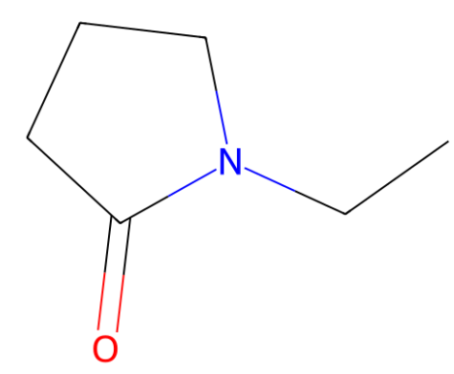
Figure S1 | Molecular structure of N-ethyl-2-pyrrolidone (NEP).

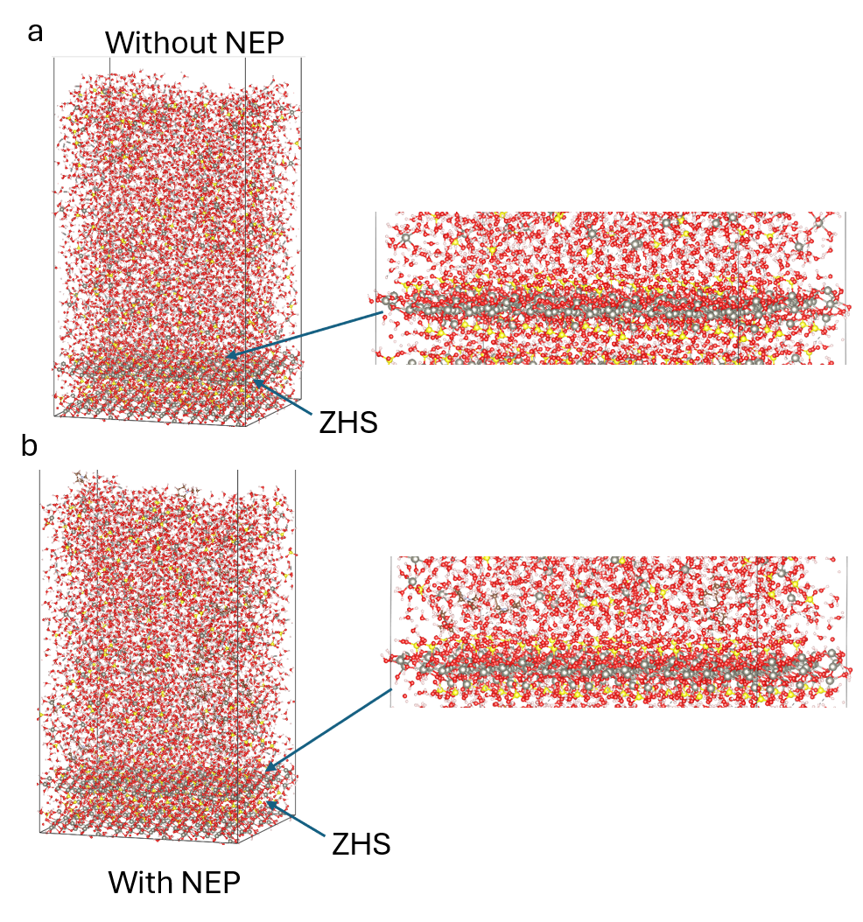
Figure S2 | Molecular Dynamics Snapshots of ZHS-Electrolyte Interfacial Structure with and without NEP. (a) ZnSO₄ electrolyte; (b) NEP-modified electrolyte. MD snapshots show evident accumulation of NEP at the ZHS surface and decreased interfacial water population.
To quantitatively evaluate the thermodynamic stabilization effect of the NEP adlayer, the intermolecular interaction energy ($E_{\text{inter}}$) between the solid ZHS substrate and the liquid electrolyte environment was extracted from the equilibrated MD trajectories. In the classical force field framework, this total interfacial interaction energy is defined as the sum of non-bonded interactions, encompassing both the short-range van der Waals (Lennard-Jones) forces and the long-range Coulombic (electrostatic) interactions, which can be expressed as:
$$E_{\text{inter}}=E_{\text{Coulomb}}+E_{\text{vdW}}$$
In this aqueous system, the Coulombic interactions dominate the overall binding affinity due to the intense electrostatic polarization between the ionic ZHS lattice and the dipole moments of interfacial water molecules. By calculating the time-averaged $E_{\text{inter}}$, we effectively captured the thermodynamic attenuation of interfacial coupling resulting from the NEP-mediated displacement of highly polar water molecules.
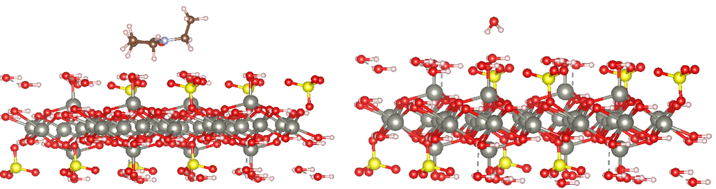
Figure S3 | Optimized adsorption configuration of NEP and H₂O molecules on the ZHS surface. The atomic model illustrates the equilibrium interfacial arrangement obtained from density functional theory calculations, with NEP and H₂O molecules distributed above the exposed ZHS surface.

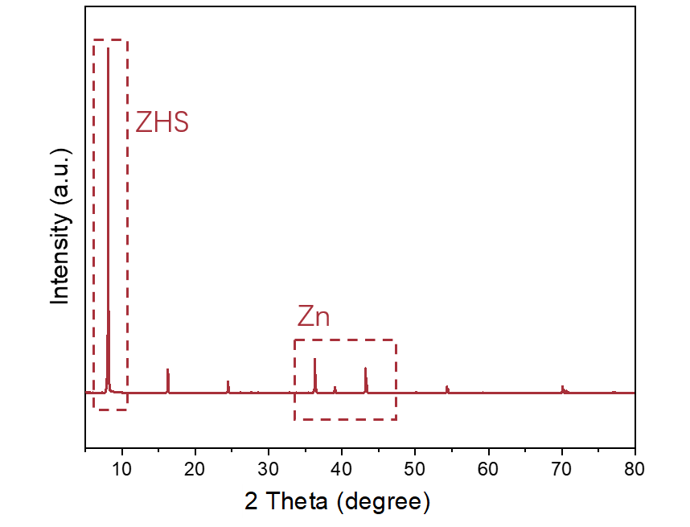
Figure S4 | Structural identification of the ZHS-coated Zn substrate. X-ray diffraction pattern of the ZHS layer grown on Zn foil after immersion in saturated ZnSO₄ solution for 7 days. The low-angle reflections are assigned to zinc hydroxide sulfate (ZHS), whereas the peaks at higher diffraction angles originate from the underlying Zn substrate.
To macroscopically evaluate the wetting behavior of different electrolytes on the byproduct layer, a native ZHS substrate was specifically fabricated. Briefly, a pristine Zn foil was mechanically polished to thoroughly remove the native surface oxides. Subsequently, the polished Zn foil was continuously immersed in a saturated ZnSO₄ aqueous solution at room temperature for 7 days. This prolonged immersion ensured the spontaneous and uniform growth of a dense ZHS layer on the Zn surface, which was then washed and dried for subsequent XRD and contact angle tests.


Figure S5 | Wettability of ZnSO₄-based electrolytes on the ZHS substrate. Static contact-angle images of the NEP-containing ZnSO₄ electrolyte and the pristine ZnSO₄ electrolyte on a ZHS-coated Zn substrate. The NEP-containing electrolyte exhibits a lower contact angle of 29°, compared with 48° for the pristine electrolyte, indicating enhanced interfacial wettability toward ZHS.

Figure S6 | Optimization of the NEP concentration in Zn||Cu asymmetric cells. Coulombic efficiencies of Zn plating/stripping in 2 mol kg⁻¹ ZnSO₄ electrolytes containing 2, 5, 7 and 10 vol% N-ethyl-2-pyrrolidone (NEP) at a current density of 2 mA cm⁻² and an areal capacity of 2 mAh cm⁻². The corresponding average Coulombic efficiencies over 50 cycles are 97.16%, 98.23%, 97.89% and 97.93%, respectively, identifying 5 vol% NEP as the optimal concentration.

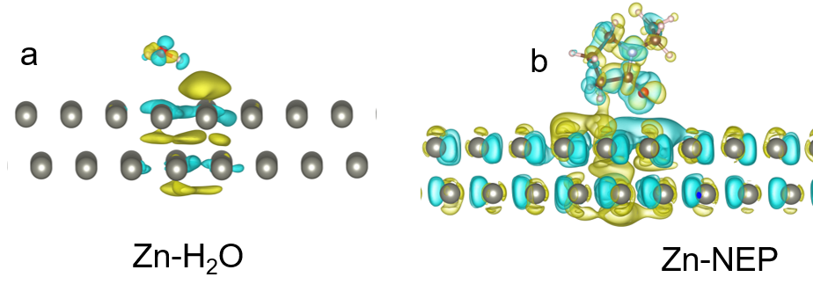
Figure S7 | Charge-density redistribution induced by interfacial adsorption on Zn. Differential charge-density maps for a, H₂O and b, N-ethyl-2-pyrrolidone (NEP) adsorbed on the Zn(002) surface. Yellow and cyan isosurfaces represent electron accumulation and depletion, respectively. The more pronounced charge redistribution in the Zn–NEP configuration indicates stronger electronic coupling between NEP and the Zn surface than between H₂O and Zn.

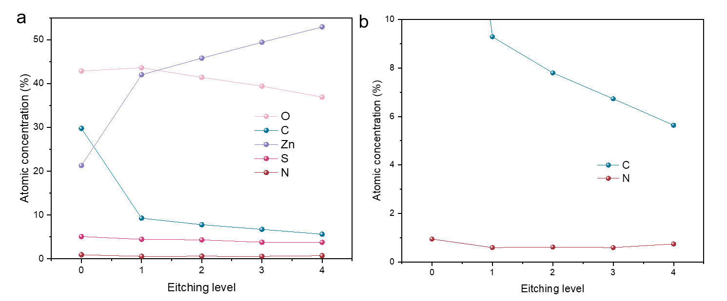
Figure S8 | Depth-dependent elemental composition of the interphase formed on Zn. a, Atomic concentrations of O, C, Zn, S and N measured by X-ray photoelectron spectroscopy as a function of successive Ar⁺ etching levels for a Zn anode after 50 cycles in the ZnSO₄-H₂O- NEP electrolyte. b, Enlarged profiles of C and N, highlighting the persistence of NEP-derived organic species throughout the interphase.(The etching duration per layer is 35 s)

.

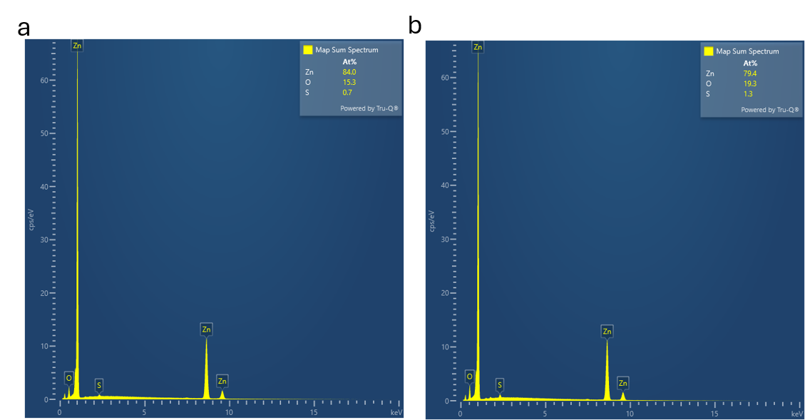
Figure S9 | Elemental composition of cycled Zn anodes. Energy-dispersive X-ray spectroscopy spectra of Zn anodes after cycling in a, the ZnSO₄-H₂O- NEP electrolyte and b, the baseline ZnSO₄-H₂O electrolyte. The corresponding atomic fractions of Zn, O and S are 84.0%, 15.3% and 0.7% for the NEP-containing system, and 79.4%, 19.3% and 1.3% for the baseline system, respectively.

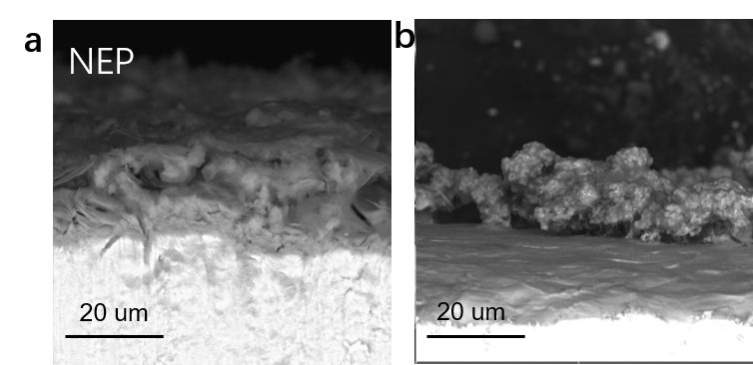
Figure S10 | Cross-sectional morphology of cycled Zn anodes. Ex situ cross-sectional scanning electron microscopy images of Zn anodes after cycling in a, the ZnSO₄-H₂O- NEP electrolyte and b, the baseline ZnSO₄-H₂O electrolyte. The NEP-containing system exhibits a comparatively compact and continuous interfacial layer, whereas the baseline electrolyte produces coarse, loosely aggregated deposits.

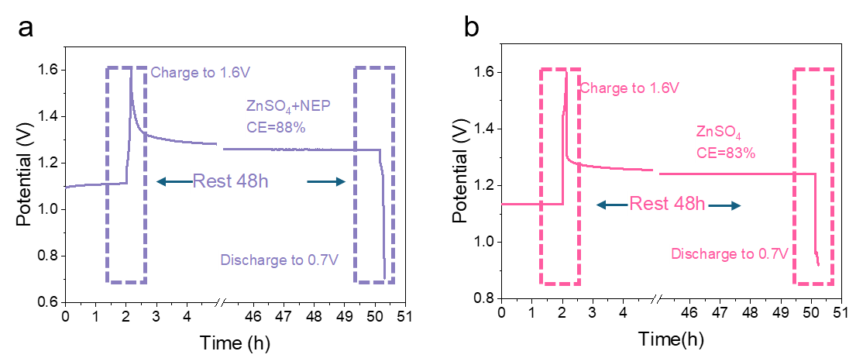
Figure S11 | Self-discharge behavior of Zn||I₂ cells. Voltage profiles of Zn||I₂ cells using a, the ZnSO₄-H₂O-NEP electrolyte and b, the baseline ZnSO₄-H₂O electrolyte. The cells were charged to 1.6 V, held at open circuit for 48 h and subsequently discharged to 0.7 V. The NEP-containing electrolyte delivers a higher post-rest capacity retention of 88%, compared with 83% for the baseline electrolyte, indicating reduced self-discharge.

Figure S12 | Galvanostatic charge–discharge profile of the Zn||I₂ cell using the NEP-containing electrolyte. Representative voltage–capacity curves of the Zn||I₂ cell employing the ZnSO₄-H₂O-NEP electrolyte, showing the characteristic iodine redox plateaus and a reversible specific capacity of approximately 160 mAh g⁻¹.

Figure S13 | Rate capability of the Zn||Zn symmetric cell using the NEP-containing electrolyte. Voltage profiles of the Zn||Zn cell cycled under stepwise current densities of 1, 2, 3, 5, 3, 2 and 1 mA cm⁻². The cell maintains stable and reversible Zn plating/stripping with a recoverable polarization response as the current density is increased and subsequently returned to 1 mA cm⁻².

Figure S14 | Representative Zn plating/stripping profiles of the Zn||Cu cell using the NEP-containing electrolyte. Voltage–capacity curves recorded at the 1st, 50th, 100th, 300th, 500th and 1,000th cycles at a current density of 1 mA cm⁻² and an areal capacity of 0.5 mAh cm⁻². The highly overlapping profiles after the initial cycle indicate stable polarization and reversible Zn deposition/dissolution during prolonged cycling.

Figure S15 | High-rate cycling performance of the Zn||Zn symmetric cell using the NEP-containing electrolyte. Long-term Zn plating/stripping profile of the Zn||Zn cell employing the ZnSO₄-H₂O-NEP electrolyte at a current density of 10 mA cm⁻² and an areal capacity of 1 mAh cm⁻². The cell maintains stable cycling with limited polarization for more than 1,000 h.

Figure S16 | Cycling performance of Zn||V₂O₅ full cells using electrolytes with and without NEP. Long-term cycling performance and corresponding Coulombic efficiencies of Zn||V₂O₅ cells employing the ZnSO₄-H₂O-NEP and baseline ZnSO₄-H₂O electrolytes at a current density of 2 A g⁻¹. The NEP-containing electrolyte enables substantially improved capacity retention and prolonged cycling stability.

Supporting references
1. Bekker H. et al. Gromacs: A parallel computer for molecular dynamics simulations. Physics Computing 92, 252-256 (1993).
2. Neese F. The ORCA program system. WIREs Computational Molecular Science 2, 73-78 (2012).
3. Lu T. & Chen F. Multiwfn: A multifunctional wavefunction analyzer. Journal of Computational Chemistry 33, 580-592 (2012).
4. Martínez L., Andrade R., Birgin E. G. & Martínez J. M. PACKMOL: A package for building initial configurations for molecular dynamics simulations. Journal of Computational Chemistry 30, 2157-2164 (2009).
5. Humphrey W., Dalke A. & Schulten K. VMD: Visual molecular dynamics. Journal of Molecular Graphics 14, 33-38 (1996).
6. Hutter J., Iannuzzi M., Schiffmann F. & VandeVondele J. cp2k: atomistic simulations of condensed matter systems. WIREs Computational Molecular Science 4, 15-25 (2014).
7. Lippert B. G., Parrinello J. H. & Michele. A hybrid Gaussian and plane wave density functional scheme. Molecular Physics 92, 477-488 (1997).
8. VandeVondele J. et al. Quickstep: Fast and accurate density functional calculations using a mixed Gaussian and plane waves approach. Computer Physics Communications 167, 103-128 (2005).
9. Goedecker S., Teter M. & Hutter J. Separable dual-space Gaussian pseudopotentials. Physical Review B 54, 1703-1710 (1996).
10. Perdew J. P., Burke K. & Ernzerhof M. Generalized Gradient Approximation Made Simple. Physical Review Letters 77, 3865-3868 (1996).
11. Grimme S., Antony J., Ehrlich S. & Krieg H. A consistent and accurate ab initio parametrization of density functional dispersion correction (DFT-D) for the 94 elements H-Pu. The Journal of Chemical Physics 132, 154104 (2010).
12. Bajdich M., García-Mota M., Vojvodic A., Nørskov J. K. & Bell A. T. Theoretical Investigation of the Activity of Cobalt Oxides for the Electrochemical Oxidation of Water. Journal of the American Chemical Society 135, 13521-13530 (2013).

