SUPPLEMENTARY MATERIAL
Supplementary Table S1. Severity grade distribution by reaction type
Reaction type | n | Grade 1, n (%) | Grade 2, n (%) | Grade 3, n (%) | Grade 4, n (%) | Severe %
Allergic | 7373 | 7,300 (99.0) | 68 (0.9) | 5 (0.1) | 0 (0.0) | 1.0
FNHTR | 1913 | 1,881 (98.3) | 31 (1.6) | 1 (0.1) | 0 (0.0) | 1.7
Anaphylactic | 332 | 154 (46.4) | 141 (42.5) | 37 (11.1) | 0 (0.0) | 53.6
TACO | 124 | 81 (65.3) | 28 (22.6) | 13 (10.5) | 2 (1.6) | 34.7
TRALI | 45 | 6 (13.3) | 20 (44.4) | 18 (40.0) | 1 (2.2) | 86.7
Hypertensive | 246 | 216 (87.8) | 19 (7.7) | 5 (2.0) | 6 (2.4) | 12.2
Hypotensive | 196 | 169 (86.2) | 20 (10.2) | 6 (3.1) | 1 (0.5) | 13.8
TAD | 228 | 192 (84.2) | 25 (11.0) | 9 (3.9) | 2 (0.9) | 15.8
Hemolytic (ABO) | 74 | 41 (55.4) | 21 (28.4) | 9 (12.2) | 3 (4.1) | 44.6
Hemolytic (Allo) | 59 | 45 (76.3) | 11 (18.6) | 2 (3.4) | 1 (1.7) | 23.7
Viral infection | 169 | 99 (58.6) | 69 (40.8) | 1 (0.6) | 0 (0.0) | 41.4
Non-immune hemolysis | 45 | 35 (77.8) | 10 (22.2) | 0 (0.0) | 0 (0.0) | 22.2
Note. Grade 1 = non-serious; Grade 2 = serious; Grade 3 = life-threatening; Grade 4 = death. Severe % = proportion of reactions graded ≥2. Reaction types with <10 total cases excluded.

Supplementary Table S2. Univariate comparison of severe vs. non-severe reactions

Variable | Severe (n = 670) | Non-severe (n = 10,830) | p
Age, median (IQR), y | 50.3 (21.2–70.5) | 46.3 (23.8–62.7) | 0.001
Sex - Female | 324 (48.4) | 5,555 (51.3) | 0.140
Sex - Male | 346 (51.6) | 5,275 (48.7) | 0.140
Infant (0–1 y) | 22 (3.3) | 324 (3.0) | 0.668
Pediatric (1–18 y) | 141 (21.0) | 1,738 (16.0) | <0.001
Young adult (18–40 y) | 111 (16.6) | 2,461 (22.7) | <0.001
Middle-aged (40–65 y) | 163 (24.3) | 3,851 (35.6) | <0.001
Elderly (≥65 y) | 233 (34.8) | 2,412 (22.3) | <0.001
Age not computable | 0 (0.0) | 44 (0.4) | 0.182
ABO - A | 220 (32.8) | 4,712 (43.5) | <0.001
ABO - O | 293 (43.7) | 3,721 (34.4) | <0.001
ABO - B | 121 (18.1) | 1,558 (14.4) | 0.009
ABO - AB | 33 (4.9) | 745 (6.9) | 0.051
ABO - Unknown | 3 (0.4) | 94 (0.9) | 0.379
Rh-negative | 77 (11.5) | 1,276 (11.8) | 0.821
Component - RBC | 345 (51.5) | 4,344 (40.1) | <0.001
Component - FFP | 194 (29.0) | 4,666 (43.1) | <0.001
Component - Platelets | 120 (17.9) | 1,659 (15.3) | 0.072
Component - Other | 11 (1.6) | 161 (1.5) | 0.748
Crossmatch - Compatible | 360 (53.7) | 5,141 (47.5) | 0.002
Crossmatch - Not performed | 271 (40.4) | 5,411 (50.0) | <0.001
Crossmatch - Incompatible | 39 (5.8) | 278 (2.6) | <0.001
Bedside filtration | 179 (26.7) | 2,347 (21.7) | 0.002
Transfusion completed | 274 (40.9) | 5,060 (46.7) | 0.003
Volume (mL), median (IQR) | 200 (100–300) | 200 (100–307) | 0.017
Reaction - Allergic | 73 (10.9) | 7,300 (67.4) | <0.001
Reaction - FNHTR | 32 (4.8) | 1,881 (17.4) | <0.001
Reaction - Anaphylactic | 178 (26.6) | 154 (1.4) | <0.001
Reaction - TACO | 43 (6.4) | 81 (0.7) | <0.001
Reaction - TRALI | 39 (5.8) | 6 (0.1) | <0.001
Reaction - Hemolytic (ABO) | 33 (4.9) | 41 (0.4) | <0.001
Reaction - Viral infection | 70 (10.4) | 99 (0.9) | <0.001
Note. Severe defined as ISBT severity grade ≥2 (serious, life-threatening, or fatal). Continuous variables compared with Mann–Whitney U; categorical variables with chi-square or Fisher exact test. Values are n (%) unless otherwise stated. IQR = interquartile range.
Supplementary Table S3. GEE logistic regression: predictors of reaction type in the 2020–2022 analytic cohort, major components only
Outcome | Events | Predictor | OR | 95% CI | p
Allergic | 7,247 | FFP (vs. RBC) | 4.96 | 4.25–5.80 | <0.001
 |  | Platelets (vs. RBC) | 2.21 | 1.93–2.54 | <0.001
 |  | Age (per year) | 0.99 | 0.99–0.99 | <0.001
 |  | Female sex | 1.20 | 1.09–1.32 | <0.001
 |  | Rh-negative | 0.96 | 0.83–1.11 | 0.593
 |  | Bedside filtration | 1.18 | 1.05–1.33 | 0.007
FNHTR | 1,872 | FFP (vs. RBC) | 0.12 | 0.10–0.14 | <0.001
 |  | Platelets (vs. RBC) | 0.49 | 0.42–0.57 | <0.001
 |  | Age (per year) | 1.00 | 1.00–1.01 | 0.010
 |  | Female sex | 0.72 | 0.64–0.81 | <0.001
 |  | Rh-negative | 1.02 | 0.85–1.23 | 0.829
 |  | Bedside filtration | 0.62 | 0.54–0.72 | <0.001
Anaphylactic | 321 | FFP (vs. RBC) | 2.19 | 1.53–3.12 | <0.001
 |  | Platelets (vs. RBC) | 4.31 | 3.12–5.96 | <0.001
 |  | Age (per year) | 0.99 | 0.98–0.99 | <0.001
 |  | Female sex | 1.04 | 0.79–1.38 | 0.781
 |  | Rh-negative | 1.02 | 0.64–1.63 | 0.936
 |  | Bedside filtration | 0.95 | 0.68–1.32 | 0.743
TACO | 123 | FFP (vs. RBC) | 0.32 | 0.19–0.53 | <0.001
 |  | Platelets (vs. RBC) | 0.37 | 0.16–0.84 | 0.018
 |  | Age (per year) | 1.04 | 1.03–1.05 | <0.001
 |  | Female sex | 0.96 | 0.66–1.40 | 0.830
 |  | Rh-negative | 0.94 | 0.53–1.65 | 0.817
 |  | Bedside filtration | 0.89 | 0.57–1.39 | 0.596
Hemolytic (ABO) | 74 | FFP (vs. RBC) | 0.13 | 0.06–0.30 | <0.001
 |  | Platelets (vs. RBC) | 0.29 | 0.09–0.92 | 0.035
 |  | Age (per year) | 1.01 | 1.00–1.02 | 0.085
 |  | Female sex | 0.96 | 0.58–1.58 | 0.868
 |  | Rh-negative | 1.92 | 1.05–3.51 | 0.033
 |  | Bedside filtration | 1.63 | 0.93–2.85 | 0.089
Note. GEE models were fitted in the 2020–2022 analytic cohort, restricted to major components and complete cases for the included covariates (11,285 observations; 7,196 patient clusters). Outcomes were modeled as binary indicators of the specified reaction type versus all other reaction types. Models included component type, age, sex, Rh status, and bedside filtration, with exchangeable working correlation and patient-level clustering. Reference component: red blood cells. OR = odds ratio; CI = confidence interval.
Supplementary Table S4. Regional distribution by blood center (2020–2022)
Center | n | % | Allergic % | FNHTR  % | Anaphylactic % | Severe % | Reconciled fatal cases | Delay (hours) | Conf  %
İstanbul (Avrupa) | 2707 | 23.5 | 69.4 | 14.1 | 3.5 | 4.0 | 11 | 7.9 | 81.1
Ankara | 1705 | 14.8 | 57.4 | 23.3 | 3.6 | 6.3 | 10 | 14.1 | 90.8
Antalya | 1134 | 9.9 | 72.0 | 9.4 | 2.8 | 5.6 | 15 | 63.6 | 99.2
Adana | 979 | 8.5 | 74.8 | 9.6 | 1.9 | 6.2 | 5 | 2.2 | 94.8
İstanbul* | 773 | 6.7 | 55.4 | 13.6 | 4.1 | 11.4 | 1 | 12.0 | 66.6
İzmir | 745 | 6.5 | 56.5 | 20.3 | 4.4 | 10.3 | 11 | 13.8 | 88.4
Samsun | 697 | 6.1 | 63.6 | 28.3 | 0.1 | 1.1 | 0 | 16.8 | 79.1
Kayseri | 541 | 4.7 | 50.5 | 23.5 | 1.1 | 1.5 | 0 | 0.5 | 99.6
Düzce | 407 | 3.5 | 60.7 | 16.2 | 2.2 | 9.8 | 1 | 33.2 | 91.4
Bursa | 396 | 3.4 | 53.3 | 18.2 | 2.3 | 5.8 | 3 | 11.5 | 85.9
Eskişehir | 361 | 3.1 | 51.0 | 31.9 | 0.3 | 3.6 | 5 | 17.8 | 98.3
Gaziantep | 255 | 2.2 | 77.3 | 3.9 | 1.2 | 2.0 | 1 | 1.8 | 93.1
Denizli | 236 | 2.1 | 58.5 | 12.7 | 5.1 | 16.1 | 3 | 1.0 | 90.3
Trabzon | 195 | 1.7 | 62.1 | 19.5 | 4.1 | 8.2 | 0 | 1.5 | 97.6
Diyarbakır | 188 | 1.6 | 87.2 | 3.7 | 2.1 | 0.5 | 0 | 14.6 | 100.0
Erzurum | 92 | 0.8 | 78.3 | 10.9 | 1.1 | 4.3 | 0 | 11.8 | 66.1
Malatya | 62 | 0.5 | 69.4 | 8.1 | 8.1 | 11.3 | 0 | 22.0 | 95.8
Van | 27 | 0.2 | 92.6 | 0.0 | 0.0 | 7.4 | 0 | 24.8 | 95.8
Total | 11500 |  |  |  |  |  | 66

Note. Severe (grade ≥2) %; Delay = median reporting delay in hours; Conf = verification confirmation rate (%). * Second İstanbul center (Kuzey Marmara). All heterogeneity tests across centers: p < 0.001.

Supplementary Table S5. Reaction-type transition matrix (1st → 2nd episode)
1st episode | n | → Allergic % | → FNHTR % | → Anaph. % | → Viral % | → Other %
Allergic | 869 | 80.2 | 9.1 | 2.1 | 0.3 | 8.3
FNHTR | 245 | 24.9 | 60.8 | 1.2 | 0.0 | 13.1
Anaphylactic | 57 | 36.8 | 7.0 | 45.6 | 0.0 | 10.5
Viral | 20 | 20.0 | 0.0 | 0.0 | 75.0 | 5.0
Other | 249 | 27.3 | 13.7 | 3.2 | 0.8 | 55.0
Note. Row percentages shown. Each row sums to 100%. Diagonal cells represent same-type recurrence. Among patients whose first reaction was allergic, 80.2% had an allergic reaction again at the second exposure. Anaphylactic first-reactors showed notable instability: only 45.6% recurred as anaphylactic, while 36.8% were reclassified as allergic. n = 1,440 patients with ≥2 episodes.

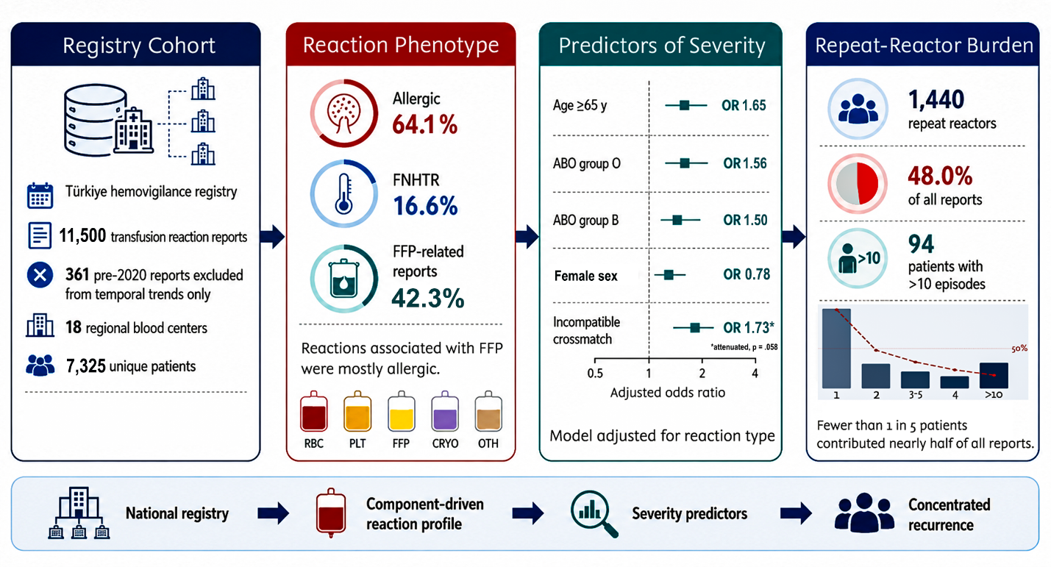
Supplementary Figure S1. Graphical overview of the study design and principal findings. Panel 1: registry cohort characteristics. Panel 2: distribution of reaction types by transfused component; FFP-associated reactions were predominantly allergic. Panel 3: selected severity-associated variables from the GEE logistic regression model adjusted for reaction type (Model 2); incompatible crossmatch is shown as an attenuated association. Panel 4: concentration of hemovigilance burden among repeat reactors in the extended recurrence-matching frame; fewer than 1 in 5 patients contributed nearly half of analyzable reports in that frame. FNHTR = febrile non-hemolytic transfusion reaction; FFP = fresh frozen plasma; RBC = red blood cells; PLT = platelets; CRYO = cryoprecipitate; OTH = other components; OR = odds ratio; GEE = generalized estimating equations; ISBT = International Society of Blood Transfusion.

