Interfacial Si–O–Mn chemistry enables redox–immune cascade amplification across tumor types

Zilin Wang¹, Song Bai¹, Xiaotian Lin¹, Xiaomei Zhang¹, Danil W. Boukhvalov^{1,4}, Zikang Zhou¹, Xin Zhang¹, Hélder A. Santos^{3*}, Bing Xia^{1,2*}

¹College of Science, State Key Laboratory of Tree Genetics and Breeding, Nanjing Forestry University, Nanjing 210037, P. R. China.
²Department of Geriatric Oncology, Affiliated Nanjing Drum Tower Hospital of Nanjing University Medical School, Nanjing 210008, P. R. China.
³Department of Biomaterials and Biomedical Technology, University Medical Center Groningen, University of Groningen, Ant. Deusinglaan 1, 9713 AV Groningen, The Netherlands.
⁴Institute of Physics and Technology, Satbayev University, Almaty 050032, Kazakhstan.

*Corresponding authors.
E-mail: xiabing@njfu.edu.cn (B. Xia); ORICD: 0000-0002-1637-7908.
E-mail: h.a.santos@umcg.nl (H. A. Santos); ORICD: 0000-0001-7850-6309.
Figure S1. (a) XPS spectra of p-type and n-type PSiNPs, and their corresponding MnO_{x}-PSiNPs, as well as p-type MnO_{x}-PSiNPs after GSH treatment. (b) Semi-quantitative analysis of elemental composition percentages (wt%) derived from the XPS data.

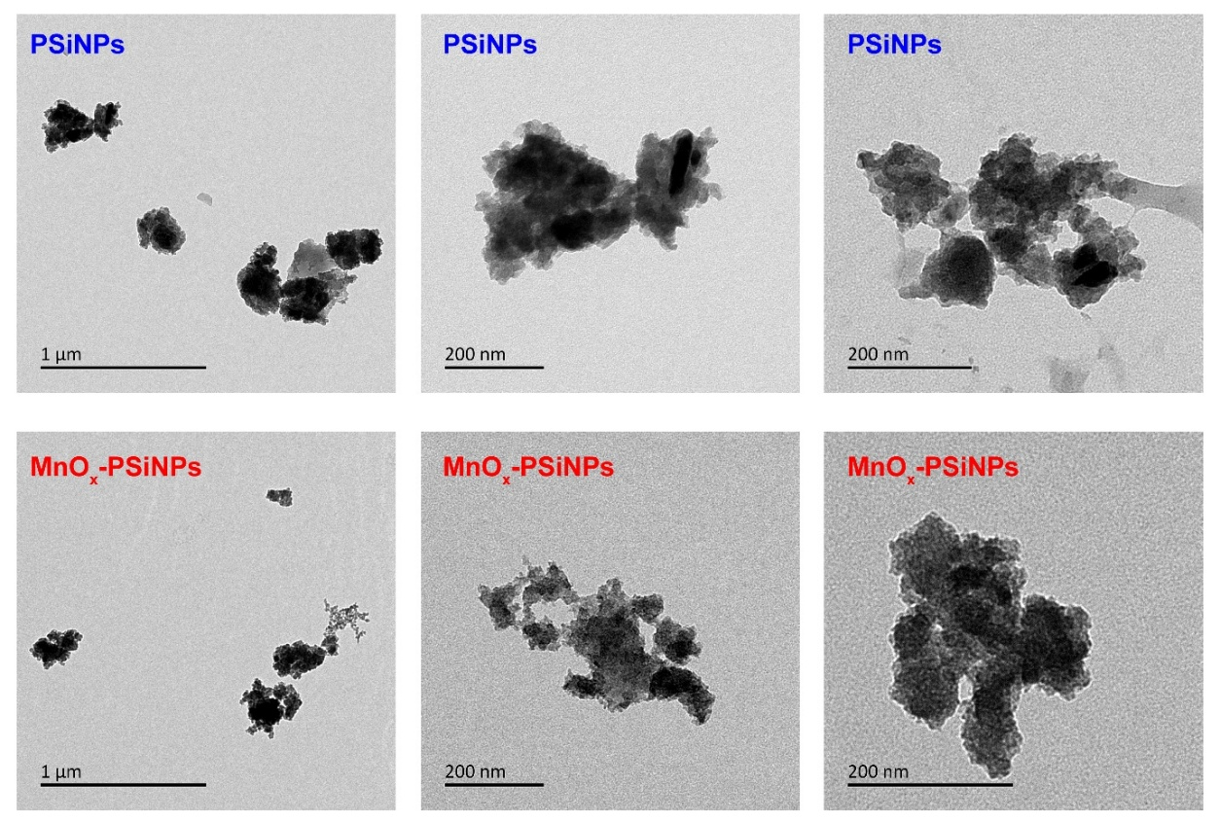
Figure S2. TEM images of PSiNPs and MnO_{x}-PSiNPs powders.

Figure S3. Hydrodynamic size and PDI of PSiNPs and MnO_{x}-PSiNPs incubated in PBS (pH = 7.4) at 37 °C within 48 h. Error bars are based on the standard error of the mean (n = 3 independent biological samples).
Figure S4. (a) Representative UV–Vis spectra of the DTNB solutions after reaction with residual GSH following depletion by p-type and n-type MnO_{x}-PSiNPs (0–50 μg/mL). (b) Standard curve showing the relationship between TNB absorbance at 412 nm and GSH concentration. (c) Concentration-dependent GSH consumption by n-type MnO_{x}-PSiNPs. (d) Representative UV–Vis spectra of DTNB solutions after reaction with residual GSH following incubation with p-type MnOx-PSiNPs for different durations (0–10 min). (e) Representative UV–Vis spectra of p-type MnO_{x}-PSiNPs suspensions after incubation with GSH at different time points (0–10 min). (f) Representative UV–Vis spectra of DTNB solutions after reaction with residual GSH following multiple cycles of GSH depletion by p-type MnO_{x}-PSiNPs. (g) Representative UV–Vis spectra of MB solutions under different treatment conditions.
Figure S5. Optimized atomic structures of the slabs used for the simulation of (a) Si₃MnO₈ and (b) Mn(III)OOH surfaces.

Figure S6. Photoluminescent (PL) spectra of MnO_{x}-PSiNPs and FITC-labeled MnO_{x}-PSiNPs.
Figure S7. •O₂⁻ scavenging efficiency of p-type PSiNPs, n-type PSiNPs, and p-type MnO_{x}-PSiNPs. Error bars are based on the standard error of the mean (n = 3 independent biological samples, ***P < 0.001 and *P < 0.05 determined by one-way ANOVA with Tukey’s post-test).

Figure S8. Cell viability of LLC, 4T1, B16-F10, HEK293T, and HUVEC cells treated with PSiNPs (0‒100 μg/mL) for 48 h, respectively. Error bars are based on the standard error of the mean (n = 3 independent biological samples).

Figure S9. (a) Gating strategy for cell sorting. Flow cytometry plots showing CD80 and CD86 expression in (b) unstimulated BMDCs, (c) BMDCs stimulated with conditioned media derived from (c) untreated, (d) PSiNPs-treated, and (e) MnO_{x}-PSiNPs-treated tumor cells (n = 3 independent biological samples).
Figure S10. Average body weight of mice in the control and MnO_{x}-PSiNPs-treated groups during the 29-day observation period. Error bars are based on the standard error of the mean (n = 6 independent biological samples).

Figure S11. Blood analysis of female C57BL/6J mice with the age of 7 weeks on day 2 including (a) blood levels of WBC, RBC, HGB, HCT, MCV, MCH, MCHC, and PLT, and (b) serum biochemistry analysis on day 29, including BUN level, TBIL, ALT, ALP, and AST. Reference ranges of hematology data of healthy female C57BL/6J mice with the age of 8−10 weeks (95% interval) were obtained from Charles River Laboratories (http://www.criver.com/). Error bars are based on the standard error of the mean (n = 3 independent biological samples).

Figure S12. (a) Average body weight of mice in the control, αPD-L1, MnO_{x}-PSiNPs, and combination groups during the 15-day observation period. Photographs of (b) euthanized tumor-bearing mice and (c) excised tumors collected on day 15. Error bars are based on standard errors of the mean (n = 5 independent biological samples).

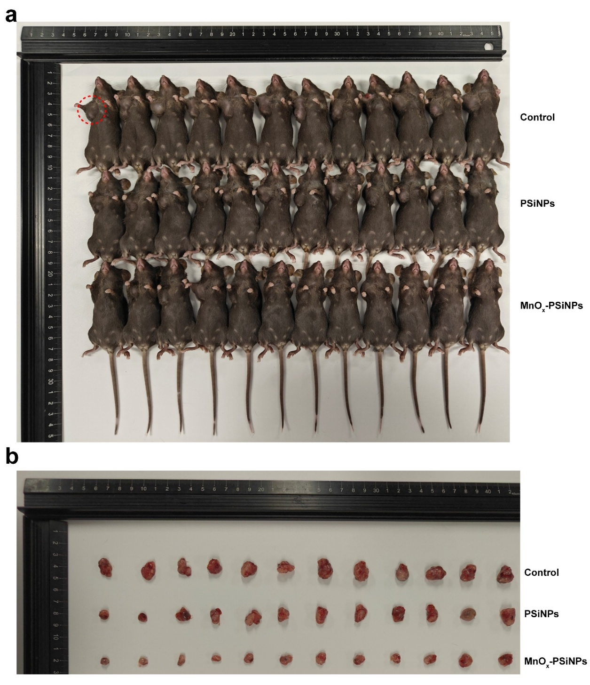
Figure S13. Photographs of (a) euthanized LLC-bearing mice in the control, PSiNPs and MnO_{x}-PSiNPs groups, and (b) excised tumors collected on day 4 (n = 12 independent biological samples).
Figure S14. Gating strategy for cell sorting, and flow cytometry plots showing CD3 and CD8 expression in single-cell suspensions harvested from LLC tumors treated with PBS, PSiNPs, or MnO_{x}-PSiNPs (n = 4 independent biological experiments).
Figure S15. Gating strategy for cell sorting, and flow cytometry plots showing CD3 and CD4 expression in single-cell suspensions harvested from LLC tumors treated with PBS, PSiNPs, or MnO_{x}-PSiNPs (n = 4 independent biological experiments).
Figure S16. Gating strategy for cell sorting, and flow cytometry plots showing CD11c and CD80 expression in single-cell suspensions harvested from LLC tumors treated with PBS, PSiNPs, or MnO_{x}-PSiNPs (n = 4 independent biological experiments).
Figure S17. Gating strategy for cell sorting, and flow cytometry plots showing F4/80 and CD80 expression in single-cell suspensions harvested from LLC tumors treated with PBS, PSiNPs, or MnO_{x}-PSiNPs (n = 4 independent biological experiments).
Figure S18. Numbers of differentially expressed (a) genes and (b) transcripts in single-cell suspensions harvested from LLC tumors treated with PBS, PSiNPs, or MnO_{x}-PSiNPs (n = 4 independent biological experiments).

