Table 1. Antidepressants used in this study and their mechanism of action.
Drug | Class | Medical uses | Mechanism of action | Reference
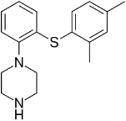  Vortioxetine | SMS | Major depressive disorder (MDD) | Inhibits serotonin reuptake by blocking SERT; acts as a 5‑HT₁A agonist, partial 5‑HT₁B agonist, and antagonist at 5‑HT₃ and 5‑HT₇, receptors | (Alvarez et al. 2014)
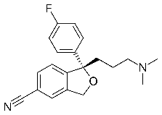  Escitalopram | SSRI | Major depressive disorder (MDD), anxiety disorder, obsessive compulsive disorder (OCD), and panic disorder. | Highly selective SERT inhibitor with an additional allosteric binding site that reduces dissociation from SERT and enhances effect | (Zhong et al. 2012)
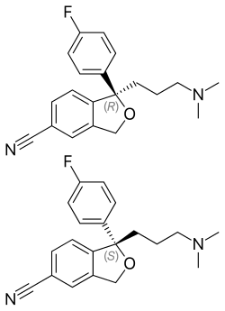  Citalopram  (R)-(−)-citalopram (top),  (S)-(+)-citalopram (bottom) | SSRI | Major depressive disorder (MDD), obsessive compulsive disorder (OCD), and panic disorder, and social phobia. | Highly selective SERT inhibitor | (Roweth et al. 2018)

