Uncropped WesternBlots image of Figure S5E
ZO-1
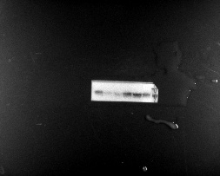
GAPDH
