Electronic Supplemental Information
A Lightweight, Low-Label Framework Towards Autonomous Morphology-Resolved SEM–EDS Analysis in Material Microscopy
Bannapol Limanond ª, Patricia Moraille ^{b,c,d}, Kajjana Boonpalit ^{e}, Kanakorn Suk-ieam ^{f}, Visarut Nganpipatmongkon ^{g}, Pasit Pakawatpanurut ^{g,h}, Antonella Badia ^{b,c,d}, Takayuki Okatani ^{a,i *}, Siraprapha Deebansok ^{j *}

ª Graduate School of Information Sciences, Tohoku University, Sendai 980-0845, Japan
^{b} Département de chimie, Université de Montréal, Complexe des sciences, C.P. 6128 succursale Centre-ville, Montréal, QC H3C 3J7, Canada
^{c} Laboratoire de caractérisation des matériaux, Complexe des sciences, Université de Montréal, Montréal, QC H3C 3J7, Canada
^{d} Institut Courtois, Université de Montréal, Complexe des sciences, C.P. 6128 succursale Centre-ville, Montréal, QC H3C 3J7, Canada
^{e} School of Information Science and Technology, Vidyasirimedhi Institute of Science and Technology, Wang Chan, Rayong 21210, Thailand
^{f} Faculty of Engineering, International School of Engineering, Chulalongkorn University, Bangkok 10330, Thailand
^{g} Department of Chemistry, Faculty of Science, Mahidol University, Bangkok 10400, Thailand
^{h} Center of Excellence for Innovation in Chemistry (PERCH-CIC), Faculty of Science, Mahidol University, Bangkok 10400, Thailand
^{i} RIKEN Center for Advanced Intelligence Project, Tokyo 103-0027, Japan
^{j} Advanced Institute for Materials Research, Tohoku University, Sendai, 980-8577, Japan

* Corresponding author
Siraprapha Deebansok; ^{j} Advanced Institute for Materials Research, Tohoku University, Sendai, 980-8577, Japan. deebansok.siraprapha.c4@tohoku.ac.jp
Takayuki Okatani; ª Graduate School of Information Sciences, Tohoku University
^{i} RIKEN Center for Advanced Intelligence Project, Tokyo 103-0027, Japan. okatani@vision.is.tohoku.ac.jp

Keywords: Scanning Electron Microscopy, Energy-Dispersive X-ray Spectroscopy, Deep learning, Canvas, MXene

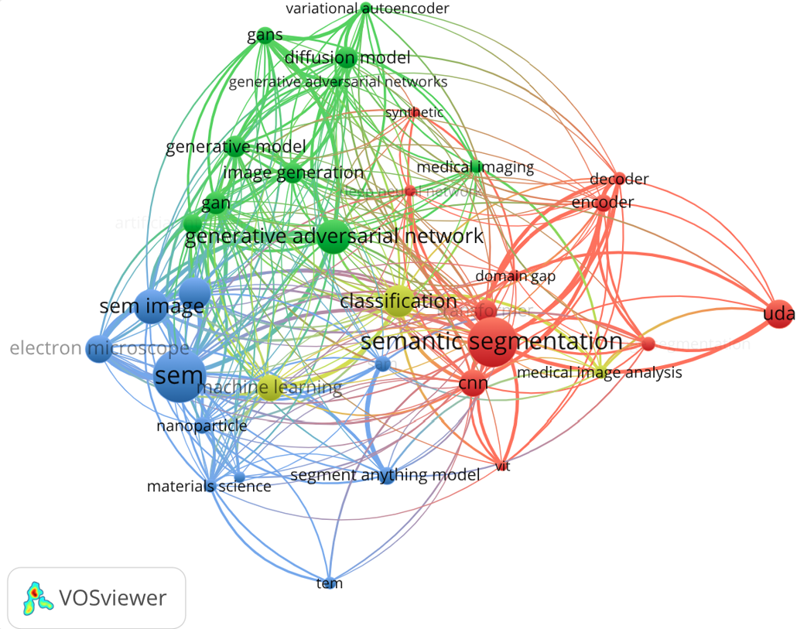

Figure S1. Bibliometric keyword co-occurrence map generated with VOSviewer, illustrating the range of research areas connected to this work.

Table S1 Comparison of representative deep-learning approaches for microscopy image segmentation and synthetic-data generation. Each entry is labeled by its first author and model strategy. In the Taskcolumn, seg denotes segmentation, gen denotes image generation, and gen + seg denotes methods that perform both; our approach (Ours) uses a canvas-based data-composition step followed by segmentation. Total parameters are given in millions for the smallest model configuration highlighted in each original study; for methods that include a generative model, the value is the sum of the segmentation- and generative-model parameters. Where a study does not report parameter counts, we estimate them from the base architecture at its smallest configuration. The number of images to prepare the method is the smallest labeled dataset reported; when several datasets are used, the smallest is taken. For methods that additionally require pretraining, generative-model training, or self-supervision, this value is the total number of images summed across those stages and the final segmentation training set. For our method, only the five manually labeled images are counted, because the synthetic images are composed from them and require no additional acquisition or annotation. See Fig. 2 in the main text for the position of our method within this landscape.
Study | Model / Strategy | Task | Numbers of Images to Prepare the Method | Total Parameters (M)
Archit et al. | SAM | seg | 17,000 | 10
Larsen et al. | SAM + post process | seg | 0 | 91
Rettenberger et al. | Self-supervised | seg | 24,810 | 8.6
Durmaz et al. | CNN | seg | 30 | 31
Rettenberger et al. | CNN | seg | 58 | 44
Bals et al. | GAN + CNN | gen + seg | 57 | 37
Azimi et al. | CNN | seg | 11 | 138
Shi et al. | CNN | seg | 237 | 7
Fotos et al. | CNN + post process | seg | 116 | 25
Stuckner et al. | Pretrain + Finetune | seg | 110,862 | 3.5
Monteiro et al. | SAM + post process | seg | 0 | 91
Monteiro et al. | SAM + post process | seg | 0 | 91
Bals et al. | CNN | seg | 450 | 7.7
Młynarczuk et al. | GAN | gen | 300 | 25
Akbar et al. | Diffusion + CNN | gen + seg | 1,564 | 13.8
Cabaneros et al. | CNN | seg | 196 | 18
Khader et al. | Diffusion + CNN | gen + seg | 1,198 | 40
DeCost et al. | CNN | seg | 20 | 42
Pozzi et al. | Diffusion | gen | 56,990 | 35
Roy et al. | CNN | seg | 90 | 40
Mahmud et al. | CNN | seg | 350 | 160
Rühle et al. | GAN + CNN | gen + seg | 40 | 23.5
Possart et al. | GAN + CNN | gen + seg | 56 | 32.8
Ours | Canvas | canvas +seg | 5 | 15

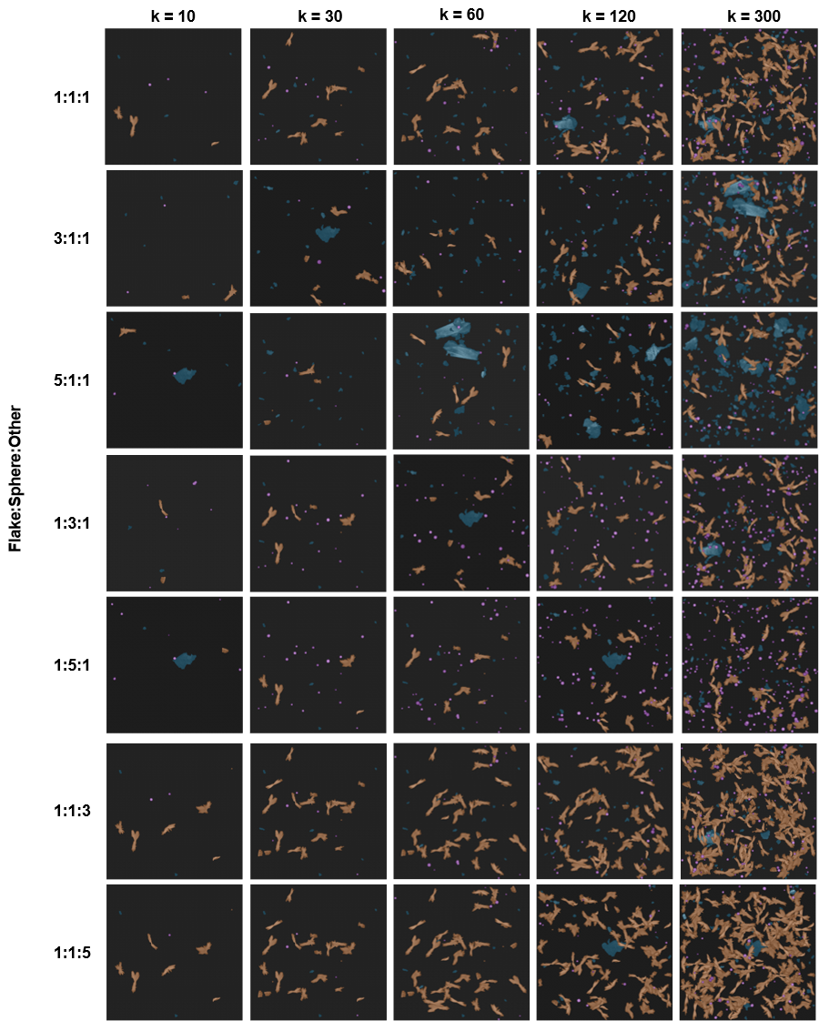

Figure S2 Examples of generated synthetic images across varying synthetic generation parameters. Each column corresponds to a different number of objects per synthetic image ($k$ = 10, 30, 60, 120, 300), and each row corresponds to a different class ratio (Flake:Sphere:Other). Objects are color-coded by class: Flake (blue), Sphere (purple), and Other (orange).
Table S2 Standard augmentation pipeline applied to the five real training images as a baseline.
Category | Transform | Parameters | Probability
Geometric | HorizontalFlip | — | 0.5
Geometric | VerticalFlip | — | 0.5
Geometric | Rotate | limit = ±180°, reflect padding | 0.5
Geometric | RandomResizedCrop | size = 1024 × 1024, scale = (0.8, 1.0), ratio = (0.95, 1.05) | 1.0
Geometric | Affine | scale = (0.95, 1.05), translation = ±5%, shear = ±5°, reflect padding | 0.3
Geometric | ElasticTransform | α = 1, σ = 50, reflect padding | 0.2
Photometric | RandomBrightnessContrast | brightness limit = 0.2, contrast limit = 0.2 | 0.5
Photometric | GaussNoise | variance limit = (6.5, 26.0), mean = 0 | 0.3
Photometric | GaussianBlur | kernel= 3 × 3, σ = (0.1, 1.0) | 0.3

Supplementary Note 1. Comparison with standard augmentation
A natural alternative to our synthetic data pipeline is to apply standard image augmentation directly to the five real training images. We trained the same UNet++ model on the five real images using a strong augmentation pipeline of geometric and photometric transforms, with full parameters listed in Table S2.
Our method substantially outperformed standard augmentation across every metric; see Figure S3. mIoU improved from 0.562 to 0.743 ( a 32% relative increase) and mDice from 0.672 to 0.845 (a 26% relative increase). The augmentation-only baseline was also far less reproducible across seeds, with mIoU standard deviation of 0.15 versus less than 0.01 for our method. We attribute this gap to two properties of our canvas-based pipeline. First, it generates new object layouts with varying positions, counts, and combinations within the field of view that whole-image transforms cannot produce. Second, it allows direct control over per-class sampling frequency, exposing minority classes during training rather than leaving them dependent on their natural rarity in the dataset.

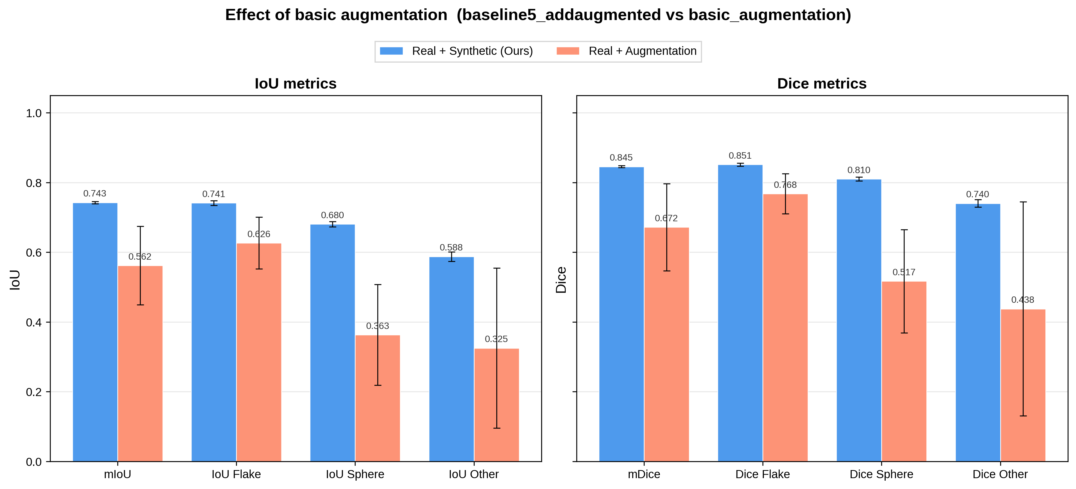
Figure S3 Comparison between standard augmentation and our canvas-based pipeline. Per-class and mean segmentation performance evaluated on the held-out test set. Bars compare a model trained with standard augmentation applied to five real images (orange) against our pipeline (blue). Left: Intersection-over-Union. Right: Dice coefficient.

Table S3 Synthetic data generation parameters. Default values and tested ranges for the parameters of the synthetic data generation pipeline explored in the ablation study (Section 2.3). Table S4-S6 ablations, and the comparisons in Notes 1-4, were performed with k = 60, the setting used prior to the object-density ablation (Table S7), which established k = 120 as the final default.
Parameter | Default | Tested range
Real images | 5 | 1–10
Synthetic images | 100 | 50–500
Objects per image | 120 | 10–300
Class ratio (Flake:Sphere:Other) | 1:1:1 | 7 ratios
2D rotation | Yes | Yes/No
Background crop size | 10 | 5, 10, 20, 50, 100

Table S4 Effect of the number of real labeled images $|D|$ on segmentation performance. Mean Intersection-over-Union (mIoU) and mean Dice coefficient (mDice) for segmentation model trained on (i) real annotated SEM images only ($D$) and (ii) real images combined with our canvas-based synthetic images ($D∪D'$), as a function of the number of real labeled images $|D|$. Values are reported as mean ± standard deviation across three independent training runs. Synthetic images were generated with k = 60 objects per image.
$$|D|$$ | mean Intersection-over-Union |  |  | mean Dice coefficient
$$|D|$$ | Real only ($D$) | Real + Synthetic  ($D∪D^{'}$) | Relative Improvement (%) | Real only ($D$) | Real + Synthetic  ($D∪D^{'}$) | Relative Improvement  (%)
1 | 0.35 ± 0.03 | 0.48 ± 0.01 | +37.1 | 0.42 ± 0.04 | 0.59 ± 0.02 | +40.5
2 | 0.40 ± 0.04 | 0.67 ± 0.01 | +67.5 | 0.50 ± 0.05 | 0.79 ± 0.01 | +58.0
3 | 0.46 ± 0.02 | 0.70 ± 0.01 | +52.2 | 0.57 ± 0.04 | 0.81 ± 0.01 | +42.1
4 | 0.54 ± 0.09 | 0.73 ± 0.02 | +35.2 | 0.65 ± 0.09 | 0.84 ± 0.02 | +29.2
5 | 0.62 ± 0.04 | 0.743 ± 0.003 | +19.8 | 0.73 ± 0.06 | 0.845 ± 0.003 | +15.8
6 | 0.65 ± 0.05 | 0.74 ± 0.03 | +13.9 | 0.75 ± 0.07 | 0.85 ± 0.02 | +13.3
7 | 0.63 ± 0.05 | 0.74 ± 0.02 | +17.5 | 0.74 ± 0.07 | 0.84 ± 0.01 | +13.5
8 | 0.68 ± 0.07 | 0.75 ± 0.01 | +10.3 | 0.77 ± 0.08 | 0.848 ± 0.008 | +10.1
9 | 0.70 ± 0.07 | 0.767 ± 0.004 | +9.6 | 0.79 ± 0.09 | 0.863 ± 0.003 | +9.2
10 | 0.70 ± 0.07 | 0.768 ± 0.009 | +9.7 | 0.79 ± 0.08 | 0.863 ± 0.007 | +9.2

Table S5 Effect of the number of real labeled images $|D|$ on segmentation performance per class. Per-class Intersection-over-Union and Dice coefficient for the segmentation model as a function of the number of real labeled images$|D|$. For each class (Flake, Sphere, Other, Background), values are reported as a / b, where the left value (a) is the model trained on real images only ($D$) and the right value (b) is the model trained on real images combined with synthetic data ($D∪D'$).
$$|D|$$ | Intersection-over-Union |  |  |  | Dice coefficient
$$|D|$$ | Flake | Sphere | Other | Background | Flake | Sphere | Other | Background
1 | 0.45 / 0.50 | 0.06 / 0.28 | 0.01 / 0.22 | 0.87 / 0.90 | 0.62 / 0.67 | 0.10 / 0.42 | 0.03 / 0.32 | 0.93 / 0.95
2 | 0.50 / 0.65 | 0.17 / 0.66 | 0.08 / 0.46 | 0.87 / 0.94 | 0.66 / 0.78 | 0.27 / 0.79 | 0.14 / 0.63 | 0.93 / 0.97
3 | 0.54 / 0.64 | 0.25 / 0.64 | 0.15 / 0.56 | 0.90 / 0.94 | 0.70 / 0.78 | 0.39 / 0.78 | 0.25 / 0.71 | 0.95 / 0.97
4 | 0.64 / 0.74 | 0.37 / 0.66 | 0.22 / 0.56 | 0.94 / 0.96 | 0.78 / 0.85 | 0.51 / 0.80 | 0.33 / 0.72 | 0.97 / 0.98
5 | 0.71 / 0.74 | 0.53 / 0.68 | 0.29 / 0.59 | 0.96 / 0.96 | 0.83 / 0.85 | 0.69 / 0.81 | 0.41 / 0.74 | 0.98 / 0.98
6 | 0.74 / 0.75 | 0.59 / 0.66 | 0.30 / 0.60 | 0.96 / 0.96 | 0.85 / 0.86 | 0.74 / 0.79 | 0.42 / 0.75 | 0.98 / 0.98
7 | 0.73 / 0.74 | 0.53 / 0.67 | 0.31 / 0.59 | 0.96 / 0.96 | 0.85 / 0.85 | 0.69 / 0.80 | 0.42 / 0.74 | 0.98 / 0.98
8 | 0.76 / 0.75 | 0.64 / 0.68 | 0.35 / 0.59 | 0.96 / 0.96 | 0.86 / 0.86 | 0.78 / 0.81 | 0.46 / 0.74 | 0.98 / 0.98
9 | 0.77 / 0.76 | 0.66 / 0.69 | 0.42 / 0.66 | 0.96 / 0.96 | 0.87 / 0.86 | 0.80 / 0.82 | 0.51 / 0.79 | 0.98 / 0.98
10 | 0.77 / 0.77 | 0.66 / 0.69 | 0.39 / 0.64 | 0.97 / 0.97 | 0.87 / 0.87 | 0.80 / 0.82 | 0.49 / 0.78 | 0.98 / 0.98

Table S6 Effect of the number of synthetic images $\left|D^{'}\right|$ on segmentation performance. Per-class and mean (a) Intersection-over-Union and (b) Dice coefficient for segmentation model trained on the union of real and synthetic images ($D∪D'$), as a function of the synthetic set size $|D^{'}|$ (50–500). The number of real images was fixed at $|D|$ = 5, with k = 60 objects per synthetic image. Values are reported as mean ± standard deviation across three independent training.
 |  | mean Intersection-over-Union
$$|D^{'}|$$ | Flake |  | Sphere | Other | Background | mIoU
50 | 0.71 ± 0.04 |  | 0.62 ± 0.06 | 0.52 ± 0.07 | 0.954 ± 0.009 | 0.70 ± 0.04
100 (default) | 0.741 ± 0.006 |  | 0.680 ± 0.007 | 0.59 ± 0.01 | 0.961 ± 0.001 | 0.743 ± 0.003
150 | 0.70 ± 0.03 |  | 0.64 ± 0.07 | 0.63 ± 0.03 | 0.948 ± 0.009 | 0.73 ± 0.03
200 | 0.70 ± 0.02 |  | 0.66 ± 0.01 | 0.59 ± 0.03 | 0.951 ± 0.006 | 0.727 ± 0.009
300 | 0.68 ± 0.07 |  | 0.69 ± 0.02 | 0.57 ± 0.05 | 0.94 ± 0.02 | 0.72 ± 0.02
400 | 0.72 ± 0.02 |  | 0.70 ± 0.01 | 0.62 ± 0.02 | 0.955 ± 0.006 | 0.75 ± 0.01
500 | 0.68 ± 0.06 |  | 0.66 ± 0.04 | 0.61 ± 0.02 | 0.95 ± 0.02 | 0.73 ± 0.03
 |  | mean Dice coefficient
$$|D^{'}|$$ | Flake |  | Sphere | Other | Background | mDice
50 | 0.83 ± 0.03 |  | 0.76 ± 0.05 | 0.68 ± 0.06 | 0.976 ± 0.005 | 0.81 ± 0.03
100 (default) | 0.851 ± 0.005 |  | 0.810 ± 0.006 | 0.74 ± 0.01 | 0.980 ± 0.001 | 0.845 ± 0.002
150 | 0.82 ± 0.02 |  | 0.78 ± 0.05 | 0.77 ± 0.03 | 0.973 ± 0.005 | 0.84 ± 0.03
200 | 0.83 ± 0.01 |  | 0.798 ± 0.007 | 0.74 ± 0.02 | 0.975 ± 0.003 | 0.835 ± 0.007
300 | 0.81 ± 0.05 |  | 0.81 ± 0.02 | 0.72 ± 0.04 | 0.97 ± 0.01 | 0.83 ± 0.02
400 | 0.84 ± 0.02 |  | 0.824 ± 0.007 | 0.76 ± 0.02 | 0.977 ± 0.003 | 0.850 ± 0.008
500 | 0.81 ± 0.04 |  | 0.80 ± 0.03 | 0.76 ± 0.01 | 0.972 ± 0.009 | 0.83 ± 0.02

Table S7 Effect of the number of objects per synthetic image (k) on segmentation performance. Per-class and mean (a) Intersection-over-Union and (b) Dice coefficient for segmentation models trained on the union of real and synthetic images ($D∪D'$), as a function of the number of objects pasted per synthetic image ($k$ = 10, 30, 60, 120, 300). The number of real images was fixed at $|D|$ = 5 and the number of synthetic images at $|D^{'}|$ = 100. Values are reported as mean ± standard deviation across three independent training runs.
 |  | mean Intersection-over-Union
$$k$$ | Flake |  | Sphere | Other | Background | mIoU
10 | 0.41 ± 0.15 |  | 0.10 ± 0.12 | 0.20 ± 0.23 | 0.86 ± 0.06 | 0.39 ± 0.09
30 | 0.68 ± 0.03 |  | 0.40 ± 0.28 | 0.56 ± 0.02 | 0.947 ± 0.009 | 0.65 ± 0.07
60 | 0.741 ± 0.006 |  | 0.680 ± 0.007 | 0.59 ± 0.01 | 0.961 ± 0.001 | 0.743 ± 0.003
120 (default) | 0.75 ± 0.01 |  | 0.69 ± 0.01 | 0.61 ± 0.02 | 0.961 ± 0.003 | 0.751 ± 0.009
300 | 0.74 ± 0.02 |  | 0.71 ± 0.01 | 0.60 ± 0.06 | 0.961 ± 0.003 | 0.75 ± 0.01
 |  | mean Dice coefficient
$$k$$ | Flake |  | Sphere | Other | Background | mDice
10 | 0.57 ± 0.15 |  | 0.16 ± 0.18 | 0.28 ± 0.29 | 0.92 ± 0.03 | 0.48 ± 0.10
30 | 0.81 ± 0.02 |  | 0.50 ± 0.35 | 0.72 ± 0.02 | 0.973 ± 0.005 | 0.75 ± 0.09
60 | 0.851 ± 0.005 |  | 0.810 ± 0.006 | 0.74 ± 0.01 | 0.980 ± 0.001 | 0.845 ± 0.002
120 (default) | 0.854 ± 0.006 |  | 0.816 ± 0.007 | 0.76 ± 0.01 | 0.980 ± 0.002 | 0.852 ± 0.006
300 | 0.85 ± 0.01 |  | 0.832 ± 0.008 | 0.75 ± 0.05 | 0.980 ± 0.001 | 0.85 ± 0.01

Table S8 Effect of the synthetic class ratio on segmentation performance. Per-class and mean (a) Intersection-over-Union and (b) Dice coefficient for segmentation models trained on the union of real and synthetic images ($D∪D'$), as a function of the Flake:Sphere:Other class ratio used when sampling object instances during synthetic image generation. All other generation parameters were held at their defaults: $|D|$ = 5 real images, $|D'|$ = 100 synthetic images, $k$ = 120 objects per synthetic image. Values are reported as mean ± standard deviation across three independent training runs.
 |  | mean Intersection-over-Union
Flake:Sphere:Other | Flake |  | Sphere | Other | Background | mIoU
1:1:1 (default) | 0.75 ± 0.01 |  | 0.69 ± 0.01 | 0.61 ± 0.02 | 0.961 ± 0.003 | 0.751 ± 0.009
1:1:3 | 0.74 ± 0.01 |  | 0.67 ± 0.01 | 0.57 ± 0.04 | 0.960 ± 0.002 | 0.74 ± 0.02
1:1:5 | 0.732 ± 0.004 |  | 0.65 ± 0.01 | 0.53 ± 0.04 | 0.959 ± 0.001 | 0.72 ± 0.01
1:3:1 | 0.750 ± 0.001 |  | 0.71 ± 0.01 | 0.61 ± 0.02 | 0.963 ± 0.001 | 0.756 ± 0.004
1:5:1 | 0.746 ± 0.006 |  | 0.714 ± 0.008 | 0.62 ± 0.02 | 0.962 ± 0.001 | 0.760 ± 0.007
3:1:1 | 0.743 ± 0.005 |  | 0.69 ± 0.02 | 0.61 ± 0.02 | 0.962 ± 0.001 | 0.750 ± 0.009
5:1:1 | 0.747 ± 0.003 |  | 0.68 ± 0.02 | 0.63 ± 0.01 | 0.962 ± 0.001 | 0.755 ± 0.006
 |  | mean Dice coefficient
Flake:Sphere:Other | Flake |  | Sphere | Other | Background | mDice
1:1:1 (default) | 0.854 ± 0.006 |  | 0.816 ± 0.007 | 0.76 ± 0.01 | 0.980 ± 0.002 | 0.852 ± 0.006
1:1:3 | 0.849 ± 0.007 |  | 0.802 ± 0.009 | 0.73 ± 0.04 | 0.979 ± 0.001 | 0.84 ± 0.01
1:1:5 | 0.845 ± 0.003 |  | 0.78 ± 0.01 | 0.69 ± 0.03 | 0.979 ± 0.000 | 0.83 ± 0.01
1:3:1 | 0.857 ± 0.001 |  | 0.828 ± 0.008 | 0.75 ± 0.01 | 0.981 ± 0.000 | 0.855 ± 0.003
1:5:1 | 0.855 ± 0.004 |  | 0.833 ± 0.006 | 0.76 ± 0.02 | 0.980 ± 0.001 | 0.858 ± 0.005
3:1:1 | 0.853 ± 0.003 |  | 0.81 ± 0.01 | 0.76 ± 0.01 | 0.981 ± 0.001 | 0.851 ± 0.007
5:1:1 | 0.855 ± 0.003 |  | 0.81 ± 0.01 | 0.77 ± 0.01 | 0.981 ± 0.000 | 0.855 ± 0.004

Supplementary Note 2. Effect of background crop size on synthetic image generation
The mosaic background of each synthetic image is constructed by sampling square crops from a randomly chosen source image and tiling them to fill the 1024$×$1024 canvas. To determine an appropriate crop size, we trained the UNet++ model on 5 real images and 100 synthetic images (k = 60) generated with crop sizes of 5$×$5, 10$×$10, 20$×$20, 50$×$50, and 100$×$100 pixels, and evaluated performance on the held-out test set.
As shown in Figure S4, mIoU remains stable at 0.74-0.76 for background crop sizes from 5$×$5 to 50$×$50 pixels. At 100$×$100 pixels, mIoU decreases to 0.697 and run-to-run variance increases substantially. We attribute this behavior to large crops capturing unwanted features from the source image, such as scratches or surface contamination. Tiling such crops repeats the same artefact many times within the synthetic image, producing unrealistic patterns that do not occur in real SEM images.

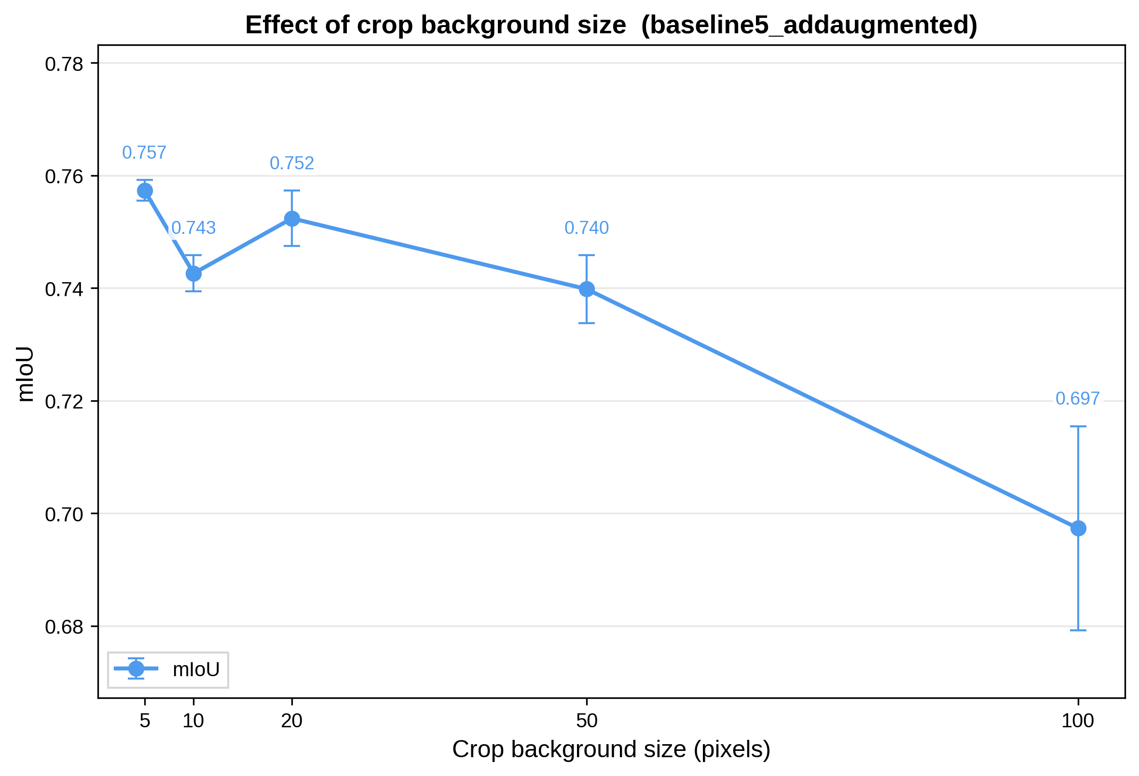
Figure S4 Effect of background crop size. mIoU of U-Net++ trained on 5 real images and 100 synthetic images, as a function of the crop size used to tile the mosaic background of the generated images. Points show the mean across three random seeds; error bars denote one standard deviation.

Supplementary Note 3. Effect of 2D rotation augmentation during synthetic image generation
To isolate the effect of rotating individual particle instances during synthetic image generation, we trained two UNet++ models, with and without rotation, while holding all other parameters fixed ($\left|D\right|$= 5 , |D'| = 100, k = 60, ratio 1:1:1). The two configurations performed nearly identically (Figure S5). The variant without rotation scored marginally higher on every metric (mIoU: 0.753 ± 0.005 vs. 0.743 ± 0.003; mDice: 0.853 ± 0.003 vs. 0.845 ± 0.002), with the largest gap on the Sphere class. All differences fall within the standard deviation across runs, indicating no practical impact on accuracy. This result is consistent with the fact that morphological shape is invariant under 2D rotation, so rotating each instance contributes no additional learning signal.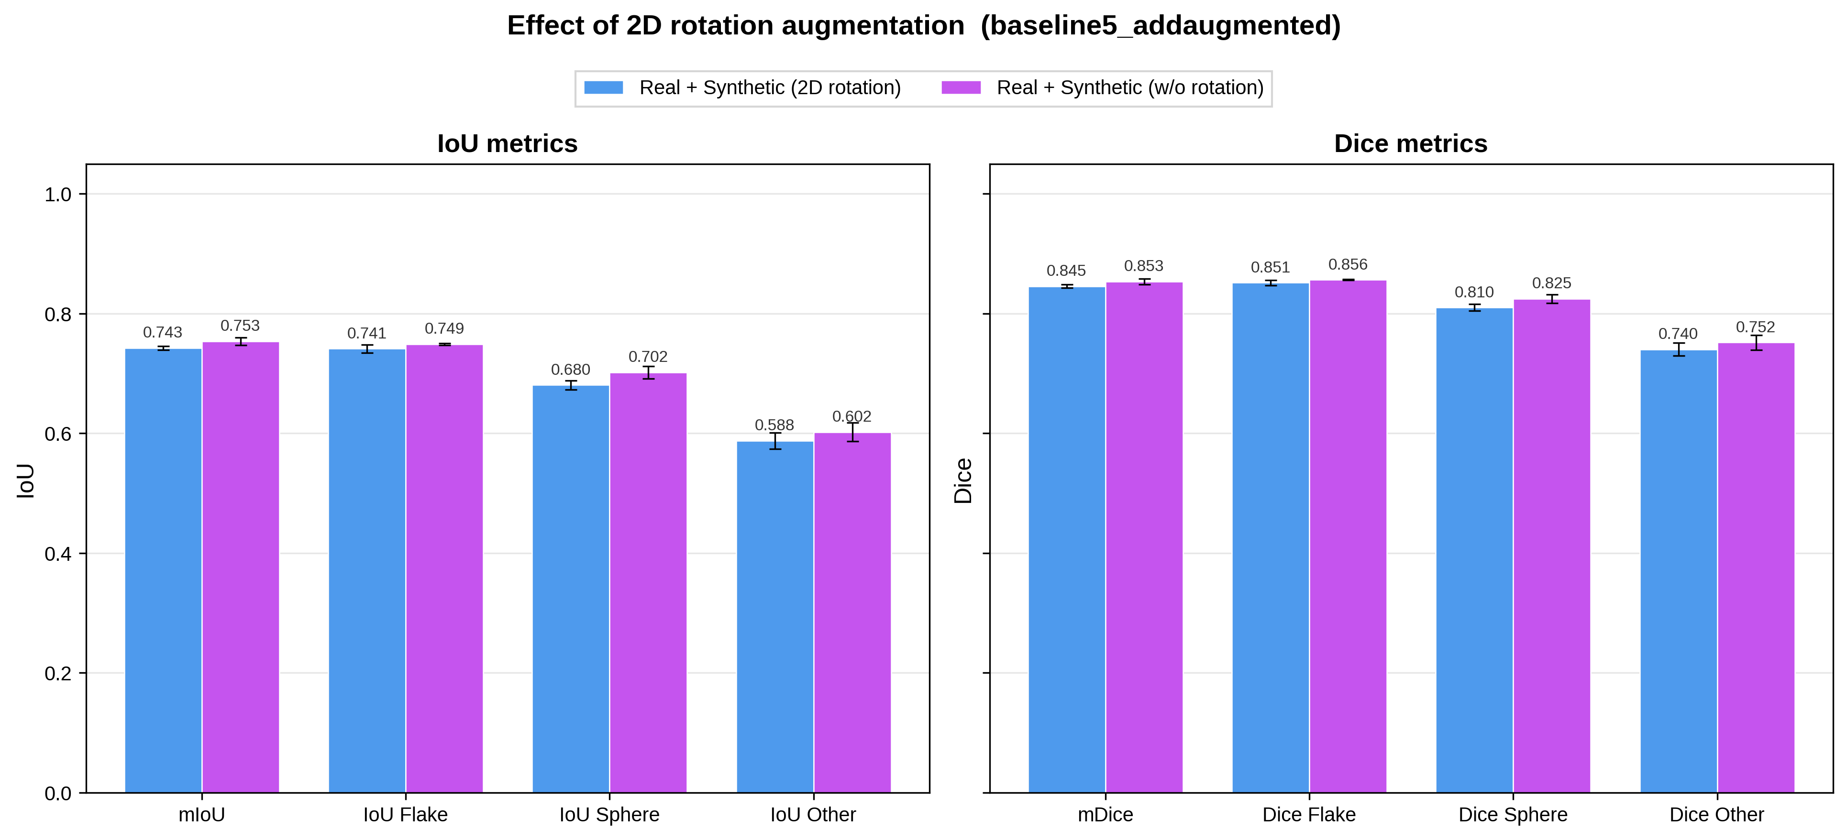
Figure S5 Effect of per-instance 2D rotation on segmentation performance. Per-class and mean segmentation performance of UNet++ trained with $\left|D\right|$= 5 real images and $\left|D'\right|$ = 100 synthetic images, comparing synthetic data generated with (blue) and without (purple) random 2D rotation of morphology instances. Left: Intersection-over-Union. Right: Dice coefficient. Bars and error bars denote mean ± one standard deviation across three independent runs with different random seeds.

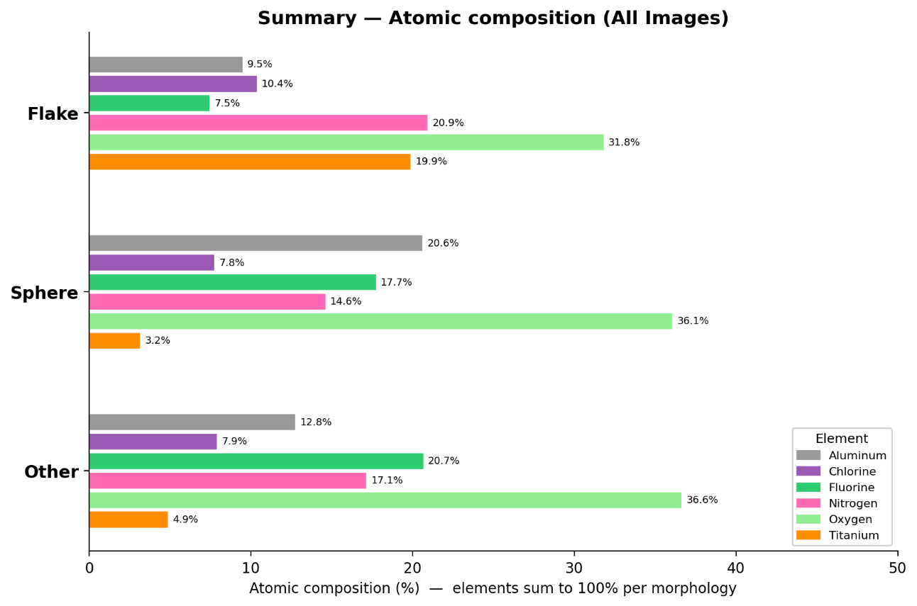
Figure S6 Morphology-resolved atomic composition. Per-class atomic percentages of the three morphology classes (Flake, Sphere, Other), aggregated over 718 segmented particles (469 Flakes, 72 Spheres, 177 Other) from 9 SEM micrographs with co-acquired EDS elemental maps for Al, Cl, F, N, O, and Ti (Dataset 2 in the main text). Atomic percentages were obtained from the EDS weight-percent intensities (Table 2, main text) by dividing each element's weight % by its atomic mass and re-normalizing the resulting molar quantities to 100 % within each morphology class. Empirical stoichiometries derived by referencing each atomic % to the least-abundant element are listed in Supplementary Tables S9-S11.

Table S9 Empirical stoichiometry of the Flake class. Elemental composition and derived stoichiometry for the Flake morphology, computed from the EDS weight-percent intensities aggregated over 469 segmented Flake particles across 9 SEM–EDS image pairs (Dataset 2 in the main text). Columns: Element, the element symbol; pix%Int, the pixel-integrated EDS weight-percent intensity (from Table 2, main text); AtWeight, the atomic mass (g·mol⁻¹); pix%/AW, the relative moles, obtained by dividing pix%Int by AtWeight; Atomic%, the atomic percentage, obtained by normalizing pix%/AW to 100% within the morphology class; Stoichio, the empirical stoichiometric coefficient, obtained by dividing each Atomic% by the smallest Atomic% in the class. The empirical formula is given in the last row.
Element | pix%Int | AtWeight | pix%/AW | Atomic% | Stoichio
Ti | 37.782 | 47.867 | 0.789308 | 19.899 | 2.664
Al | 10.159 | 26.981 | 0.376516 | 9.492 | 1.271
N | 11.631 | 14.007 | 0.830339 | 20.934 | 2.803
O | 20.19 | 15.999 | 1.261967 | 31.815 | 4.26
F | 5.628 | 18.998 | 0.296263 | 7.469 | 1
Cl | 14.61 | 35.45 | 0.412137 | 10.39 | 1.391
Formula | Ti2.7Al1.3N2.8O4.3FCl1.4

Table S10 Empirical stoichiometry of the Sphere class. Same column definitions as Table S9, computed over 72 segmented Sphere particles from 9 selected SEM micrographs (Dataset 2 in the main text).
Element | pix%Int | AtWeight | pix%/AW | Atomic% | Stoichio
Ti | 7.222 | 47.867 | 0.150876 | 3.172 | 1
Al | 26.458 | 26.981 | 0.980628 | 20.618 | 6.5
N | 9.742 | 14.007 | 0.695485 | 14.623 | 4.61
O | 27.453 | 15.999 | 1.715903 | 36.077 | 11.373
F | 16.036 | 18.998 | 0.844084 | 17.747 | 5.595
Cl | 13.089 | 35.45 | 0.369235 | 7.763 | 2.447
Formula | TiAl6.5N4.6O11.4F5.6Cl2.4

Table S11 Empirical stoichiometry of the Other class. Same column definitions as Table S9, computed over 177 segmented Other particles from 9 selected SEM micrographs (Dataset 2 in the main text).
Element | pix%Int | AtWeight | pix%/AW | Atomic% | Stoichio
Ti | 11.241 | 47.867 | 0.234833 | 4.878 | 1
Al | 16.572 | 26.981 | 0.614227 | 12.758 | 2.616
N | 11.561 | 14.007 | 0.825397 | 17.144 | 3.515
O | 28.226 | 15.999 | 1.764214 | 36.644 | 7.513
F | 18.903 | 18.998 | 0.995012 | 20.667 | 4.237
Cl | 13.497 | 35.45 | 0.380721 | 7.908 | 1.621
Formula | TiAl2.6N3.5O7.5F4.2Cl1.6

Supplementary Note 4. Comparison with Segment Anything Model family.
One might argue that we could simply use a state-of-the-art, off-the-shelf model such as the Segment Anything Model (SAM). We note, however, that SAM is built for instance segmentation, whereas our task is semantic segmentation. By the nature of these two tasks, semantic segmentation is inherently morphology-resolved, which is common with our goal, while instance segmentation such as SAM is not morphology-resolved and therefore does not meet it.

Nevertheless, an instance segmentation model can be turned into a semantic segmentation model. We take the pretrained SAM weights, freeze them, and add an MLP head that outputs pixel-wise class predictions. In this way, SAM can be repurposed for semantic segmentation. Leaving the pretrained SAM weights unfrozen might be favorable, but it would take a great deal of training time and lies outside the scope of this paper.

We used the pretrained weights of the base variant of SAM (ViT-B), the smallest variant, and added a trainable MLP head for semantic segmentation. The pretrained SAM weights have 89.7M parameters and the MLP head has 369K parameters, which together are far larger than our U-Net++ model. We used a batch size of 2, up to 300 epochs, a learning rate of 1 × 10⁻⁴, and the Adam optimizer, with early stopping at a patience of 5 epochs and a learning rate decay applied when the validation loss did not decrease for 2 epochs. We trained on the 5 real images ($D$) so that the comparison between our pipeline and SAM was carried out under the same low-data (few-shot) setting. We additionally report micro-SAM, a SAM variant that fine-tunes the original SAM on electron microscopy images. For micro-SAM, we used the same frozen-backbone plus trainable MLP head setup and the same training settings described above. All experiments were run with three independent random seeds, and we report the results as mean ± standard deviation across the three runs.

As shown in Table S12, ours lightweight pipeline outperforms the Segment Anything Model family under the same low-data setting. Our pipeline reaches an mIoU of 0.743 and a mDice of 0.845, compared with 0.43 and 0.53 for SAM and 0.478 and 0.59 for micro-SAM, despite using roughly six times fewer parameters (about 15M versus 90M). This indicates that, in the few-shot regime, freezing a large pretrained backbone and training only a lightweight head transfers poorly to our morphology classes, whereas our approach addresses the problem at the data level rather than the model level, allowing a far smaller model to learn these classes effectively. This supports our central design choice: for morphology-resolved SEM segmentation, a small, CPU-deployable model paired with synthetic data is more effective and more practical than a heavy foundation model.

Table S12 Comparison with the Segment Anything Model family. Segmentation performance of SAM, micro-SAM, and our pipeline. SAM and micro-SAM were trained on the 5 real images ($D$); our model used the combined real and synthetic dataset ($D∪D'$), generated with k = 60 objects per image. mIoU and mDice are averaged over all four classes and evaluated on the held-out test set of 35 images, reported as mean ± s.d. across three independent runs.
Model | Training Data | # Params | mIoU | mDice
SAM | $D$ (5 real) | ~90M | 0.43 ± 0.01 | 0.53 ± 0.02
Micro-SAM | $D$ (5 real) | ~90M | 0.478 ± 0.007 | 0.59 ± 0.01
Ours | $$D∪D'$$ | ~15M | 0.743 ± 0.003 | 0.845 ± 0.002

Supplementary Note 5. Model-agnostic effectiveness of the canvas-based pipeline
The synthetic-data pipeline operates entirely at the data-generation stage and is decoupled from the segmentation network: it neither modifies the loss function nor imposes any architecture-specific constraint (Section 3, Discussion). Its benefit should therefore transfer across segmentation models rather than being tied to the U-Net++ architecture used in the main text. To test this, we evaluated the pipeline on a panel of widely used semantic-segmentation models with distinct architectural designs: U-Net, U-Net++, FPN (Feature Pyramid Network), PSPNet (Pyramid Scene Parsing Network), DeepLabV3, and DeepLabV3+.

Each model was trained under two regimes: (i) real data only, using the five annotated images ($|D|$ = 5); and (ii) real data combined with synthetic data generated by our default pipeline ($|D|$ = 5, $|D'|$ = 100, $k$= 120, Flake:Sphere:Other = 1:1:1). Aside from the model architecture, all training settings were held fixed (Section 4.4). All models were evaluated on the same held-out test set (35 images).

As shown in Figure S7, every model trained on the five real images alone yields low segmentation accuracy. For example, U-Net++ reaches an mIoU of only 0.623 and DeepLabV3 just 0.134, reflecting the severe data scarcity and class imbalance of the real-only regime. Adding synthetic data raises mIoU substantially and consistently across all six models. For instance, U-Net++ improves to 0.751 and DeepLabV3 to 0.582. The gain is therefore not specific to U-Net++ but is observed uniformly across architecture families.

These results confirm that the improvement originates from the training data rather than from any architecture-specific inductive bias, establishing the canvas-based pipeline as a model-agnostic, drop-in component that can augment any segmentation model. This property is practically important: as larger or future models are adopted, the same pipeline can be reused without modification, and its relative value is expected to grow as higher-capacity models become more prone to overfitting under limited annotation.

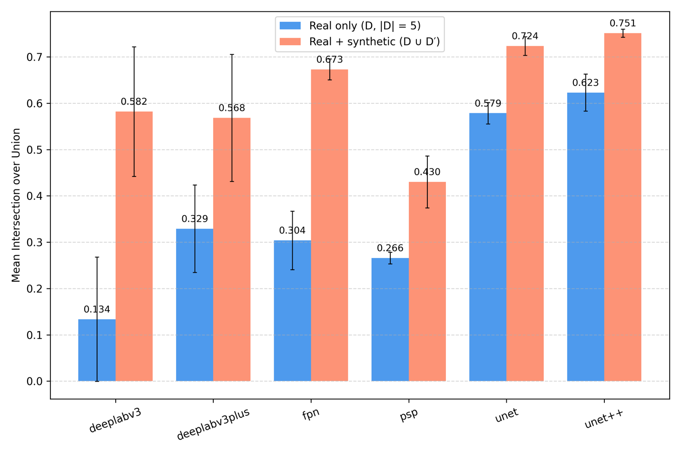
Figure S7 The canvas-based synthetic-data pipeline is model-agnostic. Mean Intersection-over-Union (mIoU) on the held-out test set for six segmentation models (U-Net, U-Net++, FPN (Feature Pyramid Network), PSPNet (Pyramid Scene Parsing Network), DeepLabV3, DeepLabV3+). For every model, bars compare training on five real annotated images only (blue; $D$, $|D|$ = 5) with training on real plus synthetic data from the default pipeline (orange; $D∪D'$; ${|D}^{'}|$ = 100, k = 120, Flake:Sphere:Other = 1:1:1). Error bars denote the standard deviation across three independent runs. Across all models, the pipeline substantially improves mIoU over the real-only baseline.

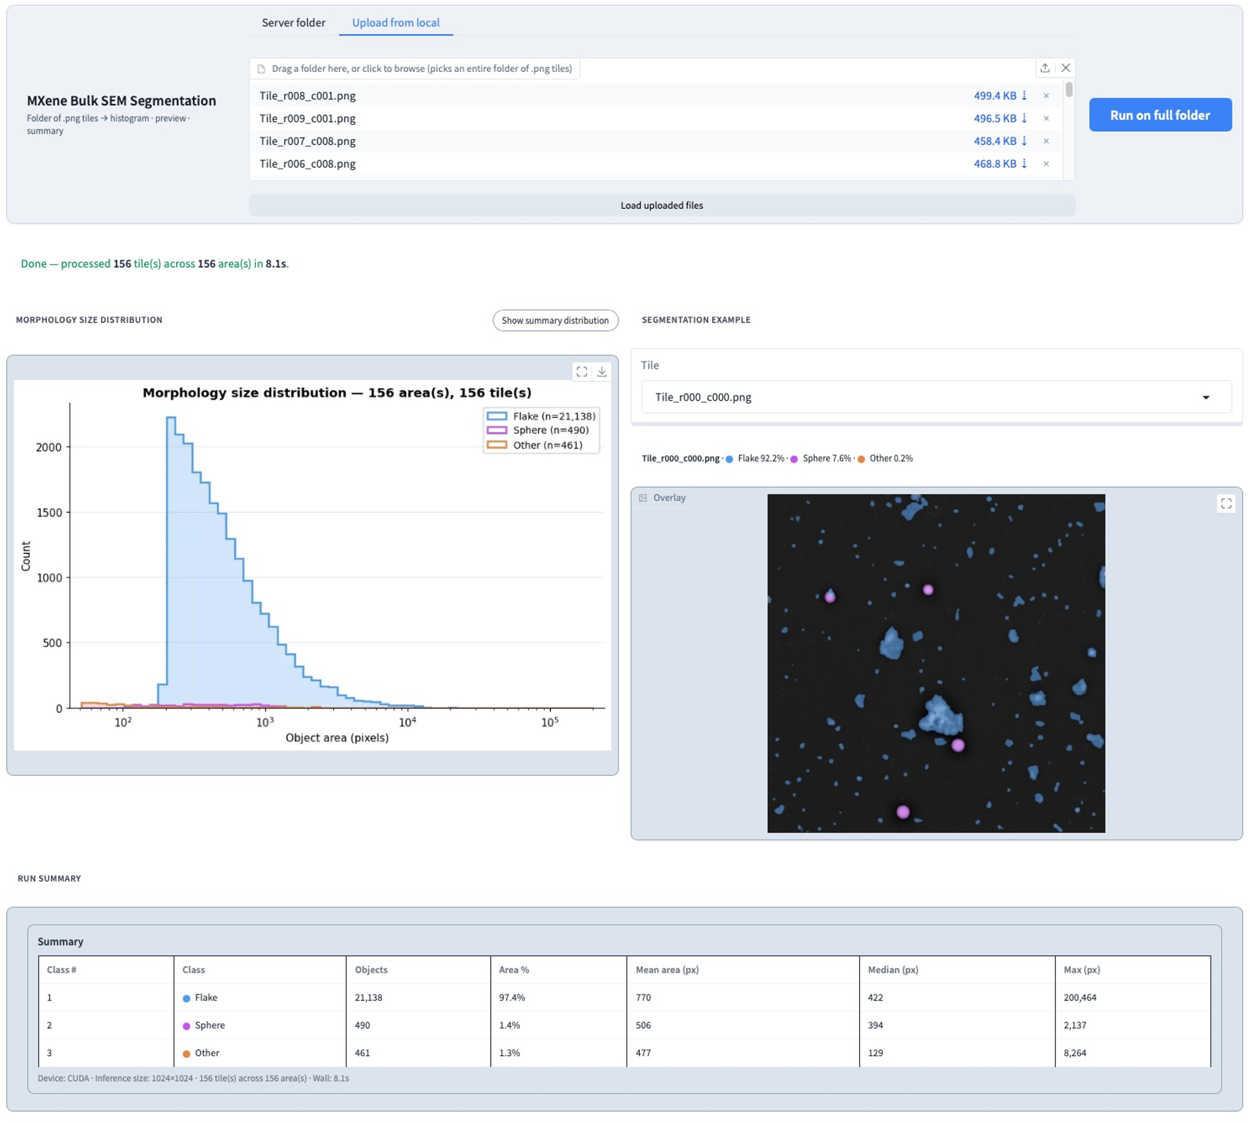
Figure S8 SEMEX.Lab bulk-mode interface for high-throughput SEM segmentation. Users upload a folder of SEM images and run segmentation across the full set in a single click. Outputs include the aggregate morphology size distribution across all images, a segmentation example with per-class area fractions for any selected tile, and a run summary reporting per-class object count, area fraction, and area statistics.

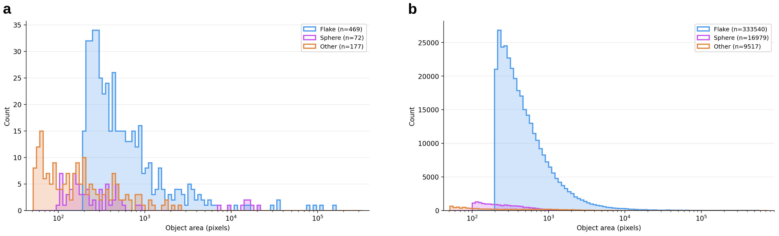
Figure S9 Object-area distributions across morphology classes for the SEM–EDS subset and the bulk SEM corpus. Histograms of segmented object area in pixels grouped by morphology class: Flake (blue), Sphere (purple), and Other (orange). (a) Distribution obtained from the 9 SEM images with co-acquired EDS elemental maps (Dataset 2 in the main text), comprising 469 Flakes, 72 Spheres, and 177 Other particles. (b) Distribution obtained from the bulk SEM corpus of 2,589 unlabeled SEM images (Dataset 3 in the main text), comprising 333,540 Flakes, 16,979 Spheres, and 9,517 Other particles. In both panels, segmentation masks were generated by the segmentation model trained on five real and 100 synthetic images, and individual object instances were extracted by connected-component analysis of the predicted masks.

Table S13 Summary of SEM datasets used in this study, including their purpose, size, annotation status, and EDS availability.
 | Dataset 1 | Dataset 2 | Dataset 3
Purpose | Model development | Morphology-resolved EDS | Bulk-scale demo
N images | 80 | 9 | 2,589
Human annotation | Yes (12,486 objects) | No | No
EDS maps | No | Yes (Cl, O, Al, Ti, F, N) | No
Used for training? | Yes (10 images) | No | No
Train / Val / Test split | 10 / 35 / 35 | — | —

Table S14 Training configuration. Hyperparameters and training settings used for all segmentation experiments. Values were held fixed across all runs unless otherwise noted.
Setting | Value
Image size | 1024 $×$ 1024
Architecture | U-Net++
Backbone | ResNet-18
Pre-training | ImageNet
Loss | Cross-Entropy
Optimizer | Adam
Learning rate | 1e-4
LR scheduler | ReduceLROnPlateau
LR scheduler patience | 2 epochs
LR scheduler factor | 0.5
Early stop patience | 5 epochs
Epochs (max) | 300
Batch size | 4
Random seeds | 3

