Interpreting feature importance under spatial heterogeneity: Evidence from urban development stages and regional migration
Appendix
Table A1
Descriptive statistics of the dependent variable and explanatory variables.
Variable | N | Mean | SD | Min | Max
Net migration rate (‰) | 1,832 | −0.95 | 18.02 | −110.23 | 137.53
PageRank (t−1) | 1,832 | 0.0044 | 0.0036 | 0.0009 | 0.0228
Closeness centrality | 1,832 | 191.59 | 65.97 | 50.40 | 366.42
Population (ln) | 1,824 | 11.83 | 1.06 | 9.09 | 14.00
Population density | 1,824 | 3,499.88 | 5,779.35 | 18.79 | 27,067.22
Ageing ratio | 1,832 | 22.59 | 8.94 | 5.56 | 47.43
Youth ratio | 1,832 | 16.42 | 4.49 | 6.80 | 33.77
Fertility rate | 1,824 | 0.96 | 0.27 | 0.30 | 2.54
Extinction-risk index | 1,824 | 0.91 | 0.54 | 0.14 | 2.90
Employment rate | 1,514 | 63.25 | 6.27 | 46.35 | 84.60
Fiscal independence | 1,808 | 20.50 | 12.99 | 4.02 | 68.86
Business establishments | 1,809 | 23,589.2 | 22,749.5 | 1,253.0 | 126,252.0
Housing age | 1,809 | 28.68 | 14.24 | 1.40 | 70.20
Sewerage supply | 1,816 | 86.65 | 15.63 | 1.20 | 100.00
Distance from Seoul | 1,824 | 169.76 | 116.59 | 1.40 | 475.40
Childcare facilities | 1,816 | 16.58 | 3.70 | 3.80 | 32.80
Doctors | 1,808 | 3.04 | 2.60 | 0.90 | 22.40
Hospital beds | 1,808 | 15.15 | 10.18 | 0.00 | 70.10
Senior-care facilities | 1,816 | 8.94 | 7.28 | 1.10 | 32.10
Private academies | 1,816 | 1.31 | 0.63 | 0.10 | 4.80
Cultural facilities | 1,816 | 13.33 | 9.62 | 2.00 | 73.00
Note: Statistics are computed on the pooled municipal panel (229 municipalities, 2017–2024) prior to model-specific preprocessing. N denotes non-missing municipality-year observations out of 1,832. Variable definitions and data sources are provided in Table 1.
Table A2
Missing observations by predictor (municipality-year records, N = 1,832).
Predictor | Non-missing | Missing | Missing (%)
PageRank (t−1) | 1,832 | 0 | 0.0
Closeness centrality | 1,832 | 0 | 0.0
Housing age | 1,809 | 23 | 1.3
Childcare facilities | 1,816 | 16 | 0.9
Population density | 1,824 | 8 | 0.4
Distance to Seoul | 1,824 | 8 | 0.4
ln(Population) | 1,824 | 8 | 0.4
Fertility rate | 1,824 | 8 | 0.4
Doctors per 1,000 | 1,808 | 24 | 1.3
Ageing ratio | 1,832 | 0 | 0.0
Youth ratio | 1,832 | 0 | 0.0
Fiscal independence | 1,808 | 24 | 1.3
Employment rate | 1,514 | 318 | 17.4
Business establishments | 1,809 | 23 | 1.3
Sewerage supply | 1,816 | 16 | 0.9
Private academies | 1,816 | 16 | 0.9
Cultural facilities | 1,816 | 16 | 0.9
Senior-care facilities | 1,816 | 16 | 0.9
Hospital beds | 1,808 | 24 | 1.3
Extinction-risk index | 1,824 | 8 | 0.4
Note: Missing predictor values were imputed with year-specific medians for model selection, estimation, and hold-out evaluation. SHAP interpretation is restricted to the 1,480 municipality-year observations with complete data on the dependent variable and all twenty predictors, so that no feature importance is attributed to an imputed value (Section 3.2). Sensitivity to both decisions is reported in Section 4.5 and Appendix Table A13.
Table A3
Cluster-number selection diagnostics for the municipal typology (k = 2–8).
k | WCSS (elbow) | Silhouette | Calinski–Harabasz
2 | 1,096.97 | 0.377 | 185.99
3 | 873.76 | 0.294 | 144.45
4 | 740.90 | 0.287 | 126.21
5 | 628.97 | 0.299 | 120.74
6 | 577.89 | 0.258 | 108.50
7 | 540.89 | 0.250 | 98.63
8 | 513.35 | 0.236 | 90.32
Note: Metrics are computed on 224 municipality-level means of the nine standardized clustering indicators (k-means++ initialization, ten random starts, fixed random seed). WCSS denotes the within-cluster sum of squares. The generating script (cluster_selection.py) is provided in the replication repository.
Table A4
Expanding-window cross-validation fold structure.
Fold | Training years | Validation years
1 | 2017–2019 | 2020
2 | 2017–2020 | 2021
3 | 2017–2021 | 2022
Final model | 2017–2022 | 2023–2024 (hold-out)
Note: The final model was trained on 2017–2022 and evaluated once on the 2023–2024 hold-out set.
Table A5
Hyperparameter search spaces and values selected by Optuna for each candidate algorithm.
Algorithm | Hyperparameter | Search range | Scale | Selected value
Linear regression | — | not tuned | — | —
Decision tree | max_depth | [3, 15] | linear | 5
 | min_samples_split | [2, 30] | linear | 11
 | min_samples_leaf | [1, 20] | linear | 13
Random forest | n_estimators | [200, 800] | linear | 350
 | max_depth | [3, 20] | linear | 20
 | min_samples_leaf | [1, 20] | linear | 1
 | max_features | [0.4, 1] | linear | 0.5726
Gradient boosting | n_estimators | [200, 600] | linear | 587
 | learning_rate | [0.01, 0.3] | log | 0.0146
 | max_depth | [2, 6] | linear | 6
 | subsample | [0.6, 1] | linear | 0.984
XGBoost | n_estimators | [200, 1000] | linear | 658
 | learning_rate | [0.01, 0.3] | log | 0.011
 | max_depth | [3, 12] | linear | 11
 | subsample | [0.6, 1] | linear | 0.6553
 | colsample_bytree | [0.6, 1] | linear | 0.6484
 | reg_lambda | [0, 5] | linear | 4.0945
LightGBM | n_estimators | [200, 1000] | linear | 988
 | learning_rate | [0.01, 0.3] | log | 0.0559
 | num_leaves | [15, 127] | linear | 68
 | feature_fraction | [0.6, 1] | linear | 0.707
 | bagging_fraction | [0.6, 1] | linear | 0.8556
 | bagging_freq | [1, 10] | linear | 1
 | reg_lambda | [0, 5] | linear | 3.6675
CatBoost | iterations | [200, 800] | linear | 677
 | learning_rate | [0.01, 0.3] | log | 0.1088
 | depth | [4, 10] | linear | 8
 | l2_leaf_reg | [1, 10] | linear | 2.1525
Note: Each algorithm was tuned over 80 trials with the TPE sampler (fixed seed); the objective was the mean validation R² across the three expanding-window folds (Appendix Table A4). The linear baseline was estimated with a small fixed ridge penalty (α = 1.0) and was not tuned. Search spaces and selected values are reproduced in the replication package (scripts/ml/hyperparameter_tuning.py).
Note: Values were selected by Optuna (TPE sampler; 80 trials per algorithm) under expanding-window time-series cross-validation. Continuous parameters are rounded to three or four significant digits.
Table A6
Bootstrap confidence intervals and paired comparisons of hold-out predictive performance.
Model | Hold-out R² | 95% CI (obs.) | 95% CI (blocks) | ΔR² vs CatBoost | ΔR² 95% CI (obs.) | ΔR² 95% CI (blocks)
Linear regression | −0.116 | [−0.280, −0.006] | [−0.564, 0.098] | 0.440 | [0.316, 0.574] | [0.248, 0.766]
Decision tree | −0.104 | [−0.340, 0.060] | [−0.499, 0.030] | 0.429 | [0.280, 0.619] | [0.310, 0.681]
Random forest | 0.303 | [0.190, 0.393] | [0.138, 0.379] | 0.021 | [−0.040, 0.075] | [−0.050, 0.089]
Gradient boosting | 0.282 | [0.118, 0.402] | [0.070, 0.362] | 0.043 | [−0.012, 0.115] | [−0.013, 0.088]
XGBoost | 0.296 | [0.191, 0.382] | [0.125, 0.407] | 0.028 | [−0.052, 0.100] | [−0.072, 0.140]
LightGBM | 0.252 | [0.107, 0.357] | [−0.013, 0.357] | 0.073 | [0.015, 0.131] | [0.009, 0.160]
CatBoost | 0.324 | [0.181, 0.435] | [0.115, 0.390] | — | — | —
Note: Bootstrap confidence intervals were estimated from the fixed hold-out predictions using 2,000 replications. Observation-level resampling treats municipality-year observations as independent, whereas province-block resampling redraws entire provinces (17 blocks) with replacement, preserving within-province spatial dependence. ΔR² = R²(CatBoost) − R²(model); a paired difference is regarded as statistically distinguishable when its 95% confidence interval excludes zero. All models were re-estimated with the tuned hyperparameters of Appendix Table A5 under the canonical training sample; point estimates reproduce Table 2 exactly for five of the seven models, and within ±0.008 for gradient boosting and XGBoost, reflecting library-version differences. Interval endpoints are subject to bootstrap Monte-Carlo variation.
Table A7
Absolute-count robustness analysis of per-capita service indicators.
Indicator | Direction (per-capita) | Direction (absolute) | Rank (per-capita) | Rank (absolute) | Sign reversal
Childcare facilities | − | − | 1 | 2 | No
Doctors | − | − | 7 | 16 | No
Senior-care facilities | + | + | 6 | 15 | No
Private academies | mixed | + | 19 | 7 | Yes
Hospital beds | − | − | 14 | 8 | No
Note: Directions denote the dominant sign of SHAP contributions; ranks are among all 20 predictors after refitting the model with absolute counts replacing per-capita indicators.
Table A8
Principal-component loadings of the nine clustering indicators.
Indicator | PC1 loading | PC2 loading
Extinction-risk index | 0.404 | −0.054
Youth ratio | 0.392 | −0.115
ln(Population) | 0.381 | −0.077
Fiscal independence | 0.324 | −0.015
Population density | 0.257 | −0.381
Childcare facilities | 0.081 | 0.865
Distance from Seoul | −0.252 | −0.237
Housing age | −0.367 | −0.166
Ageing ratio | −0.402 | −0.023
Note: Loadings are eigenvector weights of the standardized indicators (municipality-level means, n = 224); rows are ordered by the PC1 loading. PC1 explains 60.3% and PC2 12.2% of total variance. PCA is used solely for the visualization in Figure 4; clustering is performed in the full nine-dimensional indicator space. The extinction-risk index is coded such that higher values indicate lower extinction risk.
Table A9
Municipalities with the largest mean net in-migration and net out-migration rates, 2017–2024.
Rank | Largest net in-migration | Rate (‰) | Density (/km²) | Largest net out-migration | Rate (‰) | Density (/km²)
1 | Sejong | 50.8 | 759 | Gwangmyeong (Gyeonggi) | −25.8 | 7,833
2 | Hanam (Gyeonggi) | 50.6 | 3,170 | Gyeyang-gu (Incheon) | −19.7 | 6,534
3 | Hwaseong (Gyeonggi) | 45.3 | 1,223 | Dong-gu (Ulsan) | −19.7 | 2,242
4 | Jung-gu (Incheon) | 45.1 | 3,290 | Seo-gu (Daegu) | −19.3 | 2,936
5 | Yangju (Gyeonggi) | 42.2 | 773 | Dong-gu (Incheon) | −19.2 | 892
6 | Gimpo (Gyeonggi) | 32.6 | 1,659 | Jung-gu (Ulsan) | −19.1 | 5,055
7 | Gwacheon (Gyeonggi) | 31.9 | 1,935 | Taebaek (Gangwon) | −18.8 | 138
8 | Yecheon (Gyeongbuk) | 28.3 | 82 | Cheorwon (Gangwon) | −17.6 | 49
9 | Pyeongtaek (Gyeonggi) | 28.1 | 1,189 | Yanggu (Gangwon) | −17.1 | 33
10 | Siheung (Gyeonggi) | 27.8 | 3,504 | Buk-gu (Busan) | −16.9 | 2,772
11 | Gangseo-gu (Busan) | 27.6 | 1,209 | Nowon-gu (Seoul) | −16.8 | 14,667
12 | Jincheon (Chungbuk) | 26.8 | 203 | Sasang-gu (Busan) | −16.6 | 5,876
13 | Jung-gu (Daegu) | 26.1 | 1,891 | Daedeok-gu (Daejeon) | −15.6 | 2,562
14 | Seo-gu (Incheon) | 24.0 | 9,707 | Yeongdo-gu (Busan) | −15.3 | 7,947
15 | Gwangju (Gyeonggi) | 22.0 | 879 | Hwacheon (Gangwon) | −15.1 | 27
16 | Yeonsu-gu (Incheon) | 21.7 | 6,698 | Gunpo (Gyeonggi) | −14.9 | 7,413
17 | Yangpyeong (Gyeonggi) | 21.5 | 137 | Dalseo-gu (Daegu) | −14.9 | 8,842
18 | Paju (Gyeonggi) | 21.0 | 705 | Chilgok (Gyeongbuk) | −14.8 | 254
19 | Muan (Jeonnam) | 18.6 | 193 | Nam-gu (Ulsan) | −14.7 | 7,208
20 | Asan (Chungnam) | 18.2 | 602 | Dobong-gu (Seoul) | −14.6 | 15,621
Note: Entries are municipality-level means of the annual net migration rate and population density over 2017–2024, ranked among the 229 municipalities. The density columns show that municipalities of comparable density can record opposite migration outcomes (e.g., Seo-gu in Incheon, 9,707 persons/km², +24.0‰, versus Dalseo-gu in Daegu, 8,842 persons/km², −14.9‰). Underlying values are provided in the replication package.
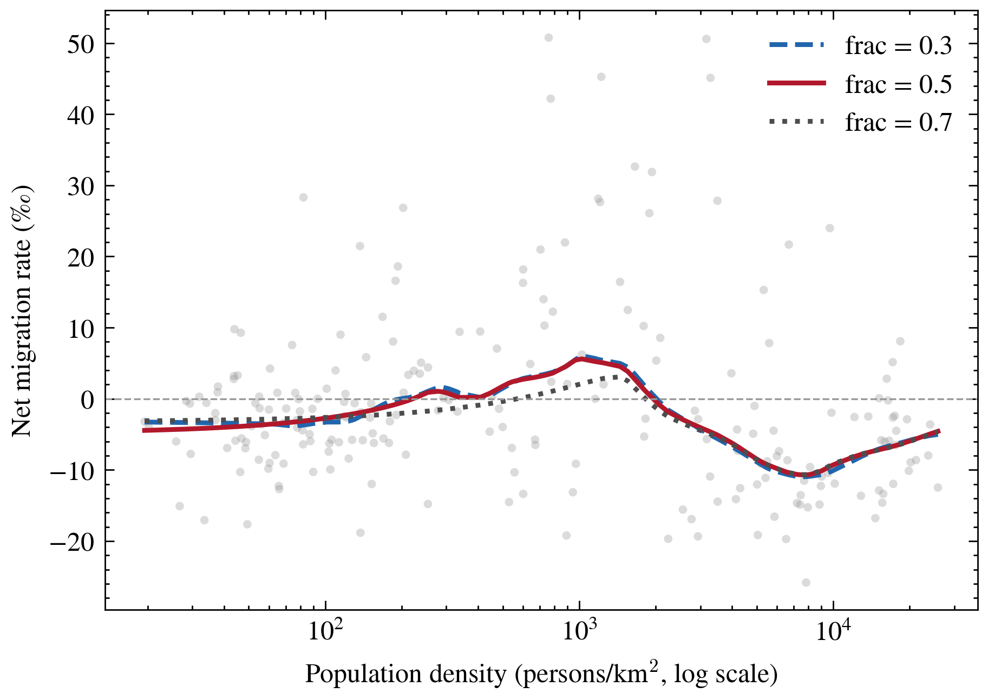
Table A10
Within-stage SHAP-importance ranks, cluster-bootstrap 95% confidence intervals, and permutation tests of stage dependence for all 20 predictors.
Predictor | Global rank | Mean |SHAP| (‰) | Low (95% CI) | Intermediate (95% CI) | High (95% CI) | Rank range | Perm. p | FDR q
Childcare facilities | 1 | 2.59 | 2 (1–2) | 1 (1–1) | 1 (1–2) | 1 | 0.001 | 0.003
Housing age | 2 | 1.99 | 4 (3–4) | 2 (2–4) | 3 (2–5) | 2 | 0.378 | 0.472
Closeness centrality | 3 | 1.87 | 3 (3–4) | 3 (2–4) | 6 (4–7) | 3 | 0.023 | 0.038
Sewerage supply | 4 | 1.84 | 6 (5–8) | 4 (2–4) | 2 (1–3) | 4 | 0.001 | 0.002
PageRank (t-1) | 5 | 1.59 | 1 (1–2) | 6 (5–8) | 9 (8–9) | 8 | 0.001 | 0.002
Senior-care facilities | 6 | 1.41 | 5 (4–6) | 7 (5–9) | 5 (3–7) | 2 | 0.116 | 0.155
Doctors | 7 | 1.35 | 8 (6–8) | 5 (5–8) | 7 (4–8) | 3 | 0.004 | 0.011
Population density | 8 | 1.07 | 17 (16–19) | 8 (6–9) | 4 (3–7) | 13 | 0.001 | 0.002
Distance from Seoul | 9 | 0.98 | 9 (8–10) | 9 (6–10) | 12 (11–15) | 3 | 0.107 | 0.154
Ageing ratio | 10 | 0.91 | 7 (6–9) | 13 (10–15) | 13 (11–15) | 6 | 0.004 | 0.011
Youth ratio | 11 | 0.88 | 13 (11–15) | 15 (11–17) | 8 (7–9) | 7 | 0.001 | 0.002
Business establishments | 12 | 0.82 | 11 (10–15) | 10 (10–11) | 11 (11–15) | 1 | 0.934 | 1.000
Employment rate | 13 | 0.79 | 15 (11–15) | 12 (11–14) | 10 (10–11) | 5 | 0.009 | 0.019
Hospital beds | 14 | 0.74 | 12 (10–15) | 11 (9–15) | 18 (15–19) | 7 | 0.013 | 0.025
Fiscal independence | 15 | 0.70 | 10 (10–13) | 17 (15–18) | 15 (10–18) | 7 | 0.001 | 0.002
Fertility rate | 16 | 0.68 | 14 (10–15) | 16 (14–18) | 14 (11–16) | 2 | 0.490 | 0.577
Population (ln) | 17 | 0.60 | 18 (16–19) | 14 (11–16) | 16 (12–18) | 4 | 0.018 | 0.033
Extinction-risk index | 18 | 0.55 | 16 (16–18) | 18 (17–20) | 17 (15–18) | 2 | 0.073 | 0.112
Private academies | 19 | 0.46 | 19 (18–20) | 19 (16–20) | 19 (17–20) | 0 | 1.000 | 1.000
Cultural facilities | 20 | 0.40 | 20 (19–20) | 20 (18–20) | 20 (19–20) | 0 | 1.000 | 1.000
Note: Within-stage ranks partition the SHAP attributions of the single fitted CatBoost model by population-density tier (n = 1,480 complete-case observations). Confidence intervals are municipality-level cluster-bootstrap percentile intervals (2,000 replications) holding the fitted model fixed. Permutation p-values test the null hypothesis that the within-stage rank is invariant to the stage partition (2,000 permutations of stage labels across municipalities); q-values apply the Benjamini–Hochberg correction across the 20 simultaneous tests.
Table A11
Agreement between stage-specific re-estimated models and the partitioned single-model ranking.
Density tier | Training observations | Spearman ρ (refit vs partitioned ranks)
Low | 456 | 0.48
Intermediate | 456 | 0.36
High | 456 | 0.73
Note: Each stage-specific CatBoost model is re-estimated on the training observations of one density tier only (456 municipality-year observations each) with the canonical hyperparameters, and its within-stage importance ranking is compared with the ranking obtained by partitioning the attributions of the single canonical model. The moderate agreement (ρ = 0.36–0.73) reflects the estimation variability of models trained on small stage-specific samples and motivates the fixed-model partitioning design of Section 3.3.2.
Table A12
Global and within-stage SHAP-importance ranks under XGBoost.
Predictor | CatBoost global rank | XGBoost global rank | XGB low | XGB intermediate | XGB high
Housing age | 2 | 1 | 2 | 1 | 2
Childcare facilities | 1 | 2 | 3 | 2 | 4
PageRank (t-1) | 5 | 3 | 1 | 4 | 7
Closeness centrality | 3 | 4 | 4 | 3 | 5
Sewerage supply | 4 | 5 | 9 | 5 | 1
Senior-care facilities | 6 | 6 | 6 | 6 | 6
Population density | 8 | 7 | 15 | 9 | 3
Doctors | 7 | 8 | 7 | 8 | 8
Ageing ratio | 10 | 9 | 5 | 11 | 10
Fiscal independence | 15 | 10 | 8 | 12 | 11
Hospital beds | 14 | 11 | 10 | 7 | 17
Distance from Seoul | 9 | 12 | 11 | 10 | 13
Population (ln) | 17 | 13 | 12 | 13 | 14
Youth ratio | 11 | 14 | 18 | 18 | 9
Employment rate | 13 | 15 | 13 | 14 | 18
Business establishments | 12 | 16 | 16 | 16 | 15
Fertility rate | 16 | 17 | 17 | 17 | 12
Private academies | 19 | 18 | 20 | 15 | 16
Extinction-risk index | 18 | 19 | 14 | 20 | 19
Cultural facilities | 20 | 20 | 19 | 19 | 20
Note: XGBoost is estimated on the canonical training sample with the tuned hyperparameters of Appendix Table A5, and its SHAP attributions are evaluated on the same 1,480 complete-case observations and partitioned by the same density tiers. The global rankings agree closely (Spearman ρ = 0.92). PageRank ranks 1, 4, and 7 across the low-, intermediate-, and high-density tiers (against 1, 6, and 9 under CatBoost), and closeness centrality remains uniformly informative.
Table A13
Sensitivity of model selection and feature importance to the missing-data treatment.
Quantity | Imputed training sample (canonical) | Complete-case training sample
Training observations | 1,374 | 1,036
Validation R² — CatBoost | 0.353 (Table 2) | 0.309
Validation R² — XGBoost | 0.350 (Table 2) | 0.339
Best validation model | CatBoost | XGBoost
Spearman ρ of global ranking vs canonical | 1.00 | 0.82
Sewerage supply global rank | 4 | 8
PageRank within-stage ranks (low/int/high) | 1 / 6 / 9 | 4 / 7 / 11
Note: The canonical specification trains on the full panel with year-specific median imputation and restricts SHAP interpretation to complete cases; the alternative discards training records with any missing predictor. Restricting the training sample changes the global ranking materially (ρ = 0.82; sewerage supply falls from rank 4 to 8) and reverses the validation ordering of CatBoost and XGBoost, whereas replacing the SHAP evaluation sample with the full imputed panel leaves the ranking essentially unchanged (ρ = 0.99). PageRank remains strongly stage dependent under both training samples.
Figure A1
Sensitivity of the LOWESS density–migration curve to the smoothing parameter (span = 0.3, 0.5, 0.7; municipality-level means, 2017–2024).
Note: The inverted-U pattern is preserved across smoothing parameters.
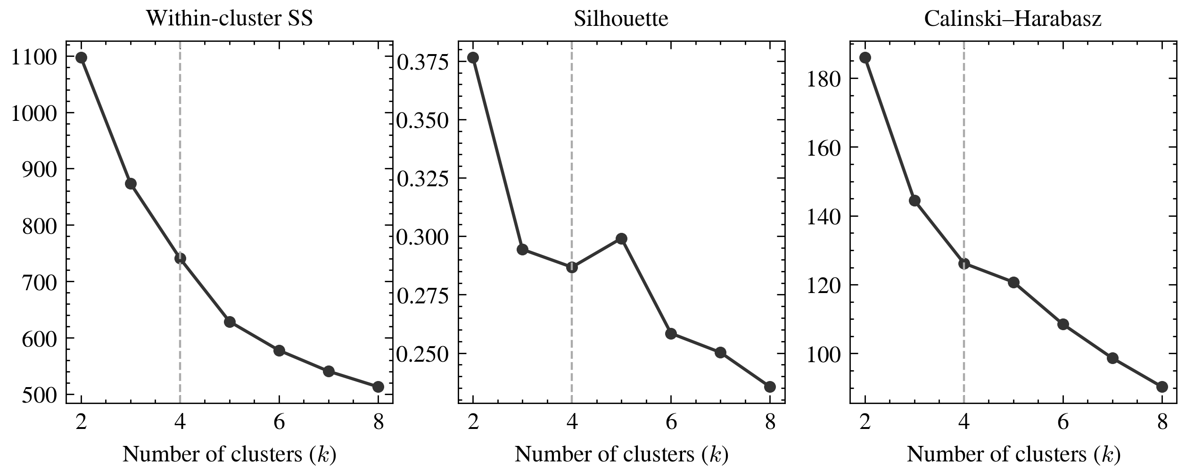
Figure A2
Cluster-number diagnostics for the k-means typology (k = 2–8): within-cluster sum of squares, silhouette coefficient, and Calinski–Harabasz index.
Note: The dashed line marks the adopted four-cluster solution (Appendix Table A3).
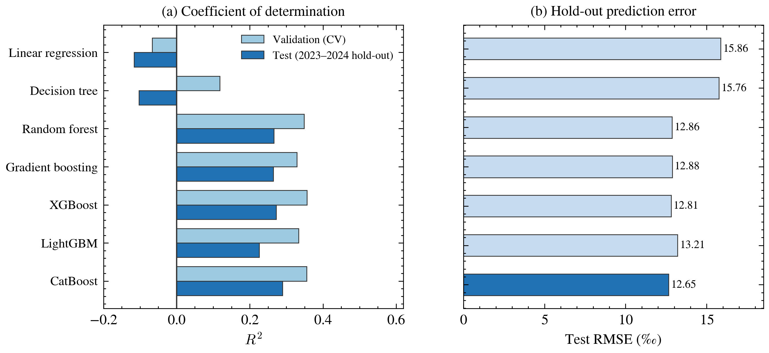
Figure A3
Predictive performance of the seven candidate models on the validation and hold-out datasets.
Note: Panel (a) compares the mean validation R² from expanding-window cross-validation with the corresponding hold-out R²; panel (b) presents hold-out RMSE (‰), with CatBoost highlighted. The figure provides a visual summary of the point estimates reported in Table 2; statistical uncertainty is reported in Appendix Table A6.
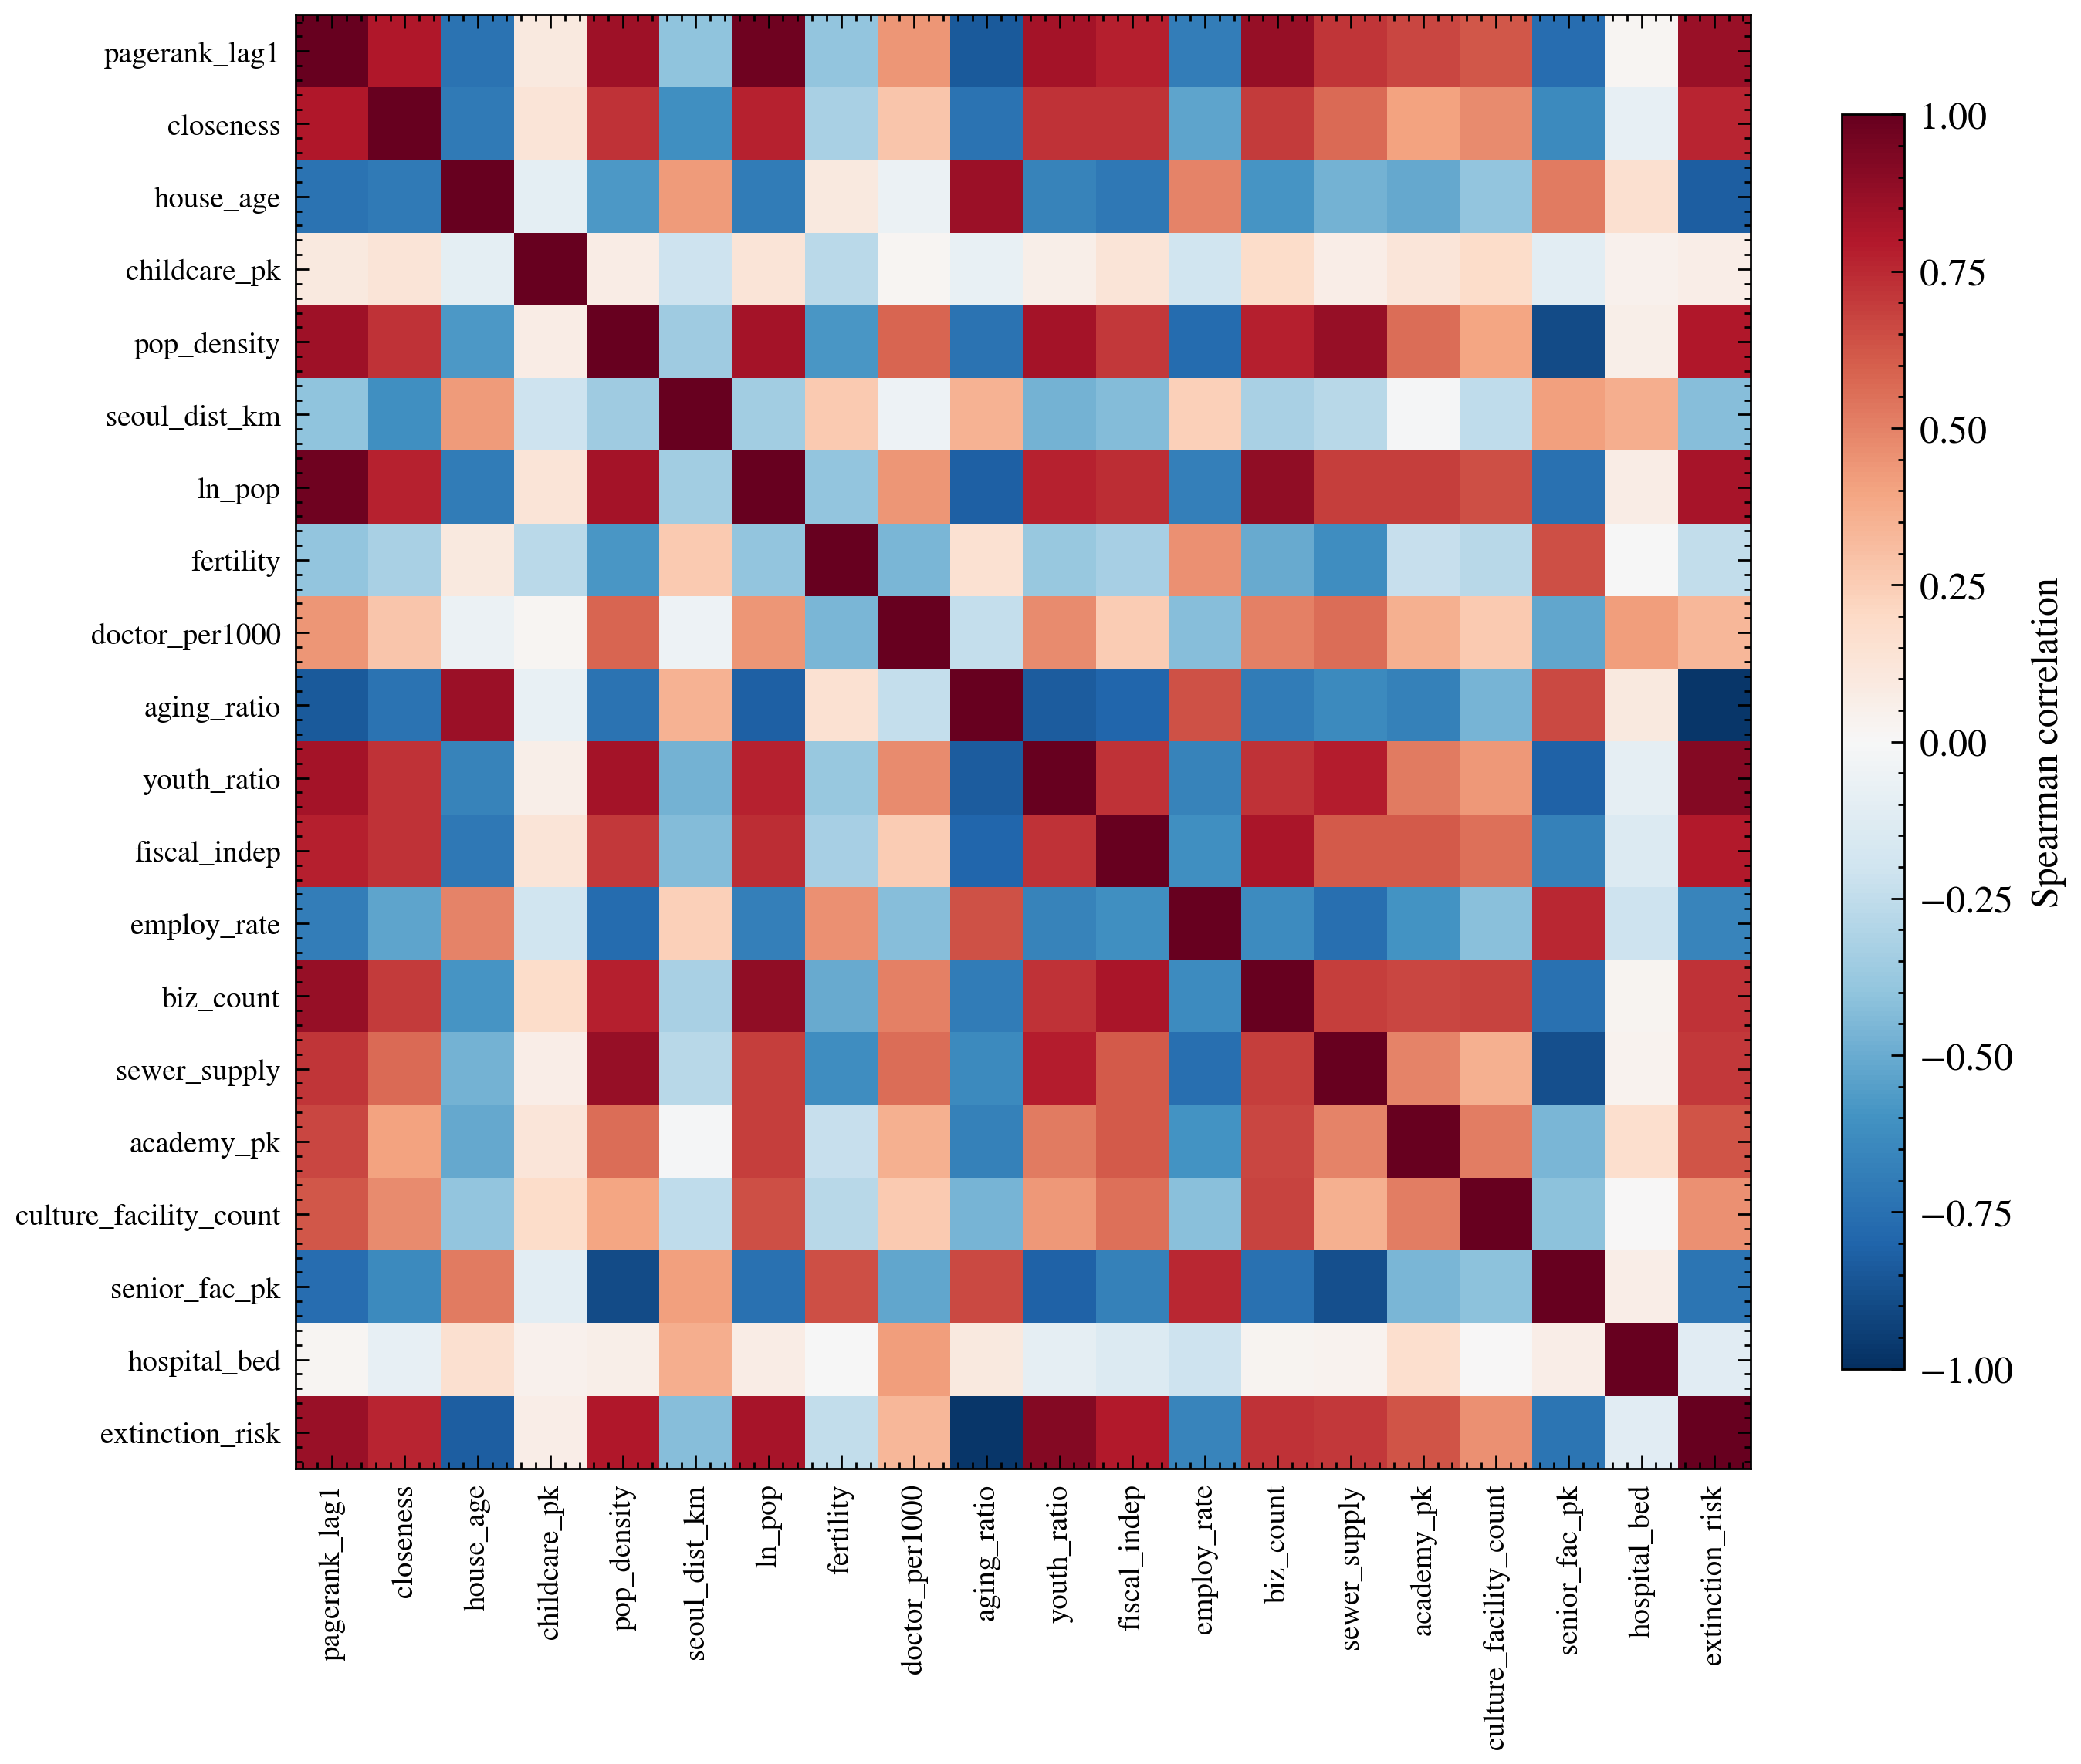
Figure A4
Spearman correlation matrix of the twenty predictors (municipality-year observations, 2017–2024).
Note: Correlated predictor groups indicate that importance attributed to one indicator may be shared with related indicators.
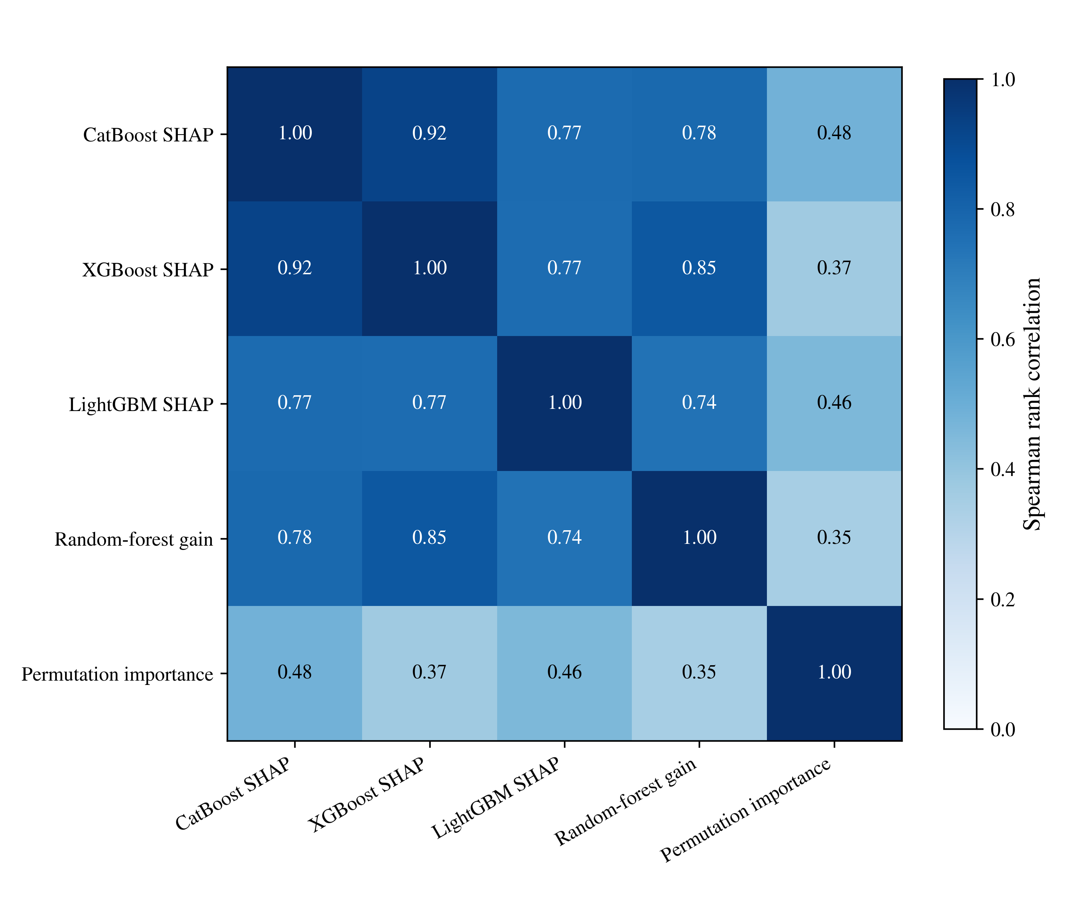
Figure A5
Agreement of feature-importance rankings across attribution methods (Spearman rank correlations between CatBoost SHAP, XGBoost SHAP, LightGBM SHAP, random-forest gain, and permutation importance).
Note: Entries are Spearman rank correlations between the importance rankings of the twenty predictors produced by each attribution method; higher values indicate closer agreement with the CatBoost SHAP ranking used in the main analysis.
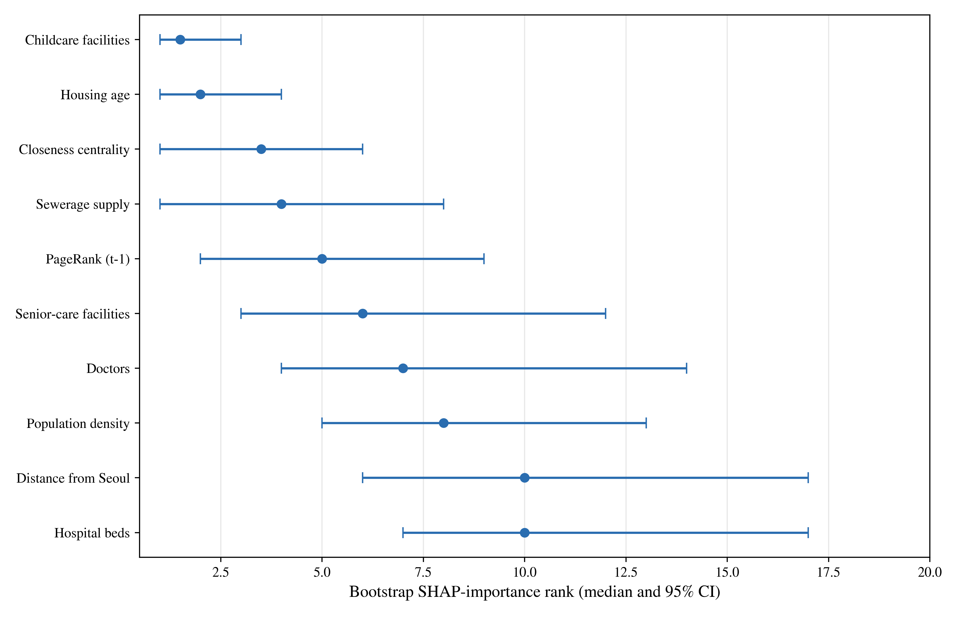
Figure A6
Bootstrap 95% confidence intervals for SHAP-importance ranks (50 replications).
Note: Points show the median SHAP-importance rank of each predictor across 50 bootstrap replications of the training data; horizontal bars give the 95% percentile interval. Predictors are ordered by median rank.
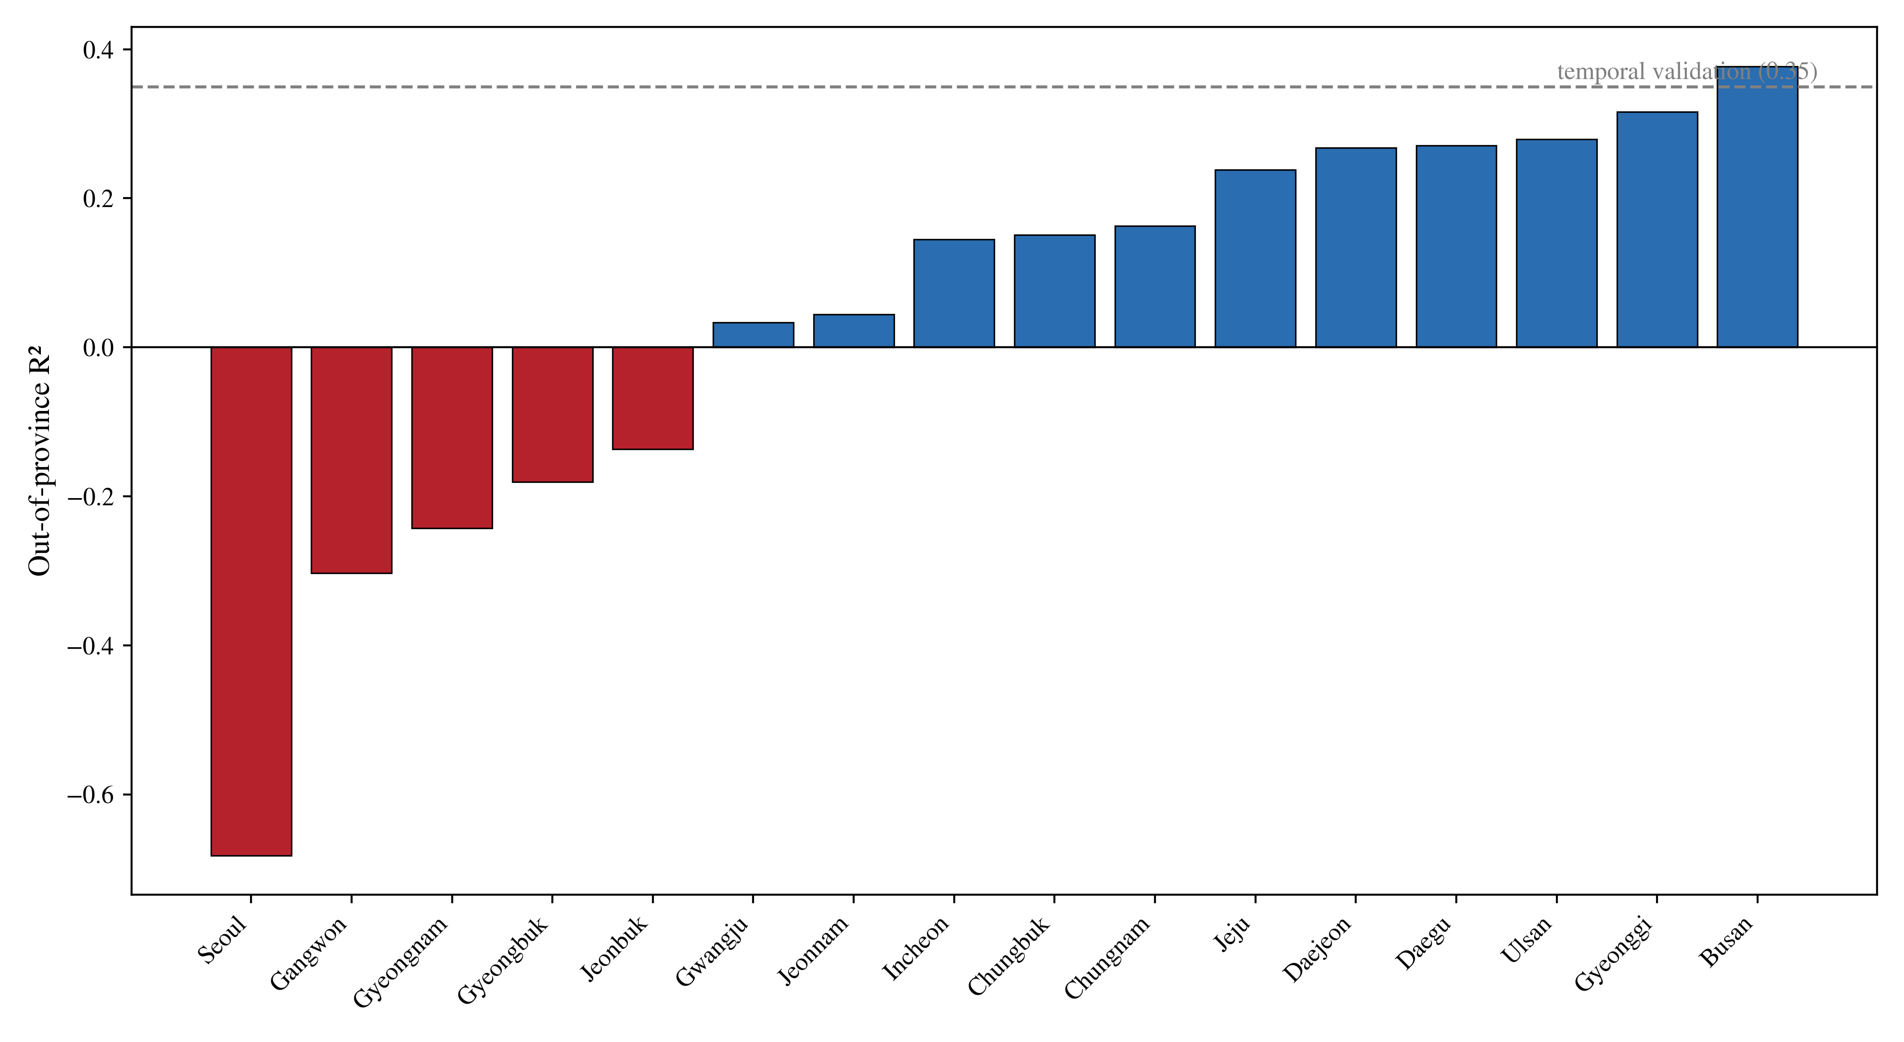
Figure A7
Leave-one-province-out spatial cross-validation performance.
Note: Bars show hold-out R² when the model is trained on all other provinces and evaluated on the named province (provinces ordered by performance); the dashed line marks the mean out-of-province R² (0.05). Negative values indicate that the model performs worse than the mean of the held-out province. Sejong is omitted because it comprises fewer than ten municipality-year observations. The comparison benchmark is the mean validation R² of 0.36 under expanding-window temporal cross-validation (Table 2).
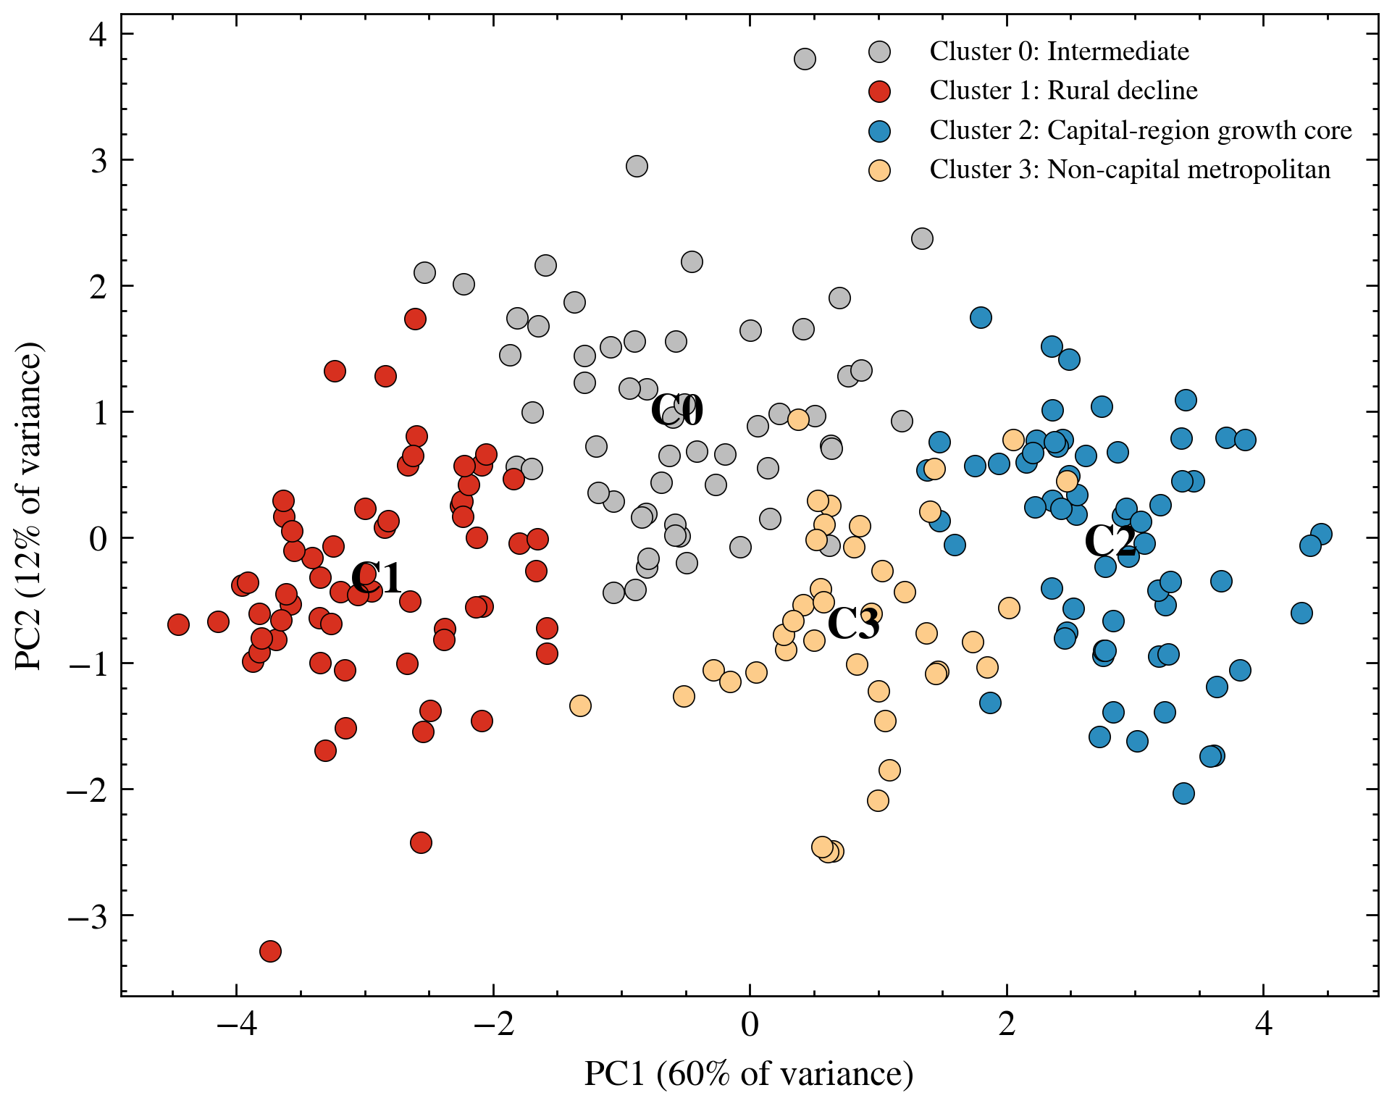
Figure A8
Municipal typology projected onto the first two principal components.
Note: Points are municipality-level means projected onto the first two principal components; colours denote cluster assignment (labels follow Table 4), and C0–C3 mark cluster centroids. PC1 separates aged, remote municipalities with older housing (left) from larger, younger, denser, and fiscally stronger municipalities (right); PC2 primarily reflects per-capita childcare provision (component loadings in Appendix Table A8).
Replication package. All analysis scripts, the processed municipal panel, and the outputs underlying every table and figure — including data preprocessing, model training, SHAP computation, robustness analyses, and figure generation — are openly available in the project repository the anonymized replication repository (URL provided upon acceptance).

