Supplementary Information
Figures
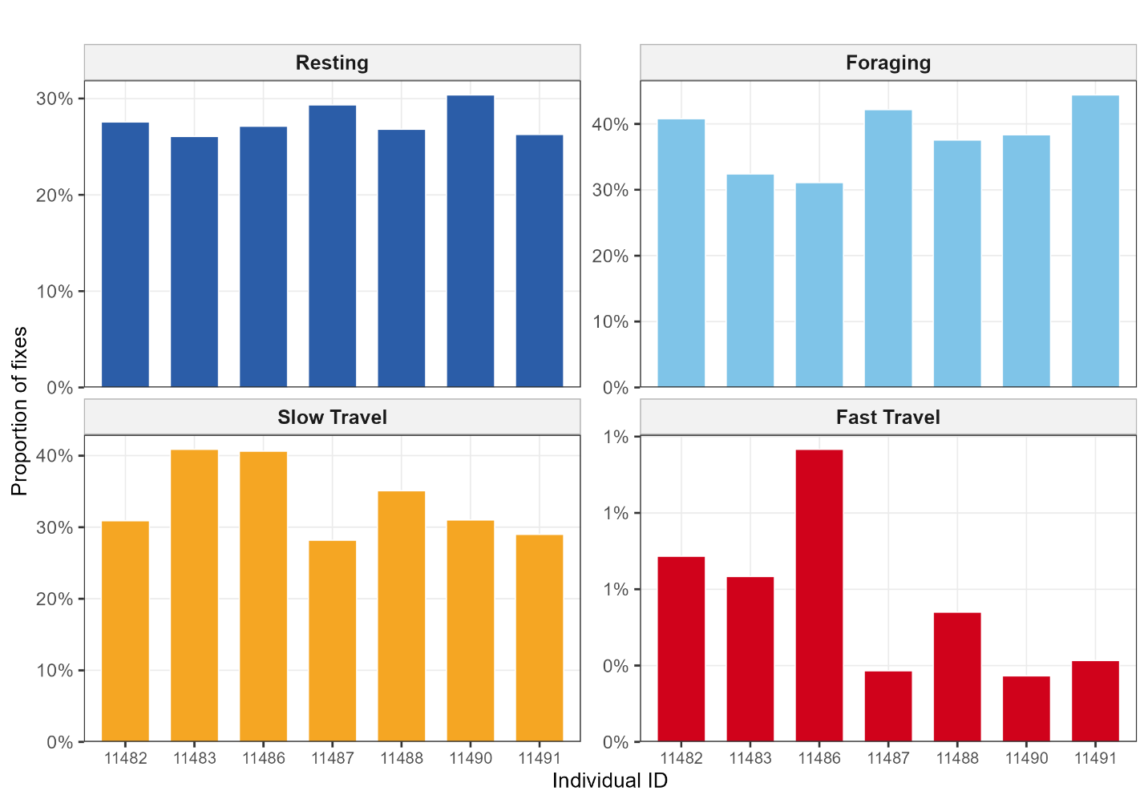
Figure S1: Individual variation in behavioural state proportions.

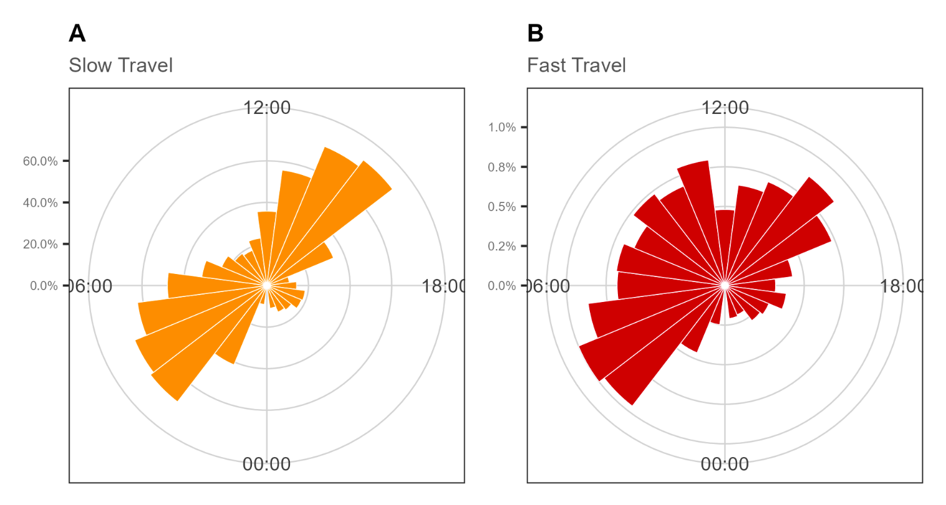
Figure S2: Diel rose plots showing the distribution of (A) Slow Travel and (B) Fast Travel across the 24-hour cycle. Note different radial scales between panels.

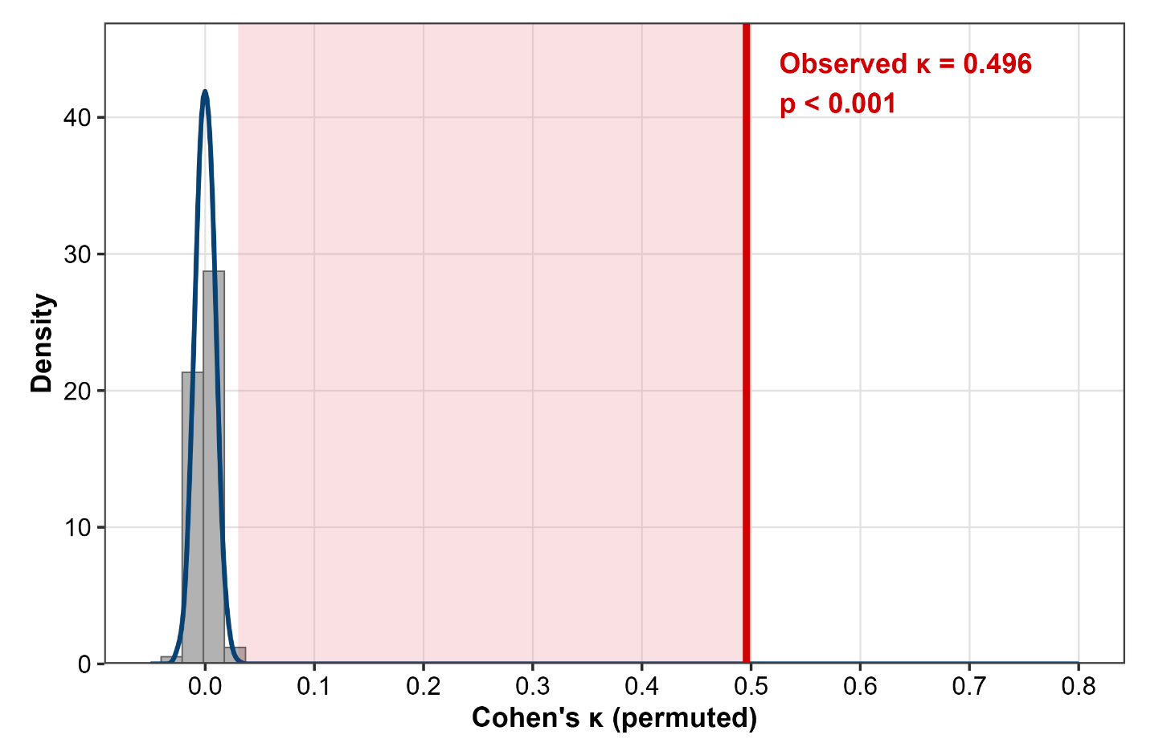
Figure S3: Permutation null distribution of Cohen's kappa (1,000 random shuffles of individual 11490's state sequence while retaining 11488's sequence intact). Red vertical line = observed kappa = 0.496; permutation p < 0.001.

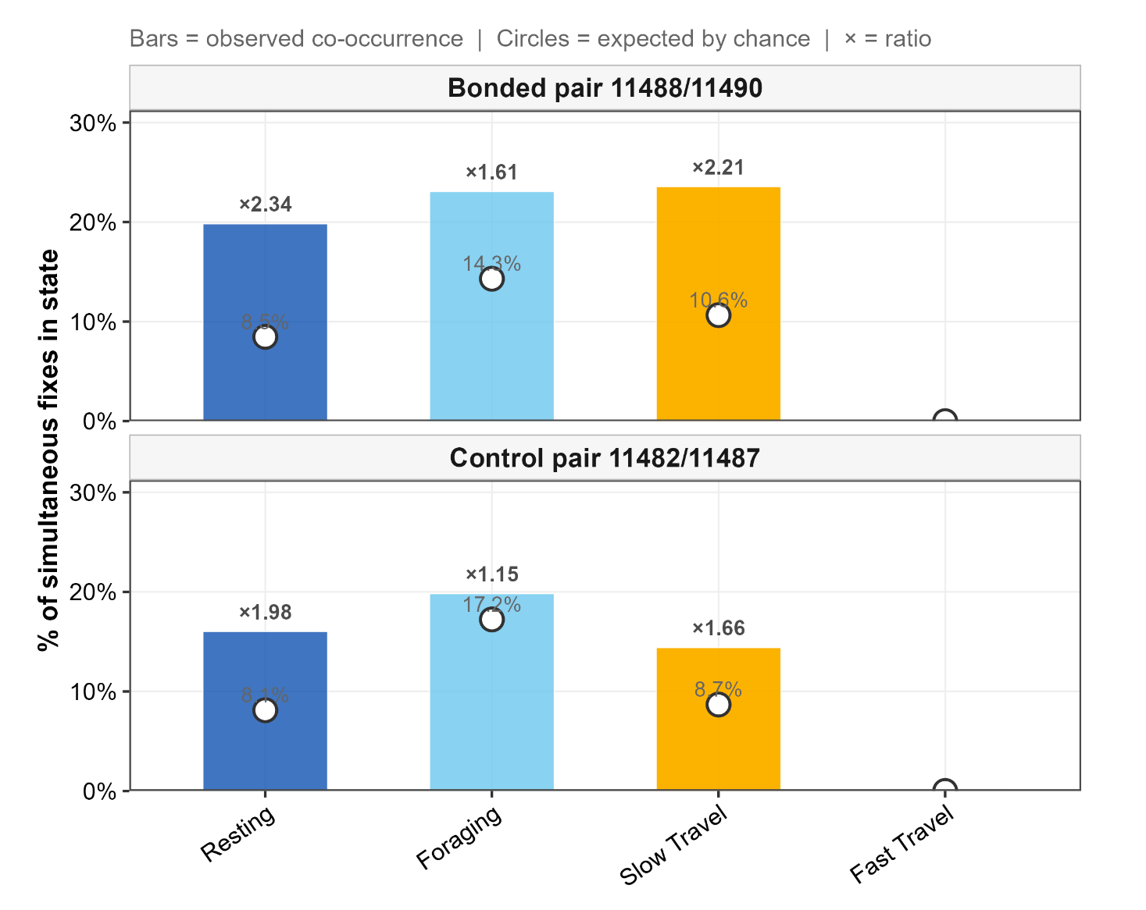
Figure S4: Per-state synchrony for the bonded pair (bars) and control pair (outlined bars), showing the proportion of matched timestamps where both individuals simultaneously occupied each state (filled bars) against the expected proportion by chance (open circles). Fast Travel not shown (zero simultaneous events).

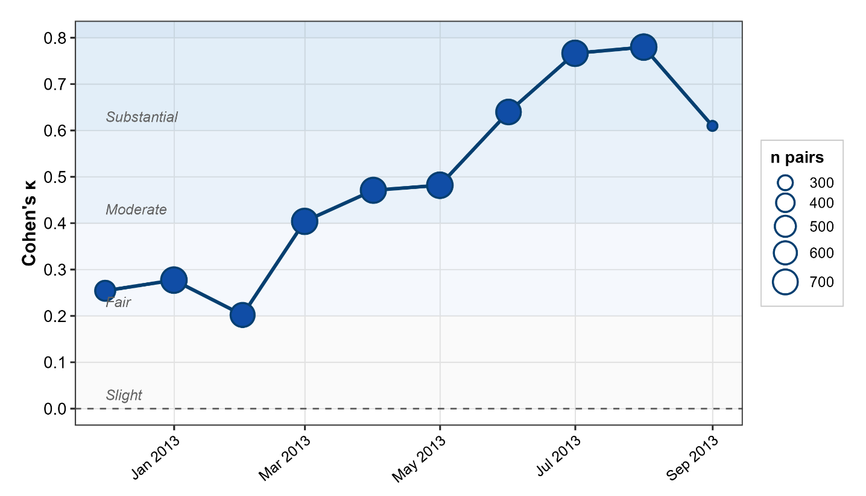
Figure S5: Monthly Cohen's kappa for the bonded pair across the December 2012 to September 2013 co-monitoring period; point size proportional to number of matched fix pairs in that month.

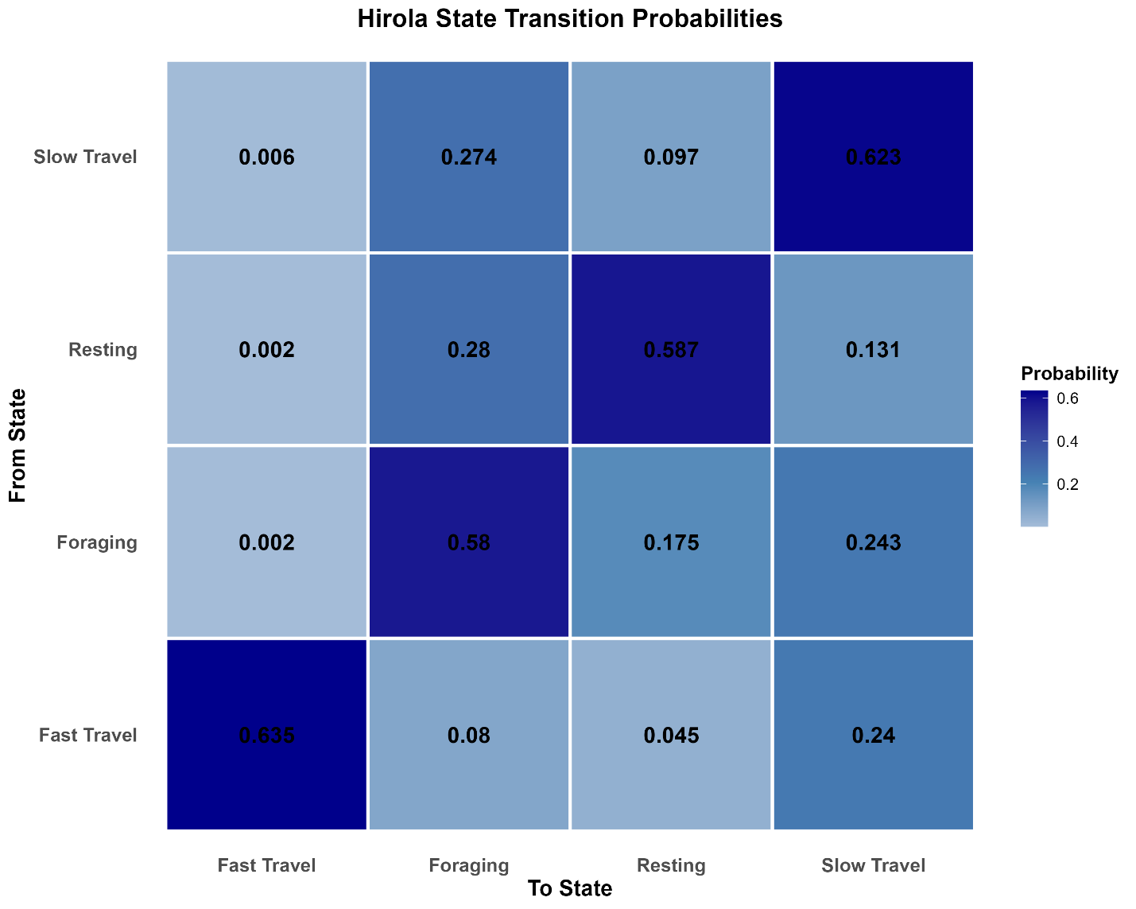
Figure S6: One-step transition probability matrix from the four-state HMM. Cell values give the probability of transitioning from the row state (From) to the column state (To) in a single GPS fix interval (~1 hr).

Tables
Table S1: Distribution summary for 1,000 non-parametric bootstrap replicates of residence times (hours) per state. Valid replicates: 1,000/1,000.
State | Bootstrap mean (hr) | Bootstrap SD | q2.5% | q97.5% | n valid
Resting | 2.67 | 0.068 | 2.55 | 2.81 | 1,000
Foraging | 2.72 | 0.092 | 2.52 | 2.88 | 1,000
Slow Travel | 3.14 | 0.143 | 2.88 | 3.42 | 1,000
Fast Travel | 3.47 | 0.374 | 2.79 | 4.21 | 1,000

Table S2: Individual-level state proportions and Fast Travel summary
ID | Resting (%) | Foraging (%) | Slow Travel (%) | Fast Travel (%) | Ali & Muriuki, (under review) ctmm model
11482 | 27.6 | 40.8 | 30.9 | 0.73 | OU (range-resident)
11483 | 26.1 | 32.4 | 40.9 | 0.65 | OUF (directionally persistent)
11486 | 27.1 | 31.1 | 40.6 | 1.15 | OUF (directionally persistent)
11487 | 29.3 | 42.2 | 28.2 | 0.34 | OUF (directionally persistent)
11488 | 26.8 | 37.6 | 35.1 | 0.51 | OU — bonded pair with 11490
11490 | 30.4 | 38.3 | 31.0 | 0.33 | OU — bonded pair with 11488
11491 | 26.3 | 44.4 | 29.0 | 0.32 | OU (range-resident)
Population mean | 27.8 | 38.2 | 33.4 | 0.60 | —

Table S3: Lunar illumination GLMM fixed effects
Term | β (estimate) | SE | z | p | 95% CI
(Intercept) | −5.720 | 0.311 | −18.40 | < 0.001 | [−6.33, −5.11]
scale(lunar_illumination_pct) | 0.063 | 0.061 | 1.02 | 0.306 | [−0.06, 0.18]

Table S4: Nocturnal Fast Travel rate by lunar quintile
Quintile | Mean lunar (%) | Range (%) | n fixes | n Fast Travel | Prop. Fast Travel (%)
1 (darkest) | 3.2 | 0–9 | 11,439 | 41 | 0.36
2 | 20.8 | 9–34 | 11,439 | 57 | 0.50
3 | 49.7 | 34–65 | 11,439 | 61 | 0.53
4 | 78.8 | 65–91 | 11,439 | 60 | 0.52
5 (brightest) | 96.8 | 91–100 | 11,439 | 49 | 0.43

Table S5: 3-state intercept HMM step-length parameters
State | Mean step (m) | SD step (m) | Zero-mass | Angle κ
Resting | 7.9 | 6.6 | 0.0021 | 0.00
Foraging | 168.2 | 167.3 | 0.0000 | 0.16
Travel | 612.5 | 639.2 | 0.0000 | 1.28

Table S6. Covariate beta coefficients from the 3-state covariate HMM
Covariate | R→F | R→T | F→R | F→T | T→R | T→F
(Intercept) | −0.87 | −3.76 | −2.28 | −1.57 | −8.07 | −0.92
hour_sin | 1.01 | −2.92 | −0.96 | 2.67 | 6.53 | −0.57
hour_cos | −0.65 | −2.33 | −0.35 | −3.29 | −5.51 | −0.11
temp_sc | −1.22 | 0.55 | −1.93 | −3.04 | −0.48 | −1.01

