A bibliometric analysis was done to understand the types of studies done in the area of climate change and school dropout. Figure SS1 shows the network map of the number of occurrences (minimum four times) of a particular word in an article when searched with keywords such as “climate variability” OR “drought” with “school attendance” OR “school dropout” OR “school attainment” OR “education”. The result was divided into three clusters. “School dropout “or “education” was mostly found to be linked with words such as “rainfall”, “climate variability”, “climate change”, “weather”, “flood” and “natural disaster”. It was evident from the analysis that though many literatures have focused on different aspects of climate variability and school dropouts, very few works have been done focussing on drought and its effects on school dropouts, specifically in India.
Figure SS2 shows the amount of co-authorship of articles related to “drought” or “climate variability” with countries. Results showed that most of the articles were co-authored by the African countries such as Ghana, South Africa, Kenya, Ethiopia and others. The western countries included countries like UK, US, Germany, Mexico and others. The important Asian countries were China, India, Vietnam and others. Very few literatures were found to be from India, which emphasizes that there is a scope to study the various dimensions of climate variability and education in India.

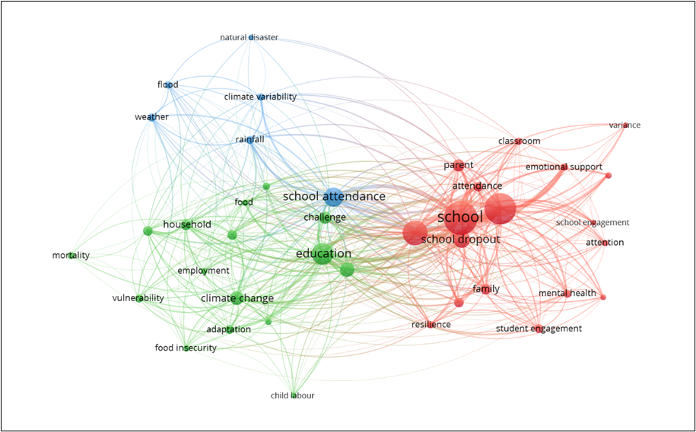
Figure S1. Co-occurrence plot for keywords in the field of climate and education.
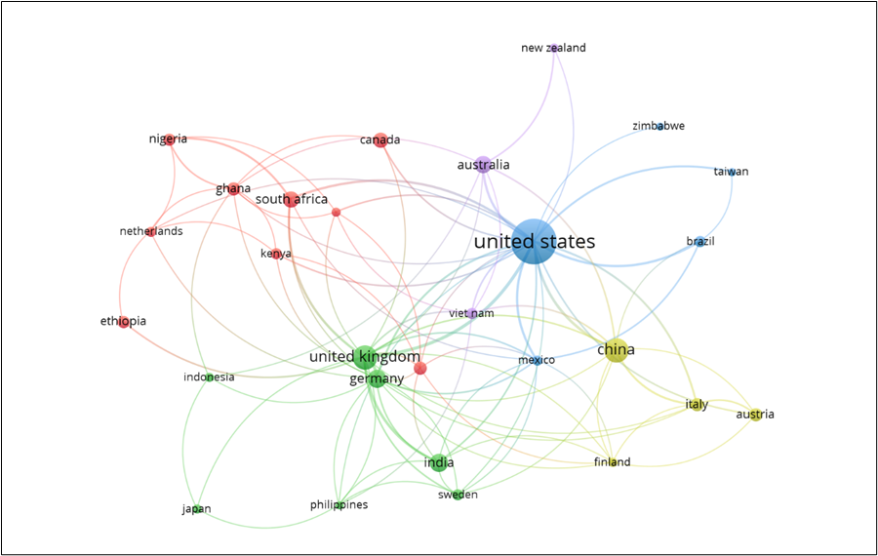
Figure S2. Network visualization map of international research collaboration countries in the climate and education association related literature.

Table S.1. Review matrix of existing studies on the relationship between climate change and education
Paper name | Data Source | Outcome Variable | Independent Variables | Model/Methods used | Results
Climate variability and educational attainment: Evidence from rural Ethiopia | Ethiopian Rural Household Survey (ERHS)  Climate Research Unit (CRU) | Climate data included temperature and rainfall data linked with survey data at village level  Children at (12-14y) for primary education and (15-16y) for secondary education  Child attending school, completed atleast a grade of schooling and schooling outcomes  Mean seasonal z-scores during school ages and in utero | Relationship to the household head (child or grandchild), dummy variables for the child’s year of age, the number of children aged zero to six in the household, the number of children aged seven to 18 in the household, age of the household head, whether the household head had any formal schooling, and land area owned by the household in hectares. | Multivariate regression models  Z score values to make different indices such as drought indices | Early life favourable climatic conditions increase likelihood for completing schooling and increased school attendance.
The Effects of Climate Change on Children’s Education Attainment | - | Search criteria used-  case studies regarding initiatives to support adaptation efforts among children to climate change  case studies of climate change education projects and initiatives focused on schools | - | Qualitative study and review of case studies  Including bibliographic search using desk review techniques. | Interventions at various level such as climate-literacy interventions and climate-education interventions can be done.
Droughts and rural households’ wellbeing: Evidence from Mexico | The Mexican Drought Monitor  Mexico’s National Labor Survey | Precipitation data (the Standardized Precipitation Index, and Percent of Average Precipitation); water availability, temperatures, and evaporation (Palmer index, Palmer hydrological index, and Palmer Z index); a vegetation health index (VHI); and soil moisture  School attendance and decrease in school employment | Earnings  Employment | Difference in differences approach | Droughts reduced female employment and male school attendance.
Climate variability and the dichotomy in male–female school attendance: a case study of Zamfara State in semi-arid Nigeria | Nigerian Meteorological Agency archive.  School enrolment and attendance data for 12 primary schools were obtained for the period 1970 to 2006, using purposive and systematic sampling techniques. | Temperature and rainfall data  School attendance was subtracted from school enrolment to calculate the dropout. | - | Bivariate (Spearman) correlation, pairwise t-test, standardised anomaly index and descriptive statistics | Rainfall had a more significant relationship with male attendance than female. The extent to which rainfall significantly determined school attendance varied from 14.82 to 25.9 %.
The effect of consecutive disasters on educational outcomes |  | The variable of interest is the days taken to drop out, measured as the 4 number of days between the exit date recorded in the DEPR-SIS and 15 September 2017. | Poverty, Income and disability. | The empirical analyses include the difference-in-difference method (DD), the Heckman–Copula estimation, Propensity Score Matching, the Cox and Weibull duration regressions, and the Ordinary Least Square (OLS) method. | Students in severely affected areas, or whose school was permanently closed after the hurricane, have higher probabilities of decreasing their academic achievement and, for some students, dropping out of school after a disaster.
Effect of drought on smallholder education expenditures in rural Iran: Implications for policy |  | The dependent variable used was per capita household expenditures on education which included enrolment fees, stationery and transportation costs and costs of out of school courses which was spent by a household for a year. |  | Tobit multiplicative heteroscedasticity regression was used to estimate the relationship between drought and smallholder expenditures on education. | In drought-affected families, girls were more likely to be pulled out of university education than were boys; however, for school education, there were no significant differences between the boys and girls.
Factors Leading to School Dropouts in India: An Analysis of National Family Health Survey-3 Data | National Family Health Survey-3 Data | Main variables were the standard attending, school attendance in the previous year (2004-05) and standard, and most important reason for dropping out of the school if member is out of school for 6-16 years age to analyse dropout from first to tenth grade. | Religion, Caste, Place of residence, household size, number of living children, sex of household head, agricultural land, standard of living index, couple’s education, parents occupation, mothers’ media exposure. | Bivariate analysis and binary logistic regression model | About 14 percent of the children never attended the school and 11 percent dropped out of school for various reasons.  Parental education, caste, religion and others as important determinants.
Determinants of school dropouts in India: a study through survival analysis approach | 75th round of NSSO data | Outcome variable-population aged 18–35 years who have dropped out from school at any level before reaching 12th standard | Gender, sector, caste groups, religious groups, MPCE quintile, household size, type of institution, and social groups, education of the household head.  Dummy variables of the major reason for not currently attending school are also included as predictor, financial constraint, engaged in domestic activities, engaged in economic activities, School is far off, unable to cope up/failure in studies, and marriage (only for female population). | Cox proportional hazard model | No interest in education, distance from school, unable to cope up/failure in studies and financial constraint are the major reasons to elevate the risk of school dropouts
Detection of hotspots of school dropouts in India: A spatial clustering approach | UDISE+ of India | Outcome variables - the district-level overall dropout rates for primary, upper primary, and secondary levels. | Promotion rate, repetition rate, and a dropout rate of boys and girls. | Univariate and Bivariate Moran’s I  Ordinary least square (OLS) model, spatial lag model (SLM) and spatial error model (SEM). | The outcomes provide clear spatial clustering and precisely highlight the hot zone dropout regions with high repetition and low promotion rates
Exploring statistical approaches for predicting student dropout in education: a systematic review and meta-analysis | - | Systematic review and meta-analysis (2000-2023) to predict school dropout from different academic databases | - | To determine the proportion of the minority class (dropouts), a PRAW (meta-analysis) with random effects and a summary measure of proportion random effects model) analysis was used. | The review highlighted unsolved problems like data imbalance, interpretability, and geographic disparities that might lead to new research in the future.
Determinants of School dropouts among adolescents: Evidence from a longitudinal study in India | Longitudinal survey data- Understanding Adults and Young Adolescents (UDAYA) for Bihar and Uttar Pradesh | Adolescents who were enrolled in school during wave-1 but not during wave-2 (UDAYA study) were classified as “yes” (school dropout), while those who were enrolled in both waves were classified as “no”. | Place of residence, caste, religion, wealth index, mother’s education, engaged in paid work, substance use, state, role model, son preference,parental interaction, participation in sports activities, and gender discriminatory practices at home | Bivariate analysis, chi-square test and binary logistic regression analysis. | Dropout was prevalent among lower social and economic strata. Mother’s education, parental interaction, participation in sports and having role models reduce school dropout. Conversely, factors such as being engaged in paid work, substance abuse among boys, and gender discriminatory practices towards girls, are risk factors for dropout among adolescents. Lack of interest in studies and familial reasons also increase dropout.
Does lack of parental involvement affect school dropout among Indian adolescents? evidence from a panel study | Round-I and round-II of the India Human Development Survey (IHDS) | Children who were enrolled in school during round-I but were not enrolled during round-II of IHDS survey were categorized as school dropouts.  Explanatory variables were whether the parents participate in parent-teacher association (PTA) meetings; parents discussed the academic progress of the students with their schoolteacher; and, parents supervise the students while doing homework. | Age of the student in years, the gender of the student, type of student , type of school attended by the student, the student takes private tuition. Parent-related characteristics were–mother’s level of education, mother’s working status, father’s level of education, father’s working status. Socio-economic characteristics of the student households were also included–household wealth quintile, household below poverty line (BPL) status, caste of the household, religion of the household, type of community the student belongs, country region a student comes from. | Bivariate and multivariable analysis using logistic regression models | Negative effect of the lack of parental involvement on their children’s academic progress.
Vulnerability of women to climate change in arid and semi-arid regions: The case of India and South Asia |  | - |  | Literature review of peer-reviewed and generic literature. | Girls are always the first casualty of the school dropout syndrome, and the drop-out rate for girls increases during and after disasters.
Remember when it rained – Schooling responses to shocks in India |  | The school enrolment of each child from NSS data. The main analysis was restricted to children aged 6–18 years living in rural households.  The NSS data allowed to analyse how rainfall shocks affect education outcomes and how that relationship has changed over time. The education datasets were merged to gridded rainfall data using the closest longitude and latitude coordinates to the centre of a district. |  | Regression model | Adverse rainfall shocks have an increasingly stronger positive impact on school enrolment over time, whereas enrolment is increasingly falling after positive rainfall shocks. This effect is stronger for girls than for boys, more pronounced for older children, and is consistent with an increase in the importance of opportunity costs of a child’s time in more recent years.
Floods and Children’s Education in Rural India |  | IHDS data was used for the analysis. The first measure, grade-for-age, is defined as grade/(age –6), where grade is completed grades of education, age is a child’s reported age, and six is the typical age children are when they complete the first grade.1. Our other two outcome measures come from IHDS’s assessment of children’s math and reading skills. The IHDS ranked children’s performance on a math test from 1 to 4 in increasing order of math skills, cannot recognize numbers, able to recognize numbers, able to do subtraction, and able to do division. A similar ranking of 1 to 5 was used for performance on a reading test, with numbers referring, respectively, to children who could not recognize letters in the alphabet, could recognize letters in the alphabet, could read words, could read paragraphs, or could read stories. |  | The ordinary least squares (OLS) regressions with each of three dependent variables, grade-for-age, math skills, and reading skills. | Interactions between flooding and marginalization characteristics indicate that flood exposure is associated with disproportionately negative learning outcomes for girls and that economic resources may mitigate flood exposure effects on delayed school progress.

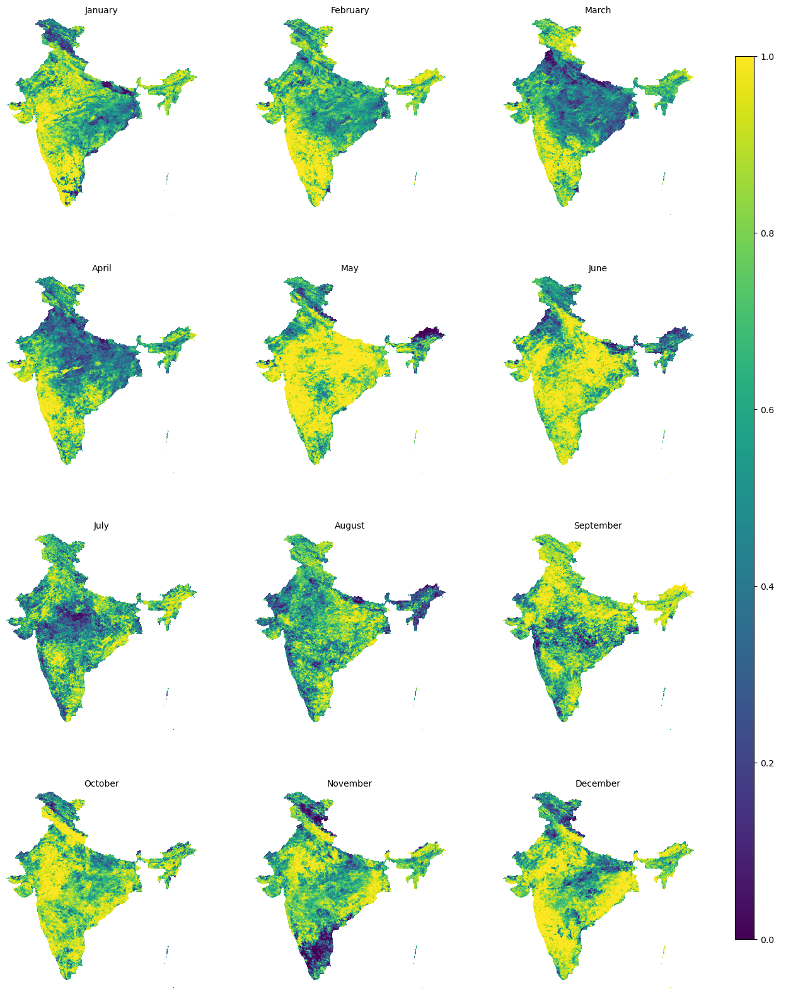
Figure S.3. Spatio-temporal distribution of VCI across India for the sample year of 2021

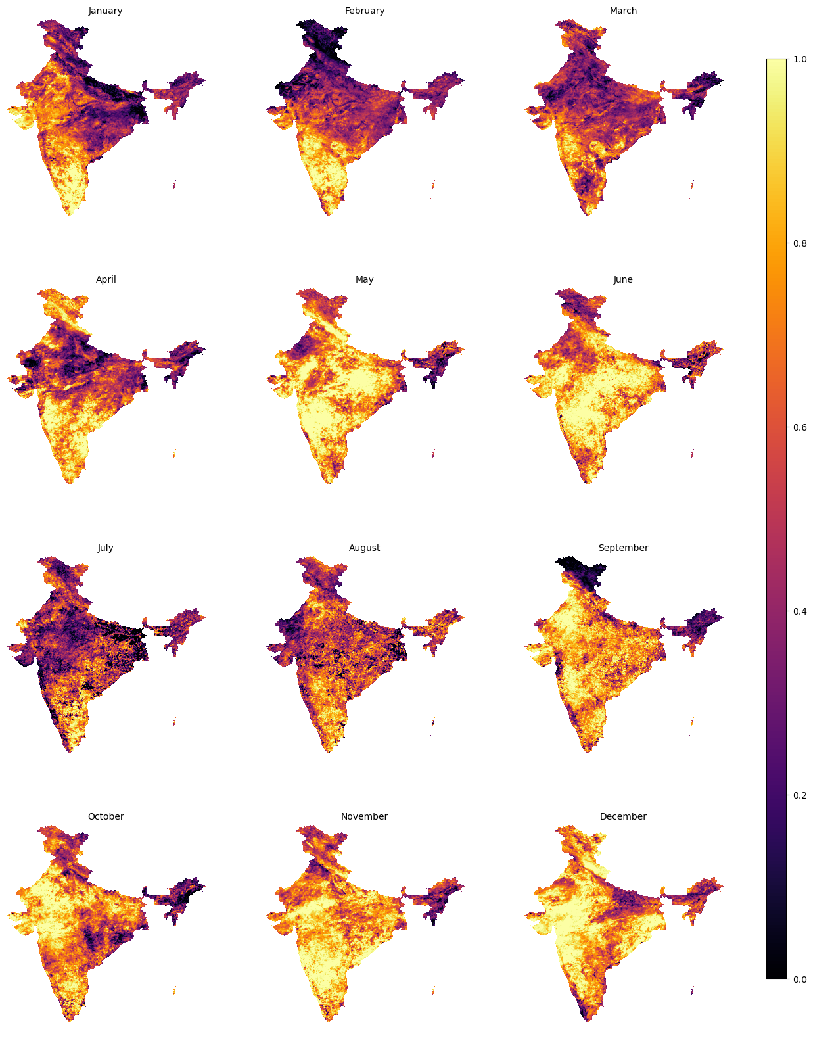
Figure S.4. Spatio-temporal distribution of TCI across India for the sample year of 2021
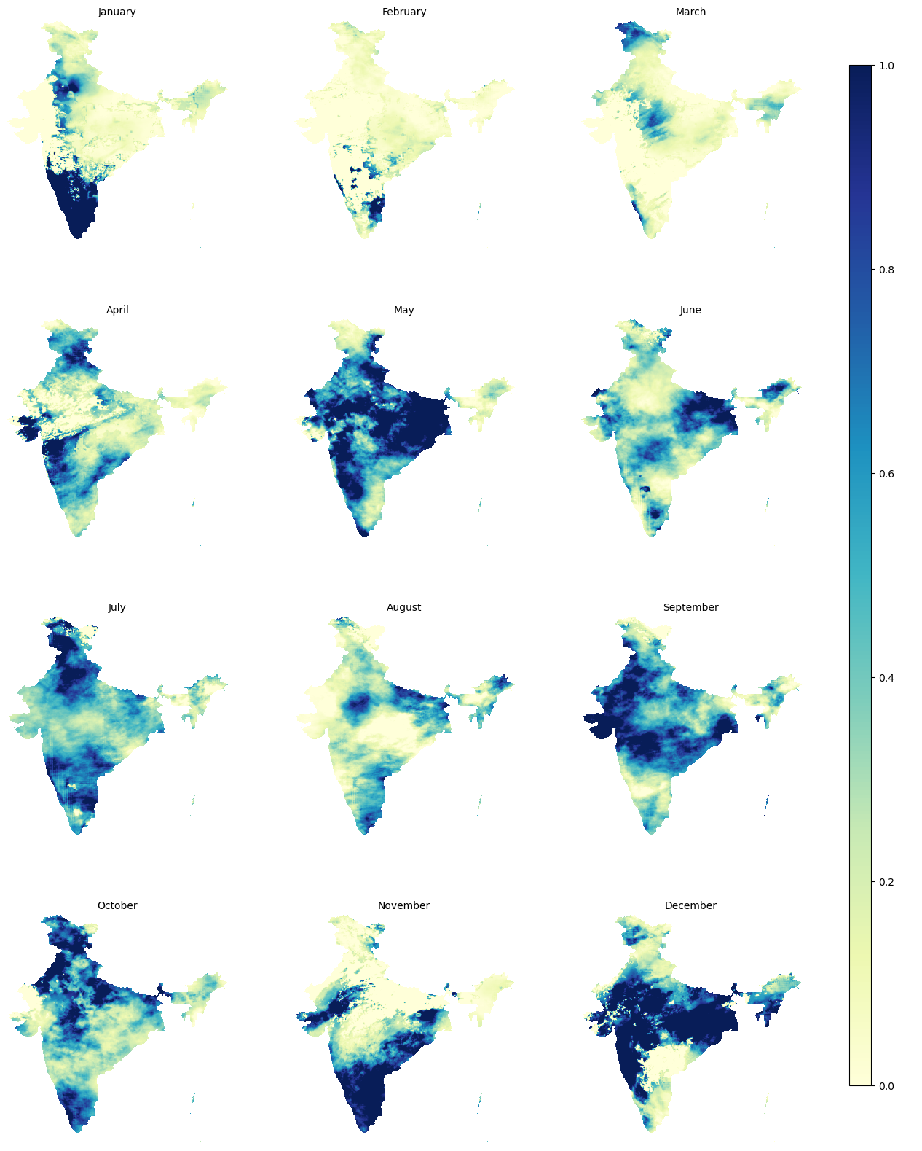
Figure S.5. Spatio-temporal distribution of PCI across India for the sample year of 2021

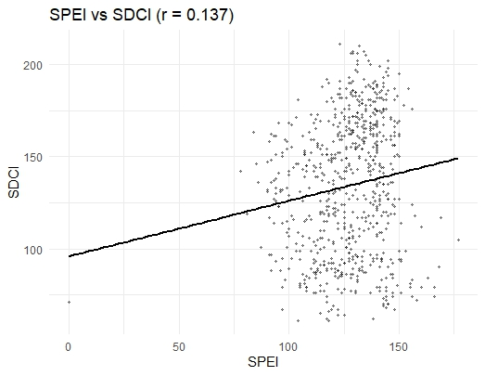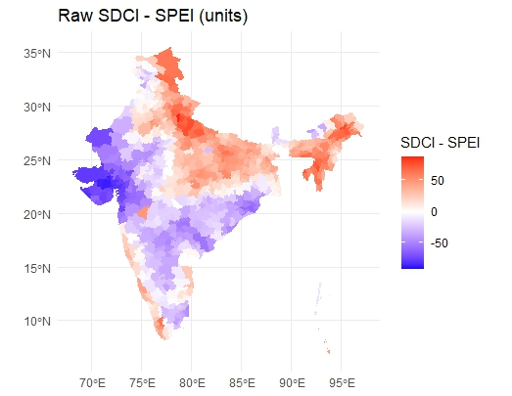
Figure S.6. Spatial association between agricultural (SDCI) and meteorological (SPCI) drought episodes across the Indian districts.

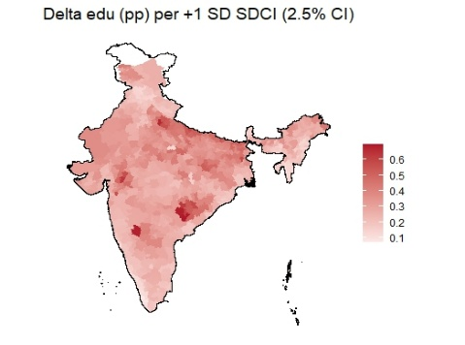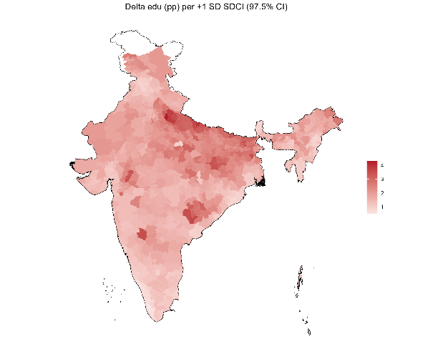
Figure S.7. Lower (left) and Upper (right) confidence bound of the estimated change in dropout rates per one standard deviation increase in SDCI.

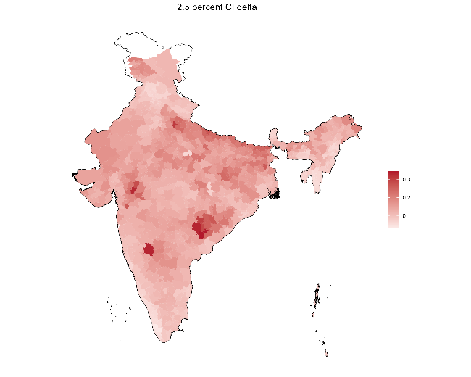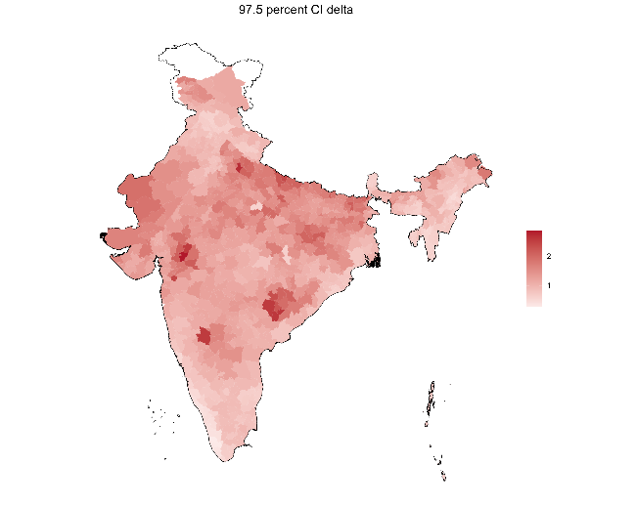
Figure S.8. Lower (left) and Upper (right) confidence bound of the estimated change in dropout rates per one standard deviation increase in SPEI.

