Supplementary file
Full uncropped gels and Blots image(s)

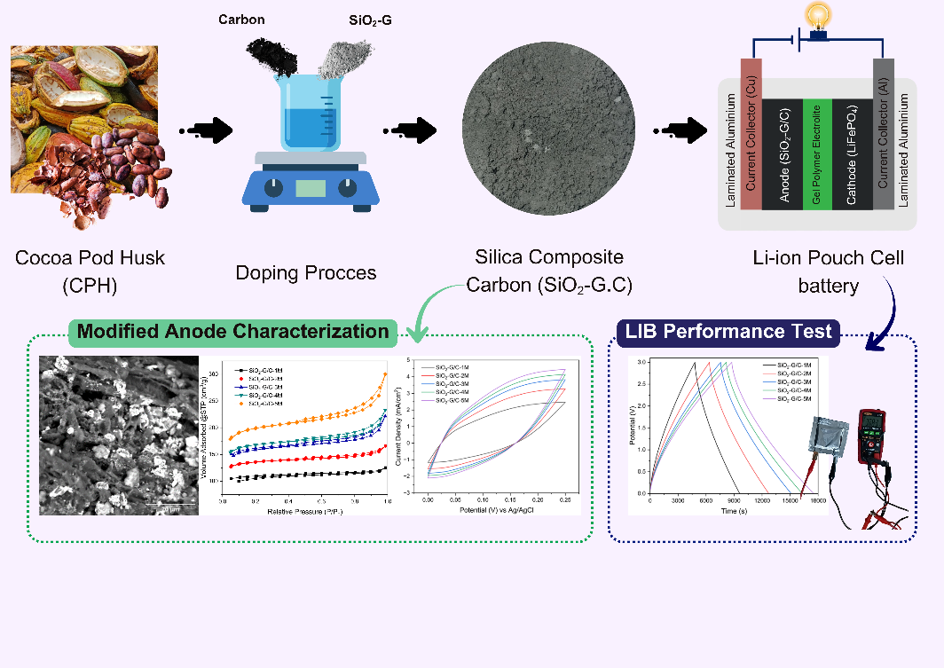
Graphical Abstract

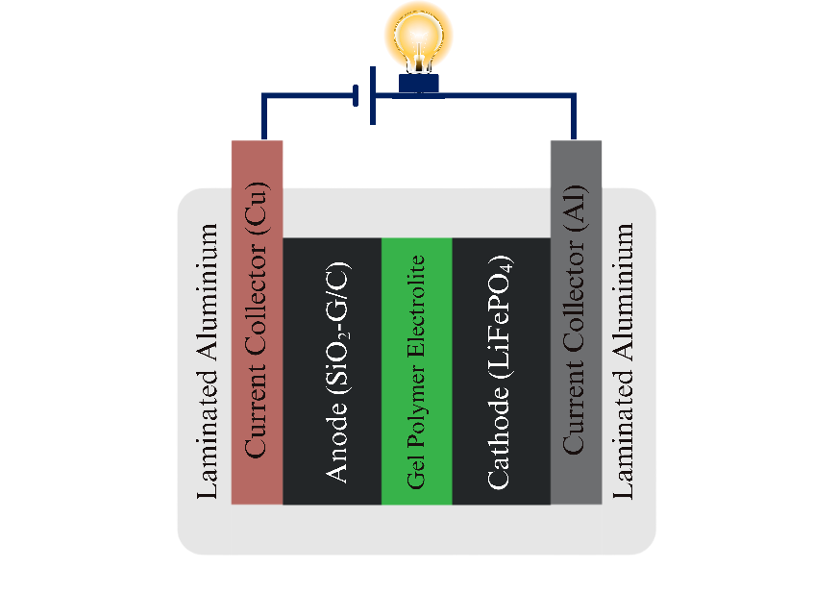
Figure 1 LIB Pouch Type Battery Cell Design

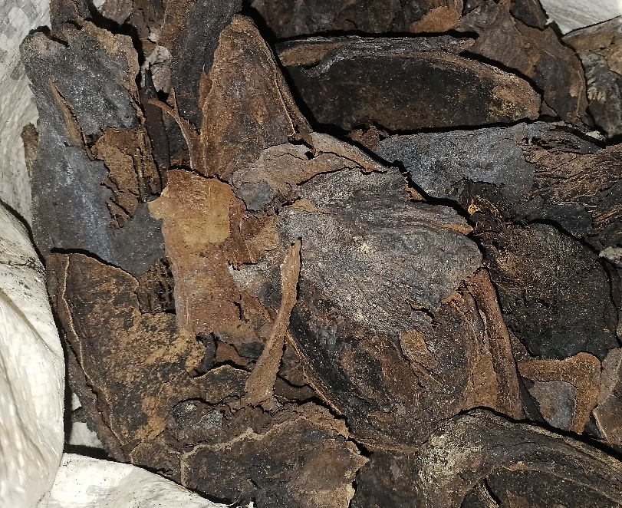
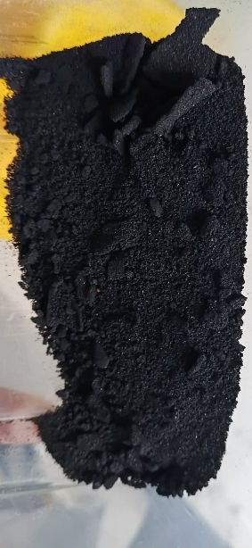
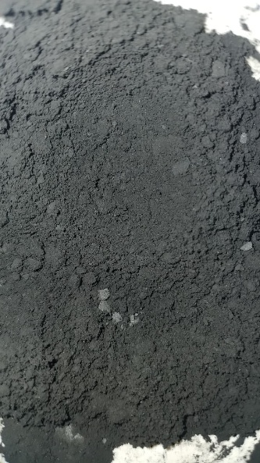
Figure 2(a) Dried CPH; (b) Activated Carbon from
CPH (C-CPH); (c) Silica Composite Carbon (SiO₂-G/C)

Figure 3 FTIR Infrared spectra of CPH, C-CPH, and SiO₂-G/C

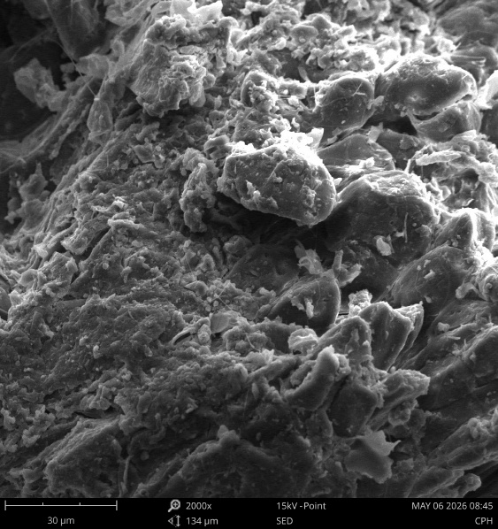 | 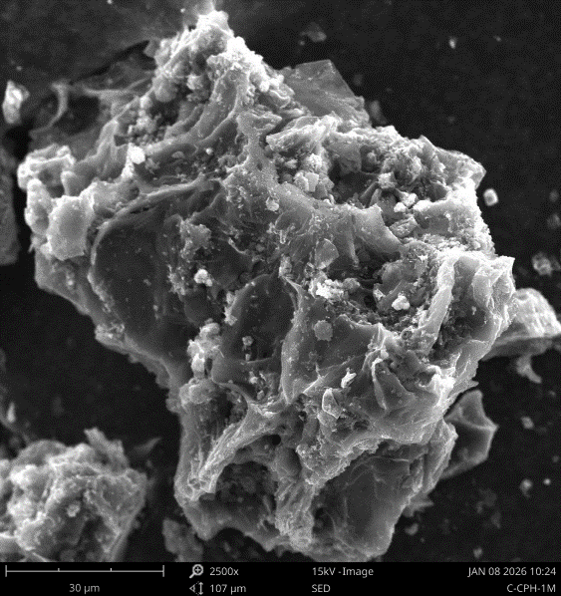
(a) | (b)
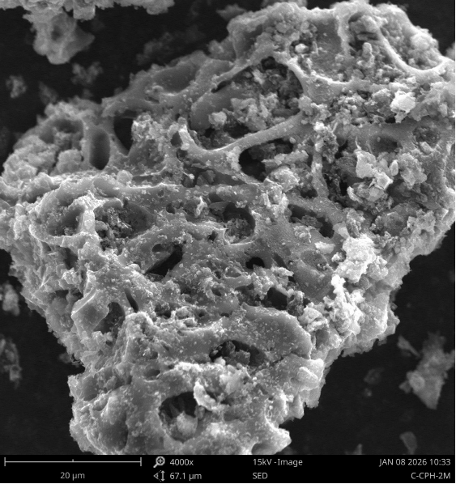 | 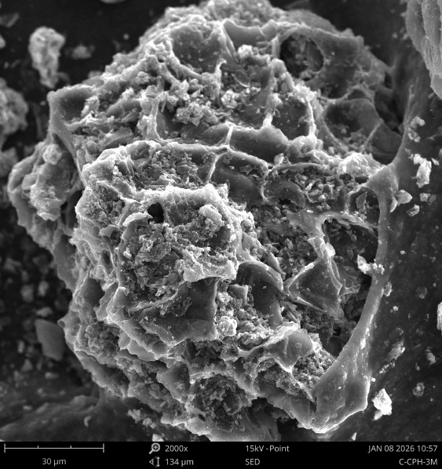
(c) | (d)
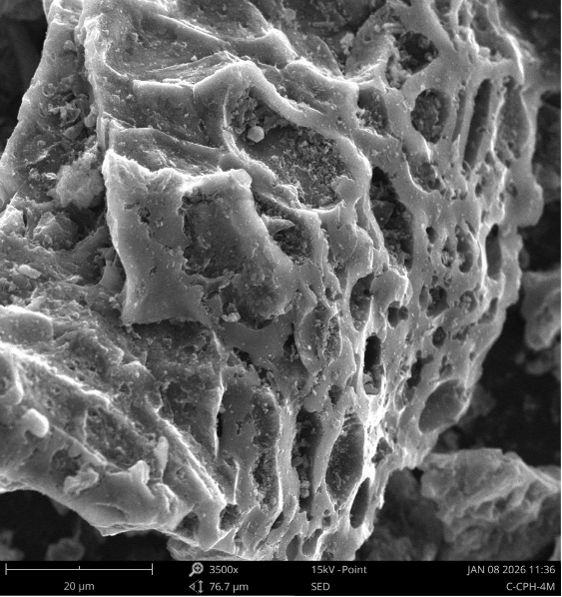 | 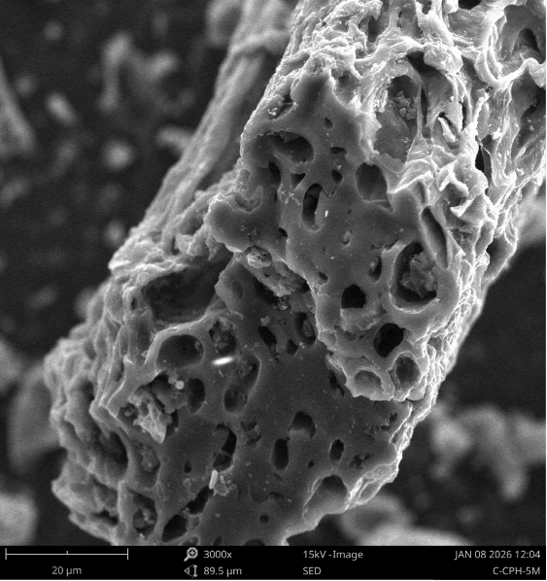
(e) | (f)
Figure 4 Activated Carbon (-CPH) Morphological Structure: (a) CPH; (b) C-CPH 1M; (c) C-CPH-2M; (d) C-CPH-3M; (e) C-CPH 4M; (f) C-CPH 5M

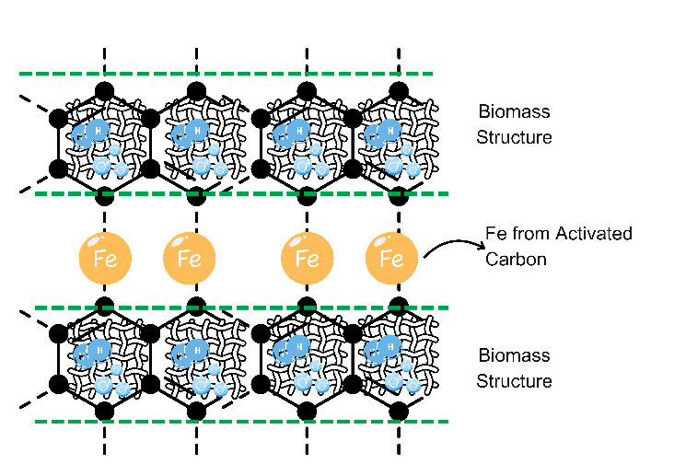
(a)
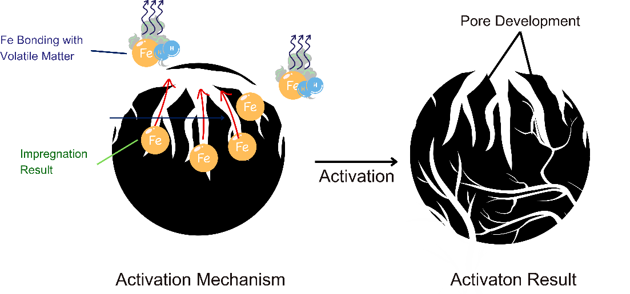
(b)
Figure 5 Activation Mechanism: (a) Iron Reaction with Volatile Matter;
(b) Iron Created Pore Template during Activation

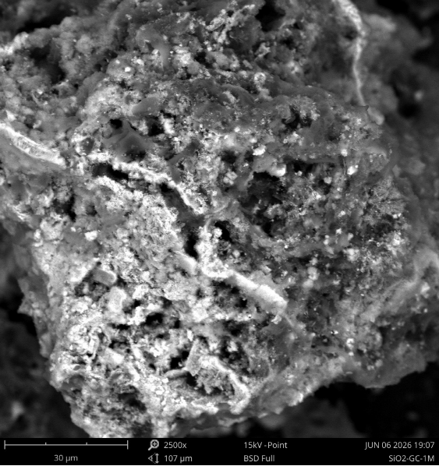 | 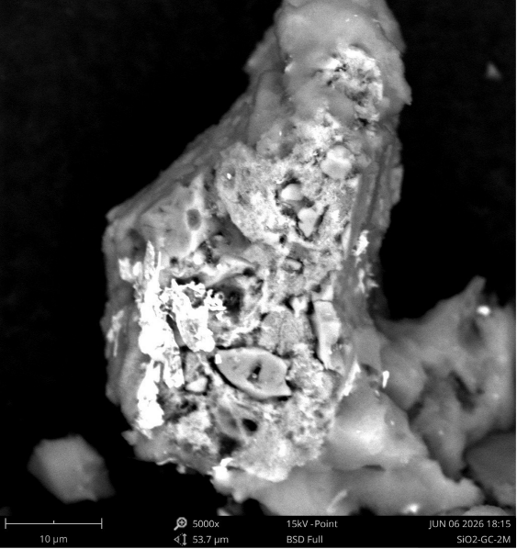
(a) | (b)
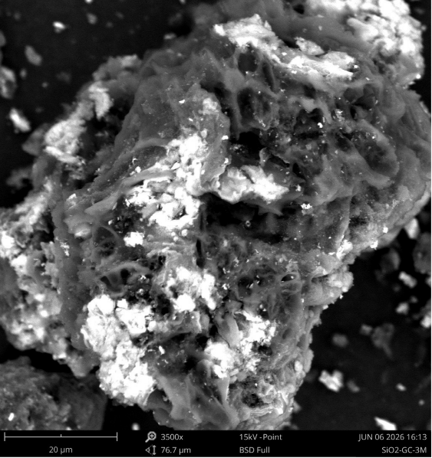 | 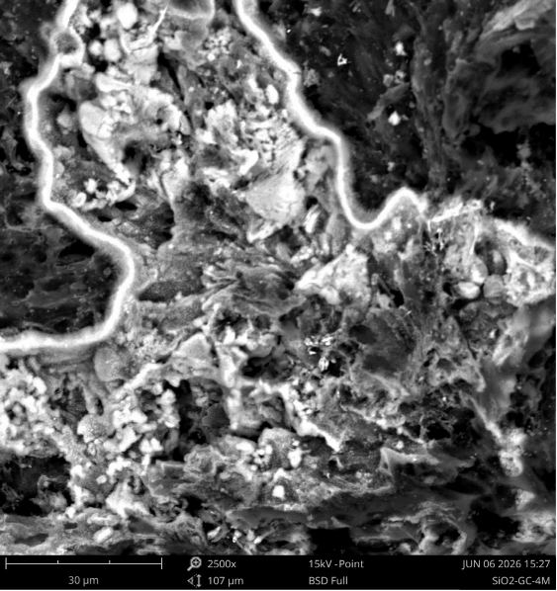
(c) | (d)
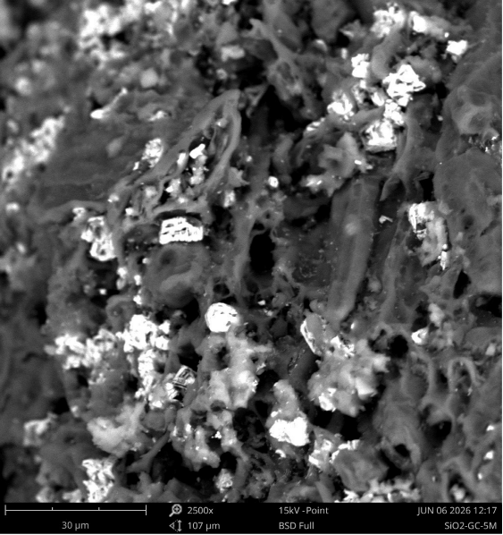
(e)
Figure 6 Morphological Structure: (a) SiO₂-G/C-1M; (b) SiO₂-G/C-2M; (c) SiO₂-G/C-3M; (d) SiO₂-G/C-4M; (e) SiO₂-G/C-5M

Figure 7 Nitrogen Adsoption-desorption of SiO₂-G/C from BET-SAA

Figure 8 Nitrogen Adsoption-desorption of SiO₂-G/C from BET-SAA

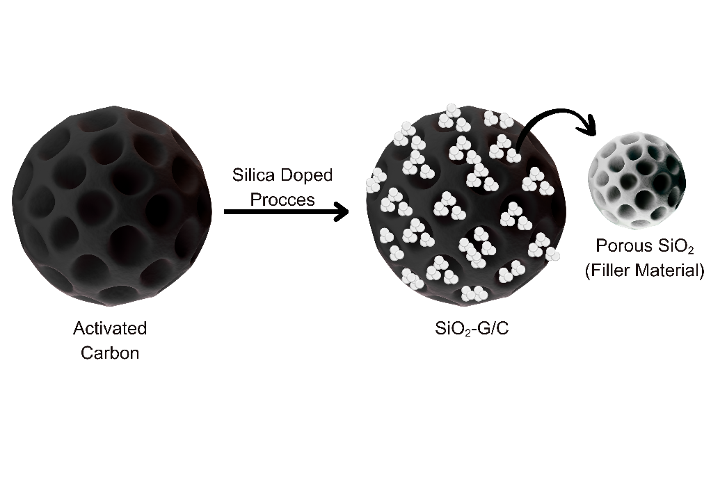
Figure 9 Improvement of Pore Structure in SiO₂-G/C Material

Figure 10 C-CPH Voltamogram Curve

Figure 11 SiO₂-G/C Voltamogram Curve

Figure 12 C-CPH Nyquist Plot Result

Figure 13 SiO₂-G/C Nyquist Plot Result

Figure 14 Voltage vs Time GCD curve of Pouch cell LIB with SiO₂-G/C Anode Modification

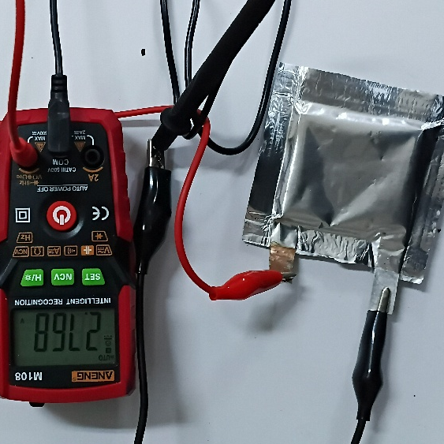 | 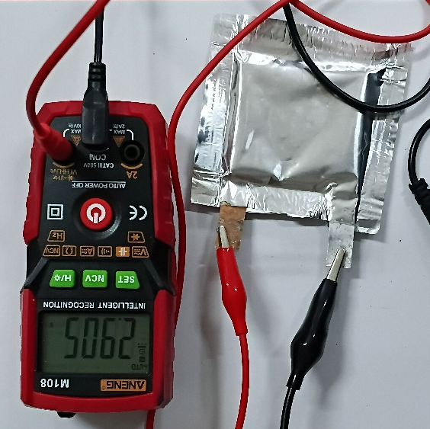
(a) | (b)
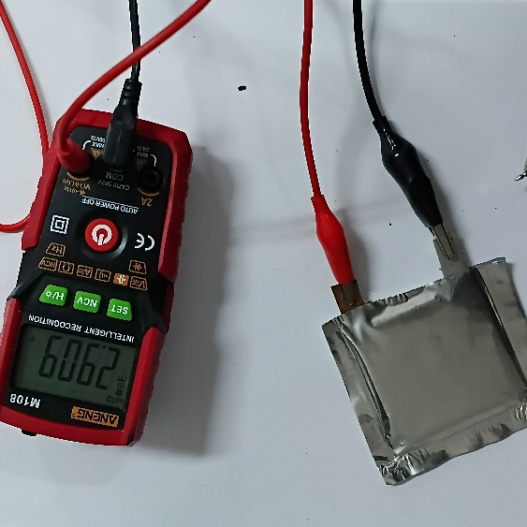 | 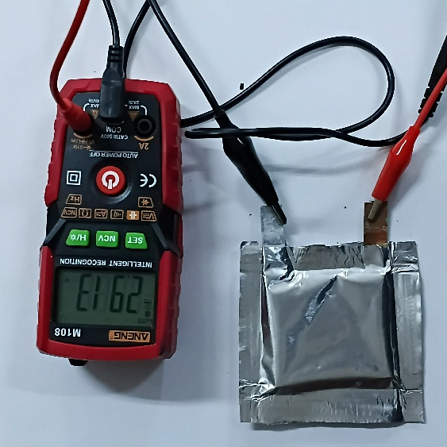
(c) | (d)
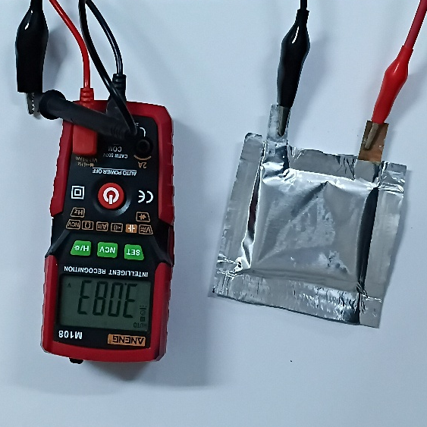
(e)
Figure 15 Voltage Test of Pouch Cell LIB with Anode Modification
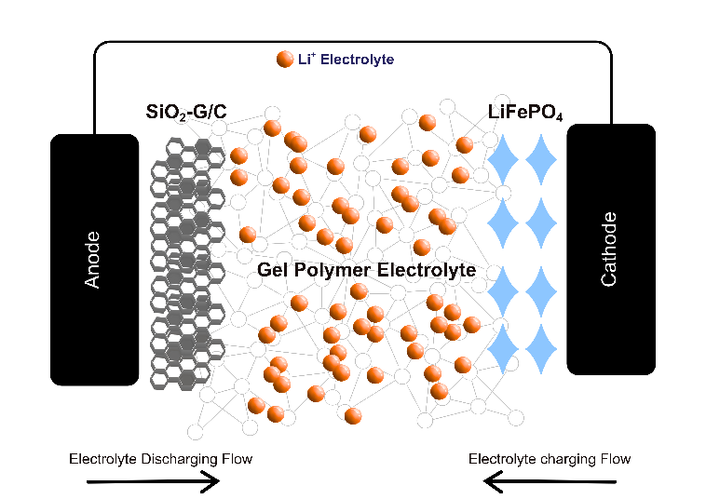
Figure 16 Charging-Discharging Mechanism of Pouch Cell LIB

