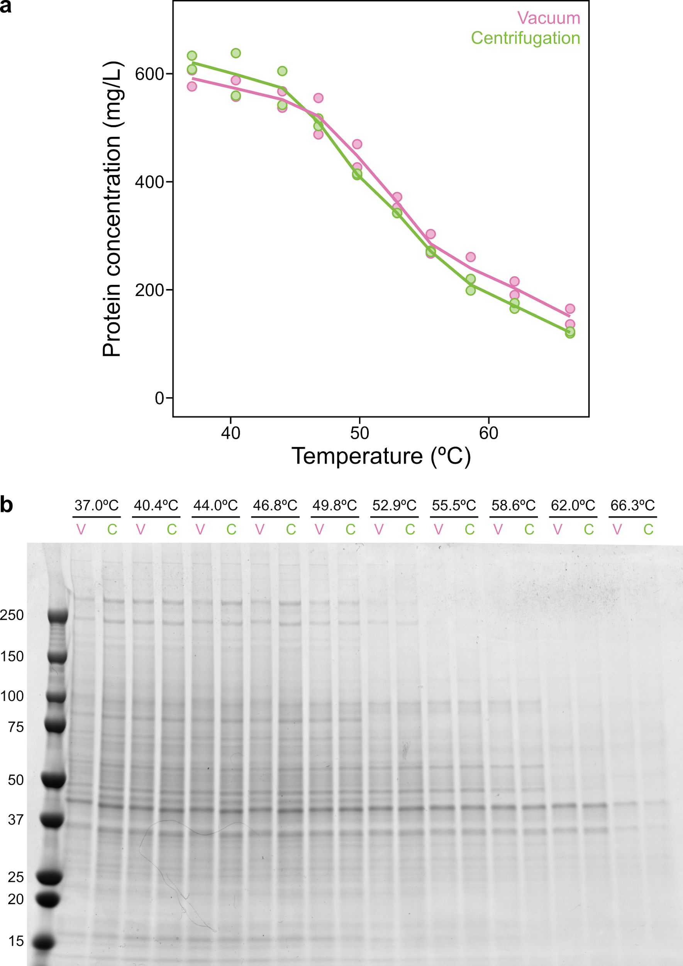
Figure S1. Comparison of centrifugation versus vacuum-based protein aggregate removal. a) Side by side comparison of centrifugation or vacuum manifold based removal of protein aggregates. Intact HeLa cells were subjected to 10 different temperatures and lysed with NP-40. Efficiency of protein aggregate removal through a 0.45 µM filter was compared between a vacuum manifold or centrifugation. Aggregate removal was assessed by quantifying the percentage of protein remaining soluble by BCA protein determination (n=2 technical replicates). b) HeLa test samples prepared according to S1A subjected to SDS-PAGE and stained with Coomassie Blue to visualize melting profiles.

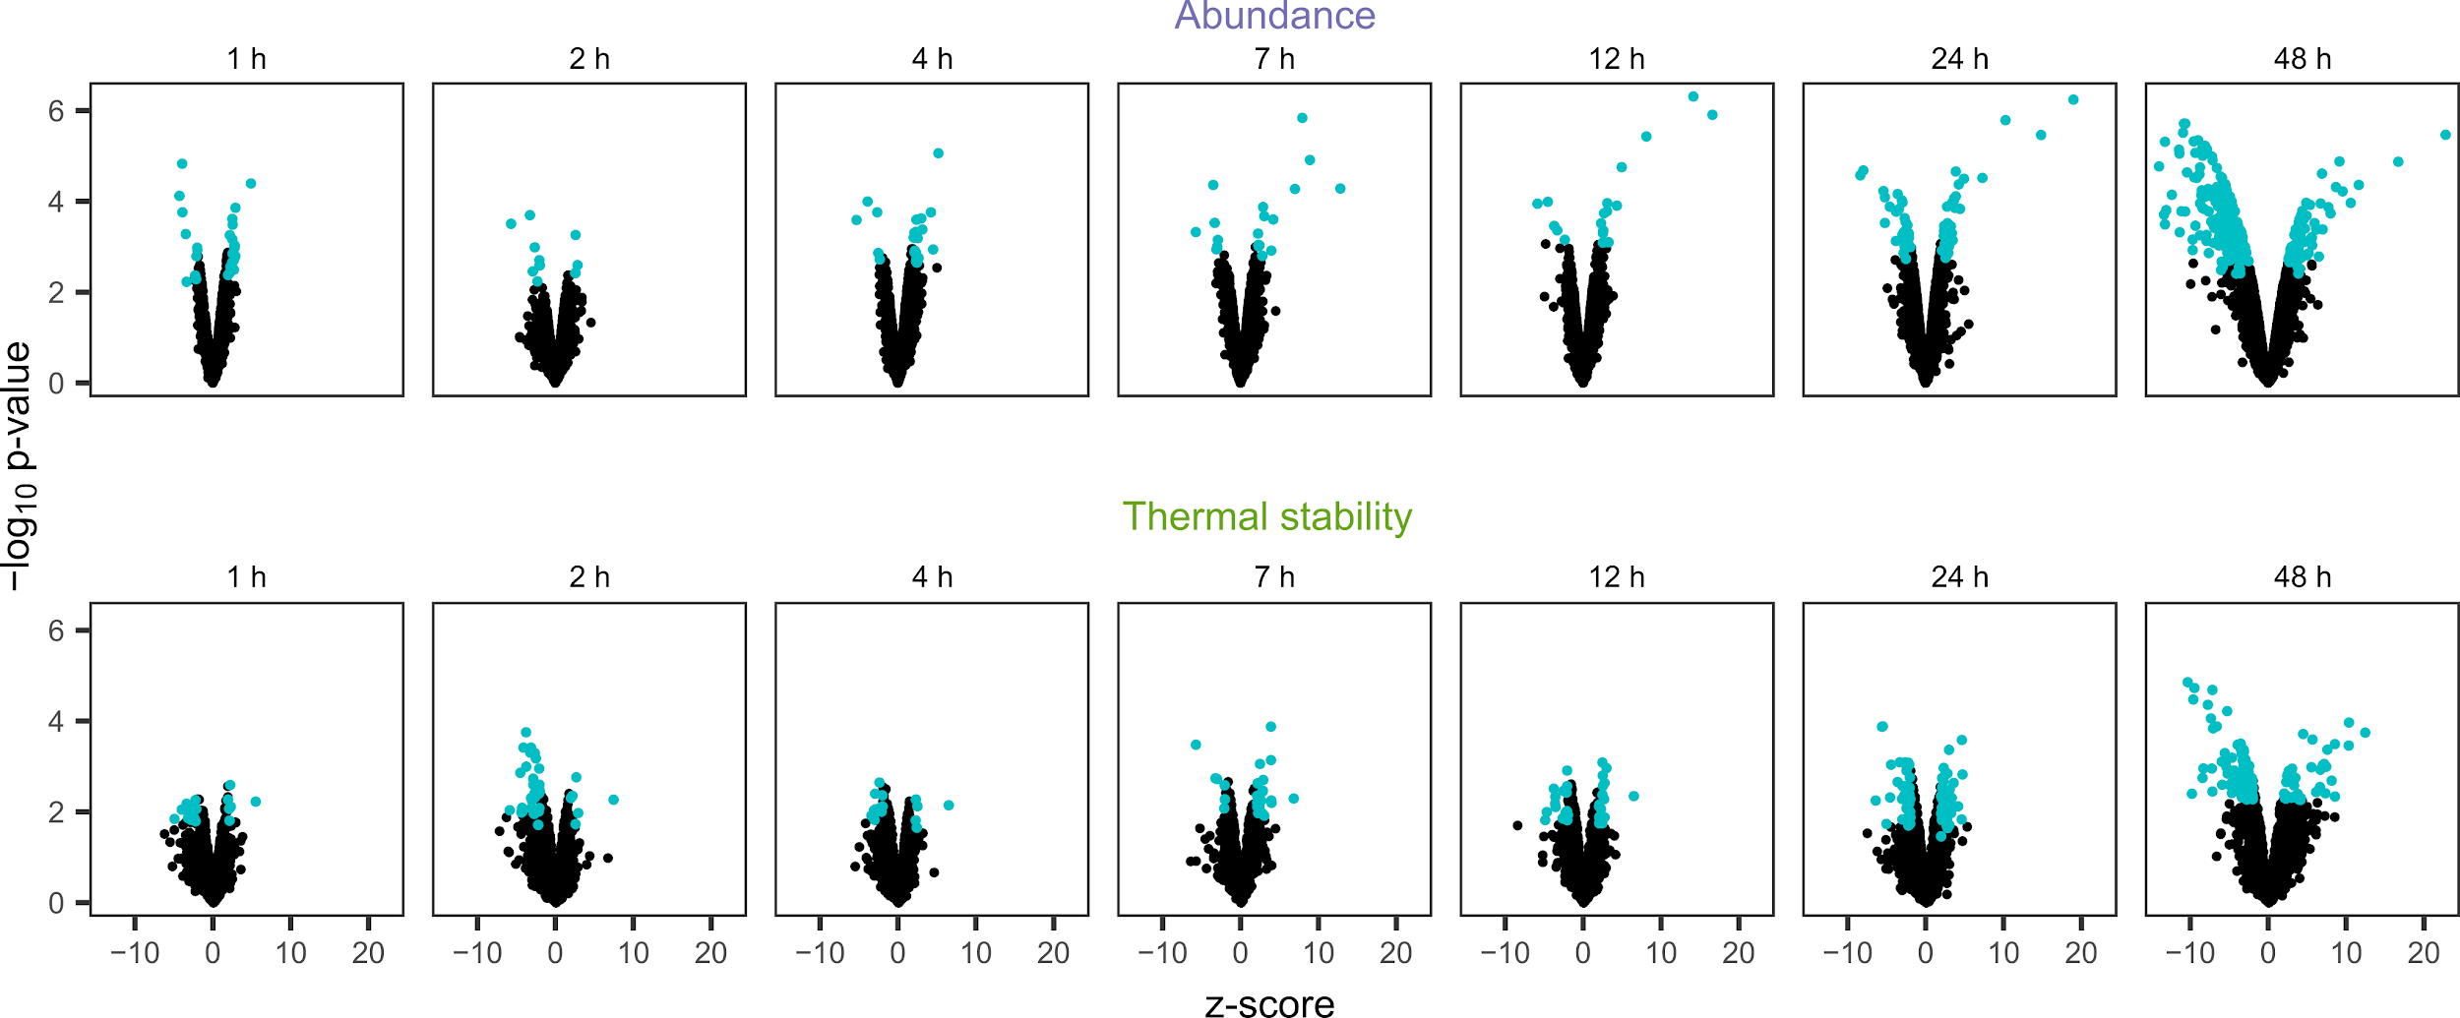
Figure S2. SARS-CoV-2 time dependent effects on proteome thermal stability and abundance. a) Volcano plots of all proteins detected in SARS-CoV-2 infected Caco-2 cells. Proteins classified as hits (|z-score| > 1.96 and q-value <0.05; see Methods for details) are indicated in cyan, data from three biological replicates.

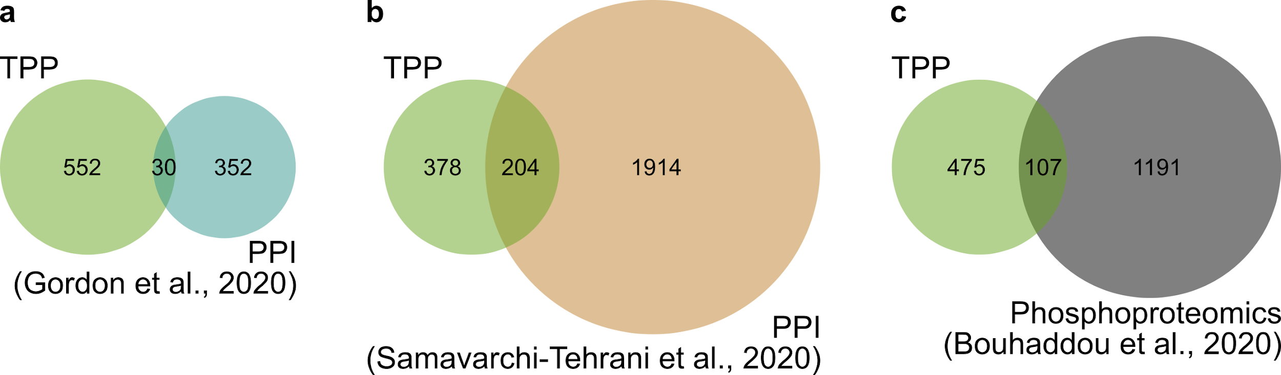

Figure S3. Convergence of SARS-CoV-2-induced changes to the host proteome. a) Venn diagram displaying overlap of proteins with altered thermostability and abundance (this work) and those that interact with SARS-CoV-2 proteins by AP-MS from previous work ^{3,6}. b) Venn diagram displaying overlap of proteins with altered thermostability and abundance (this work) and those that interact with SARS-CoV-2 proteins in BioID experiments from previous work ²⁰. c) Venn diagram displaying overlap of proteins with thermostability and abundance changes and previously observed changes in phosphorylation states upon SARS-CoV-2 infection ².

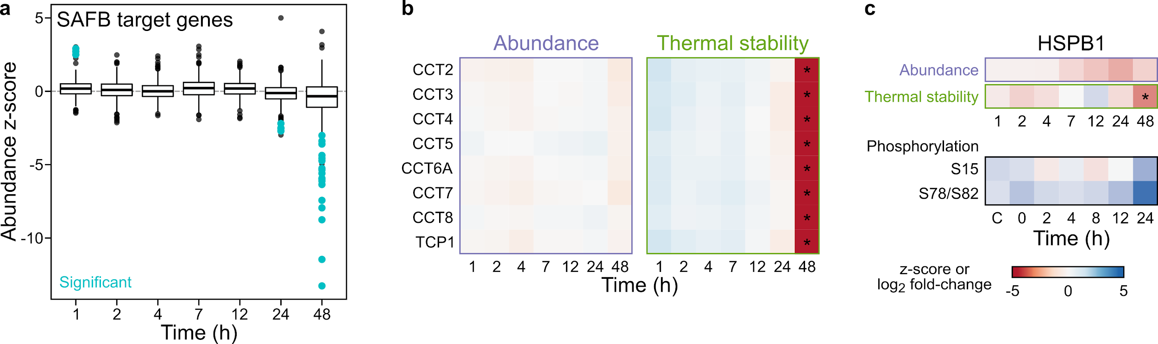
Figure S4. Thermostability changes in host proteins of significance to SARS-CoV-2.
A) A total of 362 SAFB target genes (as defined in ⁴²) protein abundance changes upon SARS-CoV-2 infection. Significantly regulated proteins are colored (turquoise). A total of 3 proteins were significantly upregulated at t_{1 ,} whereas 4 at t₂₄ and 18 at t₄₈ were downregulated. B) Protein abundance and thermal stability heatmap of individual components of the chaperonin CCT complex. C) HSPB1 thermal destabilisation coincides with S78/82 phosphorylation events. Phosphosite data from ². Note that S78/S82 could not be localized with confidence in ².

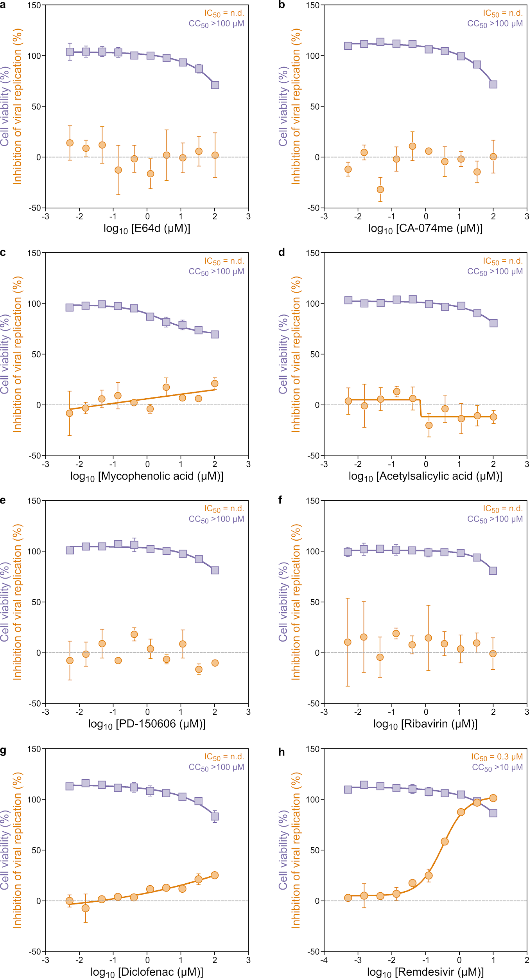

Figure S5. Testing of drugs and compounds that target proteins affected by stabilisation or abundance during SARS-CoV-2 infection. Dose response curves of compounds that inhibit activity of proteins displaying thermal stability changes in Caco-2 cells, which were ineffective or marginally affected SARS-CoV-2 infection in Calu-3 cells. A) E64d and B) CA-074me were used to inhibit cathepsins (e.g. CTSV). C) Mycophenolic acid used as an IMPDH Inhibitor, D) acetylsalicylic acid as a PTGS1 inhibitor, E) PD-150606 as a CAPN1 inhibitor, F) Ribavirin as an IMPDH inhibitor, G) Diclofenac as an inhibitor of PTGS1/PTGS2 (Cox-1/Cox-2) of prostaglandin metabolism and H) Remdesivir as an inhibitor of RNA-dependent RNA polymerase (RdRp) as an internal experimental positive control.

