Supplementary Figure S1. CONSORT diagram.

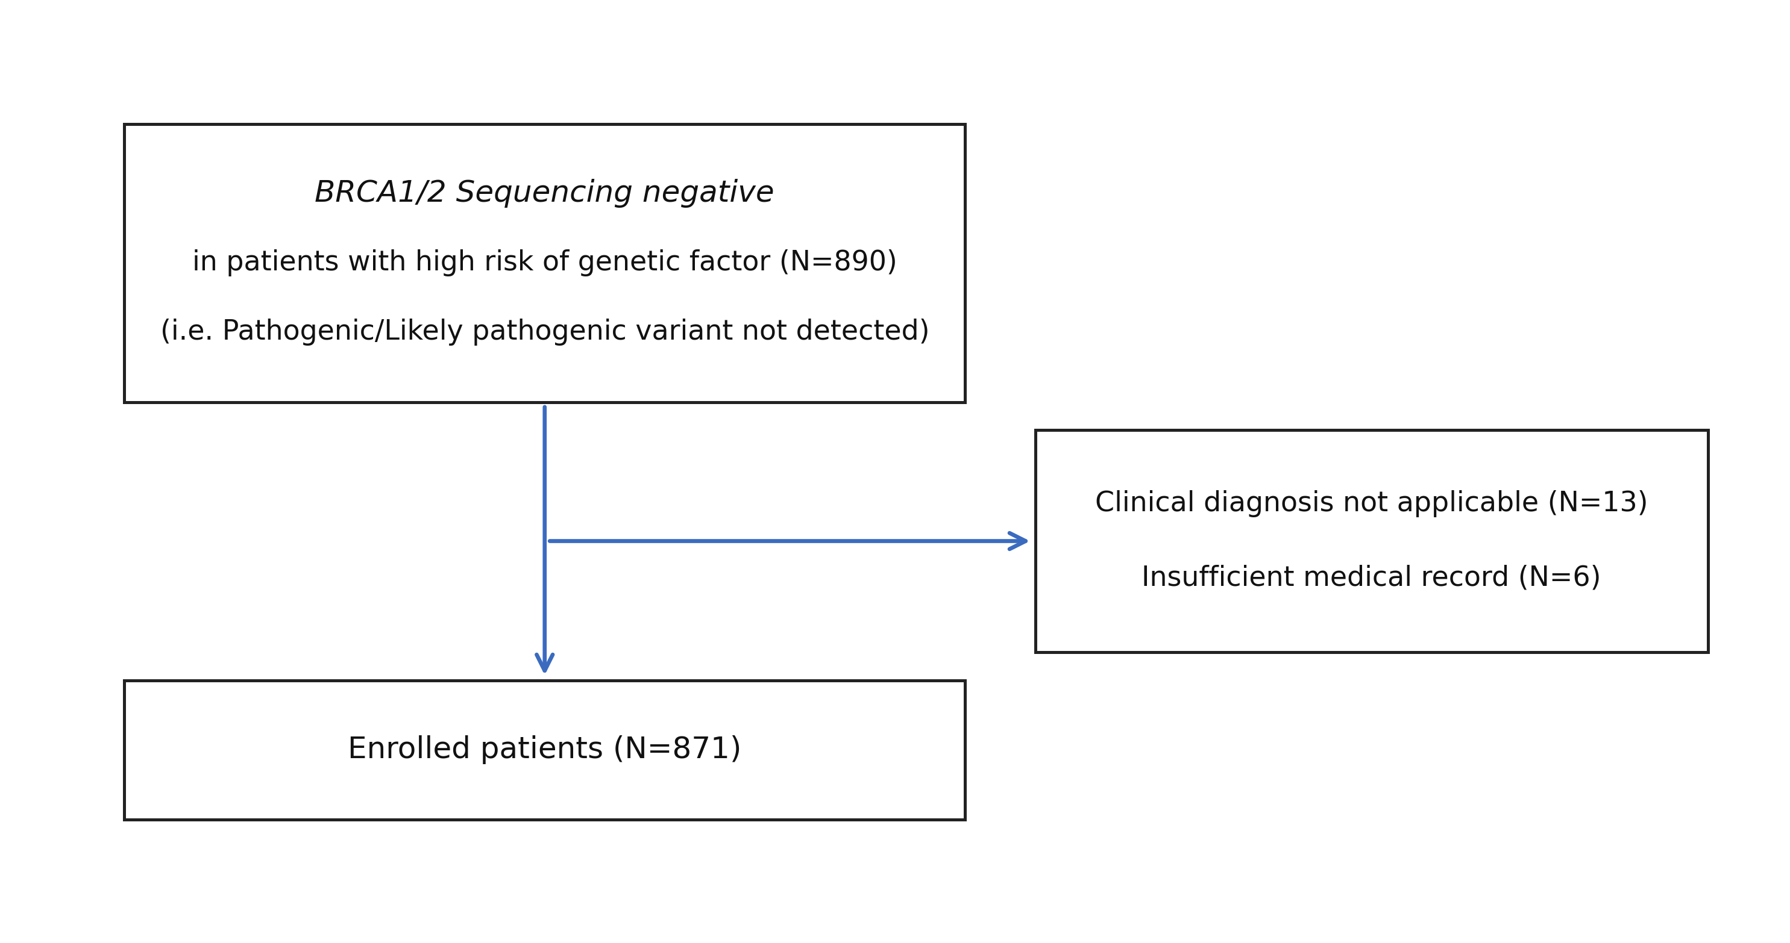

Supplementary Figure S2. Distribution of breast cancer immunohistochemistry subtypes.

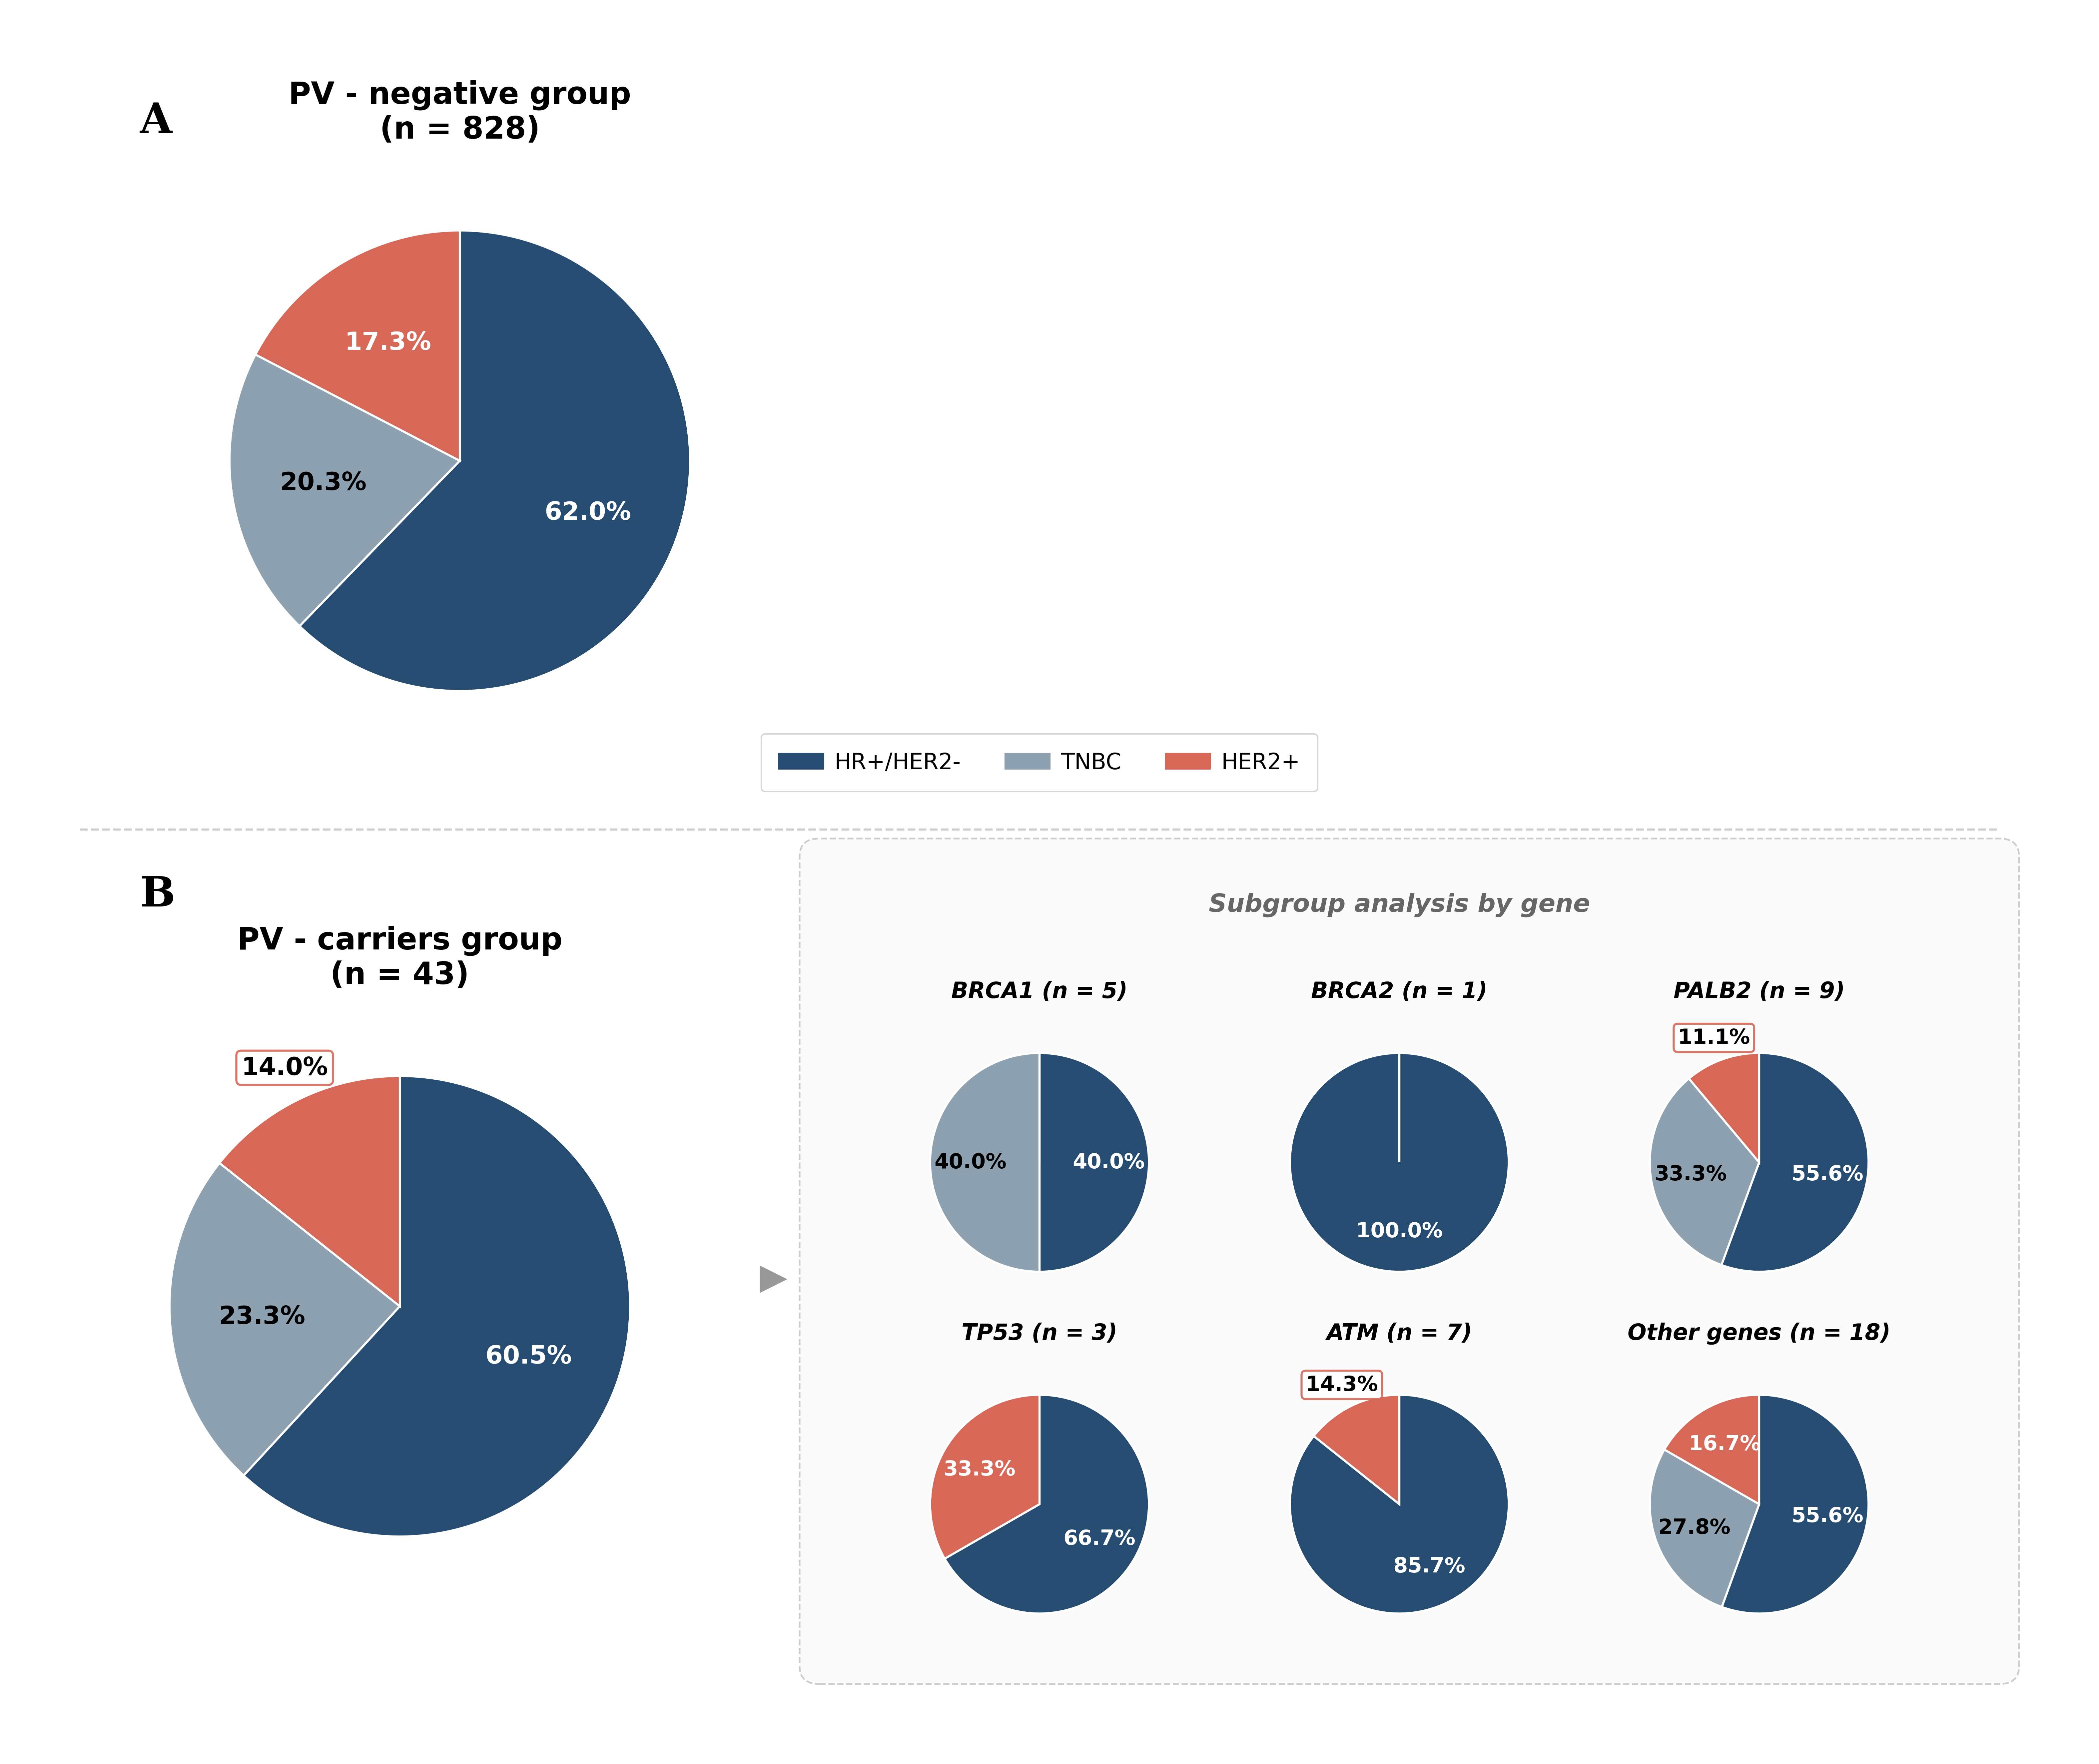

Supplementary Table S1. Clinicopathologic characteristics in each detected gene (Part 1: BRCA1 – MSH6).

Characteristics | BRCA1  (n=5, 11.6%) | BRCA2  (n=1, 2.3%) | PALB2  (n=9, 20.9%) | ATM  (n=7, 16.3%) | TP53  (n=3, 7.0%) | PTEN  (n=2, 4.7%) | BARD1  (n=2, 4.7%) | MSH2  (n=2, 4.7%) | MSH6  (n=2, 4.7%)
ER
positive | 2 (40.0%) | 1 (100.0%) | 5 (55.6%) | 6 (85.7%) | 2 (66.7%) | 2 (100.0%) | 0 (0.0%) | 0 (0.0%) | 2 (100.0%)
negative | 2 (40.0%) | 0 (0.0%) | 4 (44.4%) | 1 (14.3%) | 1 (33.3%) | 0 (0.0%) | 2 (100.0%) | 2 (100.0%) | 0 (0.0%)
unknown | 1 (20.0%) | 0 (0.0%) | 0 (0.0%) | 0 (0.0%) | 0 (0.0%) | 0 (0.0%) | 0 (0.0%) | 0 (0.0%) | 0 (0.0%)
PR
positive | 1 (20.0%) | 1 (100.0%) | 4 (44.4%) | 5 (71.4%) | 2 (66.7%) | 2 (100.0%) | 0 (0.0%) | 0 (0.0%) | 2 (100.0%)
negative | 3 (60.0%) | 0 (0.0%) | 5 (55.6%) | 2 (28.6%) | 1 (33.3%) | 0 (0.0%) | 2 (100.0%) | 2 (100.0%) | 0 (0.0%)
unknown | 1 (20.0%) | 0 (0.0%) | 0 (0.0%) | 0 (0.0%) | 0 (0.0%) | 0 (0.0%) | 0 (0.0%) | 0 (0.0%) | 0 (0.0%)
HER2
positive | 0 (0.0%) | 0 (0.0%) | 1 (11.1%) | 1 (14.3%) | 1 (33.3%) | 0 (0.0%) | 0 (0.0%) | 1 (50.0%) | 1 (50.0%)
negative | 4 (80.0%) | 0 (0.0%) | 7 (77.8%) | 6 (85.7%) | 2 (66.7%) | 2 (100.0%) | 2 (100.0%) | 1 (50.0%) | 0 (0.0%)
equivocal | 0 (0.0%) | 0 (0.0%) | 0 (0.0%) | 0 (0.0%) | 0 (0.0%) | 0 (0.0%) | 0 (0.0%) | 0 (0.0%) | 0 (0.0%)
unknown | 1 (20.0%) | 1 (100.0%) | 1 (11.1%) | 0 (0.0%) | 0 (0.0%) | 0 (0.0%) | 0 (0.0%) | 0 (0.0%) | 1 (50.0%)

Abbreviation: ER, estrogen receptor; PR, progesterone receptor; HER2, human epidermal growth factor receptor 2.

Supplementary Table S1. Clinicopathologic characteristics in each detected gene (Part 2: SDHC – TTN).

Characteristics | SDHC  (n=2, 4.7%) | CHEK2  (n=1, 2.3%) | MLH1  (n=1, 2.3%) | APC  (n=1, 2.3%) | CDKN1B  (n=1, 2.3%) | NF1  (n=1, 2.3%) | RAD51C  (n=1, 2.3%) | RAD51D  (n=1, 2.3%) | TTN  (n=1, 2.3%) | Total  (n=43, 100%) | p-value
ER |  |  |  |  |  |  |  |  |  |  | 0.002
positive | 2 (100.0%) | 1 (100.0%) | 0 (0.0%) | 1 (100.0%) | 1 (100.0%) | 1 (100.0%) | 0 (0.0%) | 0 (0.0%) | 1 (100.0%) | 28 (65.1%)
negative | 0 (0.0%) | 0 (0.0%) | 1 (100.0%) | 0 (0.0%) | 0 (0.0%) | 0 (0.0%) | 1 (100.0%) | 1 (100.0%) | 0 (0.0%) | 14 (32.6%)
unknown | 0 (0.0%) | 0 (0.0%) | 0 (0.0%) | 0 (0.0%) | 0 (0.0%) | 0 (0.0%) | 0 (0.0%) | 0 (0.0%) | 0 (0.0%) | 1 (2.3%)
PR |  |  |  |  |  |  |  |  |  |  | 0.002
positive | 2 (100.0%) | 1 (100.0%) | 0 (0.0%) | 1 (100.0%) | 1 (100.0%) | 1 (100.0%) | 0 (0.0%) | 0 (0.0%) | 1 (100.0%) | 25 (58.1%)
negative | 0 (0.0%) | 0 (0.0%) | 1 (100.0%) | 0 (0.0%) | 0 (0.0%) | 0 (0.0%) | 0 (0.0%) | 1 (100.0%) | 0 (0.0%) | 17 (39.5%)
unknown | 0 (0.0%) | 0 (0.0%) | 0 (0.0%) | 0 (0.0%) | 0 (0.0%) | 0 (0.0%) | 1 (100.0%) | 0 (0.0%) | 0 (0.0%) | 1 (2.3%)
HER2 |  |  |  |  |  |  |  |  |  |  | 0.079
positive | 1 (50.0%) | 1 (100.0%) | 0 (0.0%) | 0 (0.0%) | 0 (0.0%) | 0 (0.0%) | 0 (0.0%) | 0 (0.0%) | 0 (0.0%) | 6 (14.0%)
negative | 1 (50.0%) | 0 (0.0%) | 1 (100.0%) | 1 (100.0%) | 1 (100.0%) | 1 (100.0%) | 0 (0.0%) | 0 (0.0%) | 0 (0.0%) | 32 (74.4%)
equivocal | 0 (0.0%) | 0 (0.0%) | 0 (0.0%) | 0 (0.0%) | 0 (0.0%) | 0 (0.0%) | 0 (0.0%) | 1 (100.0%) | 0 (0.0%) | 0 (0.0%)
unknown | 0 (0.0%) | 0 (0.0%) | 0 (0.0%) | 0 (0.0%) | 0 (0.0%) | 0 (0.0%) | 1 (100.0%) | 0 (0.0%) | 1 (100.0%) | 5 (11.6%)

Abbreviation: ER, estrogen receptor; PR, progesterone receptor; HER2, human epidermal growth factor receptor 2.

Supplementary Table S2. Overview of Major Studies on Additional Susceptibility Genes Beyond BRCA1/2.

Study | BRIDGES  (Dorling, L, et al.) | CARRIERS  (Hu et al.) | Rodriguez-  Hernandez, A., et al. | Couch, F. J., et al. | Shin HC, et al. | Park JS, et al. | Kwak Y et al.  (Current)
Journal | N Engl J Med | N Engl J Med | ESMO | JAMA Oncol | Cancer Res Treat | Cancer Res Treat | -
Nation | Global | Global | Barcelona, Spain (Single center) | USA nationwide | Korea | Korea | Korea
Published year | 2021 | 2021 | 2025 | 2017 | 2020 | 2022 | -
Patient No | 60,466 | 32,247 | 912 | 65,057 | 496 | 700 | 890
Genetic testing | Multigene panel testing (34 susceptibility genes) | Multigene panel testing (28 susceptibility genes) | NGS (14 susceptibility genes) | Multigene panel testing (21 susceptibility genes) | NGS (64 susceptibility genes) | Multigene panel testing (26 susceptibility genes) | WGS
Additional mutation beside BRCA (%) | 4.65% | 2.89% | 6.78% | 6.18% | 7.7% | 10.9% | 4.90%

Abbreviation: BRIDGES, The Breast Cancer Risk after Diagnostic Gene Sequencing; CARRIERS, The Cancer Risk Estimates Related to Susceptibility Genes; NGS, Next-generation sequencing; WGS, Whole genome sequencing.

