Supporting information
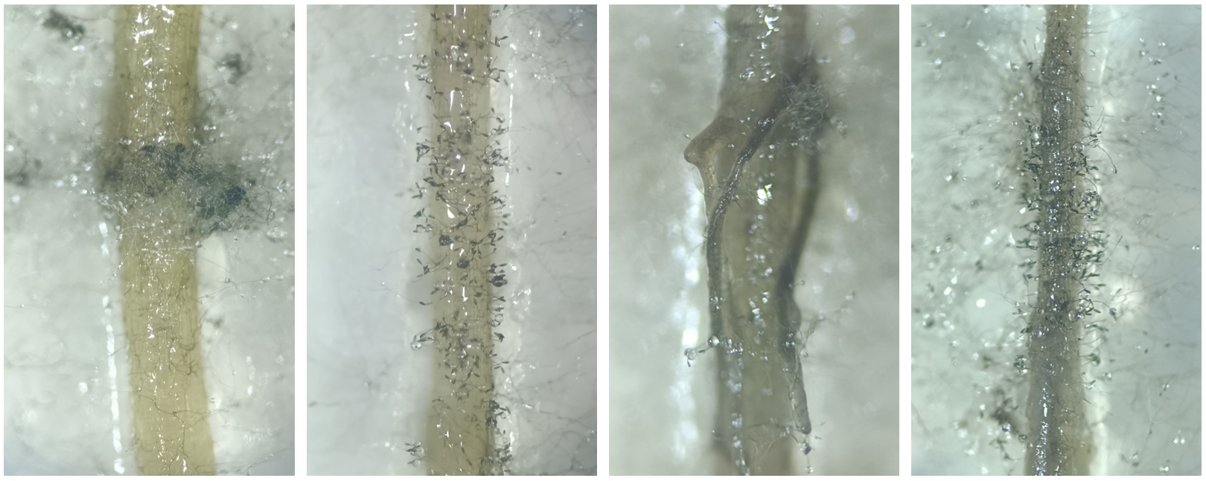

Fig. S1 Different phenotypical growth of Bipolaris sorokiniana on detached roots at 13 days post inoculation (dpi).

Table S1 Replication numbers (n per silicon (Si) and pathogen treatment).
 | 0mM Si | 0.25mM Si | 0.5mM Si | 2mM Si | 4mM Si
Control | 4 | 4 | 5 | 3 | 4
84144 | 5 | 4 | 5 | 5 | 5
84145 | 4 | 6 | 5 | 5 | 6

Table S2 Results of two-way ANOVA of plant potassium (K) and phosphorus (P) concentrations to silicon (Si) supplementation level and varying plant tissues, and their interactive influence on these responses.
Plant element | Figure | Statistical analysis
 |  | Si |  | Plant tissue |  | Si x Plant tissue
 |  | F | p | F | p | F | p
K | S2a | 13.60 | <.001 | 765.42 | <.001 | 3.39 | <.001
P | S2b | 14.41 | <.001 | 391.83 | <.001 | 3.19 | 0.015
Statistically significant (p <.05) results highlighted in bold.

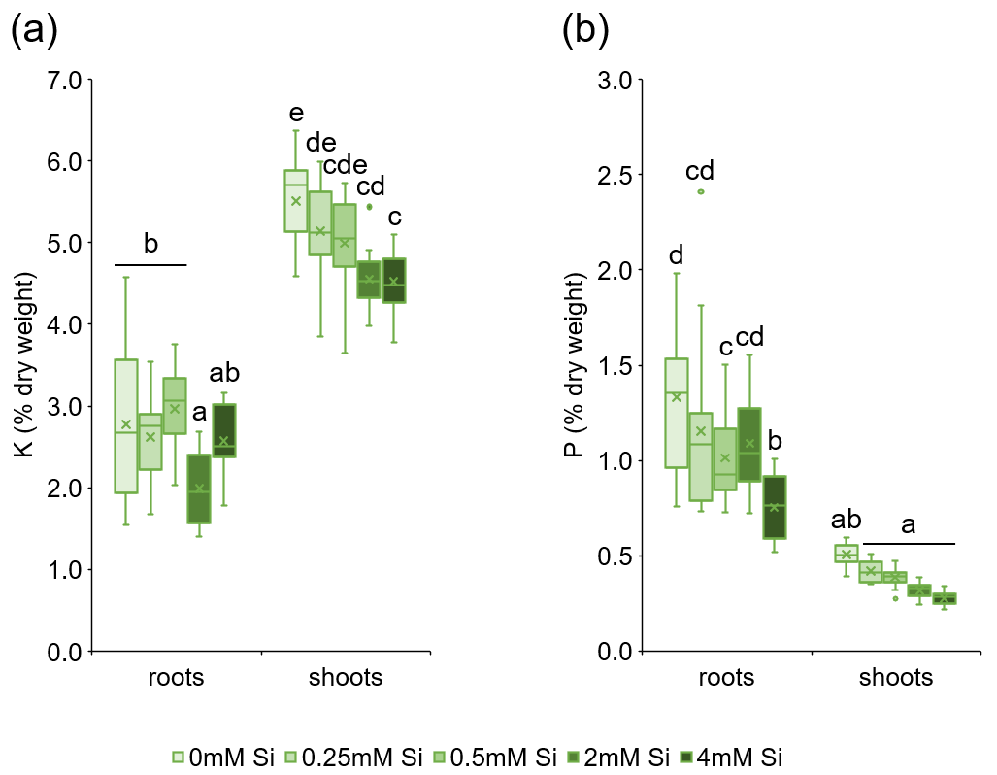

Fig. S2 Potassium (K) (a) and phosphorus (P) (b) concentrations (%) in wheat roots and shoots with increasing silicon (Si) supplementation. Box-and-whisker plots show the median (horizontal line), mean (cross), interquartile range (box; 25th–75th percentiles), and whiskers extending to the minimum and maximum non-outlier values (n = 16). Different letters indicate significant differences among treatments within each tissue type according to two-way ANOVA followed by Tukey’s post hoc test (p < 0.05).

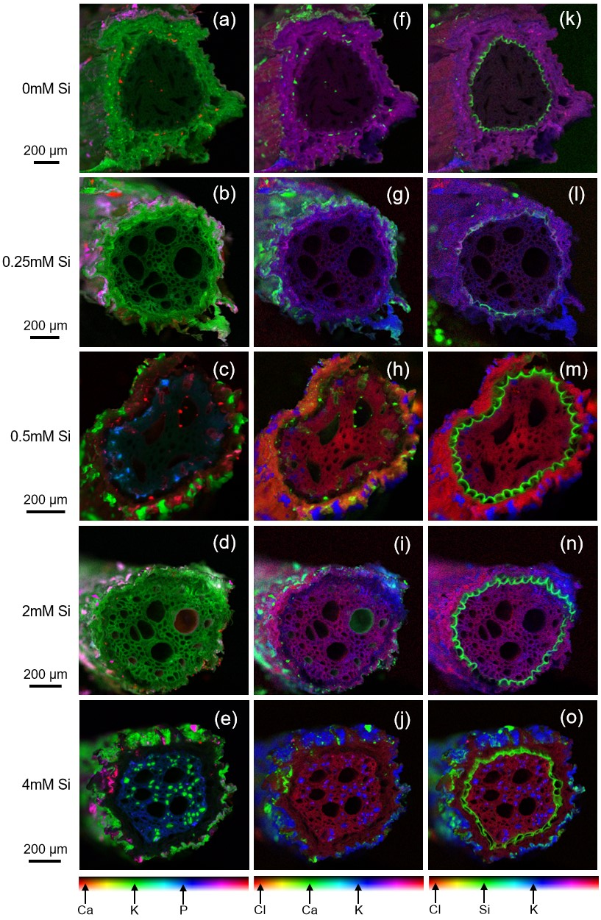

Fig. S3 Phosphorus (P), potassium (K), calcium (Ca), chlorine (Cl) and silicon (Si) deposition in wheat roots with increasing Si supplementation. Pseudo-colour x-ray mapping (XRM) images of cross sectioned roots, magnifications for increasing Si supplementations respectively 200x, 230x, 300x, 250x and 250x. a-e) P, K and Ca in respectively blue, green and red, f-j) K, Ca and Cl in respectively blue, green and red, k-o) K, Si and Cl in respectively blue, green and red.

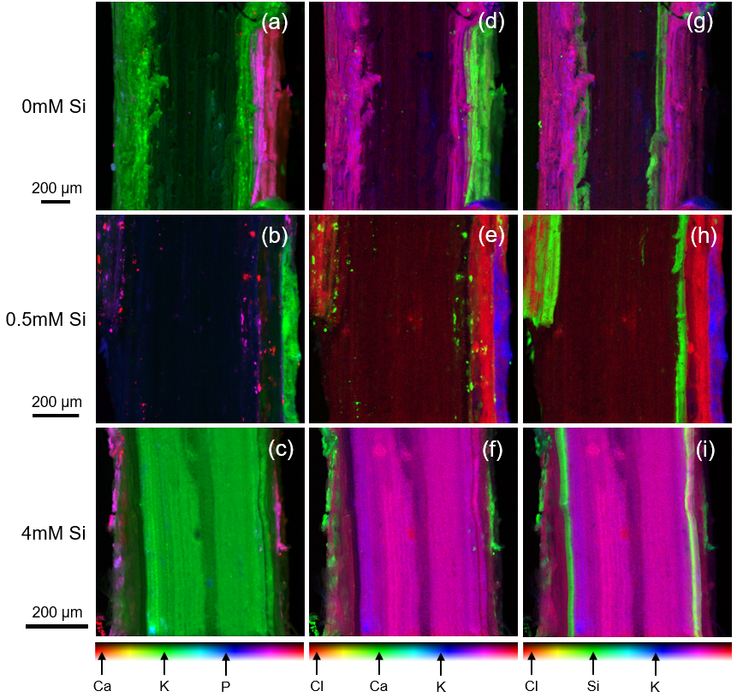

Fig. S4 Phosphorus (P), potassium (K), calcium (Ca), chlorine (Cl) and silicon (Si) deposition in wheat roots with increasing Si supplementation. Pseudo-colour x-ray mapping (XRM) images of longitudinally sectioned roots, magnifications for increasing Si supplementations respectively 180x, 300x and 400x. a-c) P, K and Ca in respectively blue, green and red, d-f) K, Ca and Cl in respectively blue, green and red, g-i) K, Si and Cl in respectively blue, green and red.

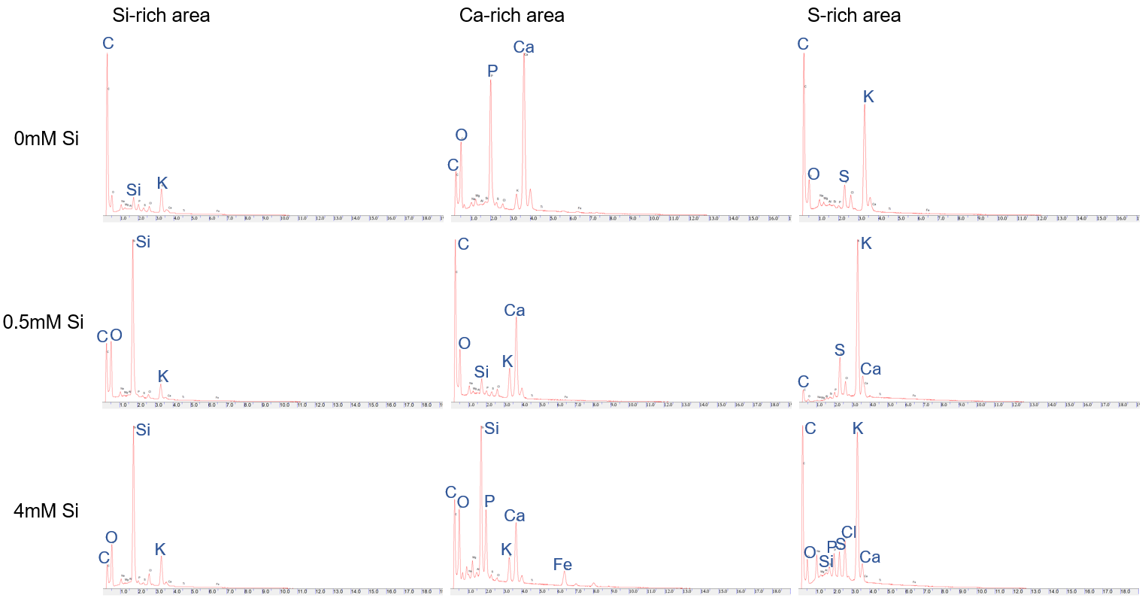

Fig. S5 Energy Dispersive Spectroscopy (EDS) graphs of areas in root samples rich in silicon (Si), calcium (Ca) or sulphur (S).

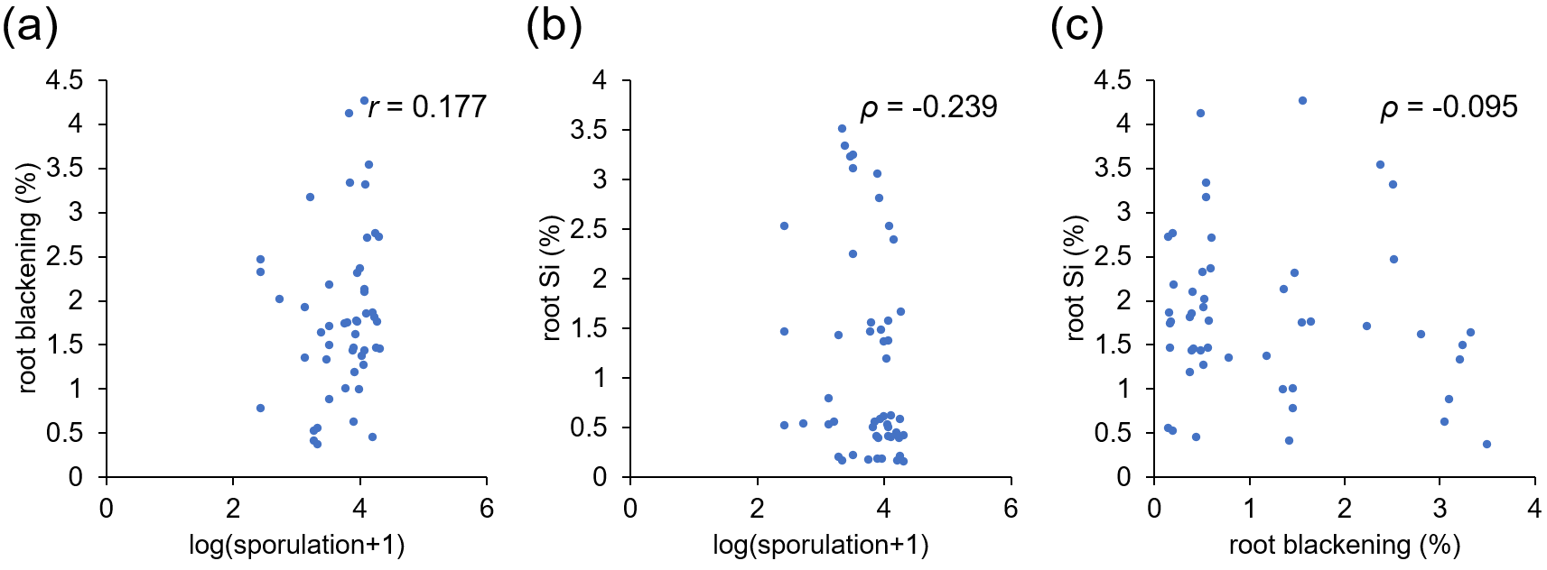

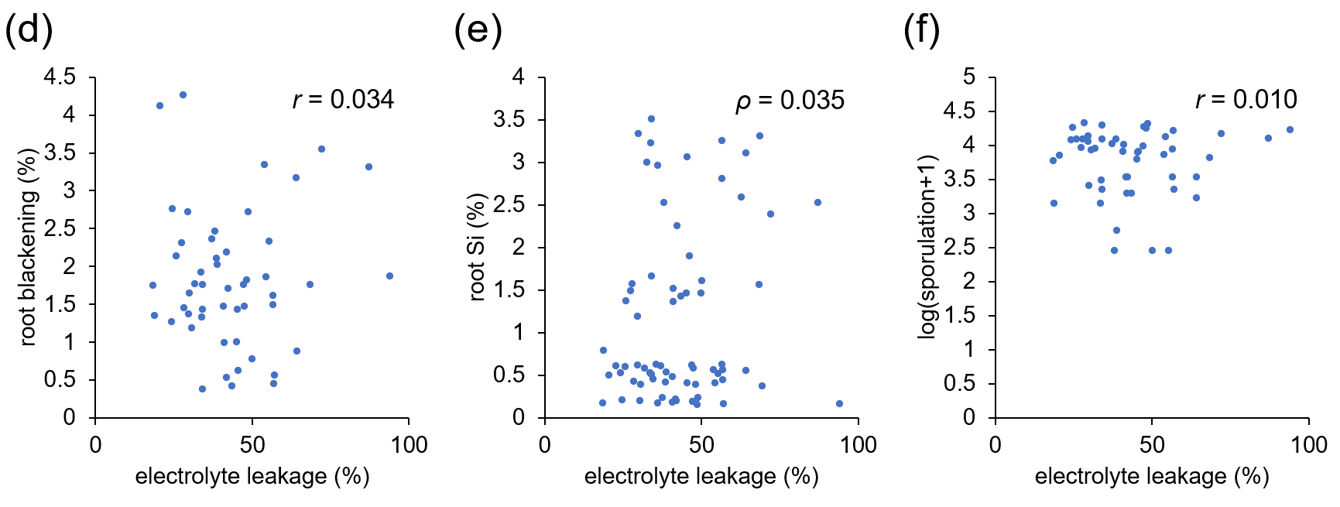

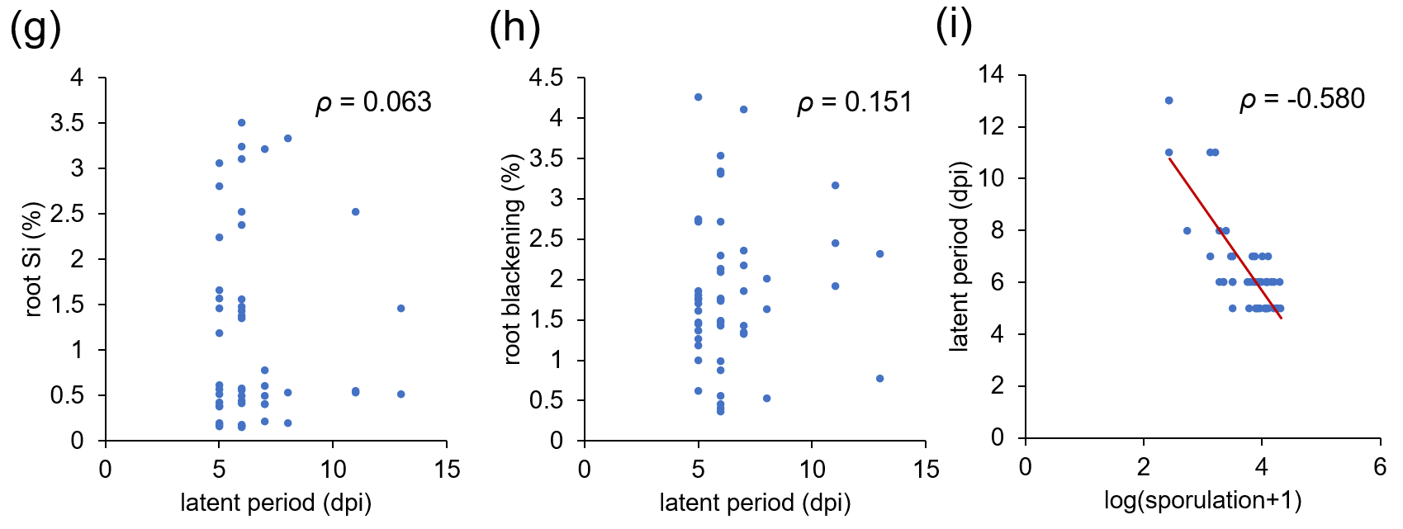

Fig. S6 Correlation analysis between silicon (Si) treatment responses, plant traits, and pathogen performance. a) Root blackening vs sporulation (Pearson, r = 0.177 and p = 0.218), b) root Si vs sporulation (Spearman, ρ = -0.239 and p = 0.094), c) root blackening vs root Si (Spearman, ρ = -0.095 and p = 0.512), d) root blackening vs electrolyte leakage (Pearson, r = 0.034 and p = 0.816), e) root Si vs electrolyte leakage (Spearman, ρ = 0.035 and p = 0.811), f) sporulation vs electrolyte leakage (Pearson, r = 0.010 and p = 0.943), g) latent period vs root Si (Spearman, ρ = 0.063 and p = 0.896), h) root blackening vs latent period (Spearman, ρ = 0.151 and p = 0.442), i) sporulation vs latent period (Spearman, ρ = -0.580 and p = <0.001).

