Supplementary Figure (Figure S1)
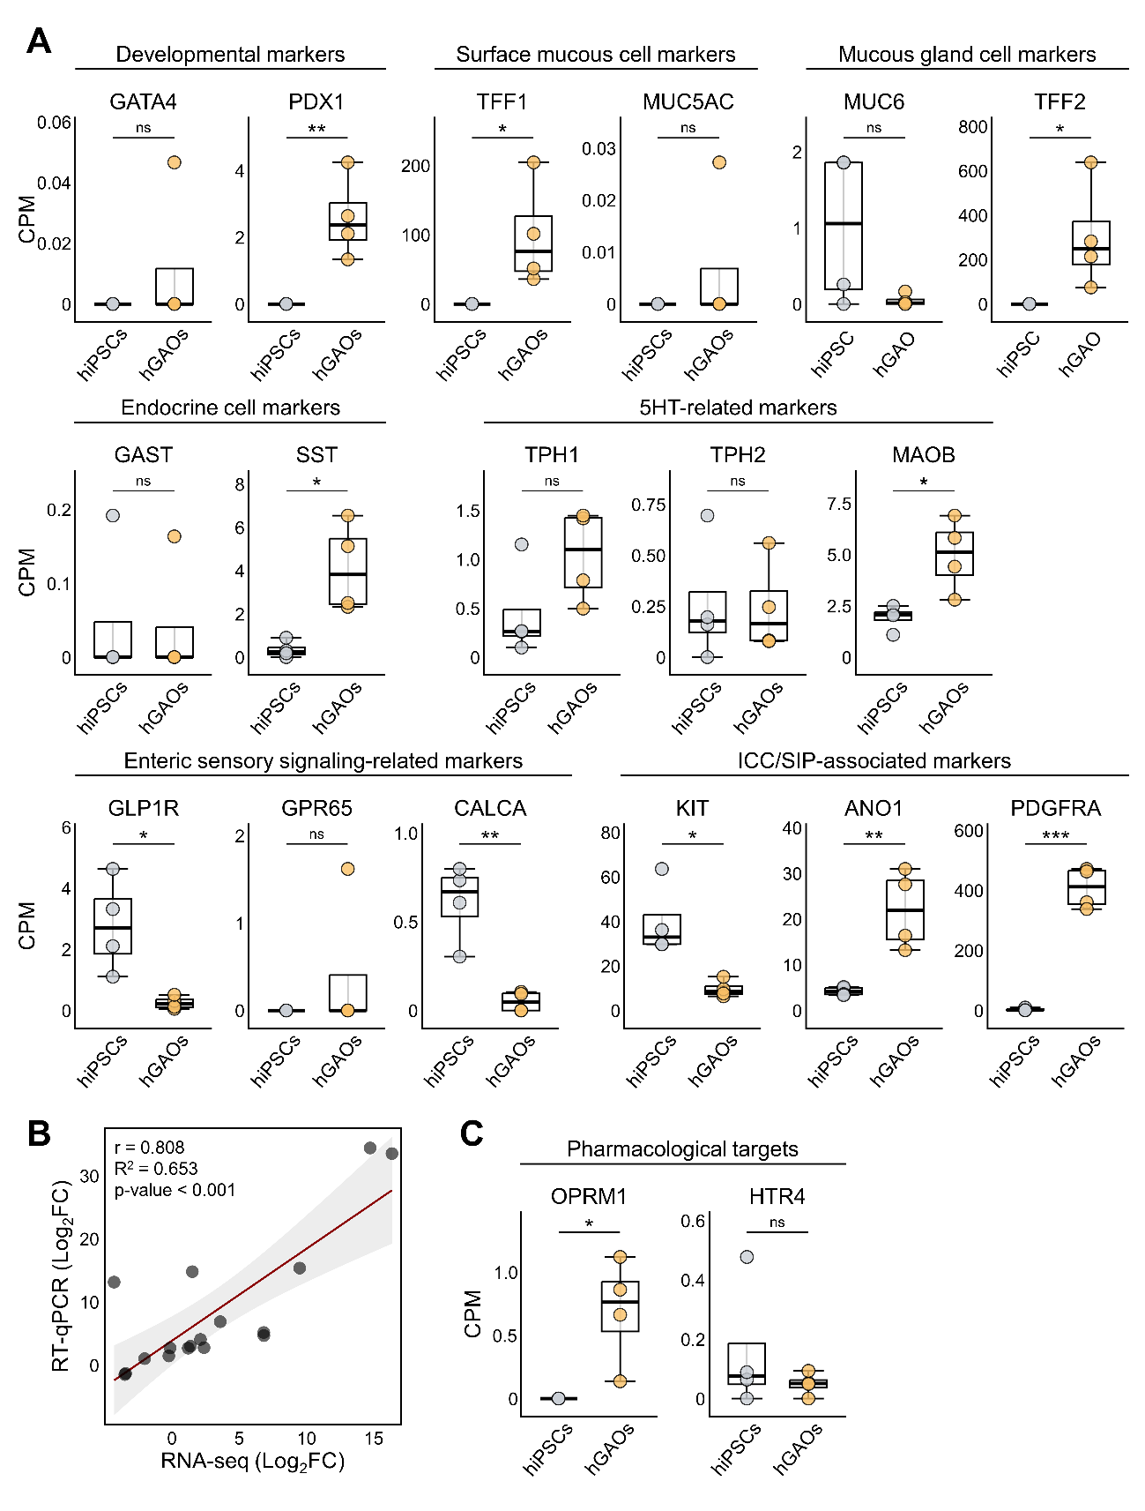
Supplementary Figure S1. RNA-seq-based expression profiles of selected hGAO-relevant marker and pharmacological target genes
(A) RNA-seq-based expression levels, expressed as counts per million (CPM), of selected developmental, surface mucous cell, mucous gland cell, endocrine, 5-HT-related, enteric sensory signaling-related, and ICC/SIP-associated marker genes in hiPSCs and Veh-only hGAOs. (B) Pearson correlation between RNA-seq- and RT-qPCR-derived log₂ fold changes in Veh-only hGAOs relative to hiPSCs across the 17 marker genes shown in panel A. The red line indicates the linear regression line, and the shaded area represents the 95% confidence interval (r = 0.808, R² = 0.653, p < 0.001). (C) RNA-seq-based expression levels, expressed as CPM, of the pharmacological target genes OPRM1 and HTR4 in hiPSCs and Veh-only hGAOs. Data in panels A and C represent n = 4 samples per group. Statistical significance was determined using an unpaired two-tailed Welch’s t-test. ns, not significant; *p < 0.05; **p < 0.01; ***p < 0.001.
Supplementary Tables (Tables S1~S7)

Supplementary Table S1. Primer sequences used for RT-qPCR
Gene | Forward primer (5′–3′) | Reverse primer (5′–3′)
GAPDH | CAATGGAAATCCCATCACCA | GGGCAGAGATGATGACCCTT
GATA4 | TCCAAACCAGAAAACGGAAGC | GCCCGTAGTGAGATGACAGG
PDX1 | CGTCCGCTTGTTCTCCTC | CCTTTCCCATGGATGAAGTC
TFF1 | AATTCTGTCTTTCACGGGGG | GGAGAACAAGGTGATCTGCG
MUC5AC | CCAAGGAGAACCTCCCATAT | CCAAGCGTCATTCCTGAG
MUC6 | CAGCAGGAGGAGATCACGTTCAAG | GTGGGTGTTTTCCTGTCTGTCATC
TFF2 | TCTGAGACCTCCATGACGC | ATGGATGCTGTTTCGACTCC
GAST | CAGAGCCAGTGCAAAGATCA | AGAGACCTGAGAGGCACCAG
SST | CCCCAGACTCCGTCAGTTTCT | CATTCTCCGTCTGGTTGGGT
TPH1 | ACGTCGAAAGTATTTTGCGGA | ACGGTTCCCCAGGTCTTAATC
TPH2 | GGCTACAGAGAGGACAATGTGC | AAGTCTCGTGGGCTCAGGTATC
MAOB | GTGAAGCAGTGTGGAGGCACAA | TTCACTCGGTCTCCAAGGAGGT
GPR65 | TGCGGCACAATAAAGCCACGGA | GCTCTAAAATGCAGCGAATCAGC
CALCA | CTGCACTGGTGCAGGACTATGT | CAGATTACCGCACCGCTTAGATC
GLP1R | CTACGCACTCTCCTTCTCTGCT | CGGACAATGCTCGCAGGATGAA
KIT | CACCGAAGGAGGCACTTACACA | TGCCATTCACGAGCCTGTCGTA
ANO1 | GAAGCGGAAACAGATGCGACTC | CTGGCTTCGTATTCAGCTCTAGG
PDGFRA | CCACCTGAGTGAGATTGTGG | TCTTCAGGAAGTCCAGGTGAA
CLDN1 | CCCAGTCAATGCCAGGTACG | GGGCCT TGGTGTTGGGTAAG
CLDN18 | ATGGAGGACTCTGCCAAAGCCA | TGGACATCCAGAAGTTAGTCACC
TJP1 | ccagcatcatcaacctctgc | catgcgacgacaatgatggt

Supplementary Table S2. Antibodies used for immunofluorescence staining
Marker/target | Antibody | Manufacturer | Cat. No. | Working dilution
PDX1 | Alexa Fluor® 488-conjugated anti-PDX1 | Bioss | bs-0923R-A488 | 1:50
CDH1 | Alexa Fluor® 594-conjugated anti-CDH1 | Cell Signaling Technology | 7687 | 1:50
KRT8 | Alexa Fluor® 647-conjugated anti-KRT8 | Abcam | ab192468 | 1:50
CLDN18 | PE-conjugated anti-CLDN18 | Miltenyi Biotec | 130-127-273 | 1:50
MUC6 | DyLight 650-conjugated anti-MUC6 | Novus Biologicals | NBP3-08352C | 1:100
MUC5AC | PE-conjugated anti-MUC5AC | Miltenyi Biotec | 130-127-552 | 1:50
c-KIT | anti-c-KIT | Invitrogen | MA5-15894 | 1:200
PDGFRα | anti-PDGFRα | Cell Signaling Technology | 3164 | 1:200
Secondary antibody for  c-KIT | Donkey anti-Mouse IgG, Alexa Fluor® 488 | Invitrogen | A21202 | 1:200
Secondary antibody for PDGFRα | Donkey anti-Rabbit IgG, Alexa Fluor® 647 | Invitrogen | A31573 | 1:200

Supplementary Table S3. Differentially expressed genes identified by bulk RNA-seq analysis
Supplementary Table S3 is provided as a separate multi-sheet Excel file. The following legend describes the contents and structure of the Excel worksheets.
This supplementary table contains lists of differentially expressed genes (DEGs) identified by bulk RNA-seq analysis. The six worksheets include upregulated and downregulated DEGs in differentiated hGAOs compared with undifferentiated hiPSCs; upregulated and downregulated DEGs in the Lo → Veh group compared with the Veh-only group; and upregulated and downregulated DEGs in the Lo → Mo group compared with the Lo → Veh group. Each worksheet provides the gene symbol, gene description, fold-change value, false discovery rate (FDR), and group-specific expression values expressed as counts per million (CPM). DEG selection criteria were applied as described in the Methods section. DEG, differentially expressed gene; CPM, counts per million; FDR, false discovery rate; hiPSCs, human induced pluripotent stem cells; hGAOs, human iPSC-derived gastric antrum organoids; Veh, vehicle; Lo, loperamide; Mo, mosapride.

Supplementary Table S4. Pathway enrichment analysis of differentiated hGAOs compared with undifferentiated hiPSCs
Supplementary Table S4 is provided as a separate multi-sheet Excel file. The following legend describes the contents and structure of the Excel worksheets.
This supplementary table contains pathway enrichment analysis results for genes differentially expressed between differentiated hGAOs and undifferentiated hiPSCs. The four worksheets include enriched pathways identified from this comparison; upregulated genes associated with selected neuron development-related pathways, including “neuron projection morphogenesis,” “neuron development,” and “axonogenesis”; upregulated genes associated with the muscle development-related pathway “muscle structure development”; and downregulated genes associated with selected cell cycle-related pathways, including “Cell Cycle,” “Cell Cycle, Mitotic,” and “mitotic cell cycle.” Pathway enrichment analysis was performed using Metascape with the Gene Ontology, KEGG, Reactome, and WikiPathways databases. GO, Gene Ontology; KEGG, Kyoto Encyclopedia of Genes and Genomes; hiPSCs, human induced pluripotent stem cells; hGAOs, human iPSC-derived gastric antrum organoids.

Supplementary Table S5. Pathway enrichment analysis of persistent loperamide-associated transcriptomic changes in hGAOs
Supplementary Table S5 is provided as a separate multi-sheet Excel file. The following legend describes the contents and structure of the Excel worksheets.
This supplementary table contains pathway enrichment analysis results for genes differentially expressed in the Lo → Veh group relative to the Veh-only group. The five worksheets include enriched pathways identified from this comparison; downregulated genes associated with selected muscle-related pathways, including “muscle contraction,” “muscle system process,” “Cytoskeleton in muscle cells,” “muscle structure development,” and “regulation of muscle contraction”; downregulated genes associated with selected neuron-related pathways, including “synaptic signaling,” “trans-synaptic signaling,” and “Nervous system development”; upregulated genes associated with selected immune-related pathways, including “innate immune response,” “Cytokine Signaling in Immune system,” “Response to cytokine,” and “Interferon Signaling”; and downregulated genes associated with selected ion transport-related pathways, including “regulation of membrane potential,” “metal ion transport,” “monoatomic cation transmembrane transport,” “monoatomic cation transport,” “calcium ion transmembrane transport,” and “calcium ion transport.” These results represent transcriptomic alterations that persisted after 2 days of loperamide treatment followed by 4 days of vehicle treatment. Veh, vehicle; Lo, loperamide; Lo → Veh, loperamide treatment followed by vehicle treatment; hGAOs, human iPSC-derived gastric antrum organoids.

Supplementary Table S6. Pathway enrichment analysis of the Lo → Mo group relative to the Lo → Veh group
Supplementary Table S6 is provided as a separate multi-sheet Excel file. The following legend describes the contents and structure of the Excel worksheets.
This supplementary table contains pathway enrichment analysis results for genes differentially expressed in the Lo → Mo group relative to the Lo → Veh group. The three worksheets include enriched pathways identified from this comparison; upregulated genes associated with selected neuron-related pathways, including “autonomic nervous system development,” “regulation of trans-synaptic signaling,” “regulation of nervous system development,” and “synapse organization”; and upregulated genes associated with selected muscle-related pathways, including “muscle system process,” “muscle organ development,” “muscle structure development,” and “muscle contraction.” These analyses were used to identify transcriptomic pathways associated with mosapride treatment following loperamide exposure. Lo, loperamide; Mo, mosapride; Lo → Veh, loperamide treatment followed by vehicle treatment; Lo → Mo, loperamide treatment followed by mosapride treatment.

Supplementary Table S7. Mfuzz clustering assignments and membership values
Supplementary Table S7 is provided as a separate Excel file. The following legend describes the contents and structure of the Excel worksheet.
This supplementary table contains the results of fuzzy c-means clustering performed using the Mfuzz package. The worksheet provides gene-level cluster assignments and membership values for the six expression clusters identified across the Veh-only, Lo → Veh, and Lo → Mo groups. It includes the gene symbol, assigned cluster, membership value, and standardized expression values across the three experimental conditions. Veh, vehicle; Lo, loperamide; Mo, mosapride; Lo → Veh, loperamide treatment followed by vehicle treatment; Lo → Mo, loperamide treatment followed by mosapride treatment.

