Supplementary Information

Enhanced Downstream Processing of 2,3-Butanediol through Salt Alcohol Aqueous Two-Phase Extraction
Pramod M Gawal*^{1,2}, and Sweta Lataye²
¹Department of Chemical Engineering, Indian Institute of Technology Guwahati, Assam-781039, India
²Department of Chemistry, Pusan National University, Busan, 46241 South Korea

Table S1. Correlation coefficient for the proposed model
Std.Dev. | 0.4637 | R² | 0.9997
Mean | 76.54 | Adjusted R² | 0.9994
C.V.% | 0.6058 | Predicted R² | 0.9985
 |  | Adeq Precision | 166.5199

Table S2. Calculation of the recovery of 2,3-BDO.
2,3-BDO:
Feed volume: 1000 ml
2,3-BDO concentration in broth:76.5g/L
Density of 2,3-BDO=0.987 g/mL
2,3-BDO in feed: (76.5×1)/0.987 = 77.5 mL
Water in feed:1000-77.5=922.5 mL
Below is a calculation based on the volume fraction of 2,3-BDO, water, and isobutanol
2,3-BDO in extract phase: 0.20× 380=76.20 mL
2,3-BD in aqueous phase: 0.0013×910=1.26 mL
2,3-BD in DC (bottom): 0.9996×76 = 75.97 mL
Extraction efficiency (Y)= (75.97/77.5) ×100
=98.31%
Distribution coefficient (D) = (76.20/1.26) =60.47
2,3-BD recovery (%) = (75.97/ 77.5) ×100
= 98.02 %
Isobutanol:
Isobutanol initially used: 300 mL
Isobutanol in (Distillate): 0.9379×300=281.37 mL
The solvent recovered = (281.37/300) × 100=94%
The solvent loss = (300-281.37)/300= 6%

Table S3. Comparison of the 2,3-BDO recovery rate using aqueous two-phase extraction with the earlier report.
ATPS with composition | 2,3-BDO Conc(g/L) | Extraction time (hr) | Partition coefficient | Extraction efficiency (%) | Ref.
30% v/v isobutanol and 25% w/v K₂HPO₄ | 76.5 | 0.25 | 61.63 | 98.31 | Present work
32 %(w/w) ethanol and 16% (w/w) ammonium sulfate | 42.24 | 10 | 7.1 | 91.7 | [1]
30% w/v (NH₄)₂SO₄ and 50% v/v isopropanol | 68.2 | 2 | 45 | 97 | [2]
34% (w/w) 2-propanol and 20% (w/w) ammonium  sulfate | 63.84 | - | 9.9 | 93.7 | [3]
35%butanol and 30%NaCl | 75.25 | 0.25 | 5.9 | 97.08 | [4]

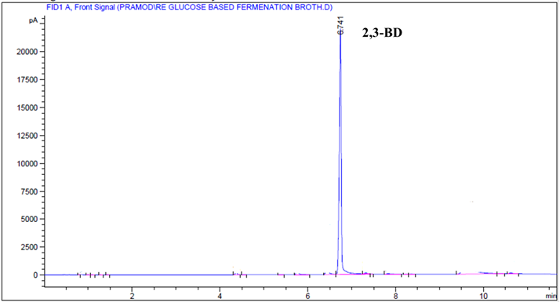
Figure S1. Chromatogram of glucose-based fermentation broth.

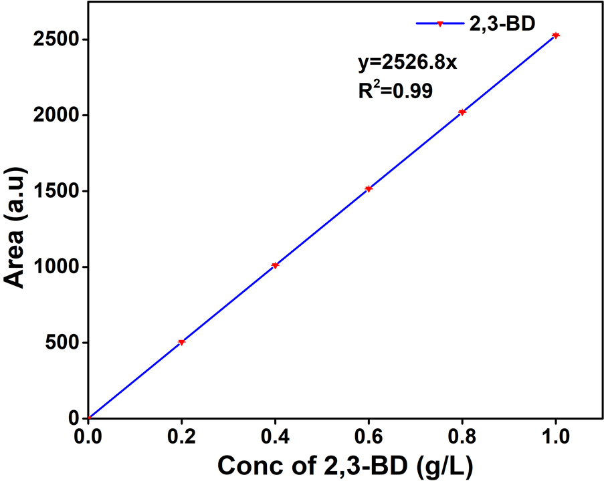
Figure S2. Calibration graph of the standard of 2,3-BDO.

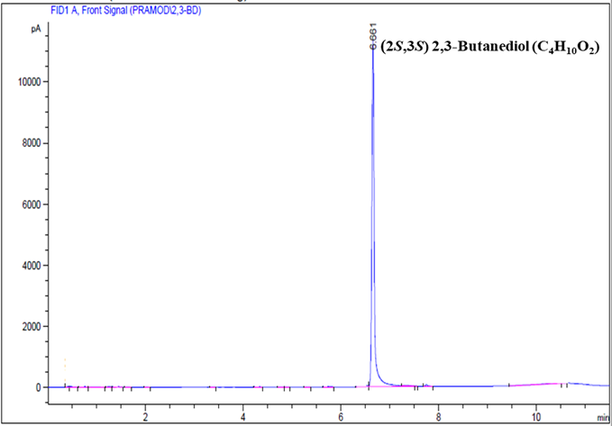
Figure S3. Chromatogram of recovered 2,3-BDO.

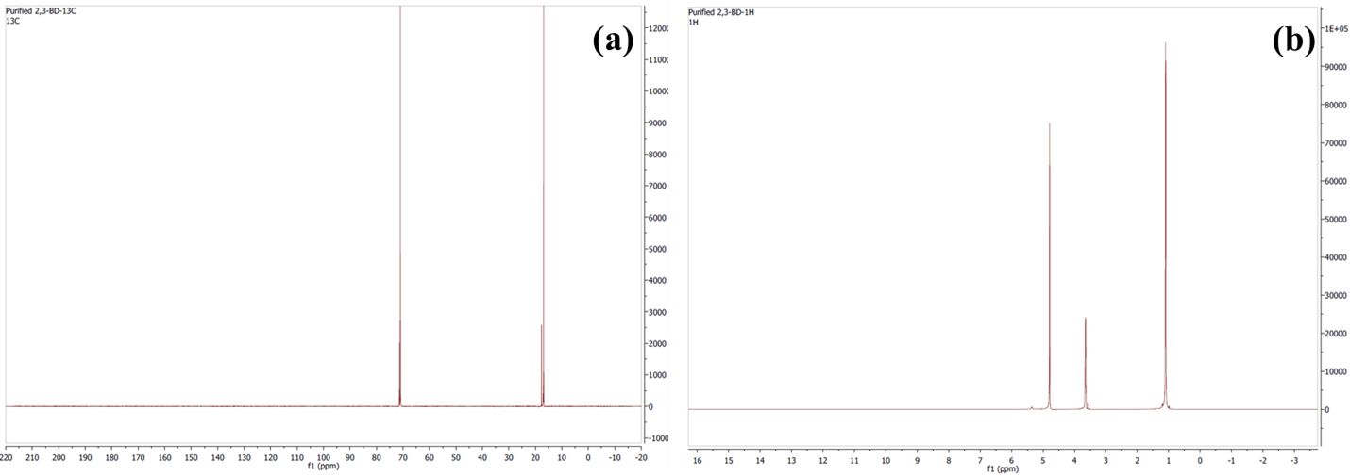
Figure S4. NMR spectra of (a) ¹³C and (b) ¹H of purified 2,3-BDO.

References
[1] Z. Li, H. Teng, Z. Xiu, Aqueous two-phase extraction of 2 , 3-butanediol from fermentation broths using an ethanol / ammonium sulfate system, Process Biochem. 45 (2010) 731–737. https://doi.org/10.1016/j.procbio.2010.01.011.
[2] V. Narisetty, Y. Amraoui, A. Abdullah, E. Ahmad, D. Agrawal, B. Parameswaran, A. Pandey, S. Goel, V. Kumar, High yield recovery of 2,3-butanediol from fermented broth accumulated on xylose rich sugarcane bagasse hydrolysate using aqueous two-phase extraction system, Bioresour. Technol. 337 (2021) 125463. https://doi.org/10.1016/j.biortech.2021.125463.
[3] li hui Sun, J.Æ.Z. Xiu, Aqueous two-phase extraction of 2 , 3-butanediol from fermentation broths by isopropanol / ammonium sulfate system, Biotechnol Lett (2009) 371–376. https://doi.org/10.1007/s10529-008-9874-3.
[4] P.M. Gawal, Cost-effective 2,3-BD separation: insights from aqueous two-phase extraction-assisted distillation, Biomass Convers. Biorefinery 15 (2025) 6757–6765. https://doi.org/10.1007/s13399-024-05392-w.

