Online Resources
Online Resource 1: Longitudinal Evolution of Echocardiographic Parameters
Echocardiographic Parameter | n | Baseline | Final Follow-up | P-Value
RVOT Z-Score | 27 | -0.98 (-2.06 to 0.13) | -0.96 (-2.35 to -0.34) | 0.20
LVEDD Z-Score | 60 | -0.17 (-1.03 to 0.67) | -0.20 (-0.91 to 0.74) | 0.63
TAPSE (cm) | 60 | 1.60 (1.30 to 1.80) | 1.60 (1.40 to 1.80) | 0.38
Shortening Fraction (%) | 58 | 38.5 (33.0 to 42.0) | 36.5 (32.3 to 40.0) | 0.12
Data are presented as median (interquartile range). To ensure internal validity, baseline and final echocardiographic parameters are presented exclusively for the subset of patients with available paired measurements at both time points. P-values calculated using the Wilcoxon signed-rank test to evaluate longitudinal intra-group changes. LVEDD: Left Ventricular End-Diastolic Diameter; RVOT: Right Ventricular Outflow Tract; TAPSE: Tricuspid Annular Plane Systolic Excursion.
Online Resource 2: Evolution of BMI Z-Score by Surgical Repair Subgroups
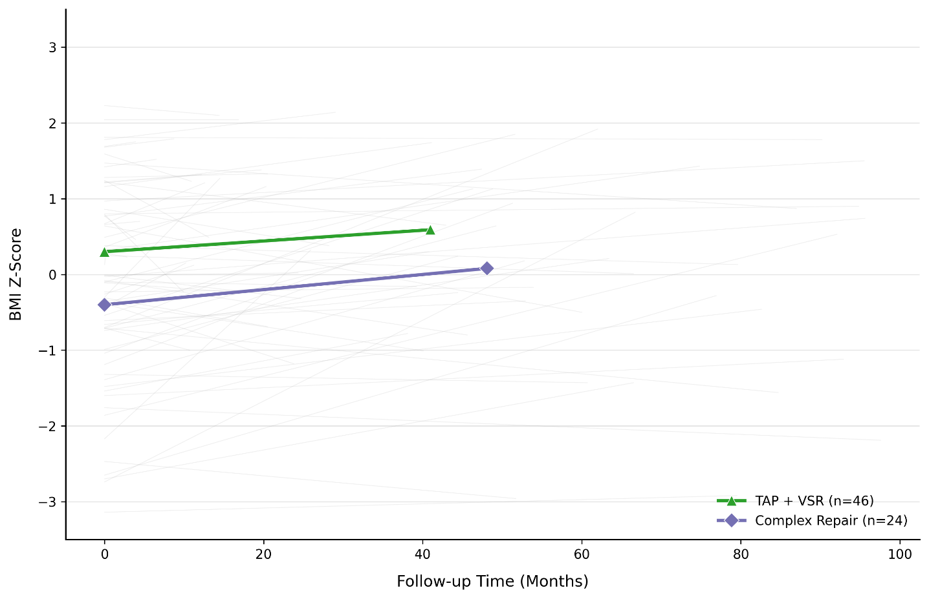
Online Resource 2: Evolution of BMI Z-score during follow-up by surgical repair strategy.
Trajectory of body mass index Z-score (zBMI) stratified by the type of surgical repair. Grey lines represent individual patient trajectories. Coloured lines represent group median trends: green, transannular patch (TAP) and valve-sparing repair (VSR) pooled cohort; purple, complex repair cohort (right ventricle–to–pulmonary artery conduit and/or unifocalization). Pooled cross-sectional analysis demonstrated that patients with complex repairs maintained significantly lower zBMI than TAP+VSR patients both initially (Mann-Whitney U test, p = 0.012) and at final follow-up (p = 0.048). Longitudinal intra-group evaluation showed a statistically significant zBMI increase exclusively in the complex repair group over time (Wilcoxon signed-rank test, p = 0.040). A p-value < 0.05 was considered statistically significant. zBMI was calculated using the WHO 2007 reference. TAP: Transannular Patch; VSR: Valve-Sparing Repair; zBMI: Body Mass Index Z-score.

