Supplementary material
Who benefits when AI guides career choice? Fairness, feasibility and human oversight in school-to-work transitions

S1. Full-scale versions of truncated figures
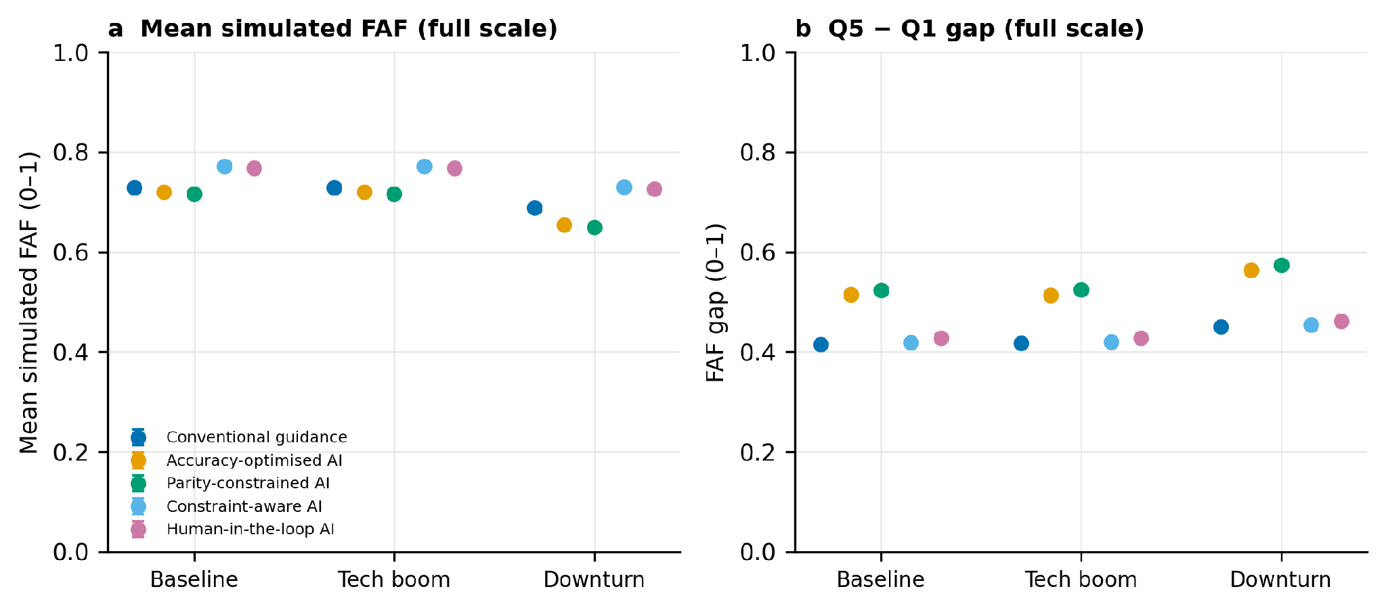
Figure S1. Study 1 results on full 0–1 axes (compare Fig. 1, main text).
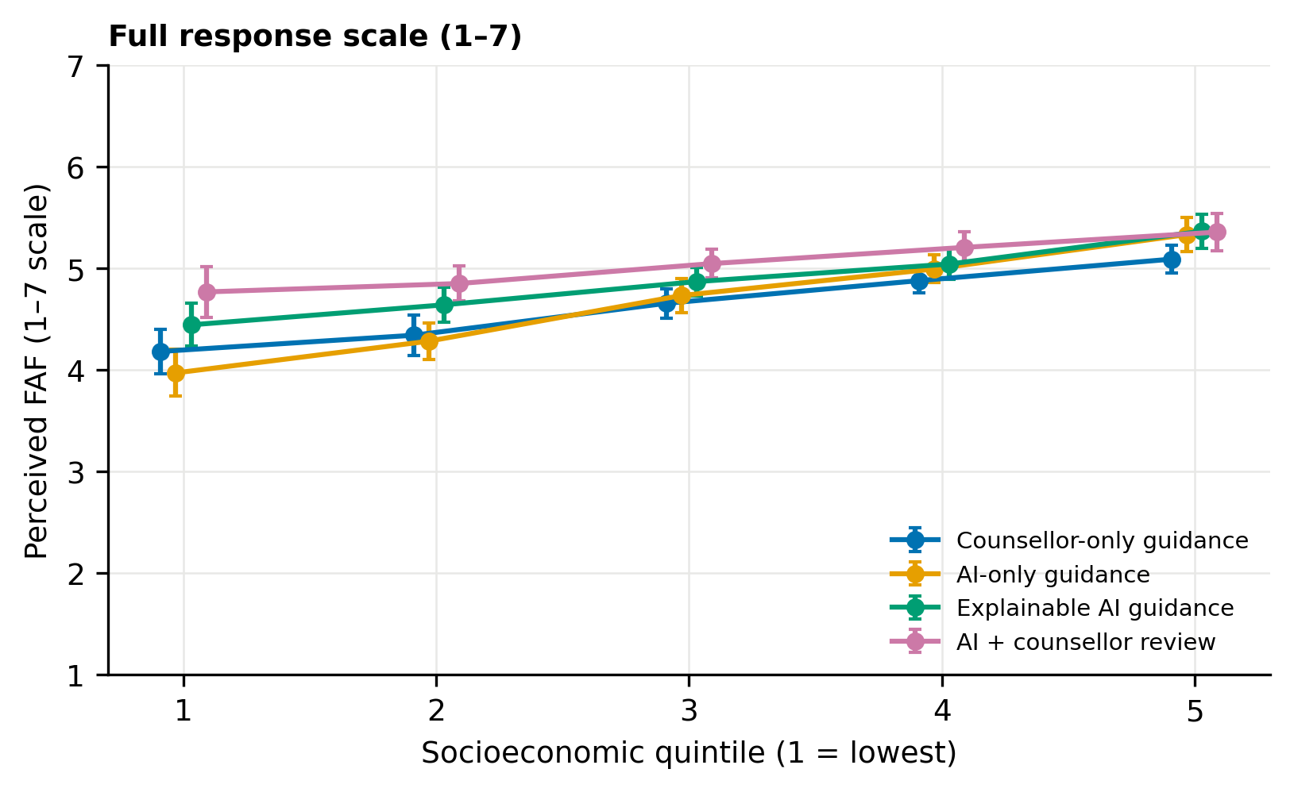
Figure S2. Perceived FAF by socioeconomic quintile and condition on the full 1–7 response scale (compare Fig. 3, main text).

S2. Simulation parameters
All parameters, distributions and the random seed (20260731) are documented in the accompanying simulation code (study1_simulation.py, supplied with the submission). Key values: N = 20,000; ability ~ Normal(0.5 + 0.03·(SES − 3), 0.15) truncated to [0, 1]; interests ~ Dirichlet(0.8); proxy achievement = ability + 0.06·(SES − 3) + Normal(0, 0.07); financial capacity and mobility freedom increase linearly with SES quintile plus individual noise; counsellor fit noise SD = 0.15; human-review judgement noise SD = 0.05; infeasibility threshold 0.40; high-opportunity threshold 0.65; downturn scenario: opportunity −0.10 across sectors, costs ×1.25; 200 bootstrap replications. Sector-level opportunity, cost and mobility vectors are given in the code header.

S3. Measurement
Sampling adequacy KMO = .80. Exploratory factor analysis (minres extraction, varimax rotation) of the eight perceived-fit and feasibility items: eigenvalues 2.94, 1.89, all subsequent < 0.65. Loadings: feasibility items .68–.75 on Factor 1 (cross-loadings ≤ .13); fit items .59–.67 on Factor 2 (cross-loadings ≤ .12). Scale-score correlation r = .21. McDonald’s ω: perceived fit .74, feasibility .82, decision clarity .77, agency .76, trust .76, fairness .70, uncertainty awareness .74, deference .74, acceptance .70.
Sensitivity of FAF specification. Geometric-mean (multiplicative) FAF: condition effect F(3, 983) = 16.97, p < .001, η² = .049; condition ordering identical to the additive specification; SES × condition interactions (versus AI-only): counsellor-only −0.12 (p = .011), explainable AI −0.14 (p < .001), AI + counsellor review −0.20 (p < .001).
Full-sample sensitivity. Retaining all 1,120 allocated participants with any outcome data: F(3, 1116) = 17.45, p < .001; condition means 4.71, 4.72, 4.85, 5.07.

S4. Study 2 instrument, vignette matrix, matching rules and counsellor-review protocol

S4.1 Profile and matching inputs
Participants first completed baseline measures and a structured interest-and-circumstances profile. The profile separated variables used by the initial matching system from conversion-factor information reserved for the counsellor-review stage. The questionnaire and experimental materials were administered in English; no translated versions were used.
Variable group | Operationalisation | Used at
Educational stage | Upper-secondary or undergraduate | Initial matching
Current subjects / degree field | Subjects studied, current stream or university major | Initial matching
Sector interests | Ratings of interest in ten career sectors | Initial matching
Academic readiness | Self-reported subject preparation, recent academic performance, relevant skills | Initial matching
Prerequisite completion | Whether minimum subject or qualification requirements were met | Initial matching
Family support | Perceived support for the proposed field and pathway | Counsellor review only
Financial capacity | Ability to meet tuition, training and related costs | Counsellor review only
Mobility freedom | Ability to relocate, commute or study away from home | Counsellor review only
Information access | Knowledge of application routes, prerequisites, scholarships, training options | Counsellor review only
Personal constraints | Health, caregiving, language or other circumstances voluntarily disclosed | Counsellor review only

S4.1.1 Baseline measures
All items were rated from 1 (strongly disagree) to 7 (strongly agree).
Family support. FS1: My family would support me if I chose a career that genuinely suited my interests and abilities. FS2: The people whose views matter to me would help me pursue the education or training required for my preferred career. FS3: Family expectations make it difficult for me to consider some careers. [reverse-scored]
Financial constraint. FC1: The cost of education or training limits the careers I can realistically consider. FC2: My family and I could manage the expected cost of the pathway required for my preferred career. [reverse-scored] FC3: I would need substantial financial aid to pursue many of the careers that interest me.
Mobility constraint. MC1: I would be able to relocate if the best educational pathway required it. [reverse-scored] MC2: Family or personal circumstances restrict how far I can travel for education or training. MC3: I need career options that can be pursued close to where I currently live.
AI literacy. AIL1: I understand, in general terms, how an AI system can use personal information to make a recommendation. AIL2: I can identify reasons why an AI-generated recommendation might be inaccurate or incomplete. AIL3: I know that AI systems can reproduce biases present in their data or design. AIL4: I feel able to question an AI recommendation rather than accept it automatically.
Baseline trust in AI. BTA1: AI systems can make useful recommendations when they are given relevant information. BTA2: I generally trust AI systems to make fair recommendations. BTA3: I would feel comfortable using AI as one source of career guidance.
Career decision self-efficacy. CDSE1: I can identify careers that fit my interests. CDSE2: I can judge whether I have the abilities required for a particular career. CDSE3: I can find the information needed to compare different education and career pathways. CDSE4: I can make a career decision even when several options appear attractive.
Career uncertainty. CU1: I am uncertain about which career direction is right for me. CU2: I find it difficult to decide which information should matter most in choosing a career. CU3: I frequently change my mind about the career I should pursue.
Prestige orientation. PO1: The social status of a career is important to me. PO2: I would prefer a highly prestigious career even if another option fitted me somewhat better. PO3: How other people view a career strongly affects whether I would consider it.

S4.2 Matching system: inputs and scoring
Component | Rule | Role
Interest–sector similarity | Mean of the participant’s standardised interest ratings for activities associated with sector s | Weight 0.60
Aptitude compatibility | Compatibility between the participant’s subject preparation, academic readiness and the demands of sector s | Weight 0.40
Prerequisite screen | Careers requiring an unmet compulsory prerequisite were excluded unless an explicit bridging pathway was available | Eligibility rule
Opportunity level | Used only as a tie-breaker where two eligible options differed by no more than 0.02 in fit score | Tie-breaker
Financial, mobility, family and information factors | Not used by the initial matching system | Reserved for counsellor review
Initial fit score: Fit(i,s) = 0.60 × InterestSimilarity(i,s) + 0.40 × AptitudeCompatibility(i,s).
For each participant, the system ranked all eligible careers by initial fit score and selected the highest-ranked. If two options were within 0.02 points, the option with the higher opportunity band was selected; any remaining exact tie was resolved by a fixed identifier to keep the procedure deterministic. The deterministic rules were implemented in Python and recommendations were generated prospectively, before participants viewed the experimental materials.

S4.3 Career and vignette structure
Two linked structures defined the recommendation materials.
Table S4.3A. Career sectors, pathway-cost and opportunity bands, and representative career labels. Each sector carried a fixed pathway-cost band (Low / Medium / High) and labour-market opportunity band (Medium / Medium-high / High). The career labels shown are sector-specific labels that could populate a recommendation.
Sector | Cost band | Opportunity band | Representative career labels
Technology | Medium | High | Software developer; data analyst; cybersecurity analyst
Healthcare | High | High | Medical doctor; nursing or allied-health professional; physiotherapist
Science & Research | High | High | Laboratory or academic researcher; biotechnology research associate
Business & Management | Medium | Medium-high | Financial analyst; operations or management professional; entrepreneur / small-business founder
Public Service & Policy | Medium | Medium | Public-policy analyst; public administration / civil services
Law & Legal Services | High | Medium-high | Lawyer; legal-services professional
Creative & Design | Medium | Medium | UX or product designer; graphic or visual-communication designer; media and communications producer
Education & Training | Low | Medium | School teacher; education-and-training professional
Skilled Trades & Technical | Low | Medium-high | Renewable-energy technician; supply-chain or logistics technician
Sustainability & Environment | Medium | High | Environmental scientist; sustainability analyst
S4.3B. Vignette templates (V_01–V_24). The 24 vignette identifiers represented standardised recommendation templates rather than 24 unique occupations. Each template could be instantiated with the career or sector selected by the matching system, allowing presentation and pathway framing to be counterbalanced across occupational sectors; the pathway-cost and opportunity information presented followed the instantiated sector’s profile (Table S4.3A). A “vignette”, as delivered, was therefore the complete rendered recommendation shown to a student — career label, pathway description, cost and opportunity information and source statement — not merely the name of a career. The full template texts are available from the corresponding author with the study materials.

S4.4 Recommendation presentation by condition
The core recommendation generated by the matching system was held constant across the counsellor-only, AI-only and explainable-AI arms. In the reviewed arm, the counsellor could retain, qualify, modify or replace the recommendation where a documented feasibility problem emerged.
Condition | Source statement | Material shown
Counsellor-only | “A qualified career counsellor reviewed your profile and prepared the following recommendation.” | Base recommendation text; no AI rationale
AI-only | “An AI career-guidance system analysed your profile and generated the following recommendation.” | Base recommendation text; no rationale or uncertainty statement
Explainable AI | “An AI career-guidance system analysed your profile and generated the following recommendation.” | Base recommendation plus plain-language rationale and explicit uncertainty statement
AI + counsellor review | “An AI career-guidance system generated this recommendation, which was then reviewed by a qualified career counsellor against the circumstances you reported.” | Counsellor-endorsed or counsellor-modified recommendation plus review note
Base recommendation template. “Based on the information in your profile, [CAREER/PATHWAY] appears to be a strong option for you. This recommendation reflects your reported interest in [INTEREST SIGNALS] and your preparation in [APTITUDE OR SUBJECT SIGNALS]. A typical route into this field is [PATHWAY DESCRIPTION].”
Explainable-AI addition. “The main factors behind this recommendation were [FACTOR 1], [FACTOR 2] and [FACTOR 3]. The system may not know everything that affects whether this pathway is practical for you, including costs, mobility, family circumstances and access to information. Treat the recommendation as one option to investigate rather than a final decision.”
Counsellor-review notes. Reviewers selected one of four structured outcomes — endorse, qualify, modify the pathway, or replace the career — and recorded an individualised free-text note explaining the decision, structured on the note framework for that outcome. Endorsed unchanged: “I reviewed the recommendation against the circumstances in your profile. It remains a reasonable option, provided that you verify the stated entry requirements and available routes.” Endorsed with qualification: “The career remains suitable, but one practical issue requires attention: [ISSUE]. Before acting, investigate [SUPPORT OR INFORMATION].” Pathway modified: “The career remains suitable, but the original route may not be the most feasible. A more realistic pathway is [ALTERNATIVE ROUTE], because [REASON].” Career replaced: “The original recommendation fits some of your interests, but a substantial feasibility or prerequisite issue makes it unsuitable at present. [REPLACEMENT CAREER] offers a closer balance of fit and practical accessibility because [REASON].”

S4.5 Post-recommendation outcome measures
All items were rated from 1 (strongly disagree) to 7 (strongly agree). Scale scores are the mean of constituent items after reverse scoring; higher scores indicate more of the named construct. Item codes match the variable names in the dataset.
Perceived career fit. PF1: The recommended career matches my interests. PF2: The recommended career would make good use of my abilities. PF3: The kind of work involved in this career suits me. PF4: Overall, this recommendation is a good fit for me.
Perceived feasibility. FEAS1: I could realistically afford the education or training required for this pathway. FEAS2: I could access the required course, institution or training from where I live, or relocate if necessary. FEAS3: My family and personal circumstances would allow me to pursue this pathway. FEAS4: I have, or could obtain, the information and support needed to take the next steps.
Decision clarity. CLAR1: This recommendation makes my possible career direction clearer. CLAR2: I now understand the next steps I would need to take. CLAR3: The recommendation helps me compare this option with other careers. CLAR4: I feel less confused about what I should consider next.
Agency. AGENCY1: The final decision still felt like mine. AGENCY2: I felt free to accept or reject the recommendation. AGENCY3: The recommendation supported my thinking rather than deciding for me. AGENCY4: I remained in control of the career decision.
Trust in the guidance. TRUST1: I believe the source of this recommendation was competent. TRUST2: The recommendation appears to be based on relevant information about me. TRUST3: I have confidence in the process used to produce the recommendation. TRUST4: I believe the guidance was intended to support my best interests.
Perceived fairness. FAIR1: The recommendation took my circumstances into account fairly. FAIR2: A student from a background like mine would be treated fairly by this guidance process. FAIR3: The recommendation did not disadvantage me because of my financial or social circumstances.
Uncertainty awareness. UA1: I understand that this recommendation could be wrong or incomplete. UA2: I understand why the recommendation is uncertain rather than guaranteed. UA3: I would seek additional information before making an important decision based on this recommendation.
Algorithmic deference. DEF1: I would follow this recommendation even if it conflicted with my own judgement. DEF2: I would assume that the source of the recommendation knows better than I do. DEF3: I would be reluctant to question this recommendation.
Recommendation acceptance. ACC1: I would seriously consider pursuing the recommended career. ACC2: I would be willing to explore this pathway further. ACC3: I would use this recommendation as a basis for my next career-related action.
Condition-specific wording. In the deference items, “source of the recommendation” was replaced with the condition-appropriate label: “career counsellor”, “AI system”, or “AI system and reviewing counsellor”.

S4.6 Counsellor-review protocol
Reviews were completed by three professional career counsellors (two holding doctorates and one a master’s degree, in psychology, counselling or education) with between 9 and 15 years of career-guidance experience. Each participant in the reviewed arm was assigned to one of the three counsellors and reviewed independently; cases were not routinely double-reviewed, and counsellors did not confer before recording their decisions. Reviewers followed the same written protocol and did not have access to post-recommendation outcome responses.
Information shown to reviewers: participant profile (interests, educational stage, subjects or degree field, academic readiness, prerequisite completion); conversion factors (financial capacity, mobility freedom, family support, information access, voluntarily disclosed personal constraints); system output (initial recommendation, vignette identifier, fit score, brief rationale). Withheld: condition assignments beyond the reviewed arm, outcome responses, and aggregate study hypotheses.
Review sequence. (1) Check that interest and aptitude evidence reasonably supported the recommended sector. (2) Check compulsory prerequisites and identify any unmet requirement. (3) Assess affordability, geographical mobility, family circumstances and information access. (4) Determine whether a detected constraint could be addressed through an alternative route, bridging course, scholarship, local option or staged pathway. (5) Select one review outcome: endorse (E0), qualify without changing the pathway (E1), modify the pathway (P), or replace the career (R). (6) Record the principal reason and, where possible, a capability-expanding action rather than simply lowering the level of aspiration.
Decision codes. E0 — endorse unchanged: career and pathway retained, no substantive feasibility concern. E1 — endorse with qualification: career and pathway retained, with a warning, information need or support referral added (E0 and E1 are combined as “endorsed unchanged” in summary reporting, since the career and pathway did not change). P — pathway modification: career retained, but route, sequence, institution type or location changed to improve feasibility. R — career replacement: a different career recommended because the original contained a substantial prerequisite or feasibility problem not reasonably resolvable within the pathway.
Review principles. Fit first (no replacement merely because a pathway was demanding or unfamiliar); no direct use of SES labels (reviewers considered disclosed constraints, not the participant’s socioeconomic-quintile label); capability expansion (where a barrier could be addressed through scholarships, bridging routes, mobility support or information, retain the aspiration and identify the support); minimum necessary change (pathway modification preferred to career replacement where fit remained strong); documented reason (every qualification, modification or replacement required a coded reason and short free-text explanation).
Review-log fields: de-identified participant ID; initial vignette ID (V_01–V_24); initial career and pathway; reviewer ID (C1–C3); primary issue code (affordability, mobility, family circumstances, information access, prerequisite, other); review outcome (E0, E1, P, R); final career/pathway; brief reason; capability-expanding action (scholarship, bridging course, local route, staged route, information referral, none); review timestamp.
Review-log summary. Of the 268 recommendations reviewed, counsellors endorsed 193 (72.0%) unchanged (E0/E1), modified the proposed educational pathway in 56 cases (20.9%), and replaced the recommended career in 19 cases (7.1%). The most frequent reasons for intervention were affordability, geographic mobility and unmet prerequisite requirements.
Example review decisions. Endorse unchanged: a student with strong quantitative interests and adequate mathematics preparation received data analyst; no material financial or mobility barrier was reported. Pathway modification: a student matched to software development could not relocate for a high-cost residential degree; the career was retained but the pathway changed to a lower-cost local degree plus a structured coding portfolio. Pathway modification with support: a student matched to environmental science reported limited finances; the career was retained and the note identified lower-cost public programmes and scholarship investigation. Career replacement: a student matched to medicine lacked compulsory science prerequisites and could not undertake the required remedial sequence; the recommendation was replaced with a health-sector pathway compatible with the student’s preparation.

S4.7 Debriefing statement
Because recommendation provenance was experimentally manipulated, participants were debriefed immediately after the outcome measures. The debriefing statement read:
“Thank you for participating in this study. The study examined how the stated source and presentation of a career recommendation influence students’ responses. To avoid affecting your answers, the complete purpose of the study and the way the recommendation source was varied were not disclosed before participation. The recommendation was produced using a standardised profile-matching procedure. In the counsellor-review condition, a qualified career counsellor also reviewed your profile and could amend the recommendation. The recommendation was provided for research purposes and should not be treated as definitive career advice. You may ask questions about the study or request withdrawal of your responses in accordance with the consent information provided.”

S4.8 Scoring summary
Perceived FAF (primary) is the arithmetic mean of the perceived-fit and perceived-feasibility scale scores; the sensitivity specification is their geometric mean (Section S3). All other constructs are means of their constituent items after reverse scoring.

