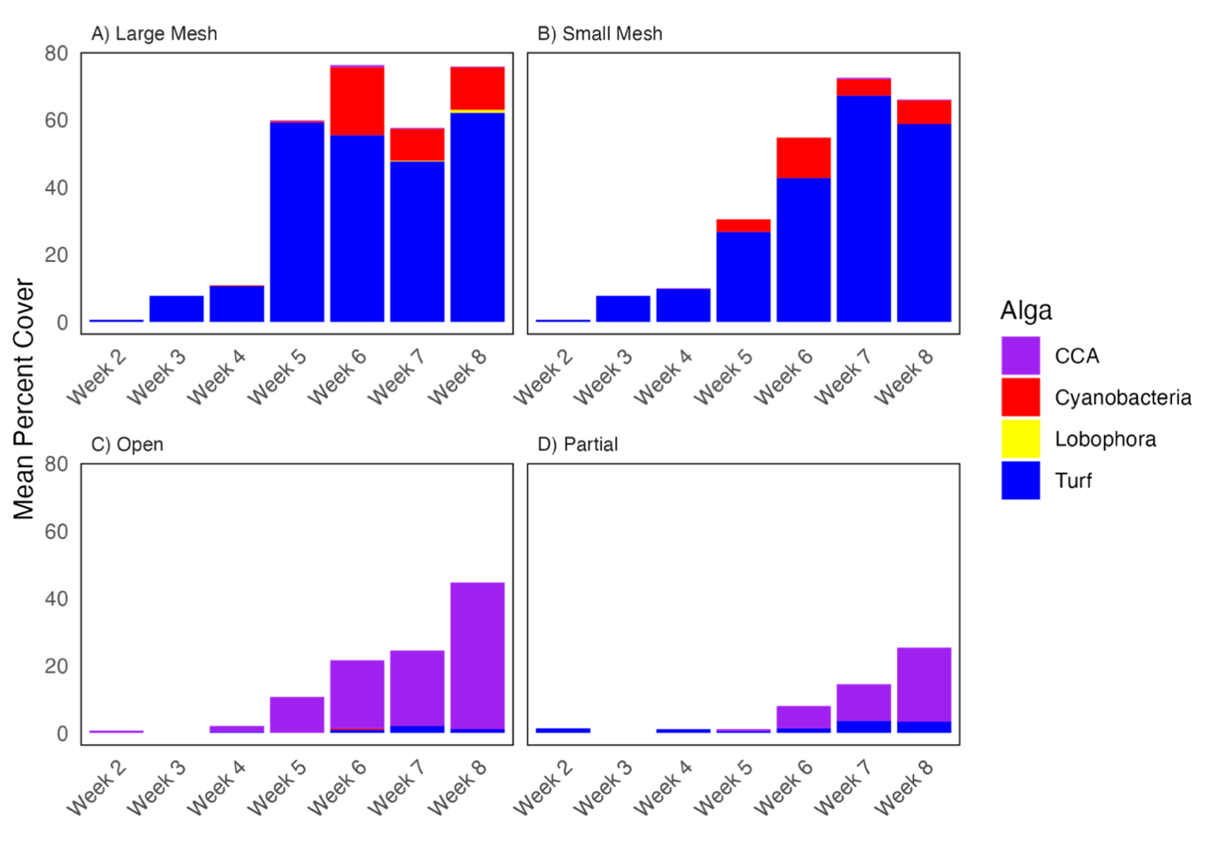
Supplementary Figure 1. Temporal progression in mean percent cover of algal groups across cage treatments from weeks 2 to 8. Stacked bars show the contribution of Cyanobacteria, Lobophora, CCA and Turf algae to total algal cover within each treatment. Panels correspond to Large Mesh, Small Mesh, Open and Partial treatments.

