APPENDIX :

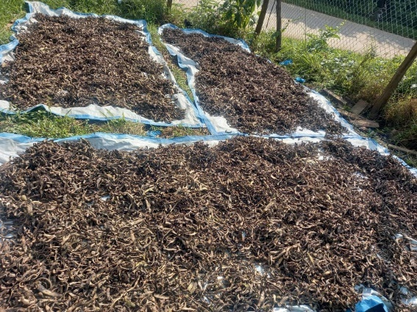
PROJECT PHOTOS
B
A
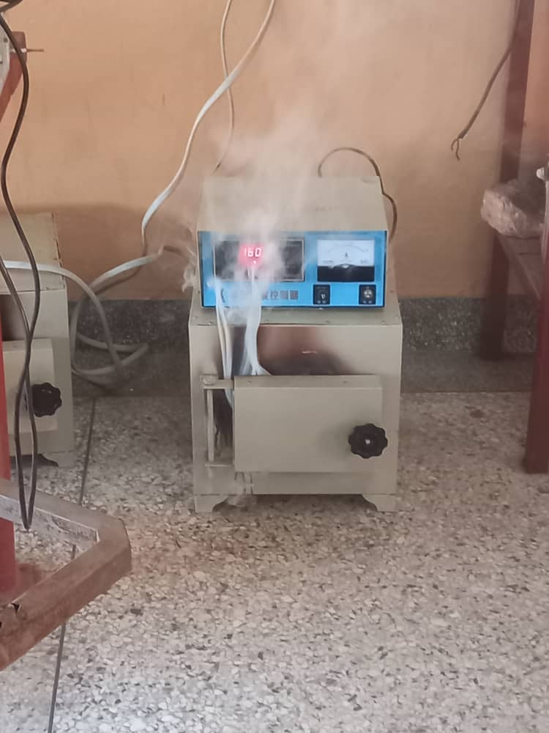

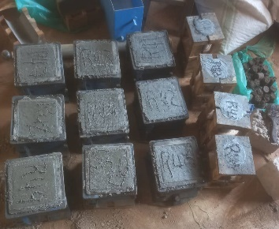
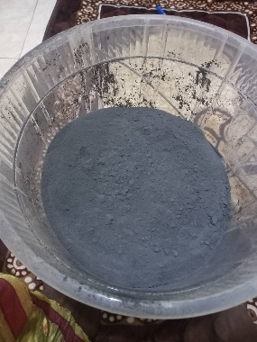

D
C

Figure 6: (A) Sun-dried banana peels; (B) GBPA incineration at 800°C; (C) Sieved GBPA; (D) GBPA concrete cubes after curing.

